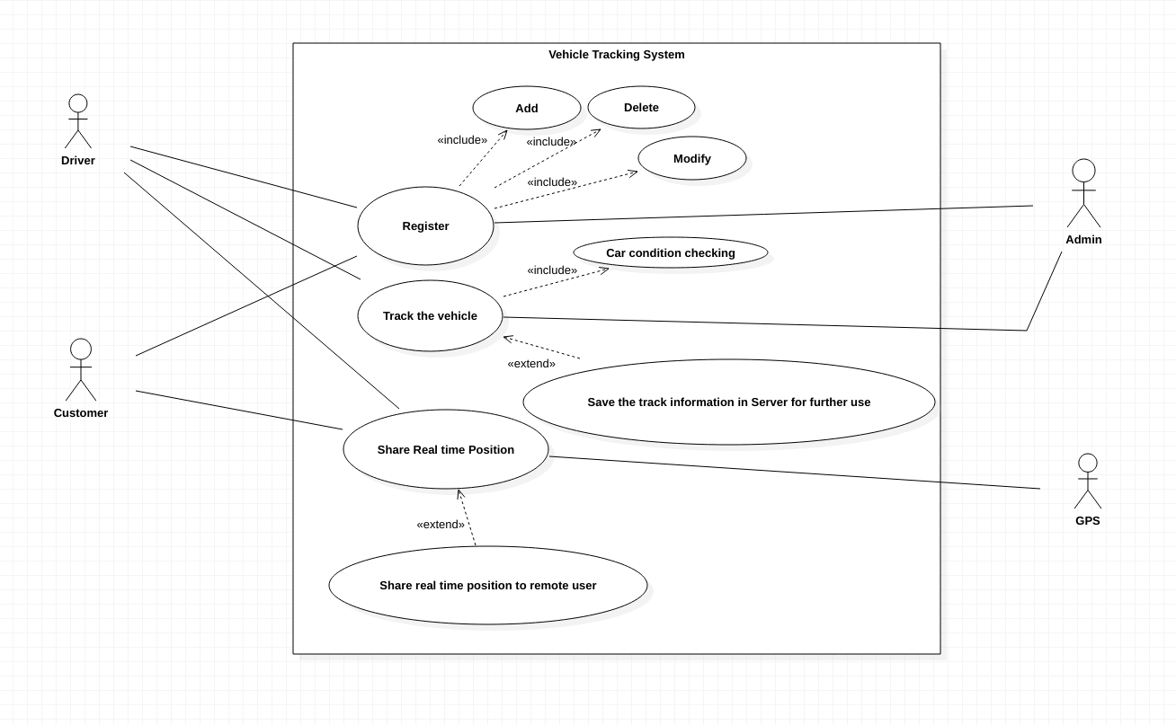

Use case UC1 – Register

Scope: Vehicle Tracking System

Primary Actor: Driver, Customer

Stakeholder and interest:

* Admin: Wants to maintain the accounts. Validates all account information. Whenever necessary, they can delete or modify the content of the account.

Preconditions:

* Drivers must have all information of car and their personal details. Also, they must have a tracking device attached in their car.
* Customer should provide correct details about him/her. They must have a tracking device.

Success Guarantee:

* Drivers’ tracking device, details of cars and their personal details are registered in the system.
* Customers’ tracking device and their personal details are registered in the system.

Main Success Scenario:

1. User access a website of Vehicle tracking system
2. Provide the necessary information
3. Click the submit button
4. Login id and password will be generated and shared with the user

Extension:

\*a. User can be customer, driver or admin

1a. Driver accesses the website of vehicle tracking system

1. Show webpages, which are specific for drivers

1b. Customer access the website of vehicle tracking system

1. Show webpages, which are specific for customers
2. Provide tracking devices’ information
3. Provide his/her personal details

1c. Admin access the website of vehicle tracking system

1. Show webpages, which are specific for admins
2. Do the maintenance
3. Validity check for new accounts

2a. Driver provides the necessary information

1. Provide driver’s car information
2. Provide tracking devices’ information
3. Provide driver’s personal details

2b. Customer provides the necessary information

1. Provide tracking devices’ information
2. Provide customer’s personal details

3a. Admin will validate the information given by the user

1. For Drivers

1a. Validate the car’s number plate

1b. Validate the tracking device

1c. Start validation process for the personal details

1. For customers

2a. Validate the tracking device

2b. Start validation process for the personal details

4a. Upon successful validation, admin will generate login id and password for an account

Special requirement:

* Modify account
* Delete account
* Add account
* At any time, user can create an account
* Simultaneously, 1000 users should be able to crate account

Technology and Data Variations List

3a. Use mobile as a tracking device and send a message to associated mobile number for validations

Frequency of occurrence: Continuous

Open issues:

* How to initiate personal details validation?
* Who will verify personal details?

Use case UC2: Track the Vehicle

Scope: Vehicle Tracking System

Primary Actor: Driver, Customer

Stakeholder and interest:

* Admin: Check feedbacks for drivers and customers. Keep track about all travel histories of drivers and customers.

Preconditions:

* Servers must be up and running all the time
* Tracking system of Vehicle should work properly
* Tracking system of customer should work properly

Success Guarantee: Once driver reach to the peek up point, all devices should be activated. Periodically, collected data will be uploaded to appropriate Servers. Once driver reach to destination, all data should be uploaded to appropriate Server.

Main Success Scenario:

1. Customer requests for a car to go to a destination
2. Server fetches condition of some cars, which are belong to close proximity
3. Server validates the conditions of cars
4. Server assigns a car to customer and notifies the driver
5. Driver reaches to peek up point
6. All tracking devices are activated
7. At regular interval, through internet, few data are saved in Server
8. Once driver reaches destination, all necessary data are saved in Server

Extension:

1a. Customer has to login to the system

1. Use the credential, given by admin
2. Login to the system
3. Set destination

2a. Server can’t validate car’s condition

1. Notify driver about it
2. Don’t assign any customer

4a. Driver rejects the request

1. Server search for another car
2. Server assigns a car to customer and notifies the driver
3. If driver rejects the request, again start from step-1
4. Above process will continue either driver accepts or all cars are assigned one by one but none accepts

7a. For some intervals, when internet is not available

1. Track customer’s device
2. If customer’s device is also facing internet issue, save information locally
3. Once internet connection restored, share all information to Server

Special requirement:

* Devices can save information locally for some time
* Track the speed
* Track the condition of several parts of car

Technology and Data Variations List:

1a. Mobile app is required to communicate all information

2a. Server-Client mechanism is required to enable such facilities

7a. Car should have tracking devices attached to necessary parts of it. Here Automotive industry can help.

Frequency of occurrence: Continuous

Open issues:

* Which parts of a car should be tracked regularly?
* What are the measurements to declare that a car is in a condition to reach at destination?
* How to track the real time car speed?
* In case of thousands of such active rides how system will track every detail of every car?

Use case UC3: Share real time position

Scope: Vehicle Tracking System

Primary Actor: Driver, Customer

Stakeholder and interest:

* Admin: Admin will continuously monitor whether driver is maintaining all perimeters or not.
* Remote User: If customer share location with someone else, that person will be able to monitor the position uninterruptedly.
* Global positioning system: This system will continuously share the longitude and latitude of the tracking device

Main Success scenario:

1. Login to the system
2. System will establish communication between tracking device and GPS
3. System will have a virtual map
4. After getting longitude and latitude information from GPS, it will accurately update position in its virtual map
5. In case of sharing, appropriate information will be communicated among different users

Extension:

1a. Driver has to login to the system before starting a ride

1. Once driver logged in, Admin will be notified
2. From peek up point to drop point Admin will monitor all parameters
3. In case of any emergency Admin can share that information to concern person

1b. Customer has to login to the system before starting a ride

1. Whenever required, customer can check his/her live location.
2. Customer can share that information with any remote user
3. Remote user can see the live location of the customer reaches drop point or stops sharing
4. From peek up point to drop point Admin will monitor the movement as well

5a. This virtual map will be shared among Admin, Drive, Customer and remote user

1. Customer can only share live location through this system
   1. Using that system remote users can track the movement of the customer.

5b. Due to some reason if tracking information is unavailable, system will show last known position to all remote users

Special requirement:

* Connectivity between tracking device and GPS
* Mapping between virtual map and actual longitude and latitude
* Keep track of the whole path in case of future analysis
* Provide securities to each account, so that users account information is remain safe
* Unless customer wants to share, no remote user should be able to access the live location feature

Technology and Data Variations List:

1a. Separate user account will be required for drivers and customers

2a. Mobile app should have capability to communicate with global positioning system

3a. Mobile app should be capable to map virtual map and longitude and latitude information

Frequency of occurrence: Continuous

Open issues:

* If customer’s tracking device malfunction, how system is going to detect that?
* What level of zoom of virtual map functionality will system provide?
* In case of thousands of such active rides how system will place every detail in the virtual map?