TDT4145: Data Modelling and Database Systems

Exercise 1: “Introduction to databases and ER-modelling”

David Rozas Domingo
Miguel Bono Tur

Task 1

a)

- Data: In computing, data is information that has been translated into a form that is more convenient to move or process.
- Database: Is a collection of data, tipically describing the activities of one or more related organizations.
- Database system: Is software designed to assist in maintaining and utilizing large collections of data.

b)

According to the book, the use of a DBMS offers many characteristics that we cannot find in traditional file systems:

- Data independence: Application programs should be as independent as possible from details of data representation and storage. The DBMS can provide an
abstract view of the data to insulate application code from such details.

- Efficient data access: A DBMS utilizes a variety of sophisticated techniques to
store and retrieve data efficiently. This feature is especially important if the data
is stored on external storage devices.

- Data integrity and security: If data is always accessed through the DBMS, the
DBMS can enforce integrity constraints on the data. For example, before inserting
salary information for an employee, the DBMS can check that the department
budget is not exceeded. Also, the DBMS can enforce access controls that govern
what data is visible to different classes of users.

- Data administration: When several users share the data, centralizing the administration of data can offer significant improvements. Experienced professionals
who understand the nature of the data being managed, and how different groups
of users use it, can be responsible for organizing the data representation to minimize redundancy and for fine-tuning the storage of the data to make retrieval
efficient.

- Data independence: Application programs should be as independent as possible from details of data representation and storage. The DBMS can provide an
abstract view of the data to insulate application code from such details.

- Efficient data access: A DBMS utilizes a variety of sophisticated techniques to store and retrieve data efficiently. This feature is especially important if the data
is stored on external storage devices.

- Data integrity and security: If data is always accessed through the DBMS, the
DBMS can enforce integrity constraints on the data. For example, before inserting
salary information for an employee, the DBMS can check that the department
budget is not exceeded. Also, the DBMS can enforce access controls that govern
what data is visible to different classes of users.

- Data administration: When several users share the data, centralizing the administration of data can offer significant improvements. Experienced professionals
who understand the nature of the data being managed, and how different groups
of users use it, can be responsible for organizing the data representation to minimize redundancy and for fine-tuning the storage of the data to make retrieval
efficient.

Task 2

Task 3

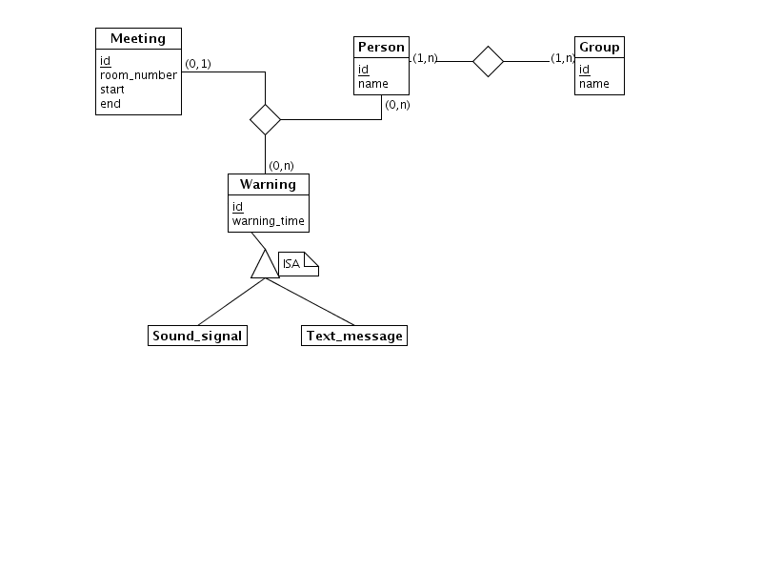
Task 4

Notes:

We have used the following notation:

- 1 employee belongs to 1 and only 1 department.
- 1 department have assigned 1..n employees.

