TDT4145: Data Modelling and Database Systems

Project: “Picture database”

[Exercise 1: “Conceptual data model”]

David Rozas Domingo
Miguel Bono Tur

ER Diagram

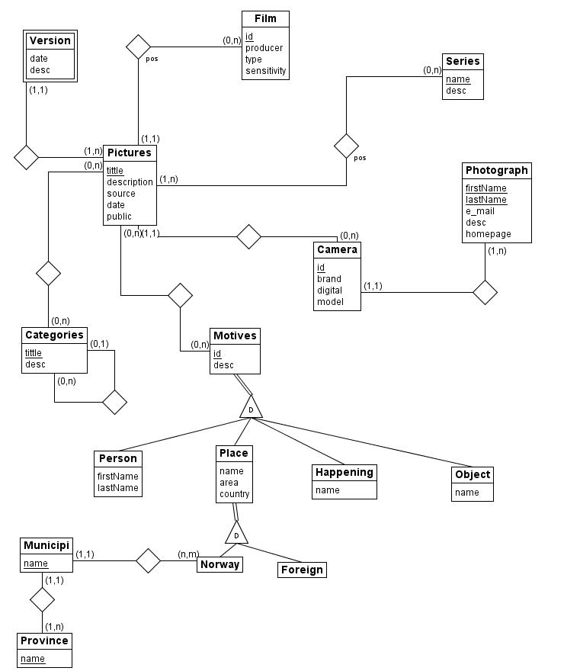
Fulfilling requirements

- This is fulfilled by the entity Picture and his attributes title, description, date and is_public.
- This is fulfilled by a weak entity Version, which has a partial key storing_date and a description.
- This is fulfilled by the attribute source in Picture. The requirement about only use these possible values will be fulfilled in SQL using a domain.
- This is fulfilled by the entity Film, which has id, producer, type and sensitivity as attributes. The number of each picture in the film is fulfilled by the descriptive attribute in the relation between Film and Picture.
- This is fulfilled by the entity Camera, and his attributes id, is_digital, brand and model. The requirement about being owned by one photograph is fulfilled by the relationship between Camera an Photographer.
- This is fulfilled by the entity Photographer, and his attributes firstName, lastName, e-mail, description and url. The requirement about registering who took the picture is fulfilled by the relationships between Photographer-Camera and Picture-Camera.
We have consider that a camera cannot be owned by more than one photographer (for instance if he cannot lend it).
We have consider that the reference to Camera could be null in Picture, representing we do not know with which camera the Picture was taken.
We have also consider that the reference to Photographer in Camera could be null, representing that it is unknown who took the picture.
- Categories are fulfilled by the entity Category, and his attributes title and description.
- This is fulfilled by a relationship in Category to himself, which will indicate who is the father.
- This is fulfilled by the entity Serie, his attributes name and description, and the relationship between Serie and Picture, which have also a descriptive atrribute position to fulfill what is the order of this picture in this serie.
- This is fulfilled by the entity Motives and the relationship between Picture and Motives. About the requirement “either” we have understood that it has to be one and only one of the subcategories, which is fulfilled by the “D” (representing disjoint) and the double line (representing total relation) in the relationship between parent and children.
- This is fulfilled by the entities Person, Place, Happening and Object. Description and id are common attributes, so they are in the parent class Motives. Name and lastName are attributes only present in Person, so they belong to this entity. The same reasoning has been applied to the attribute name respect to the entities Place, Happening and Object.
- We have considered area and country as attributes. We have fulfilled the difference between Norway and other countries creating two subclasses which are children of Place. In Norway we can have many provinces and municipalities, and a province can have many municipalities.

