TDT4145: Data Modelling and Database Systems

Project: “Picture database”

[Exercise 3: “Implementation”]

Group 17:
David Rozas Domingo
Miguel Bono Tur

ER Diagram

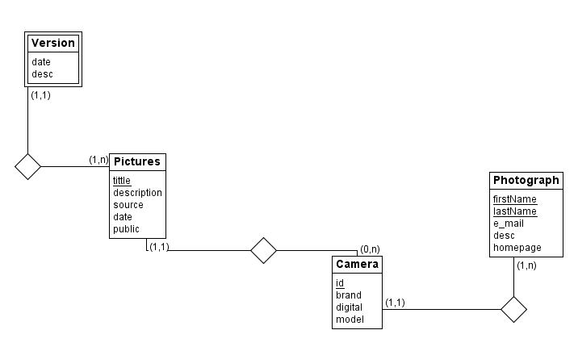
Comments about the implementation

- Entities not required in the implementation requirements have been eliminated, but no change has been made over the design.
- Derby does not allow delete on cascade, so the standard option restrict has been used.
- Derby does not have Boolean type, so Integer has been used instead.
- Our primary key for a version is date + id_picture instead of having an id_version as in the example code. So our pictures are identified by these two fields: ex: 01-01-1990-cabinTrip01.jpg. Constructors have been changed according to that as well.
- The script to create table has been changed to derby syntax (it was originally coded for mySql).

