ASTRA – Application Manager : GUI Prototype

This documents explains the proposed GUI for the bundle Application Manager, according to the use cases of the document ASTRA – Application Manager.doc.

The current prototype consists of a menu with the following options:

- Applications: Displays the functionalities related to applications management. It is the one which appears by default.
- Ontologies: Displays the functionalities related to ontologies management (the internal frame has not been designed yet).
- Help: Displays a dialog with information about how to use the application (the dialog has not been designed yet).
- Exit

The Applications frame, consists of three tabbed sections:

- My applications, which allows the user to:
  - Browse the already installed applications in the tree (all, by communities or by tags).
  - The applications will have different icons depending on its type (focus or nimbus) and on its state (shared or not shared).
  - Select applications by double-clicking in the tree. Then the title, description, tags, and options to manage them according to its state (Ex.: share button for not shared, delete button for already shared) are displayed.
  - The user tags associated to this application can also be deleted/added in this tab.

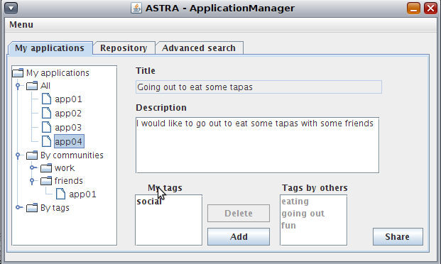

- Repository, which allows the user to:
  - Browse the repository applications in the tree (all, by communities, by user or by tags).
  - The applications will have different icons depending on its type (focus or nimbus).
  - Select applications by double-clicking in the tree. Then the title, description and the button to retrieve it are displayed.

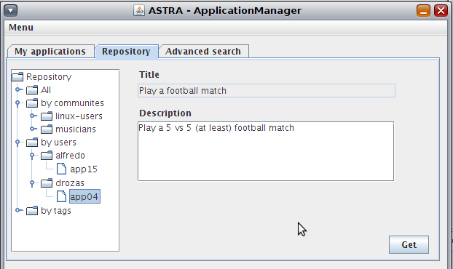

- Advanced search, which allows the user to:
  - Search in the repository according to different criteria (any, by communities, by tags, etc) or watching the recommended applications (the keywords textbox is disabled automatically in this case).
  - Once the results have been returned, the user can see its details and get the application.

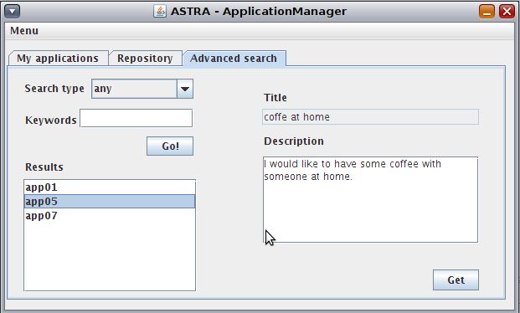
Notes:

- The GUI is currently started as a part of the bundle ApplicationManager, which requires to be started just after RemoteFrameworkManager in the Astra-Node (priority>=20, in the current execution configuration).
- The source can be found at: http://basar.idi.ntnu.no/svn/astra/WP3/Y3/SOA.2.0/ApplicationManager/
- The last version of this document can be found at: http://basar.idi.ntnu.no/svn/astra/WP3/Y3/SOA.2.0/ApplicationManager/doc/prototype/

