GsyCBook – A simple social network

David Rozas Domingo (47456048-X)

Functionalities

GsycBook is a simple social network, which has features like:

- Facilities for getting in touch with your friends, but offering you the possibility of customizing your privacy.
- Use of external applications: from google gadgets, til customized applications which allows you to share information in a very interactive way: share your favourite cities, vote for your friends, etc.
- Intuitive and clean interface.
- Different skins.
- Facilities for system administration.

As an user, the main panel offers you the following options:

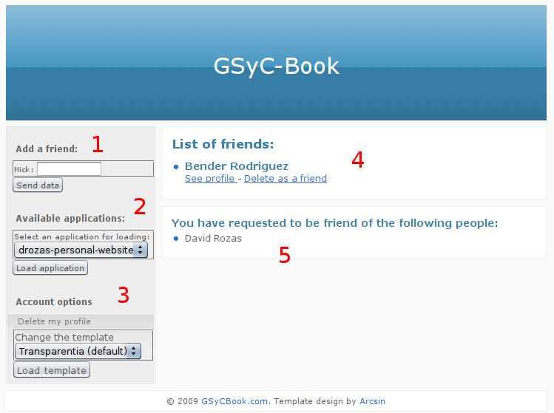
- Add new friends, typing their nicknames.
- Install external applications.
- Control panel: change the skin, delete your profile, etc.
- List of your your friends, and options to see his/her profile or delete your friendship.
- List of people you have requested to be friend of, and list of people you have requested to be their friend of (last one it is not shown in this screenshot).

While you are logged in the system, you can always navigate to the main functionalities with the links on the right upper-corner:

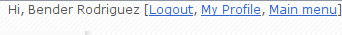

In your profile you can see your personal data, your applications, a list with your friends, etc:

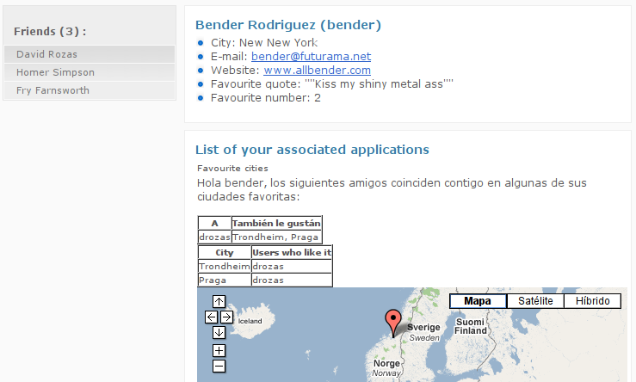

The view of other people's profile it is similar, but if you have some applications in common (for instance, common favourite cities), the application will change with your and your friends data:

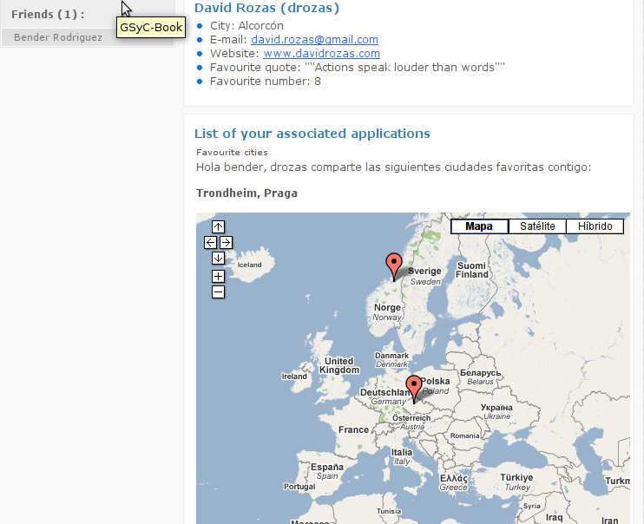
If you are visiting someone's profile and he/she is not your friend, you can directly request his/her friendship clicking on this link:



For administrators, two different panels are offered. If you logged into the system normally, you can see the list of users and visit their profiles, you can see the current installed applications, you can install new ones, etc:

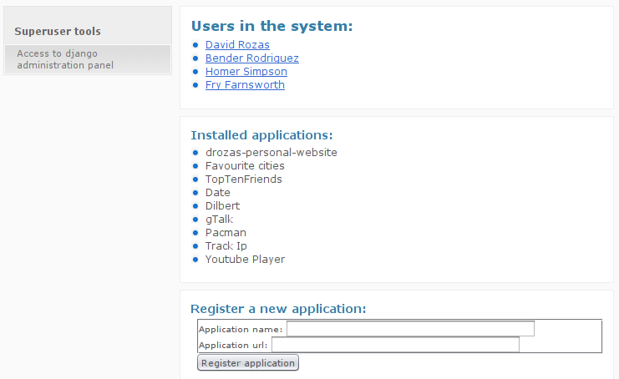
But you can also use the django admnistration panel (clicking on the link on the right shown in the previous screenshot). It offers you a really flexible way to administrate the system:

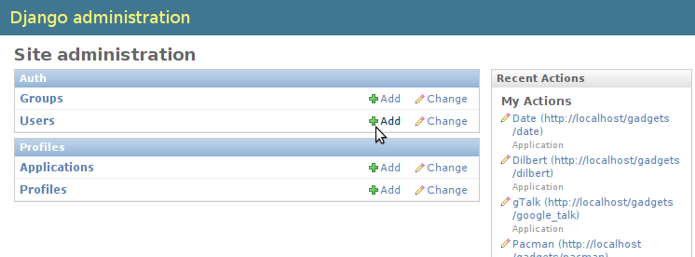

Advanced and extra features
Some of the advanced and extra features are:

- Strong relationship system: implemented with ManyToMany non symmetrical relationships.
- Different representations for the resources: xml, json, etc. and possibility of using feeds.
- Strong and coherent semantically management of errors.
- All the extra functionalities proposed in the practices:
  - Django administration panel.
  - UI for installing applications.
  - Alternative authentication methods.
  - Etc
- But also, others like
  - Use of HTTPBasic in order to protect the webservices
  - Administrator panel into the system.
  - Options for allowing an user to delete his/her account, deleting friendships, etc.
  - Favcities error management improvement.
  - Etc.

Most important difficulties
The biggest problem I had was with the implementation of HTTP Basic. I tried to use already made libraries, but I was not able to make work any of them. So finally, I created my own function based on one of them.
I had also some problems with all the functionalities related to REST, because there is a lack of documentation in the django_rest_interface project.

Conclusions

I am really satisfied with this practice. I am really eager about web applications and all the possibilities they offered, and I think I have learnt quite a lot because in this practice you really have to “get your hands dirty”.
The only problem it is the lack of time, I would have wanted to do some more extra functionalities, but, as usual, I had a big workload during the whole semester, and you have to distribute the time between all the courses.

