Project Title

David Drozd  
Faculty of Applied Science & Technology  
Sheridan College *Oakville, Canada*  
drozdda@sheridancollege.ca

Ditij Ganguly  
Faculty of Applied Science & Technology  
Sheridan College *Oakville, Canada*  
gangulyd@sheridancollege.ca

Ghassem Tofighi

Faculty of Applied Science & Technology  
Sheridan College *Oakville, Canada*  
ghassem.tofighi@sheridancollege.ca

*Abstract*— A project-based social network that connects individuals with projects that require skills from multiple disciplines. The purpose is to help increase the social circles of students and provide opportunities to apply classroom knowledge in interdisciplinary projects within educational institutions.

This traditional approach of strengthening the soft skills of students, such collaboration, communication and project management, is through in-class group assignments. This approach leaves students with a false sense of security, as they learn only how to work in homogeneous teams where all members share common skills, knowledge and perspectives, with little reflection of a real-world scenario.

An educational institution houses a variety of individuals ranging from faculty to students, any of which can identify issues and think of possible solutions. However, not everyone has the ability to work on these projects themselves or have the means to advertise for wanted help.   
Any individual within the institution looking to participate in group projects, or seeking help for their own projects, are subject to the same issues:

* **Project awareness** – you don’t know what’s already out there
* **Posting networks** – you don’t know where to look for help
* **External connections** – finding help outside one’s own discipline is difficult

Today, educational institutions such as universities are highly competitive, as rankings increasingly influence public perception of the educational quality that they offer. These institutions work to improve the various factors that influence their rankings, specifically student achievement. With today’s students growing into tomorrow’s leaders, it’s in everyone’s best interest to provide more opportunities to help them succeed.

Keywords—HCI, plexus, project, education

# Introduction (*Heading 1*)

Sheridan’s 2024 “Galvanizing Education for a Complex World” mission is to “cultivate resourceful, highly skilled and creative people and communities through cross-pollinated, active learning and the relentless incubation of new ideas.” (Sheridan, 2019)

Key elements of the 5-year plan include smart technology, fluid career pathways, transferable skills, learning-integrated local work and co-creating new approaches for hands-on learning, continual development and interdisciplinary innovation (Sheridan, 2019).

To help Sheridan achieve these goals, Plexus is being proposed to be integrated into the curriculum. Just as current graduation requirements of breadth electives “leverage the diversity” of students and capture a “cross-pollination” of education, by adopting Plexus as a graduation requirement, Sheridan will greatly further the “agility, active learning, and relentless incubation of new ideas” (Sheridan, 2019).

Plexus is a project-based social network that connects individuals with projects that require skills from multiple disciplines. The purpose is to help increase the social circles of students and provide opportunities to apply classroom knowledge in interdisciplinary projects within educational institutions.

During market research we investigated LinkedIn, Meetup, and Facebook due to their ability to bring users and projects together.

However, while testing these applications, we noticed the following issues:

1. Force user to enter information that is unneeded
2. Not fun to fill out profile. No hints or stepped process
3. Can only include professional / fixed fields in personal profile
4. No hints for search suggestions.
5. Group searches are too broad. Only Meetup sorts by location.
6. Group Tags are vague, hard to find specific group you searching for
7. Joining a group is boring and anti-climatic. Click a button.
8. Groups have no hierarchy – everyone is equal
9. Only text/ image/ video posts
10. No Guided process to create groups
11. Group discussion should be more open and casual to all members

# HCI Principles

Some of the main concepts we used were

### Match between real world and system

### Recognition vs Recall

We really focused on these two principles in order to create a easier experience for our user and for them to be more successful within our app

# Prototype Design

## Requirement Analysis (NeedFinding)

When we were tasked to find the requirements for this project, we wanted to gain that information for those that have the largest impact on our project, students and future project owners. We asked these individuals about projects they have completed at Sheridan and gain some vital knowledge from it. We found out that Students typical work on group projects with students in the same program, this provides the students with a false sense of security, as they learn only how to work in homogeneous teams where all members share common skills, knowledge and perspectives. This present us with the need of connecting these students with people outside their program so that they can gain skills, knowledge and perspectives that they otherwise would not have.

## Competitive Analysis

|  |  |  |  |
| --- | --- | --- | --- |
| Feature | LinkedIn | Meetup | Facebook |
| User Onboarding | 10 | 8 | 5 |
| User Profile Customization | 7 | 5 | 10 |
| Searching for Groups | 6 | 8 | 6 |
| Joining Groups | 5 | 8 | 4 |
| Group Collaboration | 5 | 10 | 3 |
| Group Usage | 5 | 9 | 7 |
| Score | 6.3 | 8 | 5.8 |

Meetup seems to be the best current platform to form project groups and discover people and projects according to the competitor matrix

## First Initial Prototype Alternatives

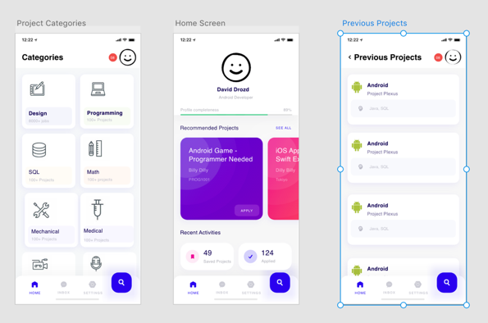.

1. First Prototype (https://xd.adobe.com/view/7d7e805a-3f6b-4b10-421b-56a7c0d64aec-0b4f/)

Two concepts we really focused on in this project are having a match between the real world and system and also recognition vs recall. You could really see these concepts being used in the category page.

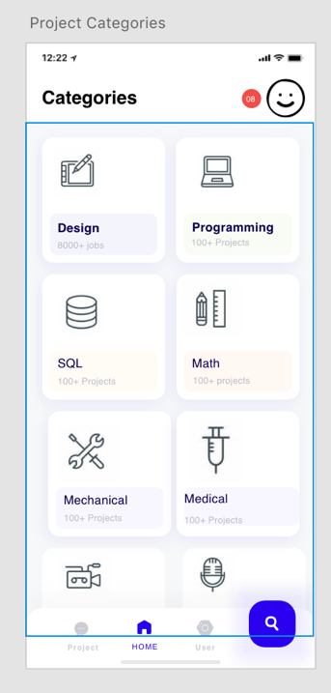

1. Concepts

The second usability heuristic “match between the real world and system” states that, “the system should speak the users' language, with words, phrases, and concepts familiar to the user, rather than system-oriented terms. Follow real-world conventions, making information appear in a natural and logical order”[1]. We accomlished by having our main menu in an area that is familiar to the average mobile user. We asked quite a few mobile users on where they expect a menu to be placed and most of them responded with either along the left edge of the screen or along the bottom. We also focused on the sixth heuristic, “recognition vs recall”. The main difference between recognition and recall is, “the amount of cues that can help the memory retrieval; recall involves fewer cues than recognition”[2]. We accomplished this by having a list of categories to search. This results in the user not having to recall and think about all the potentional categories but instead recognize the ones in front of him and pick from their. This greatly increases the amount of cues that can help memory retrival.

# Prototype evaluation

The tasks we had for UserTesting are as follow:

1. Take as much time as you need to explore this application. If you find anything that does not work, explain what you would expect it to do and move on to the next task when you're ready.
2. Search for a project titled Project Plexus and join it. Was it easy to find and join? (Keyboard functionality may not work. Just hit the search icon) [Success: Yes, No]
3. Search for a project using the category function. Try and find all projects related to "Programming" [Success: Yes, No]
4. Create a new project and publish it with the data that's already populated. [Success: Yes, No]
5. View all recent projects and try to find project named "Project Test" [Success: Yes, No]

The reason we picked these tasks is that we believe they cover the most important aspects of our project. The main purpose of our project is for students to be able to post projects they need help with or to join project that they can help with. Since that is the main goal, we determine that being able to discover projects to join and also create a project would be the most vital.

# Usability Analysis

The question we asked the users on UserTesting and the responses we got are as follow

User 1

**1. What frustrated you most about this site?**

*I was never really frustrated, everything was very simple and straight-forward.*

**2. If you had a magic wand, how would you improve this site?**

*I would try to put a little bit more colour in the design. I would also like there to be an indicator that you applied and/or created a project.*

**3. What did you like about the site?**

*I like the design. I think it was very simple and easy to use. It's really great contrast against the complexity of the projects. The size and fonts are well picked and are easily legible.*

**4. How likely are you to recommend this site to a friend or colleague (0=Not at all likely, and 10=Very Likely)?**

*9*

User 2

**1. What frustrated you most about this site?**

*The UI was not so intuitive and/or optimized. Especially for the last task, I feel like my brain couldn't make an intuitive connection between the icons, the menus and what I was aiming for. Overall, the preview had a "rough draft" feeling because of it.*

**2. If you had a magic wand, how would you improve this site?**

*I would work on clarifying the functions of the different tabs. I feel like all the tabs look the same and I can't understand the difference between all of them.*

**3. What did you like about the site?**

*In a way, it was very simple to use. Even if the UI is not really satisfying, the overall design is slick and gets the job done.*

**4. How likely are you to recommend this site to a friend or colleague (0=Not at all likely, and 10=Very Likely)?**

*6*

Based on these results there a couple of things that have to be changed within the app. Although the first user had mainly positive views about the app, one criticism they had is lack of colour. Currently the app is mainly white which results in looking a bit dull. A dash of colour could completely change the way it currently looks. User two had a few more complaints. The biggest takeaway we got from his test was the lack of clarity between tabs. They claim the they, “feel like all the tabs look the same and I can't understand the difference between all of them.” This is definitely something we have to fix in the future as we want the user to fully understand our app so they can take full advantage of it. One thing we are very proud of from these tests is that both users claim the app was simple which is one of the key attributes we were going for

# Revised Prototype

One of the complaints user 2 had was during the last task they felt like their “brain couldn't make an intuitive connection between the icons, the menus and what I was aiming for”. We fixed that by giving the icons in the page and the project titles actual meaning. Before they were just placeholders and did not make much sense.

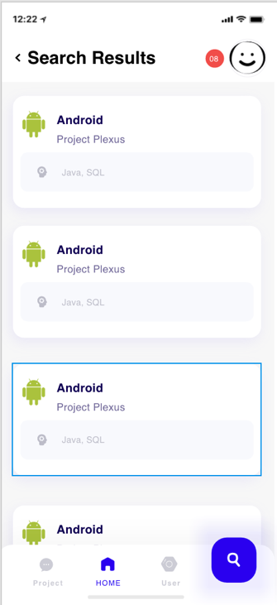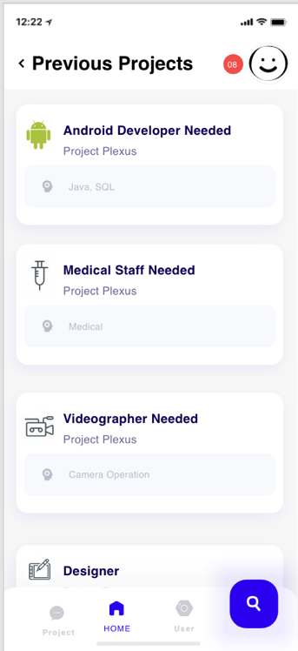

1. Revised prototype

# Future works & Conclusions

Something we can work in the future is addressing the remaining complaints. User 1 would like to see more colour in the application. They believe it is pretty dull at the current moment. We also have to address the complaint by user 2 which states the lack of clarity between tabs. This is a major issue and something we have to remedy soon

##### References

1. Kaley, Anna. “Match Between System and Real World: 2nd Usability Heuristic Explained.” *Nielsen Norman Group*, 1 July 2018, [www.nngroup.com/articles/match-system-real-world/](http://www.nngroup.com/articles/match-system-real-world/).
2. Budiu, Ralucia. “Memory Recognition and Recall in User Interfaces.” *Nielsen Norman Group*, 14 July 2014, www.nngroup.com/articles/recognition-and-recall/.