**Name** : Broken link to article

**Priority**: Medium

**Preconditions**: Open https://blynk.io/clients#foodnbev

**Steps to reproduce:**

Find article named MyBrewbot

Click picture

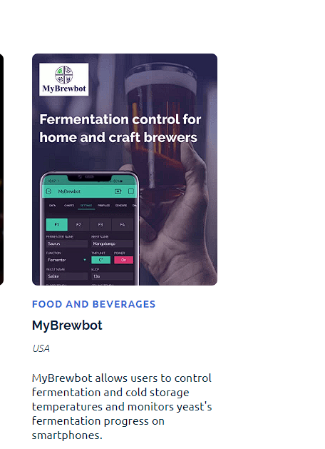

**Expected result:**

Jump to the page with this article

**Actual result:**

It is not hapenned