Supplementary Figures

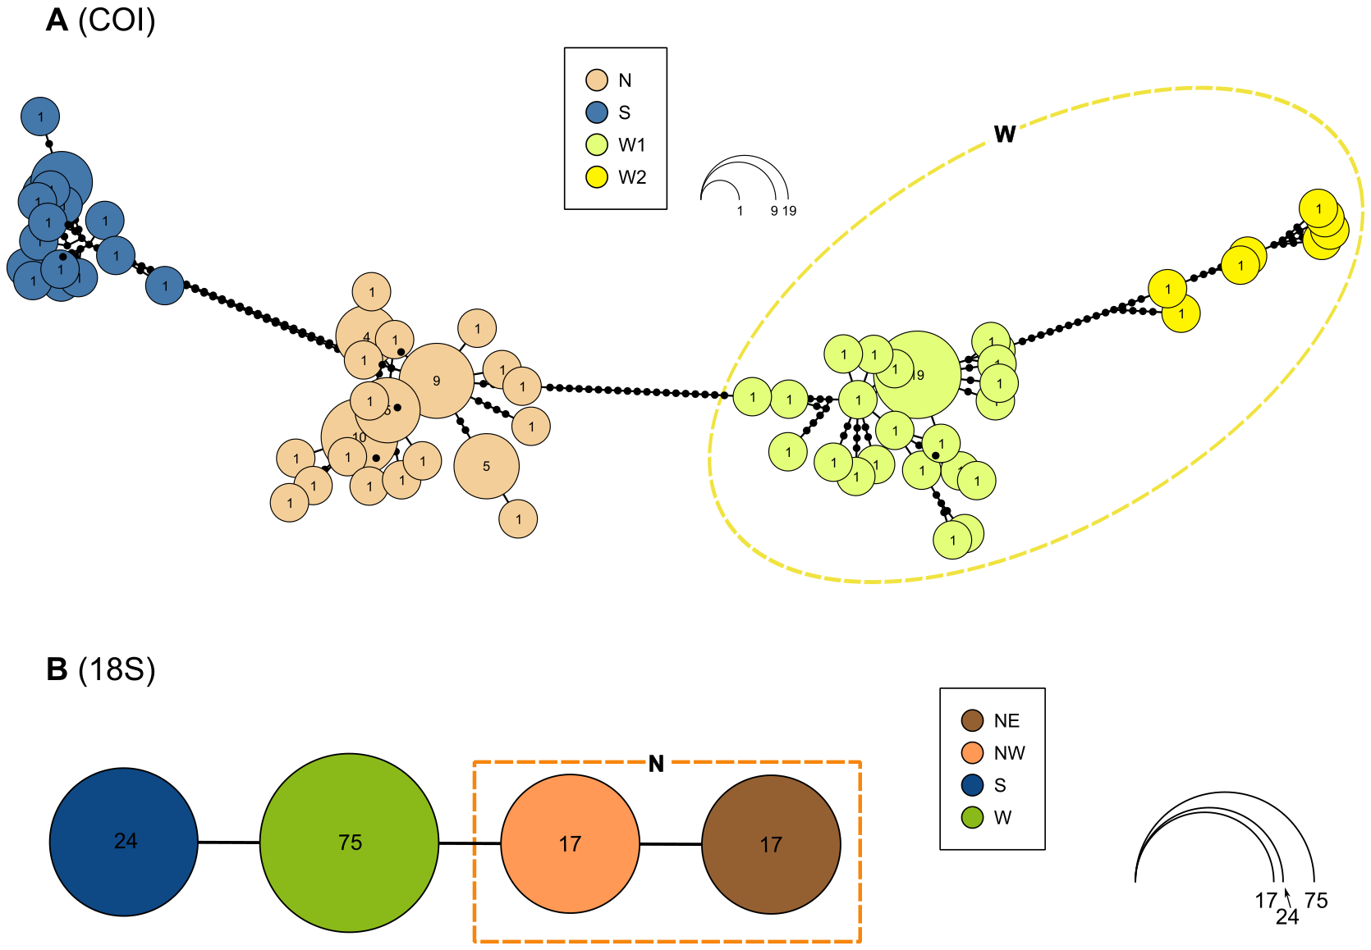

Figure S1. TCS haplotype networks for 120 COI gene fragment sequences (A) and 133 18S rRNA gene fragment (B) sequences of E. vittatus.

