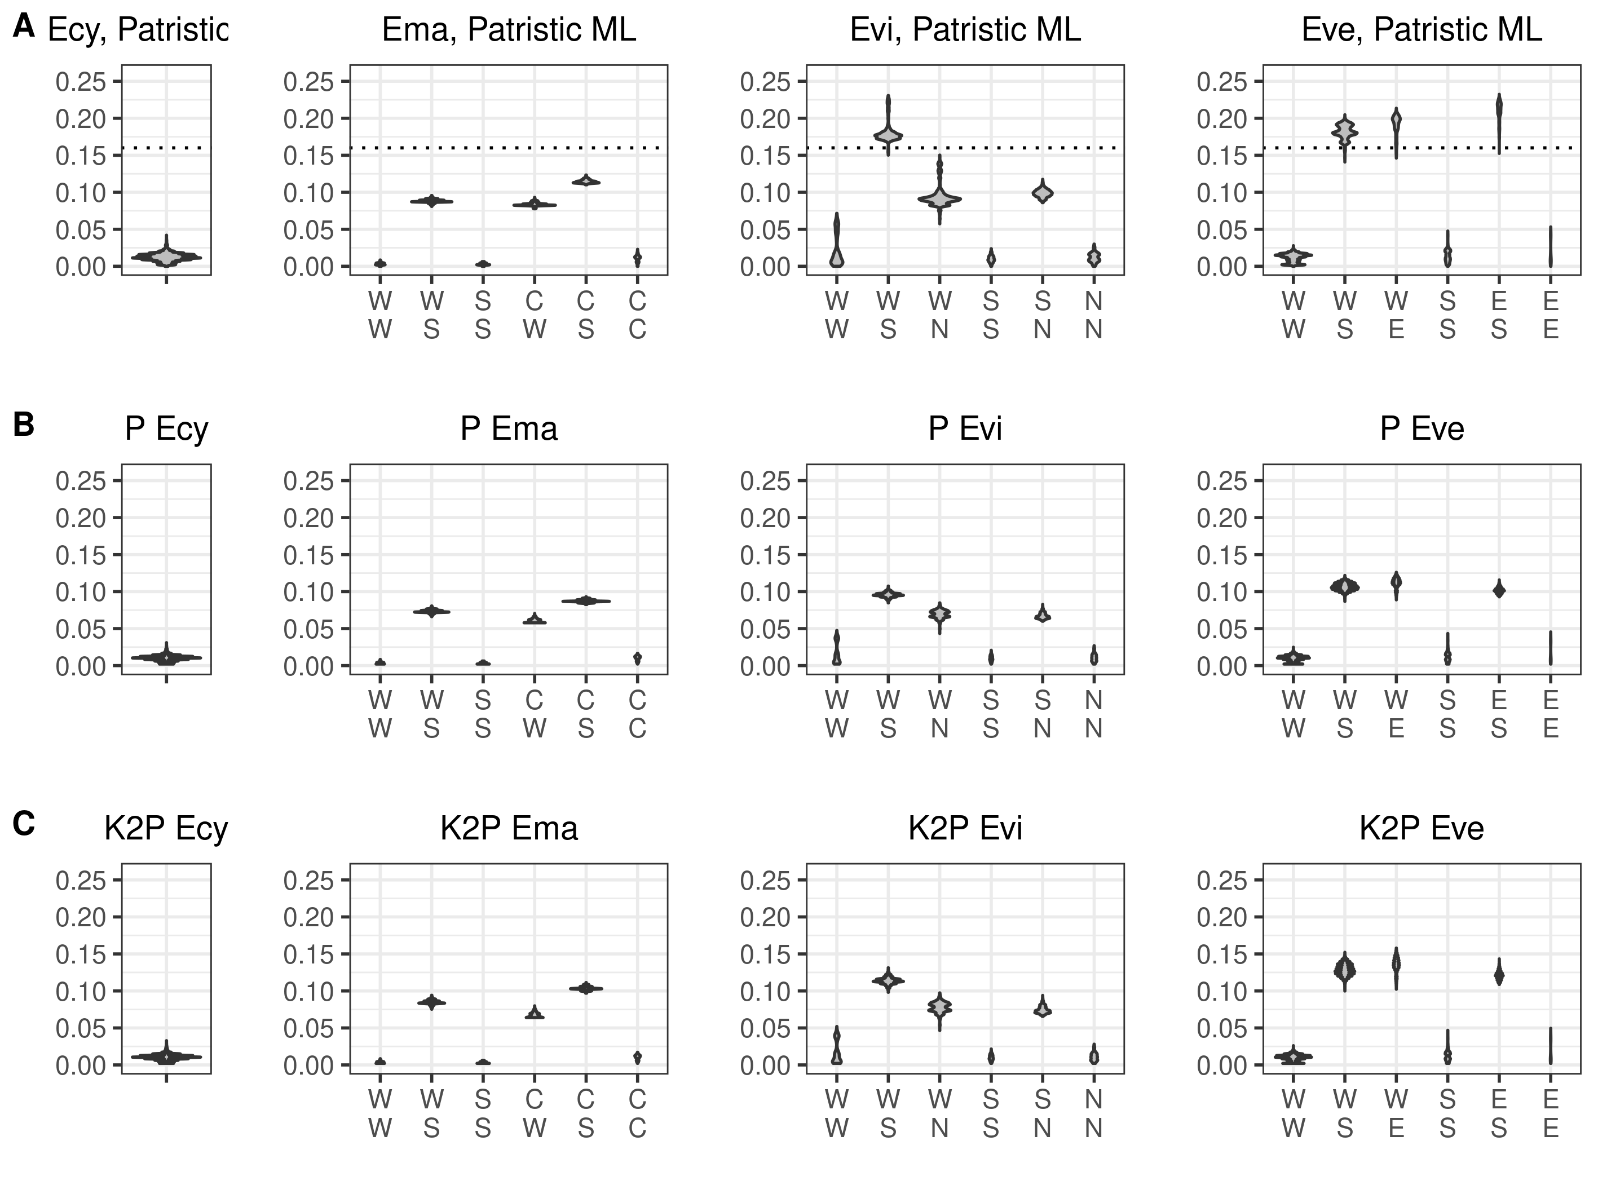
Figure S4. Comparison between uncorrected p (A), K2P (B), and patristic distances for the same set of sequences. Ecy, E. cyaneus. Ema, E. marituji. Evi, E. vittatus. Eve, E. verrucosus.

