**Individual Project: *Grades Calculator***

**Background:**

For this new project, you must develop a simple tool called *GradesCalculator*. Given a database with various data about the students in a class, *GradesCalculator* allows the instructors to get various information about the students and compute their final grade. **You will develop the *GradesCalculator* application by following a test-driven development approach such as the one we saw in P4L4, in which development happens in iterations and according to the following cycle: (1) select story cards to implement, (2) define task cards for the selected story cards, (3) write test cases for the classes in the task cards, (4) write code that makes the test cases pass.** Specifically, this project will consist of three or four deliverables. (**Being in an agile world, we will make some decisions on the fly based on how the project is progressing.)**

**Goals:**

* Develop a Java application for assessing students information and compute students’ final grades.
* Get experience with an agile, test-driven process.

**Deliverables:**

**DELIVERABLE 1**

* **provided:**
  + Story card(s)
  + Task card(s)
  + JUnit test cases
* **expected:**
  + Code that makes the test cases pass

**DELIVERABLE 2**

* **provided:**
  + Story card(s)
  + Task card(s)
* **expected:**
  + JUnit test cases

**DELIVERABLE 3**

* **provided:**
  + JUnit test cases
* **expected:**
  + Code that makes the test cases pass

**DELIVERABLE 4 (tentative)**

* **provided:**
  + TBD
* **expected:**
  + TBD

**Deliverable 1: Details**

Note: For this deliverable, we will assume to be in the first iteration of the process and that somebody has already done the steps from (1) through (3) described in the background section. You will be provided with a story card, two task cards derived from it, and a set of corresponding test cases, and your job will be to perform step (4): writing code that makes the test cases pass.

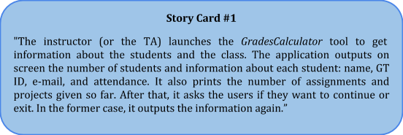

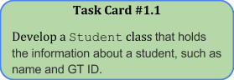 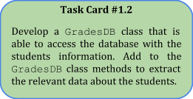

**Instructions**

* All students data is stored in the Excel file GradesDatabase6300.xlsx
* To access the spreadsheet use the [Apache POI library](http://poi.apache.org/).
* Apache POI, JUnit, and other libraries you may need are available under the directory lib. You should not need any other non-standard libraries.
* Keeping in mind the story card and the corresponding tasks, write code that makes the provided test cases pass.
* Commit and push your code.
* Paste the commit ID for your submission on T-Square.