Report.pdf for MC3-2 Daniel Rozen drozen3

**ML4T-399 Charts 1.** Training Y/Price/Predicted Y:

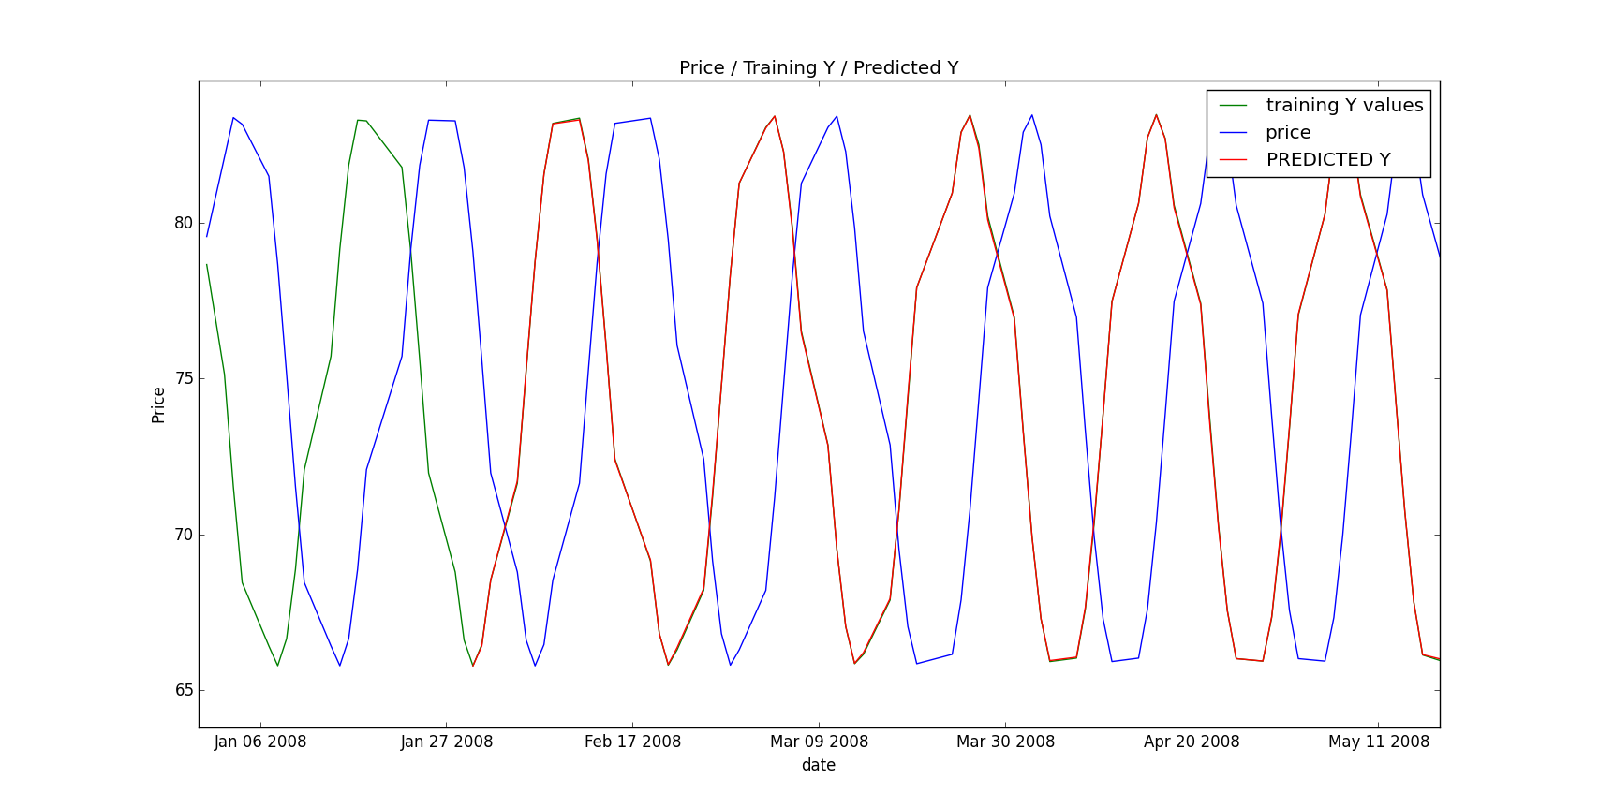

2. Sine Data In Sample Entries/Exits:

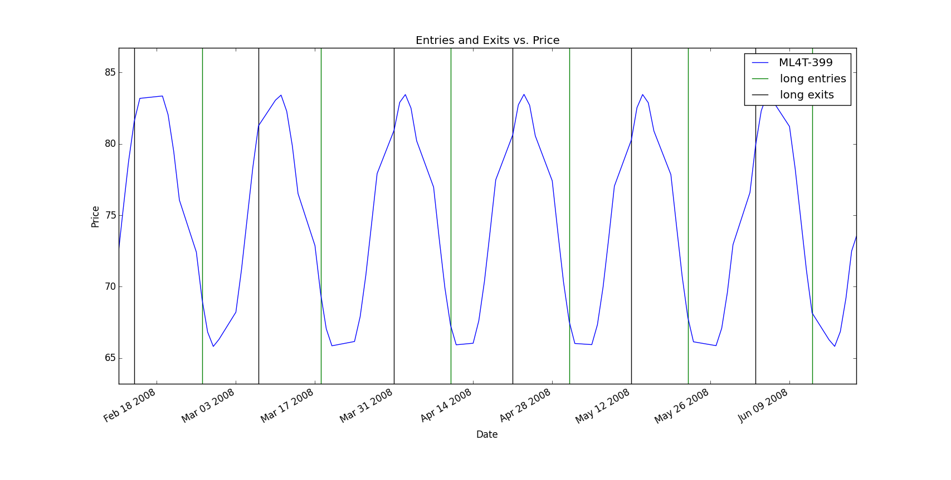

3. Sine Data In Sample Backtest

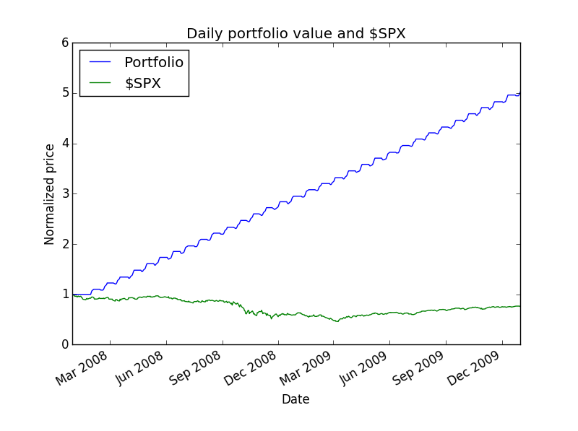

4. Sine Data Out of Sample Entries/Exits:

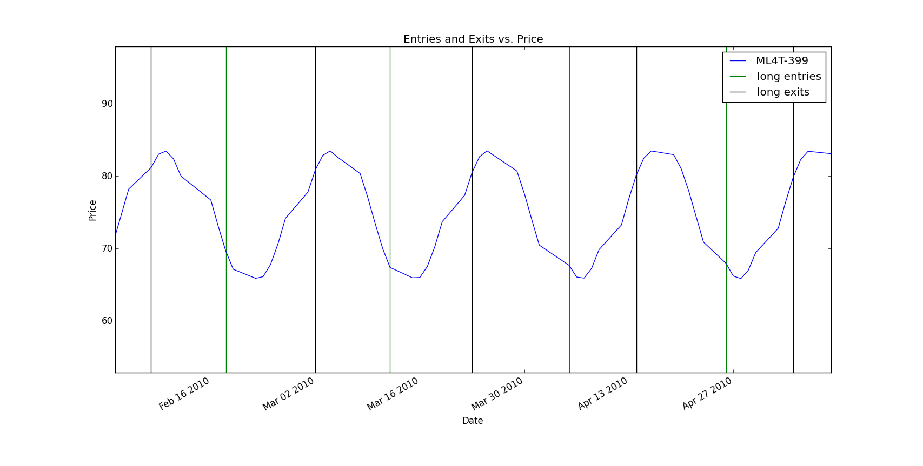

5. Sine Data Out of Sample Backtest

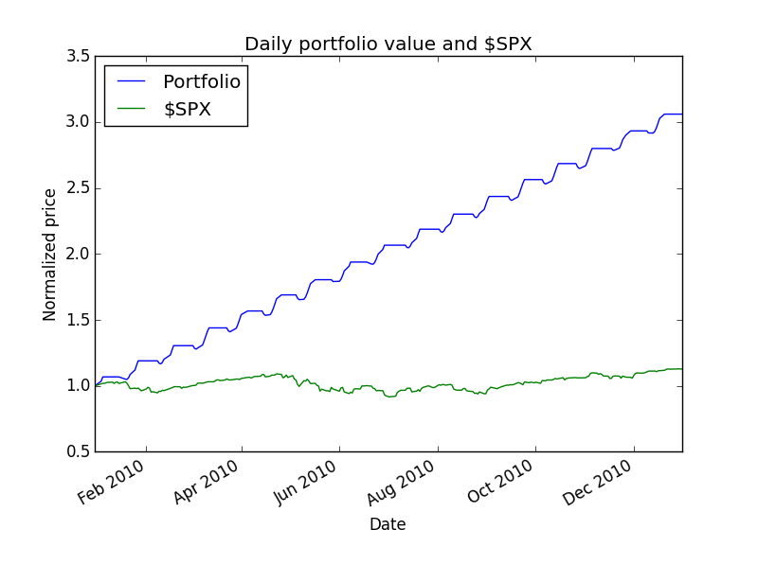

**IBM Charts** 6. IBM IN SAMPLE ENTRIES/EXITS

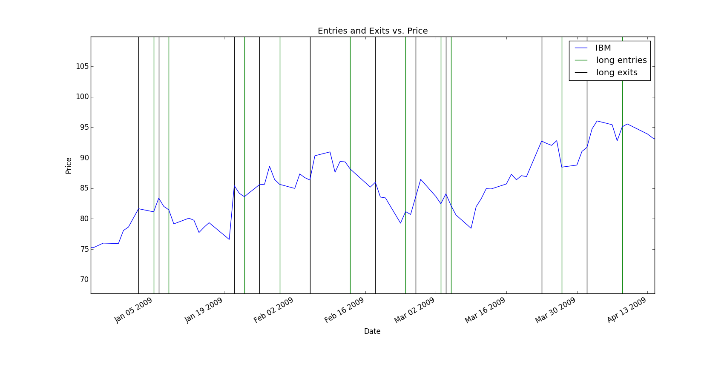

7. IBM IN SAMPLE BACKTEST

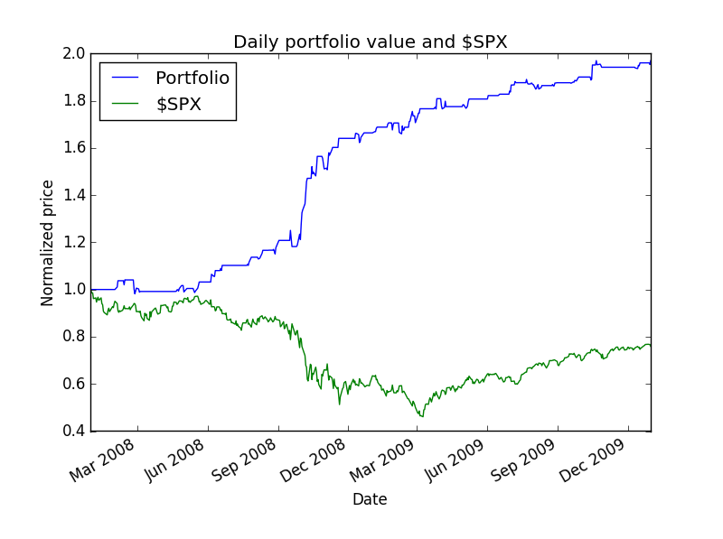

8. IBM OUT OF SAMPLE ENTRIES and EXITS

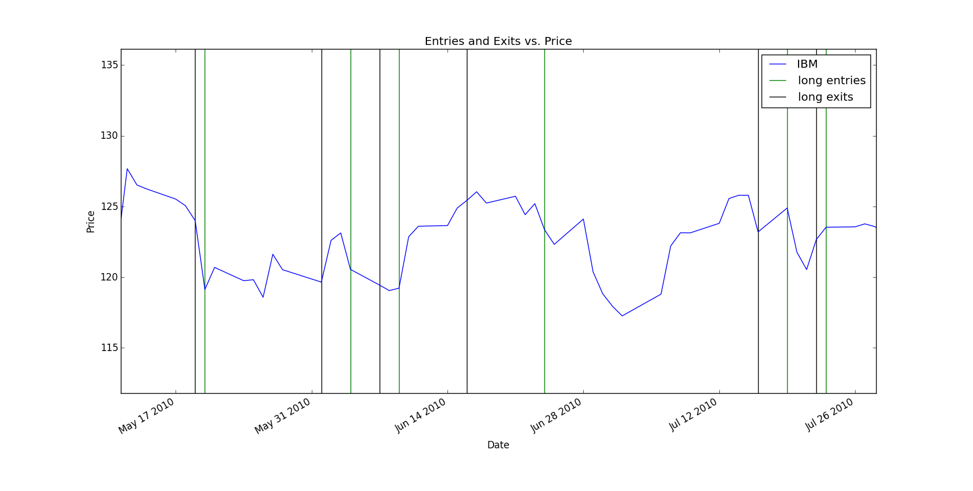

9. IBM OUT OF SAMPLE BACKTEST

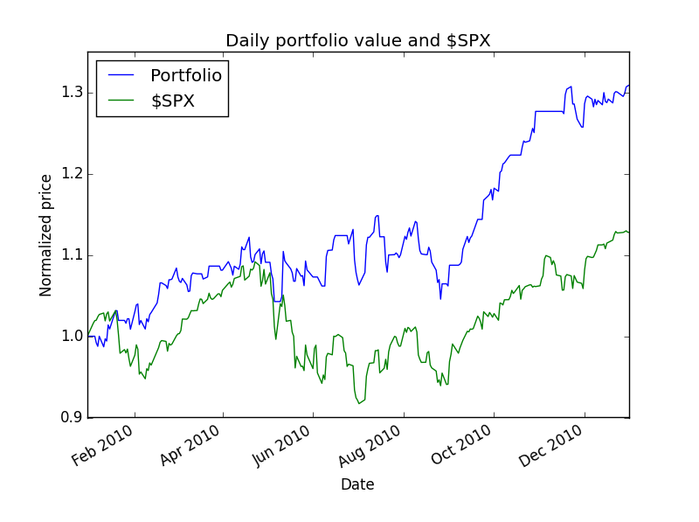

**Describe each of the indicators you have selected in enough detail that someone else could reproduce them in code.**

Bollinger value:  *bb_value[t] = (price[t] - SMA[t])/(2 * stdev[t])*

code: bb_value = (price - SMA) /(2*std)

Momentum:  *momentum[t] = (price[t]/price[t-N]) - 1 N = 10 # days*

code: momentum = price/price.shift(10) - 1

Volatility: *volatilty[t] = stddev(dailyreturns)* code: volatility = pd.rolling_std(daily_returns, window=20, min_periods = 20)

* Describe your trading policy clearly.

I used my bag learner with my knn learner with k = 5 and number of bags = 20 to forecast the 5 day future price. When 5 day future price increased > 1%, I made a long entry. I held the position until it decreased < -1% , and made a long exit and repeated.

**Summary Data of Results:**

|  |  |
| --- | --- |
| * ML4T-399 IN SAMPLE | ML4T-399 OUT OF SAMPLE |
|  |  |
| k = 5 |  |
| Number of bags: 20 |  |
| In sample results | Out of sample results |
| RMSE: 0.000740068149779 | RMSE: 0.00070504090674 |
| corr: 0.999987242947 | corr: 0.999988374019 |
|  |  |
| Data Range: 2007-12-31 to 2009-12-31 | Data Range: 2009-12-31 to 2010-12-31 |
|  |  |
| Sharpe Ratio of Fund: 6.94438547065 | Sharpe Ratio of Fund: 7.54908475589 |
| Sharpe Ratio of $SPX: -0.21996865409 | Sharpe Ratio of $SPX: 0.756512754402 |
|  |  |
| Cumulative Return of Fund: 4.02166813 | Cumulative Return of Fund: 2.06004713 |
| Cumulative Return of $SPX: -0.240581328829 | Cumulative Return of $SPX: 0.127827100708 |
|  |  |
| Standard Deviation of Fund: 0.00737807995534 | Standard Deviation of Fund: 0.00944609267468 |
| Standard Deviation of $SPX: 0.0219524869863 | Standard Deviation of $SPX: 0.0113715303326 |
|  |  |
| Average Daily Return of Fund: 0.00322757919013 | Average Daily Return of Fund: 0.00449206708097 |
| Average Daily Return of $SPX: -0.000304189525556 | Average Daily Return of $SPX: 0.000541919649169 |
| Final Portfolio Value: 50216.6813 | Final Portfolio Value: 30600.4713 |

|  |  |
| --- | --- |
| IBM IN SAMPLE |  |
|  |  |
| k = 5 | IBM OUT OF SAMPLE |
| Number of bags: 20 |  |
| In sample results | Out of sample results |
| RMSE: 0.0361430563998 | RMSE: 0.0275997887905 |
| corr: 0.561835434391 | corr: 0.0602149310415 |
|  |  |
| Data Range: 2007-12-31 to 2009-12-31 | Data Range: 2009-12-31 to 2010-12-31 |
|  |  |
| Sharpe Ratio of Fund: 2.62400664839 | Sharpe Ratio of Fund: 1.73320251849 |
| Sharpe Ratio of $SPX: -0.21996865409 | Sharpe Ratio of $SPX: 0.756512754402 |
|  |  |
| Cumulative Return of Fund: 0.9693 | Cumulative Return of Fund: 0.3089 |
| Cumulative Return of $SPX: -0.240581328829 | Cumulative Return of $SPX: 0.127827100708 |
|  |  |
| Standard Deviation of Fund: 0.0083314785834 | Standard Deviation of Fund: 0.0102675013926 |
| Standard Deviation of $SPX: 0.0219524869863 | Standard Deviation of $SPX: 0.0113715303326 |
|  |  |
| Average Daily Return of Fund: 0.00137716742955 | Average Daily Return of Fund: 0.00112102116312 |
| Average Daily Return of $SPX: -0.000304189525556 | Average Daily Return of $SPX: 0.000541919649169 |
| Final Portfolio Value: 19693.0 | Final Portfolio Value: 13089.0 |

* Discussion of results. Did it work well? Why? What would you do differently?

My learner setup worked extremely well with ML4T-399 data, with both in and out of sample RMSE almost 0 and correlation almost 1. Almost increased 5 times in portfolio value in sample and 3 times out of sample. This is because the data was a totally predictable sine wave so that the KNN learner had perfect training data to refer to. This enabled extremely well performance on sine data as we could predict to buy near the bottom at the curve and sell near the top of the curve very accurately.

My learner setup worked quite well with IBM in sample, with in sample RMSE .036, correlation .56 and it almost doubled in portfolio. For out of sample, RMSE was even slightly lower at RMSE .027 which I didn’t expect, but perhaps it’s close enough to in sample. However, correlation was quite lower at .06 which was to be expected for out of sample prediction. The portfolio did perform quite well with a 31% increase. It appears that the predictions of the KNN learner were accurate enough to predict 1% future price increases or decreases in order to enable my system to properly implement the policy of buying before price increases and selling before price decreases. Combine this with a large number of trades, more often than not the system was accurate, amounting to an increase in portfolio.

I also removed the nans from the x data and ensured that the x data where normalized values in order to optimize KNN learner accuracy. Using the bag learner at 20 bags helped remove potential overfitting. I also found that k=5 gave larger accuracy to the predictions than k=3. Perhaps because our aim was to predict 5 day price change.

Additionally the x data used momentum, volatility, and Bollinger value seemed to be good choices for indications of future price change. Momentum tends to continue into the future for a while, volatility indicates how much price change, and Bollinger value indicates how likely the price is going to go back the other direction.

A 1% increase and decrease threshold seemed to be a fair choice since the IBM price rarely fluctuated more than 2% in real data. Therefore too high of a threshold would result in no long entries and exits. Too low of a threshold would result in incorrect long entries and exits, resulting in decreased portfolio.

**“What would you do differently?”:**

I would’ve increased the number of KNN learners, with different k’s, with increased bagging to achieve higher accuracy and therefore better results with more appropriate entries and exits. I would not have combined these with LinReg learners as I found them to be much less accurate with IBM data.

I also would’ve spent more time researching indicators and trying out different combinations for more optimal results.