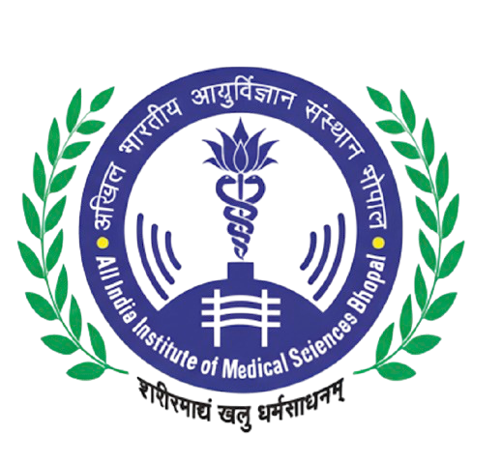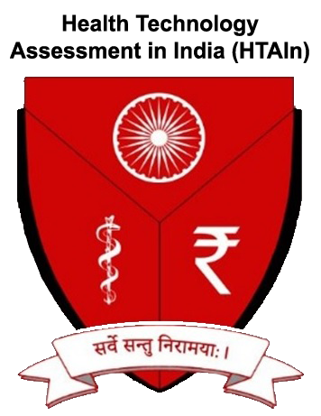
REGIONAL RESOURCE CENTRE FOR HEALTH TECHNOLOGY ASSESSMENT
(RRC-HTA)
All India Institute of Medical Sciences, Bhopal
Saket Nagar, Bhopal – 462020

Date: ___/___/2026
Ref: RRC-HTA/AIIMS-BPL/Workshop/2026/___
To,
Ms. Anu Nagar
Joint Secretary
Department of Health Research
Ministry of Health & Family Welfare
Government of India
New Delhi
Subject: Invitation for Inauguration and Nomination of Resource Person for Workshop on “R for HTA (Basics)”
Respected Ma’am,
Greetings from RRC-HTA, AIIMS Bhopal. We are pleased to inform you that the Regional Resource Centre for Health Technology Assessment (RRC-HTA) at AIIMS Bhopal is organising a three-day hands-on workshop titled “R for HTA (Basics): Using R for Health Technology Assessment — From Decision Trees to Shiny Apps” from 17 to 19 March 2026 at AIIMS Bhopal.
The workshop is designed for scientists and researchers working at Regional Resource Centres (RRCs) for HTA across India. It aims to build practical skills in R programming for cost-effectiveness analysis through real-world clinical case studies covering decision tree analysis, Markov cohort models, partitioned survival models, and probabilistic sensitivity analysis. Participants will also develop interactive Shiny applications that can be adapted for their own HTA studies.
We would be honoured to have your gracious presence for the inaugural session of the workshop on 17 March 2026 (Tuesday). Your leadership and vision in strengthening the HTA ecosystem in India have been pivotal, and your presence would greatly motivate the participants.
We also request you to kindly nominate a scientist from HTAIn as a resource person for one or more sessions of the workshop. Their expertise and experience with national-level HTA processes would greatly enrich the training programme.
The details of the workshop are as follows:
Workshop: R for HTA (Basics)
Dates: 17 – 19 March 2026
Venue: AIIMS Bhopal, Saket Nagar, Bhopal
Participants: Scientists at RRCs for HTA across India
Website: https://drpakhare.github.io/HTA-R-Workshop-2026/
We look forward to your kind confirmation and guidance.
With warm regards,

Dr. Abhijit P. Pakhare
Professor, Community & Family Medicine
Principal Investigator, RRC-HTA
AIIMS Bhopal
Email: hta@aiimsbhopal.edu.in
CC: Dr. Kavitha Rajsekar, Scientist-F & Scientist in Charge, HTAIn, DHR, Government of India

