SURVEY TITLE

ADD SURVEY DETAILS - STUDY LOCATION, STUDY PERIOD, ETC

AUTHOR

Recommended citation:

## Report template with results from WHO Anthro Survey Analyser

Analysis date: 2022-09-06 19:19:11

Link: <https://worldhealthorg.shinyapps.io/anthro/>

# Overall survey results summary

## Outcome plots

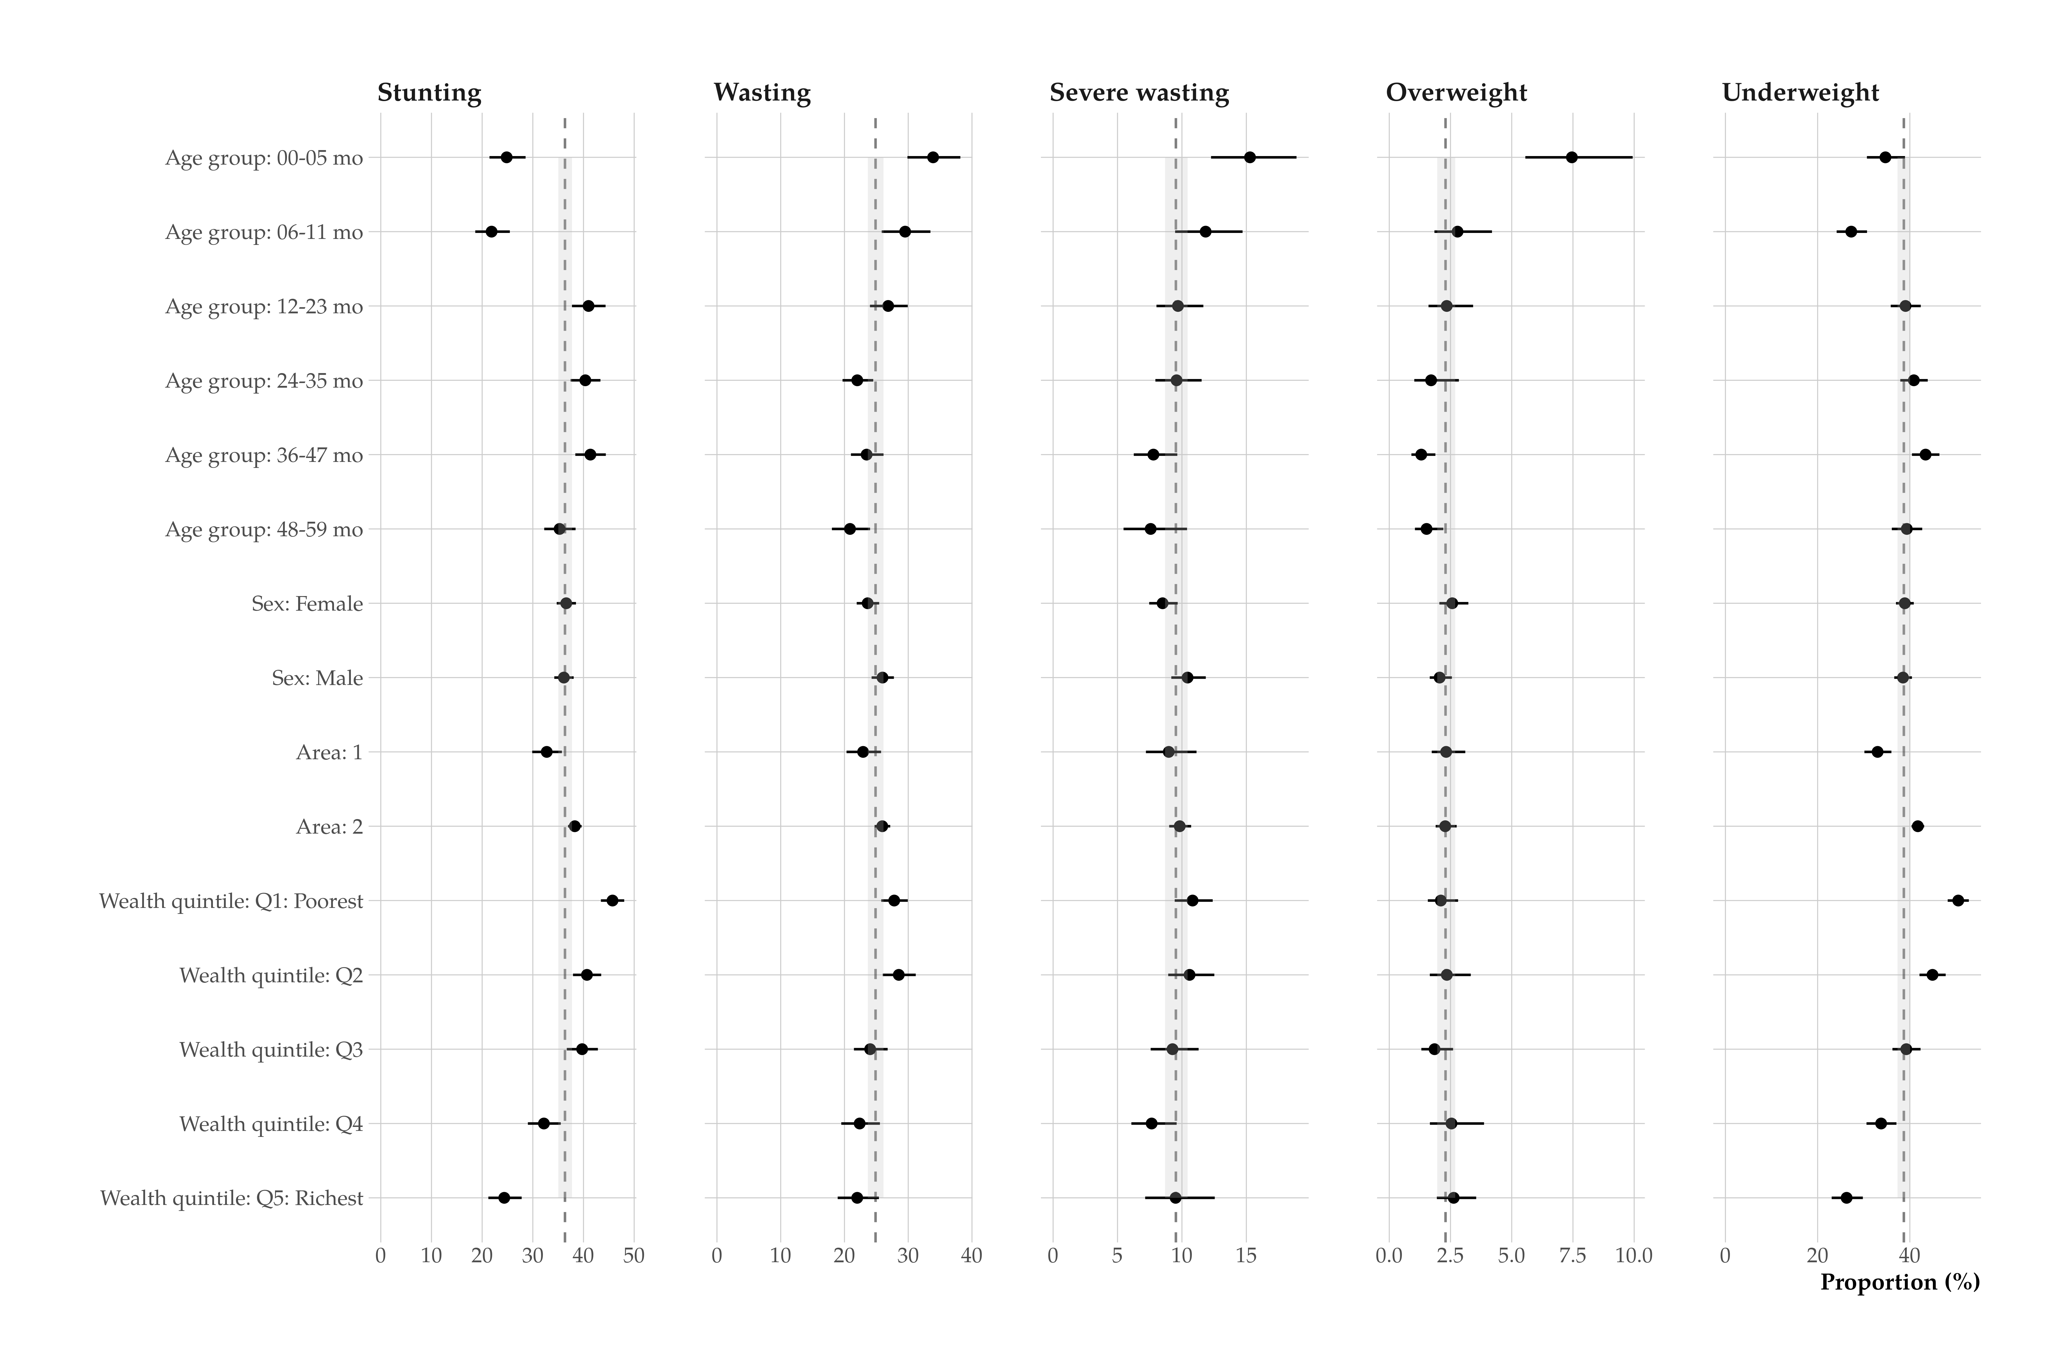

Figure 1: Nutritional status by stratification variable

# Summary on survey description

## Sample size:

The original sample was of 12299 children. There were 12299 children retained after filtering for [**INSERT DETAILS OF ANY FILTERING APPLIED**]; height measurements were obtained for 12296 (100%) children and weight measurements were obtained for 12299 (100%). There were 0 (0%) children with missing information on sex and there were 0 (0%) children with missing age.

Information on oedema was not provided.

## Sample design:

## Household listing (source or how was it done to update existing information)

## Training of field staff: How many, how many teams, how many measurements per team per day

## Standardization

## Equipment and calibration

## Data collection period

Data collection: Start: [**enter month and year the survey started MM/YYYY**]; End: [**enter month and year the survey ended MM/YYYY**]

## Data entry

## Supervision

# Other survey context important for the interpretation of results

## Seasonality (e.g. harvest and malaria)

## Climate conditions (e.g. monsoon, drought, natural catastrophes)

## Epidemics, high mortality

## Security issues, civil unrest

## Population groups not covered (e.g. slums, refugees)

# Summary of survey analysis

## Data processing: Software …..

## Data cleaning:

## Imputations:

# Data quality indicators and assessment

## Flags:

Flags were calculated as follows:…

There were 223 (1.8%) flags for length- or height-for-age, 44 (0.4%) flags for weight-for-age, 414 (3.4%) flags for body mass index-for-age, 384 (3.1%) flags for weight-for-length or height.

## Missing data

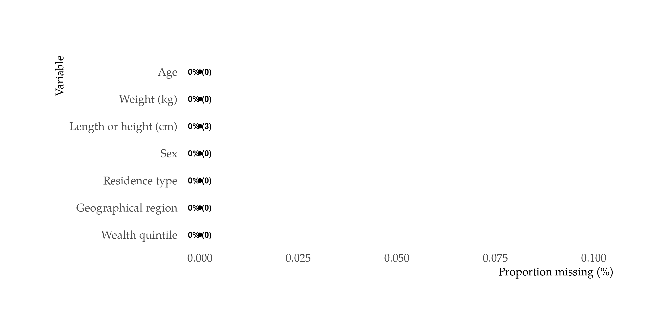

Figure 2: Missing data

## Digit heaping charts (with mapping variable labels)

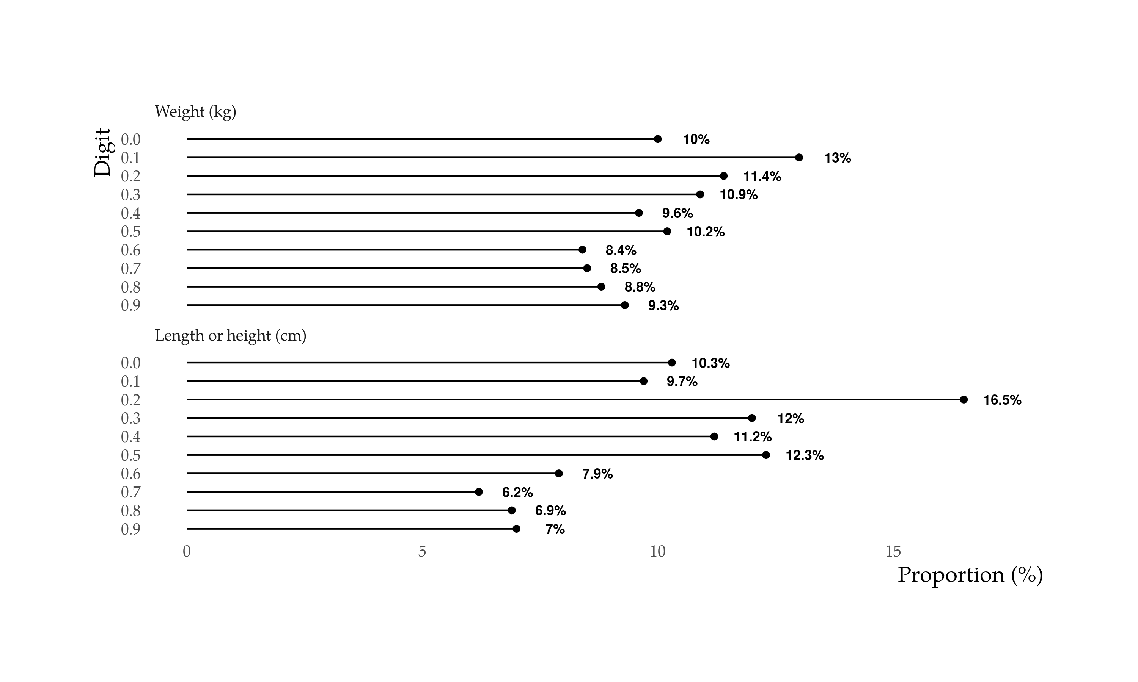

Figure 3: Digit preference for weight & height measurements

## Z-score distribution issues

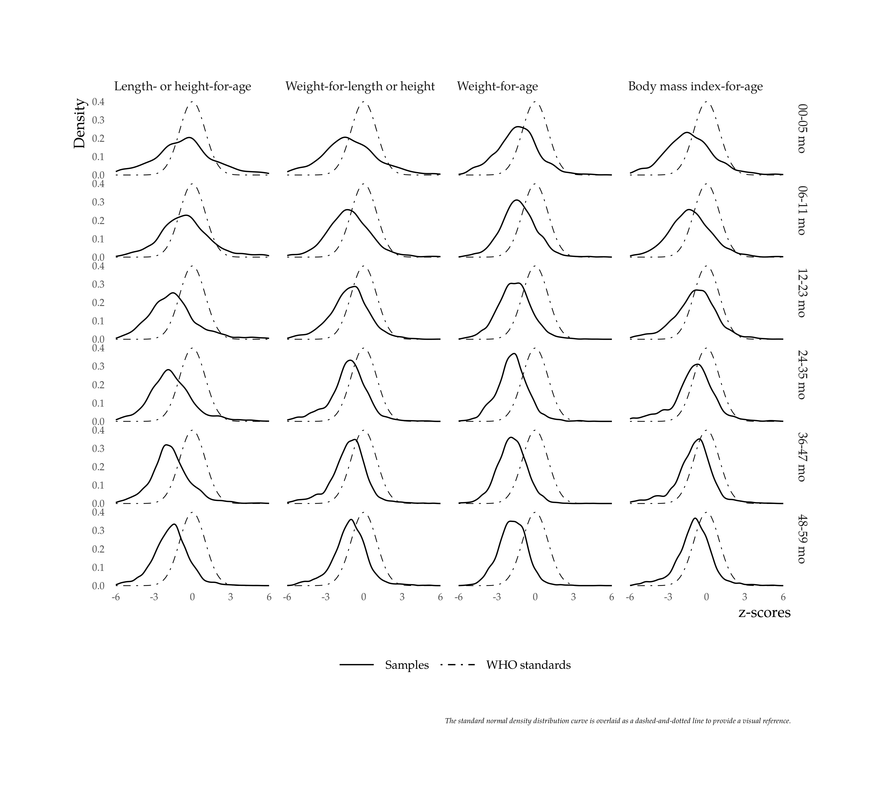

Figure 4: Z-score distributions by age group

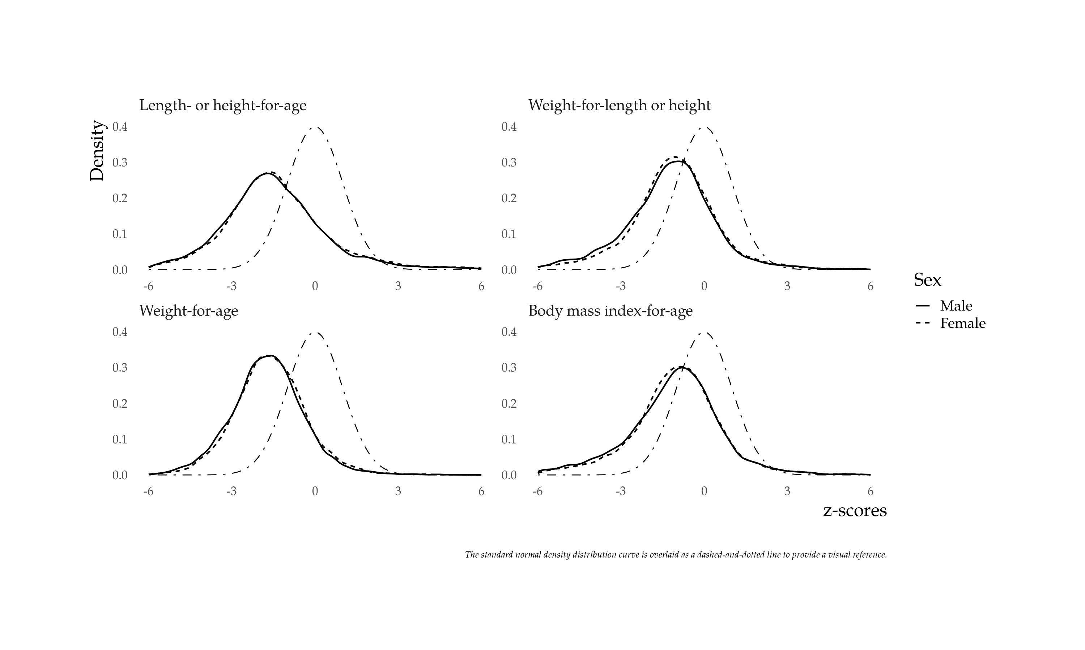

Figure 5: Z-score distributions by sex

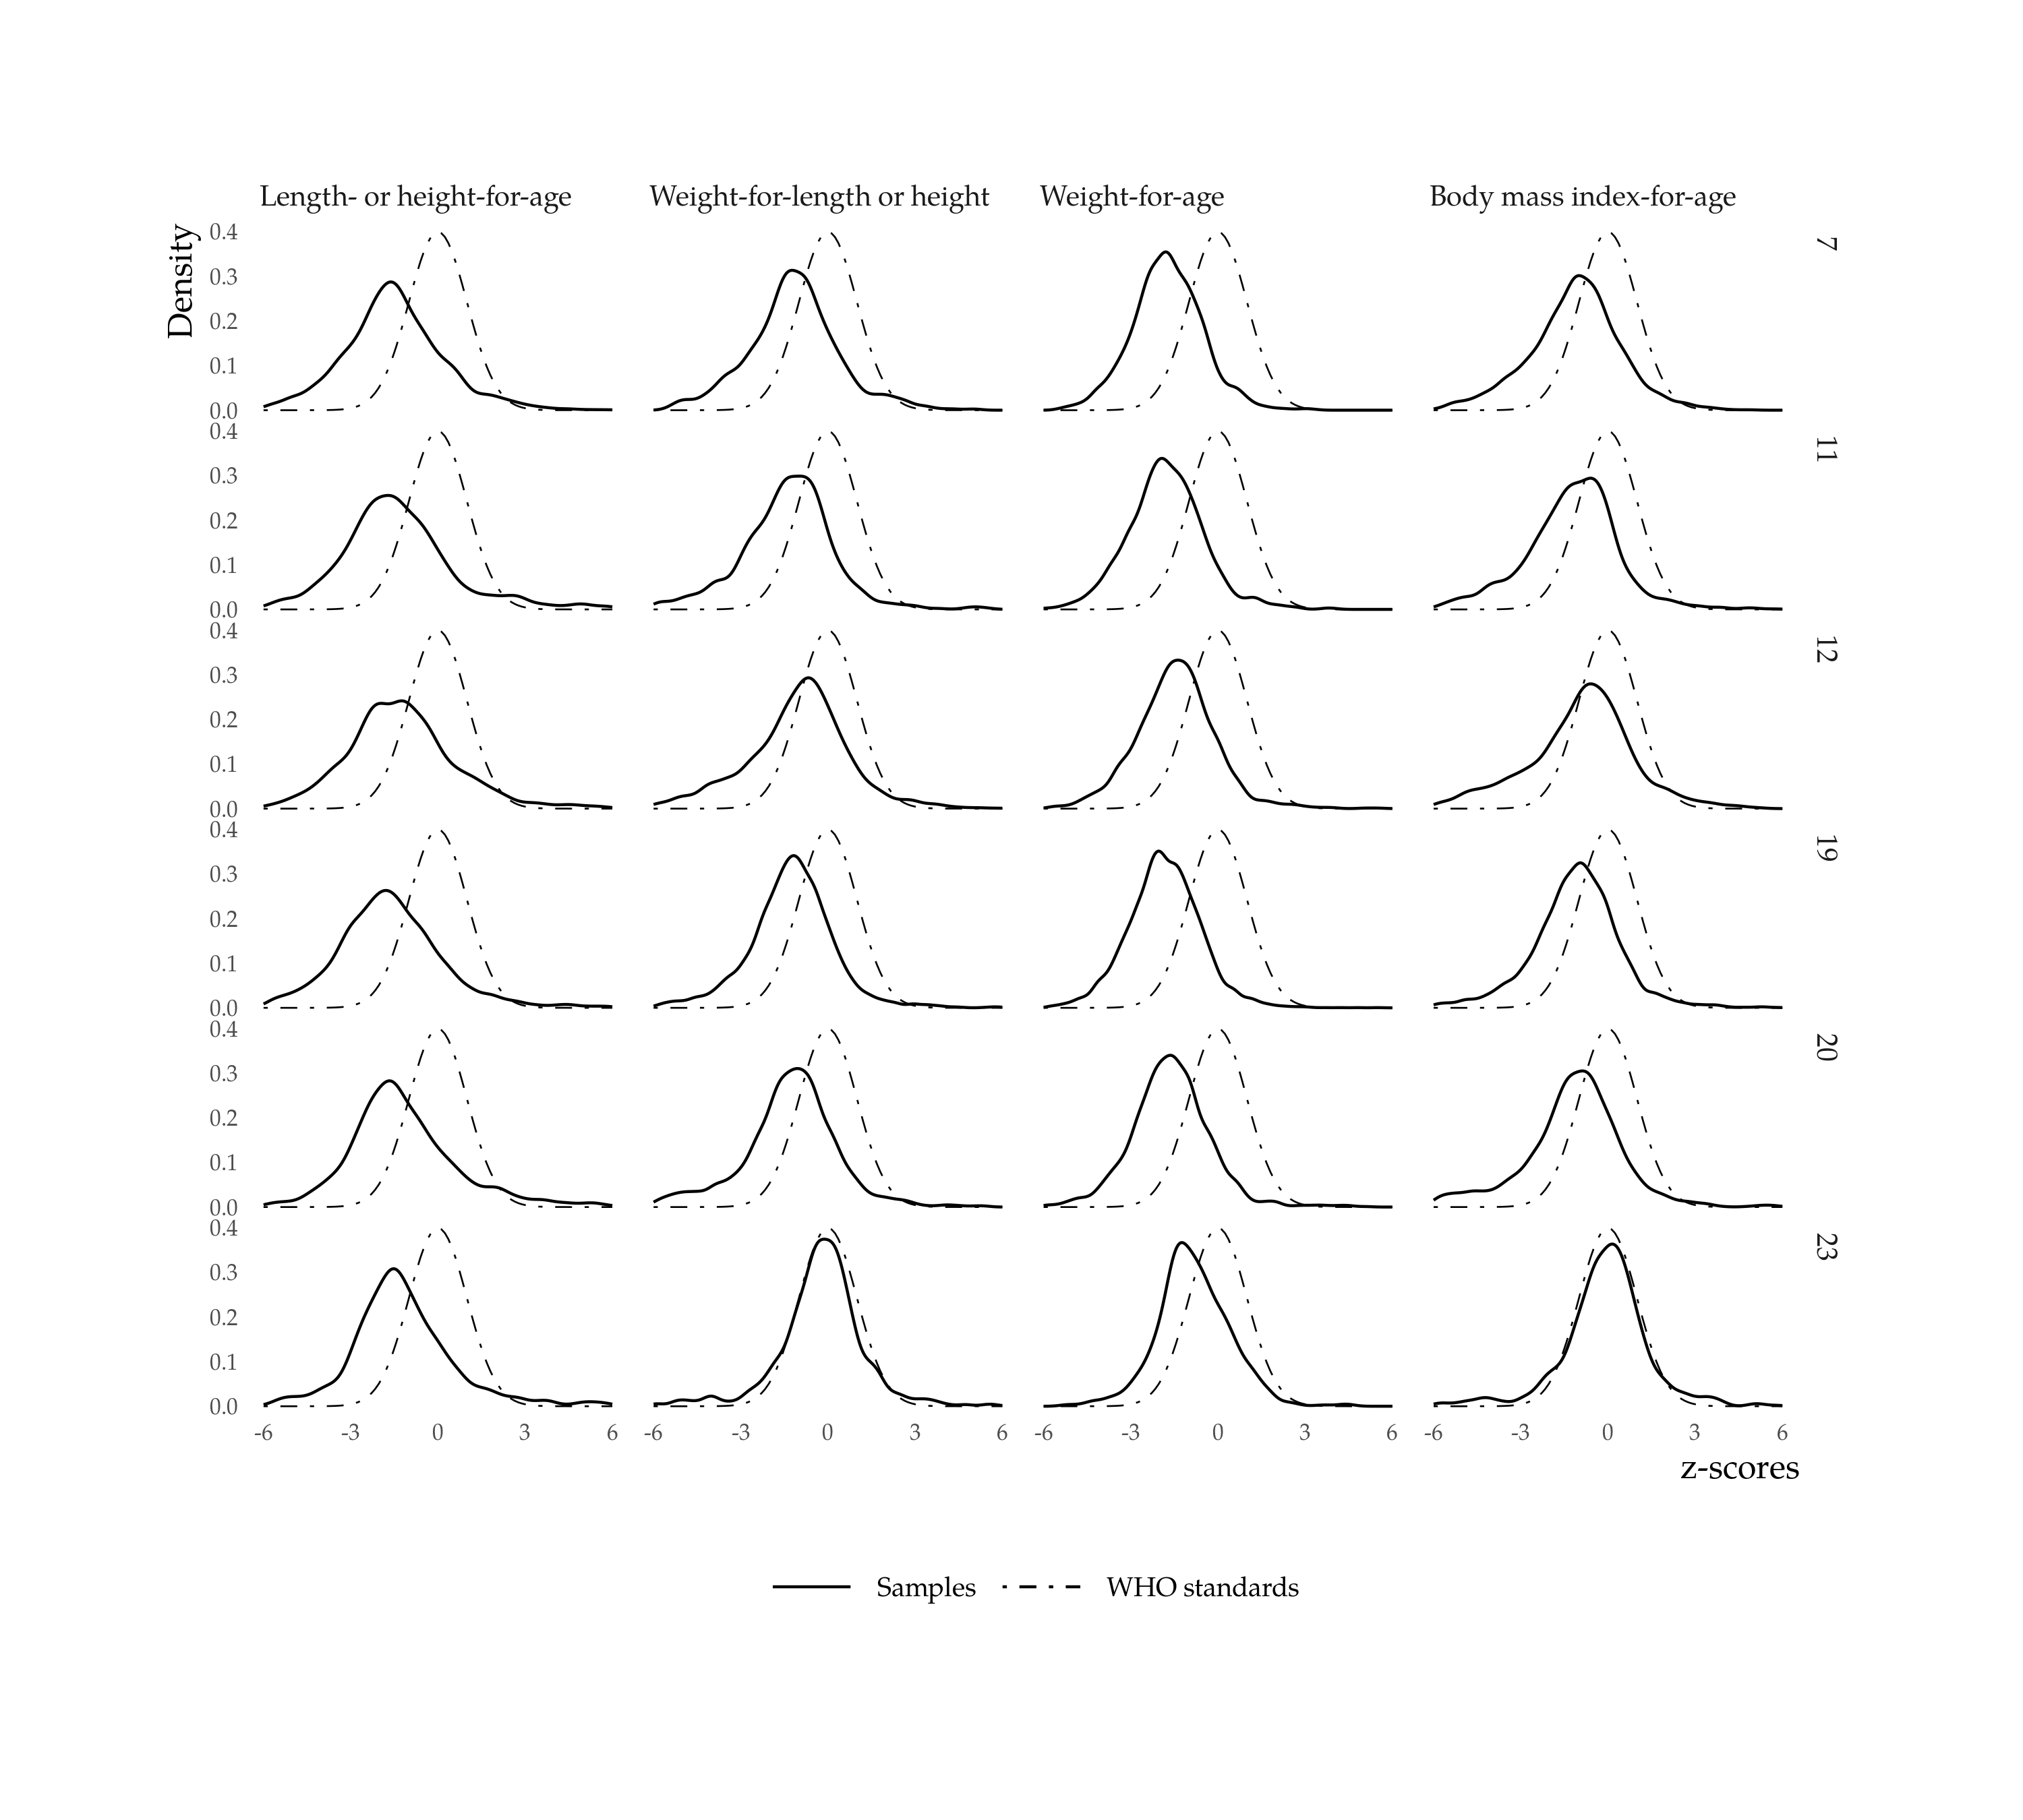

Figure 6: Z-score distributions by geographical region

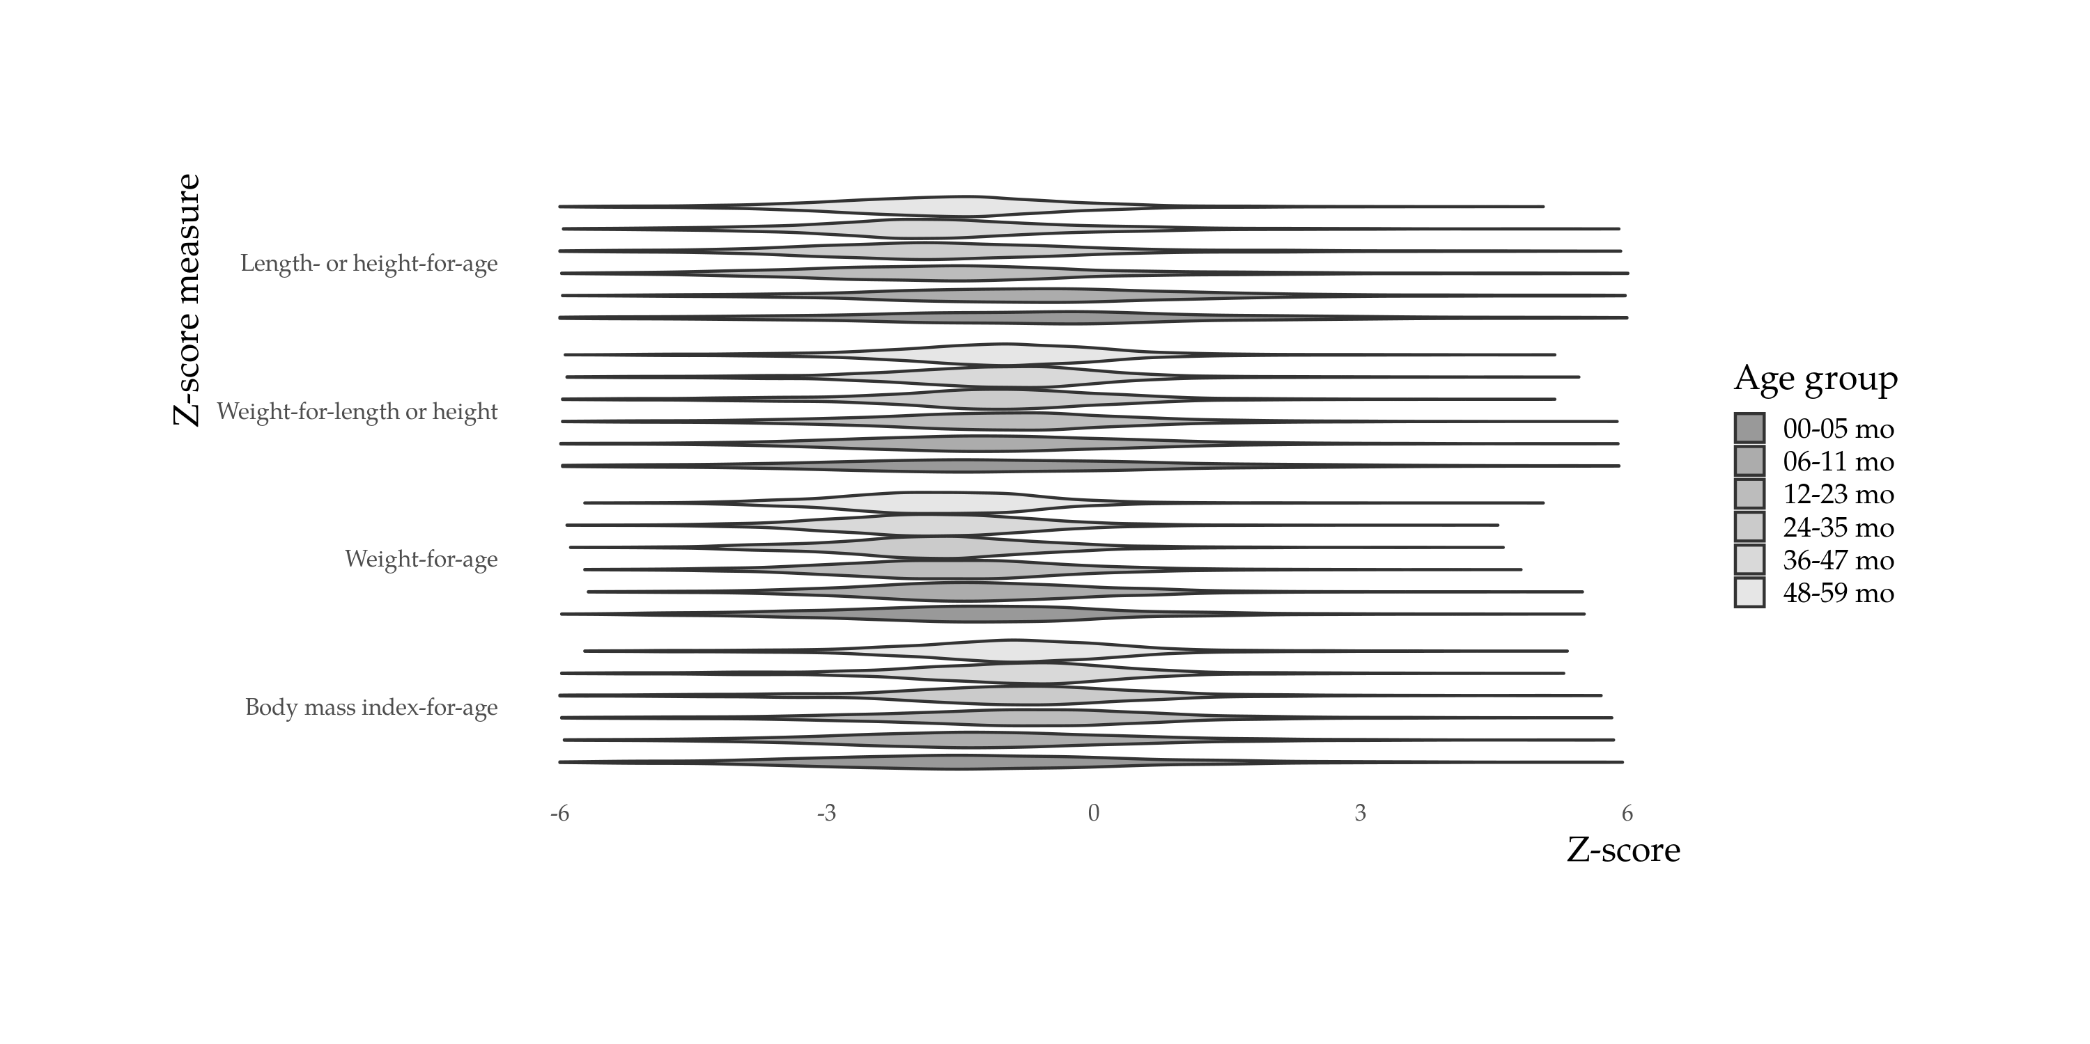

Figure 7: z-score distribution violin plot by age group

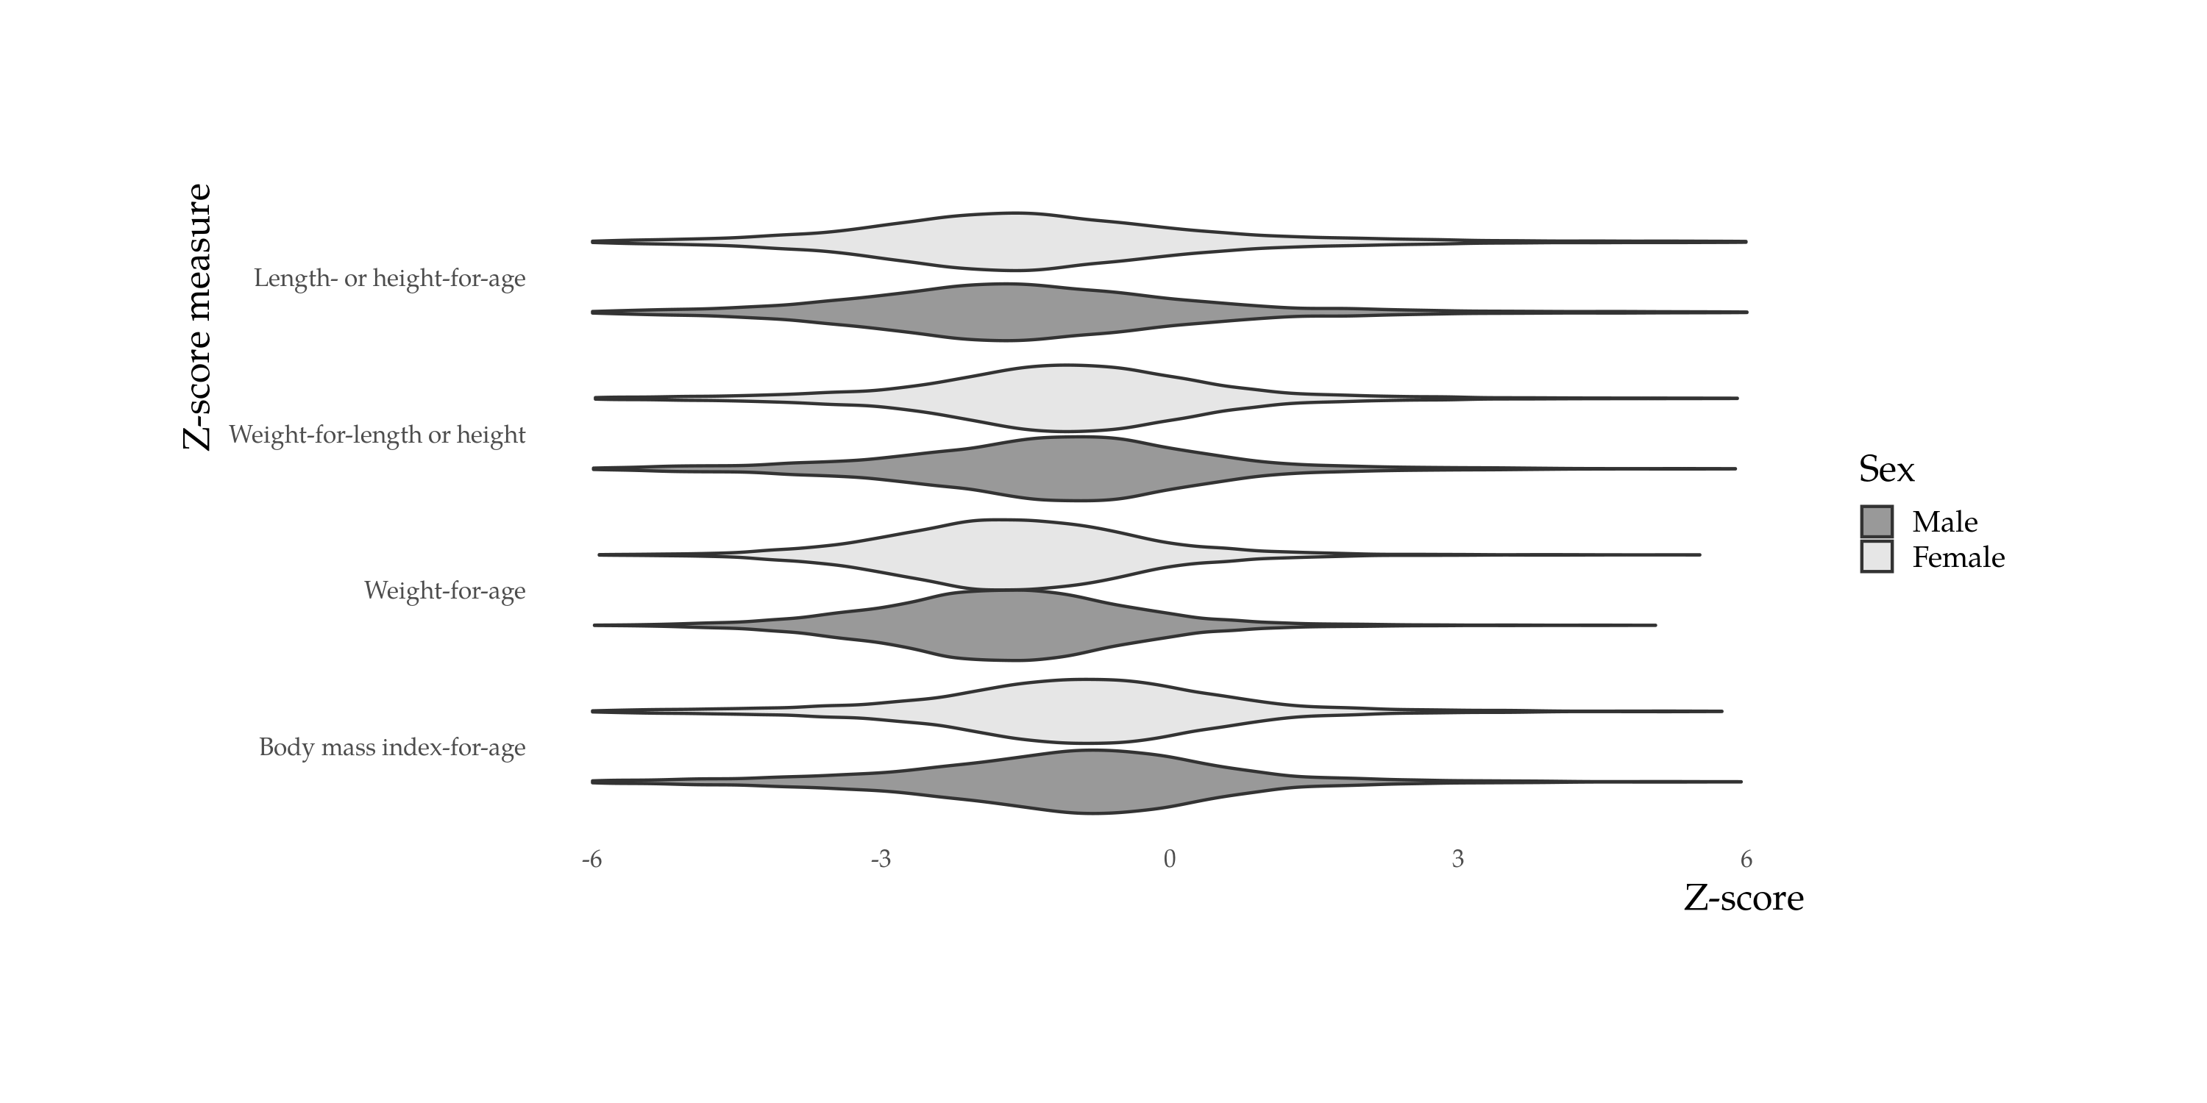

Figure 8: z-score distribution violin plot by sex

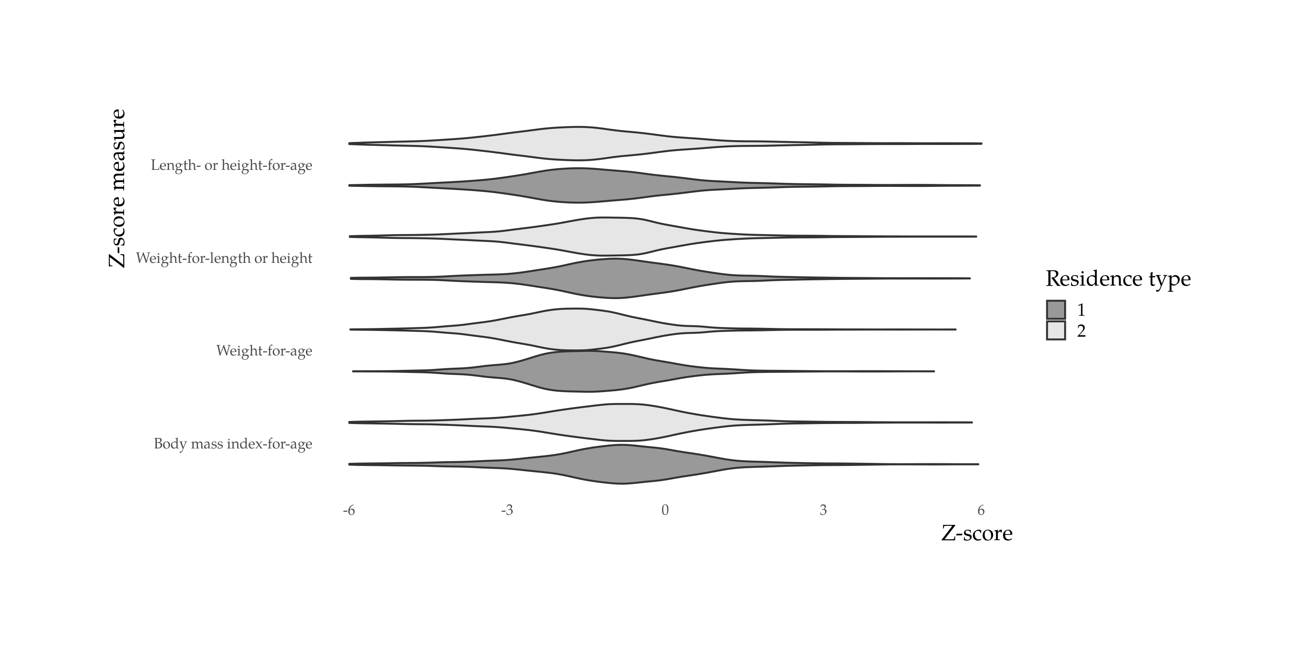

Figure 9: z-score distribution violin plot by residence type

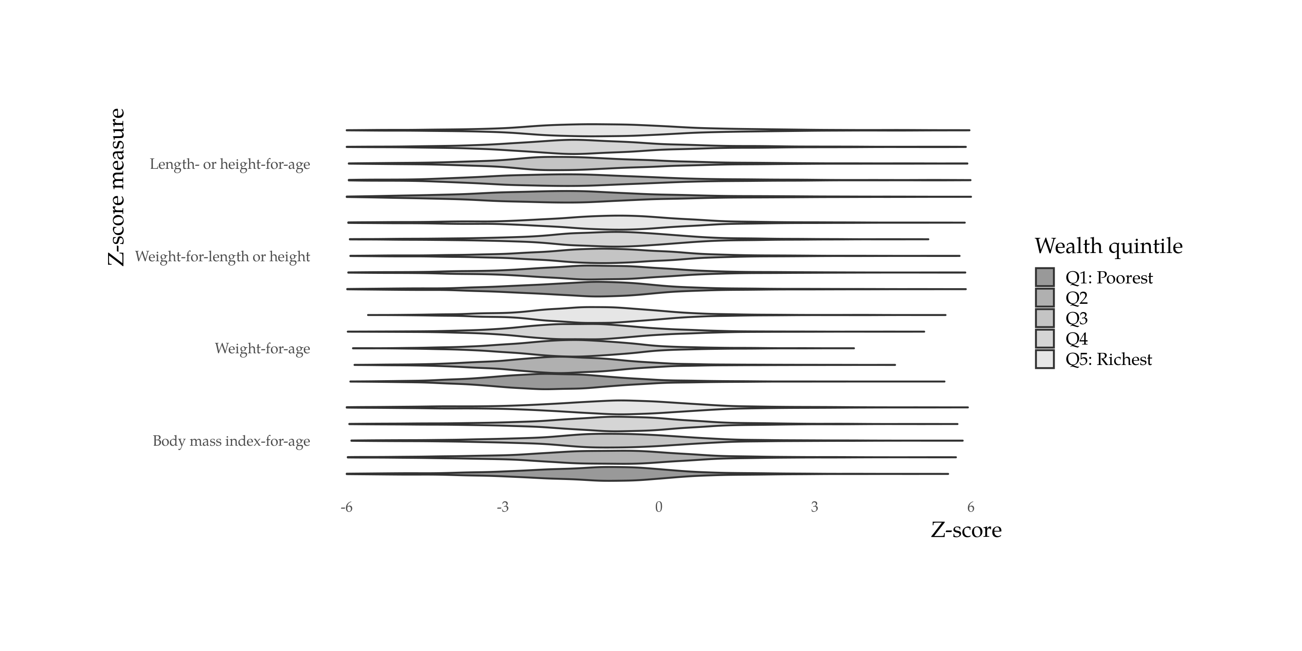

Figure 10: z-score distribution violin plots by wealth quintile

# Appendix: Nutritional status tables

Height-for-age

|  |  |  |  |  |  |  |
| --- | --- | --- | --- | --- | --- | --- |
| Group | Weighted N | Unweighted N | -3SD (95% CI) | -2SD (95% CI) | z-score mean (95% CI) | z-score SD |
| All | 11420371714 | 12073 | 14.8 (14.0; 15.8) | 36.3 (35.0; 37.7) | -1.3 (-1.4; -1.3) | 1.83 |
| Age group: 00-05 mo | 977588890 | 1151 | 14.3 (11.5; 17.7) | 24.8 (21.4; 28.6) | -0.5 (-0.7; -0.3) | 2.40 |
| Age group: 06-11 mo | 1248531816 | 1278 | 8.8 ( 6.8; 11.3) | 21.9 (18.6; 25.5) | -0.5 (-0.6; -0.3) | 1.99 |
| Age group: 12-23 mo | 2337270452 | 2405 | 18.8 (16.5; 21.3) | 41.0 (37.7; 44.4) | -1.5 (-1.6; -1.3) | 1.95 |
| Age group: 24-35 mo | 2201476489 | 2295 | 17.5 (15.5; 19.6) | 40.4 (37.4; 43.3) | -1.5 (-1.6; -1.4) | 1.81 |
| Age group: 36-47 mo | 2393790454 | 2559 | 14.2 (12.6; 16.0) | 41.4 (38.4; 44.4) | -1.6 (-1.7; -1.6) | 1.49 |
| Age group: 48-59 mo | 2261713613 | 2385 | 12.4 (10.7; 14.4) | 35.3 (32.2; 38.4) | -1.5 (-1.6; -1.4) | 1.39 |
| Sex: Female | 5351913833 | 5815 | 14.4 (13.2; 15.7) | 36.6 (34.7; 38.5) | -1.3 (-1.4; -1.3) | 1.85 |
| Sex: Male | 6068457881 | 6258 | 15.2 (14.0; 16.5) | 36.1 (34.2; 38.1) | -1.3 (-1.4; -1.3) | 1.82 |
| Age + sex: 00-05 mo.Female | 473397218 | 575 | 15.5 (11.4; 20.7) | 25.1 (20.3; 30.6) | -0.4 (-0.7; -0.1) | 2.52 |
| Age + sex: 06-11 mo.Female | 604499152 | 616 | 8.3 ( 5.2; 13.1) | 18.5 (14.4; 23.4) | -0.4 (-0.6; -0.1) | 1.91 |
| Age + sex: 12-23 mo.Female | 1105455300 | 1149 | 15.5 (12.8; 18.6) | 37.1 (32.4; 42.0) | -1.4 (-1.5; -1.2) | 1.94 |
| Age + sex: 24-35 mo.Female | 1043729005 | 1080 | 16.8 (14.0; 20.0) | 42.7 (38.3; 47.1) | -1.5 (-1.7; -1.4) | 1.83 |
| Age + sex: 36-47 mo.Female | 1143470212 | 1248 | 14.8 (12.5; 17.6) | 43.5 (39.5; 47.7) | -1.7 (-1.8; -1.6) | 1.43 |
| Age + sex: 48-59 mo.Female | 981362946 | 1147 | 13.5 (11.1; 16.5) | 38.2 (34.2; 42.4) | -1.7 (-1.8; -1.6) | 1.35 |
| Age + sex: 00-05 mo.Male | 504191672 | 576 | 13.2 ( 9.7; 17.8) | 24.6 (20.0; 29.9) | -0.6 (-0.8; -0.3) | 2.28 |
| Age + sex: 06-11 mo.Male | 644032664 | 662 | 9.2 ( 7.0; 12.0) | 25.0 (20.3; 30.4) | -0.6 (-0.8; -0.3) | 2.06 |
| Age + sex: 12-23 mo.Male | 1231815152 | 1256 | 21.7 (18.2; 25.6) | 44.5 (40.1; 49.1) | -1.6 (-1.7; -1.4) | 1.96 |
| Age + sex: 24-35 mo.Male | 1157747484 | 1215 | 18.1 (15.4; 21.1) | 38.3 (34.4; 42.3) | -1.5 (-1.6; -1.3) | 1.80 |
| Age + sex: 36-47 mo.Male | 1250320242 | 1311 | 13.7 (11.6; 16.1) | 39.4 (35.1; 43.8) | -1.6 (-1.7; -1.5) | 1.54 |
| Age + sex: 48-59 mo.Male | 1280350667 | 1238 | 11.6 ( 9.3; 14.3) | 33.0 (28.8; 37.6) | -1.4 (-1.6; -1.3) | 1.40 |
| Area: 1 | 3988881949 | 3384 | 11.7 (10.0; 13.6) | 32.7 (29.9; 35.7) | -1.2 (-1.3; -1.1) | 1.74 |
| Area: 2 | 7431489765 | 8689 | 16.5 (15.6; 17.5) | 38.3 (36.9; 39.6) | -1.4 (-1.5; -1.3) | 1.88 |
| Geographical region: 7 | 1191881671 | 1776 | 16.1 (14.2; 18.3) | 35.3 (32.7; 38.0) | -1.5 (-1.6; -1.4) | 1.62 |
| Geographical region: 11 | 1930840809 | 1417 | 15.4 (13.2; 17.9) | 37.7 (34.5; 41.0) | -1.3 (-1.4; -1.2) | 1.94 |
| Geographical region: 12 | 1074736181 | 1513 | 15.4 (13.4; 17.6) | 34.7 (31.9; 37.5) | -1.3 (-1.4; -1.1) | 1.86 |
| Geographical region: 19 | 3192523752 | 4646 | 20.1 (18.9; 21.5) | 42.4 (40.8; 44.0) | -1.6 (-1.7; -1.6) | 1.77 |
| Geographical region: 20 | 3989204850 | 1798 | 9.8 ( 8.2; 11.8) | 31.7 (28.7; 34.8) | -1.1 (-1.2; -1.0) | 1.85 |
| Geographical region: 23 | 41184451 | 923 | 8.8 ( 6.5; 11.9) | 28.9 (24.4; 33.9) | -1.2 (-1.4; -1.1) | 1.60 |
| Wealth quintile: Q1: Poorest | 2042895918 | 2876 | 23.6 (21.7; 25.5) | 45.7 (43.4; 48.0) | -1.7 (-1.8; -1.6) | 1.84 |
| Wealth quintile: Q2 | 2309571363 | 2493 | 17.8 (16.0; 19.8) | 40.7 (37.9; 43.5) | -1.5 (-1.6; -1.4) | 1.88 |
| Wealth quintile: Q3 | 2402422856 | 2345 | 15.3 (13.1; 17.9) | 39.7 (36.7; 42.8) | -1.4 (-1.5; -1.3) | 1.85 |
| Wealth quintile: Q4 | 2377285367 | 2219 | 11.4 ( 9.6; 13.5) | 32.2 (29.0; 35.5) | -1.2 (-1.3; -1.1) | 1.75 |
| Wealth quintile: Q5: Richest | 2288196210 | 2140 | 7.1 ( 5.8; 8.6) | 24.4 (21.2; 27.8) | -0.9 (-1.0; -0.7) | 1.75 |

Weight-for-age

|  |  |  |  |  |  |  |
| --- | --- | --- | --- | --- | --- | --- |
| Group | Weighted N | Unweighted N | -3SD (95% CI) | -2SD (95% CI) | z-score mean (95% CI) | z-score SD |
| All | 11593488818 | 12255 | 13.4 (12.5; 14.3) | 38.7 (37.3; 40.1) | -1.7 (-1.7; -1.6) | 1.28 |
| Age group: 00-05 mo | 1014334489 | 1203 | 15.9 (13.2; 19.0) | 34.7 (30.7; 38.9) | -1.5 (-1.6; -1.4) | 1.63 |
| Age group: 06-11 mo | 1274438612 | 1309 | 10.1 ( 8.0; 12.6) | 27.3 (24.1; 30.7) | -1.3 (-1.4; -1.2) | 1.38 |
| Age group: 12-23 mo | 2380355237 | 2455 | 13.0 (11.2; 15.0) | 39.1 (35.9; 42.4) | -1.7 (-1.7; -1.6) | 1.28 |
| Age group: 24-35 mo | 2229752953 | 2319 | 14.6 (12.6; 16.7) | 40.9 (37.9; 43.9) | -1.8 (-1.8; -1.7) | 1.26 |
| Age group: 36-47 mo | 2424191121 | 2579 | 14.6 (12.8; 16.7) | 43.4 (40.5; 46.4) | -1.9 (-1.9; -1.8) | 1.13 |
| Age group: 48-59 mo | 2270416406 | 2390 | 12.1 ( 9.9; 14.8) | 39.3 (36.1; 42.7) | -1.7 (-1.8; -1.6) | 1.15 |
| Sex: Female | 5419727677 | 5887 | 13.0 (11.7; 14.3) | 38.9 (37.0; 40.9) | -1.7 (-1.7; -1.6) | 1.27 |
| Sex: Male | 6173761141 | 6368 | 13.8 (12.5; 15.1) | 38.5 (36.6; 40.5) | -1.7 (-1.7; -1.6) | 1.29 |
| Age + sex: 00-05 mo.Female | 488790141 | 593 | 14.1 (10.4; 19.0) | 29.7 (24.8; 35.0) | -1.3 (-1.5; -1.1) | 1.63 |
| Age + sex: 06-11 mo.Female | 614313924 | 630 | 8.0 ( 5.5; 11.6) | 25.0 (20.6; 29.9) | -1.2 (-1.3; -1.1) | 1.31 |
| Age + sex: 12-23 mo.Female | 1117963173 | 1167 | 10.4 ( 8.2; 13.2) | 37.2 (32.4; 42.4) | -1.6 (-1.7; -1.4) | 1.29 |
| Age + sex: 24-35 mo.Female | 1055547043 | 1089 | 15.6 (12.6; 19.2) | 41.8 (37.5; 46.2) | -1.8 (-1.9; -1.6) | 1.28 |
| Age + sex: 36-47 mo.Female | 1159780460 | 1259 | 15.3 (12.4; 18.7) | 46.2 (42.1; 50.3) | -1.9 (-2.0; -1.8) | 1.11 |
| Age + sex: 48-59 mo.Female | 983332936 | 1149 | 12.7 (10.6; 15.3) | 42.4 (38.3; 46.6) | -1.8 (-1.9; -1.7) | 1.06 |
| Age + sex: 00-05 mo.Male | 525544348 | 610 | 17.5 (13.9; 21.9) | 39.4 (33.3; 45.8) | -1.6 (-1.8; -1.5) | 1.62 |
| Age + sex: 06-11 mo.Male | 660124688 | 679 | 12.0 ( 9.0; 15.9) | 29.5 (25.0; 34.3) | -1.4 (-1.6; -1.2) | 1.44 |
| Age + sex: 12-23 mo.Male | 1262392064 | 1288 | 15.2 (12.6; 18.2) | 40.7 (36.5; 45.0) | -1.8 (-1.9; -1.7) | 1.27 |
| Age + sex: 24-35 mo.Male | 1174205910 | 1230 | 13.6 (11.3; 16.2) | 40.1 (36.1; 44.2) | -1.7 (-1.9; -1.6) | 1.24 |
| Age + sex: 36-47 mo.Male | 1264410661 | 1320 | 14.1 (11.8; 16.7) | 40.8 (36.7; 45.1) | -1.8 (-1.9; -1.7) | 1.14 |
| Age + sex: 48-59 mo.Male | 1287083470 | 1241 | 11.7 ( 8.2; 16.3) | 37.0 (32.3; 42.0) | -1.6 (-1.8; -1.4) | 1.21 |
| Area: 1 | 4031153952 | 3429 | 10.3 ( 8.5; 12.3) | 33.0 (30.1; 36.0) | -1.5 (-1.6; -1.4) | 1.21 |
| Area: 2 | 7562334866 | 8826 | 15.1 (14.1; 16.0) | 41.7 (40.4; 43.1) | -1.7 (-1.8; -1.7) | 1.31 |
| Geographical region: 7 | 1201776278 | 1800 | 12.1 (10.4; 14.1) | 39.8 (37.1; 42.5) | -1.7 (-1.8; -1.6) | 1.20 |
| Geographical region: 11 | 1954997609 | 1438 | 15.0 (12.9; 17.3) | 41.6 (38.3; 44.9) | -1.7 (-1.8; -1.7) | 1.26 |
| Geographical region: 12 | 1101321662 | 1545 | 11.1 ( 9.5; 12.9) | 31.0 (28.5; 33.7) | -1.5 (-1.5; -1.4) | 1.31 |
| Geographical region: 19 | 3232049974 | 4711 | 15.8 (14.7; 16.9) | 43.6 (42.0; 45.2) | -1.8 (-1.8; -1.8) | 1.23 |
| Geographical region: 20 | 4061666043 | 1832 | 11.8 ( 9.9; 14.1) | 35.5 (32.4; 38.6) | -1.6 (-1.7; -1.5) | 1.33 |
| Geographical region: 23 | 41677252 | 929 | 3.8 ( 2.4; 6.0) | 11.3 ( 8.8; 14.5) | -0.7 (-0.9; -0.6) | 1.26 |
| Wealth quintile: Q1: Poorest | 2085370556 | 2936 | 20.0 (18.3; 21.8) | 50.5 (48.2; 52.8) | -2.0 (-2.0; -1.9) | 1.29 |
| Wealth quintile: Q2 | 2358777724 | 2535 | 16.7 (14.7; 18.8) | 44.9 (42.1; 47.8) | -1.8 (-1.9; -1.7) | 1.37 |
| Wealth quintile: Q3 | 2435771622 | 2375 | 12.6 (10.8; 14.7) | 39.2 (36.2; 42.3) | -1.7 (-1.8; -1.6) | 1.19 |
| Wealth quintile: Q4 | 2396128505 | 2233 | 9.9 ( 8.2; 12.0) | 33.8 (30.6; 37.1) | -1.6 (-1.6; -1.5) | 1.22 |
| Wealth quintile: Q5: Richest | 2317440411 | 2176 | 8.5 ( 6.4; 11.3) | 26.3 (23.0; 29.8) | -1.3 (-1.4; -1.2) | 1.24 |

Weight-for-height

|  |  |  |  |  |  |  |  |  |
| --- | --- | --- | --- | --- | --- | --- | --- | --- |
| Group | Weighted N | Unweighted N | -3SD (95% CI) | -2SD (95% CI) | +2SD (95% CI) | +3SD (95% CI) | z-score mean (95% CI) | z-score SD |
| All | 11166818528 | 11856 | 9.5 ( 8.7; 10.4) | 24.9 (23.7; 26.1) | 2.3 (2.0; 2.7) | 0.8 (0.6; 1.0) | -1.2 (-1.2; -1.1) | 1.43 |
| Age group: 00-05 mo | 892747010 | 1080 | 15.3 (12.3; 18.9) | 33.9 (29.9; 38.2) | 7.5 (5.6; 9.9) | 2.6 (1.6; 4.3) | -1.1 (-1.3; -1.0) | 1.90 |
| Age group: 06-11 mo | 1239731272 | 1272 | 11.8 ( 9.5; 14.7) | 29.5 (25.8; 33.5) | 2.8 (1.8; 4.2) | 0.8 (0.5; 1.5) | -1.2 (-1.3; -1.0) | 1.56 |
| Age group: 12-23 mo | 2308581322 | 2391 | 9.7 ( 8.0; 11.7) | 26.9 (24.0; 29.9) | 2.3 (1.6; 3.4) | 0.7 (0.4; 1.2) | -1.1 (-1.2; -1.1) | 1.44 |
| Age group: 24-35 mo | 2136129495 | 2246 | 9.6 ( 7.9; 11.5) | 22.0 (19.7; 24.5) | 1.7 (1.0; 2.8) | 0.5 (0.2; 1.3) | -1.2 (-1.3; -1.1) | 1.36 |
| Age group: 36-47 mo | 2350655727 | 2514 | 7.8 ( 6.3; 9.6) | 23.5 (21.0; 26.1) | 1.3 (0.9; 1.9) | 0.4 (0.2; 0.7) | -1.2 (-1.3; -1.1) | 1.27 |
| Age group: 48-59 mo | 2238973702 | 2353 | 7.6 ( 5.5; 10.4) | 20.9 (18.0; 24.0) | 1.5 (1.0; 2.2) | 0.7 (0.4; 1.2) | -1.1 (-1.2; -1.0) | 1.34 |
| Sex: Female | 5226306156 | 5724 | 8.5 ( 7.5; 9.7) | 23.6 (21.9; 25.4) | 2.6 (2.0; 3.2) | 0.8 (0.5; 1.1) | -1.1 (-1.2; -1.1) | 1.40 |
| Sex: Male | 5940512372 | 6132 | 10.4 ( 9.2; 11.9) | 26.0 (24.3; 27.8) | 2.1 (1.7; 2.6) | 0.7 (0.5; 1.0) | -1.2 (-1.3; -1.1) | 1.45 |
| Age + sex: 00-05 mo.Female | 425411721 | 537 | 15.1 (11.2; 20.2) | 30.3 (25.3; 35.8) | 8.6 (5.7; 12.8) | 2.7 (1.5; 4.9) | -1.0 (-1.2; -0.8) | 1.95 |
| Age + sex: 06-11 mo.Female | 593826783 | 611 | 10.2 ( 7.2; 14.2) | 29.7 (24.0; 36.1) | 3.4 (2.0; 5.9) | 0.8 (0.3; 2.1) | -1.1 (-1.3; -0.9) | 1.58 |
| Age + sex: 12-23 mo.Female | 1088461150 | 1141 | 8.4 ( 6.0; 11.6) | 25.6 (21.2; 30.6) | 2.3 (1.2; 4.5) | 0.4 (0.2; 0.9) | -1.1 (-1.2; -0.9) | 1.40 |
| Age + sex: 24-35 mo.Female | 1017790183 | 1061 | 9.7 ( 7.2; 13.0) | 21.8 (18.3; 25.8) | 1.8 (0.9; 3.5) | 0.8 (0.2; 2.7) | -1.2 (-1.3; -1.0) | 1.34 |
| Age + sex: 36-47 mo.Female | 1125888741 | 1238 | 6.2 ( 4.7; 8.3) | 21.4 (18.3; 25.0) | 1.6 (1.0; 2.5) | 0.5 (0.3; 1.1) | -1.1 (-1.2; -1.0) | 1.25 |
| Age + sex: 48-59 mo.Female | 974927578 | 1136 | 6.1 ( 4.5; 8.2) | 19.3 (16.2; 22.9) | 1.6 (0.9; 2.8) | 0.6 (0.3; 1.5) | -1.1 (-1.2; -1.0) | 1.23 |
| Age + sex: 00-05 mo.Male | 467335289 | 543 | 15.4 (11.2; 20.9) | 37.2 (31.1; 43.7) | 6.4 (4.2; 9.6) | 2.6 (1.3; 5.4) | -1.3 (-1.5; -1.0) | 1.85 |
| Age + sex: 06-11 mo.Male | 645904489 | 661 | 13.4 (10.0; 17.7) | 29.3 (24.8; 34.4) | 2.2 (1.2; 4.0) | 0.9 (0.4; 1.9) | -1.2 (-1.4; -1.0) | 1.55 |
| Age + sex: 12-23 mo.Male | 1220120172 | 1250 | 10.9 ( 8.7; 13.5) | 28.0 (24.4; 31.9) | 2.4 (1.6; 3.6) | 0.9 (0.4; 2.0) | -1.2 (-1.3; -1.1) | 1.48 |
| Age + sex: 24-35 mo.Male | 1118339312 | 1185 | 9.5 ( 7.5; 11.9) | 22.2 (19.2; 25.4) | 1.6 (0.8; 3.5) | 0.3 (0.1; 0.7) | -1.2 (-1.3; -1.1) | 1.39 |
| Age + sex: 36-47 mo.Male | 1224766986 | 1276 | 9.2 ( 6.8; 12.4) | 25.4 (21.7; 29.4) | 1.0 (0.5; 1.9) | 0.2 (0.1; 0.7) | -1.3 (-1.4; -1.2) | 1.29 |
| Age + sex: 48-59 mo.Male | 1264046124 | 1217 | 8.7 ( 5.4; 13.7) | 22.1 (17.8; 27.0) | 1.4 (0.9; 2.4) | 0.7 (0.3; 1.5) | -1.1 (-1.3; -0.9) | 1.42 |
| Area: 1 | 3911306577 | 3328 | 9.0 ( 7.2; 11.1) | 22.9 (20.3; 25.7) | 2.3 (1.7; 3.1) | 0.8 (0.5; 1.3) | -1.1 (-1.2; -1.0) | 1.44 |
| Area: 2 | 7255511951 | 8528 | 9.8 ( 9.0; 10.7) | 25.9 (24.7; 27.2) | 2.3 (1.9; 2.8) | 0.7 (0.5; 1.0) | -1.2 (-1.3; -1.2) | 1.43 |
| Geographical region: 7 | 1183271470 | 1760 | 9.6 ( 8.0; 11.4) | 24.9 (22.5; 27.4) | 3.1 (2.3; 4.3) | 0.7 (0.4; 1.3) | -1.1 (-1.2; -1.1) | 1.46 |
| Geographical region: 11 | 1871652824 | 1373 | 10.4 ( 8.4; 12.9) | 28.7 (25.6; 32.0) | 1.8 (1.2; 2.8) | 0.6 (0.3; 1.3) | -1.3 (-1.4; -1.2) | 1.41 |
| Geographical region: 12 | 1054830001 | 1483 | 10.5 ( 8.8; 12.5) | 22.6 (20.2; 25.2) | 3.8 (2.8; 5.1) | 1.4 (0.8; 2.3) | -0.9 (-1.0; -0.8) | 1.60 |
| Geographical region: 19 | 3149586075 | 4581 | 8.6 ( 7.7; 9.5) | 24.6 (23.2; 26.0) | 2.1 (1.6; 2.6) | 0.9 (0.6; 1.3) | -1.2 (-1.2; -1.1) | 1.37 |
| Geographical region: 20 | 3866388030 | 1746 | 9.7 ( 7.8; 11.9) | 24.1 (21.4; 27.1) | 2.0 (1.4; 3.0) | 0.5 (0.3; 1.1) | -1.2 (-1.3; -1.1) | 1.42 |
| Geographical region: 23 | 41090128 | 913 | 2.3 ( 1.5; 3.5) | 5.8 ( 4.3; 7.9) | 4.6 (2.6; 7.8) | 1.9 (0.8; 4.7) | -0.1 (-0.2; 0.1) | 1.28 |
| Wealth quintile: Q1: Poorest | 2010317289 | 2822 | 10.8 ( 9.4; 12.4) | 27.8 (25.8; 29.9) | 2.1 (1.6; 2.8) | 0.8 (0.6; 1.3) | -1.3 (-1.4; -1.2) | 1.43 |
| Wealth quintile: Q2 | 2278419379 | 2460 | 10.6 ( 8.9; 12.5) | 28.5 (26.0; 31.2) | 2.4 (1.7; 3.3) | 0.5 (0.3; 0.9) | -1.3 (-1.4; -1.2) | 1.42 |
| Wealth quintile: Q3 | 2316318626 | 2297 | 9.3 ( 7.6; 11.3) | 24.0 (21.5; 26.8) | 1.8 (1.3; 2.6) | 0.4 (0.2; 0.9) | -1.1 (-1.2; -1.1) | 1.38 |
| Wealth quintile: Q4 | 2320953383 | 2178 | 7.6 ( 6.1; 9.6) | 22.4 (19.5; 25.6) | 2.5 (1.7; 3.9) | 0.5 (0.2; 1.3) | -1.1 (-1.2; -1.0) | 1.37 |
| Wealth quintile: Q5: Richest | 2240809851 | 2099 | 9.5 ( 7.1; 12.5) | 22.0 (18.9; 25.4) | 2.6 (1.9; 3.5) | 1.4 (0.9; 2.2) | -1.0 (-1.2; -0.9) | 1.52 |