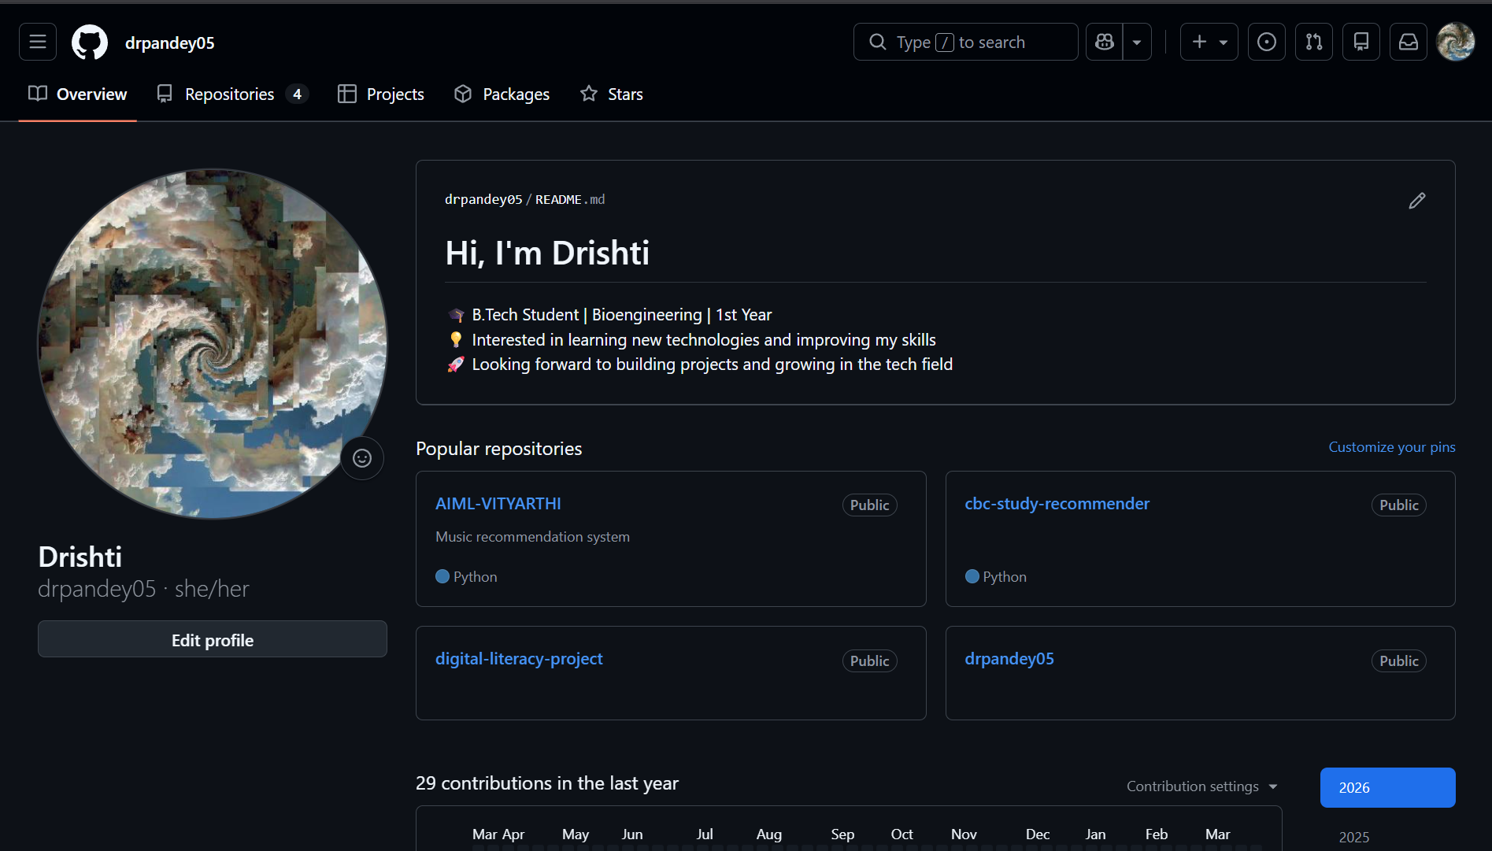
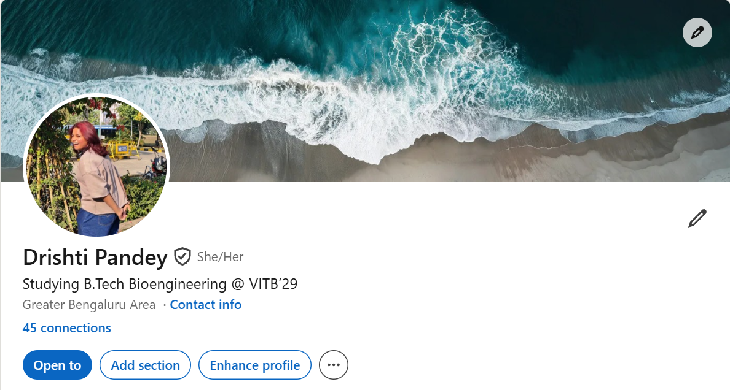
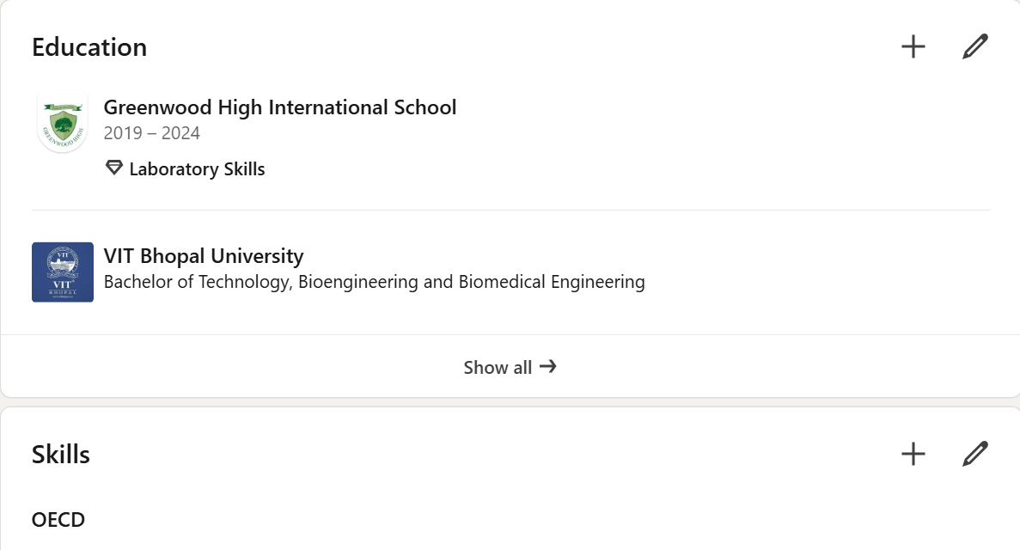
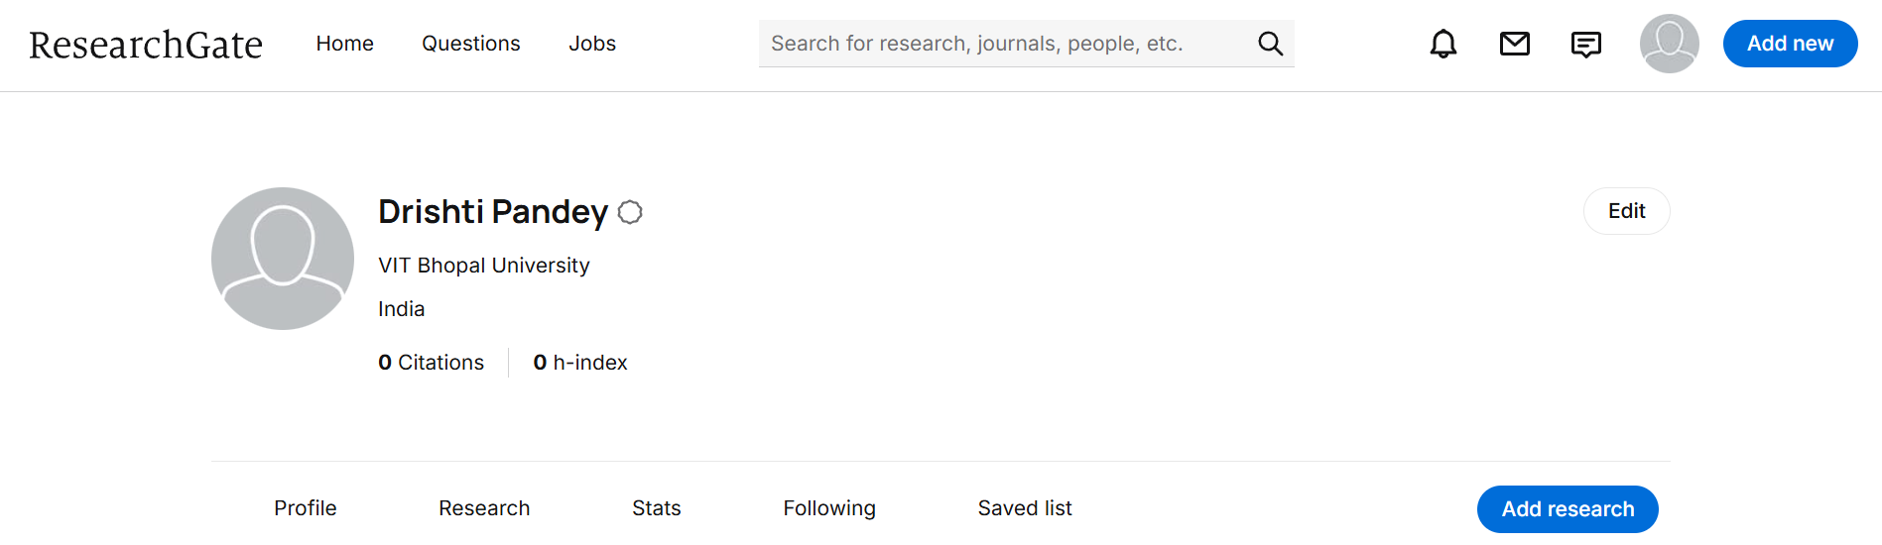

For this task, I created and updated my profiles on GitHub, LinkedIn, and ResearchGate to build a professional digital presence. GitHub is used for sharing and managing coding projects, and I created a profile README to introduce myself and my interests. LinkedIn is a professional networking platform where I added my educational details to begin building my academic and career profile. ResearchGate is a platform for researchers and students to share academic work and explore research in different fields, which I plan to use to gain exposure to research in my domain.
These platforms are important because they help showcase skills, build professional connections, and explore opportunities. Over the next four years, I plan to use GitHub to upload my projects, LinkedIn to connect with professionals and find internships, and ResearchGate to learn about research trends and possibly contribute in the future. This task helped me understand the importance of creating and maintaining a strong digital identity.

