Model: PC-010
RS485 & Counter - Websocket
PCB 140166-03-v4.1
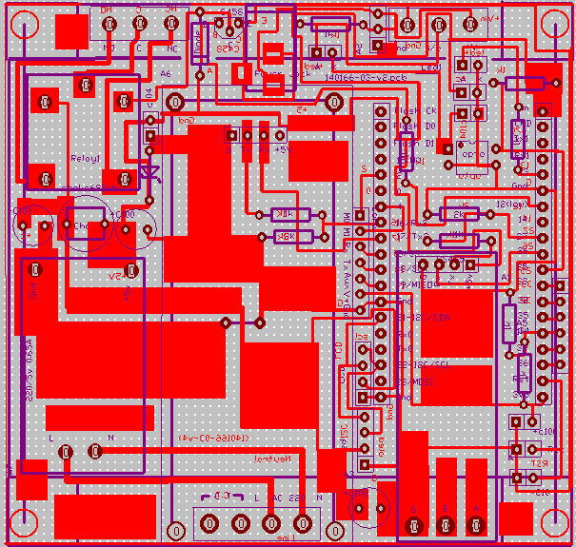
PCB Board
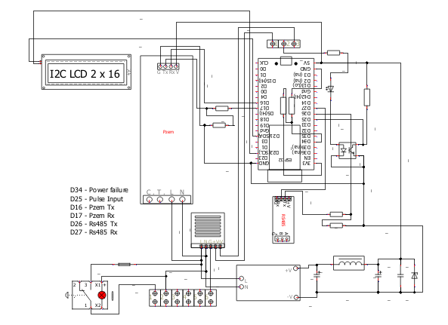
Circuit Diagram

Features:
# ESP32 RS485 Dashboard - Complete Feature Overview

## 🌐 Web Interface Features

### **Dashboard Page** (`/`)
- **Live RS485 Data Display**: 4 sensor values with customizable labels and scaling
- **Pulse Counter Display**: Shows Qty (current), Accm (accumulated), and CPM (pulses per minute)
- **Real-time Updates**: Auto-refresh every 10 seconds
- **Status Indicators**: Connection status and last send status
- **Navigation Links**: Settings, WiFi Setup, and manual send button

### **Settings Page** (`/settings`)
- **Device Configuration**: Device ID, Machine ID, Send interval
- **Remote Server Settings**: Host, RS485 path, Counter path
- **RS485 Parameters**: Slave address, start register, count, baud rate
- **Scaling Factors**: K1-K4 for sensor value calibration
- **Custom Labels**: V1-V4 sensor names (max 6 chars)
- **Pulse Configuration**: Pulse divider (default 10)
- **Dashboard Header**: Customizable page title (max 30 chars)
- **Enable/Disable Controls**:
- Counter Status (Enabled/Disabled)
- RS485 Status (Enabled/Disabled)
- **Counter Reset Buttons**:
- Reset Qty & Accm (both counters)
- Reset Qty Only (current count)
- Reset Accm Only (accumulated total)
- **System Control**: Reboot device button

### **WiFi Setup Page** (`/setup`)
- **AP Mode**: Creates hotspot "ESP32-RS485-Setup" (password: 12345678)
- **Network Scanner**: Shows available WiFi networks
- **Configuration**: SSID, password, static/DHCP IP settings
- **Auto-reboot**: Applies settings and restarts device

## 🔧 Hardware Features

### **RS485 Modbus Communication**
- **Hardware**: UART on GPIO26 (RX) and GPIO27 (TX)
- **Configurable**: Slave address, register range, baud rate
- **Error Handling**: CRC validation, timeout protection, retry logic
- **Debug Output**: Raw hex data for troubleshooting

### **Pulse Counter System**
- **Input**: GPIO25 with 30ms debouncing
- **Counters**:
- `pulse_count`: Total pulses since boot
- `pulse_accm`: Accumulated total (persists)
- `cpm`: Current pulses per minute
- **Interrupt-driven**: Efficient counting using hardware interrupts
- **Power Failure Protection**: Pin 34 with 2k-2k divider saves counters on power loss

### **LCD Display** (I2C 1602)
- **Auto-cycling Pages**:
- Page 0: Time + IP address
- Page 1: RS485 sensor values
- Page 2: Pulse metrics
- **I2C Addresses**: Auto-detects 0x27 or 0x3F
- **Pins**: SCL=GPIO22, SDA=GPIO21

## 📊 Data Management

### **Remote Server Integration**
- **RS485 Data**: `http://host/iot2025/e089/insertM.php?devid=...&v1=...&v2=...&v3=...&v4=...`
- **Pulse Data**: `http://host/iot2025/e089/insert2C.php?devid=...&mcid=...&qty=...&accm=...&cpm=...`
- **Configurable**: Remote host and paths
- **URL Debug**: Prints full URLs before sending

### **Local Data Logging**
- **Pulse Log**: `pulse_log.txt` with 200-record circular buffer
- **Format**: `timestamp,qty,accm` (newest records first)
- **Auto-rotation**: Removes oldest when exceeding 200 records

### **Configuration Persistence**
- **File**: `rs485_device_config.txt` (25 lines)
- **Stores**: All settings, counters, enable/disable states
- **Auto-save**: On settings change, pulse divider reached, power failure
- **Boot Load**: Restores all previous state

## 🔄 Operational Features

### **Pulse Divider System**
- **Function**: Sends data every N pulses (default 10)
- **Auto-reset**: Divider counter resets after send
- **Configurable**: 1-10000 pulses per divider

### **Enable/Disable Controls**
- **Counter Disable**: Stops counting, sending, and logging
- **RS485 Disable**: Stops sensor reading and sending
- **Persistent**: Settings saved across reboots

### **Power Management**
- **Power Failure Detection**: Pin 34 monitors main power
- **Emergency Save**: Immediately saves counters on power loss
- **Graceful Recovery**: Restores state on power return

### **WiFi Management**
- **Dual Mode**: Station mode (client) or AP mode (hotspot)
- **Fallback**: Auto-switches to AP if WiFi fails
- **Static/DHCP**: Configurable IP settings
- **Recovery**: AP mode for initial setup

## 🛠️ Technical Features

### **Error Handling**
- **Network**: Timeout protection, retry logic
- **File I/O**: Exception handling for config operations
- **Hardware**: Pin initialization fallbacks
- **Communication**: CRC validation for RS485

### **Performance**
- **Memory**: Garbage collection every 60 seconds
- **Interrupts**: Deferred processing for pulse counting
- **Non-blocking**: Web server handles multiple clients
- **Efficient**: Minimal CPU usage during idle periods

### **Debug Features**
- **Serial Output**: Detailed status messages
- **URL Logging**: Full request URLs printed
- **Error Codes**: Specific error reporting
- **Status Indicators**: Visual feedback on web interface

## 📱 Mobile Compatibility
- **Responsive Design**: Works on mobile browsers
- **Touch-friendly**: Large buttons and controls
- **Auto-refresh**: Live data updates
- **AP Access**: Direct connection in setup mode

This system provides a complete industrial monitoring solution with pulse counting, sensor data collection, web interface, and robust data persistence - all configurable through a simple web interface.

Web-Server
Dashboard:
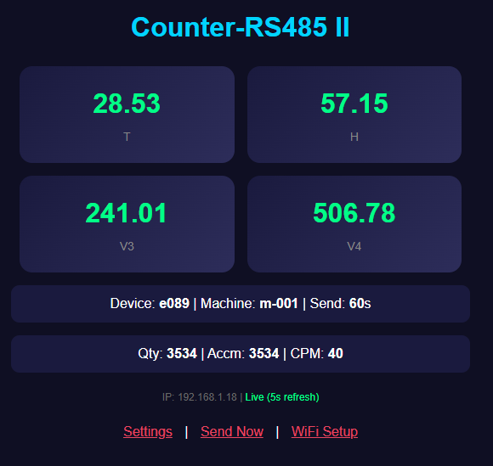

Settings:
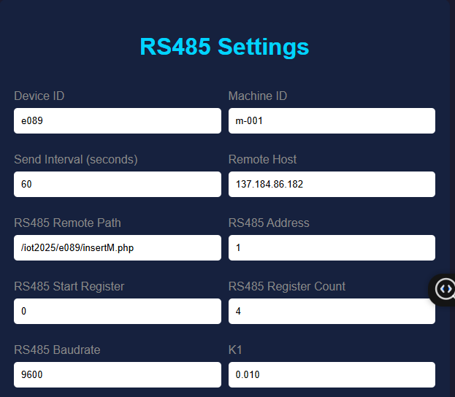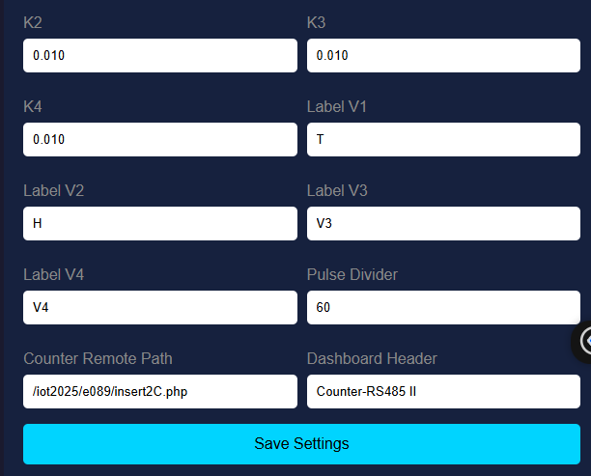
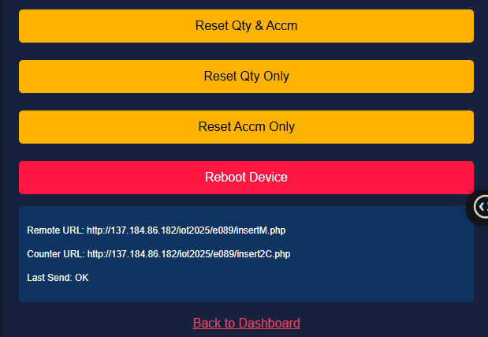

WiFi Setup
