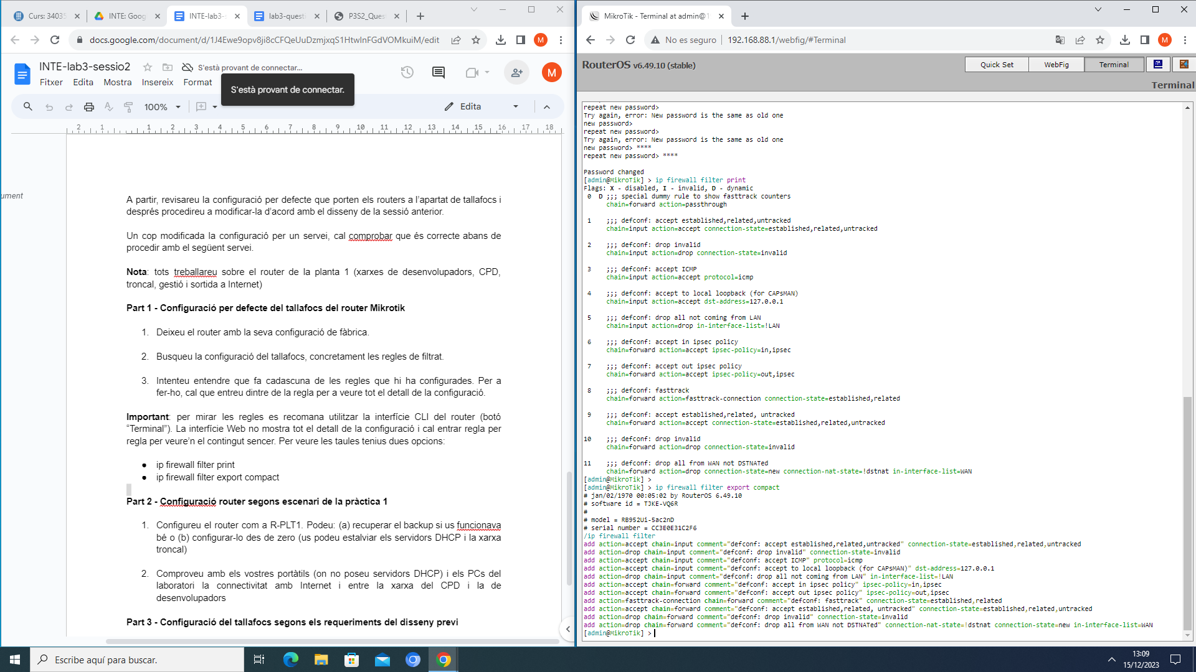

CONFIGURACIÓ DEFAULT:

[admin@MikroTik] > ip firewall filter print

Flags: **X** - disabled, **I** - invalid, **D** - dynamic

0 **D** ;;; special dummy rule to show fasttrack counters

chain=forward action=passthrough

1 ;;; defconf: accept established,related,untracked

chain=input action=accept connection-state=established,related,untracked

2 ;;; defconf: drop invalid

chain=input action=drop connection-state=invalid

3 ;;; defconf: accept ICMP

chain=input action=accept protocol=icmp

4 ;;; defconf: accept to local loopback (for CAPsMAN)

chain=input action=accept dst-address=127.0.0.1

5 ;;; defconf: drop all not coming from LAN

chain=input action=drop in-interface-list=!LAN

6 ;;; defconf: accept in ipsec policy

chain=forward action=accept ipsec-policy=in,ipsec

7 ;;; defconf: accept out ipsec policy

chain=forward action=accept ipsec-policy=out,ipsec

8 ;;; defconf: fasttrack

chain=forward action=fasttrack-connection connection-state=established,related

9 ;;; defconf: accept established,related, untracked

chain=forward action=accept connection-state=established,related,untracked

10 ;;; defconf: drop invalid

chain=forward action=drop connection-state=invalid

11 ;;; defconf: drop all from WAN not DSTNATed

chain=forward action=drop connection-state=new connection-nat-state=!dstnat in-interface-list=WAN

[admin@MikroTik] >

[admin@MikroTik] > ip firewall filter export compact

# jan/02/1970 00:05:02 by RouterOS 6.49.10

# software id = TJKE-VQ6R

#

# model = RB952Ui-5ac2nD

# serial number = CC3E0E31C2F6

/ip firewall filter

add action=accept **chain**=input comment="defconf: accept established,related,untracked" connection-state=established,related,untracked

add action=drop **chain**=input comment="defconf: drop invalid" connection-state=invalid

add action=accept **chain**=input comment="defconf: accept ICMP" protocol=icmp

add action=accept **chain**=input comment="defconf: accept to local loopback (for CAPsMAN)" dst-address=127.0.0.1

add action=drop **chain**=input comment="defconf: drop all not coming from LAN" in-interface-list=!LAN

add action=accept **chain**=forward comment="defconf: accept in ipsec policy" ipsec-policy=in,ipsec

add action=accept **chain**=forward comment="defconf: accept out ipsec policy" ipsec-policy=out,ipsec

add action=fasttrack-connection **chain**=forward comment="defconf: fasttrack" connection-state=established,related

add action=accept **chain**=forward comment="defconf: accept established,related, untracked" connection-state=established,related,untracked

add action=drop **chain**=forward comment="defconf: drop invalid" connection-state=invalid

add action=drop **chain**=forward comment="defconf: drop all from WAN not DSTNATed" connection-nat-state=!dstnat connection-state=new in-interface-list=WAN

TRIAR SUBXARXA DEV: 10.1.1.0/25

Broadcast: 10.1.1.127

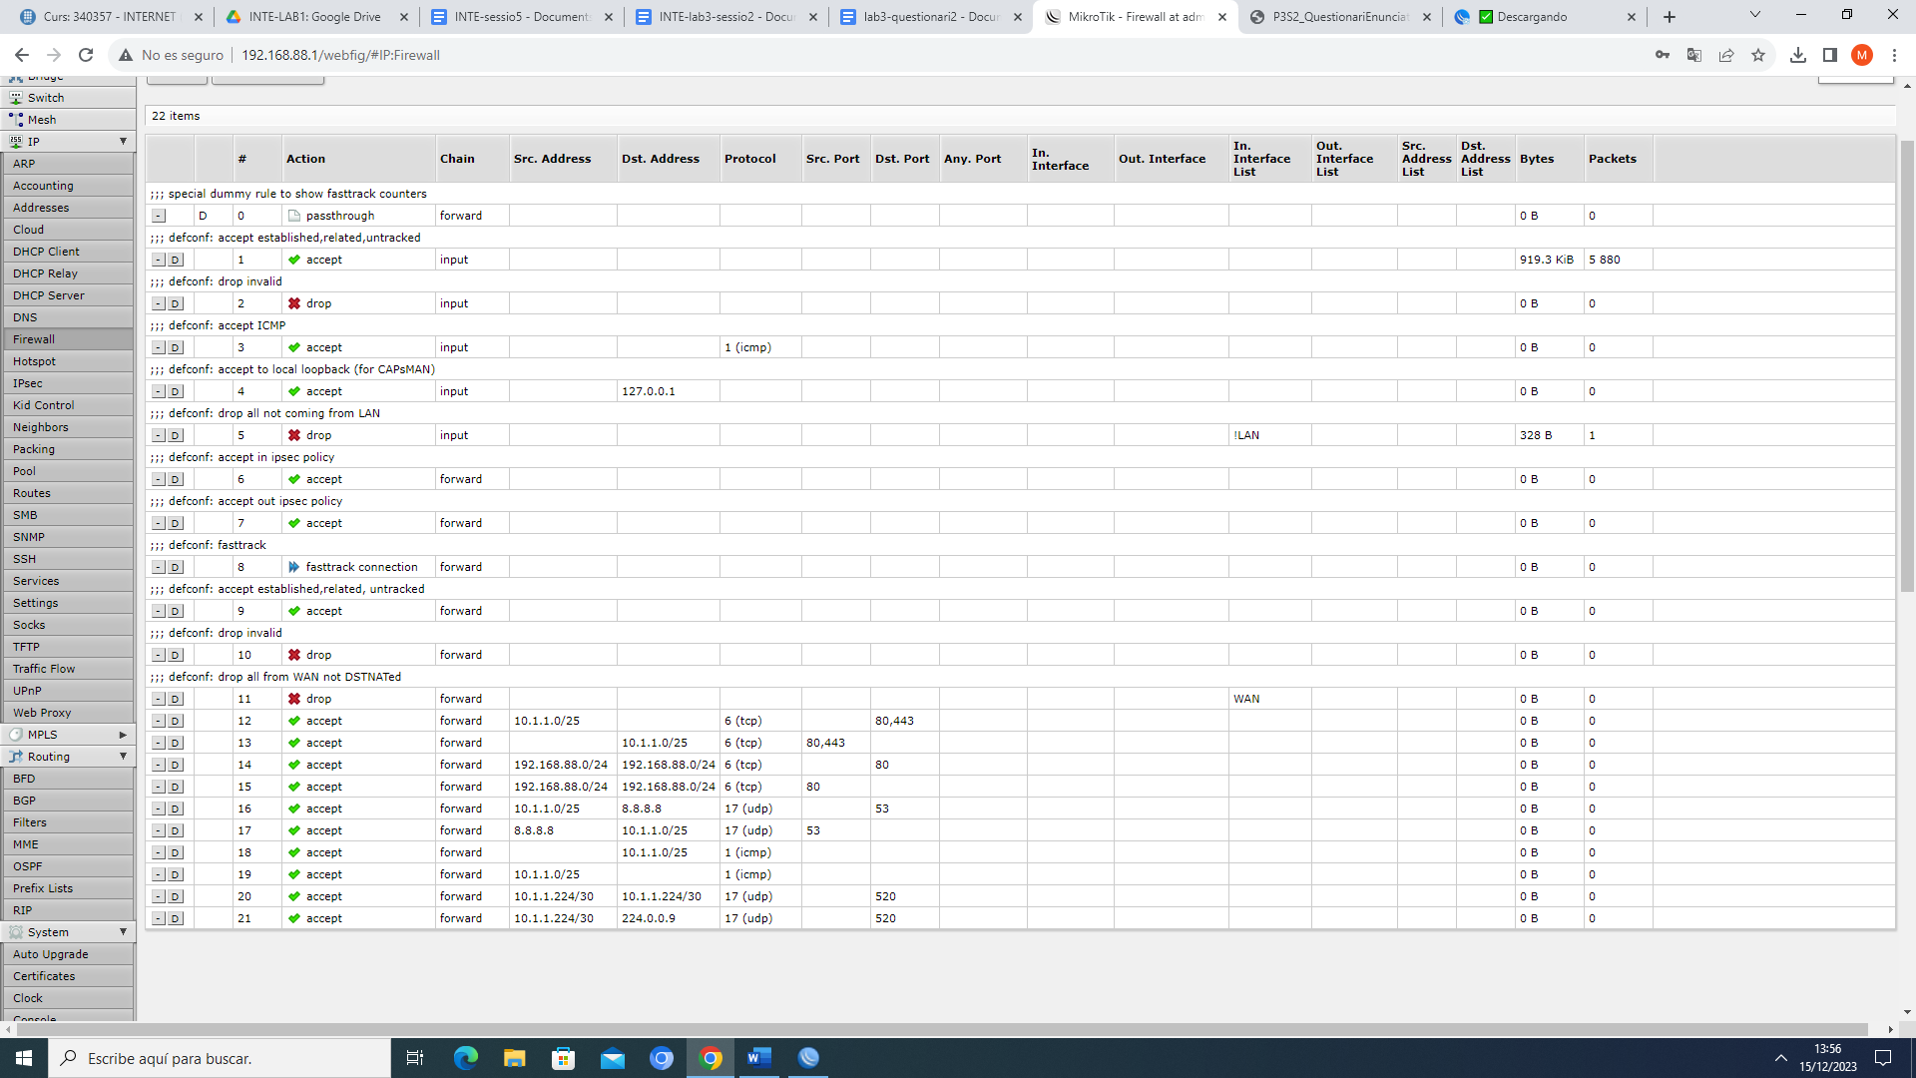

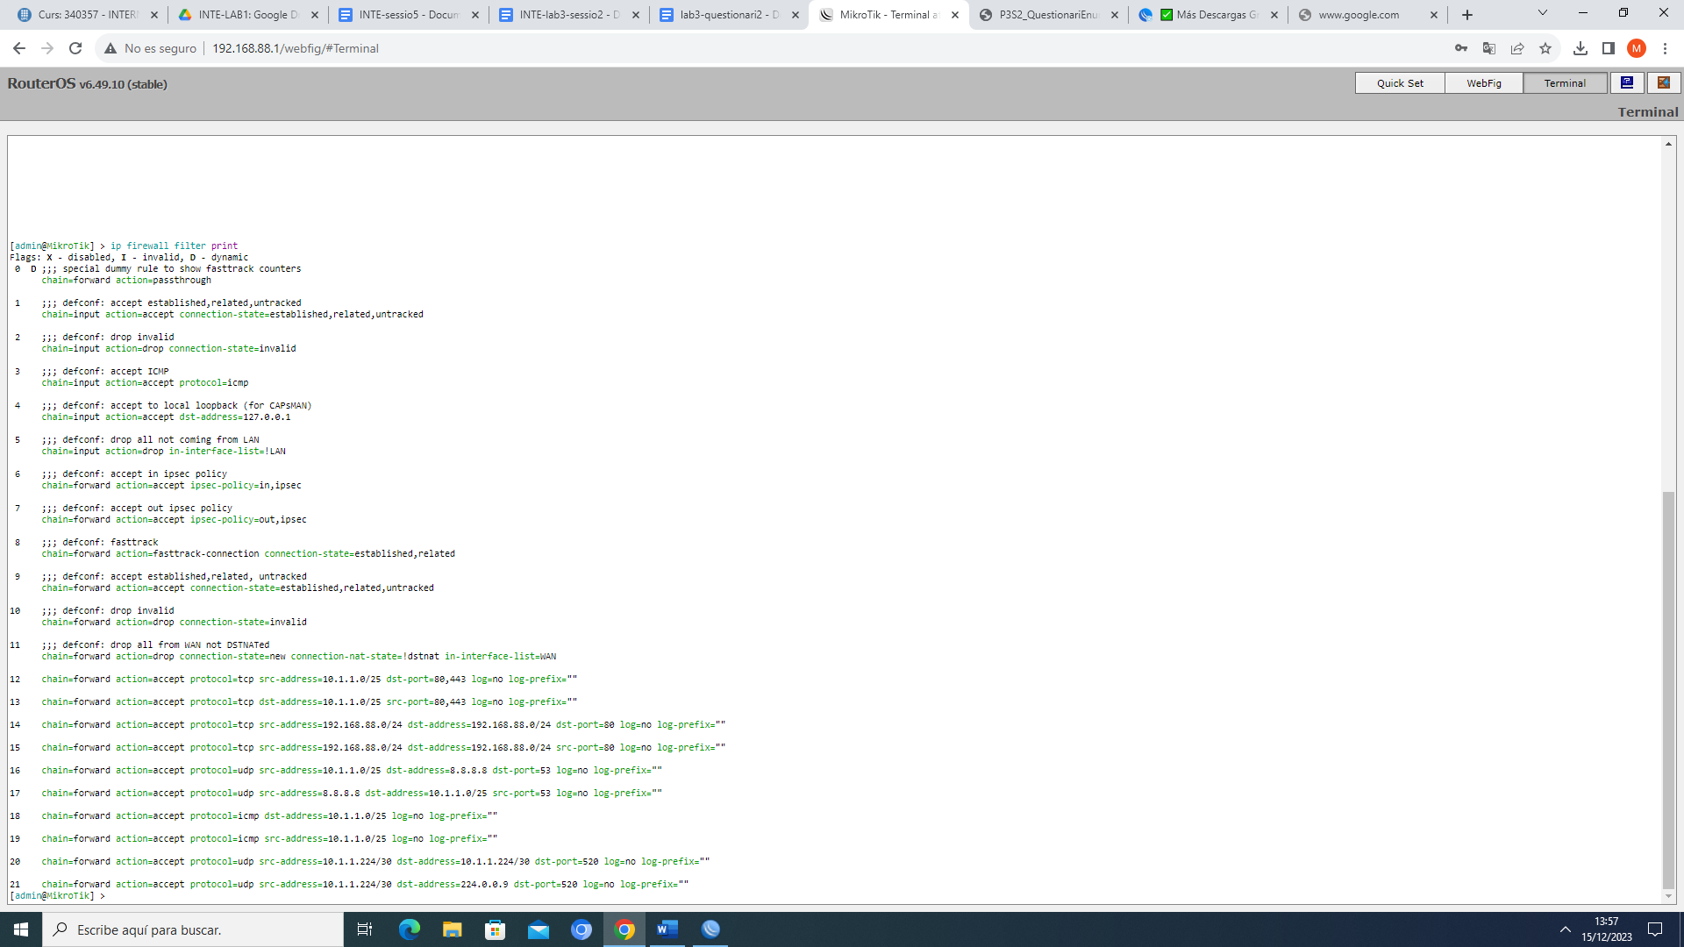

[admin@MikroTik] > ip firewall filter print

Flags: **X** - disabled, **I** - invalid, **D** - dynamic

0 **D** ;;; special dummy rule to show fasttrack counters

chain=forward action=passthrough

1 ;;; defconf: accept established,related,untracked

chain=input action=accept connection-state=established,related,untracked

2 ;;; defconf: drop invalid

chain=input action=drop connection-state=invalid

3 ;;; defconf: accept ICMP

chain=input action=accept protocol=icmp

4 ;;; defconf: accept to local loopback (for CAPsMAN)

chain=input action=accept dst-address=127.0.0.1

5 ;;; defconf: drop all not coming from LAN

chain=input action=drop in-interface-list=!LAN

6 ;;; defconf: accept in ipsec policy

chain=forward action=accept ipsec-policy=in,ipsec

7 ;;; defconf: accept out ipsec policy

chain=forward action=accept ipsec-policy=out,ipsec

8 ;;; defconf: fasttrack

chain=forward action=fasttrack-connection connection-state=established,related

9 ;;; defconf: accept established,related, untracked

chain=forward action=accept connection-state=established,related,untracked

10 ;;; defconf: drop invalid

chain=forward action=drop connection-state=invalid

11 ;;; defconf: drop all from WAN not DSTNATed

chain=forward action=drop connection-state=new connection-nat-state=!dstnat in-interface-list=WAN

12 chain=forward action=accept protocol=tcp src-address=10.1.1.0/25 dst-port=80,443 log=no log-prefix=""

13 chain=forward action=accept protocol=tcp dst-address=10.1.1.0/25 src-port=80,443 log=no log-prefix=""

14 chain=forward action=accept protocol=tcp src-address=192.168.88.0/24 dst-address=192.168.88.0/24 dst-port=80 log=no log-prefix=""

15 chain=forward action=accept protocol=tcp src-address=192.168.88.0/24 dst-address=192.168.88.0/24 src-port=80 log=no log-prefix=""

16 chain=forward action=accept protocol=udp src-address=10.1.1.0/25 dst-address=8.8.8.8 dst-port=53 log=no log-prefix=""

17 chain=forward action=accept protocol=udp src-address=8.8.8.8 dst-address=10.1.1.0/25 src-port=53 log=no log-prefix=""

18 chain=forward action=accept protocol=icmp dst-address=10.1.1.0/25 log=no log-prefix=""

19 chain=forward action=accept protocol=icmp src-address=10.1.1.0/25 log=no log-prefix=""

20 chain=forward action=accept protocol=udp src-address=10.1.1.224/30 dst-address=10.1.1.224/30 dst-port=520 log=no log-prefix=""

21 chain=forward action=accept protocol=udp src-address=10.1.1.224/30 dst-address=224.0.0.9 dst-port=520 log=no log-prefix=""

PING GOOGLE:

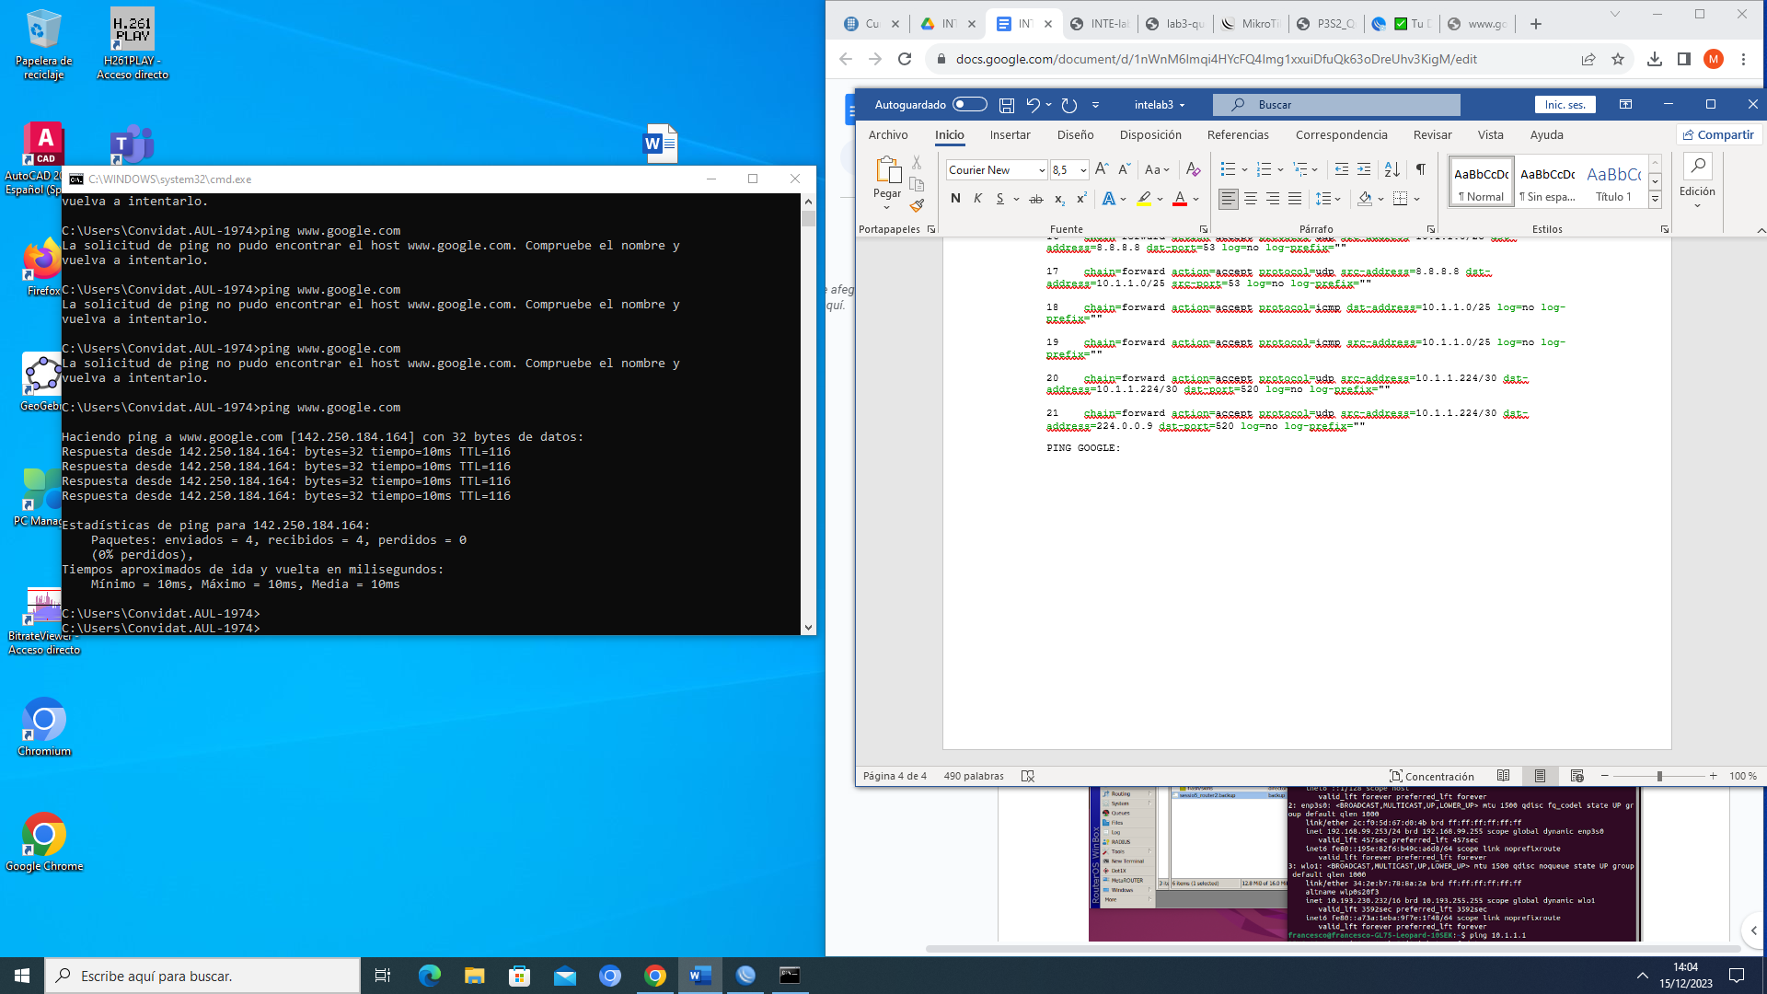

COMPROVACIÓ WEB:

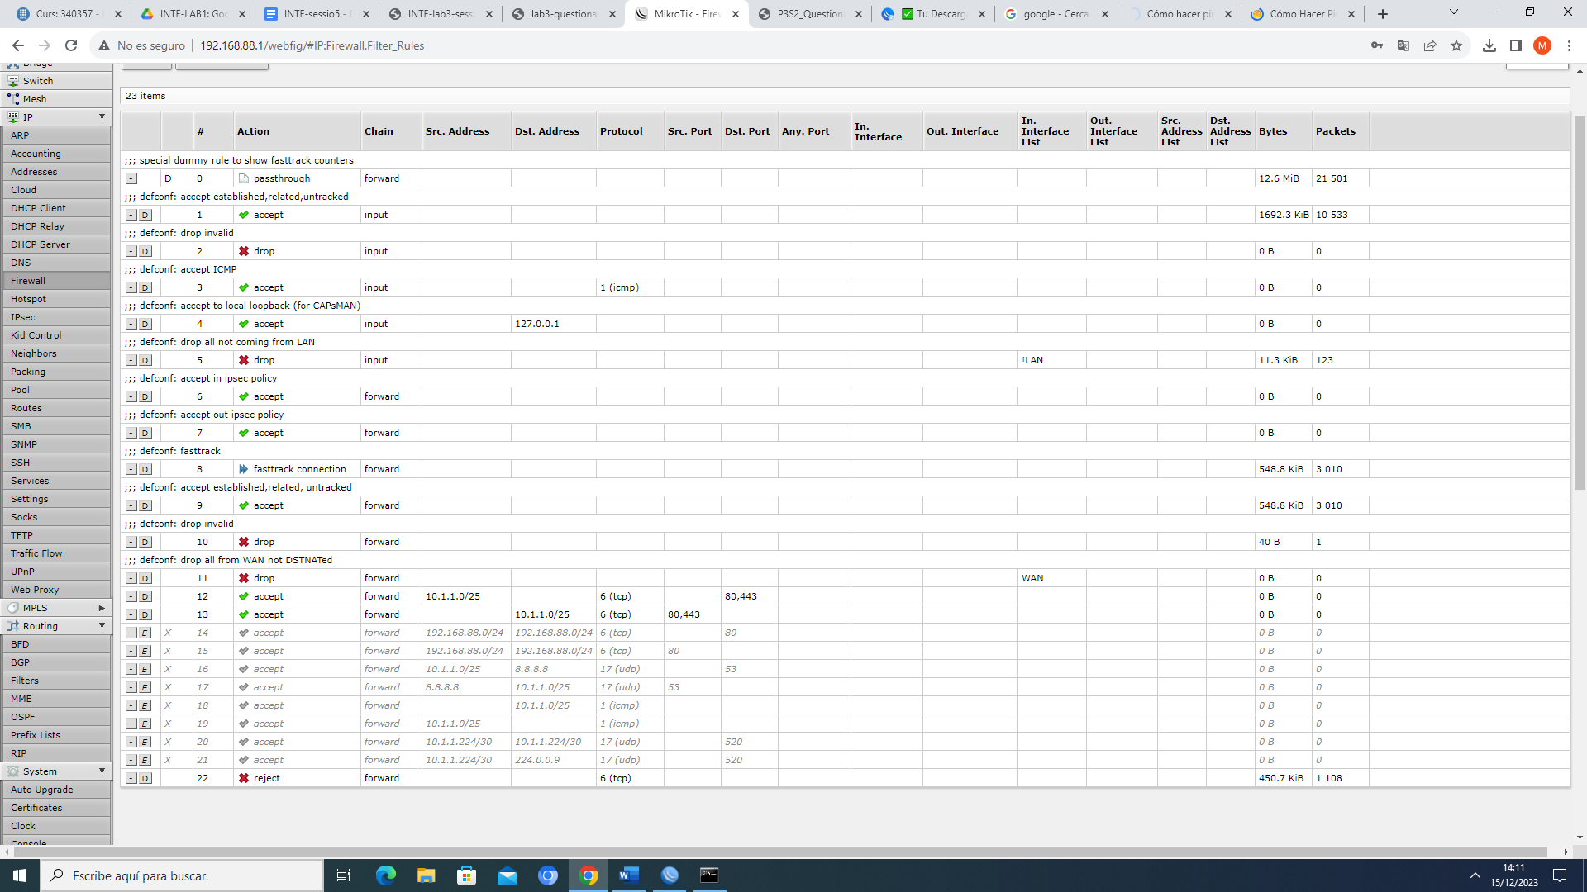

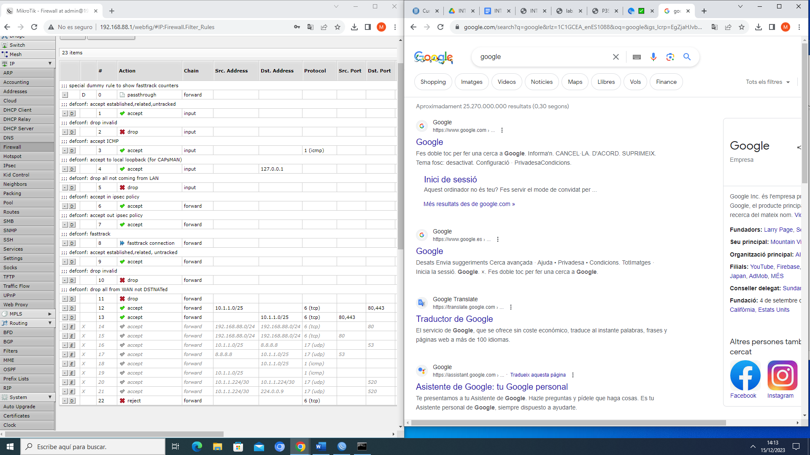

Ens podem conectar a la web i navegar sense problema

COMPROVACIÓ DNS:

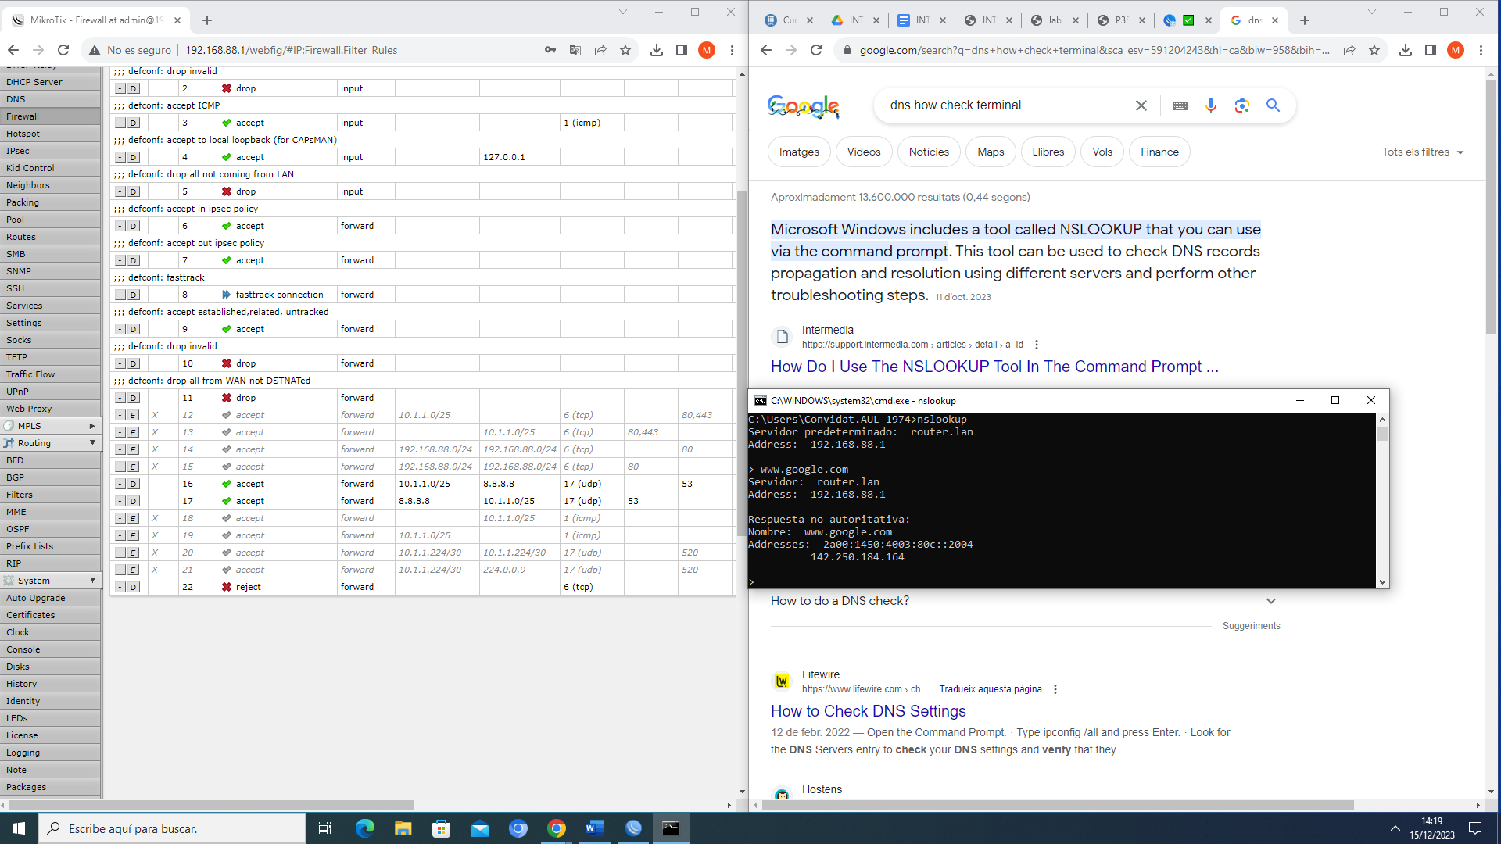

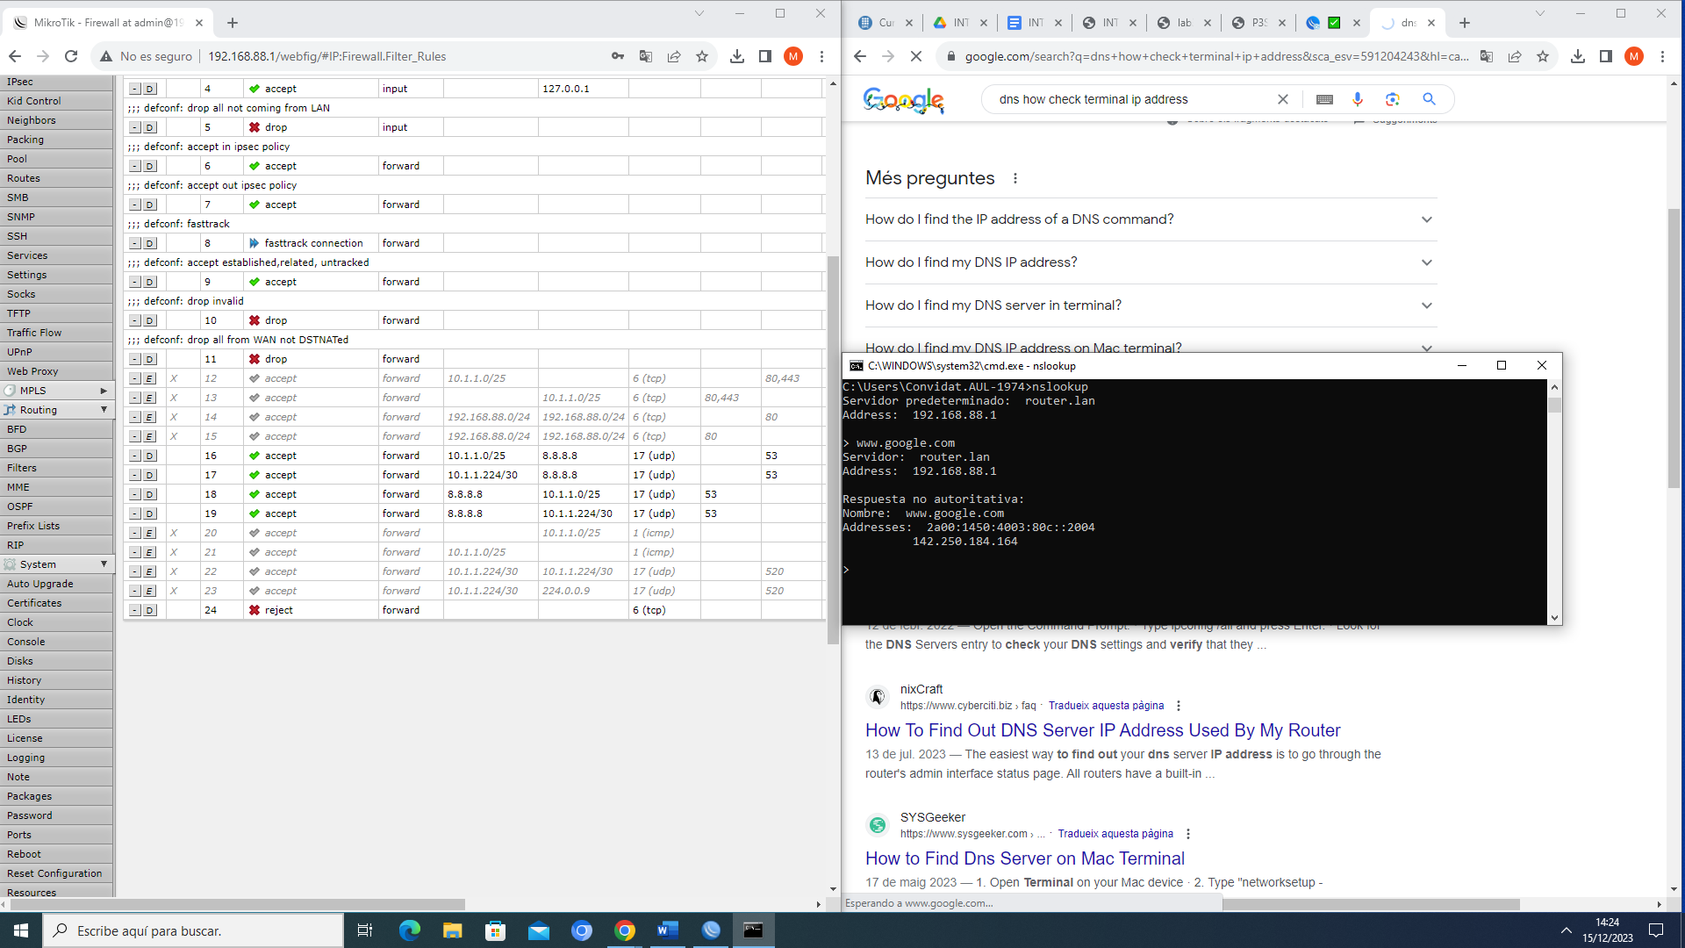

COMPROVACIÓ PING:

