**1. Introduction**

**2. Sampling time**

*2.1. Quantum simulation*

Boson-sampling is a process in which *n* indistinguishable photons are injected into an *m*-mode linear optical interferometer *U* (i.e beamsplitters and phase-shifters), and then detected at output ports using photodetectors, as shown in Fig. 1 [2]. Choosing the mode occupation-number configurations as the basis states, the input state can be written as a list of occupation numbers, where  is the number of photons in the *i*th input mode. As photon-number is preserved via linear optics transformations, the output state can be denoted in the same basis, but a superposition of all different output configurations , where , and with each basis state satisfying . We define  as the set of all photon-number configuration basis vectors. It is not hard to prove that the total number of elements in  is . The amplitude associated with each output basis is given by [2, 12]

 (1)

, where  is a homomorphism of the unitary matrix of , and  is an  submatrix of , obtained by taking  copies of the *i*th row of , and  copies of the *j*th column of . It has been proved that [2, 13, 14] one will observe a collision (i.e. two or more photons in the same mode) with probability bounded away from 0 only if the number of modes scales as at least  - the so-called ‘bosonic birthday paradox’ **(CITE)**. In this instance, it suffices to use non-photon-number-resolving detectors, substantially simplifying technological requirements. Thus, throughout this paper we only discuss the “collision-free” situation, i.e. .

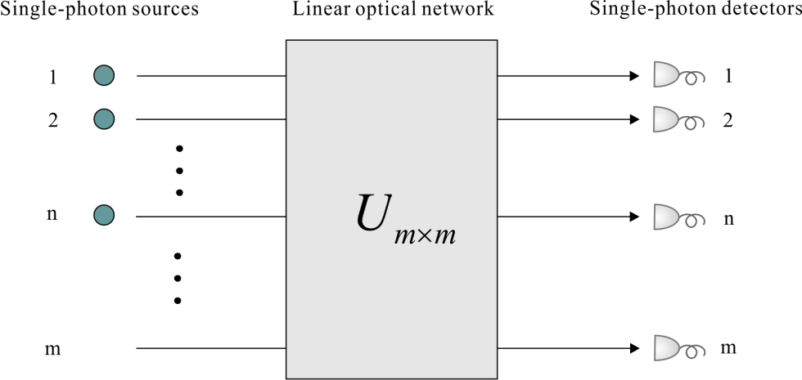

**Figure 1.** The boson-sampling model: *n* single photons are injected into an *m*-mode passive linear optical network. The output statistics are then sampled via *m*-fold coincidence measurements.

Consider the practical situation, where we have an imperfect photonic simulator to implement boson-sampling, whose net per-photon efficiency is , combining the single-photon generation rate, circuit transmission efficiency, and coupling and detection efficiency. The time required to obtain an *n*-photon coincidence event is

 (2)

, where *F* is the effective repetition rate of the quantum boson-sampler, restricted by the choice of single photon source (SPS), the experimental architecture, and the dead time of the detectors.

*2.2. Classical simulation*

How can a classical computer simulate this bosonic process, and sample from its exact or approximate probability distribution? A naïve brute-force method is to calculate all  permanents of the set of submatrices , thereby determining the probability distribution, and the sample from this known distribution. **However, neither does the boson-sampler know even the approximate probability distribution before enough samples are obtained.** Smarter classical algorithms exist to generate correct samples without knowing the entire underlying distribution. For example, using the acceptance-rejection method [15] one can sample an output configuration  uniformly from the configuration space and a number *u* from the uniform distribution over 0-1, then calculate the permanent of related submatrices and compare its value to *u*; If **, we accept the sample ; If not, it is rejected, and we repeat. Such methods could be successful with probability . One sample only requires calculating one permanent, significantly better than the brute-force method.**

The permanent is a matrix function originating from the permutation symmetry of bosons, similar to the role of determinants fermions. Naïve calculation of the permanent of an  matrix requires n! operations. However, a more efficient classical algorithm was invented by Ryser [16] in 1963, which requires  **(MAKE N+1->N)** operations, which is nonetheless exponential. No general polynomial-time algorithms have been described, in contrast to the clever Gaussian elimination method for calculate matrix determinants. In fact, calculating the permanent was proved to be #P-complete in 1979 by Valiant [17]. A more intuitive understanding is that the permanent corresponds to counting the number of different matching ways between input state and output state through the interferometer, much like adding Feynman paths **(CITE)** to determine quantum amplitudes.

Consequently, for a classical simulator, the time required to acquire a sample using this approach is

 (3)

**(ADD approx.)** , where  is the inverse of floating-point operations per second (FLOPS) of classical computer. **(JUST DIVIDE BY FLOPS INSTEAD OF USING INVERSE)**

*2.3. Threshold*

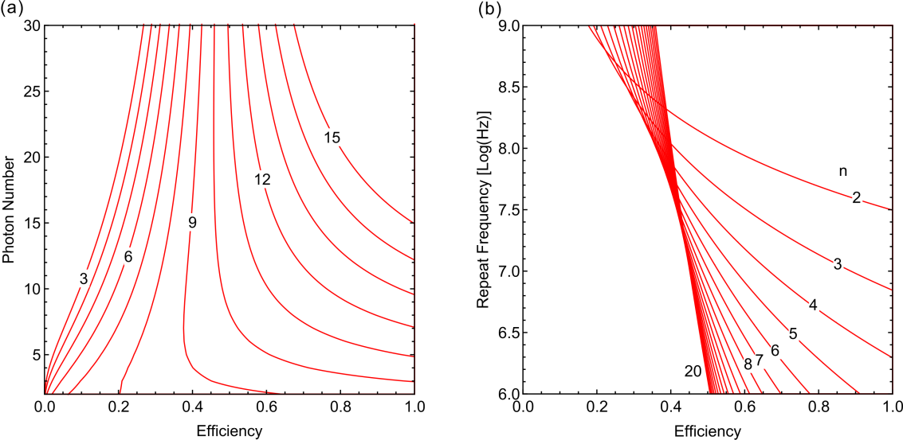

**Figure 2.** The quantum and classical supremacy of (spatially-encoded) boson-sampling is divided by the red lines, where the top right side belongs to the quantum supremeacy and vice versa. The efficiency denoted on the horizontal axis is the overall system efficiency. (a) *F*=76 MHz. The numbers 3, 6, *etc.* in the lines refer to FLOPS, FLOPS *etc.* of the classical simulator. (b) . The numbers 2, 3, *etc.* in the lines denote photon-number.

Comparing the requisite times, we plot the critical photon-number as a function of efficiency  for the quantum boson-sampler to beat its classical classical counterpart, as shown in figure 2(a). The right part of each line is the area of quantum supremacy. For a given photon efficiency, with increasing *n*, the quantum simulator’s superiority becomes more prominent. Thus, scaling the size of boson-sampling is essential to achieving quantum supremacy. But there is an upper limit. Taking  as an example, it is impossible to reach quantum supremacy for a classical computer of petaFLOPS by only enlarging the number of single photons. A more convenient way is increasing the efficiency of the quantum system. As the efficiency increases, the minimum photon-number required to achieve quantum supremacy decreases.

The repetition rate *F* is another important factor affecting the performance of quantum simulators that we must consider in a practical experiment. If  is taken as the post-selection success probability of a single trial, then **(ETA^N*A)** indicates how many successful runs we can implement per second. For example, to beat a gigaFLOPS classical computer, four-photon boson-sampling with *F*= 76 MHz **(F vs A)** is sufficient if the total efficiency is **eta=**0.4. As shown in figure 2(b), however,  and  is enough if the repetition rate increases to 1 GHz. In other words, by increasing the repetition rate, the efficiency and photon-number requirements are relaxed. However, we cannot increase the repetition rate indefinitely. It is restricted by the pulse rate of SPS, experimental architecture, and dead-time of the detectors. In the next section we discuss the impact of the choice of experimental architecture.

Here we must point out two things. First, Ryser’s algorithm is actually not faster than using the **original formula** to calculate the matrix permanent when photon number is small (). Thus the above conditions may be not tight. For example, the efficiency must be larger than ~0.6 if two- (four)-photon boson-sampling with a repetition rate of 1 GHz (76 MHz) is expected to beat a gigaFLOPS classical computer. Furthermore, why should we still scale up to more photons () even though fewer photons boson-sampling could beat current prevailing personal computers. One reason is that no finite experiment can make a decisive conclusion on the ECT, since it is a conjecture about the asymptotic limit. In the field of computational complexity, the significance of boson-sampling rests largely on its exponentially faster sampling speed than that of classical simulators**, rather than certain times of specific triumphs in the competitions between quantum and classical computers**. The other cause is that people have not physically construted relatively large multi-photon interferometers yet. The theory of boson-sampling still faces the risk of failure and quantum devices may break down for more photons.

**3. Experimental schemes**

*3.1. Space-encoding circuit*

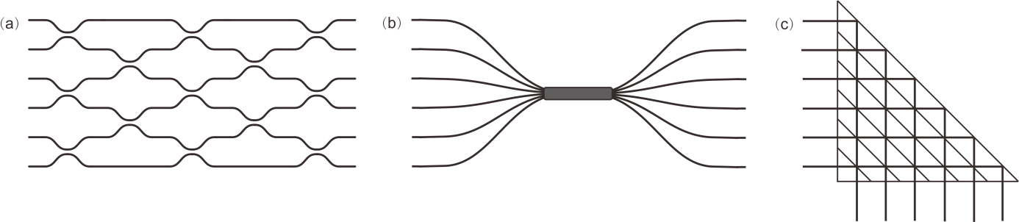

**Figure 3.** Space-encoding circuit: optical waveguide (a), fused fibre coupler (b) and bulk optical circuit (c).

*3.2. Time-encoding circuit*

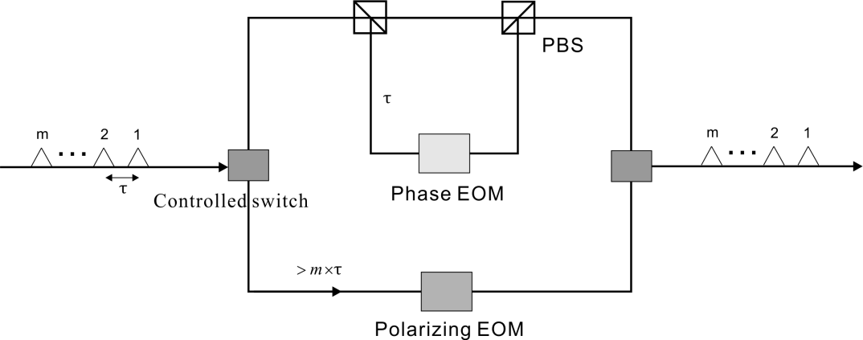

**Figure 4.** The time-bin scheme [11, 19] consists of a length  inner delay-line embedded inside a length  outer delay-line. A pulse-train of photonic modes, each separated by time , is injected into the complete fibre-loop architecture.

An alternative **(WHY ALTERNATIVE?)** scheme fully employs time-bin encoding to construct thr interferometer network, which was proposed [19] in 2014 and firstly demonstrated [11] in 2016. The main idea is utilizing the temporal resource, mapping the linear optical circuit on temporal freedom. This scheme has fixed experimental complexity and only needs one SPS, one detector and one dynamic beam splitter, which makes it much easier to align the experimental setup.

In this design, a sequence of single photons is injected and interference with one other through the time delay and fibre beamsplitter. As in figure 4, a small fibre loop of round-trip time  acts as the time delay, where the node is a dynamic beam splitter for interference. The small loop is embedded in a large fibre loop of travelling time , which is used to return the “photon-train” back for next round of interference. These two embedding fibre loops together fully construct the interference network that encodes only in the temporal degree of freedom. According to Reck’s result, one needs  beamsplitters to construct an arbitrary  interferometer. For a “photon-train” with *m* time bins, the beamsplitter works *m* times in each round trip. So *m* round trips are required to implement an arbitrary  unitary transformation. After *m* loops of evolution, the photons are all coupled out of the loop for time-resolved coincidence measurements.

As described above, the circuit itself consumes time resources , thus the effective repetition rate is , where  is the repetition frequency of the photon pulse. We use it to replace *F* in equation (2) and get

. (4)

Comparing  with  and following the same way for original boson-sampling in section 2, we plot the critical photon-number to reach quantum supremacy as a function of  for the time-bin encoding scheme.

We see that the boundary lines in figure 6 move to the right relative to figure 2(a), in the case of utilizing spatial encoding. For example, to beat a classical computer of gigaFLOPS, the minimum required photon number increases to 9 if we employ time-bin encoding. This is because, for temporal encoding, there is only one spatial mode so that all the  operations to realize a unitary transformation can only be extended in the temporal degree of freedom Thus, its scalability is forced to be more dependent on the repetition rate of the SPS and the dead-time of the single photon detector.

*3.3. Hybrid-encoding circuit*

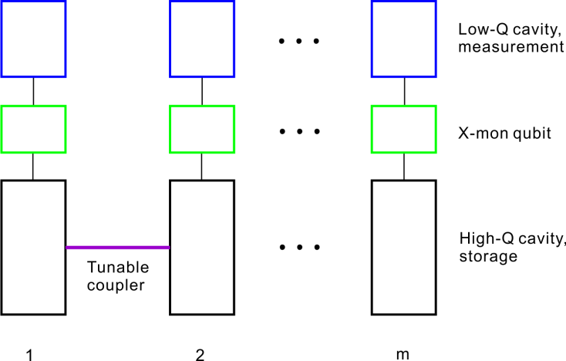

**Figure 5.** Hybrid-encoding (microwave) boson-sampling proposed in [20]. The X-mon qubit is capacitively coupled to the storage and measurement cavities. The tunable coupler between adjacent storage cavities is a superconducting ring intersected by a Josephson junction.

## The unitary network can also be treated as encoding in a hybrid scheme – partially spatial and partially temporal. Recently, Peropadre *et al.* [20] proposed such a hybrid scheme based on a superconducting device, named ‘microwave boson-sampling’. They pointed out that, the three fundamental steps of boson-sampling, i.e. preparation of single photon state, unitary transformation and detection, can all be realized on microwave photons with high fidelity (as shown in figure 5). For *m*-mode boson-sampling, one needs *m* storage resonators in total, where microwave photons are produced and stored. And between every pair of adjacent storage resonators there is a superconducting ring to tune the coupling. Each storage resonator has a corresponding X-mon qubit which plays an essential role in preparation, phase shift and measurement. At the other side of the X-mon qubit, a low-Q (measurement) resonator is coupled to implement non-demolition measurement.

Compared to fabricating a unitary network in waveguides, the spatial degree of freedom in the transverse axis is retained as there are *m* storage resonators and auxiliary qubits in microwave boson-sampling. But the longitudinal spatial modes are replaced by *m* controlled temporal steps. Supposed a single step including a beam splitter operation and phase-shifting operation takes time , so the total operational time for a unitary transformation is . Taking the reciprocal of the total operational time as the effective repeat frequency, we obtain the formula for  for this scheme. Comparing it with , we plot the supremacy boundary for microwave boson-sampling.

From the point of encoding scheme, the sampling speed (unitary transformation) of microwave boson-sampler is much slower than that of space-encoding boson-sampler. As showed in figure 6, to beat the same advanced classical computer, we actually need higher system efficiency or a larger number of photons if microwave scheme is exploited. However, the advantage of superconducting platform exactly lies in its marvelously high fidelities (>0.90) of generation and measurement process [21] to which no ordinary optical boson-sampler is comparable. Though with high processing speed, the effective repeat frequency of space-encoding optical boson-sampler is greatly dragged down by post-selection due to the limited collection and detection efficiency.

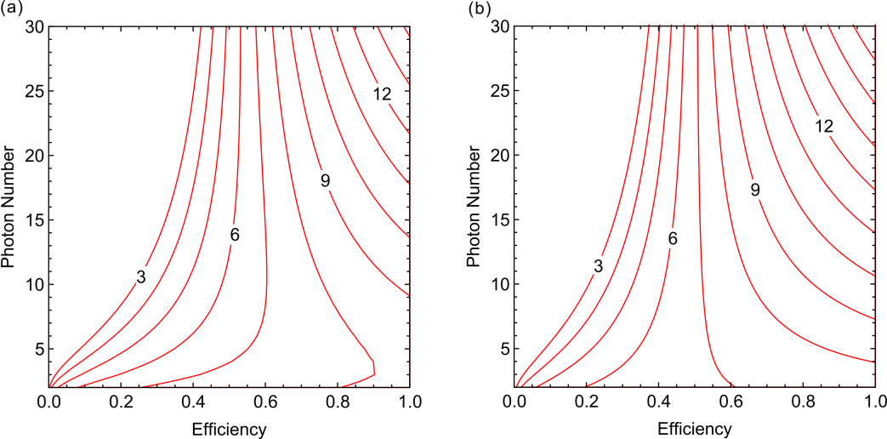

**Figure 6.** The quantum and classical supremacy of (a) temporal-encoding and (b) hybrid-encoding boson-sampling is divided by the red line, where the top right side where quantum supremacy is in the upper right, and vice versa. The numbers 3, 6, *etc.* in the line refer to FLOPS, FLOPS *etc.* of classical computers respectively. The efficiency denoted on the horizontal axis is the overall system efficiency. Given the magnitude of the coupling strength, a single step including a beam splitter operation and phase-shifting operation takes [20]. Effective repeat frequency (a) *F*=, (b) *F*=.

*3.4. Lossy boson-sampling*

In the real-world boson-sampling experiment, photons unavoidably undergo some losses and errors, making it sample from an approximate distribution rather than the exact distribution. As boson-sampling only comprises passive optical elements, it is not universal and there are no known fault tolerance or error-correction schemes. From the beginning, Aaronson and Arkhipov [2] have already noted this problem. And in their original paper introducing boson-sampling, they proved that boson-sampling is classically hard even if sampling from an approximate distribution with multiplicative error. Furthermore, several follow-up works have discussed the effect of realistic experimental imperfections in more detail, such as losses [22], mode-mismatch due to calibration errors within the linear optical network [23, 24], and photon distinguishability [25, 26, 27, 28, 29, 30]. It was shown that the hardness remains in the same complexity when the average fidelity per each optical element of the unitary network is of . In the presence of small degrees of photon distinguishability, the probability of each output event is likely to be relevant to the immanent, a more general matrix function than permanents and determinants, conjectured to be as computationally hard as the permanent in general [31, 32]. To deal with photon loss due to sub-unity transmittance of the circuit and detection inefficiency, post selection which discards the case with lost photons is usually adopted in experiment. However, assuming that on average each photon has a constant probability to finally trigger a detector at the output, the experimental runtime overhead arising from post-selection will increase exponentially with number of photons in the system.

Recently, Aaronson and Brod demonstrated that [33] if a constant number of photons was lost at the input (i.e. *k* out of *n*+*k*), the probability of each output configuration is given by

 (5)

And it was proved that calculating Per(*T*) **(change to Pr(T))** is as least as hard as calculating the permanent of a  submatrix of a  Harr-random matrix. Let us introduce a modification of  and  in the context of boson-sampling with lost photons. The average sampling interval  is obtained by replacing the probability of detecting *n* photons coincidence  in equation (2) with the following form:

 (6)

, where *n* is the photon number after loss, and *nlost* is the number of lost photons. So we have

 (7)

Because the Theorem 1 in [33] states that boson-sampling with a constant number of lost photons is (at least) as hard as the original boson-sampling. For a classical simulator,  in equation (2) can still be applied to boson-sampling with lost photons whose photon number after loss is *n*. **(I don’t understand this. The number of lost photons needs to be constant, not scaling with n)**

Provided the repeat frequency of the quantum system is 76 MHz and the clock speed of the classical computer is 1GHz, we plot the minimum required photon number after loss to achieve quantum supremacy against the increasing total efficiency of the quantum boson-sampler in figure 7.

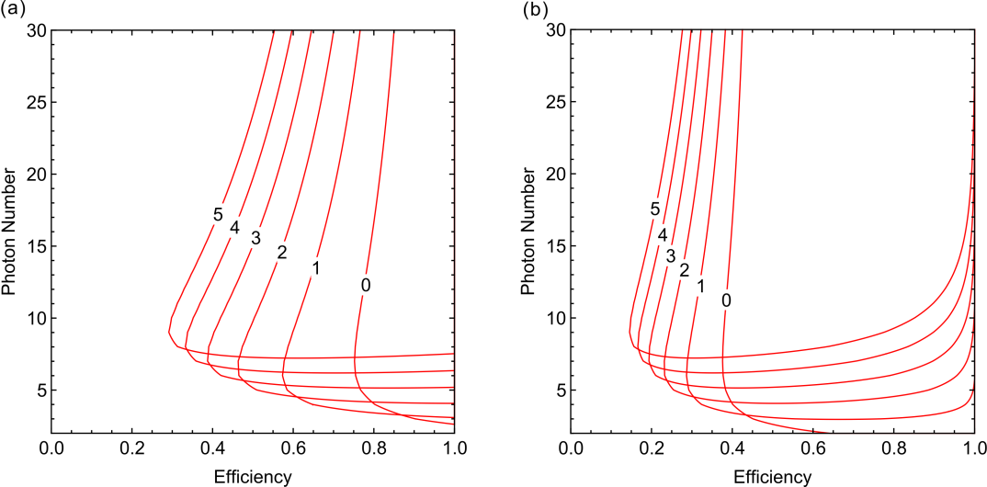

**Figure 7.** The quantum and classical supremacy of boson-sampling with lost photons is divided by the red line, where the top right side corresponds to the quantum regime and vice versa. Here the clock speed of the classical computer is Giga FLOPS i.e. FLOPS. The efficiency denoted on the horizontal axis is the overall system efficiency. The number 0, 1, 2 *etc.* in the line actually refer to the number of lost photons . The detecting efficiency: (a), (b) . **(Why does the curve have the change in direction?)**

From right to left, the lines respectively refer to no lost photons, one lost photon, and so on. It is shown that when the efficiency is lower than ~0.4, theoretically, a quantum sampler implementing standard boson-sampling cannot win the game no matter how large it scales in size. However, by employing the scheme of boson-sampling with lost photons, a quantum sampler of ~0.3 total efficiency can beat the classical competitor if 5 photons remain after loss and another extra photon was injected but lost. Our result agrees with Rohde’s theory [22] that quantum superiority can be retained by injecting extra photons to compensate for loss in the quantum device.

*3.5. Scattershot boson-sampling*

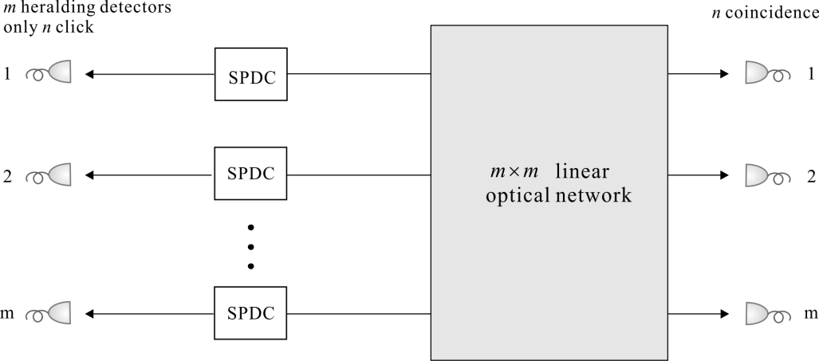

**Figure 8**. The scheme for scattershot boson-sampling [35, 36]. For a  mode interferometer, there are *m* pairs of SPDCs, of which only *n* generate single photons at a time.

The brightness of  photons will decay exponentially as  if each SPS has efficiency *p*. For the current mature heralded SPS based on the process of spontaneous parametric down-conversion (SPDC), one solution is to introduce more SPDC sources and make *p* approach unity by the technique of multiplexing [34]. For boson-sampling, there is an even simpler method known as scattershot boson-sampling (SBS) [35, 36], which allows us to an identical hard task without deterministic SPSs or multiplexers. The core idea is to run *m* SPDCs simultaneously, and post-select the instance that *n* heralded detectors are triggered regardless of which detectors click. SBS seems something of a “double sampling” problem, which can be decomposed into a uniform sampling at the input state, followed by ordinary boson-sampling. But each single sample is an instance of original boson-sampling with different input states. In fact, Aaronson [35] and Lund [36] pointed out that SBS remains in the same computational complexity class. The first three-photon experiment has been implemented with six equivalent SPDC sources in a 13-mode circuit [38].

It is well-known that the two-mode squeezed state via SPDC has the form

 (8)

, where *N* is the photon number and  is the squeezing parameter proportional to the nonlinearity of the crystal, the pump amplitude and the crystal length. Thus the SPS efficiency is . The model of SBS is illustrated in figure 8. There are in total  combinations of different acceptable input configurations, and the generation probability of *n* single photons would be promoted to

. (9)

When  or  [36], the generation probability *P(n)* can be maximized to

. (10)

This only incurs an  overhead to the initial state preparation compared to deterministic SPSs. Then given there are in total  detectors in SBS, we can express  for scattershot boson-sampling as,

 (11)

, where  is the detection efficiency of the triggering detector, and  is the net efficiency to detect a photon after the optical network.

As pointed out in section 2, the only thing we care about in the competition of quantum boson-samplers versus classical simulators is who would be the first to produce a legitimate sample from the permanent-related probability distribution. And in the context of no priori knowledge about which input configuration would be picked in experiment, to simulate SBS, a classical computer can obtain a legitimate sample just by simulating ordinary boson-sampling with deterministic input states. Thus, we follow the same  in equation (2) for SBS, which does not need to be multiplied by a combinatorial factor at all as in [37].

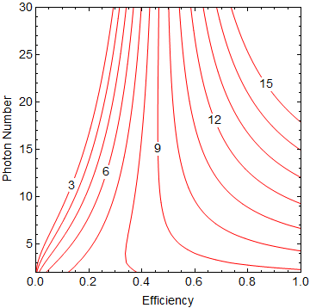

**Figure 9.** The quantum and classical supremacy of scattershot boson-sampling is divided by the red line, where the top right side belongs to the quantum and vice versa. The number 3, 6, *etc.* in the line refer to FLOPS, FLOPS *etc.* of classical computers respectively. The efficiency denoted on the horizontal axis is the overall system efficiency except the preparation efficiency of the source (the preparation efficiency of *n* sources is substituted with  [36]).

By comparing  to , we plot the supremacy boundaries for SBS using nondeterministic SPS via SPDC. We can see that, with the help of the number of different combinations, SPDC survives and SBS is a feasible approach to beating advanced classical competitors. However, in order to scale SBS to the interesting regime of 20-30 photons, other challenges remain challenging. First, SBS needs  SPDC sources, much more than the usual *n*. And a larger-depth optical network is required to fully implement an  unitary matrix, rather than in original boson-sampling, with a fixed number of *n* input modes, it can be simplified to an  matrix. Besides, as twice the number of photodetectors will be employed, to assure a certain sample rate, the requirement of detection efficiency imposed on photodetectors of SBS would be higher. Comparing figure 2 and figure 9, we see that, to beat a classical computer, SBS should either scale to a large size or require the quantum device to have a higher total efficiency with respect to ordinary boson-sampling.

*3.5.1. Scattershot boson-sampling analysis.* The scattershot method is a recipe for overcoming the exponentialy decaying efficiency of parallel SPDC sources. However, there is still a major problem to consider – the fidelity. Here, we discuss it from two aspects under the influence of coupling and detection efficiency.

On one hand, the problem results from the large number (*m* in total) of SPDC sources that SBS needs. As we mentioned before, we will record the instance when both *n* heralding detectors and *n* detectors at the output modes are fired. However, single photon pairs might be generated from more than *n* SPDC sources and coupled into the interferometer without being consciously noticed by us (without our awareness), as long as the extra photons were not successfully heralded due to the detection inefficiency. If an unheralded photon is detected in the output, but a correct heralded photon is lost in the interferometer, a wrong sample will be taken. Promoting the detection efficiency can relax the problem, whereas to put an end to “dark photons” we need high speed vacuum shutters to close the input modes whose corresponding triggering detectors did not click [38].

On the other hand, SPDC sources exhibit higher-order emission, leading to the probability that two or three photon pairs might be generated. The following two approaches may be helpful: attenuating the brightness of the source by decreasing the pump power of the SPDCs, or employing photon-number-resolving detectors [34].

When the detectors are perfect but non-number-resolving, the probability that *n* heralding detectors are triggered, and all of them result from single photon pairs generated by *n* SPDC (ignoring the third and higher order terms) is

. (12)

The total probability that *n* SPDC sources generate photons is given by

. (13)

Nevertheless, we cannot distinguish the correct preparation of *n* single photons from the total occasions of *n* heralded sources. As shown in figure 10, the correct generation ratio defined as  decreases rapidly with increasing *n*.

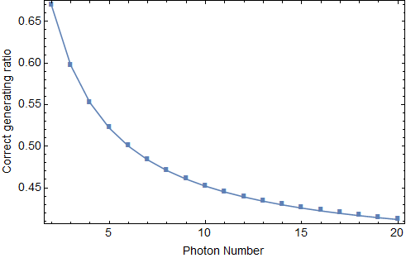

**Figure 10.** The correct generation ratio of *n* single photons in *n*2 pairs of SPDCs.

For example, for *n*=6, almost half the input states are erroneous, where some two-photon events are mixed. Without photon-number-resolving detectors, we cannot exclude this erroneous component before coupling photons into the interferometer. Consider the first possible remedy, attenuating the pump power to reducing the generation probability of higher-order terms at the cost of the brightness of the SPS. For simplicity, les us consider the example of *n*=20. To ensure the correct rate of input states is >0.9, we should keep *p*<0.006, much smaller than the scalable condition that *p* equals to, leading to the decrease of source brightness of more than 10 orders of magnitude. What does it imply? If all the coupling and detection processes are perfect, it implies we obtain 6 counts a day for 76 MHz repeat frequency. Let alone beating classical simulation, it is too difficult to keep the system stable in the data collection period. Therefore, only the second remedy – photon-number-resolving detectors – remains probable and useful to implement scalable SBS.

We take shutters and photon number resolving detectors into consideration with different configurations. As shown in figure 11, only if both of them are exploited, the rigorous requirements in detection efficiency and coupling efficiency of the quantum system can be greatly loosened. In this case, 20 photon SBS seems viable if the detection efficiency and coupling efficiency of the quantum system reach 0.95 and 0.8, respectively.

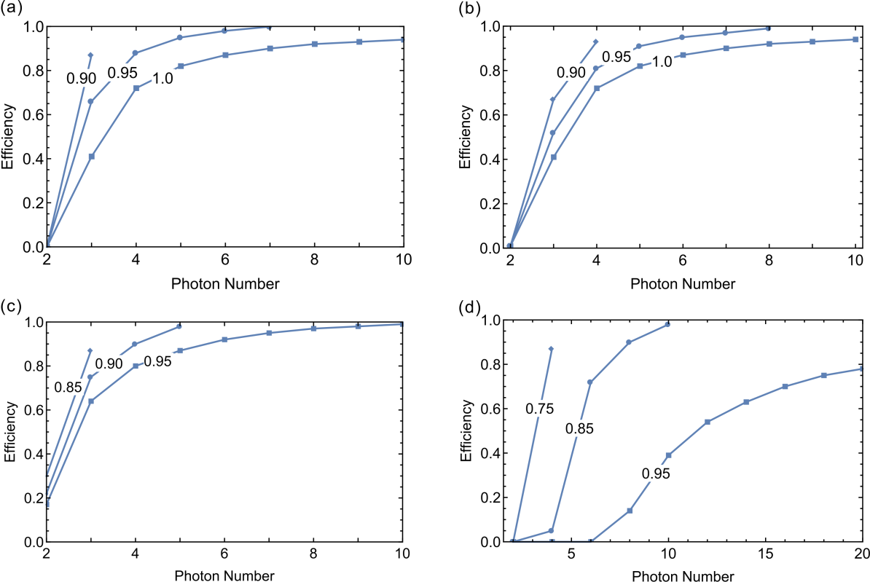

**Figure 11.** The requirements of coupling and detection efficiency for scattershot boson-sampling to guarantee SNR>2 when increasing photon number (a) without shutters and number-resolving detectors, (b) with shutters but without number-resolving detectors, (c) without shutters but with number-resolving detectors, (d) with shutters and number-resolving detectors. The efficiency denoted on the vertical axis is the coupling efficiency from SPDC sources to the interferometer. The numbers labeled in the broken lines indicate different detection efficiencies of the quantum system.

**4. Fidelity of boson-sampling devices**

**(For the text, see the attached PDF)**



**4. Advances in single photon sources**

*4.1. Spontaneous parametric down-conversion (SPDC)*

*4.2. Four-wave mixing (FWM)*

*4.3. Quantum dot (QD)*

**5. Advances in linear optical networks**

*5.1. Optical waveguide*

**Table 1**. Properties of waveguides fabricated by PLC [61] and FLDW [62] (wavelength: 1550 nm)

|  |  |  |  |  |  |
| --- | --- | --- | --- | --- | --- |
| Silica | Technology | Δ (%) | Min. radius (mm) | PL (dB/cm) | CL (dB/facet) |
| Ge-doped | PLC | 0.25 | 25 | <0.01 | <0.1 |
| Ge-doped | PLC | 1.5 | 2 | 0.05 | 2.0 |
| Fused | FLDW | 0.7 | 50 | 0.3 | 0.1 |
| Fused | FLDW | 1.0 | 15 | 0.6 | 0.1 |

*5.2. Fibre-loop*



The fibre-loop scheme for boson-sampling. A pulse-train of photons in *m* time-bins defines the input state, with time-bin separation . The pulse-train is coupled into and out of the outer loop using two outer dynamic switches. The inner loop of length allows neighboring time-bins to interfere at the central dynamic switch. The outer two switches need only switch between being completely reflective and completely transmissive, whereas the inner switch must be able to tune to any beamsplitter reflectivity. The only component that scales with the size of the interferometer is the length of the outer loop, which must be long enough to contain the entire pulse-train.

*5.3. Fibre beamsplitter*

*5.4. Miniature bulk optics*

*5.5. Microwave circuits*

**6. Advances in single photon detectors**

*6.1. Single photon avalanche diode (SPAD)*

*6.2. Superconducting nanowire single photon detector (SNSPD)*

*6.3. Superconducting transition-edge sensor (TES)*

**7. Conclusion**

**Appendix A. Numerically modelling the effect of signal-to-noise ratio**

Here we provide more details on the reasonable range of the signal-to-noise ratio (SNR) of boson-sampling output data. More specifically, we use a Bayesian approach [90] to validate ideal boson-sampling (SNR approaches infinity) against hypothetical mixed sampling (SNR equals some finite value). For the sake of simplicity, the hypothetical sampling is mixing between ideal boson-sampling and thermal state sampling [91]. As shown in figure A.1, given  and , only if , the Bayesian analysis can reach a relatively high success rate. Accordingly, we suppose  as a minimum requirement in the Appendix B.

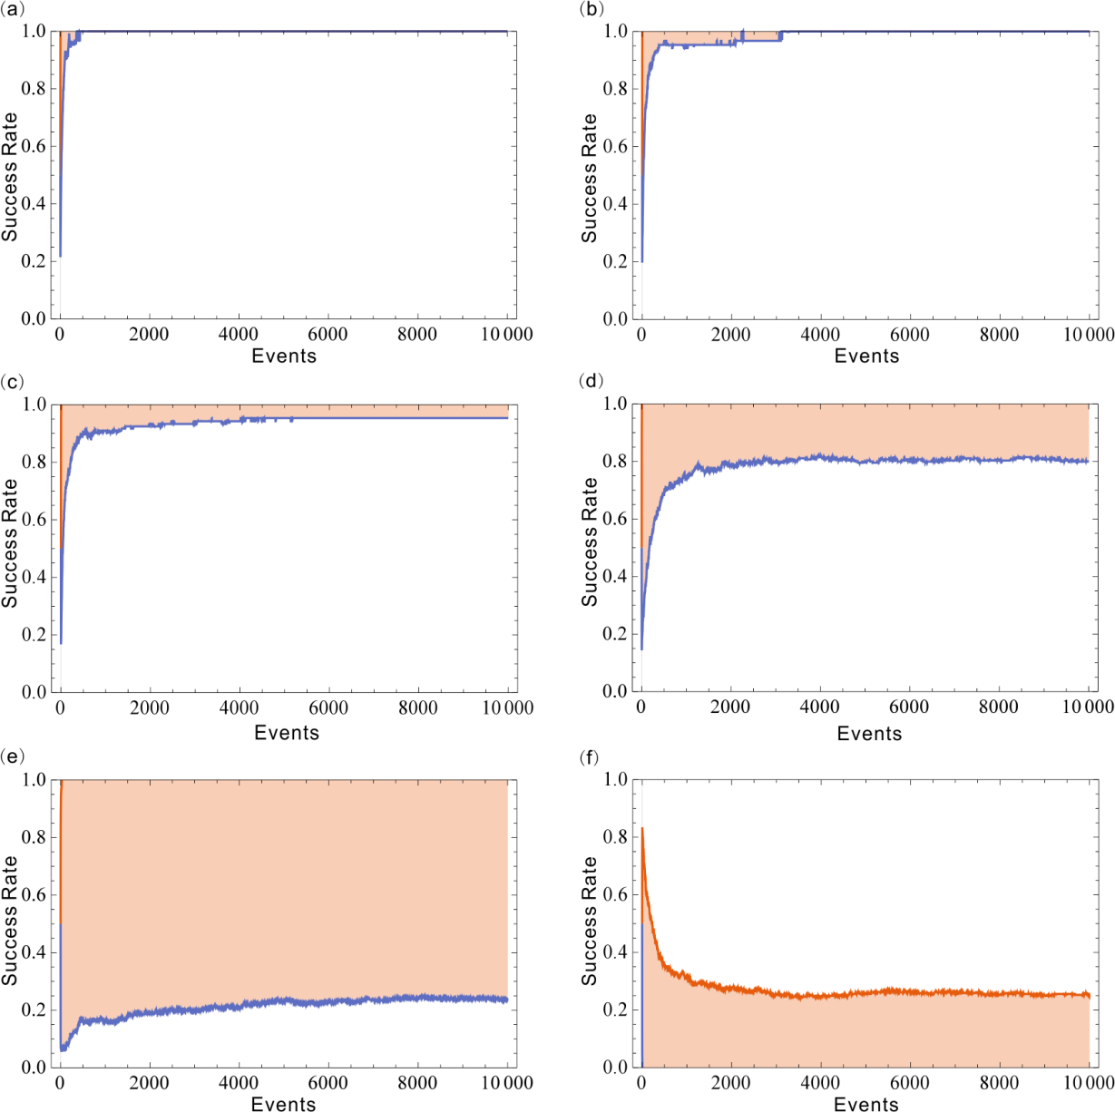

**Figure A.1**. Bayesian approach to validate ideal boson-sampling (SNR approaches infinity) against hypothetical mixed sampling (SNR equals some finite value). Here we set n=5, m=10. Red (blue) lines correspond to the boson-sampling validation as +1 (-1) standard deviations by averaging over a numerical simulation with 1,000 Haar-uniform unitary matrices. (a) , success rate: ; (b) , success rate: ; (c) , success rate: ; (d) , success rate: ; (e) , success rate: ; (f) , success rate: .

**Appendix B. Details of scattershot boson-sampling analysis**

*Case 1.*

First, let us start from the case without shutters and resolving detectors. When *n* coincidence counting were both recorded at heralding and at the output, the probability that it is a correct boson-sampling signal is given by

 (14)

, where the probability of simultaneously generating s single photons and t twin-photons in *m* sources is

. (15)

Here the subscript c indicates “correct” and (0, 0) indicates without shutter or photon-number-resolving detectors.  is the probability that a non-photon-number-resolving detector will click if a twin-photon is injected, and .

The probability of getting a signal satisfying the condition of *n* coincidence counting is of the form

 (16)

, where the subscript t indicates the total probability of getting a signal.

To ensure SNR larger than two, which is quite a low requirement for correct sampling, we plot the requirement for coupling and detection efficiency when increasing *n* in figure 10(a). As shown in figure 10(a), the requirements for detectors and coupling are rather high if without shutter or photon-number-resolving detector **(CHECK THIS SENTENCE)**. When the coupling efficiency is 0.9 and detection efficiency is 0.95, we can only scale boson-sampling experiments to 4 photons.

*Case 2.*

If employing shutters, but without photon-number-resolving detectors, we can apply some small modifications to the equations (14) and (16) to get



(17)

 (18)

To satisfy SNR>2, we plot the requirements to achieve quantum supremacy with increasing photon number in figure 10(b) **(CHECK THIS SENTENCE)**. From the figure, we can see that when the size of a boson-sampler is relatively small, i.e. *n*=3~4, the requirement for coupling efficiency is relaxed a little by employing the shutter. We can implement 4 photon SBS with 0.8 coupling efficiency and 0.95 detection efficiency without photon-number-resolving detectors.

*Case 3.*

When coming to the case with photon-number-resolving detectors but without shutters, using  to subsititude  in equation (14) and (16), we have

 (19)

 (20)

In the same way, to guarantee SNR>2, we determine the lower bound for coupling efficiency and detection efficiency against the scaling of the SBS device. Comparing figure 10(a) and figure 10(b), if photon-number-resolving detectors of 0.95 detection efficiency were utilized, the quantum system could perform almost as well as a quantum system with perfect photodetectors that were non-photon-number-resolving.

*Case 4.*

Finally, both shutters and photon-number-resolving detectors are available. Just employing equations (17) and (18), and changing to as we have done before, we obtain



(21)



(22)

We are glad to see that, in this case, the rigorous requirements in detection efficiency and coupling efficiency of the quantum system can be substantially loosened. And a SBS of 20 photons appears viable if the detection and coupling efficiency of the device can reach 0.95 and 0.8, respectively.

**References**

[1] Nielsen M A and Chuang I L 2010 *Quantum Computation and Quantum Information* (Cambridge: Cambridge University Press)

[2] Aaronson S and Arkhipov A 2013 The computational complexity of linear optics *Theory of Computing* **9** 143–252

[3] Ralph T C 2013 Quantum computation: Boson-sampling on a chip *Nat. Photon.* **7** 514–5

[4] Crespi A, Osellame R, Ramponi R, Brod D J, Galvão E F, Spagnolo N, Vitelli C, Maiorino E, Mataloni P and Sciarrino F 2013 Integrated multimode interferometers with arbitrary designs for photonic boson-sampling*Nat. Photon.* **7** 545–9

[5] Spring J B *et al* 2013 Boson-sampling on a photonic chip *Science* **339** 798–801

[6] Tillmann M, Dakić B, Heilmann R, Nolte S, Szameit A and Walther P 2013 Experimental boson-sampling *Nat. Photon.* **7** 540–4

[7] Spagnolo N *et al* 2014 Experimental validation of photonic boson-sampling *Nat. Photon.* **8** 615–20

[8] Carolan J *et al* 2014 On the experimental verification of quantum complexity in linear optics *Nat. Photon.* **8** 621–6

[9] Carolan J *et al* 2015 Universal linear optics *Science* **349** 711–6

[10] Broome M A, Fedrizzi A, Rahimi-Keshari S, Dove J, Aaronson S, Ralph T C and White A G 2013 Photonic boson-sampling in a tunable circuit *Science* **339** 794–8

[11] He Y *et al* 2016 Scalable boson-sampling with a single-photon device (arXiv:1603.04127v2)

[12] Troyansky L and Tishby N 1996 On the quantum evaluation of the determinant and the permanent of a matrix *Proc. Fourth Workshop on Physics and Computation (PhysComp 96) (Boston, 22–24 November 1996)* 96

[13] Arkhipov A and Kuperberg G 2011 The bosonic birthday paradox (arXiv:1106.0849)

[14] Spagnolo N *et al* 2013 General rules for bosonic bunching in multimode interferometers *Phys. Rev. Lett.* **111** 130503

[15] http://en.wikipedia.org/wiki/Rejection_sampling

[16] Ryser H J 1963 *Combinatorial Mathematics* (New York: The Mathematical Association of America)

[17] Valiant L G 1979 The complexity of computing the permanent *Theor. Comput. Sci.* **8** 189–201

[18] Reck M, Zeilinger A, Bernstein H and Bertani P 1994 Experimental realization of any discrete unitary operator *Phys. Rev. Lett.* **73** 58

[19] Motes K R, Gilchrist A, Dowling J P and Rohde P P 2014 Scalable boson-sampling with time-bin encoding using a loop-based architecture *Phys. Rev. Lett.* **113** 120501

[20] Peropadre B, Guerreschi G G, Huh J and Aspuru-Guzik A 2015 Microwave boson-sampling (arXiv:1510.08064)

[21] Hofheinz M *et al* 2009 *Nature* **459** 546

[22] Rohde P P and Ralph T C 2012 Error tolerance of the boson-sampling model for linear optics quantum computing *Phys. Rev. A* **85** 022332

[23] Arkhipov A 2015 BosonSampling is robust against small errors in the network matrix *Phys. Rev. A* **92** 062326

[24] Leverrier A and García-Patrón R 2015 Analysis of circuit imperfections in BosonSampling *Quant. Inf. Comp.* **15** 0489-0512

[25] Rohde P P 2012 Optical quantum computing with photons of arbitrarily low fidelity and purity *Phys. Rev. A* **86** 052321

[26] Shchesnovich V S 2014 Sufficient condition for the mode mismatch of single photons for scalability of the boson-sampling computer *Phys. Rev. A* **89** 022333

[27] Shchesnovich V S 2015 Partial indistinguishability theory for multiphoton experiments in multiport devices *Phys. Rev. A* **91** 013844

[28] Shchesnovich V S 2015 Tight bound on the trace distance between a realistic device with partially indistinguishable bosons and the ideal BosonSampling *Phys. Rev. A* **91** 063842

[29] Tichy M C 2015 Sampling of partially distinguishable bosons and the relation to the multidimensional permanent *Phys. Rev. A* **91** 022316

[30] Rohde P P 2015 Boson-sampling with photons of arbitrary spectral structure *Phys. Rev. A* **91** 012307

[31] Bürgisser P 2000 The computational complexity of immanants *SIAM J. Comput.* **30** 1023

[32] Tillmann M, Tan S H, Stoeckl S E, Sanders B C, Guise H D, Heilmann R, Nolte S, Szameit A and Walther P 2015 Generalized multiphoton quantum interference *Phys. Rev. X* **5** 041015

[33] Aaronson S and Brod D J 2016 BosonSampling with lost photons *Phys. Rev. A* **93** 012335

[34] Motes K R, Dowling J P and Rohde P P 2013 Spontaneous parametric down-conversion photon sources are scalable in the asymptotic limit for boson-sampling *Phys. Rev. A* **88** 063822

[35] Aaronson S 2013 Scattershot BosonSampling: A new approach to scalable BosonSampling experiments Shtetl-Optimized (http://www.scottaaronson.com/blog/?p=1579)

[36] Lund A P, Laing A, Rahimi-Keshari S, Rudolph T, O’Brien J L and Ralph T C 2014 Boson-sampling from a Gaussian state *Phys. Rev. Lett.* **113** 100502

[37] Latmiral L Reaching quantum supremacy with a boson-sampling experiment (arXiv:1511.08161)

[38] Bentivegna M *et al* 2015 Experimental scattershot boson-sampling *Science Advances* **1** e1400255

[39]Zhang C, Huang Y-F, Wang Z, Liu B-H, Li C-F and Guo G-C 2015 Experimental Greenberger-Horne-Zeilinger-type six-photon quantum nonlocality *Phys. Rev. Lett.* **115** 260402

[40] Yao X-C, Wang T-X, Xu P, Lu H, Pan G-S, Bao X-H, Peng C-Z, Lu C-Y, Chen Y-A and Pan J-W 2012 Observation of eight-photon entanglement *Nat. Photon.* **6** 225–8

[41] Giustina M *et al* 2013 Bell violation using entangled photons without the fair-sampling assumption *Nature* **497** 227

[42] Christensen B G *et al* 2013 Detection-loophole-free test of quantum nonlocality, and applications *Phys. Rev. Lett.* **111** 130406

[43] Silverstone J W *et al* 2013 On-chip quantum interference between silicon photon-pair sources *Nat. Photon.* **8** 104–108

[44] Spring J B *et al* 2016 A chip-based array of near-identical, pure, heralded single photon sources (arXiv:1603.06984)

[45] Goldschmidt E A, Eisaman M D, Fan J, Polyakov S V and Migdall A 2008 Spectrally bright and broad fibre-based heralded single-photon source *Phys. Rev. A* **78** 013844

[46] Smith B J, Mahou P, Cohen O, Lundeen J S and Walmsley I A 2009 Photon pair generation in birefringent optical fibres *Opt. Express* **17** 23589

[47] He Y-M, He Y, Wei Y-J, Wu D, Atature M, Schneider C, Hofling S, Kamp M, Lu C-Y and Pan J-W 2013 On-demand semiconductor single-photon source with near-unity indistinguishability *Nat. Nanotech.* **8** 213–7

[48] Wei Y-J *et al* 2014 Deterministic and Robust Generation of Single Photons from a Single Quantum dot with 99.5% indistinguishability using adiabatic rapid passage *Nano Lett.* **14** 6515

[49] Ding X *et al* 2016 On-demand single photons with high extraction efficiency and near-unity indistinguishability from a resonantly driven quantum dot in a micropillar *Phys. Rev. Lett.* **116** 020401

[50] Somaschi N *et al* 2016 Near optimal single photon sources in the solid state *Nat. Photon.* **10** 340

[51] Wang H *et al* 2016 Near transform-limited single photons from an efficient solid-state emitter *Phys. Rev. Lett.* **116** 213601

[52] Loredo J C *et al* 2016 Scalable performance in solid-state single-photon sources *Optica* **3** 433

[53] Eisaman M D, Fan J, Migdall A and Polyakov S V 2011 Invited review article: single-photon sources and detectors *Rev. Sci. Instrum.* **82** 071101

[54] Wang X-L *et al* 2016 Experimental ten-photon entanglement (arXiv:1605.08547)

[55] Grice W P, U’Ren A B and Walmsley I A 2001 Eliminating frequency and space-time correlations in multiphoton states *Phys. Rev. A* **64** 063815

[56] Mosley P J, Lundeen J S, Smith B J, Wasylczyk P, U’Ren A B, Silberhorn C and Walmsley I A Heralded generation of ultrafast single photons in pure quantum states 2008 *Phys. Rev. Lett.* **100** 133601

[57] Jin R-B, Wakui K, Shimizu R, Benichi H, Miki S, Yamashita T, Terai H, Wang Z, Fujiwara M and Sasaki M 2013 Nonclassical interference between independent intrinsically pure single photons at telecommunication wavelength *Phys. Rev. A* **87** 063801

[58] U'Ren A B, Silberhorn C, Erdmann R, Banaszek K, Grice W P, Walmsley I A and Raymer M G 2005 Generation of pure-state single-photon wavepackets by conditional preparation based on spontaneous parametric downconversion *Las. Phys.* **15** 146

[59] Mosley P J, Lundeen J S, Smith B J and Walmsley I A 2008 Conditional preparation of single photons using parametric downconversion: a recipe for purity *New J. Phys.* **10** 093011

[60] Vicent L E, U’Ren A B, Rangarajan R, Osorio C I, Torres J P, Zhang L and Walmsley I A 2010 Design of bright, fiber-coupled and fully factorable photon pair sources *New J. Phys.* **12** 093027

[61] Hibino Y 2003 Silica-based planar lightwave circuits and their applications *MRS Bulletin* **28** 365-371

[62] Eaton S M, Nga M L, Osellame R and Herman P R 2011 High refractive index contrast in fused silica waveguides by tightly focused, high-repetition rate femtosecond laser *J. Non-Cryst. Solids* **357** 2387–2391

[63] Sakuma K, Ishikawa S, Shikata T, Fukuda T and Hosoya H 2003 Ultra low-loss waveguides of 0.12 dB/cm directly written in pure silica glass by femtosecond laser pulses *Optical Fibre Communications Conf.* 1.2 445-446

[64] Bauters J F, Heck M J R, John D D, Tien M-C, Li W, Barton J S, Blumenthal D J and Bowers J E 2011 Ultra-low-loss single-mode Si3N4 waveguides with 0.7 dB/m propagation loss *ECOC Tech. Dig.* Th.12.LeSaleve.3

[65] Bauters J F, Heck M J R, John D, Dai D, Tien M-C, Barton J S, Leinse A, Heideman R G, Blumenthal D J and Bowers J E 2011 Ultra-low-loss high-aspect-ratio Si3N4 waveguides *Opt. Express* **19** 3163-3174

[66] Bonneau D *et al* 2012 Quantum interference and manipulation of entanglement in silicon wire waveguide quantum circuits *New J. Phys.* **14** 045003

[67] Peruzzo A, Laing A, Politi A, Rudolph T and O'Brien J L 2011 Multimode quantum interference of photons in multiport integrated devices *Nat. Commun.* **2** 224

[68] Lee K K, Lim D R, Luan H-C, Agarwal A, Foresi J and Kimerling L C 2000 Effect of size and roughness on light transmission in a Si/SiO 2 waveguide: Experiments and model *Appl. Phys. Lett.* **77** 1617

[69]Gnan M, Thoms S, Macintyre D, La Rue R M D and Sorel M 2008 Fabrication of low-loss photonic wires in silicon-on-insulator using hydrogen silsesquioxane electron-beam resist *Electron. Lett.* **44** 115–116

[70] Almeida V R, Panepucci R R and Lipson M 2003 Nanotaper for compact mode conversion *Opt. Lett.* **28** 1302–1304

[71] McNab S J, Moll N and Vlasov Y A 2003 Ultra-low loss photonic integrated circuit with membrane-type photonic crystal waveguides *Opt. Express* **11** 2927–2939

[72] Bogaerts W, Selvaraja S K, Dumon P, Brouckaert J, Vos K D Thourhout D V and Baets R 2010 Silicon-on-insulator spectral filters fabricated with CMOS technology *IEEE J. Sel. Top. Quantum Electron.* **16** 33–44

[73] Sheng Z, Wang Z, Qiu C, Li L, Pang A, Wu A, Wang X, Zou S and Gan F A Compact and CMOS compatible MMI coupler with very low excess loss *OFC/NFOEC Tech. Dig., 2013* JTh2A.26

[74] Xu X *et al* 2013 Near-infrared Hong-Ou-Mandel interference on a silicon quantum photonic chip *Opt. Express* **21** 5014-5024

[75] Lita A E, Miller A J and Nam S W 2008 Counting near-infrared single-photons with 95% efficiency *Opt. Express* **16** 3032–3040

[76] Winzer P, Gnauck A, Doerr C, Magarini M and Buhl L 2010 Spectrally efficient long-haul optical networking using 112-Gb/s polarization-multiplexed 16-QAM *J. Lightwave Technol.* 28 547

[77] Schindler P *et al* 2014 Monolithic GaAs electro-optic IQ modulator demonstrated at 150 Gbit/s with 64QAM *J. Lightwave Technol.* **32** 760

[78] Lin X-F, Gao J, Feng Z, Yang A-L, Ji L, Li H-G and Jin X-M 2015 Towards large-scale quantum boson-sampling *Optoelectronic Devices and Integration* (Wuhan, China)

[79] Rohde P P, Motes K R, Knott P A, Fitzsimons J, Munro W J and Dowling J P 2015 Evidence for the conjecture that sampling generalized cat states with linear optics is hard *Phys. Rev. A* **91** 012342

[80] Olson J P, Seshadreesan K P, Motes K R, Rohde P P and Dowling J P 2015 Sampling arbitrary photon-added or photon-subtracted squeezed states is in the same complexity class as boson-sampling *Phys. Rev. A* **91** 022317

[81] Seshadreesan K P, Olson J P, Motes K R, Rohde P P and Dowling J P 2015 Boson-sampling with displaced single-photon Fock states versus single-photon-added coherent states: The quantum-classical divide and computational-complexity transitions in linear optics *Phys. Rev. A* **91** 022334

[82] Huh J, Guerreschi G G, Peropadre B, McClean J R and Aspuru-Guzik A 2015 Boson-sampling for molecular vibronic spectra *Nat. Photon.* **9** 615–620

[83] Hofheinz M *et al* 2009 Synthesizing arbitrary quantum states in a superconducting resonator *Nature* **459** 546

[84] Hofheinz M, Weig E M, Ansmann M, Bialczak R C, Lucero E, Neeley M, O’Connell A D, Wang H, Martinis J M and Cleland A N 2008 Generation of Fock states in a superconducting quantum circuit *Nature* **454** 310

[85] Johnson B *et al* 2010 Quantum non-demolition detection of single microwave photons in a circuit *Nat. Phys.* **6** 663

[86] Hadfield R H 2009 Single-photon detectors for optical quantum information applications *Nat.* *Photon.* **3** 696

[87] Marsili F *et al* 2014 Detecting single infrared photons with 93% system efficiency *Nat. Photon.* **7** 210-214

[88] Fukuda D *et al* 2011 Titanium-based transition-edge photon number resolving detector with 98% detection efficiency with index-matched small-gap fibre coupling *Opt. Express* **19** 870-875

[89] Loredo J C, Broome M A, Hilaire P, Gazzano O, Sagnes I, Lemaitre A, Almeida M P, Senellart P and White A G 2016 BosonSampling with single-photon Fock states from a bright solid-state source (arXiv:1603.00054)

[90] Bentivegna M *et al* 2014 Bayesian approach to boson-sampling validation *Int. J. Quantum Inform.* **12** 1560028

[91] Rahimi-Keshari S, Lund A P and Ralph T C 2015 What can quantum optics say about computational complexity theory? *Phys. Rev. Lett.* **114** 060501