ANNUAL REVIEWS GALLEY PROOFS INSTRUCTIONS
Annual Review of Astronomy and Astrophysics

Please complete the attached copyright release, Review in Advance (RIA) authorization, disclosure of bias, and complimentary copy forms along with this signed form and return via email (as a scanned PDF), fax (650.855.9815), or postal mail (4139 El Camino Way, Palo Alto, CA 94306). Return the copyedited manuscript with your final changes/corrections within seven (7) days.

Attached you will find a copy of the edited version of your manuscript (known as the “galley proof”), with deleted material struck out (like this) and inserted material underlined (like this). This is how revisions appear in Microsoft Word. The Word document has been set so that your changes should automatically appear as revision marks. If your marks do not show up as such, please contact your Production Editor.
- Do not accept/reject changes or paste the text into a new file; we would like to see your response to each edit.
- Make any necessary corrections within the text itself. Kindly type substantial revisions within the appropriate sections within text. Be sure tracking is on.
- Type and proofread with extra care any mathematical, chemical, or other technical changes or insertions you make now.
- Treat this version as the final version of the article; we cannot allow you to make additional major alterations once you return this copy. Unless requested, the technical editor will not see the manuscript again.

Literature Cited
It is imperative that you verify all reference information at this time. Only updates of “in press” references are allowed at the next stage of production (the page proof stage; see below). References cannot be renumbered at the page proof stage.
- Check line by line for accuracy, including author names.
- Check entries against originals, if not done already.
- Update all “in press” references.
- For journals whose references are numbered:
Figures
- You will receive (or may have already received) revised figures from the Illustration Editor, Alan Stonebraker. Please contact him directly at astonebraker@annualreviews.org with any issues regarding the figure proofs.
- Please ensure that your captions correctly and thoroughly describe your figures.
- If you need to revise, add, or remove figures based on comments in the manuscript, please contact the Illustration Editor before proceeding with any changes.

***NOTE*** Please read this galley proof very carefully for style and flow; this is your final opportunity to make stylistic/copyediting changes to your article. At the next stage of production, known as the page proof stage, only typographical errors, typesetter’s errors, or actual errors of fact may be corrected. Any changes that affect the layout of the article cannot be made. Thus, requests for the deletion or addition of full sentences or paragraphs will be rejected. Please use this galley proof to your advantage.

Your signature indicates that you have reviewed the galley proofs and approve the manuscript for publication. Thank you for all your hard work.

Date________________________ Signature___________________________________
Dr. Philip Marshall

Annual Review of Astronomy and Astrophysics

Editorial Committee  Timothy C. Beers  Joss Bland-Hawthorne  Bruce T. Draine  S. M. Faber  Luis C. Ho  Ramesh Narayan  Saku Tsuneta  Ewine van Dishoeck |  | 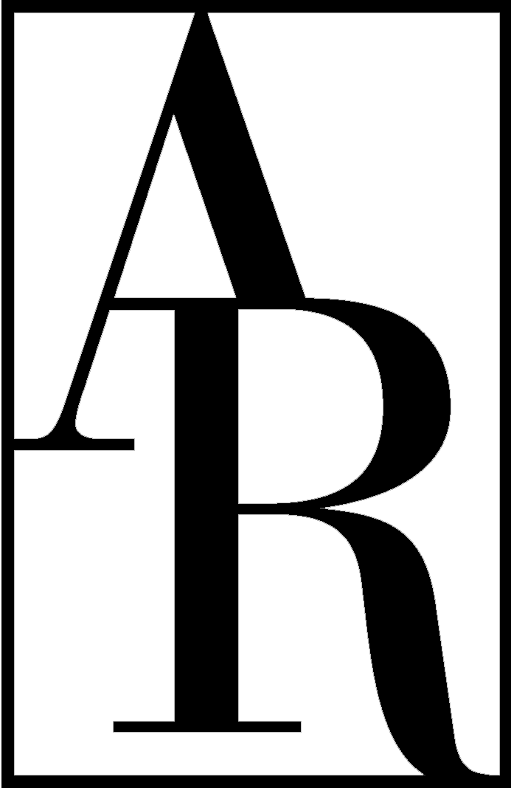 | ANNUAL REVIEWS  a nonprofit scientific publisher  4139 El Camino Way  P.O. Box 10139  Palo Alto, CA 94303-0139 USA  Telephone 650-843-6623  Fax 650-855-9815  E-mail: rlowe-webb@annualreviews.org  http://www.annualreviews.org |  | Editor  S. M. Faber  Ewine van Dishoeck  Production Editor  Roselyn Lowe-Webb

Dear Dr. Marshall:

It is the policy of Annual Reviews to obtain a written transfer of copyright ownership from our authors and then to grant back to authors a broad array of parallel rights. The transfer of copyright allows Annual Reviews (a nonprofit organization) to publish your article, to recover the costs of publication without immediate commercial competition, and potentially to make arrangements for abstracting, indexing, translating, reprinting, and other distribution services. Further, copyright transfer codifies Annual Reviews' flexibility to produce and disseminate your work as broadly as possible via whatever media and delivery mechanisms are appropriate today and in the future. For a complete explanation of our policy and its underpinnings, please see the Copyright FAQ on our website at http://www.annualreviews.org/page/authors/author-instructions/distributing/copyright_mandate.

We ask you, as the author or coauthor of an article now in production, to complete the statement below and sign either (a), (b), or (c). Please return this form to us with your revised manuscript. Note that, in the event of a jointly-authored work, all co-authors will be asked to complete this form.

Copyright Transfer and Authors’ Rights Agreement

I, Philip Marshall, am an author or coauthor of the manuscript submitted to Annual Reviews and entitled: Ideas for Citizen Science in Astronomy, scheduled to appear in Volume 53 of the Annual Review of Astronomy and Astrophysics.

AUTHOR: SIGN ONLY (a), (b), or (c)

(a) For good and valuable consideration, the receipt and sufficiency of which is hereby acknowledged, the undersigned warrants that the above manuscript is the author's original work and has not been published before, that the work contains no libelous or other unlawful statements, and that the work does not infringe on the rights of others. The work is deemed to include all material submitted for publication and includes the text, figures, tables, and any supplementary material accompanying the work. Effective upon completion of this Transfer Agreement, the author hereby assigns to Annual Reviews all right, title, and interest in and to the work in print and all electronic formats. This includes, but is not limited to, the rights to migrate the work to future formats, translate it, and include it in collections. Again notwithstanding any other rights, Annual Reviews may create adaptations, summaries, extracts, and derivative works and shall retain all rights over such adaptations, summaries, extracts, and derivative works.
Authors’ Rights After manuscript acceptance and copyright transfer, substantial rights are granted to the author(s) by Annual Reviews:

- The retention of patent and trademark rights to processes or procedures described within the work.
- The nonexclusive right to use, reproduce, distribute, perform, update, create derivatives, and make copies of the work (electronically or in print) in connection with the author’s teaching, conference presentations, lectures, and publications, provided the copies are not offered for sale and proper attribution is given. Note that self-archiving rights are treated in items #5 and #6 below.
- The nonexclusive right to store the publisher-supplied PDF file of the work (“the published version”) in electronic reserve rooms for access by students at the author’s institution as part of the author’s teaching activities, so long as these files are made available free of charge and are removed when no longer connected to the author’s own teaching.
- The nonexclusive right to use, reproduce, and distribute the publisher-supplied PDF of the work (“the published version”) in coursepacks, within the author’s own institution, so long as these copies are distributed to students free of charge.
- The right to self-archive a “preprint” version of the work, defined as a manuscript that has not yet been reviewed, edited, or prepared for publication by Annual Reviews, provided (a) any preprint posted to the Web after the completion of this Transfer Agreement states explicitly by which Annual Reviews journal the manuscript has been accepted, and (b) after the published version of the work appears on the Annual Reviews website, the preprint version is amended to include the following acknowledgment and link: “Posted with permission from the Annual Review of Astronomy and Astrophysics, Volume 53 © 2015 by Annual Reviews, http://www.annualreviews.org.”
- The right to self-archive, after the work’s publication, an Annual Reviews-supplied ePrint URL (a specially-keyed URL that allows nonsubscribers to access an Annual Review article freely via the Annual Reviews website) on one personal website and/or one institutional repository. The ePrint URL provides free access to your article; Annual Reviews does not grant permission to directly self-archive a postprint file or the PDF of the article’s published version.
- The right to distribute an Annual Reviews-supplied ePrint URL to colleagues who request reprints.
- The right to include the work, in whole or in part, in a dissertation or thesis.
- The right to use the work, in whole or in part, with attribution and without revision or modification, in print compilations or other print publications.

The author must consistently state that s/he executes any of these rights “with permission from the Annual Review of Astronomy and Astrophysics, Volume 53 © 2015 by Annual Reviews, http://www.annualreviews.org.”

_______________________________________________ _____________________
Signature Date

OR

(b) I and all my co-authors (if applicable) are United States federal employees who have created the work within the scope of our official duties. Copyright protection is not available for any work of the United States Government. Therefore, this article should appear with the following footnote to the article title: "This is a work of the US Government and is not subject to copyright protection in the United States." If the work is determined to be copyrightable at a later date, then copyright and all rights included in this will be transferred to Annual Reviews. In that event, all the rights granted to the author(s) by Annual Reviews enumerated in Section (a) above will be granted here as well.
The undersigned warrants that the above article is the author's original work, and has not been published before. The author also warrants that the article contains no libelous or unlawful statements and does not infringe on the rights of others. The work is deemed to include all material submitted for publication and includes the text, figures, tables, and all supplementary material accompanying the work.

_______________________________________________ _____________________
Signature Date

OR

(c) I and/or any of my co-authors (if applicable) are employees of the British or a British Commonwealth government who created the work within the scope of our official duties. The work is therefore subject to Crown Copyright and cannot be transferred by the authors. This article will appear with the following footnote to the article title: “This paper was authored by employees of the British Government as part of their official duties and is therefore subject to Crown Copyright. Reproduced with the permission of the Controller of Her Majesty’s Stationery Office/Queen’s Printer for Scotland and [name of Department].”

Prior to publication, all authors and co-authors must return to the Production Editor a signed and completed Publishing Articles Application (available on the National Archives’ website at http://www.nationalarchives.gov.uk/documents/information-management/Publication_of_articles_written_by_ministers_and_civil_servants_PDF_FINAL.pdf).

The undersigned acknowledges that Annual Reviews has the following rights, as enumerated by the Office of Public Sector Information:
- The right to publish the work in any format throughout the world according to the terms and conditions set forth by the Office the Controller of Her Majesty’s Stationery Office.
- The right to sub-license access to the work in the context of digital products and services.
- The right to include the work in collective licensing schemes such as that operated by the Copyright Licensing Agency.
- The right to include the work as part of document delivery, abstracting and indexing services.
If the work is determined to be copyrightable at a later date, then copyright and all rights included in this will be transferred to Annual Reviews. In that event, all the rights granted to the author(s) by Annual Reviews enumerated in Section (a) above will be granted here as well.

The undersigned warrants that the above article is the author's original work, and has not been published before. The author also warrants that the article contains no libelous or unlawful statements and does not infringe on the rights of others. The work is deemed to include all material submitted for publication and includes the text, figures, tables, and all supplementary material accompanying the work.

_______________________________________________ _____________________
Signature Date
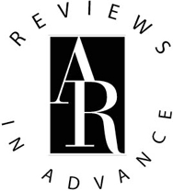 AR’S “REVIEWS IN ADVANCE” OPTION

Annual Review of Astronomy and Astrophysics, Volume 53

If you wish, Annual Reviews will publish your article online ahead of print.

AUTHORIZING THE RIA: Once you return your copyedited galley proof, your typeset page proof will be ready within 4 weeks. If you check the “Yes” box below, that typeset page proof will promptly be published online. We call this early publication of proofs a “Review in Advance” (RIA).

PUBLISHING THE RIA: One week after you receive the notification that your typeset page proof is available, it is published online as an RIA.

NO RIA ALTERATIONS: Corrections you make to the typeset page proof, if any, will not be added to your RIA. Your RIA will remain on our website until September 2015. At that time, all RIAs will be replaced by the final, permanent versions of all articles. Those final versions will include any corrections we have accepted in page proofs.

Reviews in Advance (RIA) release:

Yes, please publish my uncorrected typeset page proof as an advance version. I'll expect to see my RIA online in approximately 1-2 months.

No, please wait and publish only the final version of my article when the completed volume is ready in September 2015.

_______________________________________________ _____________________
Signature Date
Philip Marshall

DISCLOSURE OF POTENTIAL BIAS

Your disclosure of a potential bias does not indicate that the work presented has been compromised, nor does it disqualify your review from publication. However, to inform readers about factors that might bias this review, Annual Reviews requires all authors to complete the disclosure statement below. Your listing of relevant factors or your declaration of no bias will be published in the final section (“Disclosure Statement”) of your article.

------------------------------------------------------------------------------------------

Potential bias arises from any affiliations, memberships, funding, or financial holdings that may be viewed as affecting the objectivity of your review. Such factors may include, although they are not limited to, the following:

• Employment or paid consultancies
• Board memberships, professional affiliations, or membership in related advocacy organizations
• Funding, support, and/or grants received within the past three years
• Patents or significant financial holdings

------------------------------------------------------------------------------------------

Author Name: Philip Marshall

Article Title: Ideas for Citizen Science in Astronomy

Annual Reviews Journal: Annual Review of Astronomy and Astrophysics, Volume 53

Below is a list of factors that might be viewed as biasing this review:

___________________________________________________________________

___________________________________________________________________

___________________________________________________________________

___________________________________________________________________

___________________________________________________________________

___________________________________________________________________

I am not aware of any factors that might be perceived as affecting the objectivity of this review.

_______________________________________________ _____________________
Signature Date
COMPLIMENTARY COPY

The generous contribution of authors is recognized by a complimentary one-year online subscription to all volumes of the Annual Review of Astronomy and Astrophysics and unlimited electronic reprints of your review (obtained via reproduction of the PDF).

A printed copy of Volume 53 will be sent to you only on request.

No, do not send me a printed copy of the Annual Review of Astronomy and Astrophysics, Volume 53.

Yes, please send me a printed copy of the Annual Review of Astronomy and Astrophysics, Volume 53. If you have a shipping address that differs from your affiliation address, please include the address below.

We have the following address on file:

Dr. Philip Marshall
Kavli Institute for Particle Astrophysics and Cosmology
Stanford University
PO Box 20450
MS 29
Stanford, CA 94309

Alternate address:

___________________________________________________________________

___________________________________________________________________

___________________________________________________________________

___________________________________________________________________

_______________________________________________ _____________________
Signature Date

A US federal employee who created the work outside the scope of his or her employment owns the copyright in the work despite his/her federal employee status. In this event, the author should complete Section (a) of this Copyright Transfer Agreement. If any of the work’s co-authors is not a US federal employee, all authors should complete Section (a) of this Copyright Transfer Agreement.
An author who is an employee of another country’s government (not the United States or the United Kingdom and its Commonwealth) and whose status as a government employee legally prevents him or her from signing this Agreement should contact the Annual Reviews editorial office.
A British or a British Commonwealth government employee who created the work outside the scope of his or her employment owns the copyright in the work despite this employee status. In this event, the author should complete Section (a) of this Copyright Transfer Agreement. If any of the work’s co-authors is a British or a British Commonwealth government employee, all authors should complete Section (c) of this Copyright Transfer Agreement.

