Annual Review of Astronomy and Astrophysics

Editorial Committee  Timothy C. Beers  Joss Bland-Hawthorne  Bruce T. Draine  S. M. Faber  Luis C. Ho  Ramesh Narayan  Saku Tsuneta  Ewine van Dishoeck |  | 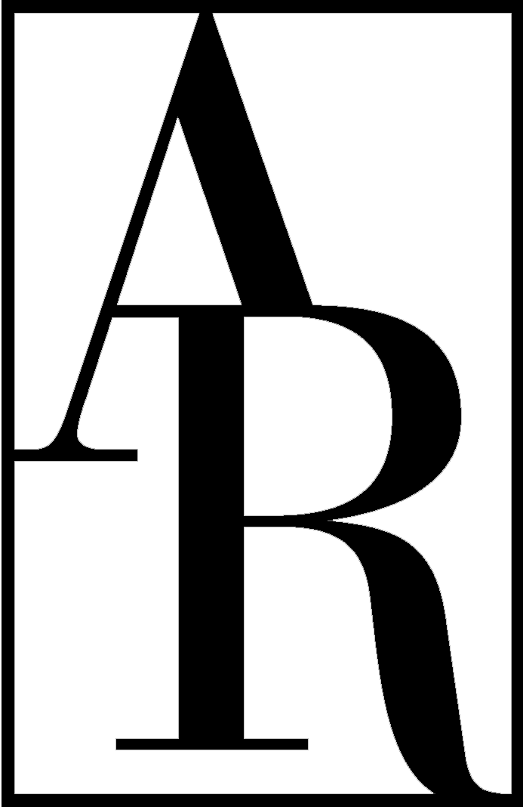 | ANNUAL REVIEWS  a nonprofit scientific publisher  4139 El Camino Way  P.O. Box 10139  Palo Alto, CA 94303-0139 USA  Telephone 650-843-6623  Fax 650-855-9815  E-mail: rlowe-webb@annualreviews.org  http://www.annualreviews.org |  | Editor  S.M. Faber  Ewine van Dishoeck  Production Editor  Roselyn Lowe-Webb

Dear Dr. Lintott:

It is the policy of Annual Reviews to obtain a written transfer of copyright ownership from our authors and then to grant back to authors a broad array of parallel rights. The transfer of copyright allows Annual Reviews (a nonprofit organization) to publish your article, to recover the costs of publication without immediate commercial competition, and potentially to make arrangements for abstracting, indexing, translating, reprinting, and other distribution services. Further, copyright transfer codifies Annual Reviews' flexibility to produce and disseminate your work as broadly as possible via whatever media and delivery mechanisms are appropriate today and in the future. For a complete explanation of our policy and its underpinnings, please see the Copyright FAQ on our Web site at http://www.annualreviews.org/page/authors/author-instructions/distributing/copyright_mandate.

We ask you, as the author or coauthor of an article now in production, to complete the statement below and sign either (a), (b), or (c). Please return this form to us with your revised manuscript. Note that, in the event of a jointly-authored work, all co-authors will be asked to complete this form.

Copyright Transfer and Authors’ Rights Agreement

I, Chris Lintott, am an author or coauthor of the manuscript submitted to Annual Reviews and entitled: Ideas for Citizen Science in Astronomy, scheduled to appear in Volume 53 of the Annual Review of Astronomy and Astrophysics.

AUTHOR: SIGN ONLY (a), (b), or (c)

(a) For good and valuable consideration, the receipt and sufficiency of which is hereby acknowledged, the undersigned warrants that the above manuscript is the author's original work and has not been published before, that the work contains no libelous or other unlawful statements, and that the work does not infringe on the rights of others. The work is deemed to include all material submitted for publication and includes the text, figures, tables, and any supplementary material accompanying the work. Effective upon completion of this Transfer Agreement, the author hereby assigns to Annual Reviews all right, title, and interest in and to the work in print and all electronic formats. This includes, but is not limited to, the rights to migrate the work to future formats, translate it, and include it in collections. Again notwithstanding any other rights, Annual Reviews may create adaptations, summaries, extracts, and derivative works and shall retain all rights over such adaptations, summaries, extracts, and derivative works.

Authors’ Rights After manuscript acceptance and copyright transfer, substantial rights are granted to the author(s) by Annual Reviews:

- The retention of patent and trademark rights to processes or procedures described within the work.
- The nonexclusive right to use, reproduce, distribute, perform, update, create derivatives, and make copies of the work (electronically or in print) in connection with the author’s teaching, conference presentations, lectures, and publications, provided the copies are not offered for sale and proper attribution is given. Note that self-archiving rights are treated in items #5 and #6 below.
- The nonexclusive right to store the publisher-supplied PDF file of the work (“the published version”) in electronic reserve rooms for access by students at the author’s institution as part of the author’s teaching activities, so long as these files are made available free of charge and are removed when no longer connected to the author’s own teaching.
- The nonexclusive right to use, reproduce, and distribute the publisher-supplied PDF of the work (“the published version”) in coursepacks, within the author’s own institution, so long as these copies are distributed to students free of charge.
- The right to self-archive a “preprint” version of the work, defined as a manuscript that has not yet been reviewed, edited, or prepared for publication by Annual Reviews, provided (a) any preprint posted to the Web after the completion of this Transfer Agreement states explicitly by which Annual Reviews journal the manuscript has been accepted, and (b) after the published version of the work appears on the Annual Reviews Web site, the preprint version is amended to include the following acknowledgment and link: “Posted with permission from the Annual Review of Astronomy and Astrophysics, Volume 53 © 2015 by Annual Reviews, http://www.annualreviews.org.”
- The right to self-archive, after the work’s publication, an Annual Reviews-supplied ePrint URL (a specially-keyed URL that allows nonsubscribers to access an Annual Review article freely via the Annual Reviews Web site) on one personal Web site and/or one institutional repository. The ePrint URL provides free access to your article; Annual Reviews does not grant permission to directly self-archive a postprint file or the PDF of the article’s published version.
- The right to distribute an Annual Reviews-supplied ePrint URL to colleagues who request reprints.
- The right to include the work, in whole or in part, in a dissertation or thesis.
- The right to use the work, in whole or in part, with attribution and without revision or modification, in print compilations or other print publications.

The author must consistently state that s/he executes any of these rights “with permission from the Annual Review of Astronomy and Astrophysics, Volume 53 © 2015 by Annual Reviews, http://www.annualreviews.org.”

_______________________________________________ _____________________
Signature Date

OR

(b) I and all my co-authors (if applicable) are United States federal employees who have created the work within the scope of our official duties. Copyright protection is not available for any work of the United States Government. Therefore, this article should appear with the following footnote to the article title: "This is a work of the US Government and is not subject to copyright protection in the United States." If the work is determined to be copyrightable at a later date, then copyright and all rights included in this will be transferred to Annual Reviews. In that event, all the rights granted to the author(s) by Annual Reviews enumerated in Section (a) above will be granted here as well.
The undersigned warrants that the above article is the author's original work, and has not been published before. The author also warrants that the article contains no libelous or unlawful statements and does not infringe on the rights of others. The work is deemed to include all material submitted for publication and includes the text, figures, tables, and all supplementary material accompanying the work.

_______________________________________________ _____________________
Signature Date

OR

(c) I and/or any of my co-authors (if applicable) are employees of the British or a British Commonwealth government who created the work within the scope of our official duties. The work is therefore subject to Crown Copyright and cannot be transferred by the authors. This article will appear with the following footnote to the article title: “This paper was authored by employees of the British Government as part of their official duties and is therefore subject to Crown Copyright. Reproduced with the permission of the Controller of Her Majesty’s Stationery Office/Queen’s Printer for Scotland and [name of Department].”

Prior to publication, all authors and co-authors must return to the Production Editor a signed and completed Publishing Articles Application (available on the National Archives’ Web site at http://www.nationalarchives.gov.uk/documents/information-management/Publication_of_articles_written_by_ministers_and_civil_servants_PDF_FINAL.pdf).

The undersigned acknowledges that Annual Reviews has the following rights, as enumerated by the Office of Public Sector Information:
- The right to publish the work in any format throughout the world according to the terms and conditions set forth by the Office the Controller of Her Majesty’s Stationery Office.
- The right to sub-license access to the work in the context of digital products and services.
- The right to include the work in collective licensing schemes such as that operated by the Copyright Licensing Agency.
- The right to include the work as part of document delivery, abstracting and indexing services.
If the work is determined to be copyrightable at a later date, then copyright and all rights included in this will be transferred to Annual Reviews. In that event, all the rights granted to the author(s) by Annual Reviews enumerated in Section (a) above will be granted here as well.

The undersigned warrants that the above article is the author's original work, and has not been published before. The author also warrants that the article contains no libelous or unlawful statements and does not infringe on the rights of others. The work is deemed to include all material submitted for publication and includes the text, figures, tables, and all supplementary material accompanying the work.

_______________________________________________ _____________________
Signature Date

DISCLOSURE OF POTENTIAL BIAS

Your disclosure of a potential bias does not indicate that the work presented has been compromised, nor does it disqualify your review from publication. However, to inform readers about factors that might bias this review, Annual Reviews requires all authors to complete the disclosure statement below. Your listing of relevant factors or your declaration of no bias will be published in the final section (“Disclosure Statement”) of your article.

------------------------------------------------------------------------------------------

Potential bias arises from any affiliations, memberships, funding, or financial holdings that may be viewed as affecting the objectivity of your review. Such factors may include, although they are not limited to, the following:

• Employment or paid consultancies
• Board memberships, professional affiliations, or membership in related advocacy organizations
• Funding, support, and/or grants received within the past three years
• Patents or significant financial holdings

------------------------------------------------------------------------------------------

Author Name: Chris Lintott

Article Title: Ideas for Citizen Science in Astronomy

Annual Reviews Journal: Annual Review of Astronomy and Astrophysics, Volume 53

Below is a list of factors that might be viewed as biasing this review:

___________________________________________________________________

___________________________________________________________________

___________________________________________________________________

___________________________________________________________________

___________________________________________________________________

I am not aware of any factors that might be perceived as affecting the objectivity of this review.

_______________________________________________ _____________________
Signature Date
COMPLIMENTARY COPY

The generous contribution of authors is recognized by a complimentary one-year online subscription to all volumes of the Annual Review of Astronomy and Astrophysics and unlimited electronic reprints of your review (obtained via reproduction of the PDF).

A printed copy of Volume 53 will be sent to you only on request.

No, do not send me a printed copy of the Annual Review of Astronomy and Astrophysics, Volume 53.

Yes, please send me a printed copy of the Annual Review of Astronomy and Astrophysics, Volume 53. If you have a shipping address that differs from your affiliation address, please include the address below.

We have the following address on file:

Dr. Chris Lintott
Department of Physics
University of Oxford
Denys Wilkinson Building
Keble Road
Oxford, OX1 3RH
United Kingdom

Alternate address:

___________________________________________________________________

___________________________________________________________________

___________________________________________________________________

___________________________________________________________________

___________________________________________________________________

_______________________________________________ _____________________
Signature Date

A US federal employee who created the work outside the scope of his or her employment owns the copyright in the work despite his/her federal employee status. In this event, the author should complete Section (a) of this Copyright Transfer Agreement. If any of the work’s co-authors is not a US federal employee, all authors should complete Section (a) of this Copyright Transfer Agreement.
An author who is an employee of another country’s government (not the United States or the United Kingdom and its Commonwealth) and whose status as a government employee legally prevents him or her from signing this Agreement should contact the Annual Reviews editorial office.
A British or a British Commonwealth government employee who created the work outside the scope of his or her employment owns the copyright in the work despite this employee status. In this event, the author should complete Section (a) of this Copyright Transfer Agreement. If any of the work’s co-authors is a British or a British Commonwealth government employee, all authors should complete Section (c) of this Copyright Transfer Agreement.

