[Document title]
[Company name] | [Company address]
[Document subtitle]
Dharma Raj Poudel
[Year]

Acknowledgement
Topics Covered:
- File>Info
- About Backstage View
- Save As>Tools
- Working with Templates
$$A=πr^{2}$$
https://github.com/drpoudel3785/itpractical.git
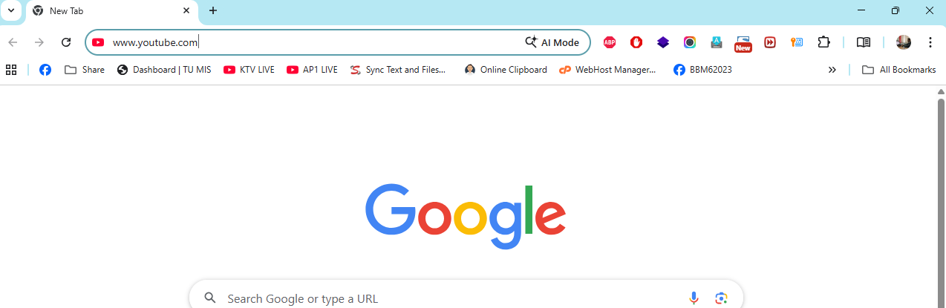Video provides a powerful way to help you prove your point. When you click Online Video, you can paste in the embed code for the video you want to add. You can also type a keyword to search online for the video that best fits your document.
To make your document look professionally produced, Word provides header, footer, cover page, and text box designs that complement each other. For example, you can add a matching cover page, header, and sidebar. Click Insert and then choose the elements you want from the different galleries.
Themes and styles also help keep your document coordinated. When you click Design and choose a new Theme, the pictures, charts, and SmartArt graphics change to match your new theme. When you apply styles, your headings change to match the new theme.

TOC
Contents
Acknowledgement I
List of Figures III
List of Tables IV
Abbreviation V
Chapter 1 1
1.1 Introduction 1
1.2 Objectives 2
1.3 Problem Statement 3
1.4 Scope 3
Chapter 2 4
2.1 System Design and Analysis 4
2.2 Methodology 5
Chapter 3 6
3.1 Literature Review 6
3.2 Study of Existing System 7
3.3 Functional Requirements 8
3.4 Non-Functional Requirements 8
References 9

List of Figures

TITLE Page No
Figure 0.1 Dr Govinda KC 1
Figure 0.1 Waterfall Model 4

List of Tables
Table 0-1 Name list of Students 6

Abbreviation

Chapter 1

1.1 Introduction
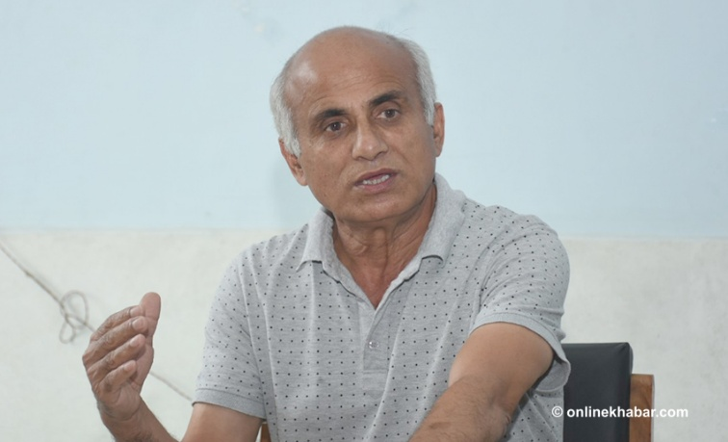
Video provides a powerful way to help you prove your point. When you click Online Video, you can paste in the embed code for the video you (Dharma Raj Poudel, 2022)want to add. You can also type a keyword to search online for the video that best fits your document.
Figure 0.1 Dr Govinda KC
To make your document look professionally produced, Word provides header, footer, cover page, and text box designs that complement each other. For example, you can add a matching cover page, header, and sidebar. Click Insert and then choose the elements you want from the different galleries.
Themes and styles also help keep your document coordinated. When you click Design and choose a new Theme, the pictures, charts, and SmartArt graphics change to match your new theme. When you apply styles, your headings change to match the new theme.
Save time in Word with new buttons that show up where you need them. To change the way a picture fits in your document, click it and a button for layout options appears next to it. When you work on a table, click where you want to add a row or a column, and then click the plus sign.
Reading is easier, too, in the new Reading view. You can collapse parts of the document and focus on the text you want. If you need to stop reading before you reach the end, Word remembers where you left off - even on another device.
Video provides a powerful way to help you prove your point. When you click Online Video, you can paste in the embed code for the video you want to add. You can also type a keyword to search online for the video that best fits your document.
To make your document look professionally produced, Word provides header, footer, cover page, and text box designs that complement each other. For example, you can add a matching cover page, header, and sidebar. Click Insert and then choose the elements you want from the different galleries.
Themes and styles also help keep your document coordinated. When you click Design and choose a new Theme, the pictures, charts, and SmartArt graphics change to match your new theme. When you apply styles, your headings change to match the new theme.
Save time in Word with new buttons that show up where you need them. To change the way a picture fits in your document, click it and a button for layout options appears next to it. When you work on a table, click where you want to add a row or a column, and then click the plus sign.

R
eading is easier, too, in the new Reading view. You can collapse parts of the document and focus on the text you want. If you need to stop reading before you reach the end, Word remembers where you left off - even on another device.
Video provides a powerful way to help you prove your point. When you click Online Video, you can paste in the embed code for the video you want to add. You can also type a keyword to search online for the video that best fits your document.
To make your document look professionally produced, Word provides header, footer, cover page, and text box designs that complement each other. For example, you can add a matching cover page, header, and sidebar. Click Insert and then choose the elements you want from the different galleries.

Themes and styles also help keep your document coordinated. When you click Design and choose a new Theme, the pictures, charts, and SmartArt graphics change to match your new theme. When you apply styles, your headings change to match the new theme.
Save time in Word with new buttons that show up where you need them. To change the way a picture fits in your document, click it and a button for layout options appears next to it. When you work on a table, click where you want to add a row or a column, and then click the plus sign.
Reading is easier, too, in the new Reading view. You can collapse parts of the document and focus on the text you want. If you need to stop reading before you reach the end, Word remembers where you left off - even on another device.

1.2 Objectives
Video provides a powerful way to help you prove your point. When you click Online Video, you can paste in the embed code for the video you want to add. You can also type a keyword to search online for the video that best fits your document.
To make your document look professionally produced, Word provides header, footer, cover page, and text box designs that complement each other. For example, you can add a matching cover page, header, and sidebar. Click Insert and then choose the elements you want from the different galleries.
Themes and styles also help keep your document coordinated. When you click Design and choose a new Theme, the pictures, charts, and SmartArt graphics change to match your new theme. When you apply styles, your headings change to match the new theme.
Save time in Word with new buttons that show up where you need them. To change the way a picture fits in your document, click it and a button for layout options appears next to it. When you work on a table, click where you want to add a row or a column, and then click the plus sign.
Reading is easier, too, in the new Reading view. You can collapse parts of the document and focus on the text you want. If you need to stop reading before you reach the end, Word remembers where you left off - even on another device.
Video provides a powerful way to help you prove your point. When you click Online Video, you can paste in the embed code for the video you want to add. You can also type a keyword to search online for the video that best fits your document.
To make your document look professionally produced, Word provides header, footer, cover page, and text box designs that complement each other. For example, you can add a matching cover page, header, and sidebar. Click Insert and then choose the elements you want from the different galleries.

1.3 Problem Statement
Themes and styles also help keep your document coordinated. When you click Design and choose a new Theme, the pictures, charts, and SmartArt graphics change to match your new theme. When you apply styles, your headings change to match the new theme.
Save time in Word with new buttons that show up where you need them. To change the way a picture fits in your document, click it and a button for layout options appears next to it. When you work on a table, click where you want to add a row or a column, and then click the plus sign.
Reading is easier, too, in the new Reading view. You can collapse parts of the document and focus on the text you want. If you need to stop reading before you reach the end, Word remembers where you left off - even on another device.
Video provides a powerful way to help you prove your point. When you click Online Video, you can paste in the embed code for the video you want to add. You can also type a keyword to search online for the video that best fits your document.
To make your document look professionally produced, Word provides header, footer, cover page, and text box designs that complement each other. For example, you can add a matching cover page, header, and sidebar. Click Insert and then choose the elements you want from the different galleries.

1.4 Scope
Themes and styles also help keep your document coordinated. When you click Design and choose a new Theme, the pictures, charts, and SmartArt graphics change to match your new theme. When you apply styles, your headings change to match the new theme.
Save time in Word with new buttons that show up where you need them. To change the way a picture fits in your document, click it and a button for layout options appears next to it. When you work on a table, click where you want to add a row or a column, and then click the plus sign.
Reading is easier, too, in the new Reading view. You can collapse parts of the document and focus on the text you want. If you need to stop reading before you reach the end, Word remembers where you left off - even on another device.

Chapter 2

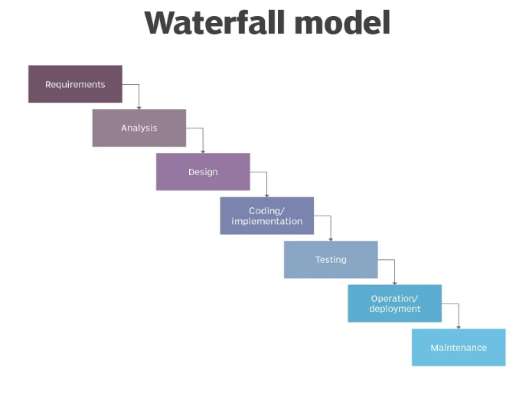
2.1 System Design and Analysis
Figure 0.1 Waterfall Model
Video provides a powerful way to help you prove your point. When you click Online Video, you can paste in the embed code for the video you want to add. You can also type a keyword to search online for the video that best fits your document.
To make your document look professionally produced, Word provides header, footer, cover page, and text box designs that complement each other. For example, you can add a matching cover page, header, and sidebar. Click Insert and then choose the elements you want from the different galleries.
Themes and styles also help keep your document coordinated. When you click Design and choose a new Theme, the pictures, charts, and SmartArt graphics change to match your new theme. When you apply styles, your headings change to match the new theme.
Save time in Word with new buttons that show up where you need them. To change the way a picture fits in your document, click it and a button for layout options appears next to it. When you work on a table, click where you want to add a row or a column, and then click the plus sign.
Reading is easier, too, in the new Reading view. You can collapse parts of the document and focus on the text you want. If you need to stop reading before you reach the end, Word remembers where you left off - even on another device.
Video provides a powerful way to help you prove your point. When you click Online Video, you can paste in the embed code for the video you want to add. You can also type a keyword to search online for the video that best fits your document.
To make your document look professionally produced, Word provides header, footer, cover page, and text box designs that complement each other. For example, you can add a matching cover page, header, and sidebar. Click Insert and then choose the elements you want from the different galleries.
Themes and styles also help keep your document coordinated. When you click Design and choose a new Theme, the pictures, charts, and SmartArt graphics change to match your new theme. When you apply styles, your headings change to match the new theme.
Save time in Word with new buttons that show up where you need them. To change the way a picture fits in your document, click it and a button for layout options appears next to it. When you work on a table, click where you want to add a row or a column, and then click the plus sign.

Reading is easier, too, in the new Reading view. You can collapse parts of the document and focus on the text you want. If you need to stop reading before you reach the end, Word remembers where you left off - even on another device.
Video provides a powerful way to help you prove your point. When you click Online Video, you can paste in the embed code for the video you want to add. You can also type a keyword to search online for the video that best fits your document.
To make your document look professionally produced, Word provides header, footer, cover page, and text box designs that complement each other. For example, you can add a matching cover page, header, and sidebar. Click Insert and then choose the elements you want from the different galleries.
Themes and styles also help keep your document coordinated. When you click Design and choose a new Theme, the pictures, charts, and SmartArt graphics change to match your new theme. When you apply styles, your headings change to match the new theme.

2.2 Methodology
Save time in Word with new buttons that show up where you need them. To change the way a picture fits in your document, click it and a button for layout options appears next to it. When you work on a table, click where you want to add a row or a column, and then click the plus sign.
Reading is easier, too, in the new Reading view. You can collapse parts of the document and focus on the text you want. If you need to stop reading before you reach the end, Word remembers where you left off - even on another device.

Chapter 3

3.1 Literature Review
Video provides a powerful way to help you prove your point. When you click Online Video, you can paste in the embed code for the video you want to add. You can also type a keyword to search online for the video that best fits your document.
To make your document look professionally produced, Word provides header, footer, cover page, and text box designs that complement each other. For example, you can add a matching cover page, header, and sidebar. Click Insert and then choose the elements you want from the different galleries.
Themes and styles also help keep your document coordinated. When you click Design and choose a new Theme, the pictures, charts, and SmartArt graphics change to match your new theme. When you apply styles, your headings change to match the new theme.
Save time in Word with new buttons that show up where you need them. To change the way a picture fits in your document, click it and a button for layout options appears next to it. When you work on a table, click where you want to add a row or a column, and then click the plus sign.
Reading is easier, too, in the new Reading view. You can collapse parts of the document and focus on the text you want. If you need to stop reading before you reach the end, Word remembers where you left off - even on another device.
Table 0-1 Name list of Students
SN | Name | Address | Email | Phone
12 | Aarati Kumari | Balkhu, KTm
1 | Dharma Raj Poudel | Dakshinkali-07 | Dharmarajpoudel@gmail.com | 98511637856
2 | Jyoti Khadka | Bhaktapur Thimi
11 | Krishal Khadka | Biruwa Bhaktapur
9 | Kritika Khatri | Tikathali, Lalitpur
6 | Sabina Danuwar | Pepsikola, Ktm
4 | Sakshi Mandal | Tinkune, Koteshwor
10 | Sangam Bhatta | Jagati, Bhaktapur
3 | Sanjita Nepali | Dallu, Kathmandu
5 | Shobha Shrestha | Pepsikola, Kathmandu
8 | Sneha Pathak | Mid Baneshwor
13 | Sumita Tamang | Maharajung, Ktm
7 | Sunistha Shrestha | Bode, Bhaktapur

Video provides a powerful way to help you prove your point. When you click Online Video, you can paste in the embed code for the video you want to add. You can also type a keyword to search online for the video that best fits your document.
To make your document look professionally produced, Word provides header, footer, cover page, and text box designs that complement each other. For example, you can add a matching cover page, header, and sidebar. Click Insert and then choose the elements you want from the different galleries.
Themes and styles also help keep your document coordinated. When you click Design and choose a new Theme, the pictures, charts, and SmartArt graphics change to match your new theme. When you apply styles, your headings change to match the new theme.
Save time in Word with new buttons that show up where you need them. To change the way a picture fits in your document, click it and a button for layout options appears next to it. When you work on a table, click where you want to add a row or a column, and then click the plus sign.
Reading is easier, too, in the new Reading view. You can collapse parts of the document and focus on the text you want. If you need to stop reading before you reach the end, Word remembers where you left off - even on another device.
Video provides a powerful way to help you prove your point. When you click Online Video, you can paste in the embed code for the video you want to add. You can also type a keyword to search online for the video that best fits your document.
To make your document look professionally produced, Word provides header, footer, cover page, and text box designs that complement each other. For example, you can add a matching cover page, header, and sidebar. Click Insert and then choose the elements you want from the different galleries.

3.2 Study of Existing System
Themes and styles also help keep your document coordinated. When you click Design and choose a new Theme, the pictures, charts, and SmartArt graphics change to match your new theme. When you apply styles, your headings change to match the new theme.
Save time in Word with new buttons that show up where you need them. To change the way a picture fits in your document, click it and a button for layout options appears next to it. When you work on a table, click where you want to add a row or a column, and then click the plus sign.
Reading is easier, too, in the new Reading view. You can collapse parts of the document and focus on the text you want. If you need to stop reading before you reach the end, Word remembers where you left off - even on another device.
Video provides a powerful way to help you prove your point. When you click Online Video, you can paste in the embed code for the video you want to add. You can also type a keyword to search online for the video that best fits your document.
To make your document look professionally produced, Word provides header, footer, cover page, and text box designs that complement each other. For example, you can add a matching cover page, header, and sidebar. Click Insert and then choose the elements you want from the different galleries.
Themes and styles also help keep your document coordinated. When you click Design and choose a new Theme, the pictures, charts, and SmartArt graphics change to match your new theme. When you apply styles, your headings change to match the new theme.
Save time in Word with new buttons that show up where you need them. To change the way a picture fits in your document, click it and a button for layout options appears next to it. When you work on a table, click where you want to add a row or a column, and then click the plus sign.
Reading is easier, too, in the new Reading view. You can collapse parts of the document and focus on the text you want. If you need to stop reading before you reach the end, Word remembers where you left off - even on another device.
Video provides a powerful way to help you prove your point. When you click Online Video, you can paste in the embed code for the video you want to add. You can also type a keyword to search online for the video that best fits your document.
To make your document look professionally produced, Word provides header, footer, cover page, and text box designs that complement each other. For example, you can add a matching cover page, header, and sidebar. Click Insert and then choose the elements you want from the different galleries.
Themes and styles also help keep your document coordinated. When you click Design and choose a new Theme, the pictures, charts, and SmartArt graphics change to match your new theme. When you apply styles, your headings change to match the new theme.
Save time in Word with new buttons that show up where you need them. To change the way a picture fits in your document, click it and a button for layout options appears next to it. When you work on a table, click where you want to add a row or a column, and then click the plus sign.
Reading is easier, too, in the new Reading view. You can collapse parts of the document and focus on the text you want. If you need to stop reading before you reach the end, Word remembers where you left off - even on another device.

3.3 Functional Requirements
Video provides a powerful way to help you prove your point. When you click Online Video, you can paste in the embed code for the video you want to add. You can also type a keyword to search online for the video that best fits your document.
To make your document look professionally produced, Word provides header, footer, cover page, and text box designs that complement each other. For example, you can add a matching cover page, header, and sidebar. Click Insert and then choose the elements you want from the different galleries.
Themes and styles also help keep your document coordinated. When you click Design and choose a new Theme, the pictures, charts, and SmartArt graphics change to match your new theme. When you apply styles, your headings change to match the new theme.

3.4 Non-Functional Requirements
Save time in Word with new buttons that show up where you need them. To change the way a picture fits in your document, click it and a button for layout options appears next to it. When you work on a table, click where you want to add a row or a column, and then click the plus sign.
Reading is easier, too, in the new Reading view. You can collapse parts of the document and focus on the text you want. If you need to stop reading before you reach the end, Word remembers where you left off - even on another device.

References

References
Dharma Raj Poudel, A. M. (2022). Net Centric Computing. Kathmandu: KEC.

VIDEO is and df kkk

