Small user guide for tier3app

1.Start page 2

2.Books 3

3.Users 4

4.History 5

## 1.Start page

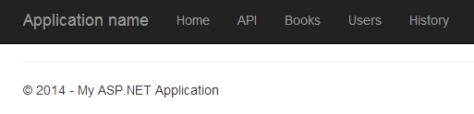

This is starting page. It doesn’t contain any information, but links.

## 2.Books

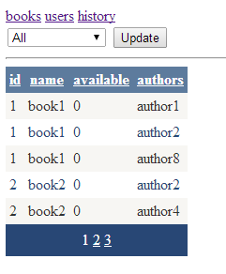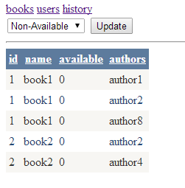

Books page. Contains grid, that allows: sorting, filtering, paging.

## 3.Users

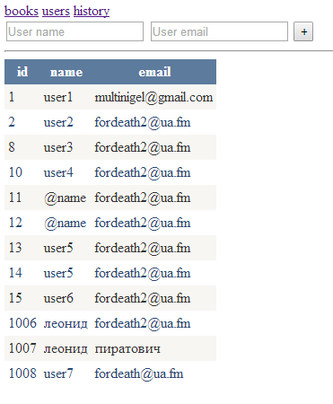

Users page. You could add a user using add-form.

## 4.History

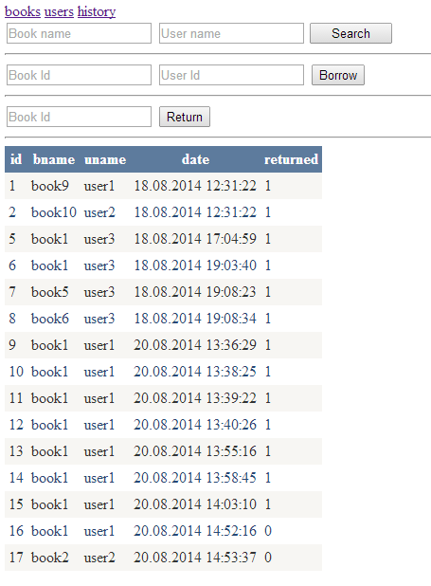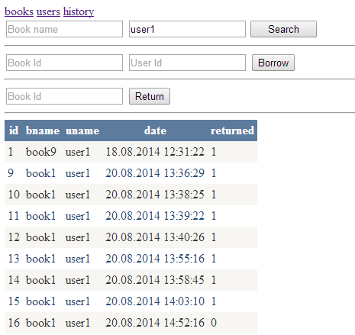History page. Contains: search-form ( to track book or user), borrow-form (to borrow book), return-form (to return book).