PROGRAMS AVAILABLE
Online version: free POSTNET / PLANET

Classic version: $15 POSTNET / PLANET
- Stand alone (off line) version

Premium version: $25 POSTNET / PLANET
- Stand alone (off line) version with debugger

Format: Internet delivery (ZIP file)

TO ORDER

on-line: www.triskelion-ltd.com

PayPal (credit cards accepted)

(or)

send payment and mailing address to:
Triskelion Ltd
PO Box 153
Bethel CT 06801-0153
Individual use licenses and institutional use licenses for the Stand Alone, and the Premium browser based PLANET decoder software programs are available from Triskelion Ltd (www.triskelion-ltd.com).

LEGAL NOTICES (the fine print)
The contents of this brochure and Triskelion Ltd (www.triskelion-ltd.com) software for decoding POSTNET barcodes are copyright (c) by Triskelion Ltd., 1991-2017. POSTNET, USPS, and ZIP are registered trademarks of the United States Postal Service. IBM is a registered trademark of International Business Machines

SAMPLE ZIP CODE FIELD TYPES
The ZIP code 12345-6789-47 is shown below in each of the field types which represent different portions of the ZIP code. The checksum is always reported within ( ) and the barcode is decoded beneath. These samples can be used to practice decoding POSTNET barcodes using this software. Currently 62 bars is standard.

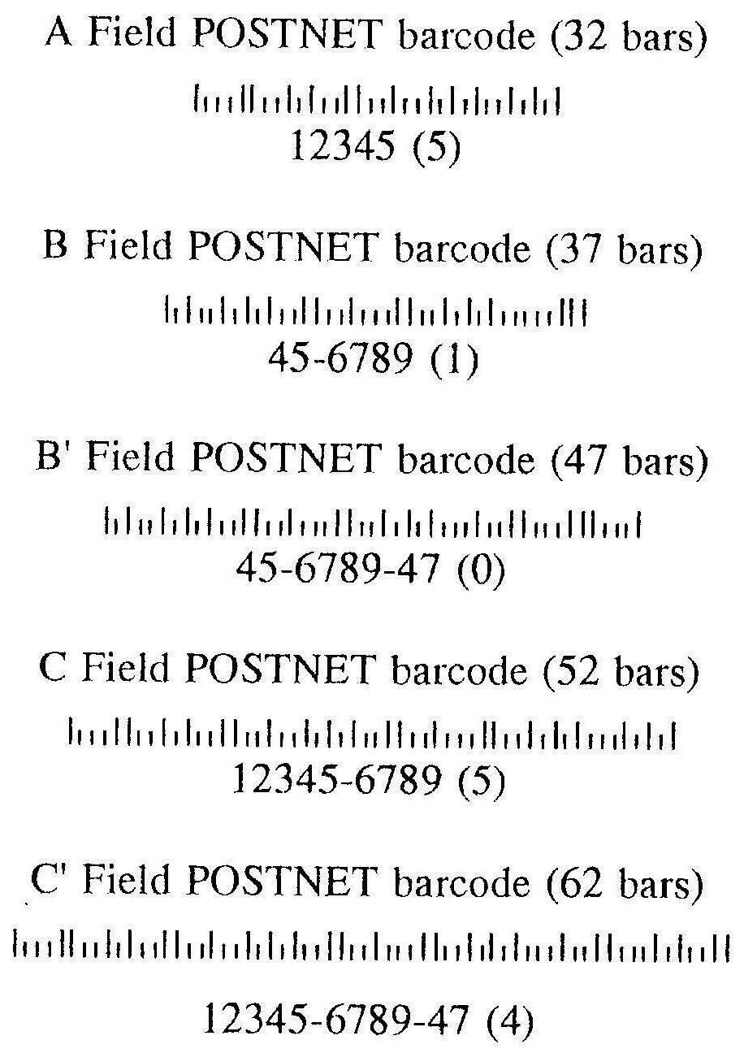


TRISKELION LTD.

POSTNET

Decoding Software

Stand Alone Version for

Personal Computers

Manual and Instructions

by Douglas B. Quine, Ph.D.

POSTNET DECODER SOFTWARE
POSTNET decoding software enables you to type in a United States Postal Service (USPS) POSTNET barcode using "1" and "." symbols and receive in response the decoded ZIP code. If the POSTNET barcode contains formatting errors, the program displays these errors. The installation instructions, user manual, and barcode explanations for A Field, B Field, B' Field, C field, C' Field, 5 digit, 9 digit, and 11 digit barcodes are shown below.

USPS POSTNET CODE DESCRIBED
USPS POSTNET barcodes encode address ZIP codes on mail for automated mail processing. Business reply barcodes are preprinted by mailers; others are applied by the USPS, by mailers, or by presort bureaus. POSTNET codes must conform to USPS standards which are described in the Domestic Mail Manual. The barcodes must have tall bars in the first and last positions, they must have a checksum which when added to the other digits of the ZIP code totals a multiple of ten, and each digit of the ZIP code must consist of 2 tall and 3 short bars according to this scheme (where "1" is a tall bar and "." a short one):
Digit Code Digit Code
1 ...11 2 ..1.1
3 ..11. 4 .1..1
5 .1.1. 6 .11..
7 1...1 8 1..1.
9 1.1.. 0 11...
Several different barcode lengths (field types) encode different length ZIP codes.

PROGRAM INSTALLATION
Hard Disk Installation (most efficient): Insert the POSTNET disk in your floppy disk drive. The programs are installed on your hard disk by dragging all files from the floppy to the hard drive or using the command: COPY A:*.* C:

Floppy Disk Installation: Insert the POSTNET disk in your floppy disk drive (this must be done every time you run the program).

PROGRAM VERSIONS
The standard version (POSTNET.EXE) decodes the POSTNET barcode that is entered into the computer.
The debug version (POSTNETB.EXE) also reports alternate solutions if the bars are shifted right one by one. This helps diagnose barcode reader errors (or missing bar fragments).

PROGRAM OPERATION
Windows: Double click on the program name (POSTNET or POSTNETB) to start.
DOS: type the program name (POSTNET or POSTNETB) and press RETURN to start.
ALL systems: The instructions are summarized upon the screen. Type the number one "1" for each tall bar and a period "." for each short bar to enter the barcode. Press RETURN for the answer. The decoded barcode and barcode type are then reported and another barcode can be entered. Press RETURN on an empty line to exit the program.

ERROR MESSAGES EXPLAINED
If the program reports an error, reenter the barcode to be sure that a data entry error was not the cause of the message. Human errors are more common than POSTNET barcode errors! When barcodes are the wrong length, when they are missing start or stop bars, or when the checksum is incorrect, you may be attempting to decode a fragment of a longer barcode.
The debug program (POSTNETB.EXE) is helpful in decoding barcode fragments since it decode the barcode and then attempts again with the view shifted right one bar at a time until each of the 5 cluster positions has been tested. Sometimes a barcode fragment lacking some initial bars can be read this way.
ERROR: ___ bars at digit ____ [POSTNET codes should have 2 tall bars in each cluster of 5]
ERROR: Checksum ___ is not modulo 10 [the digits in all POSTNET codes add to a multiple of 10]
ERROR: First bar is short [POSTNET codes should start with a tall bar]
ERROR: Last bar is short [POSTNET codes should end with a tall bar]
ERROR: Position ___ decodes as ___ [POSTNET only encodes the digits 0 to 9; use of improper bar patterns may cause reports of decode errors which are shown as "*" in the ZIP code report]
PARSE: Nonstandard barcode of length ___ [partial POSTNET codes are flagged by this message]
ZIP FRAGMENT: ___ [digits decoded from partial]

