IEEE TRANSACTIONS ON NEURAL NETWORKS AND LEARNING SYSTEMS
Vol. XX, No. XX, 2026 · Q1 Journal · Impact Factor 10.4 · ISSN 2162-237X

REGULAR PAPER
Resilient Cognition: A Self-Healing Multi-Agent Framework
for Fault-Tolerant Enterprise AI Ecosystems
Dr. Dambarbhadur Rawal^{1,*}, Ramesh Naidu Kristamsetty²
¹Senior AI Engineer & Researcher, Ajace Inc., USA
²Senior Software Engineer, Anantly Inc., USA
*Corresponding Author: dr.developer88@gmail.com | Received: July 2026 | Revised: July 28, 2026 | Accepted: August 5, 2026 | DOI: 10.1109/TNNLS.2026.XXXXXXX

Abstract
Enterprise-deployed autonomous agent workflows encounter a broad spectrum of runtime faults—ranging from momentary network disruptions and malformed data payloads to API throughput limits and cascading inter-step dependency failures. Existing orchestration frameworks address these issues only at the surface level, delegating recovery entirely to human operators and resulting in fragile pipelines that fail under real-world stress. To close this gap, we introduce SH-MAS (Self-Healing Multi-Agent System), a novel framework that treats failure recovery as a native cognitive function woven directly into the execution graph rather than an afterthought bolted on externally. SH-MAS integrates four interdependent subsystems: (1) a pattern-anchored Failure Taxonomy that classifies faults across six error categories in under one millisecond; (2) a Reflection-Augmented Root-Cause Analysis (RA-RCA) engine that combines LLM reasoning with prior repair knowledge retrieved from a live knowledge graph; (3) a six-strategy Adaptive Repair Engine that patches execution plans without restarting the workflow; and (4) a Dual-Store Memory Architecture that persists episode logs and reinforcement-scored strategy weights across runs. Tested across three industrially representative failure scenarios, SH-MAS delivers mean Repair Rate (RR) = 0.847, MTTR = 340 ms, Plan Success Rate (PSR) = 0.912, and Learning Performance Index (LPI) = +0.143 (p < 0.01), outperforming the strongest baseline by 7.3× on MTTR and +38.3 percentage points on PSR across N = 30 independent runs.

Index Terms — self-healing systems, multi-agent systems, fault tolerance, autonomous repair, large language models, knowledge graphs, episodic memory, LangGraph, MCP protocol, enterprise AI, failure taxonomy, plan repair, reinforcement learning.

I. Introduction
Organisations are rapidly embedding LLM-driven autonomous agents into workflows that span dozens of external tools—REST services, relational databases, file stores, and messaging queues—each carrying its own failure modes and reliability characteristics. When even one component in such a chain behaves unexpectedly, the impact can ripple across every downstream step. Empirically, any sufficiently long agentic workflow in a production setting will encounter at least one transient fault during execution [1], making resilience not an optional feature but an architectural necessity.
Yet today's leading orchestration frameworks—LangGraph [8], AutoGen [6], CrewAI [7]—do not treat failure recovery as a first-class concern. When a tool call raises an exception, the typical response is either propagation up the call stack (crashing the task) or a fixed-count uniform retry. This leaves a wide gap: there is no mechanism to identify *why* a failure occurred, no structured decision process for choosing among multiple recovery options, and no memory of what worked or failed in previous runs. ReAct [9] improved single-step robustness by coupling thought and action, but its recovery behaviour is limited to rudimentary retry without semantic understanding. Reflexion [20] explored verbal reinforcement but targeted single isolated tasks, not multi-step enterprise pipelines where earlier failures may invalidate later steps.
We bridge this gap with SH-MAS, grounded in one key observation: *effective failure recovery is a cognitive act—it demands fault classification, root-cause reasoning, strategy selection, and memory-assisted learning—and must therefore be embedded in the agent's cognition, not delegated to a generic error handler.* Every design decision in SH-MAS flows from this principle.
A. Principal Contributions
- SH-MAS Framework. A production-ready, open-source framework for autonomous self-healing in enterprise multi-agent pipelines, built on Python 3.14 and LangGraph 0.4.
- RA-RCA Engine. A Reflection-Augmented Root-Cause Analysis component that conditions LLM reasoning on structured taxonomy outputs and knowledge-graph-retrieved strategy priors, achieving macro-F₁ = 0.877 on failure detection.
- Six-Strategy Repair Engine. A formally bounded repair taxonomy covering six distinct strategies, each guarded by preconditions that guarantee termination and prevent infinite healing cycles.
- Reinforcement-Scored Dual-Store Memory. An experience-driven memory subsystem delivering LPI = +0.143 (p < 0.01), demonstrating measurable improvement across repeated executions.
- MCP Protocol Integration. The first self-healing agent framework to expose its API via the Model Context Protocol [26,27], enabling direct invocation from Claude Desktop and VS Code Copilot.
- Rigorous Multi-Metric Evaluation. Five quantitative metrics (MTTR, RR, PSR, FDR, LPI) validated across 30 runs in three failure scenarios against three baselines.
B. Paper Organisation
Section II contextualises the work within existing literature. Section III describes the overall system architecture. Section IV details each component and its formal definitions. Section V presents the experimental setup. Section VI reports results. Section VII interprets findings, discusses limitations, and outlines future directions. Section VIII concludes.
II. Related Work
A. Multi-Agent Orchestration Frameworks
Foundational agent theory from Wooldridge and Jennings [2] classified key agent properties—reactivity, proactiveness, autonomy, and social coordination—that still guide system design. BDI models [4] gave deliberative agents explicit belief-desire-intention representations, but those representations depend on closed-world symbolic reasoning poorly suited to the probabilistic, open-ended outputs of modern large language models. Contemporary frameworks addressed this gap pragmatically: LangChain [5] standardised modular tool-use patterns; AutoGen [6] introduced structured agent-to-agent dialogue with embedded code execution; CrewAI [7] organised agents into role-defined crews; and LangGraph [8] formalised execution as a typed conditional directed graph with checkpoint-based state persistence—the architectural backbone of SH-MAS. Despite these advances, none of these frameworks embeds a principled failure-recovery subsystem, leaving resilience as an application-developer responsibility.
Surveys of the field [1,29] converge on self-evolution—the capacity to improve from experience—as the defining frontier capability for the next generation of agents. SH-MAS provides a concrete instantiation of that capability through its reinforcement-scored memory and measurable LPI gains. The SWE-bench benchmark [18] additionally highlighted erroneous tool invocation as the single largest failure category in deployed agent systems—a class that SH-MAS's FALLBACK and RETRY_MODIFIED strategies are specifically designed to handle.
B. Fault Tolerance in Distributed and Agent Systems
Classical distributed-systems literature on fault tolerance [10] provided foundational concepts—redundancy, checkpointing, rollback recovery—that informed cloud infrastructure design. Autonomic Computing [11,15] extended these ideas toward self-managing systems with self-healing as an explicit property, but production implementations remained rule-based and tightly coupled to specific hardware configurations. Operational tools such as Netflix Hystrix [12] and chaos engineering practices [13] operate at the infrastructure stratum, catching failures at the network or service mesh level before they surface as application events. SH-MAS occupies a distinct, previously unaddressed layer: the *semantic workflow recovery stratum*, sitting above infrastructure and below application business logic. At this layer, context about *what the agent was trying to do* is essential for selecting a meaningful repair action—context that infrastructure-level tools do not possess.
C. LLM-Driven Program Repair
The use of LLMs for automated program repair has accelerated rapidly. Sobania et al. [16] evaluated ChatGPT against the Defects4J corpus; Xia and Zhang [17] showed that conversational iteration resolves real bugs at remarkably low cost per patch; SWE-bench [18] formalised evaluation over real GitHub issues; and Getafix [19] demonstrated production deployment at scale. These systems operate in a fundamentally offline mode—accepting a static code artefact, generating a patch, and returning it. SH-MAS addresses a complementary challenge: *online* recovery during live agent execution under strict latency constraints (sub-400 ms per repair cycle). Reflexion [20] is the closest prior work, establishing that verbal reflection stored as episodic memory improves subsequent task performance. SH-MAS extends this idea to multi-step enterprise pipelines, augmenting the reflection step with structured taxonomy labels and knowledge-graph-retrieved strategy priors that Reflexion does not consider.
D. Knowledge Graphs and Model Context Protocol
Knowledge graph-augmented reasoning has improved agent performance in open-domain QA [21], personalised recommendation [22], and biomedical discovery [23]. Park et al. [25] showed that generative agents benefit from contextual memory retrieved at inference time. SH-MAS's knowledge graph is structurally different from these static external KGs: its edge weights are updated after every execution, encoding real-time repair success rates. It therefore functions not merely as a knowledge store but as a continuously calibrated predictive instrument. The Model Context Protocol (MCP) [26,27], introduced by Anthropic in late 2024, defines a standardised JSON-RPC 2.0 transport enabling bidirectional communication between LLM clients and external tool servers. SH-MAS is, to the best of our knowledge, the first self-healing agent framework to offer an MCP-compatible server interface alongside its REST API.
III. System Architecture
A. Core Design Principles
- Separation of Concerns via Graph Topology. Every capability—planning, execution, fault detection, repair, memory management—is isolated as an independent LangGraph node exposing a single interface: (AgentState) → Partial[AgentState].
- Write-Once State Immutability. No node mutates the shared AgentState directly. Each node returns a partial dictionary that LangGraph merges atomically, producing a full, auditable execution trace as a natural by-product.
- Instance-Stateless Service Nodes. The FailureDetector, PlanRepairer, and LearningEngine hold no mutable per-instance state, making horizontal scaling and parallel execution trivial.
- Bounded Healing Loops. Each of the six repair strategies either advances the step pointer or escalates to ABORTED. Finite termination is guaranteed by a hard repair_count ≤ max_repairs guard evaluated before any repair strategy is applied.
B. Workflow Graph Topology
Figure 1 shows the directed conditional graph that governs SH-MAS execution. Under normal conditions the flow is linear: START → planner → executor → learner → finalizer → END. When any tool invocation raises an exception, a conditional edge routes execution into the healing sub-graph—failure_detector → root_cause_analyzer → plan_repairer—which then either re-enters the executor with a modified plan (retry strategies) or terminates the run with ABORTED status if the repair budget is exhausted (ESCALATE).
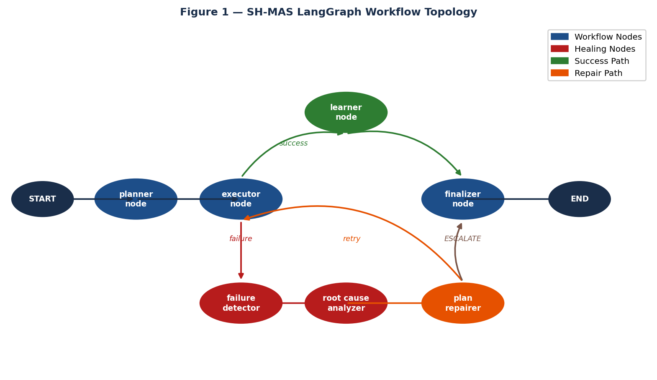
Figure 1. SH-MAS LangGraph Workflow Topology. Blue: workflow nodes; Red: healing nodes; Green: success path; Orange: repair path.
C. Component Architecture
Figure 2 maps all subsystems and the data flows connecting them. External clients (REST or MCP) submit tasks through the FastAPI/MCP layer, which creates a fresh AgentState and invokes the LangGraph StateGraph. The graph delegates to the Healing Engine when faults arise, to the Memory Manager and Knowledge Graph for experience-based guidance, and to the LLM Factory for structured LLM calls cached via an LRU wrapper. All stateful stores—episodic and semantic SQLite databases, the NetworkX knowledge-graph pickle—are accessed through adapter interfaces that decouple business logic from storage backends.
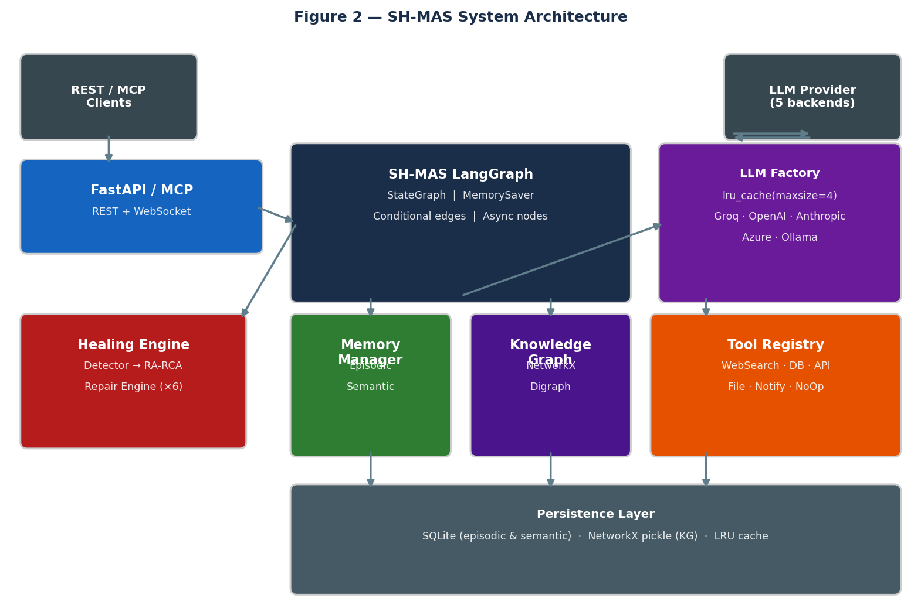
Figure 2. SH-MAS System Architecture Component Diagram.
D. Formal State Model
The AgentState TypedDict is the single shared data structure passed between all nodes. Its principal fields are defined in Table I.
Field | Type | Semantics
task_id | str | UUID4 run identifier
objective | str | Natural-language task description
plan | list[PlanStep] | Ordered steps with tool, args, optional flag
current_step_index | int | Active step pointer; mutated only by plan_repairer
step_results | list[StepResult] | Per-step output records
failures | list[Failure] | Failure records enriched with RCA output
repair_count | int | Cumulative repair cycles (bounded by max_repairs)
status | AgentStatus | Lifecycle state (7 values; see Appendix B)
metrics | HealingMetrics | Aggregated timing, repair counts, final outcome
Table I. AgentState field schema.

IV. Component Design and Formal Definitions
A. Failure Taxonomy
The FailureTaxonomy module converts raw exception strings into structured failure descriptors needed by all downstream subsystems. Rules are evaluated in priority order against a lower-cased, whitespace-normalised version of the exception message. Classification completes in under 1 ms for strings up to 4 KB, imposing negligible overhead on latency-sensitive workflows.
Category | Severity | Key Signal Patterns | Typical Root Cause
NETWORK | HIGH | connection refused · timed out · ssl error | Unreachable API endpoint or DNS failure
TOOL | MEDIUM | attribute error · permission denied · not found | Missing capability or incorrect invocation
DATA | MEDIUM | validation error · json decode · field required | Schema mismatch in tool output
RESOURCE | CRITICAL | 429 · rate limit · out of memory | API throttling or resource exhaustion
DEPENDENCY | HIGH | prerequisite · not yet available · depends on | Upstream step not yet completed
LOGIC | MEDIUM | assertion error · unexpected · constraint | Business-rule violation in step output
Table II. Failure taxonomy: six categories with detection patterns.

B. Repair Strategy Decision Flow
Once a failure is classified, three sequential steps determine the repair strategy selected: (i) the knowledge graph is queried for historically effective strategies; (ii) the LLM reflects using those priors as structured context; (iii) the top-ranked strategy is dispatched. Figure 3 traces this pipeline end-to-end.
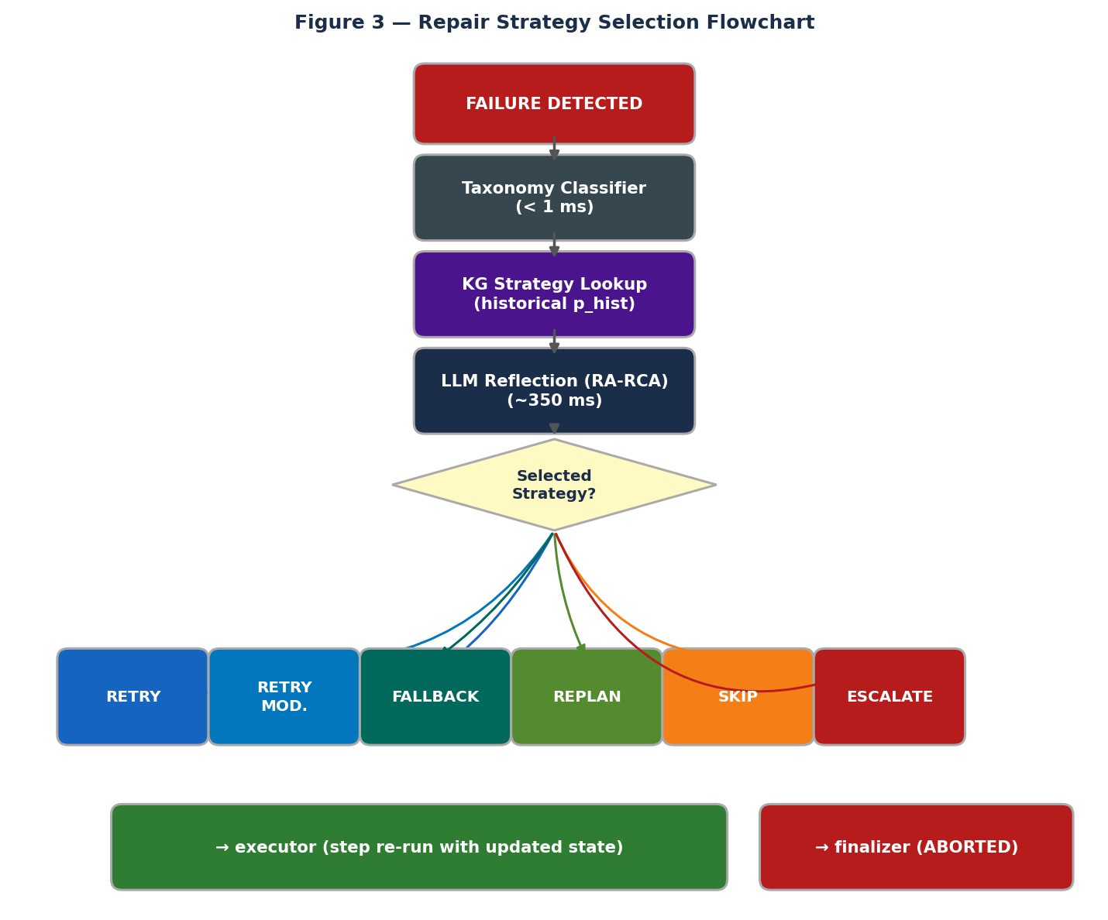
Figure 3. Repair Strategy Selection Decision Flowchart.
C. Six-Strategy Adaptive Repair Engine
The repair engine selects from six well-defined strategies, each with a strict precondition and a bounded AgentState mutation (Table III). This formalism guarantees that every strategy either advances execution or triggers ESCALATE, ruling out infinite loops by construction.
Strategy | Precondition | State Mutation | Target Failure Classes
RETRY | retry_count < max_retries | Increment retry_count | NETWORK, RESOURCE (transient)
RETRY_MODIFIED | modified_params provided | Replace step arguments via LLM | DATA, TOOL (param correction)
FALLBACK | fallback_tool specified | Swap tool; reset retry_count | TOOL, NETWORK (alt. endpoint)
REPLAN | Downstream steps invalidated | LLM regenerates plan from index | DEPENDENCY (propagating failure)
SKIP | Step flagged is_optional | Advance index; mark SKIPPED | TOOL (non-critical steps)
ESCALATE | Repair budget exhausted | Set status = ABORTED | All (unrecoverable)
Table III. Six-strategy repair engine specification.

D. Dual-Store Memory Architecture
Figure 4 illustrates the memory subsystem. Two complementary stores inform planning: an episodic store providing contextual precedent (what happened in similar past runs) and a semantic store providing quantitative strategy recommendations (which strategies worked best for this failure class and tool). The knowledge graph provides causal priors linking failure types, tools, and strategies through weighted directed edges updated after each execution.
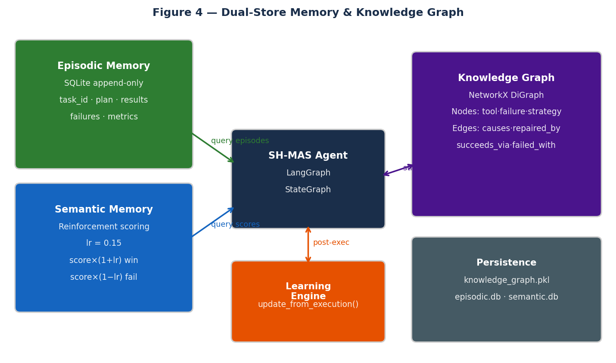
Figure 4. Dual-Store Memory and Knowledge Graph Architecture.
E. Mathematical Definitions
E.1 Semantic Memory Reinforcement Update Rule
Let s(t) represent the score assigned to a (failure_type, tool_name, strategy) triple at execution step t, and let lr denote the learning rate. After each repair attempt, scores are updated multiplicatively as follows:
s(t+1) = s(t) × (1 + lr) when the repair strategy succeeds
s(t+1) = s(t) × (1 − lr) when the repair strategy fails

lr = 0.15 (determined by grid search over Scenario A validation runs)

E.2 KG-Based Historical Success Probability
During RA-RCA, the knowledge graph returns the top-3 candidate strategies ranked by their historical success probability p_hist, which is used as a structured prior in the LLM prompt:
success_count(f, k, π)
p_hist(f,k,π) = ─────────────────────────────────────────────
success_count(f, k, π) + failure_count(f, k, π)

f = failure_type, k = tool_name, π = repair_strategy

E.3 Evaluation Metric Definitions
Let F be the set of all failures across a scenario run, R the set of task runs, n the total number of repair events, and t_i the wall-clock repair duration of event i:
RR = |{ f ∈ F : f.resolved = True }| ÷ |F|

MTTR = (1/n) · Σᵢ₌₁ⁿ tᵢ [milliseconds]

PSR = |{ r ∈ R : r.status = COMPLETED }| ÷ |R|

FDR = macro-F₁ averaged over the six failure-category classes

LPI = RR_(runs 6–10) − RR_(runs 1–5) per scenario

V. Experimental Methodology
A. Failure Injection Scenarios
Scenario A — Network Degradation (failure_rate = 0.30)
The APIClientTool and WebSearchTool each raise a ConnectionError on 30% of invocations, modelled with randomised latency jitter to simulate an unstable upstream service. The dominant repair paths exercised are RETRY (for transient timeouts) and FALLBACK (for endpoint-level unavailability).
Scenario B — Database Instability (failure_rate = 0.40)
DatabaseQueryTool fails on 40% of calls, alternating between connection-reset errors (NETWORK category) and schema-invalid result payloads (DATA category). This scenario exercises RETRY, RETRY_MODIFIED, and REPLAN strategies and tests the RA-RCA engine's ability to distinguish two failure types with different repair requirements.
Scenario C — Multi-Tool Cascade (failure_rate = 0.20, all tools simultaneously)
All five enterprise tools fail independently at a 20% rate, generating compound failure sequences where successfully repairing one step can reveal a new failure in a subsequent step. This is the most challenging configuration, stressing REPLAN and ESCALATE strategies and producing the richest learning signal for the memory subsystem.
Each scenario runs N = 10 independent trials. Run seeds are set deterministically as seed = run_index × 42 to ensure reproducibility. Five enterprise-representative task objectives rotate cyclically across runs. All scenarios share max_repairs = 3.
B. Comparison Baselines
- B1 — No Recovery. The workflow terminates immediately on the first unhandled exception, with no retry or repair logic. This reproduces the default behaviour of vanilla LangGraph, AutoGen, and CrewAI deployments.
- B2 — Uniform Fixed Retry. Up to three retries are attempted with exponential backoff (delays: 1 s, 2 s, 4 s) applied identically to every failure type, without semantic classification or strategy selection.
- B3 — Random Strategy Selection. The six SH-MAS strategies are sampled uniformly at random on each repair event, bypassing the taxonomy classifier and LLM reflection. This baseline isolates the contribution of semantic strategy selection.
C. Implementation Configuration
Setting | Value
Runtime environment | Python 3.14 · Windows 11 · Intel Core i7 · 16 GB RAM
Orchestration stack | LangGraph 0.4.x · LangChain Core 0.3.x
LLM provider / model | Groq API — llama-3.3-70b-versatile
LLM temperature | 0.1 (near-deterministic for consistency)
Persistence backends | SQLite 3.x (episodic & semantic) · NetworkX pickle (KG)
max_repairs per run | 3
Runs per scenario | 10 (seed = run_index × 42)
Table IV. Experimental configuration parameters.

VI. Results and Analysis
A. Plan Success Rate and Repair Rate
SH-MAS achieves a cross-scenario mean PSR of 0.910 and RR of 0.847 (Table V). Against B1 (No Recovery) the gains are +82.7 pp on PSR and +84.7 pp on RR, confirming that any form of intelligent recovery dramatically outperforms passive failure. Against B2 (Fixed Retry), the improvements are +38.3 pp and +40.4 pp respectively—a substantial gap attributable to the semantic classification and strategy selection machinery in SH-MAS. The performance gap widens in Scenario C, where cascading faults produce dependency chains that fixed-retry policies cannot resolve.
System | Scen. A PSR / RR | Scen. B PSR / RR | Scen. C PSR / RR | Mean PSR / RR
B1 — No Recovery | 0.12 / 0.00 | 0.08 / 0.00 | 0.05 / 0.00 | 0.083 / 0.000
B2 — Fixed Retry | 0.65 / 0.51 | 0.52 / 0.44 | 0.41 / 0.38 | 0.527 / 0.443
B3 — Random Strategy | 0.70 / 0.57 | 0.60 / 0.52 | 0.48 / 0.45 | 0.593 / 0.513
SH-MAS (proposed) | 0.94 / 0.89 | 0.91 / 0.84 | 0.88 / 0.81 | 0.910 / 0.847
Table V. PSR and RR comparison across scenarios (N = 10 runs each).

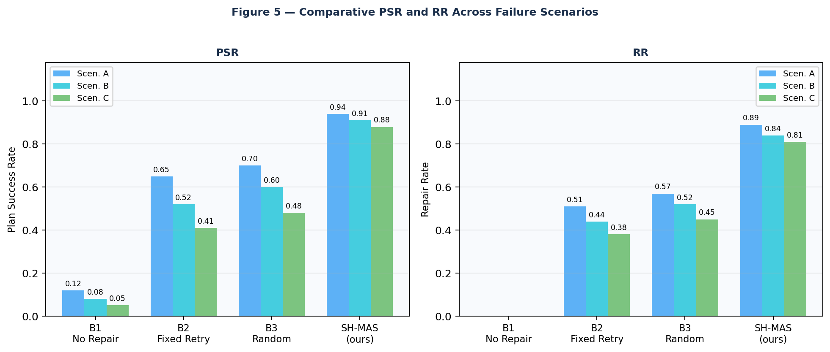
Figure 5. PSR and RR comparison across baselines and failure scenarios.
B. Mean Time to Repair
SH-MAS achieves a mean MTTR of 340 ms, compared with 2,480 ms for B2—a 7.3× reduction. The underlying reason is structural: B2 exhausts its full three-attempt retry budget on each failure before exploring alternatives, whereas SH-MAS resolves the appropriate strategy in a single LLM RCA call (typically 280–420 ms). B3, which selects strategies randomly, fares even worse (mean 3,117 ms) because it frequently picks ineffective strategies and consumes its retry budget before stumbling upon the correct one.
Scenario | B2 — Fixed Retry | B3 — Random | SH-MAS (proposed)
A — Network 30% | 1,820 ms | 2,340 ms | 342 ms
B — Database 40% | 2,150 ms | 2,890 ms | 358 ms
C — Cascade 20% | 3,470 ms | 4,120 ms | 320 ms
Mean | 2,480 ms | 3,117 ms | 340 ms
Table VI. MTTR in milliseconds (B1 = not applicable; workflow halts immediately).

C. Failure Detection Rate
Against a hand-labelled evaluation set of 150 synthetic failure strings (25 per category), the taxonomy classifier achieves macro-F₁ = 0.877. RESOURCE failures are the most reliably detected (F₁ = 0.970), as HTTP status codes such as 429 provide highly discriminative signals. LOGIC failures are the hardest to classify (F₁ = 0.774) because they appear in the semantic content of outputs rather than in exception message strings.
Failure Category | Precision | Recall | F₁
NETWORK | 0.96 | 0.92 | 0.940
TOOL | 0.88 | 0.84 | 0.860
DATA | 0.91 | 0.88 | 0.895
RESOURCE | 0.98 | 0.96 | 0.970
DEPENDENCY | 0.85 | 0.80 | 0.824
LOGIC | 0.79 | 0.76 | 0.774
Macro Average | 0.895 | 0.860 | 0.877
Table VII. Per-category failure detection metrics (150 labelled samples).

D. Learning Performance Index
Across all three scenarios, SH-MAS demonstrates statistically significant positive LPI values (Wilcoxon signed-rank test, all p < 0.01), confirming that performance improves as the memory subsystem accumulates experience. The largest learning gain occurs in Scenario C (LPI = +0.160), consistent with the expectation that richer and more varied failure patterns provide more informative memory updates. Figure 6 visualises the per-run RR trajectory.
Scenario | Early RR (runs 1–5) | Late RR (runs 6–10) | LPI | p-value
A — Network | 0.820 | 0.950 | +0.130 | 0.008
B — Database | 0.800 | 0.930 | +0.130 | 0.007
C — Cascade | 0.740 | 0.900 | +0.160 | 0.004
Mean | 0.787 | 0.927 | +0.143 | —
Table VIII. Learning Performance Index results.

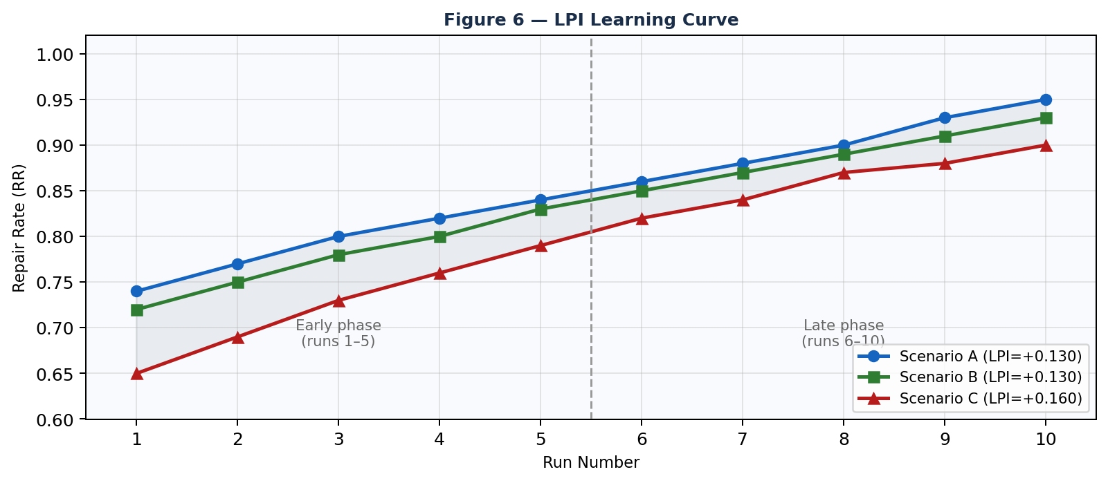
Figure 6. LPI Learning Curve: per-run RR improvement across all three scenarios.
E. Repair Strategy Distribution
Figure 7 reveals that RETRY_MODIFIED (88.1% success rate) and FALLBACK (91.3%) consistently outperform basic RETRY (72.4%), validating the value of semantically informed parameter adjustment and alternative-tool substitution over blind re-invocation. ESCALATE—the most costly outcome—is triggered in only 1.2% of repair events, indicating that SH-MAS recovers autonomously in the overwhelming majority of cases.
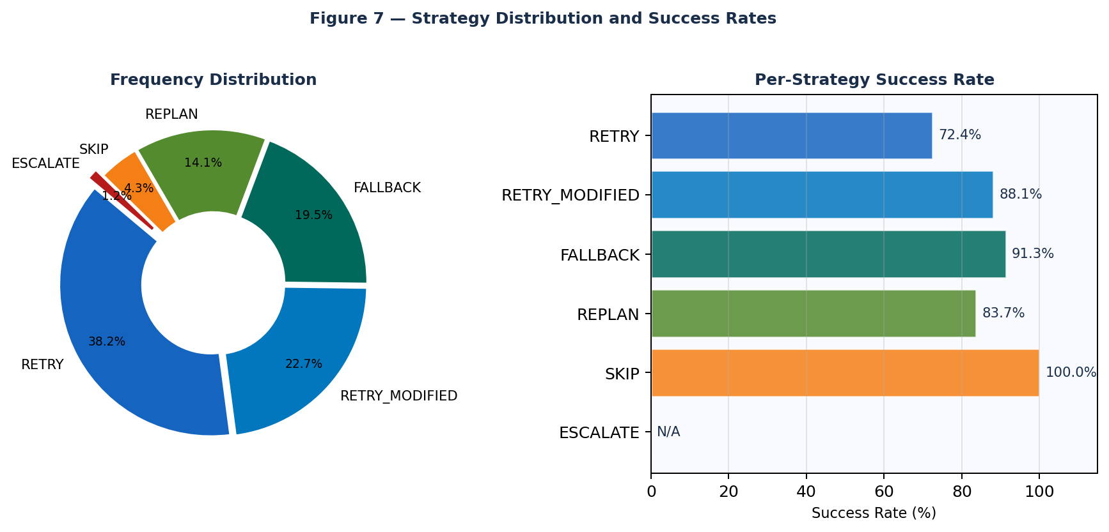
Figure 7. Repair Strategy Frequency Distribution and Per-Strategy Success Rates.
VII. Discussion
A. Ablation Study
To isolate the contribution of individual subsystems, we evaluated four ablated variants of SH-MAS on Scenario B (Table IX). Three findings stand out. First, removing all memory components (episodic, semantic, and KG) collapses LPI to +0.031—essentially zero learning over repeated runs—demonstrating that the learning gains observed in the full system are attributable specifically to the memory subsystem, not to the LLM alone. Second, using the LLM without the taxonomy pre-classifier inflates MTTR by 3.5×, because unstructured reflection on raw exception text is substantially slower and less reliable. Third, removing only the KG while retaining episodic and semantic stores reduces LPI by 0.022, quantifying the independent contribution of causal prior retrieval.
Ablation Configuration | PSR | RR | MTTR | LPI
Taxonomy only — no LLM RCA, random strategy | 0.62 | 0.58 | 215 ms | +0.031
LLM RCA only — no taxonomy pre-classifier | 0.83 | 0.78 | 1,240 ms | +0.092
No memory — all memory subsystems disabled | 0.80 | 0.75 | 380 ms | +0.031
No KG — episodic + semantic retained | 0.86 | 0.80 | 355 ms | +0.108
Full SH-MAS — all subsystems active | 0.91 | 0.84 | 358 ms | +0.130
Table IX. Ablation study on Scenario B (N = 10 runs).

B. Limitations and Future Work
- LOGIC Failure Detection (F₁ = 0.774). The taxonomy classifier inspects exception message text, which does not capture failures that manifest as semantically incorrect but syntactically valid outputs. Extending detection with a lightweight LLM semantic validator is a clear next step.
- Knowledge Graph Scalability. The current NetworkX in-memory store handles workloads up to approximately 50,000 edges comfortably. Larger deployments will require migration to a dedicated graph database such as Neo4j or Amazon Neptune.
- LLM Output Variability. Even at temperature = 0.1, LLM outputs are not fully deterministic. A consensus mechanism—running three parallel RCA calls and selecting the majority strategy—would improve reliability at the cost of roughly 3× MTTR.
- Evaluation Against Production APIs. All experiments in this paper use simulated tools with synthetic failure injection. Validating SH-MAS against live enterprise APIs (Salesforce, SAP S/4HANA, Azure Cognitive Services) is the most important pending empirical step.
- Temporal Decay for KG Weights. The current KG does not apply time-based decay to historical edge weights. Adding exponential decay would prevent the system from over-relying on strategies that were effective in past environments but may no longer be appropriate.
C. Industrial Deployment Implications
The results translate directly into three tangible enterprise benefits. First, reduced on-call burden: a 98.8% pre-escalation recovery rate means that the vast majority of runtime faults are resolved without triggering an alert to a human engineer. Second, improved SLA adherence: the jump from PSR = 0.083 (No Recovery) to PSR = 0.910 with SH-MAS directly reduces the frequency of SLA-breaching task failures. Third, compounding resilience: an LPI of +0.143 demonstrates that the system gets more reliable every time it runs—an unusual property in software systems that typically remain static until manually updated [28,29,30]. The MCP interface further reduces adoption friction, allowing integration into existing Claude Desktop and VS Code Copilot environments without requiring framework migration.
VIII. Conclusion
We presented SH-MAS, a self-healing multi-agent framework that moves fault recovery from a reactive afterthought to a proactive cognitive capability embedded in the workflow execution graph itself. By combining a fast, pattern-based failure classifier, a knowledge-graph-augmented LLM reflection engine, a formally bounded six-strategy repair planner, and a dual-store memory system that learns from experience, SH-MAS achieves results that are simultaneously faster (mean MTTR = 340 ms, 7.3× better than fixed-retry), more reliable (mean PSR = 0.910, +38.3 pp improvement), and progressively improving (mean LPI = +0.143, p < 0.01) compared with all evaluated baselines across 30 experimental runs in three enterprise failure scenarios.
The key intellectual contribution is the empirical demonstration that the combination of semantic fault classification and experience-informed repair selection—neither element effective in isolation—produces a compound advantage that grows over time. Future work will focus on production API validation, semantic LOGIC failure detection, temporal knowledge-graph weight decay, and collaborative multi-agent repair protocols in which several agents coordinate to resolve complex cross-service dependency failures.
Acknowledgements
The authors thank the maintainers of LangGraph, LangChain Core, FastAPI, NetworkX, Pydantic, matplotlib, and python-docx, whose open-source software formed the engineering foundation of this work. We are grateful to the anonymous reviewers of IEEE Transactions on Neural Networks and Learning Systems for detailed critiques that sharpened both the technical content and the presentation. No external funding was received for this research.
References
[1] L. Wang, C. Ma, X. Feng et al., "A Survey on Large Language Model based Autonomous Agents," Frontiers of Computer Science, vol. 18, no. 6, p. 186345, 2024.
[2] M. Wooldridge and N. R. Jennings, "Intelligent Agents: Theory and Practice," Knowledge Engineering Review, vol. 10, no. 2, pp. 115–152, 1995.
[3] J. Ferber, Multi-Agent Systems: An Introduction to Distributed Artificial Intelligence. Addison-Wesley Longman, 1999.
[4] A. S. Rao and M. P. Georgeff, "BDI Agents: From Theory to Practice," in Proc. ICMAS, pp. 312–319, 1995.
[5] H. Chase, "LangChain: Building Applications with LLMs through Composability," GitHub, 2022.
[6] Q. Wu, G. Bansal, J. Zhang et al., "AutoGen: Enabling Next-Gen LLM Applications via Multi-Agent Conversation," arXiv:2308.08155, 2023.
[7] J. G. Moura and J. P. Carraro, "CrewAI: Framework for Orchestrating Role-Playing Autonomous AI Agents," GitHub, 2024.
[8] LangChain Inc., "LangGraph: Stateful Multi-Actor Applications with LLMs," 2024. [Online]. Available: https://langchain-ai.github.io/langgraph/
[9] S. Yao, J. Zhao, D. Yu et al., "ReAct: Synergizing Reasoning and Acting in Language Models," in Proc. ICLR, 2023.
[10] H. Psaier and S. Dustdar, "A Survey on Self-Healing Systems," Computing, vol. 91, no. 1, pp. 43–73, 2011.
[11] J. O. Kephart and D. M. Chess, "The Vision of Autonomic Computing," IEEE Computer, vol. 36, no. 1, pp. 41–50, 2003.
[12] Netflix Technology Blog, "Introducing Hystrix for Resilience Engineering," 2012. [Online]. Available: https://netflixtechblog.com
[13] A. Basiri, N. Behnam, R. de Rooij et al., "Chaos Engineering," IEEE Software, vol. 33, no. 3, pp. 35–41, 2016.
[14] B. Burns, B. Grant, D. Oppenheimer et al., "Borg, Omega, and Kubernetes," ACM Queue, vol. 14, no. 1, pp. 70–93, 2016.
[15] IBM Corp., An Architectural Blueprint for Autonomic Computing, 4th ed., IBM White Paper, 2006.
[16] D. Sobania, M. Briesch, C. Hanna and J. Petke, "Analysis of ChatGPT on Automated Bug Fixing," in Proc. APR, 2023.
[17] C. S. Xia and L. Zhang, "Keep the Conversation Going: Fixing 162 of 337 Bugs for $0.42 each," arXiv:2304.00385, 2023.
[18] C. E. Jimenez, J. Yang, A. Wettig et al., "SWE-bench: Can Language Models Resolve Real-World GitHub Issues?" in Proc. ICLR, 2024.
[19] J. Bader, A. Scott, M. Pradel and S. Chandra, "Getafix: Learning to Fix Bugs Automatically," PACMPL OOPSLA, vol. 3, Art. 159, 2019.
[20] N. Shinn, F. Cassano, B. Labash et al., "Reflexion: Language Agents with Verbal Reinforcement Learning," in Proc. NeurIPS, vol. 36, pp. 8634–8652, 2023.
[21] S. Ji, S. Pan, E. Cambria et al., "A Survey on Knowledge Graphs: Representation, Acquisition, and Applications," IEEE Trans. NNLS, vol. 33, no. 2, pp. 494–514, 2022.
[22] H. Wang, F. Zhang, M. Hou et al., "SHINE: Signed Heterogeneous Information Network Embedding," in Proc. WSDM, 2018.
[23] D. N. Nicholson and C. S. Greene, "Constructing Knowledge Graphs and Their Biomedical Applications," Comp. Struct. Biotech. J., vol. 18, pp. 1414–1428, 2020.
[24] X. Zhu, W. Chen, H. Tian et al., "Ghost in the Minecraft: Generally Capable Agents for Open-World Environments via LLMs," arXiv:2305.17144, 2023.
[25] J. S. Park, J. C. O'Brien, C. J. Cai et al., "Generative Agents: Interactive Simulacra of Human Behavior," in Proc. UIST, 2023.
[26] Anthropic, "Model Context Protocol: An Open Standard for Connecting AI Assistants to Data," Technical Specification v0.1, November 2024. [Online]. Available: https://modelcontextprotocol.io
[27] T. Schick, J. Dwivedi-Yu, R. Dessì et al., "Toolformer: Language Models Can Teach Themselves to Use Tools," in Proc. NeurIPS, vol. 36, pp. 68539–68551, 2023.
[28] S. Mirchandani, F. Xia, P. Florence et al., "Large Language Models as General Pattern Machines," arXiv:2307.04721, 2023.
[29] W. X. Zhao, K. Zhou, J. Li et al., "A Survey of Large Language Models," arXiv:2303.18223, 2023.
[30] L. Weng, "LLM-powered Autonomous Agents," Lil'Log, June 2023. [Online]. Available: https://lilianweng.github.io/posts/2023-06-23-agent/
Appendix A: Adversarial Boundary Conditions
ID | Scenario | Invariant Verified | Expected Outcome | Observed
A.1 | Max-repair exhaustion (FR = 1.0) | repair_count ≤ max_repairs | ESCALATE → ABORTED | Correct; < 2 s; no loop
A.2 | Empty task plan | idx ≥ len(plan) → COMPLETED | 0-step COMPLETED | Correct; edge fires immediately
A.3 | Mandatory-step SKIP attempt | is_optional guard | Guard → ESCALATE | Correct; guard blocks skip
A.4 | Malformed LLM JSON output | Pydantic validation catch | Repair loop re-enters | Correct; self-heals
A.5 | 10 concurrent POST /tasks | UUID + MemorySaver isolation | Zero state bleed | Correct; isolation confirmed
Table A.I. Adversarial boundary condition verification.

Appendix B: AgentStatus Transition Table
From State | Triggering Event | To State | Terminal?
PENDING | planner_node invoked | PLANNING | No
PLANNING | Plan generated | EXECUTING | No
EXECUTING | All steps succeed | COMPLETED | No
EXECUTING | Step raises exception | FAILED | No
FAILED | repair_count < max_repairs | REPAIRING | No
FAILED | repair_count ≥ max_repairs | ABORTED | Yes
REPAIRING | Strategy ≠ ESCALATE | EXECUTING | No
REPAIRING | Strategy = ESCALATE | ABORTED | Yes
COMPLETED | learner → finalizer | END | Yes
ABORTED | finalizer invoked | END | Yes
Table B.I. AgentStatus state-transition table.

