Healthcare Marketing
Marketing and Health Economics for Applied Health Sciences
Assoc. Prof. Mohamed Yasser Hamdy
For third-year students of the Faculty of Applied Health Sciences
This book is for teaching. Prices, regulations and reimbursement rules change; check the current official sources before applying any figure in practice.
Contents
How to Use This Book vii
Part I Marketing and the Healthcare Market 1
1 Marketing in Health Care 2
1.1 Why a Health Professional Needs Marketing 2
1.2 What Marketing Is 2
1.3 The Building Blocks of Marketing 3
1.4 The Scope of Marketing 5
1.5 Why Health-Care Marketing Is Different 6
1.6 Marketing Orientations 6
1.7 Marketing and the Rest of the Book 7
Check Your Understanding 7
References 10
2 The Healthcare Market and Its Customers 11
2.1 A Market Unlike Others 11
2.2 Who Is the Customer? 11
2.3 What Triggers a Choice 12
2.4 The Healthcare Market Against Consumer Markets 13
2.5 Demand and Price Sensitivity 14
2.6 Principles of Marketing Management in Health Care 15
2.7 Problems of Marketing in Health Care 16
Check Your Understanding 17
References 19
3 Digital Marketing in Health Care 21
3.1 What Digital Marketing Is 21
3.2 Digital Channels 21
3.3 Benefits of Digital Marketing 22
3.4 Objectives of Digital Marketing 22
3.5 Digital and Traditional Marketing Compared 23
3.6 Tools a Health Service Can Use 24
3.7 Planning a Digital Campaign 24
3.8 Privacy and Ethics Online 26
Check Your Understanding 27
References 29
Part II The Marketing Mix for Health Services 30
4 The Marketing Mix: From Four Ps to Seven 31
4.1 The Marketing Mix 31
4.2 The Four Ps in Health Care 31
4.3 Why Services Need Seven Ps 32
4.4 Service Elements of a Medicine or a Test 34
4.5 The Mix Must Fit Together 35
4.6 Mapping the Service: The Blueprint 35
4.7 Ethics Across the Mix 36
Check Your Understanding 37
References 39
5 Health Products and Services 40
5.1 Goods and Services 40
5.2 Classifying Consumer Products 42
5.3 Medicines and Medical Devices 43
5.4 Customer Value 44
5.5 Properties That Create Value 45
Check Your Understanding 47
References 49
6 The Product Life Cycle 50
6.1 Products Have Lives 50
6.2 Introduction 51
6.3 Growth 51
6.4 Maturity 52
6.5 Decline 52
6.6 Summary of the Stages 53
6.7 Life Cycles of Health Technologies 54
6.8 Ethics Through the Life Cycle 55
Check Your Understanding 56
References 59
7 Pricing Health Services 60
7.1 What a Price Is 60
7.2 The Functions of Price 60
7.3 Kinds of Price 61
7.4 Pricing Methods 61
7.5 Factors That Shape Price 64
7.6 Setting the Price 65
7.7 Price Policy 65
Check Your Understanding 66
References 69
8 Distribution and Access 70
8.1 Place: Getting the Service to the Patient 70
8.2 The Tasks of Distribution Policy 70
8.3 Functions of Marketing Channels 71
8.4 Channel Levels for Medicines 71
8.5 Channels for Diagnostic Services 72
8.6 Intermediaries in the Pharmaceutical Market 73
8.7 Pharmaceutical Warehouses 74
8.8 Retail Trade and the Pharmacy 75
8.9 Choosing a Location 76
8.10 Distribution, Access and Safety 77
Check Your Understanding 78
References 80
9 Marketing Communications and Promotion 81
9.1 Communicating With the Market 81
9.2 Elements of Marketing Communications 81
9.3 Push and Pull 83
9.4 Advertising 84
9.5 Sales Promotion 84
9.6 Opinion Leaders and Regulators 85
9.7 Planning a Communication Campaign 85
9.8 The Ethical and Legal Limits of Promotion 86
Check Your Understanding 88
References 90
Part III Health Economics 91
10 Health-Care Costs 92
10.1 Why Health Care Needs Economics 92
10.2 The Cost–Outcome Principle 93
10.3 Perspectives 94
10.4 Categories of Cost 94
10.5 Putting Costs Together 95
10.6 Valuing Lost Productivity 96
10.7 Classifying Costs: A Worked Activity 97
10.8 Economics and Ethics 98
Check Your Understanding 98
References 101
11 Outcomes and Methods of Economic Evaluation 102
11.1 The Outcome Side 102
11.2 The ECHO Model 102
11.3 Perspectives Again 104
11.4 Methods of Economic Evaluation 104
11.5 Sensitivity Analysis 107
11.6 Steps of an Economic Evaluation 107
11.7 Costs and Outcomes Over Time: Discounting 108
11.8 Honest Evaluation 109
Check Your Understanding 110
References 112
12 Applying Economic Evaluation 113
12.1 Where Economic Evaluation Is Used 113
12.2 Micro-Costing 113
12.3 Choosing Between CMA and CEA 114
12.4 Cost-Benefit Analysis 116
12.5 A Laboratory Application 118
12.6 Reporting Honestly 119
Check Your Understanding 120
References 122
Glossary 123

How to Use This Book
Each chapter opens with learning objectives. Read them first; they tell you what you should be able to do by the end.
Three boxes appear in every chapter. Through Two Lenses applies the chapter's main idea to the medical laboratory and to radiology and medical imaging. In Practice shows the idea at work in a health service. Ethics Check sets out where the idea meets a professional or legal limit. Read the Ethics Check with particular care: it is the part of marketing that most distinguishes health care.
Other boxes appear where they help. Key Formula gives an equation with its symbols. Worked Example works a calculation step by step. Common Mistake names an error that students often make. Egyptian Context links the topic to the Egyptian health system.
Each chapter ends with key takeaways, ten multiple-choice questions and three essay questions. Answer the questions before reading the answers. Every multiple-choice answer has a short rationale, and every essay question has model answer points. Use the points to check your own answer, not to memorise.
Work the calculations in Part III with a pen. The steps are shown in full, so if your answer differs you can find the line where it went wrong.
Terms printed in bold are defined in the glossary at the end of the book. The consolidated reference list follows the glossary.

Part I Marketing and the Healthcare Market
Chapters 1–3
1 Marketing in Health Care
2 The Healthcare Market and Its Customers
3 Digital Marketing in Health Care

1 Marketing in Health Care
Learning Objectives
By the end of this chapter you will be able to:
LO1 Define marketing in its current form and explain how it applies to a health service.
LO2 Distinguish needs, wants and demands, and give a health-care example of each.
LO3 Explain value, satisfaction and quality from the patient's point of view.
LO4 Describe the main activities within the scope of marketing for a laboratory or an imaging centre.
LO5 Identify the ethical limits that separate health-care marketing from ordinary selling.

1.1 Why a Health Professional Needs Marketing
Many health students hear the word marketing and think of advertising. They picture billboards, discounts and pushy salespeople. That picture is too narrow, and it is not what this book is about.
A medical laboratory must decide which tests to offer. It must decide what to charge, where to open a branch, how long patients should wait and how results reach them. An imaging centre faces the same questions about scans. Every one of these decisions is a marketing decision. Each one starts from the same question: what do the people we serve actually need?
You will spend your career inside such services. You may run a laboratory section, supervise a scanner room or open your own centre. Understanding marketing lets you see your service the way patients, doctors and payers see it. It also lets you recognise marketing that crosses an ethical line.

1.2 What Marketing Is
The American Marketing Association (AMA) is the professional body most often quoted for a definition. Its current definition is:
In Practice
"Marketing is the activity, set of institutions, and processes for creating, communicating, delivering, and exchanging offerings that have value for customers, clients, partners, and society at large" (American Marketing Association, as cited in Kotler & Keller, 2016).
Read the definition slowly. It names four verbs: creating, communicating, delivering and exchanging. A laboratory creates a test menu, communicates it to doctors and patients, delivers results, and exchanges them for a fee. The definition ends with society at large. That phrase matters in health care, where a service can affect people who never pay for it.

Marketing, in short, is the work of creating and delivering offerings that have value for the people who use them and for society. Older textbooks still quote the AMA's 1985 definition. It described marketing as the process of planning and carrying out the conception, pricing, promotion and distribution of ideas, goods and services. The newer wording keeps those tasks but moves the focus from the seller's activities to the value received.
Kotler and Keller (2016) put the same idea more simply. Marketing is meeting needs profitably. For a public hospital, "profitably" becomes "sustainably". The hospital must still cover its costs, even when it does not seek a profit.

1.3 The Building Blocks of Marketing
Five linked ideas make up the marketing process. They appear in every later chapter, and Figure 1.1 shows how they connect.
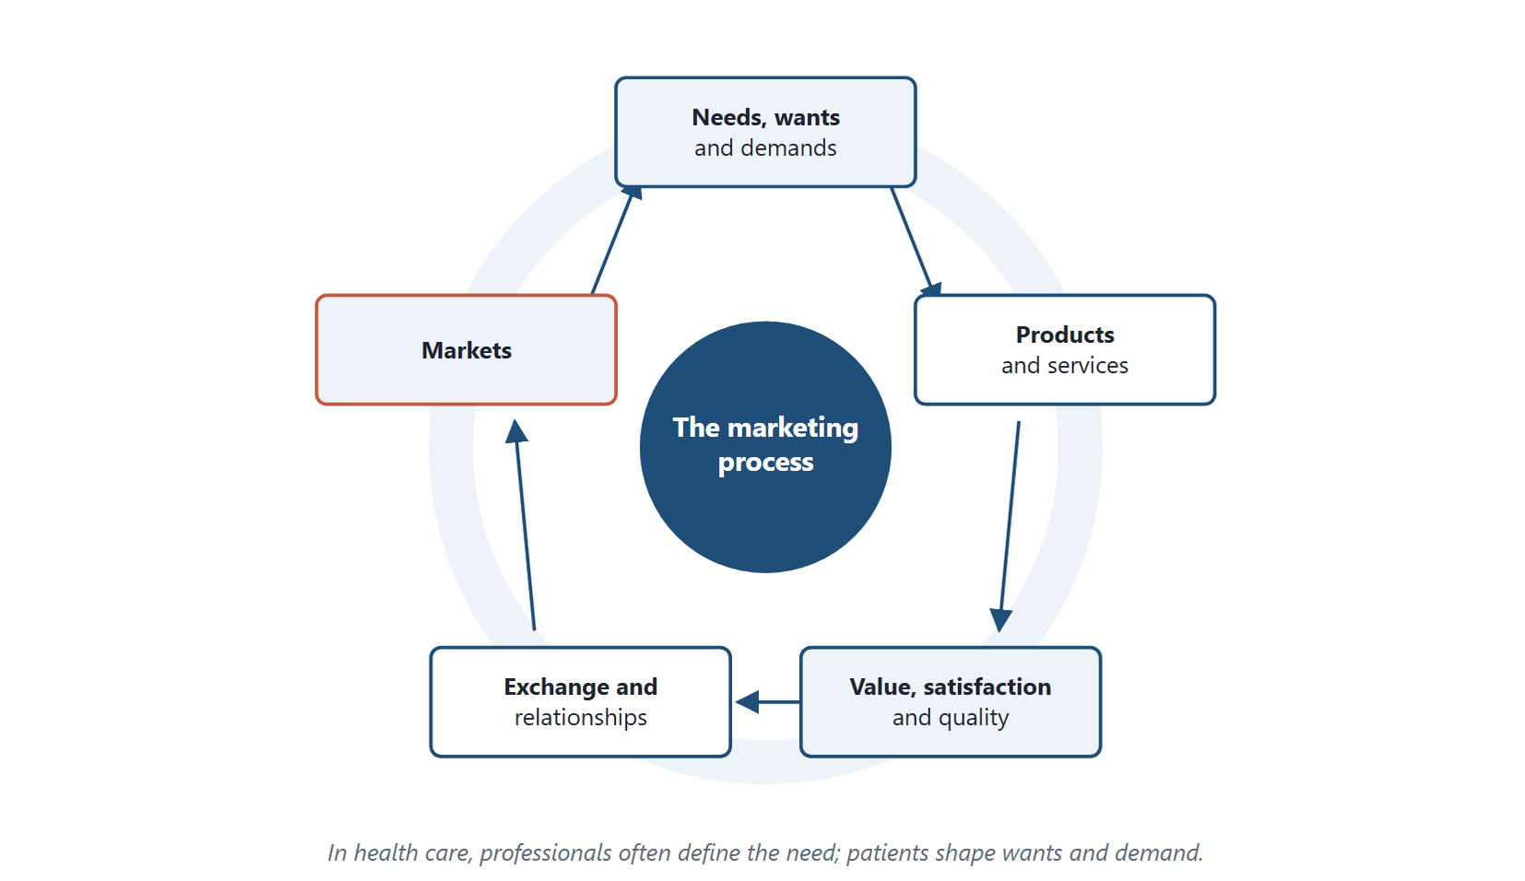
Figure 1.1 The five building blocks of the marketing process. Each leads to the next, and markets shape the needs a service sets out to meet. In health care, professionals often define the need, while patients shape wants and demand.
Original diagram (original)

Needs, wants and demands
A need is a state of felt deprivation. People need food, safety and health. A want is the form a need takes, shaped by culture and personal experience. A patient with chest pain needs a diagnosis. The patient may want a particular cardiologist or a scan at a well-known centre.
A demand is a want backed by the ability and willingness to pay. Many Egyptians want a full annual check-up. Only some can pay for one, so only some of that want becomes demand.
Health care adds a twist. Patients often cannot judge their own needs. A doctor decides that an MRI is needed, not the patient. Needs in health care are therefore often defined by professionals, while wants and demands come from patients (Berkowitz, 2017).

Products and services
A product is anything offered to satisfy a need or want. It can be a physical good, such as a glucose meter. It can be a service, such as a blood test. Most health care is a service, or a service wrapped around a good. Chapter 5 explores this difference in depth.

Value, satisfaction and quality
Customer value is the difference between what a customer gains and what the customer gives up. The gains are the benefits of the service. The costs include money, time, travel and anxiety. A patient who waits three hours for a routine test has paid a high cost, even if the fee was low.
Satisfaction is the patient's judgement of whether the service met expectations. It depends on both performance and expectation. A result delivered in two days satisfies a patient who expected three, and disappoints one who was promised one.
Quality in health care has two sides. Technical quality is whether the result is correct: an accurate haemoglobin, a clear image. Functional quality is how the service was delivered: courtesy, cleanliness, explanation. Patients usually cannot judge technical quality, so they judge what they can see (Wirtz & Lovelock, 2021).

Exchange, transactions and relationships
An exchange is the act of obtaining something of value by offering something in return. A single exchange is a transaction. A patient pays for one lipid profile and leaves.
Health services rarely want only one transaction. A diabetic patient may need a glycated haemoglobin test every three months for life. The laboratory that earns this patient's trust gains a long relationship. Relationship marketing is the practice of building such long-term, trusting links.

Markets
A market is the set of actual and potential buyers of a product. For a laboratory, the market includes patients who walk in, doctors who refer them, clinics that send samples and insurers that pay. Each group has different needs, and a good service plans for all of them.
Through Two Lenses
- Medical Laboratory: A laboratory's customers include the referring doctor as well as the patient. The doctor values accuracy and fast reporting. The patient values short waits and clear instructions for fasting. Marketing starts by serving both. - Radiology and Medical Imaging: An imaging centre's customers include the referring doctor as well as the patient. The doctor values image quality and a clear report. The patient values safety, comfort and a short wait for booking. Marketing starts by serving both.

1.4 The Scope of Marketing
Marketing covers far more than promotion. Ten activities make up its scope. Each is shown here for a health service.
1. Creating awareness. People cannot use a service they do not know exists. A new mammography unit must tell women and their doctors that it is open and what it offers.
2. Studying what customers want. Marketing research finds out what patients and doctors need. A laboratory might survey referring doctors about turnaround times before investing in a new analyser.
3. Product planning. A product is a bundle of benefits. Planning runs from the first idea to launch. A laboratory considering home sample collection must study demand, staffing and competitors first.
4. After-sales service. In health care this means everything after the result is issued. Examples include explaining a report, correcting an error quickly, sending reminders for repeat tests and handling complaints.
5. Pricing. Price is the amount of money charged for a product. It is only part of what customers give up: time, travel and effort are costs too, and Chapter 5 adds them into the total customer cost. Chapter 7 covers how health services set prices.
6. Distribution. This is how the service reaches people: branches, collection points, home visits, mobile units. Chapter 8 covers it.
7. Selling. Selling is supplying goods and services to target customers, directly or through others. In health care, most selling is really informing. A sales representative explains a new test to doctors; a doctor then decides.
8. Packaging and presentation. For goods, packaging protects the product and carries information. For services, the equivalent is the setting: a clean reception, clear signs and a well-designed report.
9. Advertising. Advertising makes a service known to a wide audience. In health care it is the most restricted tool, as Chapter 9 explains.
10. Collecting feedback. Feedback shows whether patients were satisfied and what to improve. A short survey after a scan costs little and reveals a great deal.
Common Mistake
Treating marketing as the same thing as advertising. Advertising is one of ten activities above. A laboratory with excellent advertising but long waits and lost samples has poor marketing, because its product fails the customer.

1.5 Why Health-Care Marketing Is Different
Marketing principles apply to every industry. Health care applies them under special conditions (Kotler & Keller, 2016; Berkowitz, 2017).
The customer cannot judge quality well. Most patients cannot tell whether a test was performed correctly. This gap in knowledge is called information asymmetry. It gives the provider power, and with power comes responsibility.
The decider, the payer and the user may differ. A doctor orders a scan, an insurer may pay, and the patient undergoes it. Chapter 2 examines this three-way split.
Demand can be created by the provider. A provider who both advises and sells can recommend more than is needed. Economists call this supplier-induced demand. It is one reason health marketing is regulated.
Stakes are high. A misleading advertisement for shampoo wastes money. A misleading advertisement for a test can lead to missed disease or needless anxiety.
Society has an interest. Health care is partly funded by public money and affects public health. Society therefore sets rules on what may be promised and how.
Ethics Check
A private laboratory offers a "complete health package" of forty tests at a discount. Most healthy young adults need few of those tests. Unneeded tests cost money and can produce false positives that lead to more tests and worry. Ask three questions before promoting any health service. Does the patient need it? Is the claim true and complete? Would a well-informed patient still choose it? If any answer is no, the promotion is not acceptable.

1.6 Marketing Orientations
Organisations approach their markets in different ways. Kotler and Keller (2016) describe several orientations.
A production orientation assumes customers want what is cheap and available. The focus is efficiency. A laboratory with this outlook buys the fastest analyser and ignores the waiting room.
A product orientation assumes customers want the highest quality. The focus is technical excellence, sometimes beyond what customers value.
A selling orientation assumes customers will not buy enough unless pushed. In health care this leads directly to the ethical problems of the last section.
A marketing orientation starts from the customer's needs and builds the service around them. A societal marketing orientation adds the long-term interest of society. For health services, the last is the most appropriate. A service must meet patients' needs, cover its costs and protect public health together.
Egyptian Context
Egypt's health system combines public hospitals, university hospitals, a large private sector and a new universal health insurance system introduced by law (Arab Republic of Egypt, 2018). Private laboratories and imaging centres compete for patients and referrals in most cities. More than half of all current health spending is paid out of pocket by households (World Health Organization, 2025). Marketing decisions here affect access to care as well as revenue.

1.7 Marketing and the Rest of the Book
This chapter introduced the vocabulary. Chapter 2 examines the health-care market and its customers. Chapter 3 turns to digital marketing. Chapters 4 to 9 take the marketing mix apart, one element at a time. Chapters 10 to 12 then ask the question every health system must answer: is a service worth what it costs?
Key Takeaways
- Marketing is creating, communicating, delivering and exchanging offerings of value for customers and society, in the AMA's current definition.
- Needs in health care are often defined by professionals; wants and demands come from patients.
- Customer value is benefit minus total cost, and total cost includes time, travel and anxiety as well as money.
- Patients judge the functional quality they can see because they rarely can judge technical quality.
- Marketing's scope runs from research and product planning to feedback, not only advertising.
- Information asymmetry, split decision-making and supplier-induced demand make health-care marketing different.
- The societal marketing orientation is the most appropriate orientation for a health service.

Check Your Understanding
Q1 [LO1] Which phrase in the current AMA definition of marketing most clearly extends marketing beyond the buyer and seller?
A Creating offerings
B Society at large
C Set of institutions
D Exchanging offerings
Q2 [LO2] A patient wants a scan at a famous centre but cannot afford it. This is:
A A need that has become a demand
B A demand without a want
C A want that has not become a demand
D A need that no one can define
Q3 [LO2] In health care, who most often defines the need for a diagnostic test?
A The advertising agency
B The insurer
C The laboratory receptionist
D The treating doctor
Q4 [LO3] A patient waits three hours for a routine blood test that costs little. From the patient's viewpoint, customer value is:
A Reduced, because time is part of total customer cost
B High, because the fee was low
C Unchanged, because the result is accurate
D Impossible to judge without the price list
Q5 [LO3] The courtesy of staff and the cleanliness of a waiting area are examples of:
A Technical quality
B Functional quality
C Information asymmetry
D Supplier-induced demand
Q6 [LO4] A laboratory surveys referring doctors about turnaround time before buying an analyser. This activity is:
A After-sales service
B Advertising
C Studying what customers want
D Packaging
Q7 [LO4] Explaining a report to a patient and handling complaints belong to:
A Pricing
B Distribution
C Product planning
D After-sales service
Q8 [LO5] A provider who both advises and sells recommends more tests than the patient needs. This is called:
A Supplier-induced demand
B Relationship marketing
C Functional quality
D A production orientation
Q9 [LO5] Which orientation is the most appropriate for a health service?
A Selling orientation
B Production orientation
C Societal marketing orientation
D Product orientation
Q10 [LO1] Kotler and Keller describe marketing as "meeting needs profitably". For a public hospital, the most appropriate reading of "profitably" is:
A Earning the highest possible surplus
B Covering costs so the service can continue
C Charging whatever patients will pay
D Ignoring costs because the state pays

Essay Questions
E1. [LO2] Explain the difference between needs, wants and demands, using a medical laboratory as your example. Why is the distinction harder to apply in health care than in consumer markets?
E2. [LO4] Choose five activities from the scope of marketing and describe how each would apply to opening a new imaging centre.
E3. [LO5] Describe three features that make health-care marketing different from marketing ordinary goods, and explain the ethical responsibility each creates.
Answers and Worked Solutions
Q1. B — "Society at large" extends value beyond the parties to the exchange. In health care a service can affect people who never pay for it, so this phrase matters.
Q2. C — The patient wants the scan, but a want becomes a demand only when it is backed by ability and willingness to pay.
Q3. D — Patients usually cannot judge which tests they need. The treating doctor defines the need; the patient and payer then act on it.
Q4. A — Total customer cost includes time, travel and anxiety. A long wait raises the cost and lowers value, even when the fee is small.
Q5. B — Functional quality is how a service is delivered. Technical quality is whether the result is correct, which patients rarely can judge.
Q6. C — Surveying customers before an investment is marketing research: studying what customers want. The other options come later in the process.
Q7. D — After-sales service covers everything after the result is issued, including explanation, correction, reminders and complaints.
Q8. A — Supplier-induced demand arises when the same party advises and sells. It is a central reason for regulating health-care marketing.
Q9. C — The societal marketing orientation best fits a health service, because it joins patients' needs, financial sustainability and the long-term interest of public health.
Q10. B — A public hospital does not seek a surplus, but it must still cover its costs to keep serving patients. "Profitably" becomes "sustainably".
E1 — model answer points. A need is felt deprivation, such as the need for a diagnosis. A want is the specific form, such as a test at a trusted laboratory. A demand is a want backed by ability to pay. In health care, professionals define many needs, patients may not recognise them, and third parties may pay. The three concepts therefore sit with different people.
E2 — model answer points. Creating awareness among doctors and patients; studying which scans are in short supply locally; product planning of the scan menu and opening hours; pricing that reflects costs and competitors; distribution through location, parking and booking; after-sales service through clear reports and follow-up. Any five, each tied to imaging.
E3 — model answer points. Information asymmetry creates a duty of honesty. Split decision-making creates a duty to serve the patient, not only the referrer or payer. Supplier-induced demand creates a duty to recommend only what is needed. High stakes and public funding justify regulation.

References
Arab Republic of Egypt. (2018). Law No. 2 of 2018 promulgating the Universal Health Insurance System law. Official Gazette. Berkowitz, E. N. (2017). Essentials of health care marketing (4th ed.). Jones & Bartlett Learning. Kotler, P., & Keller, K. L. (2016). Marketing management (15th ed.). Pearson. Wirtz, J., & Lovelock, C. (2021). Services marketing: People, technology, strategy (9th ed.). World Scientific. World Health Organization. (2025). Country cooperation strategy for WHO and Egypt 2024–2028. World Health Organization Regional Office for the Eastern Mediterranean. https://applications.emro.who.int/docs/9789292746926-eng.pdf

2 The Healthcare Market and Its Customers
Learning Objectives
By the end of this chapter you will be able to:
LO1 Identify the decider, the payer, the user and the influencer for a given health service.
LO2 Describe the main triggers that lead patients to choose a health service or a medicine.
LO3 Compare the healthcare market with ordinary consumer markets on seven characteristics.
LO4 Distinguish the law of demand from price elasticity and calculate an elasticity.
LO5 Explain the principles and the main problems of marketing management in health care.

2.1 A Market Unlike Others
Chapter 1 noted that health care applies marketing under special conditions. This chapter examines those conditions closely. It asks who the customers of a health service really are, why they choose as they do, and how their market differs from the market for phones or clothes.
The healthcare market is the set of patients, professionals, organisations and payers who exchange health goods and services. It includes hospitals, clinics, laboratories, imaging centres, pharmacies, manufacturers and insurers. Pharmaceutical marketing is the part of it concerned with medicines. It markets drugs both to medical practitioners and to consumers, within strict legal limits.
Traditionally, medicine companies reached doctors through sales representatives, free samples, printed literature, scientific events and continuing medical education. Laboratories and imaging centres have used similar tools: visits to doctors, printed test menus and professional meetings. Chapter 9 examines which of these tools remain acceptable.

2.2 Who Is the Customer?
In most consumer markets one person decides, pays and uses. A buyer chooses a shirt, pays for it and wears it. Health care often splits these roles among several people.
The decider chooses the service. For a prescribed test or scan this is usually the doctor. The payer funds it: the patient, an insurer, an employer or the state. The user receives it: the patient. The influencer shapes the choice without deciding it: a family member, a friend, a pharmacist or a website. Figure 2.1 shows the four roles.
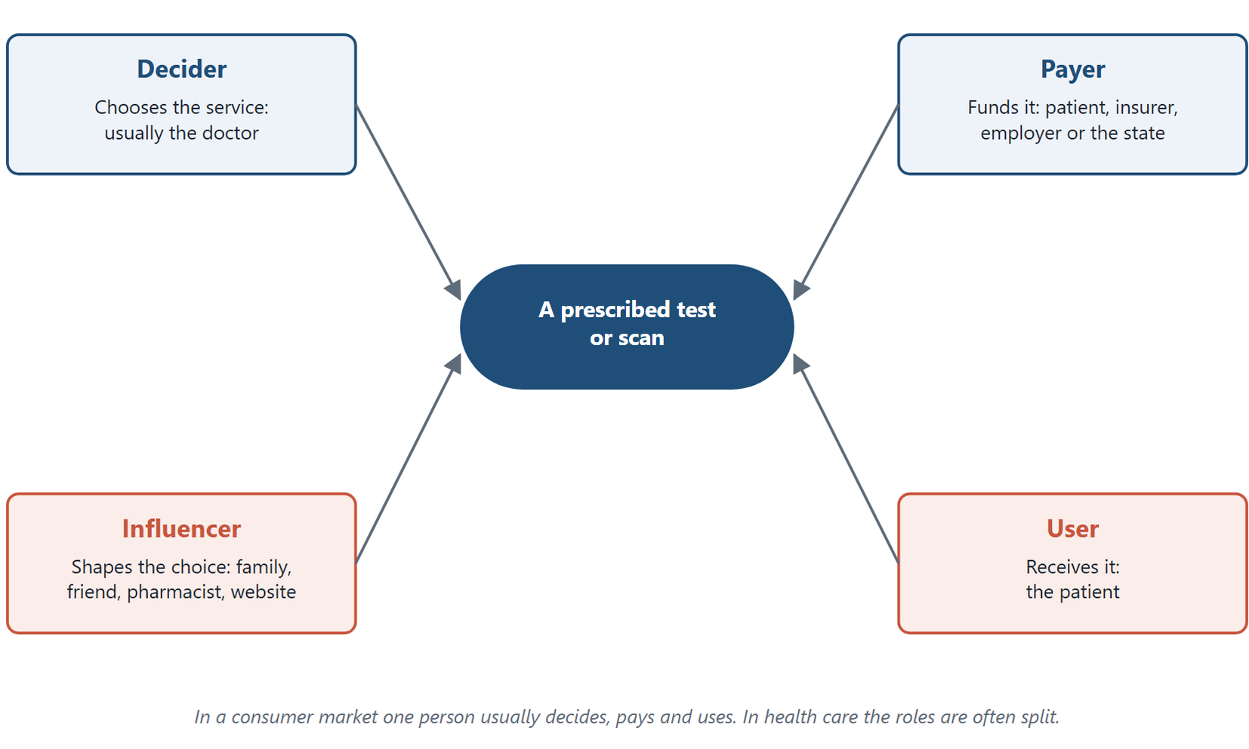
Figure 2.1 The four customer roles in a health-care purchase. For a prescribed test or scan, the decider, payer, user and influencer are often different people, and a service must satisfy each of them.
Original diagram (original)
The split changes the whole marketing task. A laboratory that serves only patients may ignore the doctors who send them. An imaging centre that pleases doctors but mistreats patients will lose them to a competitor when they have a choice.
The roles also shift from service to service. A patient who buys a pregnancy test at a pharmacy decides, pays and uses alone. A patient admitted to a public hospital under insurance decides almost nothing about the tests performed. Most laboratory and imaging services lie between these two extremes.
Through Two Lenses
- Medical Laboratory: For a routine blood test the doctor usually decides, but the patient often picks the laboratory. In the private sector the patient often pays the laboratory's fee. The laboratory must therefore satisfy two customers: the doctor's need for reliable results and the patient's need for convenience and a fair price. - Radiology and Medical Imaging: For an MRI the doctor decides that a scan is needed, and often suggests where. The patient or insurer pays, and the patient must lie still in the machine. The centre must satisfy the doctor with image quality and reports, and the patient with safety, comfort and clear instructions.

2.3 What Triggers a Choice
Why does a patient choose one laboratory, one scan centre or one medicine over another? Four kinds of trigger stand out.
1. Medical advice. For prescribed services, the professional's recommendation drives most choices. A prescription names the medicine, and a referral letter names the test and often the place. The marketer's first question is therefore how to earn the trust of the professionals who advise. The honest answer is to deserve it: accurate results, fast reports and easy communication.
2. Heuristic triggers. A heuristic is a mental shortcut. Patients often choose what the family has always used, what a friend recommends, or what worked for them before. They do not compare options rationally. A laboratory that treats one family member well often gains the whole family.
3. Symptomatic triggers. Patients are more aware of symptoms than ever. Many search online, then ask a pharmacist for an over-the-counter remedy or book a test directly. Self-referral for tests such as vitamin D, thyroid function or a lipid profile is growing.
4. Information and advertising. Information from the provider shapes preference. This includes the leaflet in a medicine pack, a laboratory's test menu, its prices and its reputation. Chapter 9 sets out the limits on such information.
In Practice
A mother notices that her son is often tired. She searches online, reads that iron deficiency is common, and books a complete blood count at a laboratory her sister used last year. Three triggers act together: a symptom, an online search and a family heuristic. No doctor was involved. The laboratory's reputation, price and location decided the rest.

2.4 The Healthcare Market Against Consumer Markets
Table 2.1 compares the two kinds of market. Each row is a tendency, not a rule. Some health services, such as a self-paid vitamin test, sit close to consumer markets.
Characteristic | Healthcare market | Ordinary consumer market
Who decides | Often a professional | The buyer
Who pays | Patient, insurer, employer or state | The buyer
Brand loyalty | Often reported as high, built on trust | Usually lower
Importance of ethics | Very high | Present but lower
Government regulation | Heavy | Lighter
Research and development | Costly and long, especially for medicines | Usually cheaper and shorter
Price sensitivity | Often low for necessary care | Usually higher

Table 2.1. The healthcare market compared with ordinary consumer markets.
Two rows deserve care in Egypt. First, "who pays" varies more than many textbooks suggest. More than half of all current health spending in Egypt is paid out of pocket by households: an estimated 54.9% in 2022, down from 62.7% in 2018–2019 (World Health Organization, 2025). Self-paid tests at private laboratories and imaging centres are part of that spending, although no published figure isolates their share. The universal health insurance system is extending coverage governorate by governorate (Arab Republic of Egypt, 2018). A textbook table that says the patient "does not pay" describes an insured Western market, not Egypt's.
Second, "who decides" depends on the service. For prescription medicines the doctor decides. For over-the-counter medicines and self-referred tests the patient decides. Many choices are shared.
Common Mistake
Assuming the patient never decides and never pays. That is true for some insured, prescribed services. It is false for over-the-counter medicines, self-referred tests and much of the private diagnostic market in Egypt. Always ask who decides and who pays for the specific service.

2.5 Demand and Price Sensitivity
Two economic ideas are often confused. They must be kept apart.
The law of demand states that, other things equal, the quantity demanded falls as the price rises. Almost all goods follow it, including health services.
Price elasticity of demand measures how strongly quantity responds to price. It is the percentage change in quantity divided by the percentage change in price.
Key Formula
Price elasticity of demand
$$E_{d}=\frac{\% change in quantity demanded}{\% change in price}$$
Because quantity usually falls when price rises, $E_{d}$ is negative. It is usually quoted as a positive number, its absolute value. Demand is elastic when the absolute value is greater than 1, and inelastic when it is less than 1.

Elasticity is what the old phrase "price sensitivity" means. A demand can obey the law of demand and still be inelastic. Quantity falls when price rises, but only a little.
Demand for necessary care is usually inelastic. A patient with suspected appendicitis will still seek an ultrasound when the price rises, because the need is urgent. Inelastic does not mean unlimited: a patient who cannot afford the scan still goes without, or looks for a public hospital. Demand for elective or cosmetic services and for many self-paid tests is more elastic (Rice & Unruh, 2016). For example, a general "wellness" panel can be expected to lose many buyers when its price rises.
Worked Example
Elasticity of demand for a self-paid test
A laboratory raises the price of a vitamin D test from 400 EGP to 500 EGP. Monthly tests fall from 300 to 270. The figures are illustrative.
Step 1 — percentage change in price. (500 − 400) ÷ 400 = 0.25, a 25% rise.
Step 2 — percentage change in quantity. (270 − 300) ÷ 300 = −0.10, a 10% fall.
Step 3 — elasticity. −10% ÷ 25% = −0.4. The absolute value is 0.4. This uses the starting values as the base of each percentage. The midpoint method, which uses the average of the two values as the base, gives about −0.47 and the same answer whichever way the price moves. Either way, the demand is inelastic.
Interpretation. The value is below 1, so demand is inelastic over this range. Revenue rises from 300 × 400 = 120,000 EGP to 270 × 500 = 135,000 EGP. The laboratory earns more, but it has lost thirty patients a month who may now go without the test.

The last sentence of the example is the health-care point. A price that does not hurt revenue can still hurt access. Figure 2.2 contrasts this inelastic demand with the elastic demand of an elective service.
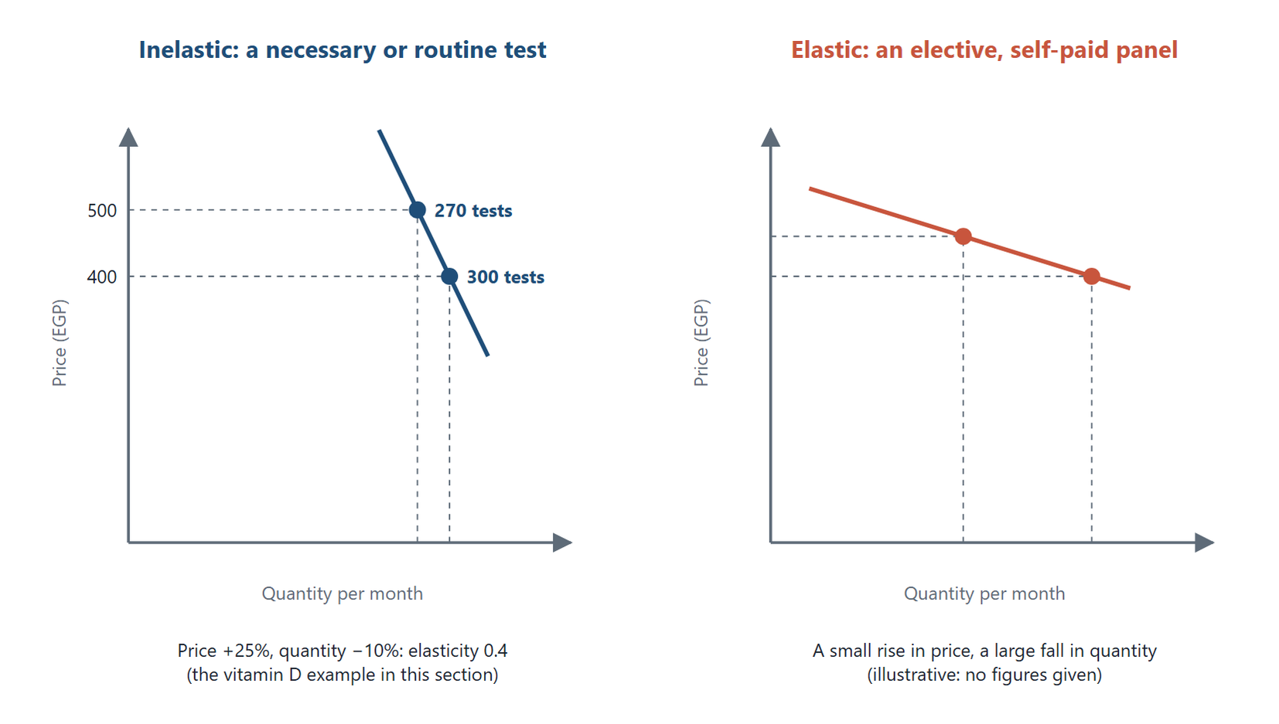
Figure 2.2 Inelastic and elastic demand. On the left, the vitamin D test of the worked example: a 25% rise in price cuts quantity by only 10%. On the right, an illustrative elective panel, where a small price rise causes a large fall in quantity.
Original diagram (original)

2.6 Principles of Marketing Management in Health Care
A health organisation's marketing should rest on principles that protect patients as well as the organisation. Six principles apply to medicine makers, and they carry over to laboratories and imaging centres.
1. Create, produce and deliver effective products. A test must be accurate; a scan must be diagnostic.
2. Minimise harm. For medicines this means reducing side effects. For imaging it means keeping radiation doses as low as reasonably achievable.
3. Use high-quality inputs. Reagents, contrast media and raw materials must meet standards.
4. Develop services that meet real needs. A new test is added because doctors and patients need it, not because it is fashionable.
5. Set fair prices. Chapter 7 discusses how.
6. Serve public health. Prevention and treatment of disease in the population is the final aim. The health of the nation is one of society's first interests.
Ethics Check
Principle 4 is often tested. A laboratory could add a heavily advertised "food intolerance" antibody panel because patients ask for it. The European Academy of Allergy and Clinical Immunology advises that IgG4 testing against foods is not a diagnostic tool for food intolerance (Stapel et al., 2008). Offering a test because it sells, not because it helps, breaks the principle even if patients want it. The ethical response is to explain the evidence, not to exploit the demand.

2.7 Problems of Marketing in Health Care
Health organisations face recurring marketing problems:
1. Studying a complex market. Many parties, split roles and heavy regulation make market research harder.
2. Revealing demand and unmet needs. Patients may not know they need a service, such as screening.
3. Planning the range and prices of services. Supply must match demand without wasting scarce equipment.
4. Organising distribution. Medicines must move from factory through warehouses to pharmacies. Samples must move from collection points to the laboratory within their stability limits.
5. Organising production. A laboratory must staff, schedule and maintain equipment to meet peaks in demand.
Each later chapter addresses one or more of these problems.
Egyptian Context
Egyptian patients commonly choose laboratories and imaging centres through a mix of doctor advice, family recommendation and price comparison. Large laboratory chains compete with independent laboratories and hospital laboratories. Under the universal health insurance system, the insurer contracts with providers that are accredited for quality, and beneficiaries choose among the contracted providers available to them, subject to referral pathways (Arab Republic of Egypt, 2018). As coverage spreads, the insurer's contracting choices will matter more and the patient's price comparison less, while the patient's choice between contracted providers remains.

Key Takeaways
- Health care often splits the roles of decider, payer, user and influencer among different people.
- Medical advice, heuristics, symptoms and information are the four main triggers of choice.
- The healthcare market differs from consumer markets in who decides and pays, loyalty, ethics, regulation, research costs and price sensitivity.
- More than half of Egypt's current health spending is paid out of pocket by households.
- The law of demand says quantity falls as price rises; elasticity says by how much.
- Demand for necessary care is usually inelastic; demand for elective and self-paid services is more elastic.
- A price change that leaves revenue unchanged can still reduce access to care.

Check Your Understanding
Q1 [LO1] A doctor orders an MRI, an insurer pays, and the patient is scanned. The insurer's role is:
A Decider
B User
C Payer
D Influencer
Q2 [LO1] A patient buys a pregnancy test at a pharmacy without advice. Which roles does the patient hold?
A Decider, payer and user
B User only
C Payer only
D Influencer only
Q3 [LO2] A patient chooses a laboratory because the family has always used it. This is:
A A symptomatic trigger
B A heuristic trigger
C Medical advice
D Price elasticity
Q4 [LO2] A patient reads about fatigue online and books a blood count directly. The main trigger is:
A Medical advice
B Brand loyalty
C Regulation
D A symptomatic trigger
Q5 [LO3] Compared with consumer markets, the healthcare market typically shows:
A Heavier government regulation
B Lower brand loyalty
C Less importance of ethics
D Cheaper research and development
Q6 [LO3] Which statement about how health care in Egypt is paid for is most accurate?
A The state pays for all health care
B Insurers pay for all health care
C More than half of current health spending is paid out of pocket by households
D Households pay nothing directly
Q7 [LO4] The statement "quantity demanded falls as price rises" describes:
A Elastic demand only
B The law of demand
C Inelastic demand only
D Supplier-induced demand
Q8 [LO4] A price rises 10% and quantity falls 5%. The absolute elasticity is:
A 2.0, elastic
B 0.5, elastic
C 2.0, inelastic
D 0.5, inelastic
Q9 [LO4] Demand is usually most inelastic for:
A An emergency ultrasound for suspected appendicitis
B A general wellness panel
C A cosmetic procedure
D An optional vitamin test
Q10 [LO5] A laboratory adds a heavily advertised test that does not reliably diagnose the condition it claims to. Which principle does it break?
A Use high-quality inputs
B Set fair prices
C Minimise radiation
D Develop services that meet real needs

Essay Questions
E1. [LO1] Using an imaging centre as your example, explain how the roles of decider, payer, user and influencer affect the centre's marketing.
E2. [LO4] Explain the difference between the law of demand and price elasticity. Why can a price rise that does not reduce revenue still be a problem for a health service?
E3. [LO3] Compare the healthcare market with an ordinary consumer market, and explain why a comparison table must be adapted for Egypt.
Answers and Worked Solutions
Q1. C — The insurer funds the scan without choosing or receiving it, so it is the payer.
Q2. A — With no advice and no third party, one person decides, pays and uses: the consumer-market pattern.
Q3. B — Choosing out of family habit is a mental shortcut, a heuristic, not a rational comparison.
Q4. D — A symptom and an online search led directly to the booking. No professional advised.
Q5. A — Health care is heavily regulated. Options C and D reverse the pattern: ethics matter more and research is costlier. Option B runs against the usual tendency in Table 2.1, though loyalty varies more between services than regulation does.
Q6. C — WHO estimates that 54.9% of Egypt's current health expenditure in 2022 was paid out of pocket. Options A, B and D describe systems Egypt does not have.
Q7. B — This is the law of demand. It holds for elastic and inelastic goods alike; elasticity measures how strongly quantity responds.
Q8. D — 5% ÷ 10% = 0.5. Below 1, so demand is inelastic.
Q9. A — Urgent need makes demand for the scan much less responsive to price, though affordability still limits it. The other services are optional.
Q10. D — A test added because it sells, not because it helps, breaks the principle of developing services that meet real needs.
E1 — model answer points. The doctor decides that a scan is needed and may suggest a centre; the patient or insurer pays; the patient undergoes the scan; family and friends influence the choice of centre. The centre must serve doctors with image quality and reports, patients with comfort and safety, and payers with fair prices and documentation.
E2 — model answer points. The law of demand is the direction of the relationship; elasticity is its strength. With inelastic demand, a price rise may leave revenue unchanged or higher. Some patients still stop using the service, so access falls. A health service must weigh access as well as revenue.
E3 — model answer points. Differences in who decides and pays, loyalty, ethics, regulation, research costs and price sensitivity. In Egypt, more than half of current health spending is out of pocket (54.9% in 2022) and the universal insurance system is still expanding. The row "patient does not pay" must therefore be qualified for Egypt, and in particular for self-paid private services.

References
Arab Republic of Egypt. (2018). Law No. 2 of 2018 promulgating the Universal Health Insurance System law. Official Gazette. Rice, T., & Unruh, L. (2016). The economics of health reconsidered (4th ed.). Health Administration Press. Stapel, S. O., Asero, R., Ballmer-Weber, B. K., Knol, E. F., Strobel, S., Vieths, S., & Kleine-Tebbe, J. (2008). Testing for IgG4 against foods is not recommended as a diagnostic tool: EAACI Task Force report. Allergy, 63(7), 793–796. https://doi.org/10.1111/j.1398-9995.2008.01705.x World Health Organization. (2025). Country cooperation strategy for WHO and Egypt 2024–2028. World Health Organization Regional Office for the Eastern Mediterranean. https://applications.emro.who.int/docs/9789292746926-eng.pdf

3 Digital Marketing in Health Care
Learning Objectives
By the end of this chapter you will be able to:
LO1 Define digital marketing and name its main channels.
LO2 Explain the benefits and objectives of digital marketing for a health service.
LO3 Compare digital and traditional marketing as tendencies rather than absolutes.
LO4 Apply basic digital tools, such as search optimisation and social media, to a laboratory or imaging centre.
LO5 Identify the privacy and ethical rules that limit digital marketing of health services.

3.1 What Digital Marketing Is
Digital marketing, also called online marketing, is the promotion of brands and services to potential customers through the internet and other digital communication (Chaffey & Ellis-Chadwick, 2019). It uses the same principles as all marketing. What changes is the channel, the speed and the amount of data available.
A patient who wants a blood test today often starts with a phone. The patient searches for a nearby laboratory, reads reviews, checks opening hours and may book online. The laboratory that appears clearly in that search, with honest information, has already done most of its marketing before the patient walks in.

3.2 Digital Channels
A digital channel is any online route by which an organisation reaches its audience. The main ones are:
- Search engines. Patients type symptoms, test names and "laboratory near me".
- Websites. The organisation's own site holds its services, prices, hours and preparation instructions.
- Social media. Facebook, Instagram, YouTube and similar platforms carry news, education and reviews.
- Email and messaging. Results notifications, reminders and newsletters reach patients who have agreed to receive them.
- Mobile applications. Apps let patients book, receive results and pay.
- New channels. Any new platform that allows communication or advertising becomes a channel as it grows.
Channels are often grouped by who controls them. Owned media are the organisation's own website, app and accounts. Paid media are advertisements bought on search engines or social platforms. Earned media are what others say: reviews, shares and news coverage (Chaffey & Ellis-Chadwick, 2019). In health care, earned media carry great weight, because patients trust other patients.
Through Two Lenses
- Medical Laboratory: A laboratory's website can publish each test's preparation rules, such as fasting times, and its sample-collection hours. Online result delivery saves patients a second trip. Clear information reduces rejected samples caused by poor preparation. - Radiology and Medical Imaging: An imaging centre's website can explain each scan, its preparation and its safety rules, such as removing metal before MRI. Online booking spreads demand across the day. Clear instructions reduce cancelled scans caused by poor preparation.

3.3 Benefits of Digital Marketing
Digital marketing offers several advantages over traditional channels (Chaffey & Ellis-Chadwick, 2019):
- Reach. A website is visible to anyone online, day and night.
- Targeting. Messages can be shown to a defined group, such as people in one city searching for a particular test.
- Measurement. Visits, clicks, bookings and enquiries can be counted and linked to campaigns.
- Cost. A small centre can start with a modest budget.
- Variety. Text, images, video and live sessions are all available.
- Engagement. Patients can ask questions and receive replies.
- Speed. A message can be changed within minutes.
- Analytics and optimisation. Data show what works, so campaigns can be improved.
- Ease of starting. A basic presence needs few specialist resources.
Each benefit has a health-care limit. Targeting must not exploit fear of disease. Measurement must not become covert tracking of patients' health searches. Engagement must not become giving medical advice through comments.

3.4 Objectives of Digital Marketing
A health service uses digital marketing to reach six common objectives:
1. Build awareness and reputation. Patients and doctors should know the service and trust it.
2. Improve search visibility. Search engine optimisation (SEO) is the practice of making a site easier for search engines to find and rank. It relies on clear, accurate, useful content, not on tricks.
3. Increase visits and enquiries. More informed visitors lead to more appropriate bookings.
4. Use paid advertising where lawful. Search and social advertisements can promote services within the law. Chapter 9 sets out what is lawful.
5. Provide useful, regular content. Articles on test preparation or screening schedules build trust and improve search ranking.
6. Reduce the cost of attracting each patient. Digital channels can lower the cost of each new booking compared with print advertising.
In Practice
An independent laboratory in a large city publishes a short page for each common test. Each page gives the purpose in plain language, preparation rules, turnaround time and price. Within months its pages appear in local searches for those tests. Rejected samples fall because patients arrive prepared. The content serves patients first; the marketing benefit follows.

3.5 Digital and Traditional Marketing Compared
Traditional marketing uses print, television, radio, outdoor signs, direct mail and personal visits. Many textbooks present digital marketing as better in every respect. The comparison is more useful as a set of tendencies, as in Table 3.1.
Aspect | Digital marketing tends to be | Traditional marketing tends to be
Cost to start | Lower | Higher
Audience | Large and targetable | Broad or local, less targetable
Formats | Many | Fewer
Measurement | Detailed and immediate | Possible, but slower and less direct
Communication | Two-way and fast | Mostly one-way and slower
Trust for older patients | Sometimes lower | Often higher

Table 3.1. Digital and traditional marketing compared as tendencies.
Two corrections to common claims are worth noting. First, traditional marketing can be measured. Advertisers measure reach, frequency, recall and responses to a phone number printed on an advertisement. It is slower and less precise, not impossible. Second, digital marketing does not always convert better. Conversion depends on the offer, the audience and the message.
Many Egyptian patients, especially older ones, still rely on a doctor's advice and word of mouth more than on online sources. A sensible health service uses both kinds of channel.
Common Mistake
Believing that a large social-media following means success. Followers are not patients. A health service should measure appropriate bookings, patient satisfaction and fewer rejected samples or cancelled scans, not likes.

3.6 Tools a Health Service Can Use
A clear website. It should list services, preparation, hours, location, prices where lawful, accreditation and contact details. It should load quickly on a phone.
Local search listings. Map services let patients find the nearest branch and read reviews. Keeping hours and phone numbers correct is basic marketing.
Educational content. Short articles and videos on test preparation, what a scan feels like, or when screening is due. Content must be accurate and reviewed by a qualified professional.
Online booking and results. Booking systems spread demand. Secure result portals save trips. Both improve service quality, which is itself marketing (Figure 3.1).
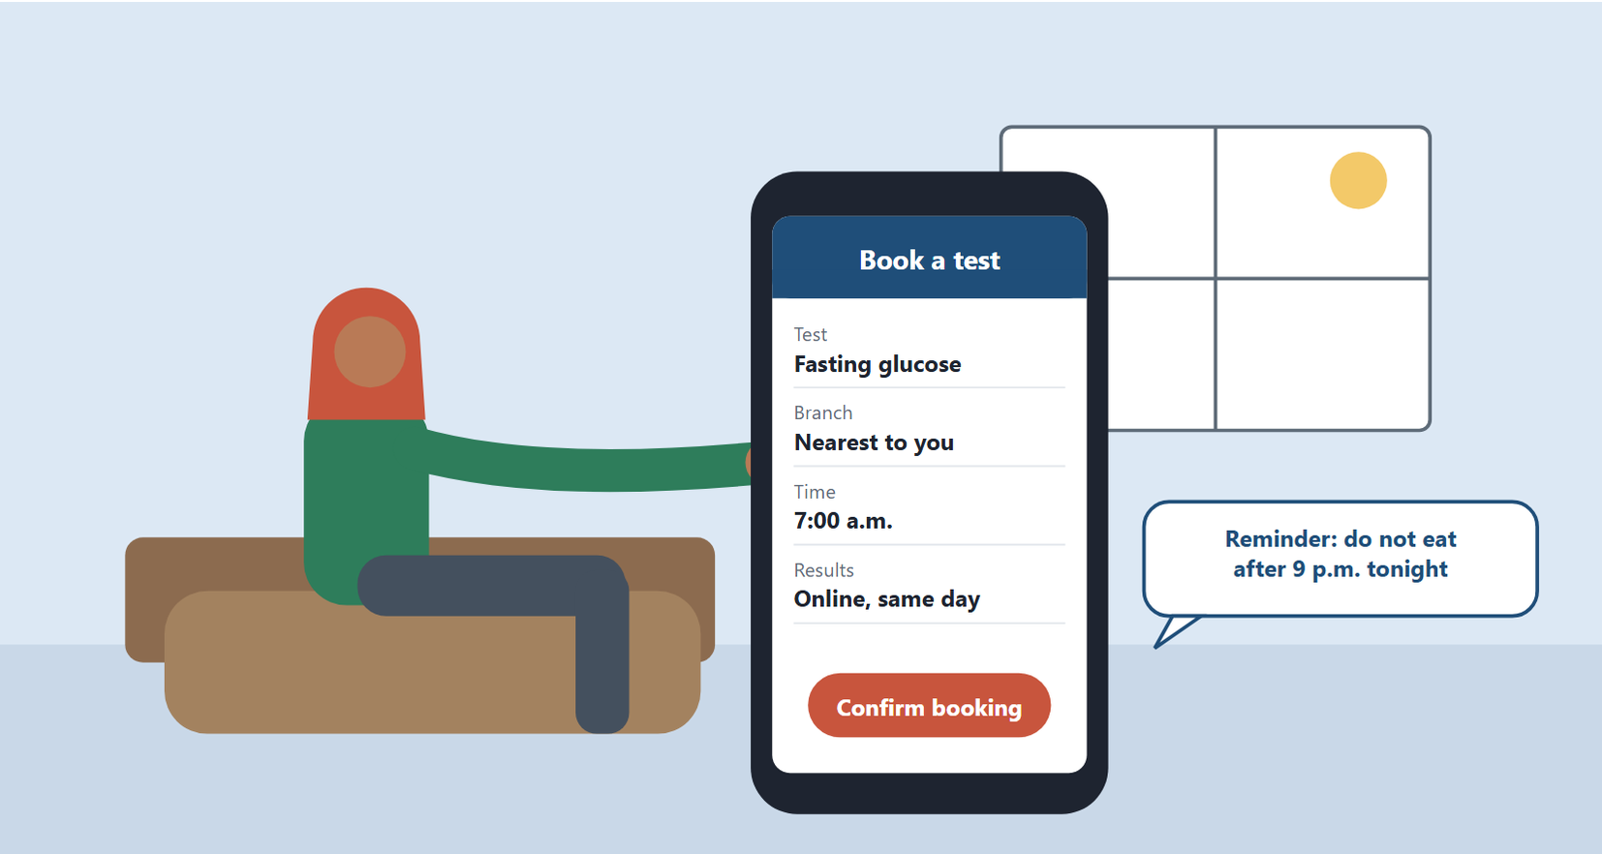
Figure 3.1 Online booking. A patient books an early-morning fasting test on a phone and receives a preparation reminder. Booking and result systems spread demand, save trips and are part of the service's quality.
Original illustration (original)
Reviews and responses. Patients' reviews are earned media. A polite, factual reply to a complaint shows other readers how the service treats people. A reply must never reveal a patient's health information.

3.7 Planning a Digital Campaign
A digital campaign is a planned set of online activities with one objective. Good campaigns follow the same six steps, whatever the channel (Chaffey & Ellis-Chadwick, 2019).
1. Set the objective. State what should change and by how much. "Increase online bookings for early-morning fasting tests by 20% in three months" is an objective; "be more visible" is not.
2. Define the audience. Who needs the service, and where are they online? Working adults who must fast before a test are a different audience from parents booking tests for children.
3. Write the message. State the benefit plainly and truthfully: "Open from 7 a.m., results online the same day." Avoid fear and exaggeration.
4. Choose the channels. Search listings and the website for people already looking; social media for awareness; reminders by message for existing patients who have agreed to receive them.
5. Set the budget. Decide what can be spent, and how it is split between channels.
6. Measure and review. Choose a few indicators before starting, then compare results with the objective.
Figure 3.2 shows the six steps as a cycle: what the last step learns shapes the next campaign.
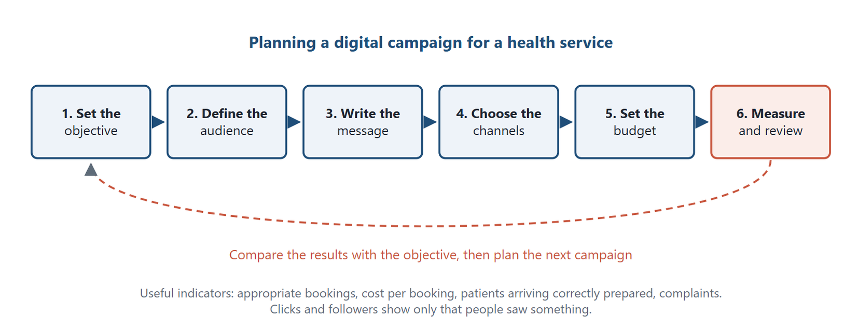
Figure 3.2 The six steps of a digital campaign. The last step, measuring and reviewing against the objective, feeds the next campaign.
Original diagram (original)
The indicators should measure what the service values. Useful ones are appropriate bookings, cost per booking, the share of patients who arrive correctly prepared, and complaints. Clicks and followers show only that people saw something.
Worked Example
Cost per booking of two channels
A laboratory spends 6,000 EGP in a month on search advertisements and 4,000 EGP on social-media advertisements. Search brings 150 bookings and social media brings 50. The figures are illustrative.
Step 1 — search. Cost per booking = 6,000 ÷ 150 = 40 EGP.
Step 2 — social media. Cost per booking = 4,000 ÷ 50 = 80 EGP.
Interpretation. Search costs half as much per booking, because it reaches people already looking for a test. Social media may still build awareness that later shows up as search. Averages show where money worked this month. Before shifting budget, the laboratory should test whether extra search spending still brings bookings at a similar cost, because the cost of each additional booking usually rises as spending grows. It should keep a smaller awareness effort and review both next month.

3.8 Privacy and Ethics Online
Health information is among the most sensitive personal data. Egypt's personal data protection law treats health data as sensitive and requires consent and safeguards for its processing (Arab Republic of Egypt, 2020). Professional ethics add further duties.
Ethics Check
A laboratory's marketing team proposes an online campaign. Patients who searched for "diabetes symptoms" would be shown advertisements for a discounted glucose test. The idea sounds helpful, but it raises three problems. It uses health-related search behaviour, which is sensitive. Its message may frighten people who are healthy. And it offers a discount tied to anxiety. A defensible alternative is a general educational campaign about diabetes risk, directing people to see a doctor, with no use of personal search data.

Four professional rules guide digital marketing of health services. They sit alongside the legal requirements described in the Egyptian Context box below, which add licensing and electronic-marketing rules of their own:
1. Consent. Send reminders and newsletters only to patients who have agreed to receive them.
2. Confidentiality. Never publish patients' images, results or stories without explicit written consent.
3. Truthfulness. Claims about accuracy, speed or price must be true and complete.
4. No remote diagnosis by marketing. Staff answering online messages must not interpret results or give medical advice. They direct the patient to a qualified professional.
Egyptian Context
Egypt's personal data protection law was issued as Law No. 151 of 2020 (Arab Republic of Egypt, 2020). Its executive regulations followed in Ministerial Decree No. 816 of 2025, which sets operational rules for consent, licences or permits for those who control or process personal data, record-keeping, breach notification, sensitive data such as health data, and direct electronic marketing (Ministry of Communications and Information Technology, 2025). Organisations were given a transition period of one year from November 2025 to comply. A laboratory's booking app, result portal and reminder messages all fall within this framework. Before launching any digital service, check with the organisation's legal adviser whether it needs a licence or permit, how consent for marketing messages must be obtained, and whether a data protection officer is required.

Key Takeaways
- Digital marketing promotes services through search, websites, social media, email, apps and new channels.
- Owned, paid and earned media differ in who controls them; earned media carry weight in health care.
- Reach, targeting, measurement and speed are digital marketing's main benefits.
- SEO rests on clear, accurate content, which also serves patients.
- Digital and traditional marketing differ in tendency; traditional marketing can be measured too.
- Success is measured in appropriate bookings and better service, not in followers.
- Health data are sensitive; consent, confidentiality and truthfulness limit every digital campaign.

Check Your Understanding
Q1 [LO1] Patients' online reviews of a laboratory are an example of:
A Owned media
B Paid media
C Traditional media
D Earned media
Q2 [LO1] A laboratory's own website and app are:
A Owned media
B Earned media
C Paid media
D Outdoor media
Q3 [LO2] Search engine optimisation mainly aims to:
A Buy advertisements on television
B Make a site easier for search engines to find and rank
C Collect patients' health searches
D Replace the laboratory's accreditation
Q4 [LO2] Which objective of digital marketing also directly reduces rejected samples?
A Increasing followers
B Lowering prices
C Providing clear preparation content
D Buying more advertisements
Q5 [LO3] Which statement about traditional marketing is correct?
A Its results cannot be measured at all
B It always converts worse than digital marketing
C It is always cheaper than digital marketing
D It can be measured, though more slowly and less directly
Q6 [LO3] Why should an Egyptian health service keep some traditional channels?
A Many patients, especially older ones, rely on doctors and word of mouth
B Digital marketing is illegal in Egypt
C Traditional channels are always measurable in real time
D Online channels cannot reach any patients
Q7 [LO4] The best measure of a health service's digital marketing success is:
A The number of followers
B The number of likes
C Appropriate bookings and service improvements
D The size of the advertising budget
Q8 [LO4] Replying publicly to a patient's online complaint, a centre should:
A Correct the patient by quoting the results
B Reply politely and factually, revealing no health information
C Delete the review immediately
D Offer free tests in exchange for removing it
Q9 [LO5] Targeting discounted test advertisements at people who searched for disease symptoms is problematic mainly because it:
A Is too expensive
B Uses sensitive health behaviour and may exploit anxiety
C Cannot be measured
D Reaches too few people
Q10 [LO5] A staff member answering online messages is asked to interpret a result. The correct response is to:
A Interpret it briefly to keep the patient happy
B Ignore the message
C Post the result publicly for others to comment on
D Direct the patient to a qualified professional

Essay Questions
E1. [LO2] Describe four benefits of digital marketing for an imaging centre, and state one health-care limit on each.
E2. [LO3] "Digital marketing is better than traditional marketing in every way." Discuss this claim for a health service in Egypt.
E3. [LO5] Set out the privacy and ethical rules a laboratory must follow before launching an online result portal and reminder service.
Answers and Worked Solutions
Q1. D — Reviews are content others create about the service: earned media.
Q2. A — The organisation controls its own website and app, so they are owned media.
Q3. B — SEO makes a site easier to find and rank, mainly through clear and useful content.
Q4. C — Clear preparation content helps patients arrive fasting or ready, which reduces rejected samples. Followers, prices and advertising do not.
Q5. D — Traditional media are measured through reach, recall and responses. Measurement is slower and less direct, not impossible.
Q6. A — Doctor advice and word of mouth remain strong, especially among older patients, so a mixed approach reaches more of the market.
Q7. C — Appropriate bookings and better service show real value. Followers and likes are not patients.
Q8. B — A polite, factual reply shows how the service treats people, and confidentiality forbids revealing any health information.
Q9. B — Health-related searches are sensitive data, and a discount tied to anxiety exploits fear. That is the ethical problem, not cost or reach.
Q10. D — Marketing staff must not interpret results. The patient should be directed to a qualified professional.
E1 — model answer points. Reach, with the limit of accuracy; targeting, with the limit of not exploiting fear; measurement, with the limit of no covert tracking of health searches; engagement, with the limit of no medical advice in comments; speed, with the limit that content must be reviewed first.
E2 — model answer points. Digital tends to be cheaper to start, targetable and measurable, but traditional marketing can be measured and may be trusted more by older patients. Conversion depends on the offer and audience. Doctors' advice and word of mouth remain strong in Egypt. The sensible conclusion is a mix of channels.
E3 — model answer points. Consent for reminders and data processing; secure access to results; compliance with the personal data protection law; no publication of results or images; truthful claims about the service; staff trained not to interpret results; legal review before launch.

References
Arab Republic of Egypt. (2020). Law No. 151 of 2020 on the protection of personal data. Official Gazette. Chaffey, D., & Ellis-Chadwick, F. (2019). Digital marketing (7th ed.). Pearson. Ministry of Communications and Information Technology. (2025). Ministerial Decree No. 816 of 2025 issuing the executive regulations of the Personal Data Protection Law No. 151 of 2020. Official Gazette.

Part II The Marketing Mix for Health Services
Chapters 4–9
4 The Marketing Mix: From Four Ps to Seven
5 Health Products and Services
6 The Product Life Cycle
7 Pricing Health Services
8 Distribution and Access
9 Marketing Communications and Promotion

4 The Marketing Mix: From Four Ps to Seven
Learning Objectives
By the end of this chapter you will be able to:
LO1 Define the marketing mix and name the four Ps.
LO2 Explain why services need the extended mix of seven Ps.
LO3 Apply people, process and physical evidence to a laboratory or imaging centre.
LO4 List the service elements that surround a medicine or a test.
LO5 Recognise where a marketing-mix decision creates an ethical risk.

4.1 The Marketing Mix
The marketing mix is the set of controllable tools an organisation uses to reach its market (Kotler & Keller, 2016). It is called a mix because the tools act together. A good test at the wrong price, or a fair price in a place no one can reach, fails.
The classic mix has four elements, known as the 4 Ps:
- Product — what is offered: its features, quality, design, brand and packaging.
- Price — the money charged for it. Time and effort are further, non-money costs to the customer.
- Place — how it reaches customers: locations, channels and access.
- Promotion — how the organisation communicates: advertising, public relations, personal selling and sales promotion.
The four Ps were designed for physical goods. They still apply to health care, but they miss much of what a patient experiences in a service. Section 4.3 adds three more Ps for services.

4.2 The Four Ps in Health Care

Product
For a laboratory, the product is the test menu and each result. For an imaging centre it is each scan and its report. Product decisions include which services to offer, their technical quality, the brand, and supporting features such as home collection or online results.
A product may have a unique selling proposition (USP): a benefit that competitors do not offer. A laboratory might be the only one in its area that reports a particular hormone test the same day. The USP must be true and must matter to patients.
Products also include packaging, quality, warranties, after-sales service and branding. For a service, the "packaging" is the report layout, the waiting area and the way results are delivered.

Price
Price in health care depends on customer demand, competitors' prices, the organisation's strategy, operating costs and the costs of marketing and selling. It often also depends on regulation and on contracts with insurers. Chapter 7 covers pricing in full.
The money price is not the whole of what a patient gives up. A patient also bears non-money costs: travel time, waiting time and time off work. Together with the price they make up the total customer cost of Chapter 5. A laboratory that opens at seven in the morning lowers that total cost for workers who must fast before a test, without changing its price.

Place
Place asks how the patient acts and buys. It covers the location of service points, the ease of the transaction, access through distribution channels, the sales force and the approaches of competitors. For medicines the chain runs from manufacturer to distributor to pharmacy to patient. For diagnostics, place includes branches, collection points, home visits and hospital contracts. Chapter 8 covers place in full.

Promotion
Promotion includes four main tools: advertising, public relations, personal selling and sales promotion. In health care, promotion is restricted by law and ethics more than any other element. Chapter 9 covers it in full.

4.3 Why Services Need Seven Ps
A service is an act or performance offered to another. It tends to be intangible, the patient usually takes part in producing it, and its capacity cannot be stored: an hour of a phlebotomist's or a scanner's time that goes unused is lost (Wirtz & Lovelock, 2021). These are tendencies, not absolutes. A laboratory sample can be stored and analysed later, and a report is read after the visit; what cannot be stored is the capacity to serve. A blood test is performed on the patient's sample, at a time the patient attends, by people the patient meets.
Because of these features, services researchers added three elements to the mix. The result is the 7 Ps of services marketing (Wirtz & Lovelock, 2021):
- People — everyone who meets the customer: receptionists, phlebotomists, technologists, radiographers and doctors.
- Process — the steps the customer goes through: booking, registration, waiting, sampling or scanning, and receiving results.
- Physical evidence — the tangible signs of an intangible service: the building, cleanliness, equipment, uniforms, signs and the report itself.
Figure 4.1 shows the seven elements around the patient.
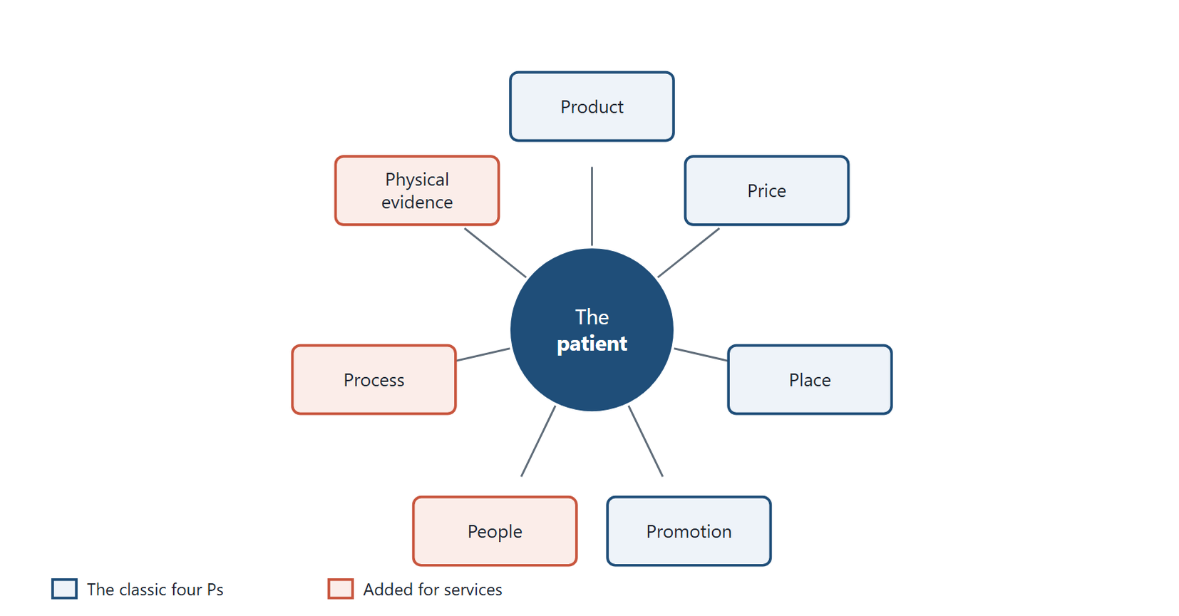
Figure 4.1 The seven Ps of services marketing around the patient. Product, price, place and promotion are the classic mix; people, process and physical evidence are added because a health service is performed with the patient present.
Original diagram (original)
These three extra Ps matter more in health care than almost anywhere else. Patients usually cannot judge whether a result is technically correct. They judge what they can see: people, process and physical evidence. Chapter 1 called this functional quality.
Through Two Lenses
- Medical Laboratory: People are the phlebotomists who draw blood with little pain and explain fasting rules. Process is registration, sampling and online results without delays. Physical evidence is a clean collection room, sealed tubes, a clear report and visible accreditation certificates. - Radiology and Medical Imaging: People are the radiographers who explain the scan and keep patients calm. Process is booking, safety screening and a report that reaches the doctor quickly. Physical evidence is a clean changing room, working equipment, clear safety signs and a readable report with images.

People
In a service, the employee is part of the product. A skilled but rude radiographer delivers a poor service. Selection, training and support of staff are marketing decisions as much as human-resource ones.
The qualifications of staff are also a signal. Patients and doctors are reassured by trained, licensed professionals. Showing those qualifications honestly is legitimate.

Process
A process can be drawn as a sequence of steps. Each step is a chance to delight or disappoint the patient. Where do queues form? Where are samples mislabelled? Where do reports stall? Improving the process improves both quality and satisfaction.

Physical evidence
Physical evidence reassures patients about what they cannot see. A patient who sees the phlebotomist open a sterile needle from an intact sealed wrapper trusts the laboratory's hygiene. A report with clear reference ranges and the laboratory's accreditation mark signals care. Figure 4.2 shows the physical evidence of an imaging room.
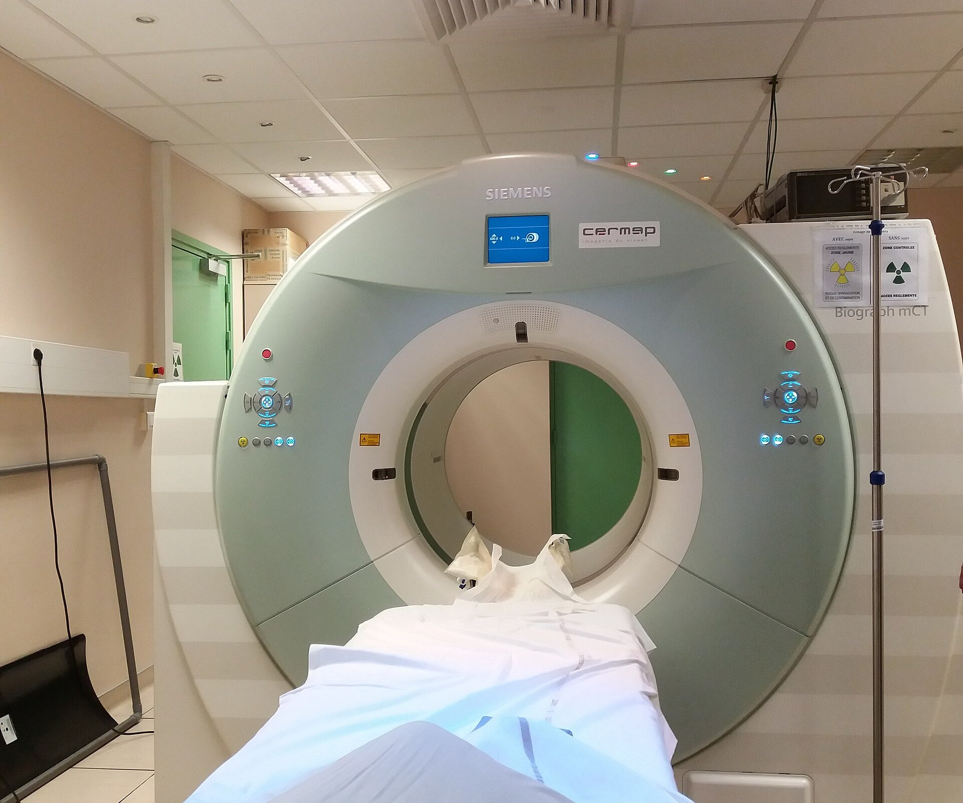
Figure 4.2 Physical evidence in an imaging centre. The patient cannot judge the scanner's technical performance, but sees the room: its cleanliness, clean linen, clear safety signs and working equipment.
Photograph: Romainbehar, via Wikimedia Commons (CC0)
In Practice
A laboratory branch receives complaints about long waits in the morning. The team maps the process and finds that registration and payment happen at one desk. They add a second desk for patients who booked online and move payment to the end. The morning wait falls sharply. No price, product or promotion changed. A process change improved the service, and satisfaction rose.

4.4 Service Elements of a Medicine or a Test
Even a physical product such as a medicine comes wrapped in services. The service elements of a pharmaceutical product include:
- the pharmaceutical service at the point of sale;
- clear instructions for use;
- pharmaceutical care and counselling during purchase;
- the qualifications of the staff;
- the speed with which orders are filled;
- the handling of complaints.
A laboratory test has equivalent service elements:
- clear preparation instructions before the test;
- courteous and skilled sample collection;
- accurate and timely reporting;
- explanation of the report, or referral to a doctor who can explain it;
- follow-up reminders for repeat tests;
- a fair and quick complaints process.
A patient who buys the same medicine from two pharmacies, or the same test from two laboratories, may receive very different value. The difference lies in these service elements.

4.5 The Mix Must Fit Together
The seven Ps must support each other. A premium price needs premium physical evidence and skilled people. A promise of fast results needs a process that can deliver them. A new branch (place) needs staff (people) before it opens.
A mix is also designed for a target group. A centre that serves insured corporate employees will design a different mix from one that serves low-income neighbourhoods. The core service, a correct result, must be the same for both.
Common Mistake
Improving one P in isolation. A laboratory that runs a promotion for a new test before training its staff and preparing its process will disappoint the patients it attracts. Promotion should follow readiness, not precede it.

4.6 Mapping the Service: The Blueprint
People, process and physical evidence can be managed together with one tool. A service blueprint is a diagram of every step a customer takes through a service, with the staff actions and support processes behind each step (Wirtz & Lovelock, 2021).
A blueprint has four layers. The top layer shows the patient's actions: booking, arriving, registering, waiting, being sampled or scanned, and receiving results. The second layer shows the front-stage actions of staff the patient sees: the receptionist, the phlebotomist, the radiographer. A line of visibility separates these from the back-stage actions the patient does not see: sample processing, image reconstruction, reporting. The bottom layer shows support processes: the information system, equipment maintenance, reagent supply.
Drawing the blueprint reveals fail points, the steps where the service most often goes wrong. In a laboratory these are often sample labelling, transport delays and results that do not reach the doctor. In an imaging centre they are often incomplete safety screening, rescheduled appointments and delayed reports. Each fail point is a place to add a check, such as a second identification step before sampling.
The blueprint also shows where physical evidence matters. The patient cannot see the analyser or the reporting workstation, so the reception, the collection room and the printed report must carry the signals of quality. Figure 4.3 shows a blueprint of a laboratory blood test.
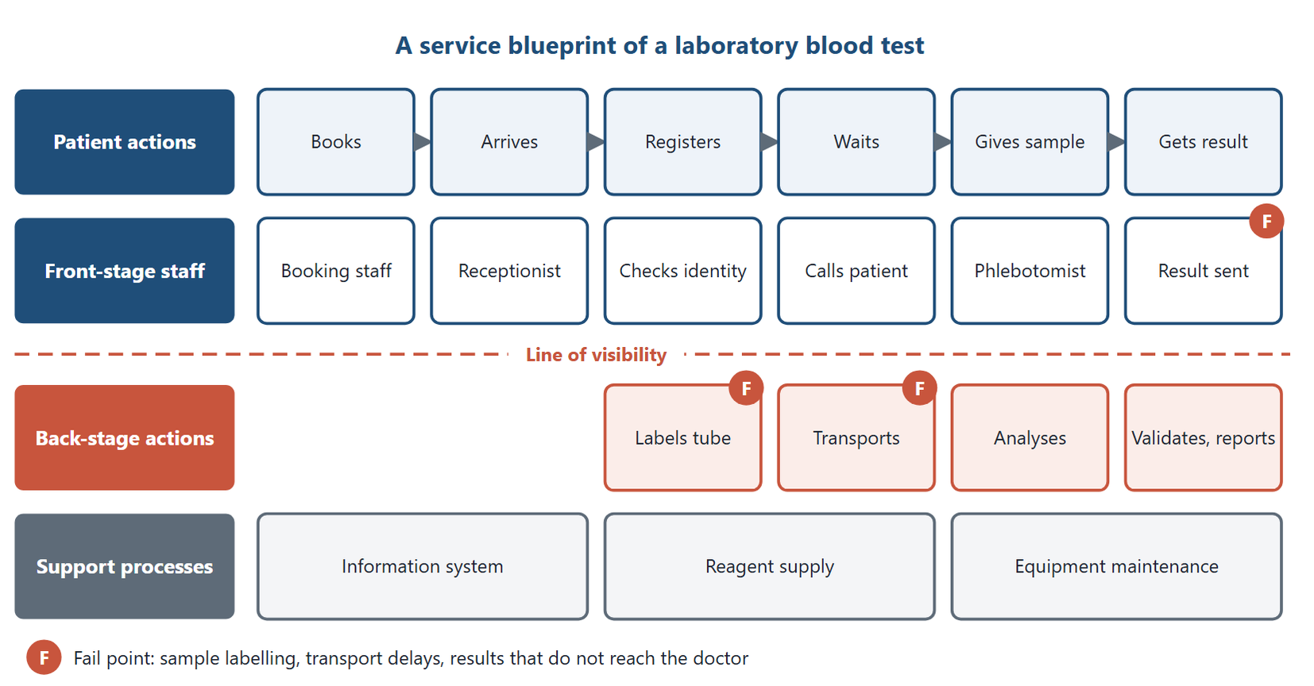
Figure 4.3 A service blueprint of a laboratory blood test. The line of visibility separates what the patient sees from the back-stage work; F marks the usual fail points.
Original diagram (original)
In Practice
An imaging centre draws the blueprint of an MRI appointment. It finds that patients are asked about metal implants twice, once by phone and once at the scanner, but never in writing. The team adds a short written checklist at registration, signed by the patient and checked by the radiographer. Safety improves and the scanner loses fewer slots to last-minute exclusions.

4.7 Ethics Across the Mix
Every element of the mix can be misused. Product decisions can add tests with no clinical value. Price decisions can exploit patients who cannot compare. Place decisions can abandon poor areas. Promotion decisions can mislead. People decisions can reward staff for selling rather than caring.
Ethics Check
A laboratory pays its reception staff a bonus for every additional test a patient adds at the desk. Staff begin to suggest extra tests to patients who came with a doctor's request. The incentive turns receptionists into salespeople for services they are not qualified to recommend. It also breaks the trust that the referring doctor placed in the laboratory. Incentives for staff must reward quality and service, never the volume of tests a patient did not need.

Egyptian Context
Egyptian laboratories and imaging centres are licensed, and accreditation is growing as a sign of quality. The universal health insurance system contracts accredited providers (Arab Republic of Egypt, 2018). Accreditation is a form of physical evidence that doctors and payers now look for.

Key Takeaways
- The marketing mix is the set of controllable tools an organisation uses to reach its market.
- The four Ps are product, price, place and promotion.
- Services tend to be intangible, their production and consumption often overlap, and their unused capacity cannot be stored.
- The seven Ps add people, process and physical evidence for services.
- Patients judge health services largely by people, process and physical evidence.
- A medicine or a test comes wrapped in service elements that create much of its value.
- The mix must fit together and must be designed within ethical limits.

Check Your Understanding
Q1 [LO1] The marketing mix is best described as:
A A company's advertising budget
B The set of controllable tools used to reach a market
C A list of competitors
D The government's rules on pricing
Q2 [LO1] Which is not one of the original four Ps?
A People
B Product
C Price
D Promotion
Q3 [LO2] Services need an extended mix mainly because they are:
A Always more expensive than goods
B Produced by machines
C Largely intangible, with perishable capacity and the customer taking part
D Free of regulation
Q4 [LO2] Which three elements does the services marketing mix add?
A Profit, planning and packaging
B Patients, prices and pharmacies
C Policy, promotion and place
D People, process and physical evidence
Q5 [LO3] A clean collection room and visible accreditation certificates are examples of:
A Physical evidence
B Process
C Price
D Place
Q6 [LO3] Adding a second registration desk to shorten morning waits is a change in:
A Product
B Process
C Promotion
D Price
Q7 [LO3] A skilled but rude radiographer mainly weakens which element?
A Place
B Price
C People
D Physical evidence
Q8 [LO4] Counselling a patient on how to take a medicine is:
A A service element of the product
B Sales promotion
C A price discount
D A distribution channel
Q9 [LO5] Paying receptionists a bonus for each extra test added at the desk is unethical mainly because it:
A Raises the laboratory's costs
B Rewards selling services staff are not qualified to recommend
C Slows down registration
D Breaks the pricing rules
Q10 [LO5] A laboratory launches promotion for a new test before training staff. The main risk is that:
A The test becomes cheaper
B Competitors copy the test
C The price rises
D Patients attracted by the promotion are disappointed

Essay Questions
E1. [LO3] Apply people, process and physical evidence to an imaging centre, giving two examples of each.
E2. [LO4] List the service elements that surround a laboratory test, and explain why two laboratories offering the same test may deliver different value.
E3. [LO5] Choose three elements of the marketing mix and describe how each could be misused in a health service. Suggest a safeguard for each.
Answers and Worked Solutions
Q1. B — The mix is the set of controllable tools used together to reach a market.
Q2. A — People is one of the three extra Ps added for services. Product, price and promotion are original.
Q3. C — Intangibility, perishable capacity and the customer's part in production are what the extra Ps address. They are tendencies: a sample can be stored, but the capacity to serve cannot.
Q4. D — People, process and physical evidence complete the seven Ps.
Q5. A — Tangible signs that reassure patients about an intangible service are physical evidence.
Q6. B — Rearranging registration changes the steps patients go through: the process.
Q7. C — In a service the employee is part of the product. Rudeness weakens the people element.
Q8. A — Counselling is one of the service elements that surround a medicine and add to its value.
Q9. B — The bonus turns receptionists into sellers of tests they cannot judge, against the patient's interest and the doctor's trust.
Q10. D — Promotion before readiness brings patients to a service that cannot yet deliver, so they are disappointed.
E1 — model answer points. People: radiographers who explain the scan; reception staff who book calmly. Process: safety screening before MRI; fast delivery of reports to doctors. Physical evidence: clean changing rooms; clear safety signs and a readable report.
E2 — model answer points. Preparation instructions, skilled collection, accurate and timely reporting, explanation or referral, reminders, complaints handling. Technical results may be equally correct, but these service elements differ, and patients judge the service by them.
E3 — model answer points. Product: adding tests without clinical value; safeguard, a clinical review of the test menu. Price: exploiting patients who cannot compare; safeguard, published prices. Promotion: misleading claims; safeguard, professional review of all material. People: sales incentives; safeguard, rewards for quality measures.

References
Arab Republic of Egypt. (2018). Law No. 2 of 2018 promulgating the Universal Health Insurance System law. Official Gazette. Kotler, P., & Keller, K. L. (2016). Marketing management (15th ed.). Pearson. Wirtz, J., & Lovelock, C. (2021). Services marketing: People, technology, strategy (9th ed.). World Scientific.

5 Health Products and Services
Learning Objectives
By the end of this chapter you will be able to:
LO1 Distinguish goods from services on five characteristics.
LO2 Classify consumer products as convenience, shopping, specialty or unsought, and as durable or non-durable.
LO3 Describe the main ways medicines and medical devices are classified.
LO4 Calculate customer value and name its four types.
LO5 Explain which product properties create value for patients, and where claims about them must stop.

5.1 Goods and Services
A good is a physical product made for sale to satisfy a need. A service, as Chapter 4 defined it, is an act or performance. Most health offerings combine the two. A glucose meter is a good sold with the service of training. A CT scan is a service that uses goods: the scanner, contrast medium and a printed report. Figure 5.1 shows a laboratory service that depends on goods.

Figure 5.1 A laboratory service uses goods. A microbiology culture needs plates, swabs and reagents, but what the patient buys is the skilled performance that turns them into a reliable result.
Photograph: U.S. Air Force, Airman 1st Class Ashley Thum, via Wikimedia Commons (public-domain)
Customers do not buy goods or services for their own sake. They buy a bundle of benefits: variety, quality, design, features, brand name, packaging and service. They expect the bundle to satisfy a need.
Goods and services differ on five characteristics (Wirtz & Lovelock, 2021), shown in Table 5.1. Each is a tendency rather than a rule, and a laboratory shows why: the patient is present for sampling, but the analysis may happen hours later and the report is read later still.
Characteristic | Goods | Services
Tangible | Yes | Largely no
Time between production and consumption | Often long | Often short; the patient-facing part happens in the patient's presence
Can be stored | Yes | Capacity cannot be stored; some inputs, such as samples, can
Customer takes part in production | Usually not | Usually yes
Ownership passes to the buyer | Yes | No: the buyer receives a performance

Table 5.1. Goods and services compared.
Each difference has a practical meaning for a health service.
Intangibility. A patient cannot inspect a test before buying it. That is why physical evidence and reputation matter so much.
Simultaneity. The patient-facing part of the service happens in the patient's presence: a sample is drawn while the patient is there, and the phlebotomist's skill is part of the product. Analysis and reporting can follow later.
Perishability. An empty scanner slot at ten in the morning is lost for ever. Imaging centres therefore work hard to fill schedules evenly.
Customer participation. The patient must fast, lie still or hold a breath. Clear instructions are part of producing a good result.
No transfer of ownership. The patient receives the performance and its results, such as the images and the report, but does not come to own the service itself. What is bought is the performance and its outcome.
Through Two Lenses
- Medical Laboratory: A laboratory's capacity perishes when analysers stand idle, yet samples can often wait a few hours. This lets laboratories pool work from many collection points and run it in batches, balancing demand across the day. - Radiology and Medical Imaging: A scanner's capacity perishes minute by minute, and the patient must be present for every scan. Imaging centres therefore rely on appointments, reminders and overbooking rules to keep their costly machines in use.

5.2 Classifying Consumer Products
Marketers classify consumer products by how people buy them (Kotler & Keller, 2016). The classification helps predict how much effort customers will spend and what marketing suits each product.
Convenience products are bought often, quickly and with little comparison. Examples are bread, water, and simple painkillers or plasters from a pharmacy.
Shopping products are compared on suitability, quality, price and style before purchase. Examples are phones, watches and, in health care, eyeglasses or a private check-up package.
Specialty products have unique features for which buyers make special effort. Examples are a particular car, or a medicine a patient's condition requires. A patient will travel to the one centre in the region that offers PET-CT.
Unsought products are products the buyer does not know about, or knows about but does not think of buying. Examples are insurance and, in health care, many screening tests. Few healthy people seek a colorectal screening test on their own.
Older texts sometimes translate these classes as "daily demand", "previous choice", "special demand" and "passive demand". The standard English terms are the four above, and students will find them in standard marketing texts.
The classification points to the marketing task. Convenience products need wide availability. Shopping products need clear information for comparison. Specialty products need awareness among the few who need them. Unsought products need education, which is why screening programmes rely on doctors and public campaigns.

Durable and non-durable goods
Goods can also be classified by how long they last. Durable goods survive many uses over a long time, usually taken as three years or more. Examples include furniture, electronics and, in health care, wheelchairs, blood-pressure monitors and diagnostic equipment. Non-durable goods are used once or over a short time. Examples include food, cosmetics, detergents and, in health care, reagents, syringes and most medicines.
Durable goods | Non-durable goods
Used over a long period | Used over a short period
Used many times | Used once or a few times
Can often be resold | Usually cannot be resold
Examples: cars, televisions, ultrasound machines | Examples: fuel, soap, reagents, test strips

Table 5.2. Durable and non-durable goods.
In Practice
A company selling glucose meters faces both classes at once. The meter is durable; the test strips are non-durable and bought every month. Many companies price the meter low and earn their revenue on strips. A patient choosing a meter should therefore compare the cost of strips over a year, not only the meter's price.

5.3 Medicines and Medical Devices
Health products form a special group with two main subgroups: medicines and medical devices.

Medicines
A medicine is a substance or combination of substances, in a dosage form, intended to treat or prevent disease in people, to diagnose it, or to restore, correct or modify physiological functions. Medicines are registered by a regulator before they can be sold. In Egypt that regulator is the Egyptian Drug Authority.
Medicines are classified in several ways, each useful for a different purpose:
- by anatomical site of action — the respiratory, cardiovascular or digestive system;
- by therapeutic use — analgesics, antibiotics, antihypertensives;
- by pharmacological action — diuretics, anticoagulants, antipsychotics;
- by chemical structure — alkaloids, cardiac glycosides, steroid hormones;
- by legal control — narcotics and psychotropic substances;
- by supply — prescription-only or non-prescription (over-the-counter);
- by route — internal or external use;
- by storage needs — light-sensitive or heat-sensitive;
- by dosage form — solutions, suspensions, tablets, ointments;
- by origin — industrially manufactured or individually compounded.
For marketing, the supply classification matters most. Prescription medicines are marketed mainly to doctors, within strict rules. Over-the-counter medicines may be marketed to the public, also within rules.

Medical devices and consumables
A medical device is an instrument, apparatus, machine, material or other article intended for diagnosis, prevention, monitoring or treatment of disease, which does not act mainly by pharmacological means. X-ray machines, dressings, syringes and examination gloves belong here. Older translated texts call this group "products of medical appointment". The international term is medical devices, with in-vitro diagnostic (IVD) devices as the laboratory subgroup. What makes an analyser or a reagent an IVD is its manufacturer's intended purpose: it is meant for examining specimens from the human body to give information for diagnosis, monitoring or screening. A reagent labelled "for research use only", or general laboratory equipment such as an ordinary centrifuge or refrigerator, is not an IVD, and must not be used to report patient results as if it were.
Medical devices and supplies can be grouped:
- by material — rubber, glass or plastic;
- by product group — dressings, hygiene items, personal-care products;
- by function — patient-care items, instruments, apparatus and equipment;
- by storage group — rubber products, dressings, plastics, equipment.
Regulators also group devices by risk. A plaster carries low risk; an implant or an imaging system carries higher risk and faces stricter review.
Common Mistake
Treating the reagents and analysers used for patient testing as ordinary supplies. Those intended by their manufacturer for examining human specimens are in-vitro diagnostic medical devices. Their registration, storage and quality control affect patient safety as directly as a medicine does.

5.4 Customer Value
Chapter 1 introduced customer value. This section defines it precisely.
Key Formula
Customer value
$$CV=\text{perceived customer benefit}-\text{total customer cost}$$
Total customer cost includes money, time, effort and psychological cost such as anxiety. When perceived benefit exceeds total cost, customers are more likely to be satisfied, return and recommend the service. Satisfaction itself still depends on how the service performs against what the customer expected (Chapter 1).

Customers must believe the product is worth more than its price (Kotler & Keller, 2016). This book groups the kinds of worth customers look for into four types, a grouping common in consumer research:
- Functional value — what the offering does: the solution it provides. An accurate diagnosis is functional value.
- Monetary value — the price paid relative to the perceived worth. A fair price for a reliable test offers monetary value.
- Social value — how using the product connects the customer with others. Attending a respected centre may reassure a family.
- Psychological value — how the product helps customers feel better or express themselves. A calm, reassuring scan experience reduces fear.
Worked Example
Comparing value between two laboratories
A patient scores two laboratories for a routine test on a 100-point scale of perceived benefit, and converts all costs to the same scale. The figures are illustrative.
Laboratory A: perceived benefit 80; money 30, travel and waiting 20, anxiety 5. Total cost = 30 + 20 + 5 = 55. Customer value = 80 − 55 = 25.
Laboratory B: perceived benefit 75; money 35, travel and waiting 5, anxiety 5. Total cost = 35 + 5 + 5 = 45. Customer value = 75 − 45 = 30.
Laboratory B charges more money but offers more value, because it is close by and quick. Price is only one part of cost.

Figure 5.2 draws the two laboratories' benefits and costs side by side.
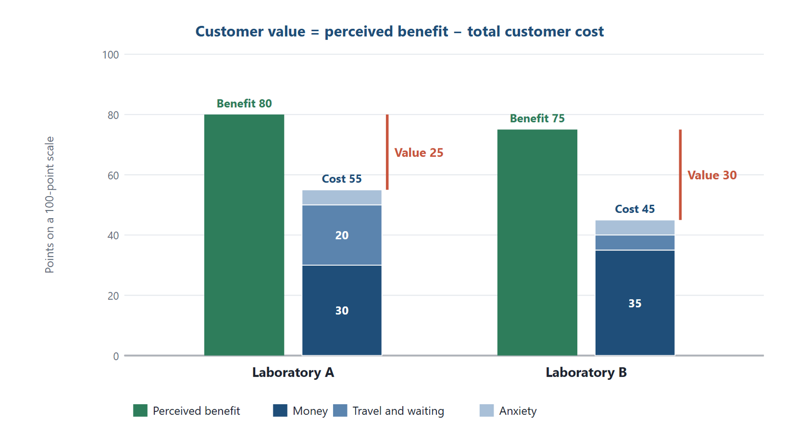
Figure 5.2 Customer value in the worked example. Laboratory B charges more money than Laboratory A, but its lower travel and waiting cost gives the patient more value: 30 points against 25.
Original diagram (original)

5.5 Properties That Create Value
For goods in general, value comes from quality (reliability, suitability, design), a price that matches quality, clear documentation, good after-sales service and a range that offers choice.
For medical products, four properties create value:
- Therapeutic effectiveness — the product does what it is meant to do.
- Safety — its risks are low and known.
- Convenience — it is easy to use: a once-daily tablet, a painless sampling device, a short scan.
- Economic efficiency — its benefits justify its cost to patients and payers. Chapters 10 to 12 show how this is measured.
For a diagnostic service the same four apply. Effectiveness is analytical and diagnostic accuracy. Safety covers infection control and radiation dose. Convenience covers access and turnaround time. Economic efficiency covers the price and the avoided costs of a correct early diagnosis.
Ethics Check
Marketing may describe these properties, but only truthfully and within evidence. An imaging centre that calls its low-dose CT "radiation-free" is making a false safety claim. A laboratory that advertises "100% accurate results" claims what no test can deliver, because every test has error. Claims of effectiveness and safety must be supported, specific and honest about limits.

Egyptian Context
In Egypt, medicines and medical devices are regulated by the Egyptian Drug Authority, which registers products before sale. Laboratories and imaging centres must also be licensed. Marketers of any health product should confirm its registration status before promoting it.

Key Takeaways
- Goods tend to be tangible and storable; services tend to be intangible, their unused capacity perishes, and their patient-facing part happens with the customer present.
- Consumer products are convenience, shopping, specialty or unsought; screening tests are often unsought.
- Durable goods last three years or more; reagents and most medicines are non-durable.
- Medicines are classified by site, use, action, structure, control, supply, route, storage, form and origin.
- Medical devices include analysers, reagents and imaging equipment; "products of medical appointment" is an outdated translation.
- Customer value is perceived benefit minus total cost, and it has functional, monetary, social and psychological types.
- Claims of effectiveness and safety must be supported and honest about limits.

Check Your Understanding
Q1 [LO1] An empty MRI slot at ten o'clock that cannot be used later shows that services are:
A Tangible
B Transferable
C Storable
D Perishable
Q2 [LO1] A patient must fast before a fasting glucose test. This illustrates:
A Customer participation in producing the service
B Transfer of ownership
C Storage of the service
D Durability
Q3 [LO2] Most healthy people do not seek colorectal screening on their own. Screening is therefore usually:
A A convenience product
B A shopping product
C An unsought product
D A durable good
Q4 [LO2] A patient compares several private check-up packages on price and content before choosing. The package is:
A A shopping product
B An unsought product
C A convenience product
D A non-durable good
Q5 [LO2] Which is a durable good?
A A box of test strips
B An ultrasound machine
C A bottle of reagent
D A syringe
Q6 [LO3] Which classification of medicines decides whether promotion is directed mainly to prescribers or may, within regulation, address the public?
A Chemical structure
B Dosage form
C Supply: prescription or over-the-counter
D Storage needs
Q7 [LO3] Reagents and analysers that their manufacturer intends for examining patients' blood samples for diagnosis are best classified as:
A Medicines
B Cosmetics
C Food products
D In-vitro diagnostic medical devices
Q8 [LO4] A service offers perceived benefit of 70 and total customer cost of 50 on the same scale. Customer value is:
A 20
B 120
C 1.4
D −20
Q9 [LO4] A calm, reassuring scan experience that reduces fear mainly provides:
A Monetary value
B Psychological value
C Functional value
D Social value
Q10 [LO5] A laboratory advertises "100% accurate results". The claim is unacceptable because:
A It uses a number
B It is too modest
C Every test has some error, so the claim is false
D Laboratories may not advertise at all

Essay Questions
E1. [LO1] Explain the five differences between goods and services, and show what each means for an imaging centre.
E2. [LO2] Classify a screening mammogram, a pharmacy painkiller and a PET-CT scan in the four consumer-product classes, and describe the marketing task for each.
E3. [LO4] Define customer value and its four types. Using an example, show why a more expensive laboratory can offer greater value.
Answers and Worked Solutions
Q1. D — Service capacity cannot be stored; an unused slot is lost. That is perishability.
Q2. A — The patient's preparation is part of producing a valid result: customer participation.
Q3. C — Products people do not think of buying, such as screening, are unsought and need education to reach buyers.
Q4. A — Products compared on price, quality and suitability before purchase are shopping products.
Q5. B — The machine lasts for years and many uses. Strips, reagents and syringes are used up.
Q6. C — Prescription medicines are marketed mainly to doctors and over-the-counter medicines to the public, so supply class shapes the marketing.
Q7. D — Intended for examining human specimens for diagnosis, they are in-vitro diagnostic medical devices, regulated for safety like other devices. A research-use-only reagent would not be.
Q8. A — Customer value = 70 − 50 = 20. Option C divides instead of subtracting.
Q9. B — Feeling calmer and less afraid is psychological value.
Q10. C — No test is perfectly accurate, so "100% accurate" is a false claim about effectiveness.
E1 — model answer points. Intangible: patients judge by physical evidence and reputation. Simultaneous: the radiographer's skill is part of the product. Perishable: empty slots are lost, so scheduling matters. Customer participation: patients must prepare and keep still. No ownership transfer: the patient receives a performance and a report.
E2 — model answer points. Screening mammogram: unsought; needs education and doctor referral. Painkiller: convenience; needs wide availability. PET-CT: specialty; needs awareness among referring specialists and easy access for the few who need it.
E3 — model answer points. CV = perceived benefit − total customer cost; functional, monetary, social and psychological types. A laboratory charging more money can offer greater value if it saves travel, waiting and anxiety, because those are costs too.

References
Kotler, P., & Keller, K. L. (2016). Marketing management (15th ed.). Pearson. Wirtz, J., & Lovelock, C. (2021). Services marketing: People, technology, strategy (9th ed.). World Scientific.

6 The Product Life Cycle
Learning Objectives
By the end of this chapter you will be able to:
LO1 Describe the four stages of the product life cycle and the sales and profit pattern of each.
LO2 Select marketing strategies suited to each stage.
LO3 Explain how early adopters shape the spread of a new medicine, test or scan.
LO4 Choose between deletion and harvesting for a declining service, and list ways to delay decline.
LO5 Identify ethical risks at each stage of the life cycle of a health product.

6.1 Products Have Lives
Products tend to pass through recognisable stages, from launch to withdrawal. The pattern is called the product life cycle (PLC). It traces sales and profit over time through four stages: introduction, growth, maturity and decline (Kotler & Keller, 2016). Figure 6.1 shows the typical curve.
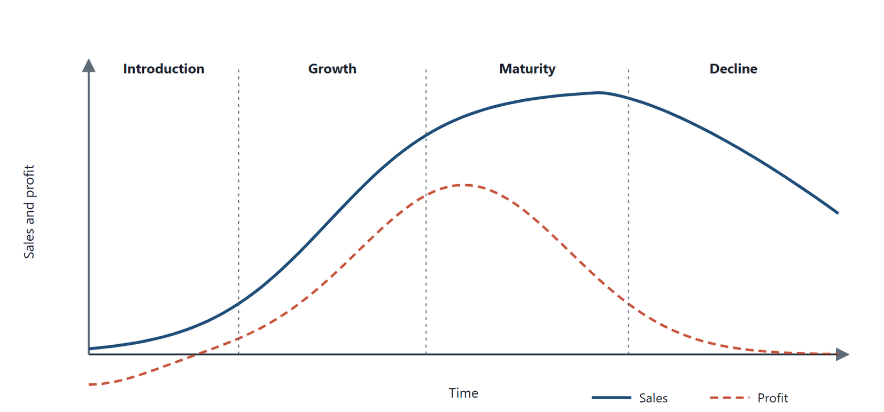
Figure 6.1 The product life cycle. Sales rise slowly at introduction, quickly in growth, level off in maturity and fall in decline. Profit is negative at launch, peaks around the end of growth and falls through maturity.
Original diagram (original)
The length of the cycle is not fixed. A fashionable test may rise and fall within a few years. A basic test such as a complete blood count has been in maturity for decades. The PLC is a way of thinking, not a timetable. Its value is that each stage calls for a different marketing approach.
The PLC can describe a product class, such as MRI scanning, or a single brand, such as one company's scanner model. The class usually lives much longer than any one brand within it.

6.2 Introduction
The introduction stage is the period after launch, when market acceptance is still uncertain. Sales usually grow slowly.
Its properties are:
- profits are low or negative, because launch and marketing costs are high;
- production and marketing costs per unit, and often prices, are high;
- few models or versions exist, and they change often as problems are found;
- competition is limited;
- the failure rate is high: many new products never reach growth.
The marketing task is to create awareness and encourage trial. Promotion explains what the new product category does, not why one brand is better; this is stimulating primary demand. Intensive personal contact with wholesalers, retailers and professionals is needed.
Two pricing strategies are possible. Skimming sets a high entry price and lowers it later. Penetration sets a low entry price to gain share quickly. Chapter 7 compares them.
In health care, the first users of a new medicine, test or scan are usually a small group of professionals. Rogers (2003) called such people innovators and early adopters. They try new things first and influence their colleagues. If the product proves as effective and safe as they hope, word spreads to the wider profession. If the product only does an old job in a new way, persuading doctors to change can be slow.
Through Two Lenses
- Medical Laboratory: A laboratory introducing a new cardiac marker test must first convince cardiologists and emergency doctors. Early adopters try it, compare it with the old test and share results at meetings. The laboratory supports them with validation data and fast reporting. - Radiology and Medical Imaging: A centre introducing a new scanning technique must first convince the specialists who would request it. Early adopters refer a few patients, judge the images and tell colleagues. The centre supports them with sample images and a clear referral pathway.

6.3 Growth
In the growth stage the product concept is widely accepted and sales rise quickly.
Its properties are:
- profits improve substantially, as development costs have been recovered;
- sales volume creates economies of scale, so costs per unit fall;
- competitors enter, often with modified versions;
- brand advertising becomes heavy, and differences between brands matter;
- large companies may acquire small pioneering firms;
- prices tend to fall, both because of scale and because of competition.
Strategies for growth include:
- improving the product and adding new features or models;
- entering new market segments;
- stimulating selective demand, the demand for one brand rather than the category;
- adjusting prices.
Gaining wider distribution is a key goal. Toward the end of growth, prices usually fall and profits reach their peak.

6.4 Maturity
In the maturity stage sales growth slows and then flattens. Profits are at or just past their peak and begin to decline.
Its properties are:
- competition reaches its peak, as most firms seeking share are now present;
- the market approaches saturation;
- product lines are widened or extended, often with emphasis on style over function;
- heavy promotion to both intermediaries and consumers is needed;
- prices and profits begin to fall;
- marginal competitors, financially or technically weak, start to leave.
Total sales of the product class may still rise, but at a decreasing rate. The net effect is price competition.
Strategies for maturity include:
- finding new markets and new uses for the product;
- improving quality or modifying the product;
- changing other elements of the marketing mix.
For medicines, maturity brings every variation: tablets, capsules, liquids, skin preparations, long-acting forms and combinations. Promotion tries to add life by segmenting the market, with messages aimed at particular specialties. For diagnostic services, maturity brings bundled packages, home collection, extended hours and faster reporting.
In Practice
Routine blood tests are deep in maturity. Most laboratories offer the same menu at similar prices. Competition therefore moves to the seven Ps of Chapter 4: shorter waits, home collection, online results, early opening and courteous staff. A laboratory that cannot compete on the test itself competes on the service around it.

6.5 Decline
The decline stage is marked by a long-run fall in sales. Falling demand forces many competitors out.
Its properties are:
- a declining product is not necessarily unprofitable;
- the speed of decline depends on how fast tastes change or substitutes are adopted;
- a few specialist firms may continue to supply the product;
- when a clearly better product causes the decline, it can be rapid: only those slow to change keep using the old one.
In health care, decline often follows new evidence or new technology. A medicine may decline when a safer or more effective therapy appears. A laboratory test may decline when a more accurate test replaces it. A plain X-ray examination may decline for some indications as CT or MRI takes over.
Promotion in decline may return to primary demand, or may be reduced to a core of loyal professional users. Some firms leave, which can leave an opportunity for those who remain.
Two strategies are available for a declining product (Kotler & Keller, 2016):
- Deletion — dropping the product from the line. It is the most drastic choice.
- Harvesting — keeping the product but cutting marketing support, taking the remaining profit.

Delaying decline
A firm may try to prevent a product slipping into decline by:
- promoting more frequent use among current customers;
- finding new target markets;
- finding new uses;
- pricing below the market;
- developing new distribution channels;
- adding or removing ingredients;
- offering a strong new guarantee.
Several of these carry ethical risks in health care, as the next section shows.
Common Mistake
Treating the PLC as a law that predicts sales. It describes a common pattern, and many products do not follow it. A test may be revived by a new guideline, and a scan may leap from introduction to maturity in a few years. Use the PLC to ask the right questions at each stage, not to forecast numbers.

6.6 Summary of the Stages
 | Introduction | Growth | Maturity | Decline
Sales | Slow growth | Rapid growth | Slowing, flat | Falling
Profit | Low or negative | Rising to peak | Peak, then falling | Falling
Competitors | Few | Increasing | Most | Fewer
Marketing aim | Awareness and trial | Share and distribution | Defend share | Harvest or delete
Price | High or penetration | Falling | Competitive | Low, or held for loyal users

Table 6.1. The four stages of the product life cycle.

6.7 Life Cycles of Health Technologies
Health technologies follow life cycles with features of their own.
Medicines and patents. A new medicine is usually launched under patent. When the patent expires, generic versions enter and prices fall sharply. The originator's brand may move quickly from maturity to decline in sales, while the medicine itself, as a class, stays in maturity for decades. Companies often respond at maturity with new formulations or combinations. Such line extensions are legitimate when they offer a real benefit to patients.
Diagnostic tests and evidence. A laboratory test's life depends on evidence and guidelines. A test enters growth when a guideline recommends it, and it enters decline when a better test replaces it or when evidence shows it adds little. A laboratory that reviews its menu every year keeps tests that help and retires tests that no longer do.
Imaging equipment and upgrades. An imaging centre faces two life cycles at once: the cycle of each type of examination, and the cycle of each machine. Scanners age, and their maintenance costs rise while newer models offer faster scans and lower doses. The decision to replace a scanner weighs these against the cost of the new one. Chapters 10 to 12 give the tools for that decision. Figure 6.2 shows a newer hybrid technology at an early stage of its life cycle.
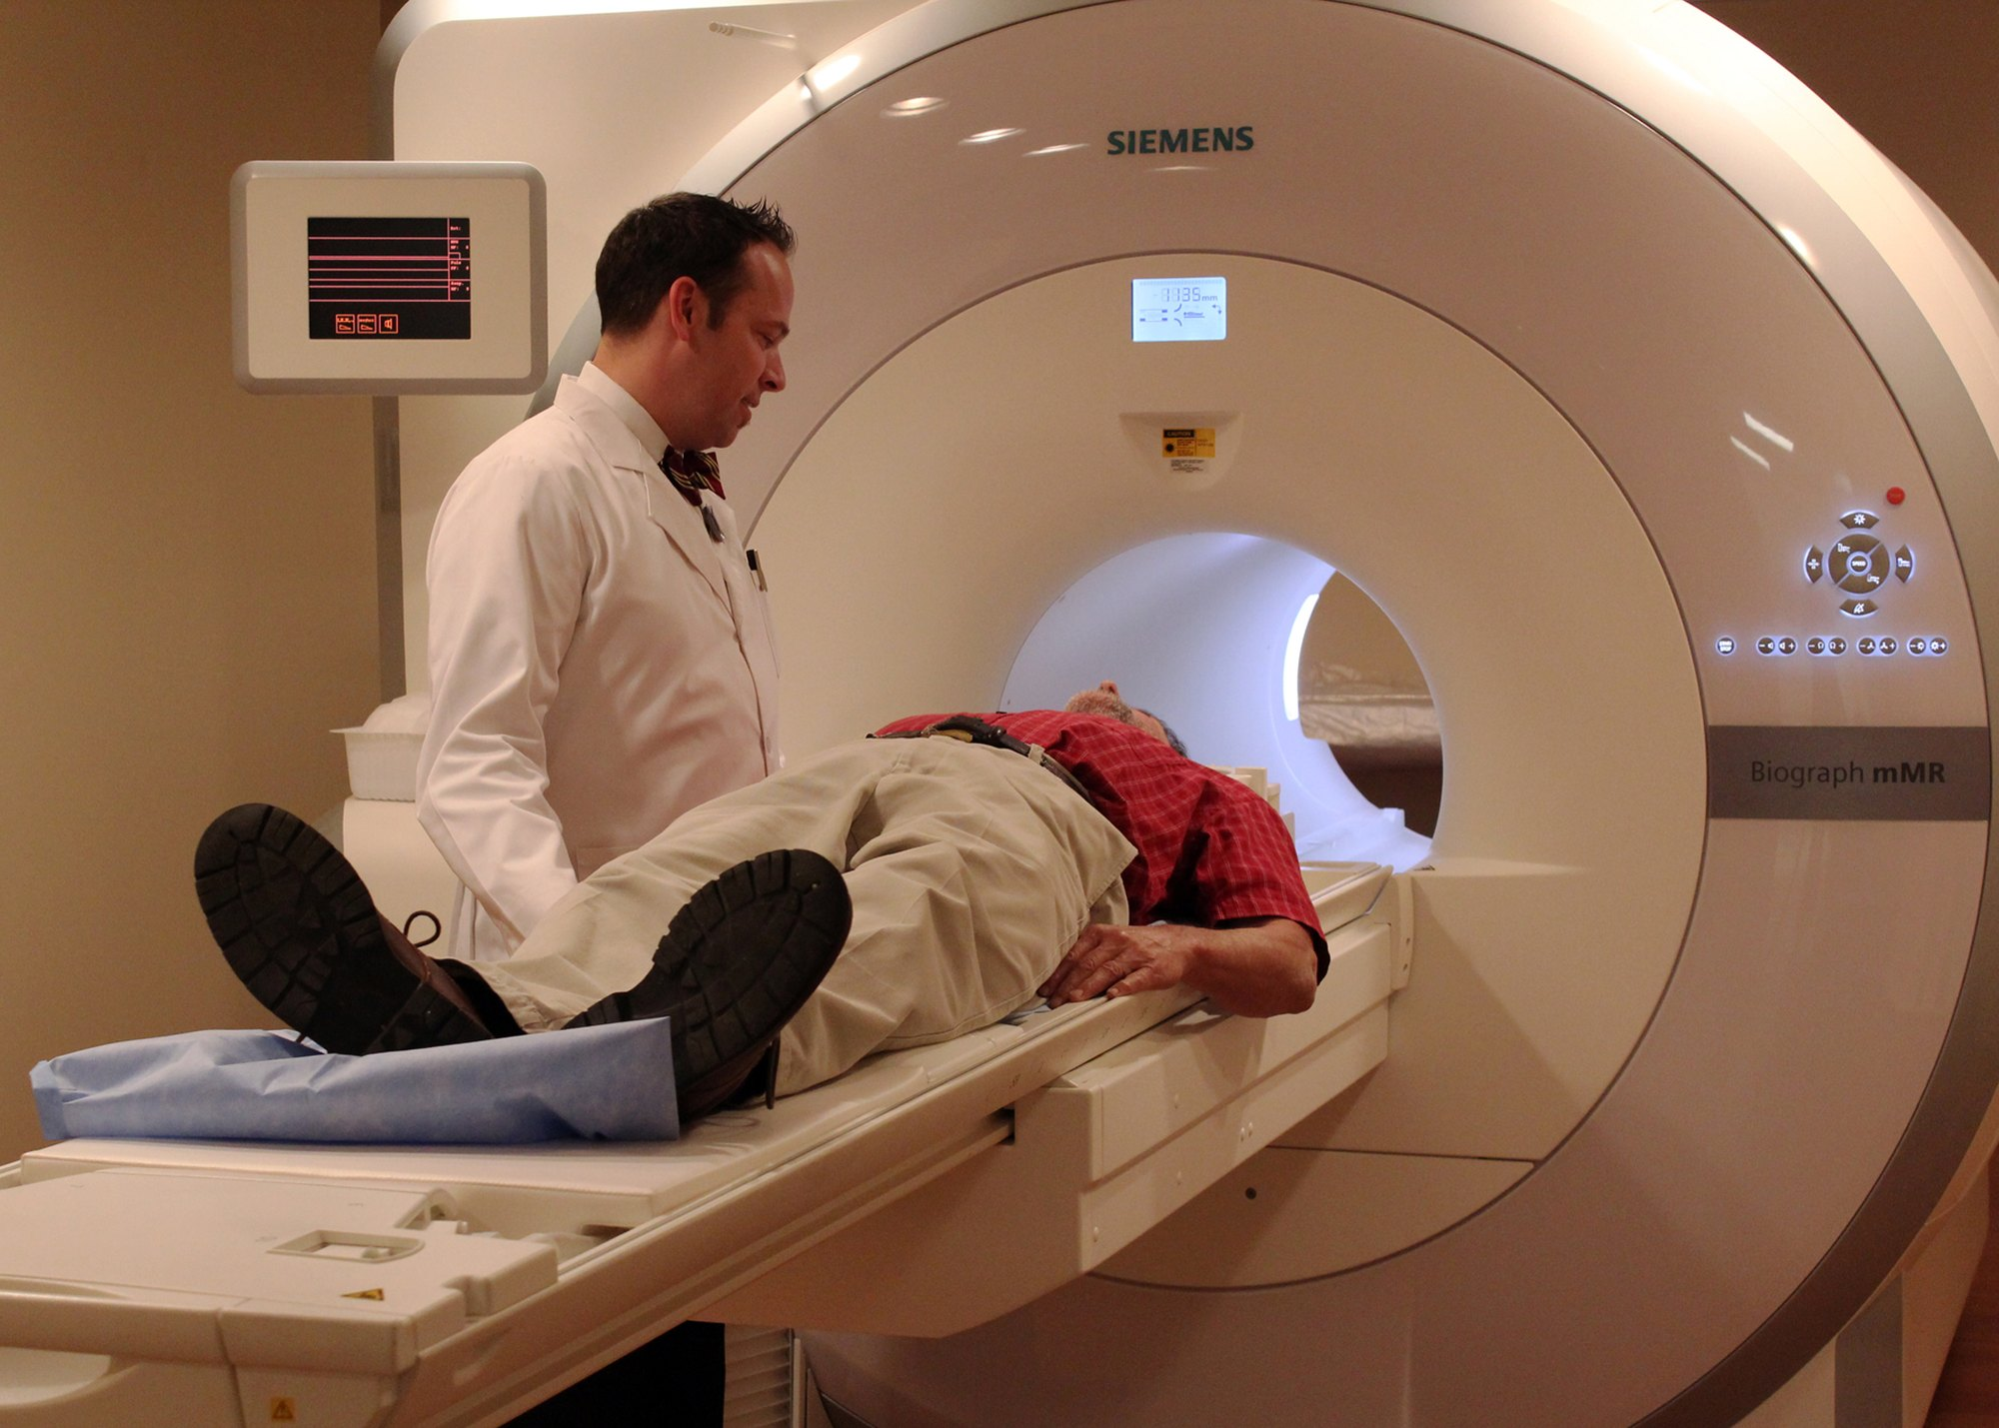
Figure 6.2 A new imaging technology. A combined PET-MRI scanner at its introduction is costly and available in few centres; its use grows as evidence and payers' coverage follow.
Photograph: NIH Image Gallery, National Institutes of Health, via Wikimedia Commons (public-domain)
Payment rules. In health care, a decision by a payer to cover a service can move it from introduction to growth almost overnight. Withdrawal of coverage can push it into decline just as fast. Marketing plans must therefore follow coverage decisions as closely as they follow competitors.

6.8 Ethics Through the Life Cycle
Each stage carries its own temptation in health care.
At introduction, a firm may overstate the benefits of a new product before evidence is complete. At growth and maturity, it may push a product into uses the evidence does not support. "Finding new uses" is legitimate for a medicine only after the new indication is approved, and for a test only where guidelines support it. Guarantees of health outcomes are misleading in health care and should not be offered. In decline, it may promote "more frequent use" of a test that patients do not need more often.
Ethics Check
A laboratory's vitamin D test is in maturity, and revenue has flattened. The marketing team proposes promoting "a vitamin D test every three months for everyone". The Endocrine Society's clinical practice guideline advises against routine vitamin D testing in healthy people without a specific indication (Demay et al., 2024), and repeated testing every three months has even less support. The proposal uses a strategy for delaying decline, promoting more frequent use, in a way that serves revenue, not patients. The acceptable version targets the groups for whom testing is recommended, and states the interval the evidence supports.

Egyptian Context
Medicines are registered with the Egyptian Drug Authority before they can be sold in Egypt, and the authority also regulates medical devices. For prescription medicines, the authority's promotion guidelines cover registered products and require promotional material to be pre-cleared and directed to health professionals (Egyptian Drug Authority, 2020). Devices and in-vitro diagnostics fall under the authority's separate device rules, which should be checked before any launch activity. Planning a launch includes planning the regulatory timeline.

Key Takeaways
- The product life cycle traces sales and profit through introduction, growth, maturity and decline.
- Introduction needs awareness and trial; early adopters among professionals are decisive in health care.
- Growth brings competitors, falling prices and a push for wider distribution.
- Maturity brings peak competition; for mature services, competition moves to the service around the product.
- Decline can be managed by deletion or harvesting, or delayed by new uses and markets.
- The PLC is a way of thinking, not a forecasting law.
- Each stage carries an ethical temptation, especially promoting use the evidence does not support.

Check Your Understanding
Q1 [LO1] In which stage are profits usually low or negative because launch costs are high?
A Introduction
B Growth
C Maturity
D Decline
Q2 [LO1] Competition reaching its peak and the market approaching saturation are features of:
A Introduction
B Growth
C Maturity
D Decline
Q3 [LO2] Promotion that explains what a new category of test does, rather than why one brand is better, stimulates:
A Selective demand
B Primary demand
C Harvesting
D Deletion
Q4 [LO2] Stimulating demand for one brand rather than the category is typical of which stage?
A Introduction
B Decline
C Growth
D Before launch
Q5 [LO3] The small group of professionals who try a new test first and influence colleagues are called:
A Laggards
B Harvesters
C Marginal competitors
D Early adopters
Q6 [LO3] A new product that only does an old job in a new way is likely to be adopted:
A Slowly, because doctors need persuading to change
B Immediately by all doctors
C Only by patients
D Faster than a genuinely new product
Q7 [LO4] Keeping a declining product but cutting its marketing support is called:
A Deletion
B Penetration
C Skimming
D Harvesting
Q8 [LO4] Which is a way to delay decline?
A Finding new uses for the product
B Raising the price above all competitors
C Stopping all distribution
D Removing the product from the line
Q9 [LO5] Promoting a test "every three months for everyone" when guidelines do not support it misuses which strategy?
A Deletion
B Promoting more frequent use
C Penetration pricing
D Harvesting
Q10 [LO5] Why may a new prescription medicine not be promoted in Egypt before registration?
A Promotion is never allowed in health care
B Registration only affects the price
C An unregistered medicine may not lawfully be marketed or promoted
D Only foreign products need registration

Essay Questions
E1. [LO1] Describe the four stages of the product life cycle, with the sales, profit and competition pattern of each. Illustrate each stage with a health-care example.
E2. [LO2] A laboratory's routine blood tests are in maturity. Propose three strategies to defend its share, and explain why they focus on service rather than on the test.
E3. [LO5] Choose two stages of the life cycle and describe the ethical risk each carries for a health product, with an acceptable alternative.
Answers and Worked Solutions
Q1. A — Introduction carries high launch and marketing costs against slow sales, so profits are low or negative.
Q2. C — Peak competition and saturation define maturity.
Q3. B — Promoting the category rather than a brand stimulates primary demand, typical of introduction.
Q4. C — As competitors enter in growth, firms promote their own brand: selective demand.
Q5. D — Early adopters try new products first and influence others.
Q6. A — If the benefit is only a new way to do an old job, doctors need persuading, so adoption is slow.
Q7. D — Harvesting keeps the product while cutting support to take the remaining profit.
Q8. A — New uses extend a product's life: for a medicine once the new indication is approved, for a test where guidelines support it. Removing the product is deletion; the other options accelerate decline.
Q9. B — Promoting more frequent use is a legitimate strategy only where the evidence supports it. Here it serves revenue, not patients.
Q10. C — The legal rule is the reason: a medicine must be registered with the Egyptian Drug Authority before it may be marketed, and the authority's prescription medicine promotion guidelines cover registered products only. That the introduction stage starts after registration is a consequence of the rule, not its cause.
E1 — model answer points. Introduction: slow sales, losses, few competitors (a new cardiac marker). Growth: rapid sales, rising profit, new competitors (home collection services). Maturity: flat sales, peak competition (routine blood tests). Decline: falling sales, competitors leave (an old test replaced by a more accurate one).
E2 — model answer points. Shorter waits and early opening; home collection and online results; courteous staff and clear reports. The tests are the same everywhere, so value comes from people, process and physical evidence.
E3 — model answer points. Introduction: overstating benefits before evidence; alternative, claims limited to validated data. Maturity or decline: pushing more frequent use; alternative, promotion aimed at groups and intervals the evidence supports.

References
Demay, M. B., Pittas, A. G., Bikle, D. D., Diab, D. L., Kiely, M. E., Lazaretti-Castro, M., Lips, P., Mitchell, D. M., Murad, M. H., Powers, S., Rao, S. D., Scragg, R., Tayek, J. A., Valent, A. M., Walsh, J. M. E., & McCartney, C. R. (2024). Vitamin D for the prevention of disease: An Endocrine Society clinical practice guideline. The Journal of Clinical Endocrinology & Metabolism, 109(8), 1907–1947. https://doi.org/10.1210/clinem/dgae290 Egyptian Drug Authority. (2020). Prescription medicine promotion guidelines (Version 01) [Guideline]. https://edaegypt.gov.eg/media/ieph2wot/prescription-medicine-promotion-guidelines.pdf Kotler, P., & Keller, K. L. (2016). Marketing management (15th ed.). Pearson. Rogers, E. M. (2003). Diffusion of innovations (5th ed.). Free Press.

7 Pricing Health Services
Learning Objectives
By the end of this chapter you will be able to:
LO1 Describe the functions of price and classify prices by state influence and by sphere of trade.
LO2 Calculate a cost-plus price and a break-even volume for a health service.
LO3 Compare skimming, penetration and competition-based pricing.
LO4 Explain how demand, regulation and market structure shape health-care prices.
LO5 Set out the stages of setting a price and the ethical limits on pricing health care.

7.1 What a Price Is
A price is the value of a good or service expressed in money: the amount charged for it. Chapters 1, 4 and 5 treat time, travel and effort separately, as non-money parts of the total customer cost. Price is not the same as cost. Cost here means the resources used to produce the service; price is what is charged for it; value is what the customer believes it is worth. For the seller the price must cover costs and, for a private firm, provide a return. For the buyer it must be worth paying, compared with the benefit.
In health care, price has a special weight. A price that is too high can keep a patient away from a test they need. A price that is too low can bankrupt a service or force it to cut quality.

7.2 The Functions of Price
Price does several jobs in an economy (Nagle & Müller, 2018; Rice & Unruh, 2016):
1. Information and accounting. Prices let organisations measure sales, stocks, costs and profitability in one unit.
2. Incentive. Prices signal to producers what to supply and to consumers what to economise on. A high price for a scarce scan encourages new centres to open.
3. Distribution. Prices distribute income between sectors, regions and social groups. Subsidised prices shift resources toward those who need care.
4. Balancing supply and demand. Prices link production and consumption. Where prices cannot move, as in controlled markets, queues and waiting lists do the balancing instead.
Older translated texts call the first of these the "registration" function. The idea is the same: prices make economic activity countable.

7.3 Kinds of Price

By degree of state influence
Free prices are set by agreement between seller and buyer, through supply and demand, without state intervention. The state may still monitor them. A private laboratory's own price list for self-paid tests is largely a free price.
Controlled prices have a ceiling set by the state, which prices may not exceed; sellers may charge less. They are used for vital goods such as strategic raw materials, energy, public transport and basic consumer goods, and in many countries for medicines.
Fixed prices are set by a state body and cannot be changed by the seller. Examples are official fees for public services and regulated utility tariffs. Registered medicines in Egypt are an example: the Egyptian Drug Authority approves the public price of each product, and pharmacies sell at that price rather than setting their own. A tariff agreed by a national insurer for a listed service works in a similar way for contracted providers.

By sphere of trade
- Wholesale prices — prices at which producers sell to firms and organisations, such as a manufacturer's price to a distributor.
- Retail prices — prices at which goods are sold to the public, such as the price printed on a medicine pack.
- Tariffs — prices for services, such as a schedule of fees for tests or scans.

Other market prices
An auction price is set by bidding, and may differ sharply from the usual market price. Hospitals sometimes buy through tenders, a sealed-bid form of auction in which suppliers compete to offer the lowest price for a stated specification. A stock exchange quotation is the price of goods or securities traded on an exchange. A world market price is the price recognised in international trade for a commodity, such as gold or crude oil.

7.4 Pricing Methods
Pricing methods fall into three families (Nagle & Müller, 2018), shown in Table 7.1.
Family | Basis | Examples
Cost-based | The seller's costs | Cost-plus, markup, break-even, target return
Demand-based | What customers will pay | Skimming, penetration, value-based
Competition-based | Competitors' prices | Going rate, premium, discount

Table 7.1. The three families of pricing methods.
Other approaches include psychological pricing, such as 199 instead of 200, and bundled pricing, which sells several services together for one price. A check-up package is a bundle.

Cost-based pricing
Cost-plus pricing adds a percentage markup to the cost of producing the service. It is simple and is common for laboratory tests. A markup is a percentage of cost; a margin is a percentage of the price. The two are easily confused: a 25% markup on a cost of 240 EGP gives a price of 300 EGP, on which the margin is 60 ÷ 300 = 20%.
Key Formula
Cost-plus price
$$P=C×(1+m)$$
where $C$ is the full cost per unit and $m$ is the markup as a fraction of cost. To reach a target margin $g$ as a fraction of price instead, use $P=C/(1-g)$.

Break-even pricing asks how many units must be sold for revenue to equal total cost. Below that volume the service loses money; above it, it makes a surplus.
Key Formula
Break-even volume
$$Q_{BE}=\frac{F}{P-V}$$
where $F$ is total fixed cost for the period, $P$ is the price per unit and $V$ is the variable cost per unit. The difference $P-V$ is the contribution each unit makes to fixed costs.

Fixed costs do not change with volume in the short run: rent, equipment leases, salaried staff. Variable costs rise with each unit: reagents, contrast media, disposables.
Worked Example
Pricing a new hormone test
A laboratory plans a new hormone test. The figures are illustrative. Reagents and disposables cost 120 EGP per test. The analyser lease, maintenance and share of staff time add 60,000 EGP per month in fixed cost.
Step 1 — full cost per test at the expected volume. The laboratory expects 500 tests a month. Fixed cost per test = 60,000 ÷ 500 = 120 EGP. Full cost per test = 120 + 120 = 240 EGP.
Step 2 — cost-plus price. With a 25% markup, P = 240 × 1.25 = 300 EGP. The margin on that price is 60 ÷ 300 = 20%.
Step 3 — break-even volume at that price. Contribution per test = 300 − 120 = 180 EGP. Break-even volume = 60,000 ÷ 180 = 333.3, so 334 tests a month.
Interpretation. At 300 EGP the test covers its costs once monthly volume passes 334 tests. If demand turns out to be 300 tests, the service loses money at this price. Cost-plus pricing hides that risk, because the full cost per test was worked out at an assumed volume. Always check the break-even volume against a realistic forecast of demand.

Figure 7.1 shows the same calculation as a break-even chart.
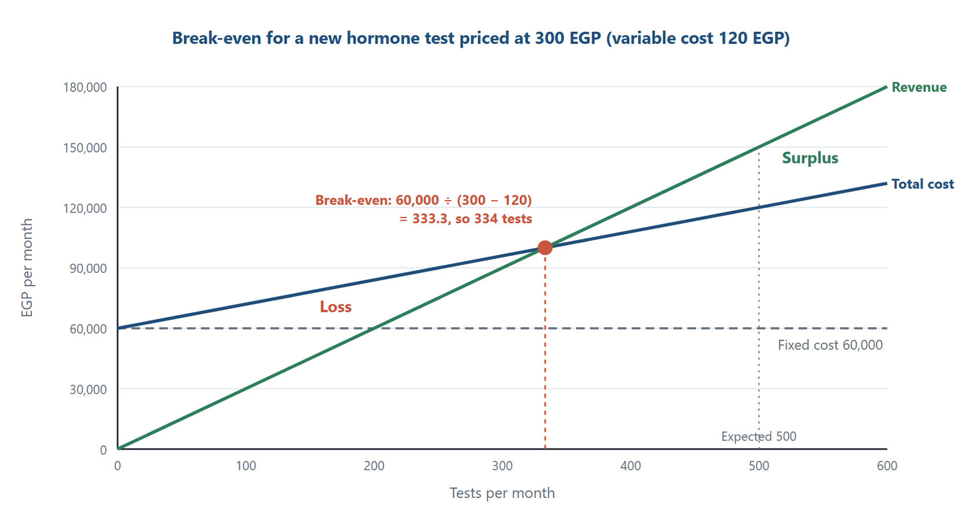
Figure 7.1 The break-even chart for the new hormone test. Revenue at 300 EGP per test crosses total cost at 333.3 tests a month, so the test needs 334 tests to cover its costs; below that volume it makes a loss.
Original diagram (original)

Demand-based pricing
Demand-based pricing sets the price from what customers are willing to pay. It aims to optimise revenue.
Skimming sets a high entry price that falls over time. It suits products with real novelty, few competitors and early buyers who value them highly. A centre with the only new scanner in a region might skim.
Penetration sets a low entry price, sometimes raised later. It suits markets where customers are price-sensitive and where volume lowers costs. A new laboratory branch might offer low introductory prices to build a patient base.
Value-based pricing sets price by the value the product creates for the customer. In health care, value can be measured with the economic evaluation methods of Chapters 11 and 12.

Competition-based pricing
Going-rate pricing charges about what competitors charge. It is common for mature, standard tests. Premium pricing charges more than competitors, justified by better service, faster results or a stronger brand. Discount pricing charges less to attract price-sensitive patients.
Through Two Lenses
- Medical Laboratory: Routine tests in a mature market usually follow the going rate. A laboratory adds value through speed and service rather than price. For a costly new test it must check break-even volume carefully, because reagents are expensive and demand may be low at first. - Radiology and Medical Imaging: Imaging has high fixed costs: scanners, shielding and specialist staff. Break-even volume therefore drives pricing. Centres try to fill every slot, and may price off-peak appointments lower to spread demand across the day.

7.5 Factors That Shape Price
Pricing decisions depend on external and internal factors (Nagle & Müller, 2018), summarised in Table 7.2.
External factors | Internal factors
Customers and demand | Marketing objectives
State regulation | Marketing strategy
Intermediaries | Costs
Competitors | Stage of the product life cycle

Table 7.2. External and internal factors in pricing.

Customers and demand
Two economic ideas explain the customer's influence. The first is the law of demand and elasticity, introduced in Chapter 2. The second is market segmentation: buyers in different segments react differently to price. Insured corporate employees react less to price than self-paying families.
Demand for medical products depends on:
- the burden of disease in the population;
- the need for the product;
- whether substitutes (analogues) exist, and how competitive they are;
- the price of the product and its analogues;
- the product's popularity, including through information and advertising;
- the purchasing power of patients;
- habits of use.

State regulation
The state influences price by setting ceilings, by taxes, and by subsidies to producers or consumers. Medicines are the clearest case in Egypt. Contracts with public insurers are another: a provider accepts the insurer's tariff in return for its patients.

Competitors and market structure
Economists distinguish four market structures (Rice & Unruh, 2016):
Pure competition. Many small buyers and sellers, a uniform product, full information, free entry and exit. No one controls the price. Farm produce such as grain comes close.
Monopolistic competition. Many sellers offer similar but differentiated products, and information is incomplete. Each seller seeks an advantage. Private laboratories in a large city are a good health example: many compete, each differentiates by service, location or brand.
Oligopoly. A few sellers, each with a large share, each watching the others. Steel, oil refining and some imaging-equipment markets are examples.
Monopoly. One seller controls supply. Patents create temporary legal monopolies: a patented medicine has no identical competitor until the patent expires. A single specialised centre in a remote region may hold a local monopoly.
The pharmaceutical industry does not fit one box. A patented medicine is a temporary monopoly. The class it belongs to may be an oligopoly of a few similar brands. Once the patent expires, generics can make the market highly competitive.
Common Mistake
Thinking that elastic demand means "patients buy more when the price falls". That is the law of demand, true of almost every product. Elasticity is how strongly they respond. A price cut on an emergency test barely changes demand; a price cut on a wellness package may change it a lot.

In Practice
A laboratory chain reviews its price list for self-paying patients. It finds that the same thyroid panel is priced differently at two branches, and that patients are often surprised by the total at the payment desk. The chain publishes one price list for all branches, shows the price of each test at booking, and prices common bundles clearly. Complaints about billing fall, and staff spend less time explaining charges. Transparent pricing is both good service and good ethics.

7.6 Setting the Price
Setting a price follows seven stages (Nagle & Müller, 2018):
1. Choose the pricing objective. Survival, market share, profit, or cost recovery for a public service.
2. Estimate demand. How many patients at different prices?
3. Analyse costs. Fixed and variable costs, and break-even volume.
4. Analyse competitors' prices. What do alternatives cost the patient?
5. Choose the method. Cost-based, demand-based or competition-based.
6. Set the final price. Including psychological and bundling decisions.
7. Adjust the price. Discounts, off-peak prices, insurance contracts, and review over time.

7.7 Price Policy
A price policy is the organisation's set of rules for pricing. It covers how prices are determined, surcharges and discounts, payment terms, and how prices are managed over time.
Its possible purposes are grouped around three core aims: survival, keeping market share, and increasing profit. More specific purposes include a target sales volume, maximum or average profit, a return on investment, stability, and a sound financial position. For a public or charitable provider, the purpose is usually cost recovery with access for all.
Ethics Check
Pricing in health care must respect four limits. Prices must be transparent, so patients know the cost before the test. Patients must not be charged for services they did not receive or need. Emergency need must not be exploited with surge prices. And discounts must never be used to reward doctors for referrals, which turns price into an inducement. A laboratory that displays its prices, explains what each test includes and refuses referral kickbacks meets these limits.

Egyptian Context
Each registered medicine in Egypt has an officially approved public price, so a pharmacy does not set its own retail price; the Egyptian Drug Authority is the body to consult for the current pricing rules. Private laboratories and imaging centres set their own prices for self-paying patients. They accept the insurer's tariff for patients covered by contracts, including those of the universal health insurance system (Arab Republic of Egypt, 2018).

Key Takeaways
- Price is the money value of a product and must be worth paying for the buyer and sustainable for the seller.
- Prices inform, give incentives, distribute income and balance supply and demand.
- Prices may be free, controlled (a ceiling) or fixed (an official price); registered medicines in Egypt have fixed official prices.
- Cost-plus price = full cost × (1 + markup); a markup is a share of cost, a margin a share of price; break-even volume = fixed cost ÷ (price − variable cost).
- Skimming suits novel products with eager early buyers; penetration suits price-sensitive markets.
- Private laboratories in a city form a monopolistically competitive market; patents create temporary monopolies.
- Health-care prices must be transparent, fair in emergencies and free of referral inducements.

Check Your Understanding
Q1 [LO1] A ceiling set by the state, below which sellers may charge any price, is a:
A Free price
B Controlled price
C Auction price
D World market price
Q2 [LO1] A schedule of fees for laboratory tests is best described as:
A A wholesale price
B A stock exchange quotation
C A tariff
D A world market price
Q3 [LO2] A test costs 200 EGP in full. With a 20% markup on cost, the cost-plus price is:
A 220 EGP
B 180 EGP
C 400 EGP
D 240 EGP
Q4 [LO2] Fixed costs are 40,000 EGP a month, the price is 250 EGP and the variable cost is 50 EGP per test. The break-even volume is:
A 160 tests
B 200 tests
C 800 tests
D 133 tests
Q5 [LO3] A centre with the only new scanner in a region sets a high entry price that falls as competitors arrive. This is:
A Penetration pricing
B Going-rate pricing
C Discount pricing
D Skimming
Q6 [LO3] A new laboratory branch offers low introductory prices to build a patient base quickly. This is:
A Penetration pricing
B Skimming
C Premium pricing
D Break-even pricing
Q7 [LO4] Many private laboratories in a city compete, each differing by service and location. The market structure is:
A Pure competition
B Oligopoly
C Monopolistic competition
D Monopoly
Q8 [LO4] A patented medicine with no identical competitor is an example of:
A Pure competition
B A temporary legal monopoly
C Monopolistic competition
D A world market price
Q9 [LO5] Which is the first stage in setting a price?
A Set the final price
B Analyse competitors' prices
C Adjust the price
D Choose the pricing objective
Q10 [LO5] Which pricing practice breaks the ethical limits of health-care pricing?
A Giving doctors discounts in return for referrals
B Displaying prices before the test
C Lower prices for off-peak appointments
D Recovering costs in a public service

Essay Questions
E1. [LO2] An imaging centre's new scan has variable costs of 300 EGP and fixed costs of 90,000 EGP a month. Calculate the break-even volume at prices of 900 EGP and 1,200 EGP, and discuss which price the centre should choose.
E2. [LO3] Compare skimming and penetration pricing, and explain which suits a new, specialised test and which suits a new branch of a laboratory chain.
E3. [LO5] Describe four ethical limits on pricing health services and explain why each matters more in health care than in consumer markets.
Answers and Worked Solutions
Q1. B — A state-imposed ceiling makes it a controlled price. An official price the seller cannot change, as for registered medicines in Egypt, is a fixed price instead.
Q2. C — A tariff is a price for services, such as a fee schedule.
Q3. D — 200 × 1.20 = 240 EGP. Option A adds 20 EGP instead of 20%.
Q4. B — 40,000 ÷ (250 − 50) = 40,000 ÷ 200 = 200 tests. Option A divides by the price alone.
Q5. D — A high entry price lowered over time is skimming, suited to a novel service with few competitors.
Q6. A — Low entry prices to gain share quickly are penetration pricing.
Q7. C — Many sellers with differentiated services and incomplete information form monopolistic competition.
Q8. B — A patent gives temporary exclusive rights, so the product is a legal monopoly until it expires.
Q9. D — The objective comes first, because it determines how demand, costs and competitors are weighed.
Q10. A — Discounts tied to referrals are inducements. They corrupt the doctor's advice and harm patients.
E1 — model answer points. At 900 EGP: 90,000 ÷ (900 − 300) = 90,000 ÷ 600 = 150 scans a month. At 1,200 EGP: 90,000 ÷ (1,200 − 300) = 90,000 ÷ 900 = 100 scans a month. The higher price breaks even sooner, but fewer patients may afford it. The choice depends on forecast demand at each price, competitors' prices and the centre's access objectives.
E2 — model answer points. Skimming: high entry price for novelty with few competitors and eager early users; suits a specialised new test. Penetration: low entry price to build volume in a price-sensitive market; suits a new branch entering a competitive area.
E3 — model answer points. Transparency, because patients cannot compare easily; no charging for unneeded services, because of information asymmetry; no exploiting emergencies, because demand is inelastic; no referral inducements, because they corrupt medical advice.

References
Arab Republic of Egypt. (2018). Law No. 2 of 2018 promulgating the Universal Health Insurance System law. Official Gazette. Nagle, T. T., & Müller, G. (2018). The strategy and tactics of pricing: A guide to growing more profitably (6th ed.). Routledge. Rice, T., & Unruh, L. (2016). The economics of health reconsidered (4th ed.). Health Administration Press.

8 Distribution and Access
Learning Objectives
By the end of this chapter you will be able to:
LO1 Define distribution and distribution channels, and list the functions of a marketing channel.
LO2 Classify channels for medicines by level and describe the equivalent channels for diagnostic services.
LO3 Distinguish independent from dependent intermediaries by ownership and risk.
LO4 Describe the functions of pharmaceutical warehouses and of retail pharmacies.
LO5 Explain how distribution decisions affect access to care and product safety.

8.1 Place: Getting the Service to the Patient
Place, the third P, asks how a product reaches the people who need it. For medicines, place is a chain of warehouses, distributors and pharmacies. For diagnostic services, place is the location of branches, collection points, home visits and the routes by which samples, images and reports travel.
Distribution is the planning, organising and control of the physical movement of materials and finished products from where they are made to where they are used. Its purpose is to meet customers' needs and, for a firm, to earn a return. A distribution channel is the set of firms or individuals who take ownership of a product, or help to transfer it, on its way from producer to consumer (Kotler & Keller, 2016). Channel members other than the producer and the final customer are called intermediaries.
In health care, distribution is also a question of access. A test that exists only in the capital is of little use to a patient in a distant governorate. A vaccine that loses its cold chain in transit is worse than useless.

8.2 The Tasks of Distribution Policy
Distribution policy has strategic and tactical tasks, shown in Table 8.1.
Strategic tasks | Tactical tasks
Forecasting future distribution channels | Serving existing customers and attracting new ones
Choosing systems, methods and types of channel | Finding and choosing supply offers
Planning sales routes | Organising orders, transport and handling
Building a network of wholesale and retail outlets | Checking that marketing is effective

Table 8.1. Strategic and tactical tasks of distribution policy.

8.3 Functions of Marketing Channels
Channels do more than move boxes. Adapted from the channel flows described by Kotler and Keller (2016), they perform eight functions:
1. Information. Gathering and processing market information for planning.
2. Promotion. Spreading information about products to attract buyers.
3. Contact and negotiation. Building relationships with buyers and agreeing prices, volumes and delivery terms.
4. Ordering. Placing and monitoring contracts along the channel.
5. Adapting the product. Sorting, packing, assembling and after-sales service.
6. Physical distribution. Transport and storage.
7. Financing. Finding and allocating funds to cover the channel's costs, including credit to buyers.
8. Risk taking. Carrying the risk of stock that does not sell, expires or is damaged, which falls on whoever owns the goods (Section 8.6).
The choice of channel depends on costs and benefits. With external channels, both are shared among the channel members. A manufacturer that uses a distributor gives up part of its margin but gains reach, storage and financing.

8.4 Channel Levels for Medicines
The channel level is the number of intermediaries between producer and consumer. Figure 8.1 shows the four levels found in the pharmaceutical market.
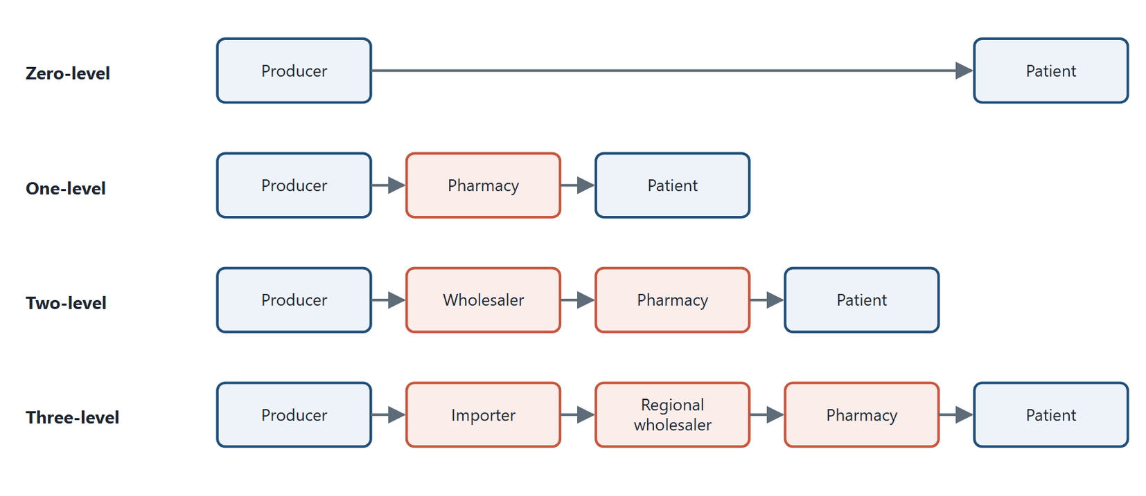
Figure 8.1 Channel levels for medicines. Each level adds one intermediary between producer and patient; longer channels reach further but add cost and more points where quality can fail.
Original diagram (original)
Level | Channel
Zero-level | Producer → final user, with no intermediary (for example, a manufacturer supplying a hospital that uses the product itself)
One-level | Producer → pharmacy or hospital pharmacy → patient
Two-level | Producer → national wholesaler → pharmacy → patient
Three-level | Producer → importer → regional wholesaler → pharmacy → patient

Table 8.2. Channel levels for medicines.
Count the levels to the final user of the product. When a hospital buys a medicine for its own wards, the hospital is the final user and a direct supply is zero-level. When a hospital pharmacy dispenses to an outpatient who takes the medicine home, the patient is the final user and the hospital pharmacy is an intermediary, so the channel is one-level. Longer channels reach more places but add cost and more points where quality can fail. Every transfer is a chance for temperature damage, delay or diversion.

8.5 Channels for Diagnostic Services
Diagnostic services also have channels, although the product is a service.
Direct access. The patient comes to the laboratory or imaging centre. This is the zero-level channel of services.
Collection points and home visits. A laboratory may run small collection points in many neighbourhoods and one central laboratory. Samples travel; patients do not. This hub-and-spoke model extends reach while keeping costly analysers in one place.
Referral from other providers. Clinics and hospitals send samples or patients to a specialist laboratory or imaging centre. The referring provider acts as an intermediary for the patient.
Remote reporting. In teleradiology, images are sent electronically to radiologists elsewhere for reporting. The scan happens locally; the expertise travels.
Mobile units. Mobile mammography or X-ray units bring imaging to villages, factories and schools.
Through Two Lenses
- Medical Laboratory: A laboratory's channel design centres on the sample. Collection points must keep samples at the right temperature and deliver them within their stability window. A haemolysed or delayed sample fails the patient as surely as a wrong result, so the transport chain is part of quality. - Radiology and Medical Imaging: An imaging centre's channel design centres on the patient and the image. The patient must reach the scanner, but the images can travel. Teleradiology and electronic reports let a small centre offer specialist reporting it could not staff locally.

In Practice
A laboratory chain opens six collection points across a governorate, each staffed by a phlebotomist. Samples reach the central laboratory twice a day by courier in temperature-controlled boxes. Patients no longer travel an hour for a blood test, and the chain uses one set of analysers efficiently. The chain tracks sample arrival times and rejection rates for each point to protect quality.

8.6 Intermediaries in the Pharmaceutical Market
Intermediaries differ in one key respect: whether they own the goods they sell. Ownership decides who carries the risk of unsold, expired or damaged stock.

Independent intermediaries (they own the goods)
Wholesaler. Buys large quantities from many manufacturers and moves them to retailers or directly to institutions. Profit comes from the difference between buying and selling prices.
Distributor. Often handles imports, acting under contracts with producers and buyers. Buys and sells in its own name and at its own expense, usually in the importing country.
Dealer. An independent intermediary specialising in durable goods that need after-sales service, such as laboratory analysers or imaging equipment. Operates in its own name and at its own expense.
Retailer. Sells directly to the final consumer, having bought from a wholesaler or manufacturer. The pharmacy is the retailer of medicines.

Dependent intermediaries (they do not own the goods)
Broker. Brings buyer and seller together and earns a commission on completed deals. Does not buy goods and takes no responsibility for them.
Commission agent. Sells goods in its own name but on behalf of, and at the expense of, the owner. It is paid a percentage of each sale.
Consignee. Holds goods sent on consignment. The owner, called the consignor, keeps ownership and carries the risk of unsold goods. The consignee sells them on the consignor's behalf and is paid a commission on what it sells. Unsold goods return to the consignor. A pharmacy may hold a supplier's stock on these terms. A related arrangement, consignment stock, is used with end users: a laboratory keeps a supplier's reagents on its shelves and pays only for what it uses. The laboratory sells nothing and earns no commission, so it is a buyer, not an intermediary.
Agent. Works for a manufacturer under a specific agreement, sometimes with exclusive rights in a region. Paid a commission set by the manufacturer, usually a percentage of each deal.
Common Mistake
Confusing who owns the goods with who holds them. A consignee holds the goods in its store but does not own them; the consignor does. When consigned medicines expire on a pharmacy's shelf, the loss usually falls on the consignor, and the same holds for consignment stock of reagents in a laboratory. Always ask who owns the stock and who carries the risk.

8.7 Pharmaceutical Warehouses
A pharmaceutical warehouse is a licensed establishment that stores medicines and medical products and supplies them wholesale to pharmacies, hospitals and other institutions. Its functions are:
1. buying medicines and medical products from manufacturers and other licensed suppliers;
2. importing, exporting and exchanging goods where licensed;
3. ensuring quality control of the medicines it handles;
4. storing products under conditions suited to their properties, such as temperature and light;
5. supplying pharmacies and health institutions;
6. transporting goods.
International guidance on good distribution practice sets standards for storage, transport, records and recalls (World Health Organization, 2010). Its purpose is that a medicine reaches the patient with the quality it had when it left the factory.
Laboratories and imaging departments depend on the same kind of distribution. Reagents, calibrators and quality-control materials are supplied by specialised distributors of in-vitro diagnostic products, and many must be kept cold from the manufacturer to the laboratory refrigerator. A break in this cold chain can change a reagent's performance and so the patient's result. Iodinated and gadolinium contrast media for imaging are stored within the temperature range on their labels and are tracked by batch so that a recall can reach every department that holds them. When a laboratory chooses a supplier, storage and delivery conditions are part of the quality it is buying, not only the price. Figure 8.2 shows the links of this cold chain.
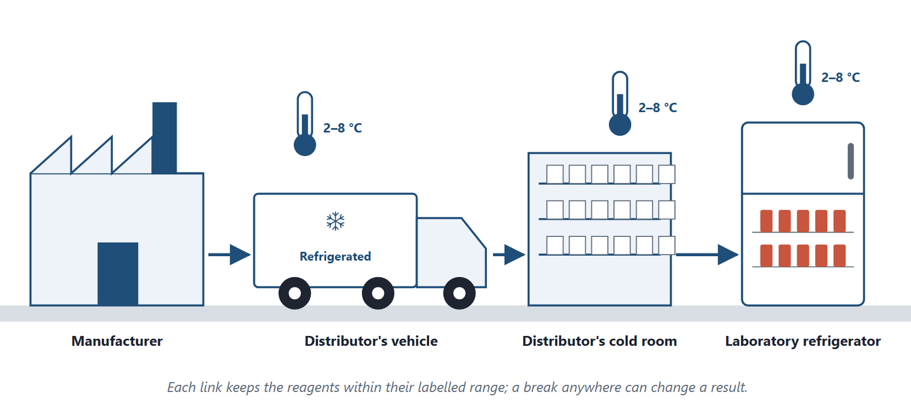
Figure 8.2 The cold chain for laboratory reagents. Many reagents must stay within a labelled temperature range, often 2–8 °C, from the manufacturer through the distributor to the laboratory refrigerator.
Original illustration (original)

8.8 Retail Trade and the Pharmacy
Retail trade is any business activity that sells goods and services to final consumers for personal, non-commercial use. Pharmacies are the retail outlets for medicines.
Retail trade performs these functions:
- studying local market conditions and demand;
- finding and selecting products;
- building an assortment for sale;
- paying suppliers;
- receiving, storing, labelling and pricing products.
A retailer makes several marketing decisions: choosing its target market, developing its product range, offering services and a pleasant setting, setting retail prices within regulation, and informing customers. For a pharmacy, the most valuable service is professional: counselling patients on their medicines (Figure 8.3).

Figure 8.3 The pharmacy as a retail outlet. The counter, the shelves and the information on display are part of the service, and the pharmacist's counselling is its most valuable part.
Photograph: Bill Branson, National Cancer Institute, via Wikimedia Commons (public-domain)
The same retail decisions face a laboratory or imaging centre that serves patients directly. It chooses whom it serves, which tests or scans it offers, what services surround them, such as home sample collection, online results or evening hours, and its prices within regulation. Like a pharmacy, its most valuable service is professional: preparing patients correctly and explaining what a test or scan involves.

8.9 Choosing a Location
For a service, place is first of all location. Choosing where to open a laboratory branch or an imaging centre is one of the largest marketing decisions a health organisation makes, because it is costly to reverse.
Four groups of questions guide the choice (Kotler & Keller, 2016):
- Catchment and need. How many people live within a reasonable travel time, and what services do they need? A catchment area is the area from which a service draws most of its patients. An area with many older residents needs more imaging and chronic-disease testing.
- Referral sources. Where are the clinics, hospitals and doctors who will send patients? A laboratory near a cluster of clinics gains referrals that a better-equipped laboratory further away loses.
- Competition. Which services already exist nearby, and how busy are they? A long queue at a competitor is a sign of unmet demand.
- Access. Can patients reach the site easily by public transport or car? Is there parking, and step-free access for patients in wheelchairs or on crutches?
Time is also part of place. Opening hours decide who can use a service. A branch that opens at seven for fasting tests, or runs evening scans for working patients, is more accessible than one with the same address and shorter hours.

8.10 Distribution, Access and Safety
Distribution decisions shape who can reach care. A chain that opens branches only in wealthy districts serves the market it prefers, not the population that needs it. A public programme may need mobile units, collection points or subsidised transport to reach remote areas.
Ethics Check
A distributor offers a pharmacy a large bonus for stocking an expensive brand and keeping a cheaper equivalent off its shelves. The pharmacist earns more, but patients lose the choice of a cheaper medicine, and some cannot afford the brand. Channel incentives that restrict patients' access to suitable, affordable products are unacceptable. The same applies to a laboratory that refuses to transfer samples to a better-equipped competitor when its own test is unavailable.

Egyptian Context
In Egypt, pharmaceutical warehouses and pharmacies are licensed and supervised under national regulation, and medicines are registered with the Egyptian Drug Authority. Many laboratory chains now operate hub-and-spoke networks with collection points in several governorates. Anyone setting up a channel for medicines or samples should confirm the current licensing and storage requirements before starting.

Key Takeaways
- Distribution moves products from where they are made to where they are used; channels are the firms that transfer them.
- Channels perform information, promotion, negotiation, ordering, adaptation, physical distribution, financing and risk taking.
- Medicine channels run from zero-level (direct) to three-level (importer, regional wholesaler, pharmacy).
- Diagnostic services use direct access, collection points, referral, teleradiology and mobile units.
- Independent intermediaries own the goods; dependent intermediaries do not, so the owner carries the risk.
- On consignment, the consignor keeps ownership and risk; the consignee sells for a commission.
- Distribution decides access and protects quality; channel incentives must not restrict patients' choices.

Check Your Understanding
Q1 [LO1] Channel members between the producer and the final customer are called:
A Intermediaries
B Consignors
C Regulators
D Tariffs
Q2 [LO1] Offering credit to buyers is which channel function?
A Promotion
B Physical distribution
C Information
D Financing
Q3 [LO2] Producer → national wholesaler → pharmacy → patient is a:
A Zero-level channel
B One-level channel
C Two-level channel
D Three-level channel
Q4 [LO2] Sending CT images electronically to radiologists in another city for reporting is:
A A three-level channel
B Teleradiology
C Retail trade
D Consignment
Q5 [LO3] Which intermediary owns the goods it sells?
A Broker
B Agent
C Consignee
D Wholesaler
Q6 [LO3] Under consignment, who carries the risk of unsold goods?
A The consignee
B The consignor
C The patient
D The broker
Q7 [LO3] An intermediary that brings buyer and seller together for a commission, without buying the goods, is a:
A Broker
B Dealer
C Distributor
D Retailer
Q8 [LO4] Storing medicines at the right temperature is a function of:
A Brokers
B Advertising agencies
C Pharmaceutical warehouses
D Insurers
Q9 [LO4] The most valuable service a pharmacy offers as a retailer is:
A Discounts
B Professional counselling on medicines
C Advertising
D Credit to wholesalers
Q10 [LO5] A distributor pays a pharmacy to keep a cheaper equivalent medicine off its shelves. This is unacceptable mainly because it:
A Raises the distributor's costs
B Breaks storage rules
C Is a two-level channel
D Restricts patients' access to affordable medicines

Essay Questions
E1. [LO2] Compare the channel levels for medicines with the channels a laboratory can use to reach patients. Which quality risks arise in each?
E2. [LO3] Explain the difference between independent and dependent intermediaries, using consignment of medicines to a pharmacy and consignment stock of laboratory reagents as your examples.
E3. [LO5] A laboratory chain plans to expand into a governorate with poor transport. Propose a distribution design and explain how it protects both access and sample quality.
Answers and Worked Solutions
Q1. A — Firms and individuals between producer and final customer are intermediaries.
Q2. D — Funding the channel, including credit to buyers, is the financing function.
Q3. C — Two intermediaries, the wholesaler and the pharmacy, make it a two-level channel.
Q4. B — Images travel electronically for remote reporting: teleradiology.
Q5. D — The wholesaler buys the goods and profits from the price difference. Brokers, agents and consignees do not own them.
Q6. B — The consignor keeps ownership and so carries the risk; unsold goods return to it.
Q7. A — A broker only brings the parties together and is paid a commission.
Q8. C — Proper storage conditions are a core function of pharmaceutical warehouses.
Q9. B — Counselling patients on their medicines is the pharmacy's professional value, beyond supplying the product.
Q10. D — Keeping a cheaper equivalent off the shelves denies patients a suitable, affordable choice.
E1 — model answer points. Medicine channels: zero to three levels, with risks of temperature damage, delay and diversion at each transfer. Laboratory channels: direct access, collection points, referral, home visits, with risks of sample instability, labelling errors and delay. Longer channels reach more patients but add points of failure.
E2 — model answer points. Independent intermediaries own the goods and carry the risk; dependent ones sell without owning. Under consignment, a supplier (consignor) keeps ownership of goods that a pharmacy (consignee) sells for a commission; unsold stock returns to the supplier. The laboratory case is consignment stock: the supplier keeps ownership of reagents on the laboratory's shelves, the laboratory pays for what it uses as the end user, and expired stock is the supplier's loss.
E3 — model answer points. Hub-and-spoke design with collection points in towns; scheduled courier runs in temperature-controlled boxes; tracking of arrival times and rejection rates; home visits or mobile units for remote areas; electronic results. These widen access while keeping samples within stability limits.

References
Kotler, P., & Keller, K. L. (2016). Marketing management (15th ed.). Pearson. World Health Organization. (2010). Good distribution practices for pharmaceutical products (WHO Technical Report Series, No. 957, Annex 5). World Health Organization.

9 Marketing Communications and Promotion
Learning Objectives
By the end of this chapter you will be able to:
LO1 Name the major modes of marketing communication and their purposes in health care.
LO2 Distinguish push and pull strategies and choose between them for a health product.
LO3 Compare advertising with sales promotion and classify advertisements.
LO4 Explain the role of opinion leaders and of regulators in health-care communication.
LO5 Apply the ethical and legal limits on promoting medicines and health services.

9.1 Communicating With the Market
Marketing communications are the means by which an organisation informs, persuades and reminds its market about its products and itself (Kotler & Keller, 2016). Promotion is the part of marketing that builds and supports long-term relations with the market through such communication. Its goals are to activate sales and to create a positive image.
In health care, communication has a second, stricter goal: the patient and the professional must be told the truth. A misleading message about a medicine or a test can harm health. For this reason, promotion is the most regulated element of the health-care marketing mix.

9.2 Elements of Marketing Communications
Kotler and Keller (2016) describe eight major modes of communication, shown in Table 9.1 with a health-care example of each.
Mode | Health-care example
Advertising | A newspaper notice of a laboratory's opening hours
Sales promotion | A lawful discount on a self-paid service
Events and experiences | A stand at a medical conference; a health awareness day
Public relations and publicity | A news story about a new screening service
Online and social media marketing | A website page on test preparation
Mobile marketing | A booking reminder sent to a patient's phone
Direct and database marketing | A letter to referring doctors about a new test
Personal selling | A representative's visit to a doctor

Table 9.1. The eight major modes of marketing communication (after Kotler & Keller, 2016).
Advertising is paid, non-personal communication from an identified sponsor through media. Personal selling is face-to-face presentation, such as a representative's visit to a doctor. Public relations builds goodwill and reputation through news, community activity and information. Sales promotion offers short-term incentives to encourage purchase.
The four classic tools, advertising, personal selling, public relations and sales promotion, are the ones this chapter treats in most depth. Branding and the way a service treats its patients are not modes in this framework, but they communicate too: a logo on a clear report and a courteous reception tell patients what to expect.

Purposes in health care
A health organisation communicates to:
1. draw the attention of professionals to a product or service;
2. inform them accurately about its properties and benefits;
3. support appropriate prescribing by doctors, or recommendation by pharmacists for over-the-counter products;
4. present its advantages honestly against competing products;
5. build a trustworthy brand image among professionals and patients.
The phrase "neutralise competitors' advertising", still found in some teaching notes, is better stated as the fourth purpose: answer competitors with accurate, comparative evidence, never with disparagement.

Channels
Communication travels through personal channels, such as visits and professional meetings, and non-personal channels, such as print, broadcast, events and the setting of the service itself. Social media platforms and websites are now central. Chapter 3 covered them.

What decides the choice of tools
Three factors decide which tools to use: the goals of the communication, the type of product, and the promotion strategy. A prescription medicine, a self-paid test and a hospital service call for different tools.

9.3 Push and Pull
Two strategies describe how promotion moves a product through its channel, as Figure 9.1 shows.
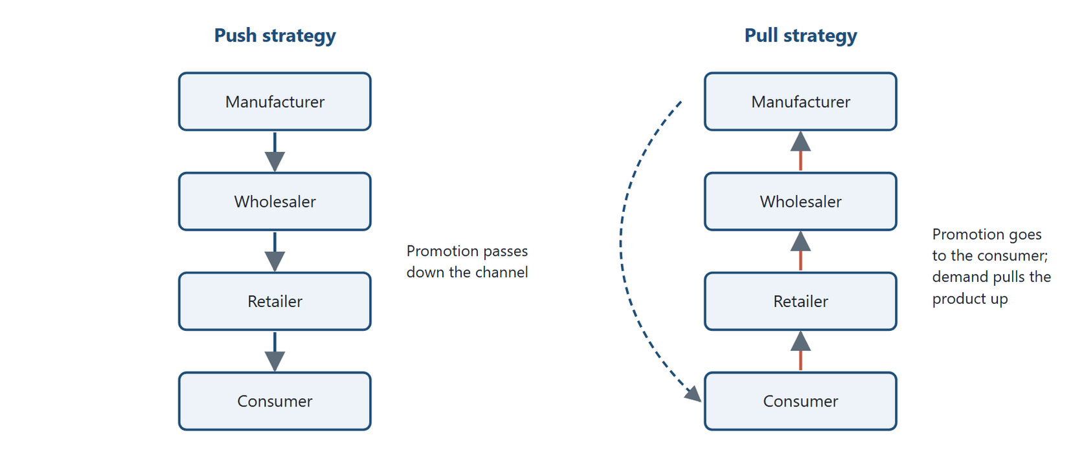
Figure 9.1 Push and pull strategies. In push, each channel member promotes the product to the next. In pull, the manufacturer promotes to the final customer, whose demand draws the product up the channel. Pull aimed at the public is not permitted for prescription medicines in Egypt and most other countries.
Original diagram (original)
A push strategy directs promotion at the channel. The manufacturer promotes to wholesalers, wholesalers to retailers, and retailers to consumers. Each member pushes the product to the next.
A pull strategy directs promotion at the final customer. Customers then ask retailers for the product, retailers ask wholesalers, and demand pulls the product up the channel.
In health care the choice is constrained. For prescription medicines, the "customer" whom promotion may address is mainly the prescriber. Pull strategies aimed at the public are prohibited in most countries, because patients cannot judge prescription medicines alone. The United States and New Zealand are the main exceptions, where direct-to-consumer advertising of prescription medicines is permitted under regulation. For over-the-counter products and self-paid services, lawful pull strategies are possible.
Through Two Lenses
- Medical Laboratory: A laboratory mostly uses push toward doctors: visits, test menus and scientific evenings. It may use careful pull toward the public only for tests with a clear indication for a defined group, such as recommended screening. Messages must be accurate, state who should be tested, and advise medical consultation. - Radiology and Medical Imaging: An imaging centre mostly uses push toward referring doctors: visits, sample images and fast reporting. It may use careful pull toward the public for booking information and screening awareness campaigns. Every message must state safety facts accurately, such as radiation and contrast risks.

9.4 Advertising
Advertising is paid, non-personal communication by an identified sponsor, through media, to inform or persuade an audience (Kotler & Keller, 2016). It can be produced in-house, used to build an organisation's standing in the community, or delivered digitally.

Classifying advertisements
By reach | By audience | By medium | By function
Local | Consumers | Print | To inform
Regional | Businesses | Broadcast | To persuade
National | Professionals | Online | To remind
International |  | Outdoor

Table 9.2. Four ways to classify advertisements.
In health care, advertisements to professionals and to consumers follow different rules. A journal advertisement for a prescription medicine addresses doctors and must carry prescribing information. A newspaper advertisement for a laboratory's opening hours addresses the public and must make no misleading health claims.

The advertising process
Four parties take part. The advertiser pays for the message. The advertising agency plans and manages it. The media carry it: newspapers, magazines, broadcast, direct mail, posters and, increasingly, websites and social platforms. The audience is the target group most likely to need the product, defined by age, location, profession, needs and similar factors.

What advertising of medicines may do
Advertising of medicines has three legitimate functions. It informs professionals and, where permitted, the public about products and their correct use. It communicates a new, approved indication or formulation. It supports entry into a new market for an approved use. It must stay within the product's approved labelling. Advertising is one tool of the promotion mix, not the best tool; in health care it is the most restricted one.

9.5 Sales Promotion
Sales promotion offers short-term incentives to buy. Unlike other tools, it can change behaviour quickly. General sales-promotion tools include price discounts, credit terms, free samples, premiums and coupons, contests, special packaging, special campaigns and service offers.
Many of these are restricted in health care. Free samples of prescription medicines may be given only to qualified prescribers, in limited quantities, under industry codes (International Federation of Pharmaceutical Manufacturers & Associations, 2019). Contests and lotteries tied to the purchase of medicines, or to the number of prescriptions, are inappropriate. Coupons for self-paid services must not pressure patients into tests they do not need.

Advertising and sales promotion compared
 | Advertising | Sales promotion
Time horizon | Long term | Short term
Nature | One-way persuasive message from an identified sponsor | Immediate incentive to buy
Cost | Often high | Often lower
Link to sales | Indirect | Direct
Speed of effect | Slow | Fast
Typical aim | Brand building and sales | Sales

Table 9.3. Advertising and sales promotion compared.

9.6 Opinion Leaders and Regulators
An opinion leader is a person whose views influence others. In health care, key opinion leaders are respected clinicians and scientists whose practice and teaching shape colleagues' choices. Companies may invite them to speak or advise.
Such relationships must be transparent. Payment to a clinician must be for genuine services, at fair value, and must not be linked to prescribing or referrals (International Federation of Pharmaceutical Manufacturers & Associations, 2019).
Regulators and international health bodies are not opinion leaders in this sense. The World Health Organization, the US Food and Drug Administration and the Egyptian Drug Authority are independent public bodies. Their guidance is evidence that communication must respect, not a channel for promotion. Implying that a regulator "recommends" a brand, when it has only approved it, is misleading.
In Practice
A laboratory introducing a new test invites a respected university professor to speak at a scientific evening for doctors. The professor presents published validation data, including the test's limitations. The laboratory pays a fair speaking fee disclosed to the audience, and the invitation carries no link to referrals. The event informs doctors honestly. That is the acceptable form of working with an opinion leader.

9.7 Planning a Communication Campaign
A communication campaign turns the tools of this chapter into a plan. It follows six steps (Kotler & Keller, 2016).
1. Identify the target audience. Referring doctors, patients, or both. A campaign for a new test usually starts with the doctors who will request it.
2. Set the communication objective. To inform (the test now exists), to persuade (it is faster than the alternative), or to remind (screening is due).
3. Design the message. What will be said, how, and by whom. In health care the message must be accurate, balanced and within the product's approved use.
4. Choose the channels. Personal channels, such as visits and scientific evenings, or non-personal ones, such as print, online and outdoor media.
5. Set the budget. Four methods are common. The affordable method spends what the organisation can spare. The percentage-of-sales method spends a fixed share of revenue. The competitive-parity method matches competitors' spending. The objective-and-task method costs the tasks needed to reach the objective. The last is the most logical, because it starts from what the campaign must achieve.
6. Measure the results. Compare the outcome with the objective: new referrals, appropriate bookings, awareness among doctors.
A campaign aimed at the public can use events and experiences, one of the eight modes in Table 9.1. Figure 9.2 shows a stand at a health awareness day.
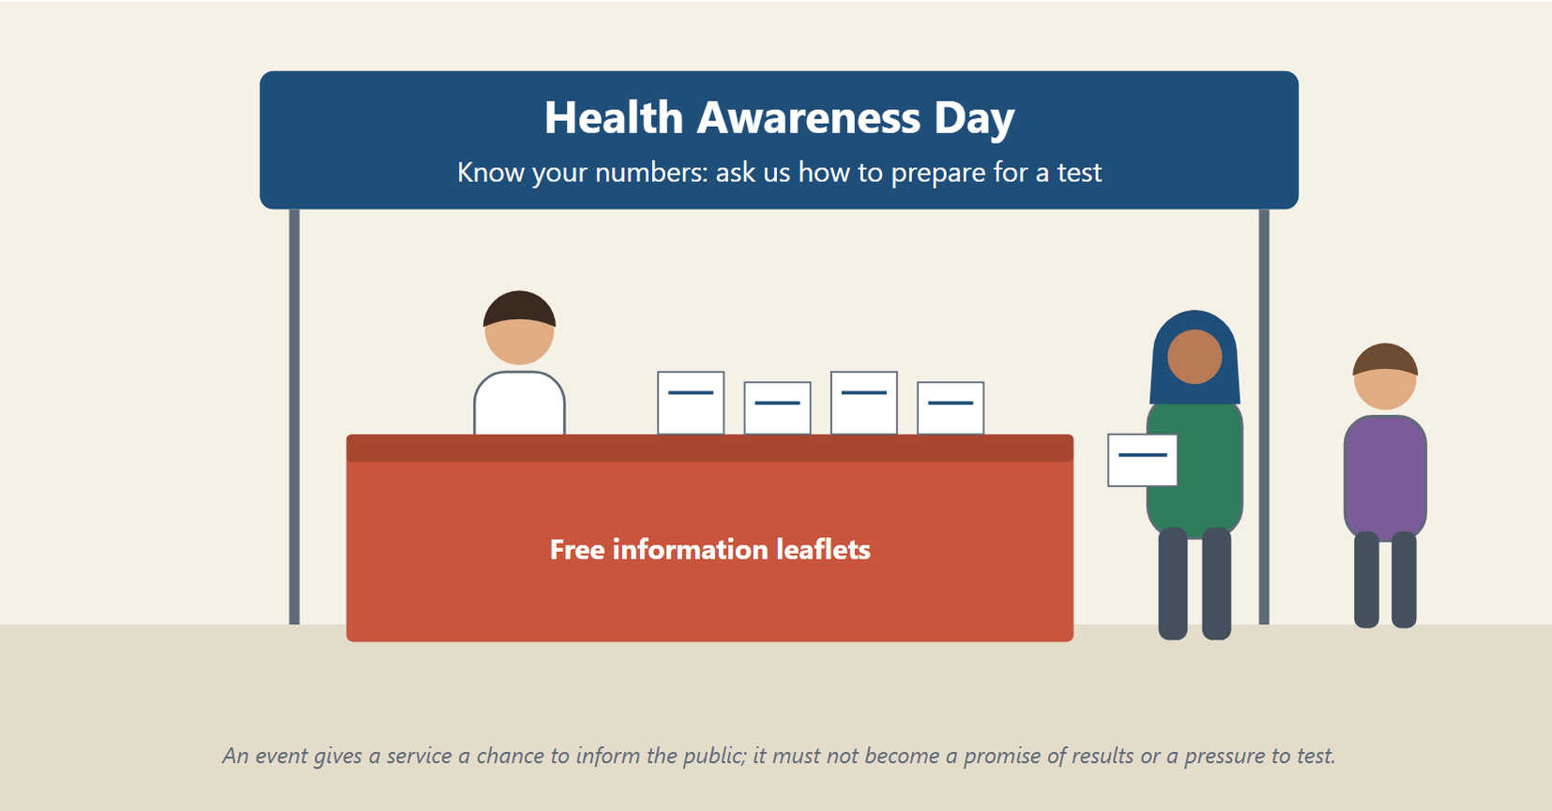
Figure 9.2 A health awareness day stand. Events and experiences let a service meet the public and inform them, for example on how to prepare for a test; they must not promise results or pressure people to be tested.
Original illustration (original)
In Practice
A laboratory launches a new rapid test for a common infection. Its audience is primary-care doctors in two districts. The objective is to inform them within two months. The message is a one-page summary of the test's accuracy and turnaround, with its limitations. The channels are personal visits and one scientific evening. The budget is set by costing these tasks. After two months the laboratory counts how many doctors requested the test and asks them what they thought of the information.

9.8 The Ethical and Legal Limits of Promotion
The World Health Organization (1988) set out ethical criteria for promoting medicines. The IFPMA Code of Practice governs member companies' promotion to professionals (International Federation of Pharmaceutical Manufacturers & Associations, 2019). National regulators add their own rules. Together they establish principles that apply equally well to laboratories and imaging centres:
1. Truthfulness. Claims must be accurate, balanced, supported by evidence and not misleading.
2. Completeness. Benefits must be presented with risks and limitations.
3. Approved use only. Medicines may be promoted only for their approved indications.
4. No public promotion of prescription medicines. Prescription medicines are promoted to professionals, not to the public, in Egypt and most other countries.
5. No inducements. Gifts, payments or benefits must not be offered to influence prescribing, dispensing or referral.
6. Disclosure. Sponsorship of events, speakers and materials must be disclosed.
7. Respect for patients. Communication must not exploit fear, vulnerability or lack of knowledge.
Ethics Check
An imaging centre offers referring doctors a cash payment for every MRI patient they send. This is a referral inducement. It tempts doctors to refer patients who do not need a scan, or to choose the centre for money rather than quality. It breaks professional ethics and, in many countries, the law. The centre may compete for referrals only through quality, speed, reports and fair prices.

Common Mistake
Thinking that small gifts are always harmless. A systematic review of contacts between doctors and the pharmaceutical industry found that such contacts, including small gifts and meals, were associated with changes in prescribing (Fickweiler et al., 2017). Industry codes therefore limit gifts to items of modest value related to practice or education, or ban them entirely, depending on the code.

Egyptian Context
In Egypt, the Egyptian Drug Authority's prescription medicine promotion guidelines require promotional material for registered prescription medicines to be pre-cleared and directed to health professionals only, with claims tied to the approved indication (Egyptian Drug Authority, 2020). Advertisements for health products and health services in Egypt, which include the services of laboratories and imaging centres, need a licence from a higher committee chaired by the Minister of Health under Law No. 206 of 2017 (Arab Republic of Egypt, 2017). The committee checks that an advertisement complies with the law, and advertising without a licence is a criminal offence. Laboratories and imaging centres are also bound by professional ethics and by the rules of their licensing bodies. Before running any campaign, check the current rules with the regulator.

Key Takeaways
- Marketing communications inform, persuade and remind; in health care they must above all be true.
- Kotler and Keller's eight modes are advertising, sales promotion, events and experiences, public relations, online and social media, mobile, direct and database marketing, and personal selling.
- Push promotes through the channel; pull promotes to final customers, and pull aimed at the public is prohibited for prescription medicines in Egypt and most other countries.
- Advertisements can be classified by reach, audience, medium and function.
- Sales promotion acts fast but many of its tools are restricted in health care.
- Key opinion leaders are clinicians; regulators are independent bodies, not promotional channels.
- Truthfulness, completeness, approved use, no inducements, disclosure and respect for patients limit all health promotion.

Check Your Understanding
Q1 [LO1] Paid, non-personal communication by an identified sponsor through media is:
A Advertising
B Personal selling
C Public relations
D Sponsorship
Q2 [LO1] A laboratory's stand at a medical conference is an example of:
A Personal selling only
B A price discount
C Events and experiences
D A distribution channel
Q3 [LO2] Promotion directed at wholesalers and retailers, each passing the product on, is a:
A Pull strategy
B Push strategy
C Harvesting strategy
D Skimming strategy
Q4 [LO2] Why is a pull strategy aimed at the public prohibited for prescription medicines in most countries?
A It is too expensive
B Wholesalers object to it
C It cannot be measured
D Patients cannot judge prescription medicines alone
Q5 [LO3] Which statement about sales promotion is correct?
A It is usually long term and slow
B It acts quickly and links directly to sales
C It is the same as public relations
D It never uses samples
Q6 [LO3] A journal advertisement for a medicine aimed at doctors is classified by audience as:
A Professional
B Consumer
C International
D Outdoor
Q7 [LO4] In health-care marketing, key opinion leaders are:
A Regulators such as the Egyptian Drug Authority
B Advertising agencies
C Respected clinicians and scientists who influence colleagues
D Wholesalers
Q8 [LO4] Saying that a regulator "recommends" a brand it has only approved is:
A Acceptable public relations
B Misleading
C Required by law
D A form of sales promotion
Q9 [LO5] An imaging centre pays doctors for every patient they refer. This is:
A Sponsorship
B Premium pricing
C A lawful sales promotion
D A referral inducement
Q10 [LO5] Which principle requires that benefits be presented together with risks and limitations?
A Completeness
B Disclosure
C Approved use only
D Push strategy

Essay Questions
E1. [LO2] Compare push and pull strategies. Explain which a laboratory should use for a new specialised test and which it may use for an evidence-based screening test offered to a defined group of the public.
E2. [LO3] Compare advertising and sales promotion on six criteria, and explain which sales-promotion tools are restricted in health care and why.
E3. [LO5] Set out the ethical principles for promoting health services, and apply them to a campaign by a new imaging centre.
Answers and Worked Solutions
Q1. A — This is the definition of advertising.
Q2. C — A conference stand is an event, one of the eight major modes of communication in Kotler and Keller's framework.
Q3. B — Promotion passed down through channel members is a push strategy.
Q4. D — Patients cannot judge prescription medicines unaided, so promotion is directed at prescribers instead.
Q5. B — Sales promotion gives an immediate incentive; its effect is fast and tied directly to sales.
Q6. A — An advertisement aimed at doctors is professional advertising and must carry prescribing information.
Q7. C — Key opinion leaders are influential clinicians and scientists. Regulators are independent public bodies.
Q8. B — Approval is not recommendation. Implying endorsement misleads the audience.
Q9. D — Paying for referrals is an inducement that corrupts medical judgement.
Q10. A — Completeness requires balance: benefits with risks and limitations.
E1 — model answer points. Push: promotion through the channel, toward doctors, by visits and scientific evenings; suits a specialised test requiring medical judgement. Pull: promotion to the public; may be used only where testing is clinically appropriate for the people addressed, such as screening recommended for a defined age or risk group. The message must state the eligibility criteria, make accurate claims and advise medical consultation. Truthful wording alone does not make promotion ethical if the tests are not indicated (Chapter 1).
E2 — model answer points. Time horizon, nature, cost, link to sales, speed, aim. Restricted tools: samples of prescription medicines (prescribers only, limited), contests and lotteries (inappropriate for medicines), coupons that pressure patients into unneeded tests. Restrictions protect patients from inducement and overuse.
E3 — model answer points. Truthfulness, completeness, approved use, no public promotion of prescription medicines, no inducements, disclosure, respect for patients. Applied: accurate claims about equipment and reports; honest statements on radiation; no payments to referrers; disclosed sponsorships; no fear-based messages.

References
Arab Republic of Egypt. (2017). Law No. 206 of 2017 regulating the advertisement of health-related products and services. Official Gazette. Egyptian Drug Authority. (2020). Prescription medicine promotion guidelines (Version 01) [Guideline]. https://edaegypt.gov.eg/media/ieph2wot/prescription-medicine-promotion-guidelines.pdf Fickweiler, F., Fickweiler, W., & Urbach, E. (2017). Interactions between physicians and the pharmaceutical industry generally and sales representatives specifically and their association with physicians' attitudes and prescribing habits: A systematic review. BMJ Open, 7(9), e016408. https://doi.org/10.1136/bmjopen-2017-016408 International Federation of Pharmaceutical Manufacturers & Associations. (2019). IFPMA code of practice 2019 [Industry guidance]. IFPMA. Kotler, P., & Keller, K. L. (2016). Marketing management (15th ed.). Pearson. World Health Organization. (1988). Ethical criteria for medicinal drug promotion. World Health Organization.

Part III Health Economics
Chapters 10–12
10 Health-Care Costs
11 Outcomes and Methods of Economic Evaluation
12 Applying Economic Evaluation

10 Health-Care Costs
Learning Objectives
By the end of this chapter you will be able to:
LO1 Define health economics and pharmacoeconomics and explain why health systems use them.
LO2 Explain the cost–outcome principle and the four perspectives of an economic analysis.
LO3 Classify costs as direct medical, direct non-medical, indirect or intangible, and apply the concepts of opportunity and incremental cost.
LO4 Calculate the total cost of one option and the incremental cost between two options.
LO5 Compare the human capital, friction cost and willingness-to-pay approaches to valuing lost productivity.

10.1 Why Health Care Needs Economics
Every health system has limited money, staff and equipment. Demand for care is almost unlimited. Choices are unavoidable. Should a hospital buy a second CT scanner or a new laboratory analyser? Should an insurer pay for a costly new test? Economics gives a structured way to answer such questions.
Health economics is the study of how scarce resources are allocated to produce health and health care (Rice & Unruh, 2016). Pharmacoeconomics is the branch of health economics that describes and analyses the costs of medicines and drug therapy to the health system and society. Economic evaluation, of which pharmacoeconomics is one application, identifies, measures and compares the costs and consequences of health-care interventions: medicines, devices, tests and procedures (Drummond et al., 2015).
This book uses both terms. Pharmacoeconomics compares one drug with another, or drug therapy with other treatment. The same methods compare one test, scan or service with another, which is why they matter to laboratory and imaging professionals.

What economic evaluation is used for
1. Formulary and coverage decisions. Which medicines, tests or scans should a hospital stock or an insurer pay for? An option that is both more effective and less costly than the alternatives is chosen outright. More often one option is better but dearer, and the decision rests on the extra cost per unit of extra effect (Chapter 11).
2. Clinical guidelines. Guidelines can steer professionals toward the most efficient choice.
3. Direct comparison. Economic evaluation compares options head to head to find the best value.
4. Pricing and reimbursement. Evidence of value supports a fair price.

10.2 The Cost–Outcome Principle
An economic evaluation weighs what an intervention uses against what it achieves. The inputs are resources, measured as costs. The outcomes are the health and economic consequences.
Figure 10.1 shows the balance, with the intervention at the centre.
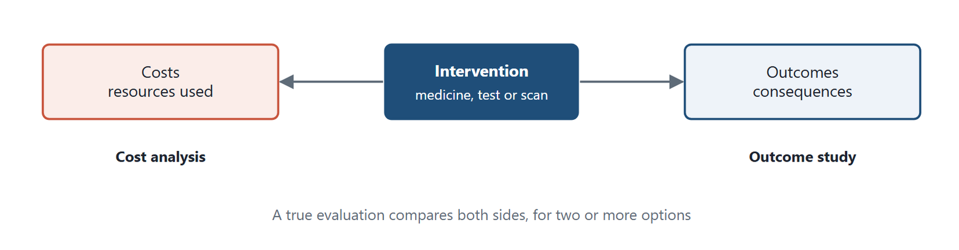
Figure 10.1 The cost–outcome principle. The intervention sits at the centre; cost analysis measures the resources it uses and outcome study measures its consequences. An economic evaluation compares both sides for two or more options.
Original diagram (original)
Key Formula
The cost–outcome principle
Costs ← intervention → outcomes
The intervention sits at the centre. Cost analysis measures the left side; outcome study measures the right. A true economic evaluation compares both sides, for two or more options.

Inputs (costs) | Outcomes (consequences)
Price of the medicine or test and its administration | Longer life
Hospital stay | Better quality of life
Transport | Longer time free of relapse
Treatment of adverse reactions | Better adherence to treatment

Table 10.1. Examples of inputs and outcomes.
Three terms recur:
- Cost — the value of the resources an intervention uses.
- Consequences — the effects, outputs or outcomes it produces.
- Perspective — whose costs and consequences are counted, which depends on the purpose of the study.

10.3 Perspectives
The same intervention can look cheap from one viewpoint and expensive from another. Four perspectives are common (Drummond et al., 2015):
- Patient — costs the patient and family bear: fees and copayments not covered by insurance, transport, time spent travelling, waiting and being treated, lost earnings, and the unpaid time of relatives who give care.
- Provider — costs to the hospital, laboratory or imaging centre delivering the service, mainly direct costs.
- Payer — costs to whoever pays: an insurer, an employer or the government.
- Society — all costs, to everyone, direct and indirect. This is the broadest perspective.
A study must state its perspective, and count only the costs that belong to it.
Through Two Lenses
- Medical Laboratory: A rapid point-of-care test may cost the laboratory more per test than a batch analyser. From society's perspective it may still save money, if faster results shorten hospital stays and avoid repeat visits. The perspective decides which answer is correct. - Radiology and Medical Imaging: A CT scan in the emergency department may cost the hospital more than observation. From the patient's and society's perspectives it may save money, if it avoids days off work and an unneeded admission. The perspective decides which answer is correct.

10.4 Categories of Cost
Health-care costs fall into four categories: direct medical, direct non-medical, indirect and intangible. Two further concepts are used with them: opportunity cost, a way of valuing the resources in any category, and incremental cost, a difference between the totals of two options. Neither is a category to add.

Direct medical costs
Direct medical costs are the resources used to prevent, diagnose or treat disease. They include medicines and materials, laboratory tests and imaging, professionals' time and fees, hospital stays, and medical equipment and supplies.

Direct non-medical costs
Direct non-medical costs result from illness but are not medical services. They include transport to and from care, lodging near a hospital, special food, and the costs of child or family care while the patient is treated.

Indirect costs
Indirect costs are the value of lost productivity. They include the patient's lost earnings during illness, which is morbidity cost, and the production lost through premature death, which is mortality cost.

Intangible costs
Intangible costs are the non-financial burdens of disease and care: pain, suffering, grief and anxiety. They are real but have no market price. They are usually reported separately rather than added to money costs. Where they are given a money value, this book follows one convention: the value of avoiding pain or anxiety, measured by willingness to pay (Section 10.6), is counted as a benefit of the intervention, never also as a cost, so it is not counted twice.

Opportunity cost
Opportunity cost is the value of the best alternative use of the resources actually used. When a hospital spends a budget on a new scanner, the opportunity cost is the benefit the same money would have produced in its next best use, for example more nursing staff. Economists regard every cost as an opportunity cost in this sense (Drummond et al., 2015). It is a way of valuing resources, not an extra category to add.

Incremental cost
Incremental cost is the additional cost of one option compared with another. If a new test costs 400 EGP per patient in total and the current test costs 250 EGP, the incremental cost is 150 EGP per patient. Incremental cost is the numerator of the incremental cost-effectiveness ratio in Chapter 11.
Common Mistake
Adding incremental cost to the other categories to get "total cost". Incremental cost is a difference between the totals of two options. Adding it counts the same resources twice. First find each option's total cost; then subtract.

10.5 Putting Costs Together
Key Formula
Total cost of one option
$$\text{Direct costs}=\text{direct medical}+\text{direct non-medical}$$
$$\text{Indirect costs}=\text{morbidity costs}+\text{mortality costs}$$
$$\text{Total cost}=\text{direct costs}+\text{indirect costs}$$
Intangible costs are reported alongside the total, unless they have been valued in money. Incremental cost is the difference between the total costs of two options.

Worked Example
Total and incremental cost of two diagnostic pathways
A hospital compares two pathways for patients with suspected kidney stones, from the societal perspective. The figures are illustrative, per patient, in EGP.
Pathway A, ultrasound first: direct medical 900; direct non-medical 100; indirect 600. Total = 900 + 100 + 600 = 1,600 EGP.
Pathway B, low-dose CT first: direct medical 1,500; direct non-medical 50; indirect 250. Total = 1,500 + 50 + 250 = 1,800 EGP.
Incremental cost of B over A = 1,800 − 1,600 = 200 EGP per patient.
Interpretation. Pathway B costs more to deliver but saves travel and working days, because diagnosis is faster. From the hospital's perspective the difference is 1,500 − 900 = 600 EGP; from society's it is only 200 EGP. Whether 200 EGP is worth paying depends on the outcomes, which Chapter 11 measures.

10.6 Valuing Lost Productivity
Two methods value lost productivity, the indirect costs of this chapter. A third tool, willingness to pay, values benefits rather than lost production, and it is described here because it is often confused with them.
Human capital approach. Lost productivity is valued at the earnings the patient would have made; it is also called the foregone earnings approach. Where actual wages are unknown, average earnings for the patient's age and sex are used. The pure method does not count unpaid work, such as home-making, child care or volunteering, which undervalues the productivity of people outside paid work.
Friction cost approach. Lost productivity is valued only over the friction period: the time until the worker is replaced or output is otherwise restored (Koopmanschap et al., 1995). After that, the work is done by someone else, so no further production is lost to society. The friction cost method also counts the employer's costs of recruiting and training a replacement as part of the friction costs (Koopmanschap et al., 1995). This method usually gives lower indirect costs than the human capital approach.
Willingness to pay (WTP). People are asked, through carefully phrased questions, the most they would pay for a benefit or to avoid a harm. WTP is not a productivity method. It values outcomes and welfare, including intangible ones such as pain avoided, and so belongs on the benefit side of the balance. Chapter 11 uses it in cost-benefit analysis.
In Practice
A factory technician breaks a wrist and is off work for six weeks. By the human capital approach the indirect cost is six weeks of wages. The factory moves a colleague to cover the job within one week and pays overtime. By the friction cost approach the indirect cost is that one week's lost output plus the overtime. The two methods can differ several-fold, so a study must state which it used.

10.7 Classifying Costs: A Worked Activity
Worked Example
The injured worker
A worker falls at work and injures his left foot. He takes a taxi to the nearby primary-care unit, though he could have gone to a large hospital in the city centre. He pays the registration fee, and the doctor orders an X-ray, which shows a fracture. The fracture is set, and he is told to rest at home for a month, take prescribed medicines and eat foods that help healing. He buys crutches. He is off work for a month; his employer pays part of his wages as sick pay, and he loses the rest. He feels sad and anxious, because he has no one to care for him. His employer brings in a replacement worker for the month.
Perspective. Society, so that the costs of the patient, the health service and the employer are all counted.
Classification. Table 10.2, after this box, sets out every cost by category.
Two corrections to a common answer. The large hospital he did not use is not his opportunity cost. He did not use its resources, so it costs nothing in this analysis; it would matter only if we compared the two places of care as options. The replacement worker is not the patient's cost. It falls on the employer, and it is counted because the perspective is society's. Under the friction cost method, recruiting and training the replacement would be part of the friction costs, together with the production lost until the replacement is working. Here lost production is valued by the human capital approach, so the replacement cost is listed as a separate cost to the employer. The two rows are not simply added: if the replacement restores output, the month is not fully lost, and adding a full month of lost production to the replacement cost counts the same absence twice. Add them only when no output is restored during the month.

Category | Items
Direct medical | Registration fee, doctor's examination, X-ray, fracture treatment, medicines, crutches
Direct non-medical | Taxi fare, special foods
Indirect | One month of lost production, valued by the human capital approach at his full wage, whether paid by him or by his employer as sick pay (morbidity cost)
Intangible | Pain, sadness, anxiety
Replacement cost to the employer | Recruiting and training the replacement worker
Incremental | None, because only one option is being costed

Table 10.2. Classification of the injured worker's costs, from the societal perspective.

10.8 Economics and Ethics
Ethics Check
Cost analysis can be misused. A service might choose the perspective that makes its product look best, for example the provider's view to hide costs to patients. It might omit intangible costs because they are hard to measure. Honest analysis states its perspective at the outset, counts every cost that belongs to it, reports intangible costs, and tests its conclusions against other assumptions. Chapter 11 shows how.

Egyptian Context
In Egypt, more than half of current health spending is paid out of pocket by households (World Health Organization, 2025), so costs from the patient's perspective are large and visible. As the universal health insurance system expands (Arab Republic of Egypt, 2018), payer-perspective analysis becomes more important for deciding which services are covered.

Key Takeaways
- Health economics studies how scarce resources are allocated to health; pharmacoeconomics applies it to medicines.
- An economic evaluation compares costs and outcomes of two or more options.
- The perspective (patient, provider, payer or society) decides which costs count.
- Direct medical, direct non-medical, indirect and intangible costs are the main categories.
- Opportunity cost is the value of the best alternative use of resources used, not a service not used.
- Incremental cost is a difference between two totals, never an extra term in one total.
- Human capital and friction cost value lost productivity; willingness to pay values benefits, not production.

Check Your Understanding
Q1 [LO1] Pharmacoeconomics is best described as:
A Marketing of medicines to doctors
B Analysis of the costs and consequences of medicines and drug therapy
C Setting retail prices for pharmacies
D Accounting for a pharmacy's stock
Q2 [LO2] Which perspective counts all costs, direct and indirect, to everyone?
A Society
B Patient
C Provider
D Payer
Q3 [LO3] The taxi fare to a hospital is a:
A Direct medical cost
B Indirect cost
C Direct non-medical cost
D Intangible cost
Q4 [LO3] A patient's lost wages during illness are:
A An intangible cost
B A direct medical cost
C An incremental cost
D An indirect (morbidity) cost
Q5 [LO3] Pain and anxiety caused by illness are:
A Intangible costs
B Direct medical costs
C Opportunity costs
D Direct non-medical costs
Q6 [LO4] Option A costs 2,000 EGP in total and option B costs 2,600 EGP. The incremental cost of B over A is:
A 4,600 EGP
B 1.3
C 2,600 EGP
D 600 EGP
Q7 [LO4] Why must incremental cost not be added into the total cost of one option?
A It is too small to matter
B It is intangible
C It is a difference between two totals, so adding it double-counts
D It belongs only to the patient perspective
Q8 [LO3] A hospital spends its budget on a new scanner instead of hiring nurses. The benefit the nurses would have produced is the:
A Incremental cost
B Opportunity cost
C Indirect cost
D Friction cost
Q9 [LO5] Valuing lost productivity only over the period until the worker is replaced or output restored is the:
A Friction cost approach
B Human capital approach
C Willingness-to-pay approach
D Cost-of-illness approach
Q10 [LO5] A weakness of the pure human capital approach is that it:
A Counts too much unpaid work
B Cannot use average wages
C Ignores lost earnings
D Does not count unpaid work such as child care

Essay Questions
E1. [LO2] Explain the four perspectives of economic evaluation, and show with a laboratory example how the choice of perspective can change a conclusion.
E2. [LO3] A patient with pneumonia travels to hospital, has a chest X-ray and blood tests, stays three nights and misses a week of work. Classify every cost, and explain where intangible and opportunity costs fit.
E3. [LO5] Compare the human capital, friction cost and willingness-to-pay approaches, and state one strength and one weakness of each.
Answers and Worked Solutions
Q1. B — Pharmacoeconomics analyses the costs and consequences of medicines and drug therapy.
Q2. A — The societal perspective counts all costs, direct and indirect, whoever bears them.
Q3. C — Transport results from illness but is not a medical service: a direct non-medical cost.
Q4. D — Lost earnings during illness are lost productivity, a morbidity cost within indirect costs.
Q5. A — Pain and anxiety are non-financial burdens: intangible costs.
Q6. D — 2,600 − 2,000 = 600 EGP. Option B divides the totals instead of subtracting.
Q7. C — Incremental cost is the difference between two totals; adding it to one total counts resources twice.
Q8. B — The benefit forgone from the next best use of the same resources is the opportunity cost.
Q9. A — The friction cost approach counts lost production only over the friction period. Willingness to pay is not a productivity method at all.
Q10. D — The pure human capital approach values only paid work, so it misses child care, home-making and volunteering.
E1 — model answer points. Patient, provider, payer, society, with the costs each counts. A rapid test may cost the laboratory more but save society money through shorter stays; the provider perspective rejects it, the societal perspective accepts it. A study must state its perspective.
E2 — model answer points. Direct medical: X-ray, blood tests, hospital stay, medicines, professional fees. Direct non-medical: travel, family's lodging or food. Indirect: lost week of wages. Intangible: discomfort and anxiety, reported separately. Opportunity cost is the value of the resources' best alternative use, a way of valuing them, not an extra item.
E3 — model answer points. Human capital: simple, uses wage data; ignores unpaid work and may overstate losses. Friction cost: realistic about replacement; depends on labour-market assumptions and the length of the friction period. Willingness to pay is a different kind of tool: it values benefits, including intangible ones, not lost production; its answers depend on income and question wording.

References
Arab Republic of Egypt. (2018). Law No. 2 of 2018 promulgating the Universal Health Insurance System law. Official Gazette. Drummond, M. F., Sculpher, M. J., Claxton, K., Stoddart, G. L., & Torrance, G. W. (2015). Methods for the economic evaluation of health care programmes (4th ed.). Oxford University Press. Koopmanschap, M. A., Rutten, F. F. H., van Ineveld, B. M., & van Roijen, L. (1995). The friction cost method for measuring indirect costs of disease. Journal of Health Economics, 14(2), 171–189. https://doi.org/10.1016/0167-6296(94)00044-5 Rice, T., & Unruh, L. (2016). The economics of health reconsidered (4th ed.). Health Administration Press. World Health Organization. (2025). Country cooperation strategy for WHO and Egypt 2024–2028. World Health Organization Regional Office for the Eastern Mediterranean. https://applications.emro.who.int/docs/9789292746926-eng.pdf

11 Outcomes and Methods of Economic Evaluation
Learning Objectives
By the end of this chapter you will be able to:
LO1 Classify outcomes with the ECHO model and calculate quality-adjusted life years.
LO2 Choose the right method of economic evaluation for a given comparison.
LO3 Calculate and interpret cost-effectiveness and incremental cost-effectiveness ratios using the cost-effectiveness plane.
LO4 List the steps of an economic evaluation and state the purpose of sensitivity analysis.
LO5 Identify practices that make an economic evaluation misleading.

11.1 The Outcome Side
Chapter 10 measured the cost side of the balance. This chapter measures the outcome side, then joins the two. Outcomes can be positive, the desired effects of an intervention, or negative, such as adverse effects and toxicity. An honest evaluation counts both.

11.2 The ECHO Model
The ECHO model groups outcomes into three kinds: economic, clinical and humanistic (Rascati, 2014). Research that measures them is called outcomes research. Figure 11.1 summarises the three groups.
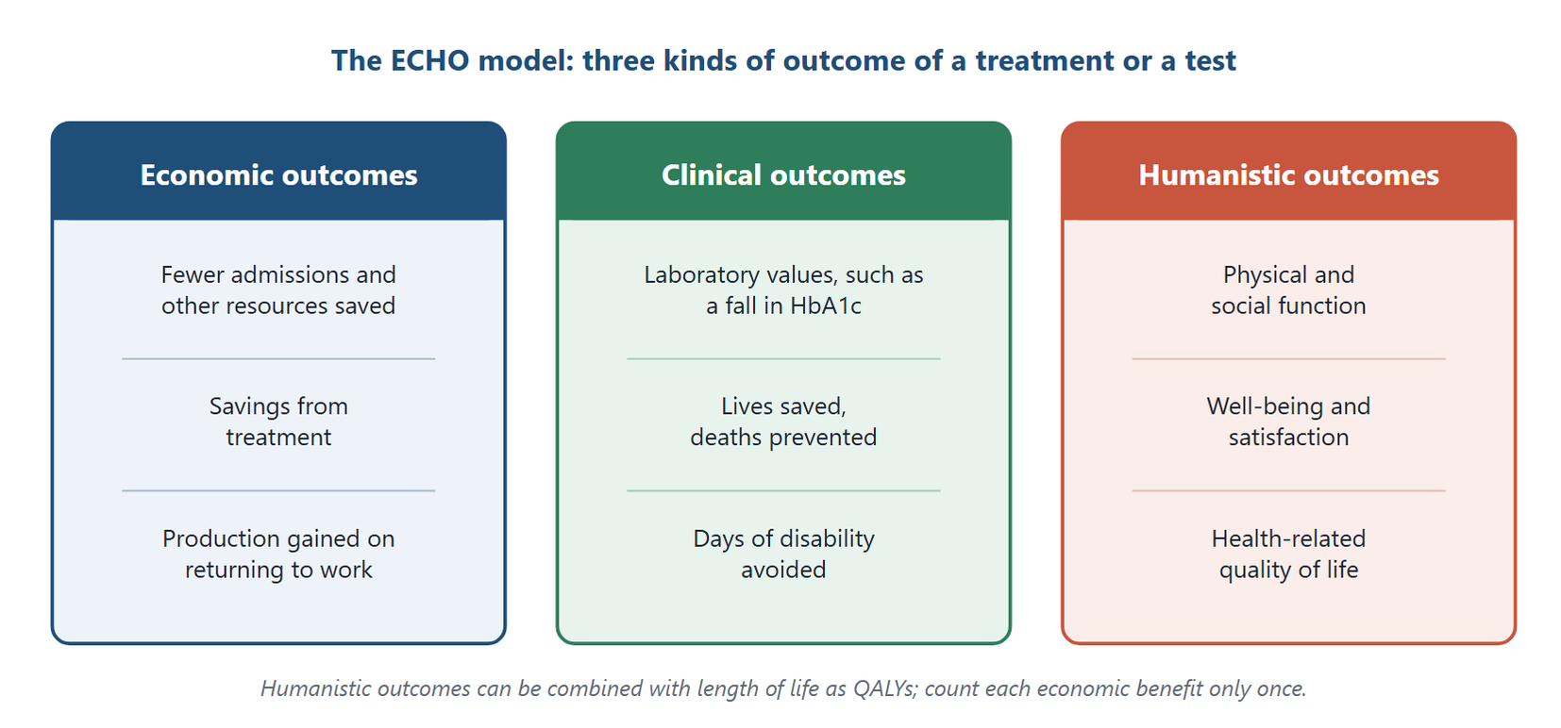
Figure 11.1 The ECHO model. Outcomes are grouped as economic, clinical and humanistic; each economic benefit is counted only once.
Original diagram (original)
Economic outcomes are changes in resource use and money:
- reduced use of resources, such as fewer admissions;
- savings from treatment, a direct monetary benefit;
- production gained when a patient returns to work, an indirect monetary benefit.
These economic outcomes must not be counted twice. This book counts lost production as an indirect cost and treatment costs as direct costs (Chapter 10). A return to work therefore appears as a smaller indirect cost, and a saving in treatment as a smaller direct cost, in the option that achieves them. Neither is also added as a benefit. A study may choose the other convention, counting them as benefits instead, but it must use one or the other for each item.
Clinical outcomes are medical events resulting from disease or treatment, including safety and efficacy end points:
- laboratory values, such as a fall in glycated haemoglobin;
- lives saved and deaths prevented;
- days of disability avoided.
Humanistic outcomes are the effects of disease or treatment on the patient's life: physical and social function, general health, well-being and satisfaction. They are measured as changes in health-related quality of life (HRQOL), often expressed as utilities.

Utilities and QALYs
A utility is a number that represents the value of a health state on a scale where 1.0 is full health and 0 is death. Some instruments allow values below 0 for states people judge worse than death. Utilities are usually measured with questionnaires completed by patients or the public (Drummond et al., 2015).
The quality-adjusted life year (QALY) combines length and quality of life in one measure.
Key Formula
Quality-adjusted life years
$$\text{QALYs}=\text{years of life}×\text{utility}$$
One year in full health is 1 QALY. One year at utility 0.5 is 0.5 QALY. Over several periods, the QALYs of each period are added.

Worked Example
QALYs gained by a treatment
A treatment extends life by 2 years, but its adverse effects reduce the patient's utility by 25% during those years.
Case 1 — full health before the effects. If the patient's utility would otherwise be 1.0, the utility with the effects is 1.0 × (1 − 0.25) = 0.75. QALYs gained = 2 × 0.75 = 1.5 QALYs.
Case 2 — a lower baseline. If the patient's utility is 0.8 because of the underlying disease, the utility with the effects is 0.8 × 0.75 = 0.6. QALYs gained = 2 × 0.6 = 1.2 QALYs.
Interpretation. The answer of 1.5 QALYs holds only when the patient starts in full health. Always state the baseline utility.

11.3 Perspectives Again
Chapter 10 introduced the patient, provider, payer and societal perspectives. They apply to outcomes too. A return to work lowers indirect costs for the patient and for society, but it does not change a hospital's budget. A study must use the same perspective on both sides of the balance.

11.4 Methods of Economic Evaluation
A pharmacoeconomic evaluation is any study that assesses the costs and consequences of alternative therapies. A full economic evaluation compares two or more options on both costs and consequences, and four methods do this: CMA, CEA, CUA and CBA (Drummond et al., 2015). A fifth kind of study, cost-of-illness analysis, is related but descriptive: it measures the burden of a disease and compares no interventions. Table 11.1 sets the five side by side.
Method | Costs measured in | Outcomes measured in | Result
Cost-minimisation analysis (CMA) | Money | Shown to be equivalent, so not compared | The least costly option
Cost-effectiveness analysis (CEA) | Money | Natural units: cases cured, lives saved | Cost per unit of effect
Cost-utility analysis (CUA) | Money | QALYs | Cost per QALY
Cost-benefit analysis (CBA) | Money | Money | Benefit–cost ratio or net benefit
Cost-of-illness analysis (COI) | Money | Not compared: describes the burden | Total cost of a disease

Table 11.1. The four comparative methods of economic evaluation, and cost-of-illness analysis as a related descriptive study.

Cost-minimisation analysis (CMA)
Cost-minimisation analysis compares the costs of two or more options whose outcomes have been shown to be equivalent. It is the simplest method. Its aim is to find the least costly option.
Common candidates are a brand against its bioequivalent generic, the same medicine by two routes, or two laboratory methods with equivalent accuracy. They become CMA only once equivalence has been shown in every relevant outcome, including safety and adherence, not in one end point alone. Assuming equivalence without evidence turns CMA into a guess.
In Practice
Two antibiotics were compared in a trial designed to test equivalence, and were shown to be equivalent within a prespecified margin in cure rate (about 90% each), safety and adherence. Drug A costs 250 EGP per course and drug B costs 350 EGP. Because equivalence has been demonstrated, CMA applies. Two equal percentages from different studies would not be enough; without a proper equivalence analysis, CEA is the safer method. Drug A is preferred, saving 100 EGP per course.

Cost-effectiveness analysis (CEA)
Cost-effectiveness analysis compares options that produce the same kind of outcome in different amounts. Costs are in money; outcomes are in natural units such as cases cured, lives saved, admissions avoided or millimetres of mercury of blood pressure. It is used for a specific condition. An example is comparing a proton-pump inhibitor with an H2-receptor blocker for severe reflux oesophagitis, with healing as the outcome.
Key Formula
Cost-effectiveness ratios
$$CER=\frac{C}{E}$$
$$ICER=\frac{C_{A}-C_{B}}{E_{A}-E_{B}}$$
The cost-effectiveness ratio (CER) is the cost of one option divided by its effect. The incremental cost-effectiveness ratio (ICER) is the extra cost of option A over option B divided by the extra effect. Decisions between options rest on the ICER, not on comparing CERs.

The average cost-effectiveness ratio (ACER) is the same thing as the CER: the total cost of one option divided by its total effect. A ratio of net differences, (cost − cost of the comparator) ÷ (effect − effect of the comparator), is incremental, even when the comparator is doing nothing.

Reading an ICER: the cost-effectiveness plane
An ICER on its own can mislead. A negative ICER arises in two very different situations: when the new option is cheaper and more effective, and when it is more expensive and less effective. The cost-effectiveness plane separates them (Black, 1990). Figure 11.2 shows it.
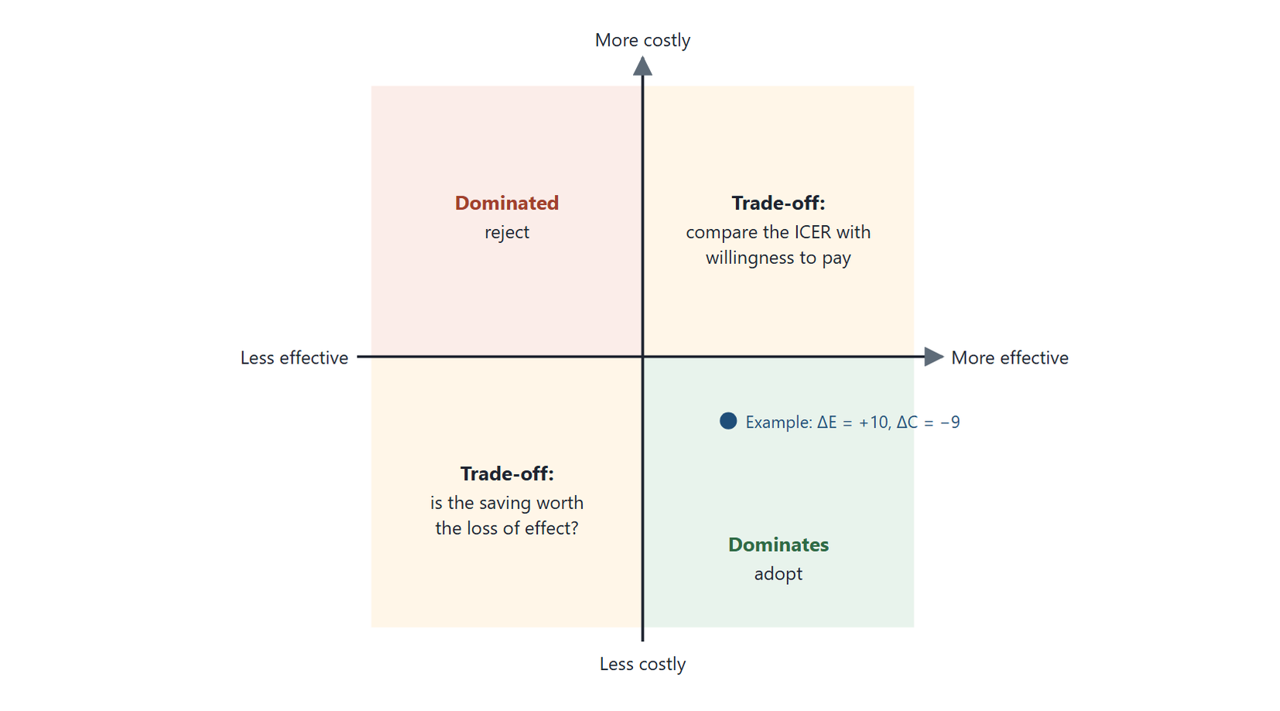
Figure 11.2 The cost-effectiveness plane. The horizontal axis is the difference in effect and the vertical axis the difference in cost of a new option against its comparator. Dominance is read from the quadrant, not from the sign of the ICER. The marked point is the metformin example of Chapter 12.
Original diagram (original)
The horizontal axis is the difference in effect; the vertical axis is the difference in cost. Each quadrant has its own meaning:
- More effective, less costly (south-east): the new option dominates. Adopt it.
- Less effective, more costly (north-west): the new option is dominated. Reject it.
- More effective, more costly (north-east): a trade-off. Compare the ICER with what the decision-maker is willing to pay per unit of effect.
- Less effective, less costly (south-west): a trade-off in the other direction. Is the saving worth the loss of effect?
Dominance is read from the signs of the two differences, not from the sign of the ratio.
Common Mistake
Concluding that a negative ICER always means dominance. An option that saves 10 EGP and loses 5 units of effect also gives a negative ICER, yet it is not better. Always look at which quadrant the result falls in.

Cost-utility analysis (CUA)
Cost-utility analysis measures outcomes in QALYs, so it compares options across different diseases. The average cost per QALY of one option, the cost-utility ratio, describes it but does not decide between options: ranking options by their average ratios can pick the wrong one. The decision uses the incremental cost per QALY gained, read on the cost-effectiveness plane and compared with a threshold (Section 11.7). The US Second Panel on Cost-Effectiveness in Health and Medicine recommends cost per QALY for its reference case (Sanders et al., 2016), and many health-technology-assessment bodies take a similar approach. Its main difficulties are measuring utilities and comparing QALYs between different patients and populations.

Cost-benefit analysis (CBA)
Cost-benefit analysis measures both costs and benefits in money. Results are a benefit–cost ratio (benefits ÷ costs) or a net benefit (benefits − costs). Because both sides are in money, CBA can compare very different programmes, such as a screening programme and a road-safety scheme. Benefits may be valued by willingness to pay. Many CBAs count only direct costs and direct benefits, which should be stated. Chapter 12 works examples.

Cost-of-illness analysis (COI): a descriptive study
Cost-of-illness analysis is not a full economic evaluation, because it compares no options. It measures the economic burden of a disease on society: the total direct and indirect costs it causes. That total is not an estimate of what could be saved. Eliminating a disease has costs of its own, some shared costs would remain, people who live longer go on to use other care, and not all of the burden is preventable. A cost-of-illness study therefore says how large a problem is, not whether any way of reducing it is worth the money; that question needs a comparative evaluation. It is used for any disease whose burden needs describing, from diabetes to road injuries.
Through Two Lenses
- Medical Laboratory: A laboratory comparing two analysers with equivalent accuracy uses CMA. Comparing a rapid test with a slower one that detects more infections uses CEA, cost per case detected. The method follows the outcome, and equivalence must be shown before CMA is used. - Radiology and Medical Imaging: A centre comparing two MRI protocols with equivalent diagnostic accuracy uses CMA. Comparing low-dose CT screening with no screening uses CUA, cost per QALY. The method follows the outcome, and equivalence must be shown before CMA is used.

11.5 Sensitivity Analysis
Costs and outcomes are estimated, and estimates have ranges. Sensitivity analysis recalculates the result using different plausible values, to see whether the conclusion changes (Drummond et al., 2015). If the conclusion holds across the range, it is robust. If it reverses, the decision is uncertain.
Typical questions are:
- Would option A still be most cost-effective if option B's effect were larger than the trial found?
- Would it still be preferred if B's monitoring costs were lower?
The more assumptions a study makes, the more important sensitivity analysis becomes.

11.6 Steps of an Economic Evaluation
1. Define the problem. Name the disease and the question, for example the most cost-effective way to control glucose in type 2 diabetes.
2. Choose the perspective. Who will use the results, for which decision?
3. Identify the alternatives. Usually the new option against the current standard or most likely substitute. The comparator need not be a medicine; it can be a test, a scan or a lifestyle programme.
4. Identify and measure outcomes. Cure rates, quality of life, reduced complications, years of life gained, symptom relief and adverse events.
5. Identify, measure and value costs. Direct medical, direct non-medical, indirect and intangible, as the perspective requires.
6. Choose the method. CMA, CEA, CUA or CBA, according to the outcome. A cost-of-illness study may come first, to describe the burden, but it cannot choose between options.
7. Calculate and interpret. Compute the ratios and read them on the cost-effectiveness plane.
8. Test the result. Run sensitivity analysis.
9. Report transparently. Reporting standards such as CHEERS 2022 list what a report must contain (Husereau et al., 2022).

11.7 Costs and Outcomes Over Time: Discounting
Many interventions pay out over years. A screening programme costs money now and prevents disease later. People and health systems value money and health received now more than the same amounts received in the future. Discounting converts future costs and outcomes to their value today, so options with different timings can be compared fairly (Drummond et al., 2015).
Key Formula
Present value
$$PV=\frac{F}{{\left(1+r\right)}^{t}}$$
where $F$ is the future cost or outcome, $r$ is the discount rate per year, and $t$ is the number of years until it occurs. The result is its present value.

Guidelines usually discount both costs and health outcomes, at a rate set by the country's health-technology-assessment body or finance ministry. The rate must be stated, and a sensitivity analysis should test other rates, because the choice can change the conclusion for long-term programmes such as screening and vaccination.
Worked Example
Discounting a future saving
A screening programme is expected to save 10,000 EGP of treatment costs five years from now. The discount rate is 3% a year.
Step 1 — the discount factor. (1 + 0.03)⁵ = 1.1593, which rounds to 1.159.
Step 2 — present value. 10,000 ÷ 1.1593 = 8,626 EGP. (Dividing by the rounded 1.159 gives 8,628 EGP; carry the unrounded factor.)
Interpretation. A saving of 10,000 EGP in five years is worth about 8,626 EGP today. Counting it at face value would overstate the saving by about 16%, and so understate the programme's net cost.

Thresholds and willingness to pay
When an ICER falls in the north-east quadrant, the decision-maker must judge whether the extra effect is worth the extra cost. Many systems compare the ICER with a cost-effectiveness threshold: the most they are willing to pay for one unit of effect, usually one QALY. An option below the threshold is considered cost-effective. Thresholds differ between countries and are debated, and a threshold is a guide to judgement, not a substitute for it.

11.8 Honest Evaluation
Ethics Check
A company funds an evaluation of its own product. The analysts choose a weak comparator, a short time horizon that hides later costs, and the perspective that looks best. They report only the favourable sensitivity analyses. Each choice seems technical, but together they mislead. Honest evaluation uses the relevant comparator, a suitable time horizon and the perspective stated in advance. It reports all sensitivity analyses and discloses its funding (Husereau et al., 2022).

Egyptian Context
As the universal health insurance system decides which services to cover (Arab Republic of Egypt, 2018), economic evaluation offers a structured way to compare value. For Egyptian decisions, costs should be local, in EGP, and outcomes should reflect the Egyptian population where data allow.

Key Takeaways
- The ECHO model groups outcomes as economic, clinical and humanistic.
- QALYs = years × utility; the baseline utility must always be stated.
- CMA needs equivalence shown in all relevant outcomes; CEA uses natural units; CUA uses QALYs; CBA uses money; COI describes burden.
- CER (or ACER) = total C ÷ total E for one option; ICER = ΔC ÷ ΔE between options; decisions rest on the ICER, and average cost per QALY does not rank options.
- Dominance is read from the quadrant of the cost-effectiveness plane, not from the sign of the ICER.
- Sensitivity analysis tests whether the conclusion survives plausible changes in assumptions.
- Honest evaluation states its perspective, comparator and funding, and reports all analyses.

Check Your Understanding
Q1 [LO1] A fall in glycated haemoglobin after treatment is which kind of ECHO outcome?
A Economic
B Clinical
C Humanistic
D Intangible
Q2 [LO1] A patient lives 4 years at utility 0.5. The QALYs are:
A 4.5
B 8
C 3.5
D 2
Q3 [LO2] Two generics with demonstrated equivalent outcomes are compared on cost alone. The method is:
A Cost-minimisation analysis
B Cost-utility analysis
C Cost-benefit analysis
D Cost-of-illness analysis
Q4 [LO2] Which method measures both costs and outcomes in money?
A Cost-effectiveness analysis
B Cost-utility analysis
C Cost-benefit analysis
D Cost-minimisation analysis
Q5 [LO2] Comparing a screening programme for one disease with a treatment for another, using quality-adjusted life years as the common measure, requires:
A Cost-minimisation analysis
B Cost-of-illness analysis
C Cost-effectiveness analysis in natural units
D Cost-utility analysis
Q6 [LO3] Treating 100 patients with option A costs 90,000 EGP and cures 60; treating 100 with option B costs 60,000 EGP and cures 50. The ICER of A over B is:
A 3,000 EGP per additional patient cured
B 1,500 EGP per additional patient cured
C 1.5
D 30,000 EGP per additional patient cured
Q7 [LO3] A new test costs less and detects more cases than the current test. On the cost-effectiveness plane it:
A Is dominated
B Requires a willingness-to-pay threshold
C Dominates
D Falls in the north-east quadrant
Q8 [LO3] Why can a negative ICER alone be misleading?
A It also arises when an option is more costly and less effective
B ICERs are never negative
C It means the calculation is wrong
D It always means dominance
Q9 [LO4] Recalculating a result with different plausible values to see whether the conclusion changes is:
A Cost-of-illness analysis
B Discounting
C Sensitivity analysis
D Micro-costing
Q10 [LO5] Which practice makes an economic evaluation misleading?
A Stating the perspective in advance
B Choosing a weak comparator to flatter the product
C Reporting all sensitivity analyses
D Disclosing funding

Essay Questions
E1. [LO1] Explain the ECHO model with one laboratory and one imaging example of each outcome. Then calculate the QALYs for a patient living 3 years at utility 0.7.
E2. [LO3] Draw and explain the cost-effectiveness plane. Show why dominance cannot be read from the sign of the ICER alone.
E3. [LO2] For each of the four comparative methods of economic evaluation and for cost-of-illness analysis, give the unit of outcome, one suitable question in diagnostics, and one limitation.
Answers and Worked Solutions
Q1. B — A laboratory value changed by treatment is a clinical outcome.
Q2. D — QALYs = 4 × 0.5 = 2.
Q3. A — With equivalence shown, only costs differ, so CMA applies.
Q4. C — CBA values both costs and benefits in money.
Q5. D — Outcomes measured in QALYs define cost-utility analysis. A CEA could also compare the two if both used a shared natural unit such as life-years gained, but with QALYs specified, CUA is the method.
Q6. A — ICER = (90,000 − 60,000) ÷ (60 − 50) = 30,000 ÷ 10 = 3,000 EGP per additional patient cured. Option D is the cost difference alone, and option C divides the costs instead of the differences.
Q7. C — Less costly and more effective places it in the south-east quadrant: it dominates.
Q8. A — A more costly, less effective option also gives a negative ratio, so the quadrant must be checked.
Q9. C — Sensitivity analysis tests the robustness of the conclusion.
Q10. B — A weak comparator makes the product look better than it is. The other options are features of honest evaluation.
E1 — model answer points. Economic: fewer repeat visits after a rapid test; fewer admissions after early CT. Clinical: correct diagnosis rates; complications avoided. Humanistic: less anxiety waiting for results; comfort during a scan. QALYs = 3 × 0.7 = 2.1.
E2 — model answer points. Axes: difference in effect (horizontal) and difference in cost (vertical). South-east dominates; north-west is dominated; north-east and south-west are trade-offs judged against willingness to pay. A negative ICER arises in both south-east and north-west, so the quadrant, not the sign, decides.
E3 — model answer points. CMA: no outcome compared (equivalence shown); two equivalent analysers; needs proof of equivalence. CEA: natural units; cost per case detected; limited comparison across diseases unless they share a meaningful natural outcome such as life-years gained. CUA: QALYs; screening programmes; utilities are hard to measure. CBA: money; a screening programme against other public spending; valuing health in money is contested. COI: burden only; cost of anaemia to society; compares no interventions.

References
Arab Republic of Egypt. (2018). Law No. 2 of 2018 promulgating the Universal Health Insurance System law. Official Gazette. Black, W. C. (1990). The CE plane: A graphic representation of cost-effectiveness. Medical Decision Making, 10(3), 212–214. https://doi.org/10.1177/0272989X9001000308 Drummond, M. F., Sculpher, M. J., Claxton, K., Stoddart, G. L., & Torrance, G. W. (2015). Methods for the economic evaluation of health care programmes (4th ed.). Oxford University Press. Husereau, D., Drummond, M., Augustovski, F., de Bekker-Grob, E., Briggs, A. H., Carswell, C., Caulley, L., Chaiyakunapruk, N., Greenberg, D., Loder, E., Mauskopf, J., Mullins, C. D., Petrou, S., Pwu, R.-F., & Staniszewska, S. (2022). Consolidated Health Economic Evaluation Reporting Standards 2022 (CHEERS 2022) statement: Updated reporting guidance for health economic evaluations. BMJ, 376, e067975. https://doi.org/10.1136/bmj-2021-067975 Rascati, K. L. (2014). Essentials of pharmacoeconomics (2nd ed.). Lippincott Williams & Wilkins. Sanders, G. D., Neumann, P. J., Basu, A., Brock, D. W., Feeny, D., Krahn, M., Kuntz, K. M., Meltzer, D. O., Owens, D. K., Prosser, L. A., Salomon, J. A., Sculpher, M. J., Trikalinos, T. A., Russell, L. B., Siegel, J. E., & Ganiats, T. G. (2016). Recommendations for conduct, methodological practices, and reporting of cost-effectiveness analyses: Second panel on cost-effectiveness in health and medicine. JAMA, 316(10), 1093–1103. https://doi.org/10.1001/jama.2016.12195

12 Applying Economic Evaluation
Learning Objectives
By the end of this chapter you will be able to:
LO1 Calculate the total cost of a course of care by micro-costing.
LO2 Choose between cost-minimisation and cost-effectiveness analysis for a given pair of options, and justify the choice.
LO3 Calculate CERs and an ICER and locate the result on the cost-effectiveness plane.
LO4 Calculate simple and incremental benefit–cost ratios and net benefit, and apply the decision rules.
LO5 Apply economic evaluation to a laboratory or imaging decision and report it honestly.

12.1 Where Economic Evaluation Is Used
Economic evaluation supports three kinds of decision (Drummond et al., 2015):
1. Assessing the value of a new product or service, such as a new medicine, test or scanner.
2. Pricing, where evidence of value supports a fair price for a new product.
3. Clinical and policy decisions, including formulary and coverage decisions, treatment choices, medication policy and the allocation of budgets.
This chapter works through examples that use the methods of Chapters 10 and 11. Each calculation is shown step by step. All prices and effects are illustrative.

12.2 Micro-Costing
Micro-costing builds the cost of care from each resource used: the number of units of each resource times its unit cost, summed. Some teaching notes call the result a "standardisation cost value". The standard term is the total cost from resource use.
Resource | Units used | Price
Doctor visits | 8 visits | USD 20 per 2 visits
Medicine | 28 capsules | USD 1.05 per 4 capsules
Hospital stay | 7 nights | USD 50 per night

Table 12.1. Resources used in one course of care, with their prices.
Worked Example
Micro-costing a course of care
A patient's course of care uses the resources in Table 12.1. The unit costs are given in US dollars (USD), and some are priced per group of units.
Step 1 — convert each resource to priced units. Doctor visits: 8 ÷ 2 = 4 priced units. Medicine: 28 ÷ 4 = 7 priced units. Hospital stay: 7 nights.
Step 2 — cost each resource. Doctor visits: 4 × USD 20 = USD 80. Medicine: 7 × USD 1.05 = USD 7.35. Hospital stay: 7 × USD 50 = USD 350.
Step 3 — sum. Total cost = 80 + 7.35 + 350 = USD 437.35.
Check. The hospital stay is 80% of the total, 350 ÷ 437.35 = 0.80. A cost analysis that ignores the stay would miss most of the cost.

12.3 Choosing Between CMA and CEA
The method follows the outcome. Chapter 11 set the rule: CMA only when equivalence is shown; CEA when outcomes are of the same kind but differ in size. Figure 12.1 sets out the whole choice.
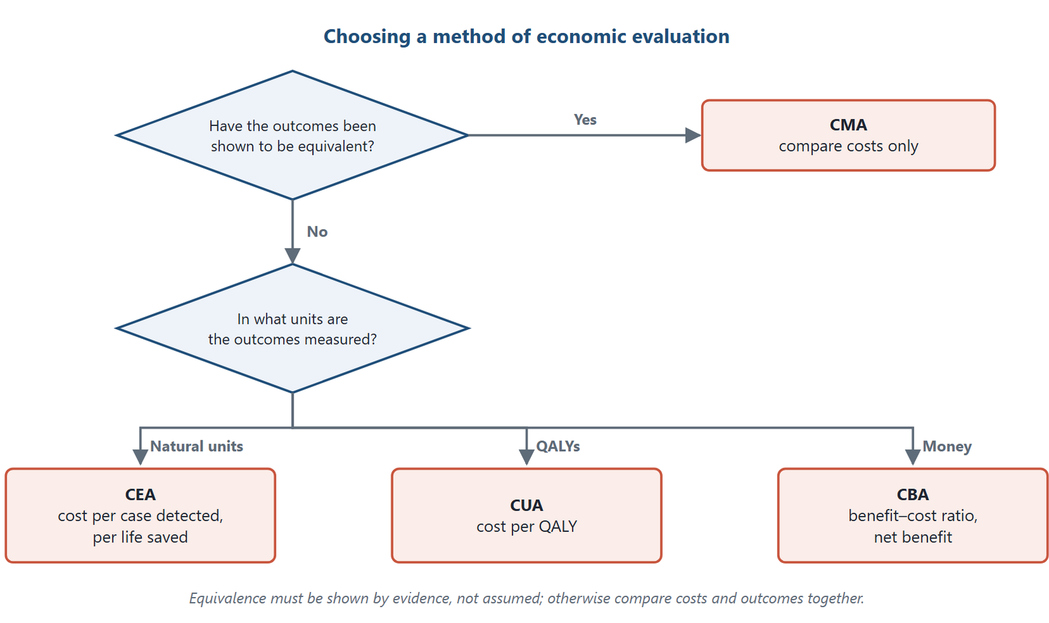
Figure 12.1 Choosing a method of economic evaluation. CMA is used only when equivalent outcomes have been shown; otherwise the unit in which outcomes are measured decides between CEA, CUA and CBA.
Original diagram (original)
Medicine | Strength | Cost (EGP) | Average fall in fasting glucose
1. Metformin, generic brand | 1 g | 18 | 25%
2. Metformin, originator brand | 1 g | 35 | 25%
3. Glimepiride | 1 mg | 27 | 15%

Table 12.2. Three medicines for type 2 diabetes: cost per patient for one month, and effect at the end of that month.
Worked Example
Three medicines for type 2 diabetes
Three tablets, listed in Table 12.2, are compared for lowering fasting blood glucose. The costs and effects are illustrative, and the products are identified by generic descriptions rather than brand names. Costs are per patient for one month of treatment; effects are the average fall in fasting glucose measured at the end of that month. Costs and effects cover the same patients over the same period. Without such a stated basis, an ICER cannot be interpreted.
Question (a): medicines 1 and 2. Same active ingredient, same strength, same effect. If their equivalence has been shown in every relevant outcome, including safety, the right method is CMA, and only cost matters. One equal glucose end point is not proof of equivalence by itself. Medicine 1 is preferred and saves 35 − 18 = 17 EGP.
Question (b): medicines 1 and 3. Same kind of outcome, a fall in glucose, but different sizes. The right method is CEA.
Step 1 — CER of each. Medicine 1: 18 ÷ 25 = 0.72 EGP per percentage point. Medicine 3: 27 ÷ 15 = 1.8 EGP per percentage point.
Step 2 — ICER of medicine 1 over medicine 3. ΔC = 18 − 27 = −9 EGP. ΔE = 25 − 15 = 10 percentage points. ICER = −9 ÷ 10 = −0.9 EGP per percentage point.
Step 3 — locate it on the plane. Medicine 1 costs 9 EGP less and lowers glucose by 10 points more. It falls in the south-east quadrant, so medicine 1 dominates medicine 3.
A common wrong answer. An ICER of −15.36 is sometimes given for this example. The arithmetic gives −0.9. The conclusion, dominance, is right, but it follows from the quadrant: one option is both cheaper and more effective. It does not follow from the negative sign alone.

Key Formula
The ratios of this chapter
$$ICER=\frac{C_{A}-C_{B}}{E_{A}-E_{B}}$$
$$\frac{B}{C}=\frac{\text{total benefits}}{\text{total costs}}NB=B-C$$
$$\text{incremental }\frac{B}{C}=\frac{B_{A}-B_{B}}{C_{A}-C_{B}}$$

12.4 Cost-Benefit Analysis
Cost-benefit analysis values both costs and benefits in money. It gives three results: each option's own benefit–cost ratio, its net benefit, and the incremental ratio between options. They answer different questions.
Before computing an incremental ratio, order the options by increasing cost, so that the incremental cost is positive, and remove any option that is dominated. With the order reversed, the sign of the ratio misleads, just as a negative ICER can. Where signs are awkward, compare net benefits instead.
The decision rules for a benefit–cost ratio are:
- greater than 1 — benefits exceed costs: a net gain;
- equal to 1 — benefits equal costs: break-even;
- less than 1 — costs exceed benefits: a net loss.
Net benefit gives the same verdict in money: positive, zero or negative.
Cost item | Treatment A | Treatment B
Doctor visits | 10 | 15
Intravenous supplies | 5 | 7
Medicine | 30 | 20
Transport | 15 | 40
Total cost | 60 | 82

Table 12.3. Costs of treatments A and B, in US dollars.
 | Treatment A | Treatment B
Total benefits | 30 | 35

Table 12.4. Benefits of treatments A and B, in US dollars.
Worked Example
Two treatments compared by CBA
Two treatments have the costs and benefits in Tables 12.3 and 12.4, in US dollars (USD). Each option's costs and benefits are measured against no treatment, whose cost and benefit are taken as zero; this baseline is what gives each option's own ratio a meaning.
Step 1 — totals. Cost of A = 10 + 5 + 30 + 15 = USD 60. Cost of B = 15 + 7 + 20 + 40 = USD 82.
Step 2 — each option's own ratio and net benefit. A: B/C = 30 ÷ 60 = 0.50; net benefit = 30 − 60 = −USD 30. B: B/C = 35 ÷ 82 = 0.43; net benefit = 35 − 82 = −USD 47.
Step 3 — the incremental ratio of B over A. (35 − 30) ÷ (82 − 60) = 5 ÷ 22 = 0.23.
Interpretation. The incremental ratio, 0.23, is below 1: moving from A to B costs USD 22 more to gain USD 5 more. The extra cost of B is not justified. Many worked answers stop there, but Step 2 adds a second finding, which rests on the stated baseline of no treatment: against that baseline, neither treatment returns its own cost in money, since both ratios are below 1. If the relevant comparator were current care rather than no treatment, the costs and benefits would have to be measured against it instead. The result may also simply mean the study counted only some benefits. Health gains that were not valued in money are missing, which is common when only direct benefits are measured.

Common Mistake
Reporting only the incremental ratio and calling a treatment "beneficial" or not. The incremental ratio compares two options; each option's own ratio compares it with the baseline its costs and benefits were measured against, usually no treatment, and means nothing unless that baseline is stated. Report both, and say which question each answers.

12.5 A Laboratory Application
Worked Example
Cost per case detected for two screening tests
A public programme screens 1,000 pregnant women for a treatable infection. The figures are illustrative.
Test A, a rapid test: total cost 60,000 EGP; detects 18 cases. Test B, a laboratory method: total cost 90,000 EGP; detects 24 cases.
Step 1 — CERs. A: 60,000 ÷ 18 = 3,333 EGP per case detected. B: 90,000 ÷ 24 = 3,750 EGP per case detected.
Step 2 — ICER of B over A. (90,000 − 60,000) ÷ (24 − 18) = 30,000 ÷ 6 = 5,000 EGP per additional case detected.
Step 3 — interpret. B is more costly and more effective: the north-east quadrant, a trade-off. The question is whether detecting one more case is worth 5,000 EGP to the decision-maker. Comparing 5,000 EGP with the cost of one complication is not enough, because not every extra case detected would have developed a complication, and detected cases also need confirmatory tests and treatment. A sound decision either compares the ICER with an explicit willingness to pay per additional case detected, or models what happens after detection (treatment costs, complications avoided and health gained) to give a cost per QALY or a net benefit. The CERs alone would suggest A, but the decision rests on the incremental comparison.
Sensitivity check. If test B's cost fell to 78,000 EGP, the ICER would be (78,000 − 60,000) ÷ 6 = 3,000 EGP per additional case. The case for B becomes stronger.

Worked Example
Cost per QALY of an imaging strategy
A hospital compares two strategies for patients with a suspected condition, over the patients' remaining lifetime. The figures are illustrative, per patient, already discounted.
Strategy A, current practice: cost 20,000 EGP; 8.00 QALYs. Strategy B, early MRI: cost 26,000 EGP; 8.20 QALYs.
Step 1 — differences. ΔC = 26,000 − 20,000 = 6,000 EGP. ΔE = 8.20 − 8.00 = 0.20 QALY.
Step 2 — incremental cost per QALY. 6,000 ÷ 0.20 = 30,000 EGP per QALY gained.
Step 3 — interpret. B is more costly and more effective: the north-east quadrant. It is cost-effective only if the decision-maker is willing to pay at least 30,000 EGP for one QALY. Choosing the lower average ratio, 2,500 against about 3,171 EGP per QALY, would pick A, but that comparison is invalid: the choice between A and B rests on the ICER of 30,000 EGP per QALY, or on the net benefit at the decision-maker's threshold.

Through Two Lenses
- Medical Laboratory: The screening example shows why laboratories should know cost per case detected, not only cost per test. A cheaper test that misses cases can be the more expensive choice once missed cases are counted. Laboratory staff supply the accuracy data such analyses depend on. - Radiology and Medical Imaging: Imaging decisions are often cost-utility questions, because scans change treatment and quality of life. A costlier scan that avoids unneeded surgery may give more QALYs at an acceptable cost. Imaging staff supply the diagnostic accuracy data such analyses depend on.

12.6 Reporting Honestly
Ethics Check
A laboratory preparing a business case for a new analyser reports only the best-case volume and leaves out the sensitivity analysis. The case looks strong, and the board approves it. When volume falls short, the service loses money and cuts staff. Honest reporting shows the base case, the assumptions and the sensitivity analysis, including the cases where the conclusion changes (Husereau et al., 2022).

In Practice
A hospital committee reviewing two imaging protocols asks for three things before deciding. It wants the perspective of the analysis, the source of every cost and effect, and the result when the most uncertain value changes by a plausible range. These three questions catch most weak economic evaluations.

Egyptian Context
Economic evaluation in Egypt should use local costs in EGP and, where possible, local data on disease and outcomes. As purchasing under the universal health insurance system grows (Arab Republic of Egypt, 2018), laboratories and imaging centres that can document the value of their services will be better placed.

Key Takeaways
- Micro-costing multiplies units by unit costs and sums them; the course of care in Section 12.2 totals USD 437.35.
- Use CMA only when equivalence is shown; use CEA when outcomes differ in size.
- An ICER of −15.36 for the tablet example is a common wrong answer; the correct value is −0.9 EGP per percentage point.
- Dominance comes from the quadrant: cheaper and more effective.
- Report each option's own B/C and net benefit as well as the incremental B/C.
- A B/C ratio above 1 is a net gain, equal to 1 is break-even, below 1 is a net loss.
- Decisions rest on the ICER, tested by sensitivity analysis and reported honestly.

Check Your Understanding
Q1 [LO1] A patient has 6 doctor visits priced at 30 EGP per 2 visits. The cost of the visits is:
A 180 EGP
B 60 EGP
C 90 EGP
D 30 EGP
Q2 [LO1] In the micro-costing example, which resource makes up most of the total cost?
A Doctor visits
B Medicine
C Transport
D Hospital stay
Q3 [LO2] Two brands of the same medicine have demonstrated equivalence in efficacy, safety, adherence and every other relevant outcome, and different prices. The right method is:
A Cost-minimisation analysis
B Cost-effectiveness analysis
C Cost-utility analysis
D Cost-of-illness analysis
Q4 [LO2] Two medicines lower blood glucose by 25% and 15%. To compare them the right method is:
A Cost-minimisation analysis
B Cost-of-illness analysis
C Cost-effectiveness analysis
D No evaluation is possible
Q5 [LO3] Medicine 1 costs 18 EGP for a 25% fall; medicine 3 costs 27 EGP for a 15% fall. The ICER of 1 over 3 is:
A −15.36 EGP per point
B −0.9 EGP per point
C 0.72 EGP per point
D 1.8 EGP per point
Q6 [LO3] An option that is cheaper and more effective than its comparator:
A Dominates
B Is dominated
C Needs a willingness-to-pay threshold
D Falls in the north-west quadrant
Q7 [LO4] A treatment costs 82 and yields benefits of 35. Its own benefit–cost ratio is about:
A 2.3
B 0.23
C 1.0
D 0.43
Q8 [LO4] A benefit–cost ratio of exactly 1 means:
A A net loss
B A net gain
C The analysis is invalid
D Break-even
Q9 [LO5] Test B costs 90,000 EGP and detects 24 cases; test A costs 60,000 EGP and detects 18. The ICER of B over A is:
A 3,750 EGP per case
B 3,333 EGP per case
C 5,000 EGP per additional case
D 30,000 EGP per additional case
Q10 [LO5] Which report of a business case is honest?
A Best-case volume only
B Base case, assumptions and sensitivity analysis
C Only the favourable scenarios
D The conclusion without the costs

Essay Questions
E1. [LO2] Using the three diabetes medicines, explain why CMA suits the comparison of medicines 1 and 2 and CEA suits medicines 1 and 3. Show the ICER calculation and interpret it on the cost-effectiveness plane.
E2. [LO4] Rework the CBA example. Calculate each treatment's B/C and net benefit and the incremental B/C, and explain what each result tells the decision-maker.
E3. [LO5] A laboratory must choose between a cheaper test and a more accurate one. Describe how you would evaluate the choice economically, including perspective, outcomes, costs, method and sensitivity analysis.
Answers and Worked Solutions
Q1. C — 6 ÷ 2 = 3 priced units; 3 × 30 = 90 EGP. Option A multiplies all 6 visits by 30.
Q2. D — The stay costs USD 350 of USD 437.35, 80% of the total.
Q3. A — Equivalence shown in every relevant outcome means only costs differ: CMA. Equivalence in one effect alone would not be enough.
Q4. C — Same kind of outcome in different amounts calls for CEA.
Q5. B — (18 − 27) ÷ (25 − 15) = −9 ÷ 10 = −0.9. Option A is a common wrong answer; options C and D are the CERs.
Q6. A — Cheaper and more effective is the south-east quadrant: the option dominates.
Q7. D — 35 ÷ 82 = 0.43. Option B is the incremental ratio from the example.
Q8. D — Benefits equal costs: break-even. A common wrong rule groups a ratio of 1 with a loss.
Q9. C — (90,000 − 60,000) ÷ (24 − 18) = 30,000 ÷ 6 = 5,000 EGP per additional case. Options A and B are the CERs.
Q10. B — Honest reporting shows the base case, assumptions and sensitivity analysis, including unfavourable results.
E1 — model answer points. Medicines 1 and 2 share ingredient, strength and effect: with equivalence shown, CMA; medicine 1 saves 17 EGP. Medicines 1 and 3 differ in effect: CEA. ICER = (18 − 27) ÷ (25 − 15) = −0.9 EGP per point; medicine 1 is cheaper and more effective, south-east, so it dominates. An answer of −15.36 is an arithmetic error.
E2 — model answer points. Costs 60 and 82. A: B/C 0.50, net benefit −30. B: B/C 0.43, net benefit −47. Incremental B/C 5 ÷ 22 = 0.23. Neither option returns its cost in money; B's extra cost is not justified by its extra benefit; unvalued health gains may be missing.
E3 — model answer points. State the perspective; define outcomes such as cases detected or QALYs; cost tests, confirmatory testing and consequences of missed cases; choose CEA or CUA; compute CERs and the ICER and locate it on the plane; vary uncertain values such as accuracy and price in sensitivity analysis; report all results.

References
Arab Republic of Egypt. (2018). Law No. 2 of 2018 promulgating the Universal Health Insurance System law. Official Gazette. Drummond, M. F., Sculpher, M. J., Claxton, K., Stoddart, G. L., & Torrance, G. W. (2015). Methods for the economic evaluation of health care programmes (4th ed.). Oxford University Press. Husereau, D., Drummond, M., Augustovski, F., de Bekker-Grob, E., Briggs, A. H., Carswell, C., Caulley, L., Chaiyakunapruk, N., Greenberg, D., Loder, E., Mauskopf, J., Mullins, C. D., Petrou, S., Pwu, R.-F., & Staniszewska, S. (2022). Consolidated Health Economic Evaluation Reporting Standards 2022 (CHEERS 2022) statement: Updated reporting guidance for health economic evaluations. BMJ, 376, e067975. https://doi.org/10.1136/bmj-2021-067975

Glossary

4 Ps — Product, price, place and promotion: the four elements of the classic marketing mix (Chapter 4).
7 Ps of services marketing — The four Ps plus people, process and physical evidence, used for services such as tests and scans (Chapter 4).
advertiser — The person or organisation that pays for an advertisement.
Advertising — Paid, non-personal communication by an identified sponsor through media, to inform, persuade or remind an audience.
advertising agency — A firm that plans, creates and manages paid marketing communication for advertisers.
affordable method — Setting a promotion budget at what the organisation can spare.
auction price — A price set by competitive bidding; it may differ sharply from the usual market price.
audience — The target group of an advertisement: the people most likely to need the product.
average cost-effectiveness ratio (ACER) — The total cost of one option divided by its total effect; the same as the CER.
benefit–cost ratio — Total benefits divided by total costs, both in money. Above 1 is a net gain, 1 is break-even, below 1 is a net loss.
Break-even pricing — Pricing that uses the volume at which revenue equals total cost; below it the service loses money.
bundled pricing — Selling several products or services together for one price, as in a check-up package.
catchment area — The area from which a service draws most of its patients.
channel level — The number of intermediaries between producer and consumer in a distribution channel.
Clinical outcomes — Medical events that result from disease or treatment, such as laboratory values, lives saved or disability days avoided.
competitive-parity method — Setting a promotion budget to match competitors' spending.
Consequences — The effects, outputs or outcomes of an intervention in an economic evaluation.
consignment — An arrangement in which the owner (consignor) keeps ownership and risk of goods held and sold by another (consignee) for a commission.
consignment stock — Supplier-owned stock held by an end user, such as reagents in a laboratory, paid for only as it is used.
Controlled prices — Prices with a ceiling set by the state; sellers may charge less but not more.
Convenience products — Products bought often and quickly with little comparison, such as simple painkillers.
Cost — In economic evaluation, the value of the resources an intervention uses.
Cost-benefit analysis — An economic evaluation that values both costs and benefits in money, giving a benefit–cost ratio or net benefit.
Cost-effectiveness analysis — An economic evaluation that compares options with the same kind of outcome, measured in natural units such as cases cured.
cost-effectiveness plane — A graph with the difference in effect on one axis and the difference in cost on the other; its quadrant shows dominance or a trade-off.
cost-effectiveness ratio (CER) — The cost of one option divided by its effect.
cost-effectiveness threshold — The most a decision-maker is willing to pay for one unit of effect, usually one QALY.
Cost-minimisation analysis — An economic evaluation that compares only costs, used when outcomes have been shown to be equivalent.
Cost-of-illness analysis — A descriptive study of the total economic burden of a disease. It compares no interventions, so it is not a full economic evaluation, but it gives a baseline.
Cost-plus pricing — Setting a price by adding a percentage markup to the full cost per unit.
Cost-utility analysis — An economic evaluation that measures outcomes in quality-adjusted life years.
cost-utility ratio — Cost per QALY. The average ratio of one option only describes it; decisions use the incremental cost-utility ratio, ΔC ÷ ΔQALYs between options, after checking for dominance and against a threshold.
Customer value — Perceived customer benefit minus total customer cost, where cost includes money, time, effort and anxiety.
decider — The person who chooses a product or service; in health care often a professional.
decline stage — The stage of the product life cycle marked by a long-run fall in sales.
Deletion — Dropping a declining product from the line; the most drastic decline strategy.
demand — A want backed by the ability and willingness to pay.
digital channel — Any online route by which an organisation reaches its audience, such as search, websites, social media, email or apps.
Digital marketing — Promotion of brands and services through the internet and other digital communication; also called online marketing.
Direct medical costs — Resources used to prevent, diagnose or treat disease: medicines, tests, professional time, hospital stay and supplies.
Direct non-medical costs — Costs that result from illness but are not medical services, such as transport, lodging and special food.
Discount pricing — Charging less than competitors to attract price-sensitive customers.
discount rate — The yearly rate used in discounting future costs and outcomes.
Discounting — Converting future costs and outcomes to their value today, so options with different timings can be compared.
Distribution — Planning, organising and controlling the movement of products from where they are made to where they are used.
distribution channel — The set of firms or individuals that take ownership of a product, or help transfer it, from producer to consumer.
Durable goods — Goods that survive many uses over a long time, usually three years or more.
Earned media — Coverage an organisation does not pay for or control, such as reviews, shares and news.
ECHO model — The grouping of outcomes into economic, clinical and humanistic kinds.
Economic outcomes — Changes in resource use and money that result from an intervention, such as savings or production regained.
elastic — Describes demand whose percentage change exceeds the percentage change in price (absolute elasticity above 1).
exchange — Obtaining something of value by offering something in return.
fail points — The steps of a service where it most often goes wrong, such as sample labelling or safety screening.
Fixed costs — Costs that do not change with volume in the short run, such as rent and equipment leases.
Fixed prices — Prices set by a state body that the seller cannot change, such as the official public prices of registered medicines in Egypt.
foregone earnings approach — Another name for the human capital approach to valuing lost productivity.
Free prices — Prices set by agreement between buyer and seller through supply and demand, without state intervention.
friction period — The time until a sick worker is replaced or output is otherwise restored; the friction cost approach values lost production only over this period.
Functional value — What an offering does for the customer: the solution it provides.
Going-rate pricing — Charging about what competitors charge.
good — A physical product made for sale to satisfy a need.
growth stage — The stage of the product life cycle in which sales rise quickly and competitors enter.
Harvesting — Keeping a declining product while cutting its marketing support.
Health economics — The study of how scarce resources are allocated to produce health and health care.
health-related quality of life (HRQOL) — The effect of health and treatment on a person's physical, social and emotional well-being.
healthcare market — The set of patients, professionals, organisations and payers who exchange health goods and services.
heuristic — A mental shortcut used in choosing, such as buying what the family has always used.
hub-and-spoke — A network with one central facility and many small collection or service points.
Humanistic outcomes — The effects of disease or treatment on a patient's function, well-being and quality of life.
in-vitro diagnostic (IVD) devices — Medical devices, such as reagents and analysers, that their manufacturer intends for examining specimens from the human body to give information for diagnosis, monitoring or screening.
Incremental cost — The additional cost of one option compared with another.
incremental cost-effectiveness ratio (ICER) — The difference in cost between two options divided by the difference in their effects.
Indirect costs — The value of lost productivity: morbidity cost plus mortality cost.
inelastic — Describes demand whose percentage change is smaller than the percentage change in price (absolute elasticity below 1).
influencer — A person who shapes a choice without making it, such as a relative or pharmacist.
information asymmetry — A gap in knowledge between provider and customer; in health care the patient usually knows less.
inputs — The resources an intervention uses, measured as costs.
Intangible costs — Non-financial burdens of disease and care, such as pain, suffering and anxiety.
intermediaries — Channel members between the producer and the final customer.
introduction stage — The stage of the product life cycle after launch, when acceptance is uncertain and sales grow slowly.
key opinion leaders — Respected clinicians and scientists whose views shape colleagues' practice.
law of demand — Other things equal, the quantity demanded falls as the price rises.
line of visibility — In a service blueprint, the line separating the staff actions the customer sees from those behind the scenes.
market — The set of actual and potential buyers of a product.
market segmentation — Dividing a market into groups of buyers who respond differently to marketing, including price.
Marketing — The activity, institutions and processes for creating, communicating, delivering and exchanging offerings of value for customers and society.
Marketing communications — The means by which an organisation informs, persuades and reminds its market.
marketing mix — The set of controllable tools an organisation uses to reach its market.
marketing orientation — An approach that starts from customers' needs and builds the offering around them.
markup — An amount added to cost, expressed as a percentage of cost; a margin is the same amount expressed as a percentage of the price.
maturity stage — The stage of the product life cycle in which sales growth slows, competition peaks and prices fall.
media — The channels that carry messages, such as print, broadcast, outdoor and online media.
medical device — An instrument, apparatus, material or other article for diagnosis, prevention, monitoring or treatment that does not act mainly by pharmacological means.
medicine — A substance in a dosage form intended to treat, prevent or diagnose disease, or to modify physiological functions.
Micro-costing — Building a total cost from the units of each resource used times their unit costs.
Monetary value — The price paid relative to the perceived worth of an offering.
morbidity cost — Earnings or production lost because of illness.
mortality cost — Production lost because of premature death.
need — A state of felt deprivation, such as the need for a diagnosis.
net benefit — Total benefits minus total costs, in money.
Non-durable goods — Goods used once or over a short time, such as reagents and most medicines.
objective-and-task method — Setting a promotion budget by costing the tasks needed to reach the campaign's objective.
opinion leader — A person whose views influence others.
Opportunity cost — The value of the best alternative use of the resources actually used.
outcomes — The health and economic consequences of an intervention.
outcomes research — Research that measures economic, clinical and humanistic outcomes.
Owned media — Channels an organisation controls, such as its own website, app and accounts.
Paid media — Advertising space an organisation buys, such as search or social-media advertisements.
payer — The party that funds a product or service: patient, insurer, employer or state.
Penetration — A pricing strategy that sets a low entry price to gain share quickly.
People — In the services mix, everyone who meets the customer during the service.
percentage-of-sales method — Setting a promotion budget as a fixed share of revenue.
Personal selling — Face-to-face presentation to buyers, such as a representative's visit to a doctor.
Perspective — Whose costs and consequences an economic evaluation counts: patient, provider, payer or society.
Pharmaceutical marketing — The part of health-care marketing concerned with medicines, directed at professionals and, within limits, consumers.
pharmaceutical warehouse — A licensed establishment that stores medicines and supplies them wholesale.
pharmacoeconomic evaluation — Any study that assesses the costs and consequences of alternative therapies.
Pharmacoeconomics — The branch of health economics that analyses the costs and consequences of medicines and drug therapy.
Physical evidence — In the services mix, the tangible signs of an intangible service: setting, equipment, reports and certificates.
Place — The element of the mix concerned with how a product reaches its customers.
Premium pricing — Charging more than competitors, justified by better service or a stronger brand.
present value — The value today of a future cost or outcome: F ÷ (1 + r) to the power t.
Price — The amount of money charged for a product; time, travel and effort are separate, non-money parts of the total customer cost.
Price elasticity of demand — The percentage change in quantity demanded divided by the percentage change in price.
price policy — An organisation's set of rules for determining and managing prices.
primary demand — Demand for a product category rather than for one brand.
Process — In the services mix, the steps a customer goes through to receive the service.
product — Anything offered to satisfy a need or want, whether a good or a service.
product life cycle (PLC) — The pattern of sales and profit of a product over time: introduction, growth, maturity and decline.
product orientation — An approach that assumes customers want the highest quality, sometimes beyond what they value.
production orientation — An approach that assumes customers want what is cheap and available, and focuses on efficiency.
Promotion — The element of the mix concerned with communication: advertising, public relations, personal selling and sales promotion.
Psychological value — How far a product helps customers feel better or express themselves.
Public relations — Building goodwill and reputation through news, community activity and information.
pull strategy — Promotion aimed at final customers, whose demand pulls the product up the channel.
push strategy — Promotion aimed at channel members, each of whom pushes the product to the next.
Quality — In health care, technical quality (a correct result) and functional quality (how the service is delivered).
quality-adjusted life year (QALY) — A measure combining length and quality of life: years of life times utility.
relationship — A long-term, trusting link between an organisation and its customer.
Retail prices — Prices at which goods are sold to the public.
Retail trade — Selling goods and services to final consumers for personal use.
Sales promotion — Short-term incentives to encourage purchase, such as samples, coupons and discounts.
Satisfaction — The customer's judgement of whether a service met expectations.
Search engine optimisation (SEO) — Making a website easier for search engines to find and rank, mainly through clear and useful content.
selective demand — Demand for one brand rather than for the product category.
selling orientation — An approach that assumes customers will not buy enough unless pushed.
Sensitivity analysis — Recalculating a result with different plausible values to see whether the conclusion changes.
service — An act or performance offered to another; it tends to be intangible, its capacity cannot be stored, and the customer usually takes part in producing it.
service blueprint — A diagram of every step a customer takes through a service, with the staff actions and support processes behind each step.
Shopping products — Products compared on quality, price and suitability before purchase.
Skimming — A pricing strategy that sets a high entry price and lowers it over time.
Social value — How far using a product connects the customer with others.
societal marketing orientation — A marketing orientation that also protects the long-term interest of society; the most appropriate one for health services.
Specialty products — Products with unique features for which buyers make a special effort.
stock exchange quotation — The price of goods or securities traded on an exchange.
supplier-induced demand — Demand created when a provider who advises also sells, and recommends more than is needed.
Tariffs — Prices for services, such as a schedule of fees for tests or scans.
teleradiology — Sending images electronically to radiologists elsewhere for reporting.
tenders — Sealed competitive bids by suppliers to provide goods or services to a stated specification.
Through Two Lenses — The box in every chapter that applies the chapter's idea to the medical laboratory and to radiology and medical imaging.
Traditional marketing — Marketing through print, broadcast, outdoor signs, direct mail and personal visits.
unique selling proposition (USP) — A true and relevant benefit that competitors do not offer.
Unsought products — Products buyers do not know about or do not think of buying, such as many screening tests.
user — The person who receives or uses a product or service; in health care, the patient.
utility — A number valuing a health state, where 1 is full health and 0 is death; some instruments allow values below 0 for states judged worse than death.
Value-based pricing — Setting a price from the value a product creates for the customer.
Variable costs — Costs that rise with each unit produced, such as reagents and disposables.
want — The form a need takes, shaped by culture and experience.
Wholesale prices — Prices at which producers sell to firms and organisations.
world market price — The price recognised in international trade for a commodity.

