**Registration System Proposal**

David Lambertson

Jacob Bowser

Kevin Johnson

Shawn Sandberg

**Contents**

Executive Summary……………………………………………………………...…………Page 3

Summary of the entire proposal

Problem Statement……………………………………………………………..……………Page 5

The current registration system issues

Objectives…………………………………………………………………....………………Page 7

The integration of Grad Planner and the registration system

Plan………………………………………………………………………………….……….Page 9

Outline of tasks and their time frames

Budget………………………………………………………………...……….……..…….Page 10

Costs of equipment and labor

Personnel and Qualifications…………………………………………....……………...…..Page 11

Education and experience

Facilities and Equipment………………………………………….…………....……..........Page 12

Required materials

Sources……………………………………………………………………………………..Page 13

**Executive summary:**

The registration system at Brigham Young University-Idaho (BYU-Idaho) is confusing and time consuming. Rather than trying to fix an outdated system, we propose to improve the registration system at BYU-Idaho by creating a streamlined system, that will be linked with students’ information from Grad Planner. The new system will use the information from Grad Planner to suggest multiple different schedule options that the student could use. This will make the entire registration system much simpler to use and will help students stick to what’s in Grad Planner to graduate faster, saving precious tithing funds. This will save a lot of time for the students who are registering as well as the employees at the Registration department, IT department, and the Help Desk who handle the calls from frustrated students. The environment of the school during registration will become more wholesome for both students and employees by reducing the stress levels of everyone involved. The programming and implementation of the improved registration system will take approximately three months. The total budget is estimated to be $150,000.

1. **Introduction**
   1. The Problem

The registration process is frustrating for students to use because it is time-consuming and confusing. It creates stress for both students and employees every time registration comes around because of the extra amount of work it adds on to the students’ and employees’ already busy schedule.

* 1. The Solution

The new registration system will help BYU-Idaho make the registration process user-friendly by linking the registration system to the Grad Planner. Then it will use the grad plan of the students to offer options for previously planned schedules, therefore making the registration process more efficient and simpler. This will also cut down on time that the students and employees would be using during registration.

* 1. Why is it important?

The significant decrease of stress and frustration on campus will help to uphold and maintain the fourth part of BYU-Idaho’s mission statement, which is “maintain a wholesome academic… environment”.

* 1. Organization

Problem Statement: The current registration system issues

Objectives: The integration of Grad Planner and the registration system

Plan: Outline of tasks and their time frames

Budget: Costs of equipment and labor

Personnel and Qualifications: Education and experience

Facilities and Equipment: Required materials

1. **Problem Statement**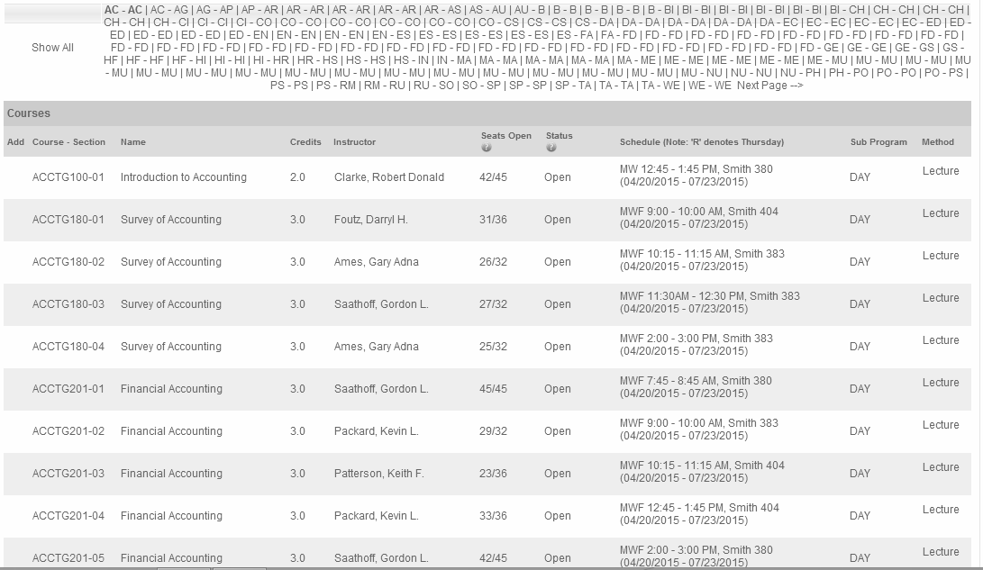

*Figure 1*

*The current registration system*

2.1. The current registration system is overwhelming

The current registration system is difficult to use. As shown in Figure 1, the registration system is overwhelming. The students who are registering have a difficult time getting through all the required steps. They have to do research to find what classes are offered during the specific semester for which they are registering. They then have to figure out which classes work for their schedule. Finally, they have to find those classes in the catalogue one at a time sifting through hundreds of other classes to find and register for them. This makes the registration process a very time-consuming procedure. The students currently attending school already have to deal with papers, projects, and assignments from their current classes. Those off-track are generally dealing with an internship or a full-time job. Both students currently attending classes and those off-track do not want to deal with the anxiety and stress that the registration process adds onto their already stressful schedules.



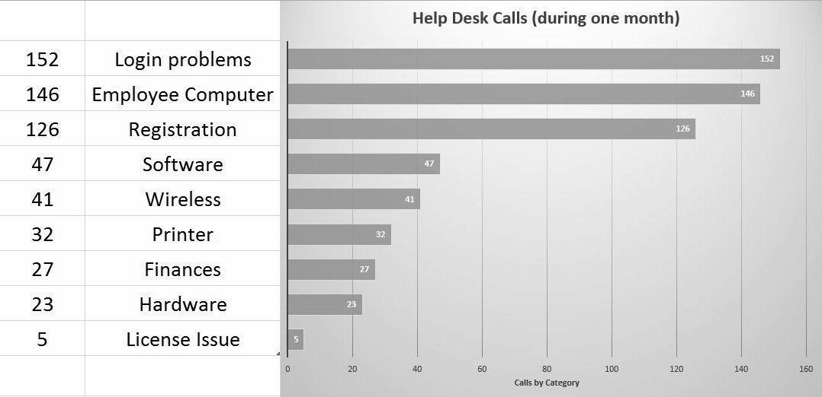

*Figure 2*

*Chart of calls to the Help Desk during a one month period*

2.2. The current registration system is expensive

These problems lead to hundreds of calls each year from students to the Help Desk, the Online Support Center, the Registration department, and the advisors for each department creating more work for school employees an example of this can be seen inFigure 2. Each semester registration is one of the most frequent issues the Help Desk addresses. During the registration period each of these departments has extended hours increasing the time that the employees work, leading to greater expenses for the school.

Without the guide of a Grad Planner, students do not have a structure to help them choose which classes they should take for the semester. This prevents them from graduating on time which will thus waste tithing funds, as well as the students’ time and the university’s.

The increased stress and time required by both students and employees that the registration process causes, leads to a very unwholesome environment. This directly conflicts with the mission statement of BYU-Idaho: “maintain a wholesome academic… environment”.

1. **Objectives**
   1. Integration of systems

The first objective is to recognize the format that the Grad Planner stores all the information in, so that it can recognize how to best read it into our improved registration system. Using a database, we will then assign each semester a unique ID such as Wi15, Sp15, Su15, and Fa15, where the first two letters are the semester and the last two numbers are the year. It will then assign the course ID to each class along with that class's section number. Each class within the Grad Planner will be assigned the same ID's. 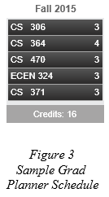

With the information in the Grad Planner and the registration system data both uniform, we then read in the data from both systems. The new registration system will take the desired course list, as seen in Figure 3, that the student has previously planned for within the Grad Planner. It will find those courses within the registration system to check for the availability, which days of the week, and the time of day these courses are offered. The new registration system will then take the students desired course list and will formulate different schedules, depending on the available courses offered and all possible situations. The student will have access to view different options available, allowing the student choose the optimal schedule. An example of this kind of system can be seen in Figure 4. Once the student has found the optimal schedule, the student will then be able to select the "register for selected classes" button and will then be enrolled in these classes for the selected schedule.

In addition, the system will still allow students to make single changes to their schedules through a functional and simple to use search system.

*Figure 4* 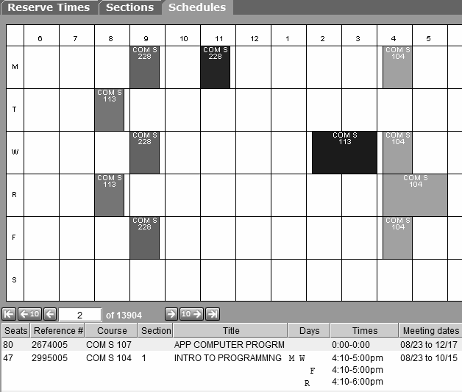

*Example of the new registration system*

* 1. Simplify registration searches

We would only have the necessary input for the search. Items such as class name or number would suffice and greatly simplify the searches. It would search class names or their ID numbers and return those that contain the given parameters.

1. **Plan**
   1. Week One: Setup workstations and become familiar with the current set up and how to use current data to most effectively use our time and code to accommodate the new system. Begin programming the new registration system. We will give our weekly progress report to registration IT.
   2. Week Two: Setup complete, begin linking classes in the Grad Planner with those in the registration system. Continue writing code for the new registration system, weekly progress report to registration IT.
   3. Week Three: Begin user interface for the system and designing graphics, weekly progress report to registration IT.
   4. Week Four: Organize all code and graphics into single interface, prepare for debugging, weekly progress report to registration IT.
   5. Week Five and Six: Debug system and iron out kinks in the new registration system, weekly progress report to registration IT.
   6. Week Seven: Begin alpha testing, crush the remaining bugs, weekly progress report to registration IT.
   7. Week Eight: Finish alpha testing and begin beta testing, weekly progress report to registration IT.
   8. Week Nine and Ten: Continue beta testing, stress testing, exploit any possible flaws or issues that may occur, create tutorials and provide training on how to use the new system, weekly progress report to registration IT.
   9. Week Eleven: Stop beta testing, full system launch, deactivate old registration system and redirect to new and improved system, weekly progress report to registration IT.
   10. Week Twelve:Pack up workstations and move out, final progress report to registration IT.

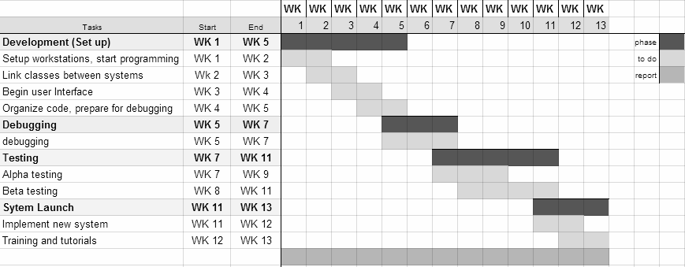

*Figure 5*

*Gantt Chart*

1. **Budget**

Overall budget: The budget for the entire project will be a total of $150,000. This breaks down into two main sections of our budget: equipment and personnel pay.

* 1. Equipment budget

The equipment that is required for this project includes computers and servers along with all the cables needed for them. The school already has the servers in place but the computers will be needed for the programming, implementation, and support. Overall, purchasing about a half a dozen computers, it will cost $9,000. The cables would be on a needed basis but having close to $3,000 allotted for this expense would bring the total cost of equipment to $12,000.

* 1. Personnel budget

For personnel pay, the absolute is $126,720 for the four people leading the project. Working eight hours a day, for five days a week the pay would be about $66 per hour. The project is planned around a twelve week schedule from start to finish. The surplus $11,280 would be for the developer that we would counsel with and receive support from, in the registration IT department.

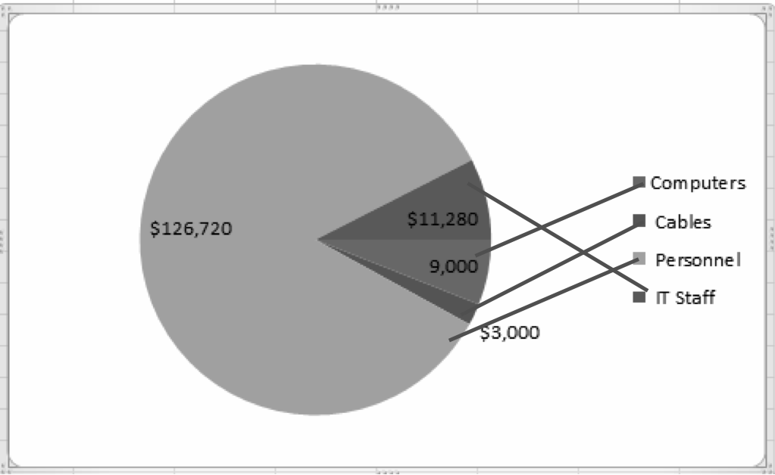

*Figure 6*

*Budget Chart*

1. **Personnel Qualifications**
   1. Experience

Together the team has over 7 years of experience in programming and is well suited to the task at hand.

* 1. Specific qualifications

David - HTML5, CSS, Java, JavaScript, C++, XML, PHP, and databases.

Jacob - C++, HTML, CSS and JavaScript.

Kevin - C++, Java, HTML5, CSS, JavaScript and PHP.

Shawn - C++, and electrical designs.

* 1. These qualifications are beneficial because we will be working with the server side of web data. This is done through programming using C++, PHP and Java. We also need an understanding of HTML5 so we can interact with the client side of registration.

1. **Facilities and Equipment**
   1. Computers

The team will need workstation computers on campus for secure access to the registration system and for the supporting IT member.

* 1. Server

The server will hold the registration information gathered from the registration system. The server will need to be able to handle the population of the school accessing it over the registration period.

* 1. Access to the application of Grad Planner

The project will connect directly to Grad Planner through an application program interface(API) provided by the IT staff. This will allow the creation of class schedules using what has been approved by the university.

* 1. Registration IT staff

A member of the school’s registration IT staff will be needed in order to help familiarize the team with the functionality of the registration system and provide the APIs necessary to complete the project.

* 1. Access to the registration system

By allowing access directly to the registration system, the team can pull the required information for all the course data and the available seats in each class.

**Sources:**

Figure 1 - https://my.byui.edu/ICS/Academics/Academic_Information.jnz?

portlet=Registration&screen=Add+Drop+Courses+BYUI&screenType=next

Figure 2 - Shawn Sandberg -Data from BYU-Idaho’s Help Desk Team Dynamix report

http://td.byui.edu/TDNext/Home/Desktop/Default.aspx

Figure 3 - https://web.byui.edu/gradplan/

Figure 4 - http://planner.iastate.edu

Figure 5 - Gantt chart - Jacob Bowser

Figure 6 - Budget Chart - David Lambertson