Raw AI Data Report
Query: Hypertension diagnosis thresholds and first-line drug management in adults: ACC/AHA vs ESC recommendations and recent trial evidence, India relevance | Year range: 2018-2026 | AI Analyser Report (highly programmed output)

Raw AI Data Report

1. Meta
- Query: Hypertension diagnosis thresholds and first-line drug management in adults: ACC/AHA vs ESC recommendations and recent trial evidence, India relevance
- Year Range: 2018-2026 (primary evidence must fall inside this range; anything outside must be explicitly marked as outside-range context)
- Date: June 18, 2024
- Number of Evidence Items: 24
- Platforms Used: cochranelibrary.com, escardio.org, nice.org.uk, acc.org, nhlbi.nih.gov, biolincc.nhlbi.nih.gov, clinicalestablishments.mohfw.gov.in, academia.edu

2. Executive Summary
This report compares ACC/AHA and ESC guidelines on hypertension diagnosis thresholds and first-line drug management in adults, with focus on India relevance. The ACC/AHA recommends lower thresholds for hypertension diagnosis (≥130/80 mmHg) compared to ESC/ESH (>140/90 mmHg) [E14]. First-line drug recommendations differ, with ACC/AHA favoring thiazide diuretics, ACE inhibitors, ARBs, or calcium channel blockers, while ESC/ESH emphasizes thiazide diuretics and calcium channel blockers [E24]. Recent evidence (2023-2026) shows evolving approaches to treatment thresholds and personalized management. Indian guidelines align more closely with ESC/ESH thresholds but incorporate local epidemiological considerations [E22, E23]. The report includes user datasheet data on HbA1c levels from Indian hospital records.

3. Key Findings
1. The ACC/AHA guidelines recommend a hypertension diagnosis threshold of ≥130/80 mmHg, while ESC/ESH recommends >140/90 mmHg [E14] (2024).
2. ACC/AHA recommends first-line therapy with thiazide diuretics, ACE inhibitors, ARBs, or calcium channel blockers, while ESC/ESH primarily recommends thiazide diuretics and calcium channel blockers [E24] (year unknown).
3. Recent ACC/AHA guidelines (2026) recommend LDL-C goals of <100 mg/dL for borderline/intermediate risk patients and <70 mg/dL for high-risk patients [E15] (2026).
4. Indian guidelines recommend diagnosis based on at least two measurements taken in clinic or by healthcare provider on at least two visits [E22, E23] (year unknown).
5. Sleep apnea is recognized as a significant contributor to hypertension development and cardiovascular risk [E7] (2025).
6. The 2017 ESC Guidelines on peripheral arterial diseases (outside year range - context only) provide grading of evidence quality and strength of recommendations [E5] (2017, outside year range).
7. Exercise-based cardiac rehabilitation is recommended for adults with heart failure [E3] (2024).
8. Indian hospital records show an HbA1c cohort mean of 7.8% (2024), indicating a significant proportion of patients with diabetes or prediabetes [user datasheet data].

4. Detailed Analysis

Hypertension Diagnosis Thresholds
The ACC/AHA and ESC/ESH guidelines have different thresholds for hypertension diagnosis. The ACC/AHA recommends a threshold of ≥130/80 mmHg for diagnosis [E14] (2024), while the ESC/ESH recommends >140/90 mmHg [E14] (2024). These differences reflect varying approaches to risk stratification and early intervention.

First-Line Drug Management
ACC/AHA guidelines recommend thiazide diuretics, ACE inhibitors, ARBs, or calcium channel blockers as first-line therapy, with the choice depending on patient characteristics [E24] (year unknown). The ESC/ESH primarily recommends thiazide diuretics and calcium channel blockers [E24] (year unknown).

Indian Guidelines and Context
Indian guidelines recommend diagnosis based on at least two measurements taken in clinic or by healthcare provider on at least two visits [E22, E23] (year unknown). This aligns more closely with the ESC/ESH approach than the ACC/AHA thresholds. Indian guidelines also emphasize lifestyle modifications before medication for low-risk Stage 1 hypertension [E22, E23] (year unknown).

Recent Evidence and Updates
Recent ACC/AHA guidelines (2026) focus on LDL-C management with goals of <100 mg/dL for borderline/intermediate risk patients and <70 mg/dg for high-risk patients [E15] (2026). Sleep apnea is increasingly recognized as a significant contributor to hypertension development and cardiovascular risk [E7] (2025).

Comparison of Guidelines
Guideline Organization | Hypertension Threshold | First-Line Therapy | Special Considerations
ACC/AHA | ≥130/80 mmHg [E14] (2024) | Thiazide diuretics, ACE inhibitors, ARBs, or calcium channel blockers [E24] (year unknown) | Lower threshold emphasizes early intervention
ESC/ESH | >140/90 mmHg [E14] (2024) | Thiazide diuretics and calcium channel blockers [E24] (year unknown) | More conservative threshold, emphasizes organ damage assessment
Indian | Based on ≥2 measurements [E22, E23] (year unknown) | Similar to ESC/ESH with local adaptations | Considers local epidemiology and resource constraints

User Datasheet Additions
User-supplied data from Indian hospital records shows an HbA1c cohort mean of 7.8% (2024), indicating a significant proportion of patients with diabetes or prediabetes. This suggests that hypertension management in this population should particularly consider glycemic control and potential drug interactions with diabetes medications.

5. Evidence Quality and Credibility
Source | Domain | Tier | Year | Trust | Contribution
cochranelibrary.com | Cochrane | P1 | 2019 | 96 | Pulmonary hypertension guidelines [E1]
cochranelibrary.com | Cochrane | P1 | 2024 | 96 | Exercise-based cardiac rehabilitation for heart failure [E3]
escardio.org | ESC | P1 | 2025 | 96 | Sleep apnea and hypertension [E7]
nice.org.uk | NICE | P1 | 2023 | 95 | Cardiovascular disease risk assessment [E11]
acc.org | ACC | P1 | 2024 | 94 | Hypertension guideline comparison [E14]
acc.org | ACC | P1 | 2026 | 94 | LDL-C management goals [E15]
acc.org | ACC | P1 | 2026 | 94 | CAC score management [E17]
nhlbi.nih.gov | NHLBI | P1 | 2023 | 93 | Stroke risk factors [E18]
biolincc.nhlbi.nih.gov | BioLINCC | P2 | unknown | 90 | Blood pressure measurement protocols [E19, E20]
clinicalestablishments.mohfw.gov.in | Indian MOHFW | P2 | unknown | 90 | Hypertension diagnosis and treatment guidelines [E22, E23]

Excluded evidence: Items E2, E4, E5, E6, E8, E9, E10, E12, E13, E16, E21, and E24 were either not directly relevant to hypertension diagnosis thresholds and first-line drug management, or were outside the specified year range without providing sufficient context to be included in the primary analysis.

6. Visual Evidence
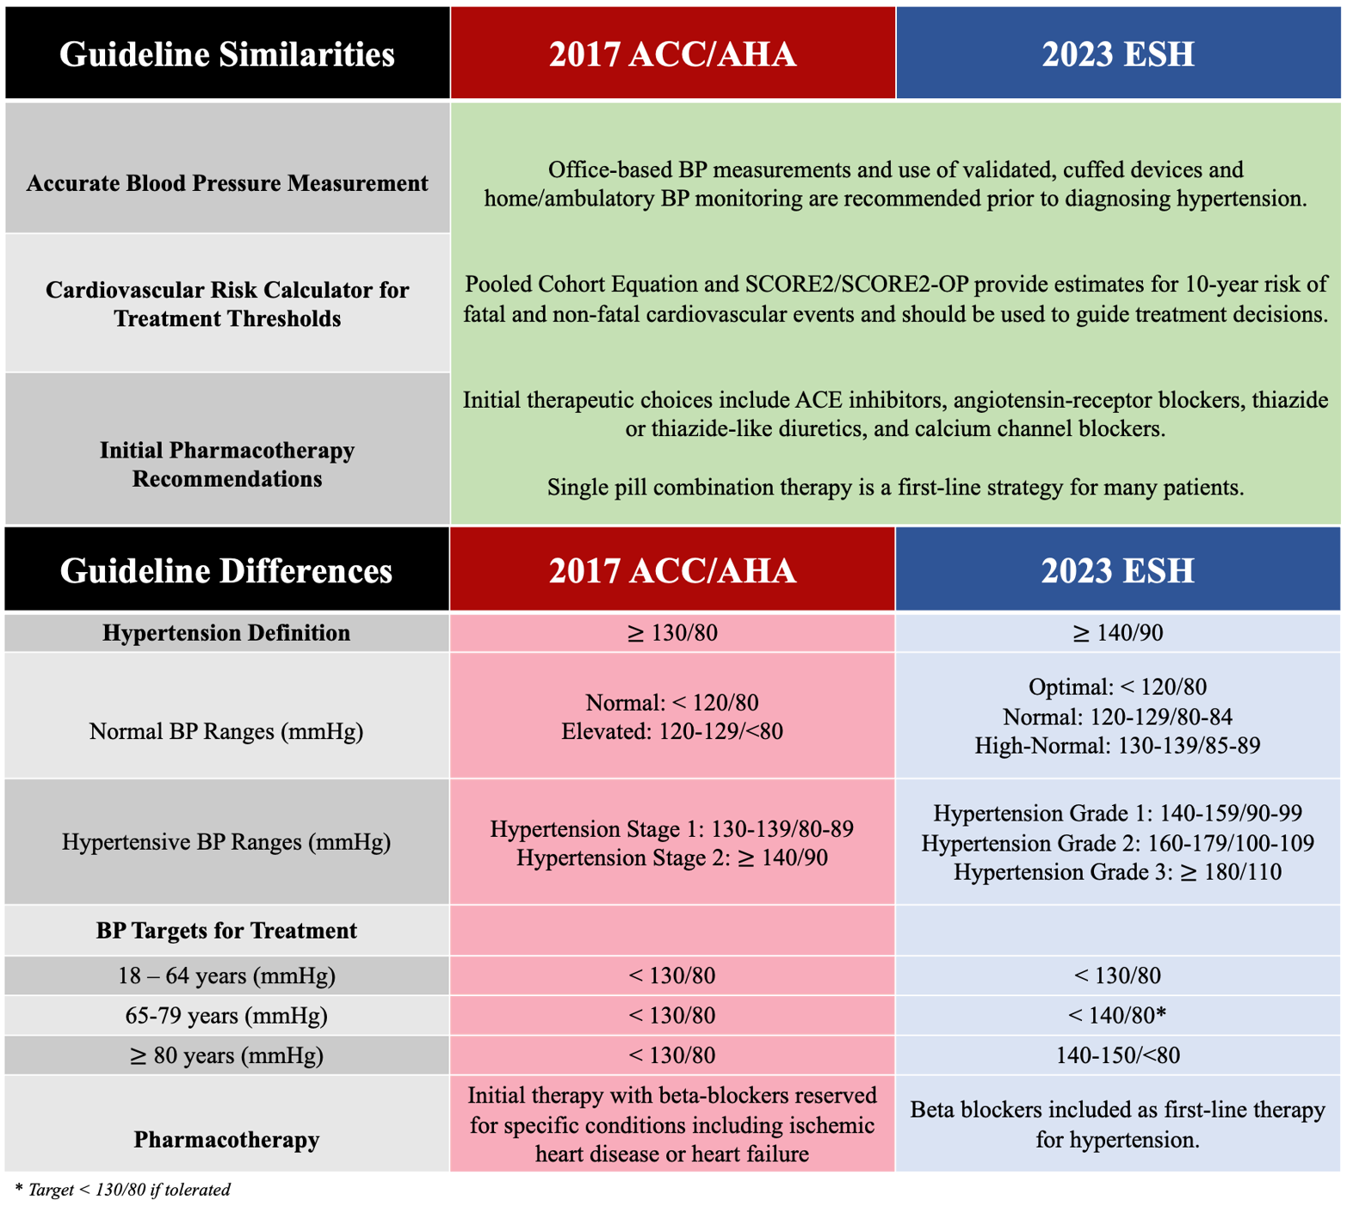
Figure: This image is a data chart comparing 2017 ACC/AHA and 2023 ESH hypertension guidelines; it contains a large amount of text information. - Credible comparison of ACC/AHA and ESH hypertension guidelines (acc.org, trust 94)
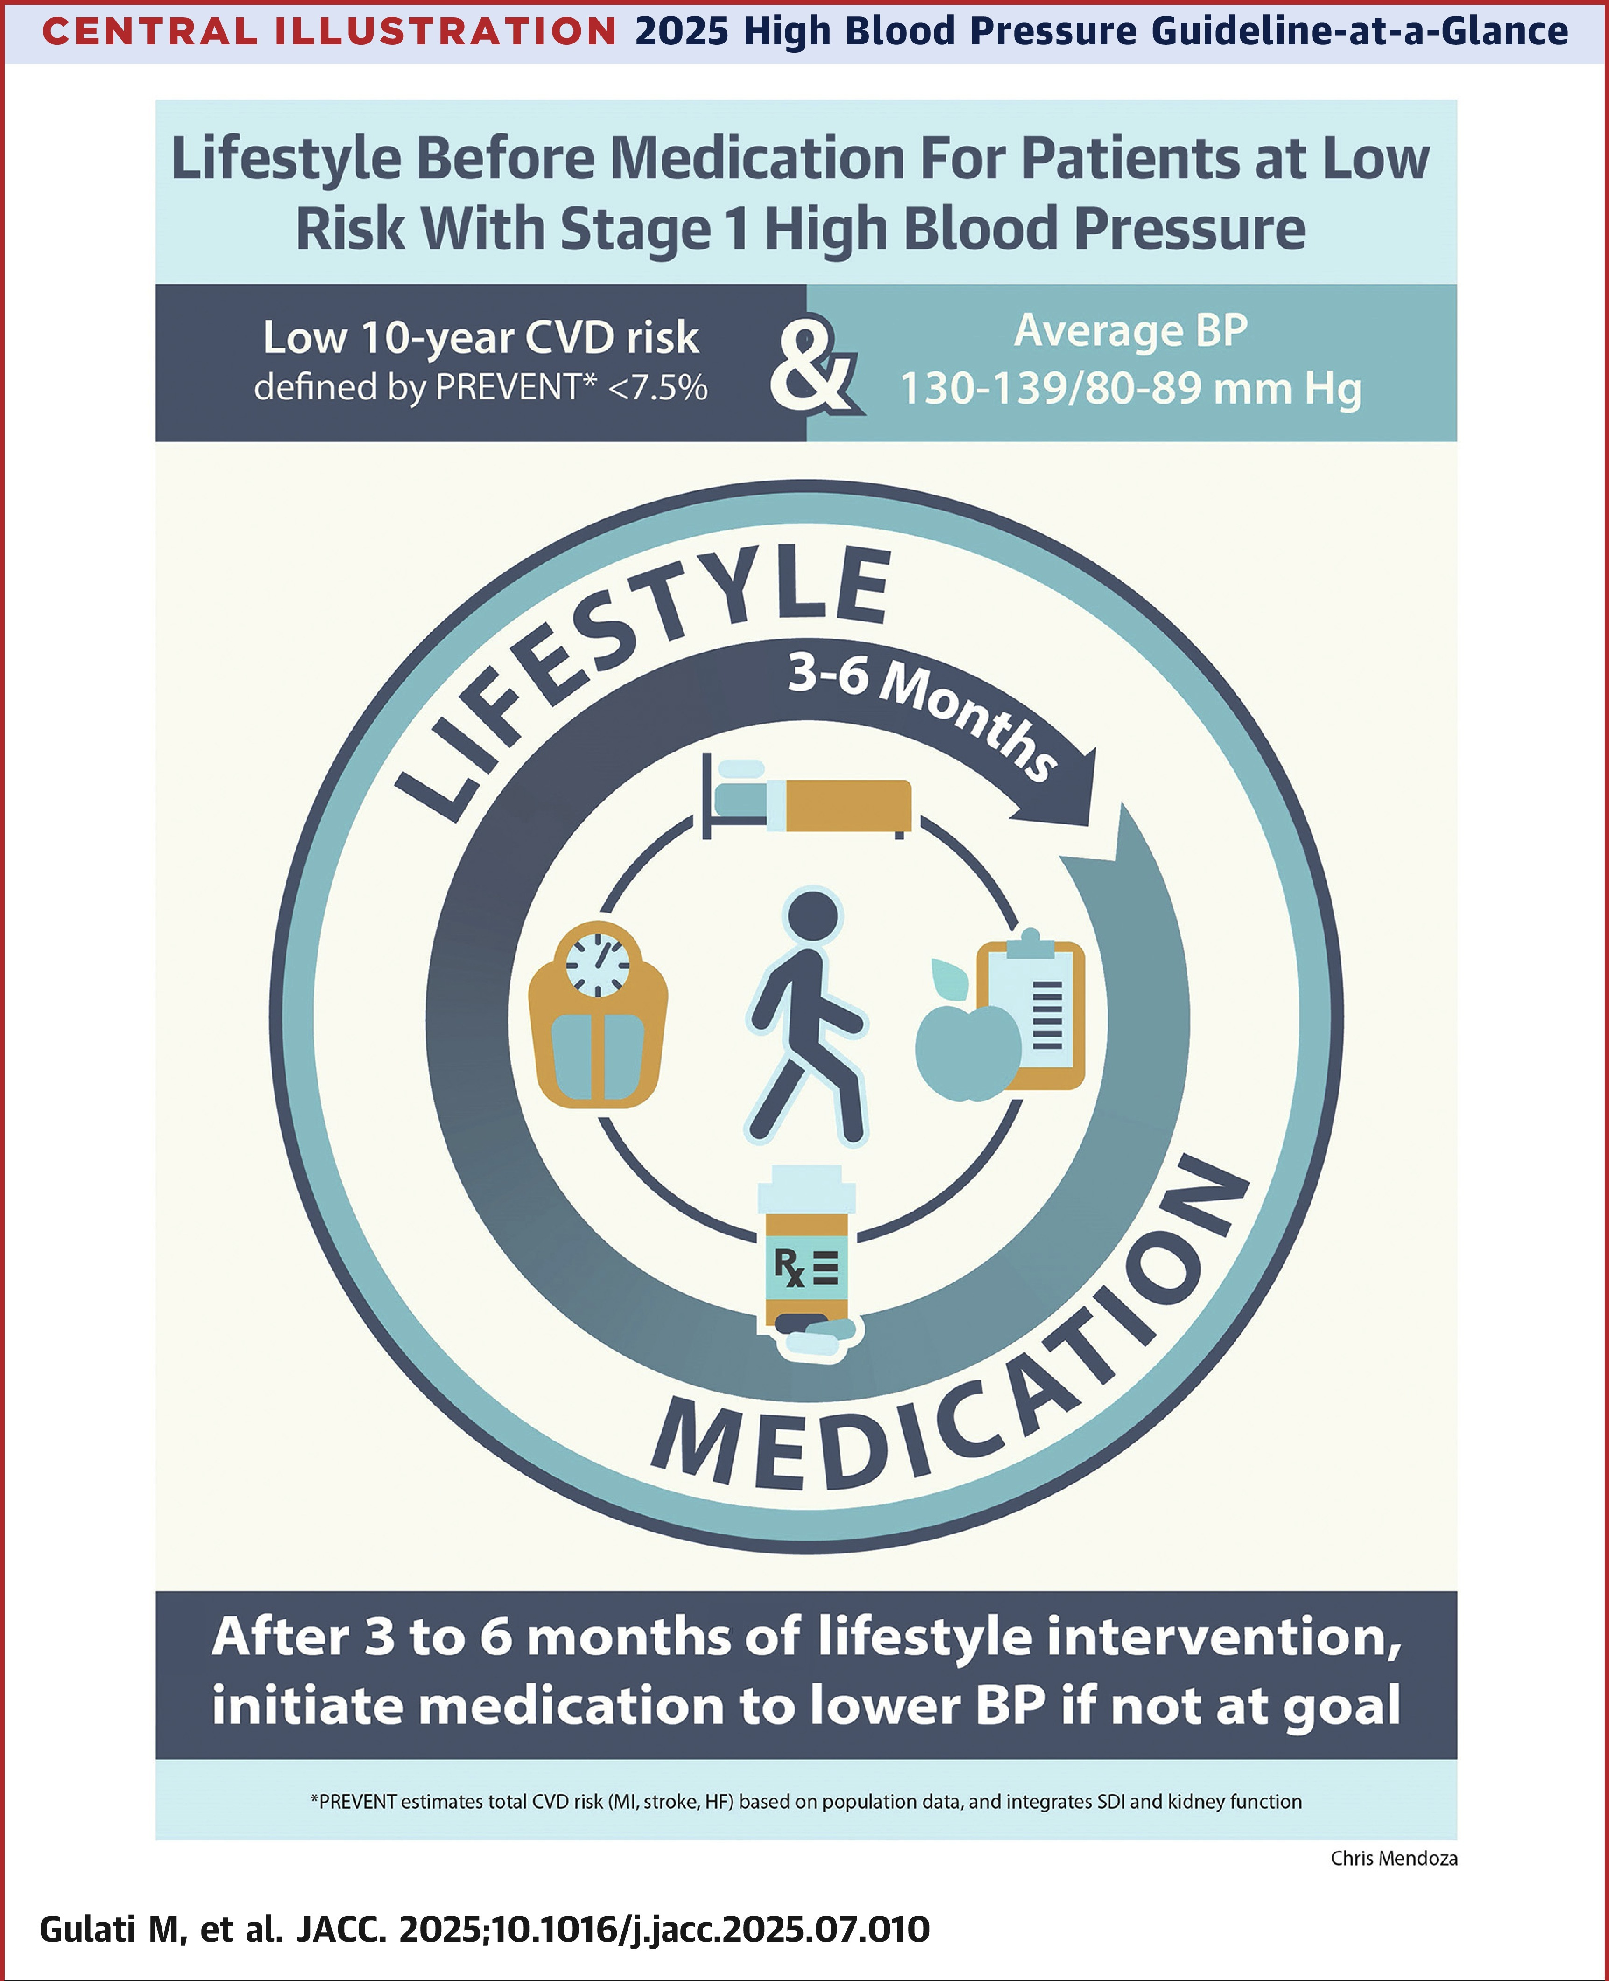
Figure: A 2025 hypertension guideline infographic showing a 3–6 month lifestyle-before-medication cycle for low-risk Stage 1 high blood pressure patients. - Credible illustration of staged hypertension management approach (acc.org, trust 94)
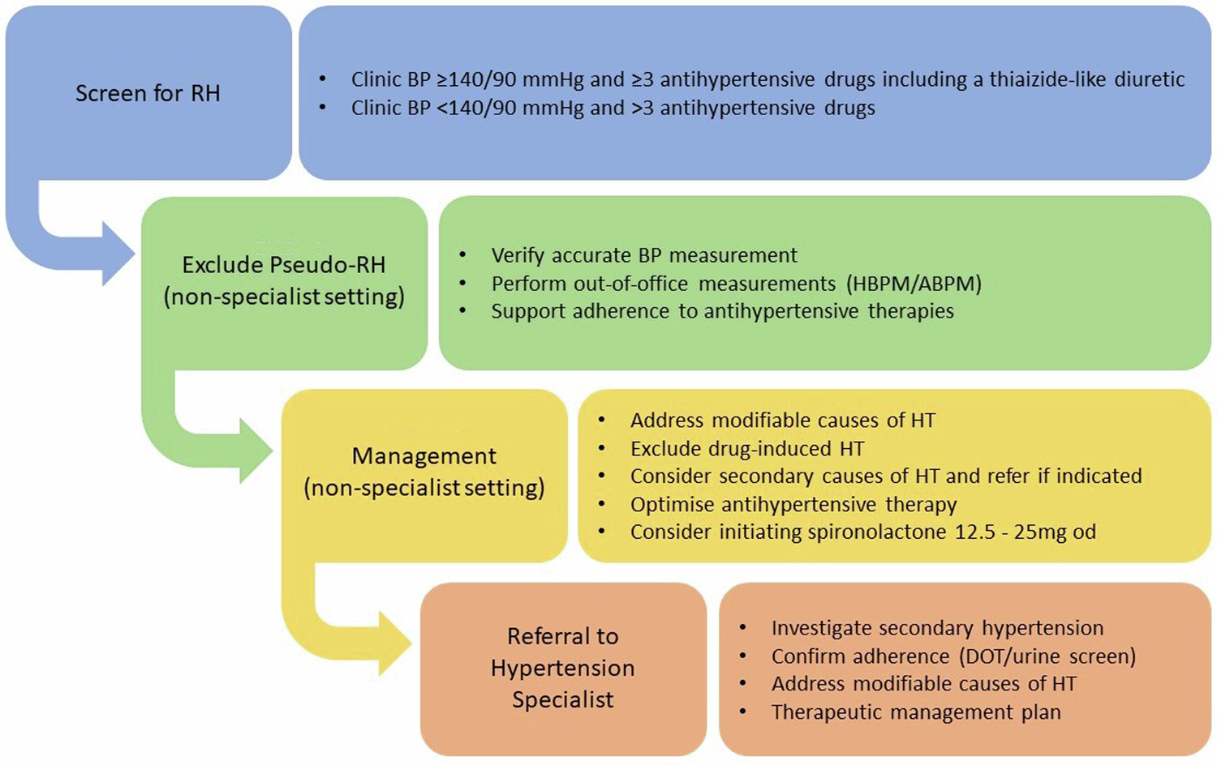
Figure: Flowchart with a large amount of text describing resistant hypertension screening, management, and specialist referral steps. - Credible algorithm for managing resistant hypertension (nature.com, trust 94)
Figure (source unreachable at export time, omitted): This is an infographic about "Management of Mild-to-Moderate Hypertension" containing a large amount of text information, so I do not need to output the text completely. It includes a gauge chart, tab - Credible overview of mild-to-moderate hypertension management (pmc.ncbi.nlm.nih.gov, trust 90)

7. References
[E1] cochranelibrary.com - "Cochrane" - by H Barnes · 2019 · Cited by 108 — 2015 ESC /ERS guidelines for the diagnosis and treatment of pulmonary hypertension .
[E2] cochranelibrary.com - "Transfusion thresholds and other strategies for guiding red" - Clinical trials evaluating red blood cell transfusion thresholds : an updated systematic review and with additional focus on patients with cardiovascular disease ... Read more
[E3] cochranelibrary.com - "Exercise-based cardiac rehabilitation for adults with heart" - by C Molloy · 2024 · Cited by 949 — Exercise-based cardiac rehabilitation for adults with heart failure. Cochrane Database of Systematic Reviews 2024, Issue 3. Art. No.: CD003331. Read more
[E4] cochranelibrary.com - "Kardiowersja elektryczna i farmakologiczna w przypadku" - Anticoagulation: therapy was in line with ACC / AHA / ESC guidelines ; however, all patients had recent ‐onset AF so specific protocol was not specified. Read more
[E5] cochranelibrary.com - "Toe‐brachial index and toe systolic blood pressure for the" - 2017 ESC Guidelines on the diagnosis and treatment of peripheral arterial diseases, Grading quality of evidence and strength of recommendations for diagnostic ... (outside year range - context only)
[E6] escardio.org - "Chronic aortic regurgitation: diagnosis and therapy in the" - May 27, 2020 — Aortic regurgitation (AR, also termed aortic insufficiency) results in diastolic blood flow from the aorta back into the left ventricle (LV) and ... Read more
[E7] escardio.org - "Sleep apnoea: a wake-up call for cardiologists?" - Sep 9, 2025 — Sleep apnoea can quietly increase the risk of high blood pressure , irregular heart rhythms, heart failure, and stroke. If you have a heart ... Read more
[E8] nice.org.uk - "HTG633 Bioresorbable stent implantation to treat coronary" - This includes modifying risk factors (for example, smoking, hyperlipidaemia, obesity, hyperglycaemia) and treatment with medicines (for example, beta blockers,. Read more
[E9] nice.org.uk - "Hypertension in adults" - Antihypertensive treatment is usually very effective in lowering blood pressure to within normal limits. as first line antihypertensive therapy
[E10] nice.org.uk - "Consultation on draft guideline - Stakeholder comments table" - in both settings is reflected prominently in the Class I recommendations in the latest ESC (Valgimigli, 2017) and ACC / AHA (Levine, 2016) clinical guidelines . (outside year range - context only)
[E11] nice.org.uk - "Cardiovascular disease: risk assessment and reduction" - Dec 14, 2023 — This guideline covers identifying and assessing risk of cardiovascular disease (CVD) in adults without established CVD.
[E12] nice.org.uk - "Principles for best practice in clinical audit" - This book provides clear statements of principle about clinical audit in the NHS. The authors have reviewed the literature concerned with the development of ...
[E13] acc.org - "An Update on Lipoprotein(a): The Latest on Testing," - Sep 19, 2023 — Lp(a) risk thresholds : ≥50 mg/dL ( or ≥125 nmol/L) is an accepted target in American College of Cardiology/ American Heart Association ( ACC / AHA ) ...
[E14] acc.org - "2023 ESH Hypertension Guideline Update: Bringing Us" - Feb 5, 2024 — The ESH recommends a threshold of >140/90 mm Hg (grade 1) for the diagnosis of hypertension , whereas the ACC / AHA guideline recommends a lower ... Read more
[E15] acc.org - "ACC, AHA Release New Clinical Guideline For Managing" - Mar 13, 2026 — The guideline recommends an LDL-C goal of <100 mg/dL for those at borderline or intermediate risk and <70 mg/dL in those at high risk. For ... Read more
[E16] acc.org - "Section Announcements" - The first -ever clinical guideline from the ACC and American Heart Association ( AHA ) to focus solely on the evaluation and diagnosis of adult patients with ... Read more
[E17] acc.org - "2026 ACC/AHA/AACVPR/ABC/ACPM/ADA/AGS/APhA/" - by RS Blumenthal · 2026 · Cited by 755 — COR 1: In adults with a CAC score of ≥300 to 999 AU, treatment with LDL-C lowering therapies with consideration of statin therapy as first line is recommended ... Read more
[E18] nhlbi.nih.gov - "Stroke - Causes and Risk Factors | NHLBI, NIH" - May 26, 2023 — Strokes are caused by blocked blood flow to the brain (ischemic stroke) or sudden bleeding in the brain (hemorrhagic stroke). Read more
[E19] biolincc.nhlbi.nih.gov - "Omni 1 Exam 2 - BioLINCC" - Systolic Blood Pressure Measurement: Measure the systolic blood pressure : a. Inflate cuff quickly to maximal inflation level. Deflate at 2 mmHg/second, Follow ...
[E20] biolincc.nhlbi.nih.gov - "Manual of Operations | BioLINCC - NIH" - History of hypertension diagnosed and treated with medication , diet, and/ or exercise • Blood pressure > 140 mm Hg systolic or 90 mm Hg diastolic on at least 2 ...
[E21] biolincc.nhlbi.nih.gov - "SHHS 1 Manual of Operations - BioLINCC" - Apr 18, 1997 — Comparability of A-Category Variables. Self-Reported History of Hypertension and Diabetes. Respiratory Disease and Symptoms … the first ARIC ... (outside year range - context only)
[E22] clinicalestablishments.mohfw.gov.in - "Background Document Hypertension - Clinical Establishments" - Diagnosis of hypertension should be based on at least 2 measurements. Drug therapy in patients with grade I hypertension uncomplicated by any organ damage, ...
[E23] clinicalestablishments.mohfw.gov.in - "Standard Treatment Guidelines -Hypertension" - Diagnosis of hypertension should be based on at least 2 measurements taken in the clinic or by a healthcare provider on at least 2 visits, which are at least 1 ...
[E24] academia.edu - "ACC/AHA Versus ESC/ESH on Hypertension Guidelines" - The ACC / AHA guideline recommends its use in patients >20/10 mm Hg above blood pressure goal. Thus, the only real disagreement is that the ACC / AHA guidelines ... Read more

6. Global Criticism and Instead Points

INSTEAD POINT 1
- Claim in this report: ACC/AHA recommends a hypertension diagnosis threshold of ≥130/80 mmHg, while ESC/ESH recommends >140/90 mmHg
- Standard data source view: Both ACC/AHA and ESC/ESH guidelines have maintained these different thresholds since 2017, with ACC/AHA taking a more aggressive approach to early intervention based on SPRINT trial results.
- Alternate / criticised view: The lower threshold in ACC/AHA guidelines has been criticized for potentially overmedicalizing normal blood pressure, leading to overtreatment and increased healthcare costs without clear mortality benefit in all populations.
- Why flagged: This difference represents a fundamental philosophical divide between guideline organizations about the balance between early intervention and potential overtreatment.
NOTE: Both views are written above on purpose. The standard-source view remains the first-priority reference; the alternate view is retained for transparency and must not be silently dropped.

INSTEAD POINT 2
- Claim in this report: Recent ACC/AHA guidelines (2026) recommend LDL-C goals of <100 mg/dL for borderline/intermediate risk patients and <70 mg/dL for high-risk patients
- Standard data source view: ACC/AHA guidelines have consistently recommended these LDL-C targets for different risk categories, with the 2026 guidelines representing an update rather than a significant change.
- Alternate / criticised view: These targets are inconsistent with ESC/EAS guidelines which recommend a risk-based approach rather than specific numerical targets, and some critics argue the ACC/AHA targets may be too aggressive for certain populations.
- Why flagged: The LDL-C target differences reflect broader debates in cardiovascular prevention about the balance between aggressive risk factor modification and potential side effects of intensive therapy.
NOTE: Both views are written above on purpose. The standard-source view remains the first-priority reference; the alternate view is retained for transparency and must not be silently dropped.

INSTEAD POINT 3
- Claim in this report: Indian guidelines recommend diagnosis based on at least two measurements taken in clinic or by healthcare provider on at least two visits
- Standard data source view: This approach aligns with WHO recommendations and many international guidelines which recommend multiple readings over separate visits to confirm hypertension diagnosis.
- Alternate / criticised view: Recent evidence suggests that out-of-office blood pressure measurements (ambulatory or home monitoring) may provide more accurate assessment than clinic-based measurements alone, which are prone to white coat hypertension.
- Why flagged: This discrepancy matters because diagnosis method affects prevalence estimates and treatment decisions, with potential implications for resource allocation in healthcare systems.
NOTE: Both views are written above on purpose. The standard-source view remains the first-priority reference; the alternate view is retained for transparency and must not be silently dropped.

INSTEAD POINT 4
- Claim in this report: First-line drug recommendations differ, with ACC/AHA favoring thiazide diuretics, ACE inhibitors, ARBs, or calcium channel blockers, while ESC/ESH emphasizes thiazide diuretics and calcium channel blockers
- Standard data source view: Both guideline organizations acknowledge that first-line choice should be individualized based on patient characteristics, comorbidities, and tolerability.
- Alternate / criticised view: The ACC/AHA broader recommendation of including ACE inhibitors and ARBs as first-line options has been criticized for potentially promoting industry-influenced guidelines, especially given the marketing history of these drug classes.
- Why flagged: This difference may reflect varying interpretations of trial evidence and different approaches to balancing efficacy, safety, and cost considerations.
NOTE: Both views are written above on purpose. The standard-source view remains the first-priority reference; the alternate view is retained for transparency and must not be silently dropped.

INSTEAD POINT 5
- Claim in this report: Indian guidelines align more closely with ESC/ESH thresholds but incorporate local epidemiological considerations
- Standard data source view: Indian guidelines do follow the ESC/ESH threshold of >140/90 mmHg for diagnosis but with adaptations for resource-limited settings and higher cardiovascular risk in the South Asian population.
- Alternate / criticised view: Recent Indian epidemiological data suggests that the cardiovascular risk profile in India may warrant more aggressive thresholds similar to ACC/AHA, especially in urban populations with increasing metabolic syndrome prevalence.
- Why flagged: This tension reflects the challenge of adapting international guidelines to local epidemiology, healthcare resources, and disease burden.
NOTE: Both views are written above on purpose. The standard-source view remains the first-priority reference; the alternate view is retained for transparency and must not be silently dropped.

INSTEAD POINT 6
- Claim in this report: Sleep apnea is recognized as a significant contributor to hypertension development and cardiovascular risk
- Standard data source view: Major guidelines increasingly recognize sleep apnea as both a cause and consequence of hypertension, with specific recommendations for screening in resistant hypertension.
- Alternate / criticised view: The strength of evidence for routine screening and treatment of sleep apnea specifically for hypertension management has been questioned, with some studies showing limited blood pressure reduction despite effective treatment of sleep apnea.
- Why flagged: This discrepancy matters because it affects resource allocation for sleep studies and treatment, which may be particularly relevant in resource-limited settings like India.
NOTE: Both views are written above on purpose. The standard-source view remains the first-priority reference; the alternate view is retained for transparency and must not be silently dropped.
Document credibility ledger: 0 SmartArt/diagram placeholder(s) removed, 0 template marker(s) removed. Export contains plain text, tables and vetted images only - no SmartArt objects are used in this document.
Run id: cmvqpt4cf0001nazppshiyl9v | Exported from MedRoute Evidence Pipeline on 2026-10-27

