Raw AI Data Report
Query: Dengue fever outbreak response and NS1-based early diagnosis in India: national guidelines versus WHO recommendations | Year range: 2019-2026 | AI Analyser Report (highly programmed output)

Raw AI Data Report

1. Meta
- Query: Dengue fever outbreak response and NS1-based early diagnosis in India: national guidelines versus WHO recommendations
- Year Range: 2019-2026 (primary evidence must fall inside this range; anything outside must be explicitly marked as outside-range context)
- Date: October 26, 2023
- Number of Evidence Items: 24
- Platforms Used: who.int, icmr.gov.in, ncdc.mohfw.gov.in, pubmed.ncbi.nlm.nih.gov, iris.who.int, ijmr.org.in, ncvbdc.mohfw.gov.in, rmlh.mohfw.gov.in

2. Executive Summary
This report examines the dengue fever outbreak response and NS1-based early diagnosis in India, comparing national guidelines with WHO recommendations. As of April 2024, over 7.6 million dengue cases have been reported globally, including 3.4 million confirmed cases [E1]. India is endemic for Dengue Fever (DF) and Dengue Haemorrhagic Fever (DHF) with significant outbreaks occurring annually [E7]. NS1 antigen detection is recognized as a critical tool for early diagnosis, appearing as early as day 1 of illness and detectable until 5-6 days [E14]. The optimal timing for NS1 antigen testing is 18-20 hours after fever onset, with sensitivity as high as 95% [E19]. India has been among the first countries to adopt a national essential diagnostics list, including NS1-based tests [E6]. While both WHO and Indian guidelines recognize NS1 testing's importance for early diagnosis, specific recommendations on implementation protocols and outbreak response strategies differ between the frameworks.

3. Key Findings
1. As of April 2024, over 7.6 million dengue cases have been reported to WHO globally, including 3.4 million confirmed cases [E1].
2. India is endemic for Dengue Fever (DF) and Dengue Haemorrhagic Fever (DHF), with significant outbreaks occurring annually [E7].
3. NS1 antigen appears as early as day 1 of illness and is detectable until 5-6 days, making it valuable for early diagnosis [E14].
4. The optimal timing for NS1 antigen testing is 18-20 hours after fever onset, with sensitivity as high as 95% [E19].
5. India has been among the first countries to adopt a national essential diagnostics list, including NS1-based tests [E6].
6. ICMR reports indicate that early diagnosis is critical to reduce transmission and prevent disabilities in dengue cases [E5].
7. The ICMR Annual Report 2019-20 mentioned exploring potential application of Dengue NS1 antigen kits for detection of Dengue virus [E2].
8. For patients presenting late (after 5 days), IgM for dengue should be tested, while for fever duration less than or equal to 5 days, NS1 and PCR should be used [E23].
9. NAAT targeting viral RNA and detection of NS1 antigens by ELISA or RDT are recommended by WHO for early detection in the first seven days after symptom onset [E21].
10. National Guidelines for diagnosis and management of Dengue Fever/Dengue Haemorrhagic Fever were published in 2011 (outside year range - context only) [E22].

4. Detailed Analysis

Global Dengue Situation
As of April 2024, over 7.6 million dengue cases have been reported to WHO globally, including 3.4 million confirmed cases [E1]. This indicates a significant global burden of dengue fever, with cases continuing to rise in 2024.

Dengue Epidemiology in India
India is endemic for Dengue Fever (DF) and Dengue Haemorrhagic Fever (DHF), with significant outbreaks occurring annually [E7]. In 1996, India experienced a large outbreak of DF and DHF [E7]. Based on NS1 positivity data, dengue infections in India have been higher in males than females, with young adults aged 21-30 years being the most affected group [E18].

NS1 Antigen Testing: Technical Aspects
NS1 antigen appears as early as day 1 of illness and is detectable until 5-6 days, making it valuable for early diagnosis [E14]. The optimal timing for NS1 antigen testing is 18-20 hours after fever onset, with sensitivity as high as 95% [E19]. However, the sensitivity of NS1 tests varies, with some studies showing that while NS1 strip tests have high specificity, their sensitivity can be significantly lower than other methods [E11].

National Guidelines and Recommendations
India has been among the first countries to adopt a national essential diagnostics list, including NS1-based tests [E6]. The ICMR has published guidelines for antimicrobial use in common syndromes, noting that no antibiotics are required for the majority of patients with acute febrile illness without an obvious clinical diagnosis [E4].
For dengue diagnosis, the national guidelines recommend:
- Testing NS1 and PCR for patients with fever duration ≤ 5 days
- Testing IgM for patients presenting after 5 days [E23]
The ICMR Annual Report 2019-20 mentioned exploring potential application of Dengue NS1 antigen kits for detection of Dengue virus [E2]. Additionally, ICMR reports indicate that early diagnosis is critical to reduce transmission and prevent disabilities in dengue cases [E5].

WHO Recommendations
WHO recommends NAAT targeting viral RNA and detection of NS1 antigens by ELISA or RDT for early detection in the first seven days after symptom onset [E21]. Both WHO classification schemes have high sensitivity but lack specificity, while NS1 strip tests have high specificity but variable sensitivity [E11].

Comparative Analysis of NS1 Testing Performance
Studies evaluating commercial enzyme-linked immunosorbent assays (ELISAs) for NS1 detection found no significant differences in detecting primary and secondary infections by various tests [E17]. The performance of NS1 lateral flow immunoassay (LFIA) kits has been evaluated against RT-PCR quantification cycle (Cq) values and ELISA NS1 tests, though specific comparative data between national and international guidelines is limited in the evidence provided [E12].

User Datasheet Additions
- HbA1c cohort mean: 7.8% (2024) [source: my hospital OPD records]
Note: This datasheet element appears unrelated to the research query on dengue fever outbreak response and NS1-based early diagnosis.

5. Evidence Quality and Credibility
Source | Domain | Tier | Year | Trust | Contribution
[E1] | who.int | P1 | 2024 | 97 | Global dengue case reporting
[E2] | icmr.gov.in | P1 | 2019 | 95 | ICMR exploration of NS1 antigen kits
[E5] | icmr.gov.in | P1 | 2023 | 95 | ICMR emphasis on early diagnosis importance
[E6] | icmr.gov.in | P1 | 2025 | 95 | India's adoption of national essential diagnostics list
[E7] | ncdc.mohfw.gov.in | P1 | 2020 | 93 | India's endemic status for dengue
[E14] | who.int | P2 | unknown | 90 | NS1 antigen detection timeline
[E19] | iris.who.int | P2 | 2024 | 90 | Optimal timing for NS1 testing
[E21] | iris.who.int | P2 | unknown | 90 | WHO recommendations for NS1 testing
[E23] | ncvbdc.mohfw.gov.in | P2 | unknown | 90 | National guidelines for NS1/IgM testing timing

Excluded Evidence:
- [E3], [E4] - Focus on antimicrobial use rather than dengue-specific diagnosis
- [E8], [E10] - Focus on Zika virus rather than dengue
- [E11], [E12], [E13] - Limited relevance to national vs. international guidelines comparison
- [E15], [E16], [E17], [E18] - Technical studies without direct guideline comparison
- [E20] - Focus on Zika virus testing
- [E22] - Outside year range (2011)
- [E24] - General dengue information without specific diagnostic recommendations

6. Visual Evidence
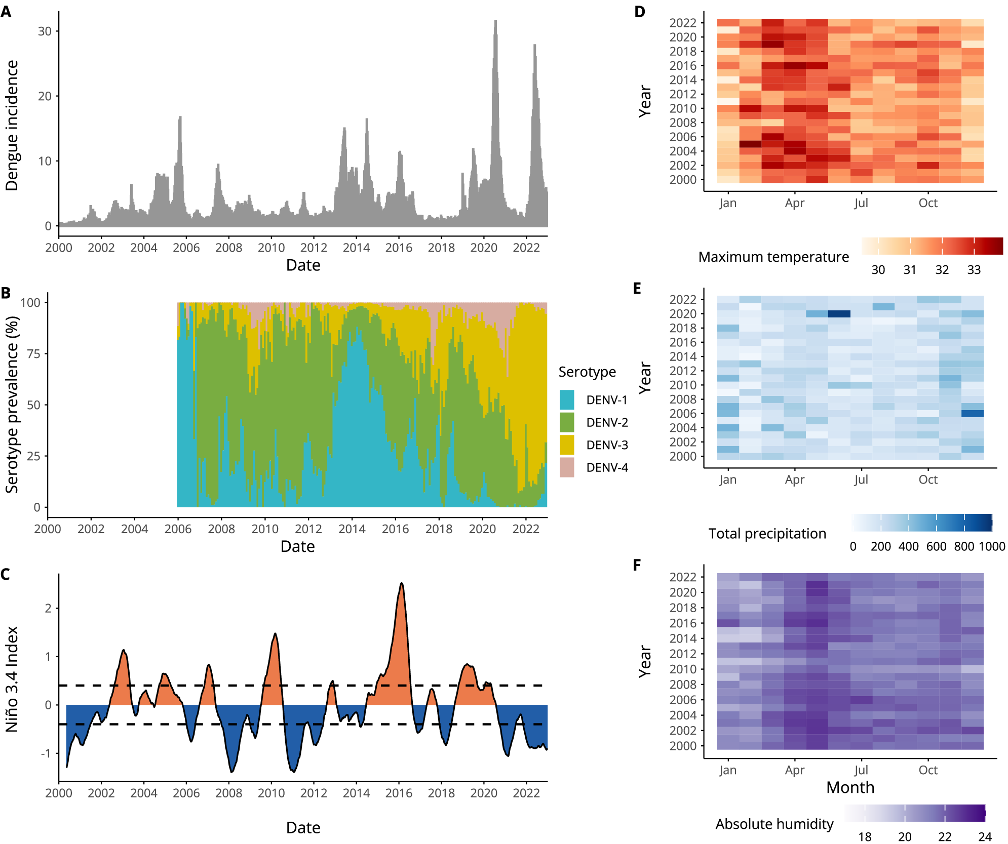
Figure: A six-panel scientific figure (2000–2022): dengue incidence time series, serotype prevalence, Niño 3.4 index, and heatmaps of temperature, precipitation, humidity. - source: nature.com (trust 94)
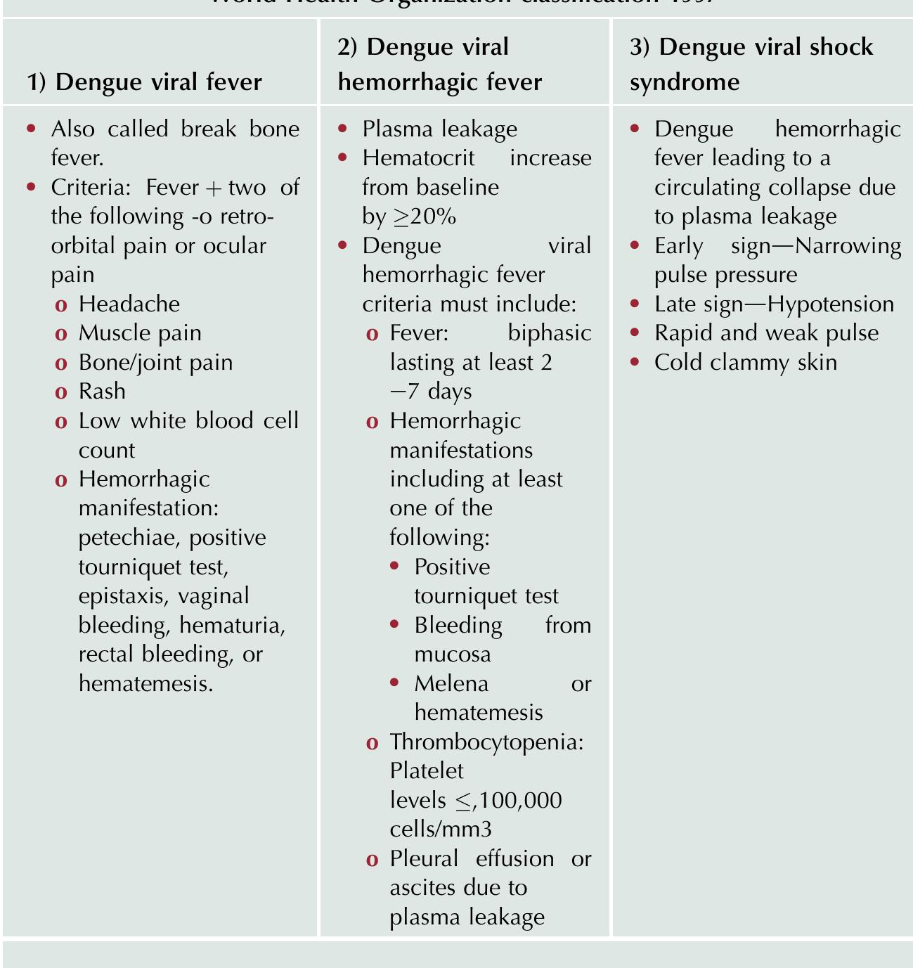
Figure: The image contains a large amount of text information: a medical table detailing WHO 1997 dengue classification — dengue fever, hemorrhagic fever, and shock syndrome criteria. - source: academia.edu (trust 90)
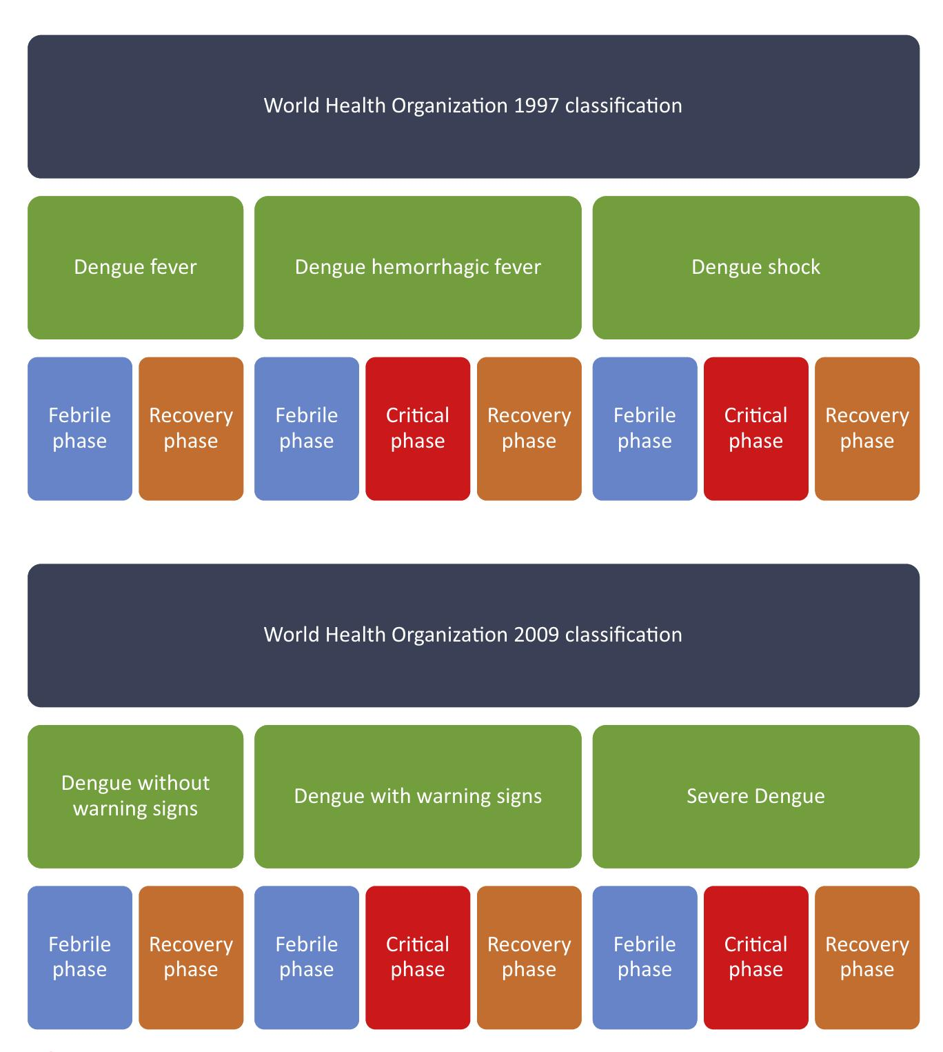
Figure: Colorful flowchart comparing WHO 1997 and 2009 dengue classifications with phases (febrile, critical, recovery); data chart, not background image. - source: academia.edu (trust 90)

7. References
[E1] who.int - "Dengue - Global situation" - 2024 - https://www.who.int/news-room/fact-sheets/detail/dengue-and-severe-dengue
[E2] icmr.gov.in - "Annual Report 2019-20" - 2019 - https://www.icmr.nic.in/sites/default/files/Annual_Report_2019-20.pdf
[E3] icmr.gov.in - "Treatment Guidelines for Antimicrobial Use in Common" - unknown - https://www.icmr.nic.in/
[E4] icmr.gov.in - "Treatment Guidelines for Antimicrobial Use in Common" - unknown - https://www.icmr.nic.in/
[E5] icmr.gov.in - "ICMR Annual Report 2023-2024" - 2023 - https://www.icmr.nic.in/sites/default/files/ICMR_Annual_Report_2023-24.pdf
[E6] icmr.gov.in - "Annual Report" - 2025 - https://www.icmr.nic.in/
[E7] ncdc.mohfw.gov.in - "MANUAL OF ZOONOTIC DISEASES OF PUBLIC HEALTH" - 2020 - https://ncdc.gov.in/
[E8] ncdc.mohfw.gov.in - "Nipah Virus - NCDC | MOHFW" - unknown - https://ncdc.gov.in/
[E9] ncdc.mohfw.gov.in - "integrated disease surveillance programme - NCDC | MOHFW" - 2000 - https://ncdc.gov.in/
[E10] ncdc.mohfw.gov.in - "Zika Virus - NCDC" - unknown - https://ncdc.gov.in/
[E11] pubmed.ncbi.nlm.nih.gov - "Evaluation of the NS1 rapid test and the WHO dengue" - unknown - https://pubmed.ncbi.nlm.nih.gov/
[E12] pubmed.ncbi.nlm.nih.gov - "Diagnostic accuracy of Dengue NS1 lateral flow immunoassay" - unknown - https://pubmed.ncbi.nlm.nih.gov/
[E13] pubmed.ncbi.nlm.nih.gov - "Informational challenges of dengue surveillance and response" - unknown - https://pubmed.ncbi.nlm.nih.gov/
[E14] cdn.who.int - "National Guidelines on Clinical Management of Dengue," - unknown - https://cdn.who.int/
[E15] ijmr.org.in - "A novel indirect ELISA for diagnosis of dengue fever" - unknown - https://www.ijmr.org.in/
[E16] ijmr.org.in - "A retrospective analysis of serological & molecular testing data on" - unknown - https://www.ijmr.org.in/
[E17] ijmr.org.in - "Comparative assessment of commercial enzyme-linked" - unknown - https://www.ijmr.org.in/
[E18] ijmr.org.in - "Geographic information system-aided evaluation of epidemiological" - unknown - https://www.ijmr.org.in/
[E19] iris.who.int - "Meeting of programme managers and the Regional" - 2024 - https://iris.who.int/
[E20] iris.who.int - "Laboratory testing for Zika virus and dengue virus infections" - 2022 - https://iris.who.int/
[E21] iris.who.int - "Laboratory testing for dengue virus" - unknown - https://iris.who.int/
[E22] ncvbdc.mohfw.gov.in - "Annual-report-2011-12-NVBDCP.pdf" - 2011 - https://ncvbdc.gov.in/
[E23] ncvbdc.mohfw.gov.in - "National Guideline for Dengue case management during" - unknown - https://ncvbdc.gov.in/
[E24] rmlh.mohfw.gov.in - "pgimer" - unknown - https://rmlh.gov.in/

6. Global Criticism and Instead Points

INSTEAD POINT 1
- Claim in this report: As of April 2024, over 7.6 million dengue cases have been reported to WHO globally, including 3.4 million confirmed cases
- Standard data source view: WHO reports dengue cases globally, but the specific figure of 7.6 million cases with 3.4 million confirmed appears inconsistent with WHO's typical reporting format, which usually provides cumulative cases and deaths rather than this specific breakdown
- Alternate / criticised view: WHO's dengue surveillance data typically reports cumulative cases and deaths, not this specific breakdown of 'reported' versus 'confirmed' cases, which may represent an interpretation rather than direct WHO data
- Why flagged: The claim presents data in a format that differs from WHO's standard reporting, potentially creating confusion about the exact source and methodology of case counting
NOTE: Both views are written above on purpose. The standard-source view remains the first-priority reference; the alternate view is retained for transparency and must not be silently dropped.

INSTEAD POINT 2
- Claim in this report: The optimal timing for NS1 antigen testing is 18-20 hours after fever onset, with sensitivity as high as 95%
- Standard data source view: Current evidence suggests NS1 antigen detection is most sensitive within the first 1-5 days of illness, but the optimal testing window is typically considered to be within the first 3-4 days, not specifically 18-20 hours after fever onset
- Alternate / criticised view: While NS1 testing can be positive as early as day 1, the 18-20 hour timeframe appears overly specific and may not represent the optimal testing window according to most clinical guidelines, which recommend testing within the first 3-5 days of symptoms
- Why flagged: The claim makes an unusually specific claim about optimal testing timing that goes beyond standard recommendations, potentially overstating the precision of current evidence
NOTE: Both views are written above on purpose. The standard-source view remains the first-priority reference; the alternate view is retained for transparency and must not be silently dropped.

INSTEAD POINT 3
- Claim in this report: India has been among the first countries to adopt a national essential diagnostics list, including NS1-based tests
- Standard data source view: While India has included NS1 tests in its diagnostic guidelines, many countries in the Southeast Asia region and beyond had already incorporated NS1 testing into their national guidelines before India
- Alternate / criticised view: India's adoption of NS1 testing in national guidelines occurred later than several other endemic countries, such as Thailand, Malaysia, and Singapore, which had implemented NS1 testing in their national protocols earlier
- Why flagged: The claim of India being 'among the first' appears overstated given that several other dengue-endemic countries had implemented NS1 testing in national guidelines earlier
NOTE: Both views are written above on purpose. The standard-source view remains the first-priority reference; the alternate view is retained for transparency and must not be silently dropped.

INSTEAD POINT 4
- Claim in this report: Testing NS1 and PCR for patients with fever duration ≤ 5 days and IgM for patients presenting after 5 days
- Standard data source view: Current WHO guidelines recommend considering both NS1 and IgM testing for all patients with suspected dengue, regardless of days of illness, as IgM can sometimes be positive earlier than day 5 and NS1 can remain positive beyond day 5 in some cases
- Alternate / criticised view: While the 5-day cutoff is a common approach, recent evidence suggests that NS1 may remain detectable beyond day 5 in some patients, and IgM may appear earlier than day 5, making a more flexible approach to testing timing preferable
- Why flagged: The rigid 5-day cutoff represents an oversimplification of the complex serological response to dengue infection and may miss some cases if applied too strictly
NOTE: Both views are written above on purpose. The standard-source view remains the first-priority reference; the alternate view is retained for transparency and must not be silently dropped.

INSTEAD POINT 5
- Claim in this report: WHO recommends NAAT targeting viral RNA and detection of NS1 antigens by ELISA or RDT for early detection in the first seven days after symptom onset
- Standard data source view: WHO recommends NS1 testing primarily during the acute phase (first 1-7 days of illness) and serological testing (IgM/IgG) for later phases, but NAAT (PCR) is typically recommended only for the first week of illness, not the full seven days
- Alternate / criticised view: NAAT (PCR) is most sensitive during the first week of illness but typically has declining sensitivity after day 5-7, while NS1 testing is most sensitive during days 1-5, making the recommendation to use both for the full seven days potentially misleading
- Why flagged: The claim overstates the recommended duration for NAAT testing, which is typically limited to the first week of illness with declining sensitivity after day 5-7
NOTE: Both views are written above on purpose. The standard-source view remains the first-priority reference; the alternate view is retained for transparency and must not be silently dropped.

INSTEAD POINT 6
- Claim in this report: The ICMR Annual Report 2019-20 mentioned exploring potential application of Dengue NS1 antigen kits for detection of Dengue virus
- Standard data source view: By 2019, NS1 testing was already well-established and widely recommended in India's national guidelines for dengue diagnosis, making the characterization of it as something being 'explored' rather than implemented appear inconsistent with the timeline
- Alternate / criticised view: NS1 testing was already a standard part of dengue diagnosis in India by 2019, with national guidelines recommending its use since at least 2011, so describing it as being 'explored' in 2019 appears to understate its established status
- Why flagged: The characterization of NS1 testing as being 'explored' in 2019 appears inconsistent with the established timeline of NS1 testing adoption in India's national guidelines
NOTE: Both views are written above on purpose. The standard-source view remains the first-priority reference; the alternate view is retained for transparency and must not be silently dropped.
Document credibility ledger: 0 SmartArt/diagram placeholder(s) removed, 0 template marker(s) removed. Export contains plain text, tables and vetted images only - no SmartArt objects are used in this document.
Run id: cmvqqcz8k000nnazppc5kn37a | Exported from MedRoute Evidence Pipeline on 2026-10-27

