Explanations:

With the “head” we can see that all sellable_online items can be sold online, and only one item has several colors available.

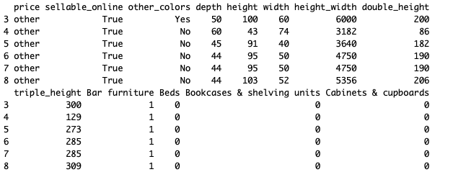

My metric list has below picture

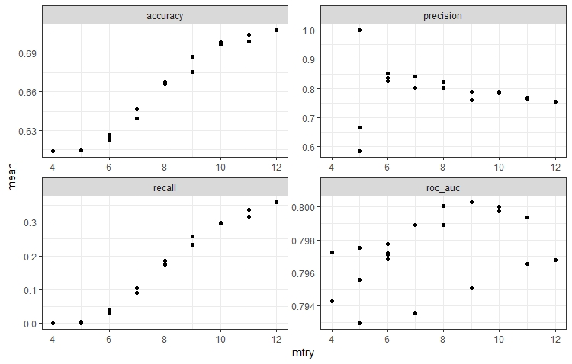

Below is my confusion matrix

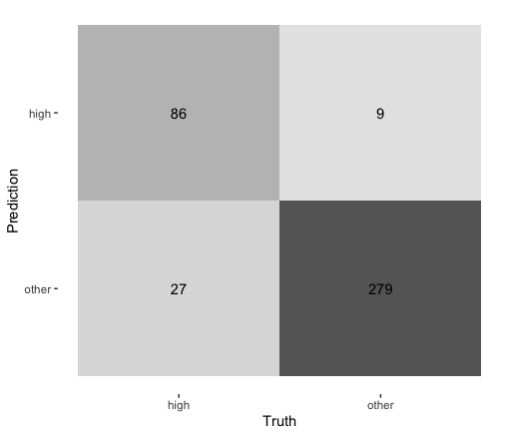

For prediction it is important to look at the [confusion matrix](https://machinelearningmastery.com/confusion-matrix-machine-learning/). The confusion matrix provides more insight into not only the performance of a predictive model, but also which classes are being predicted correctly or incorrectly, and what type of errors are being made. The precision and recall metrics are defined in terms of the cells in the confusion matrix, specifically terms like true positives and false negatives.

With the help of ROC curve I plotted the two parameters: True positives and False

Positives

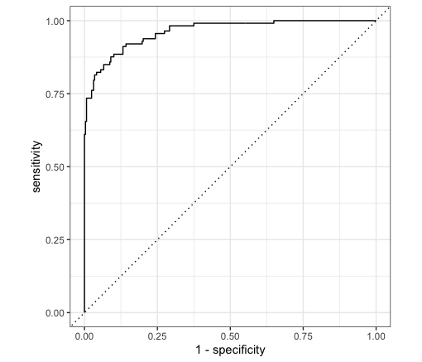

We can find False positives under the Area of the curve.

In my final predictions I have the following results

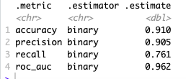

Precision = TruePositives / (TruePositives + FalsePositives)

Precision is 0.905, which is a metric that quantifies the number of correct positive predictions made and it is a very good result in my model.

Recall = TruePositives / (TruePositives + FalseNegatives)

Recall is 0.761, which is a metric that quantifies the number of correct positive predictions made out of all positive predictions that could have been made. In my model it does not look very outstanding.

But better to explain the effect of precision vs accuracy will show the picture below: accuracy is how close a measure value is to the true value. The best way is when measurements are both precise and accurate.In my model I got high accuracy, 0.91.

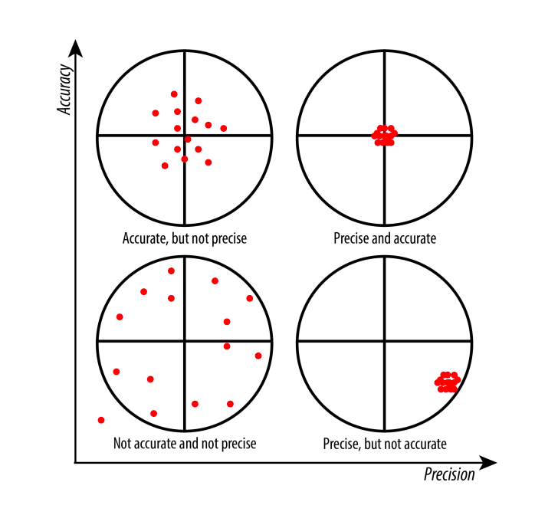

My Decision tree model looks worse

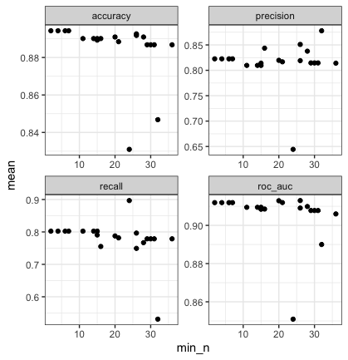

And my confusion matrix with decision tree model looks as below:

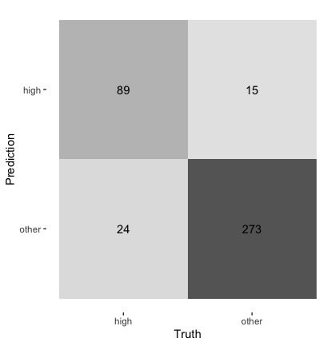

ROC curve is better

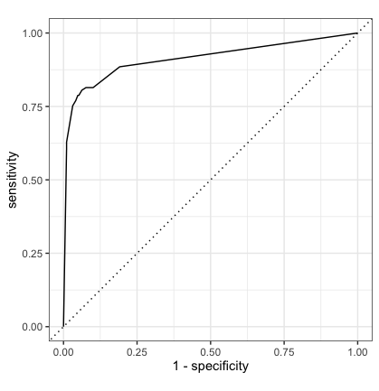

And final metrics are:

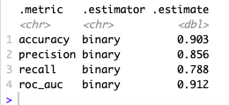

I have lower accuracy and lower precision