This document is used to give a brief overview of how to use the ILoveZappos android application.

The Splash screen:

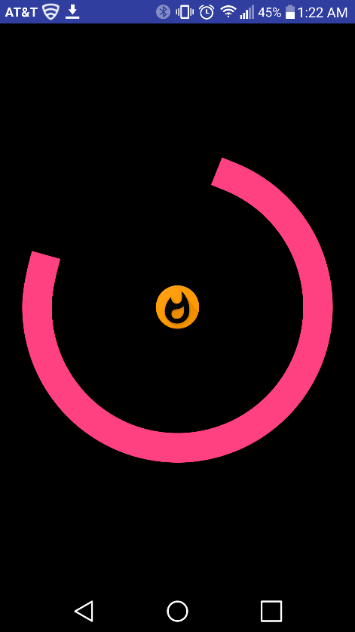

This is the start screen of the app.

The Search Screen:

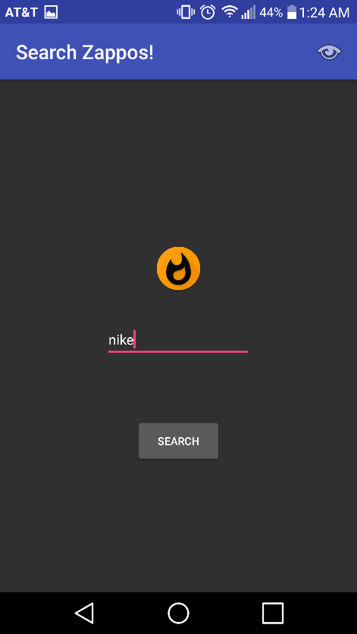

The Result Screen:

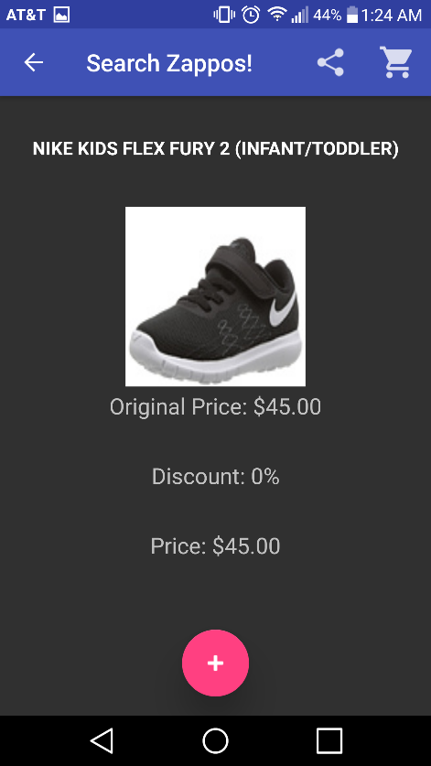

The Add to cart action and the Cart Screen:

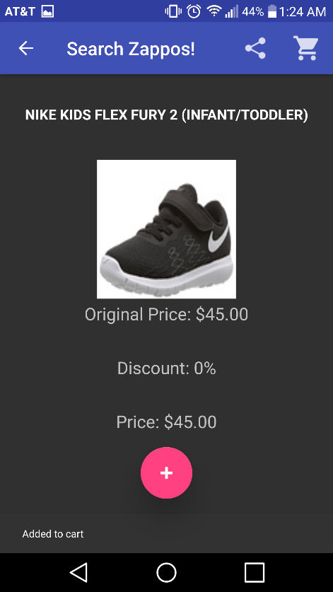 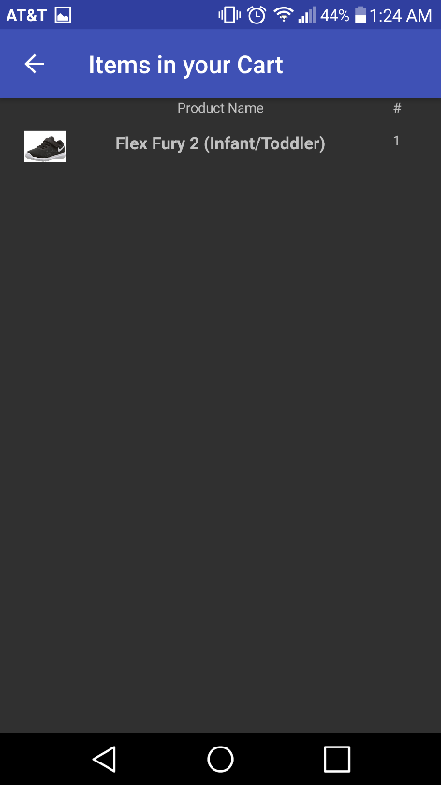

Also, Along with the basic application activities, the ILoveZappos app also supports the functionality of sharing the product with nearby users running the same application.

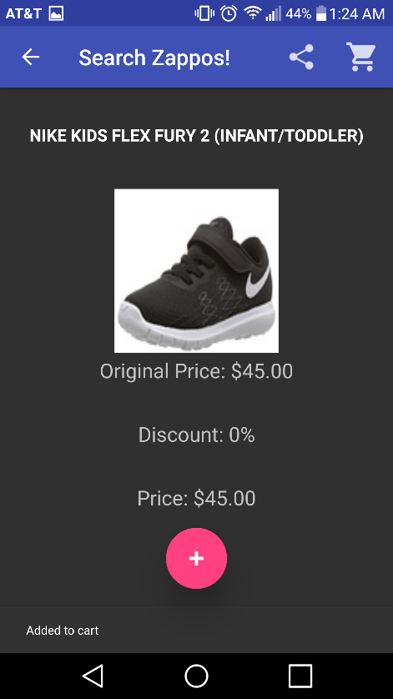

The highlighted icon allows the user to start sharing the product. The users who are in the view shared products mode, will be then able to see the products that are shared by other users.

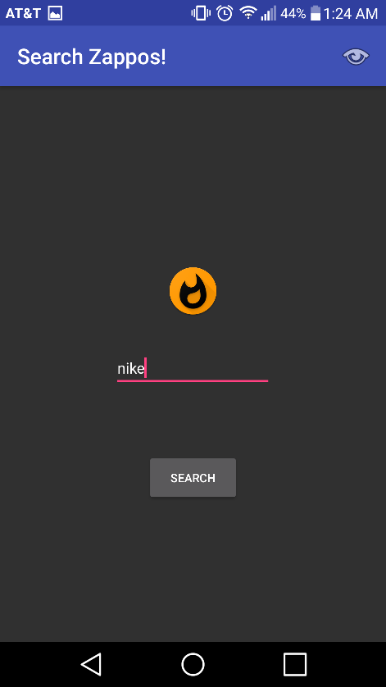

This icon allows any user to enter the view shared products mode. Once on this mode, the user will be able to see all the products that are shared by the nearby users.

Enjoy using the application!

Cheers!

Deepak Ravi Shankar.