

Safety Plan Lane Assistance

**Document Version: [Version]**

**Template Version 1.0, Released on 2017-06-21**



# Document history

|  |  |  |  |
| --- | --- | --- | --- |
| Date | Version | Editor | Description |
| 22/05/2018 | 1.0 | Sanchit Agrawal | First Submission |
|  |  |  |  |
|  |  |  |  |
|  |  |  |  |
|  |  |  |  |

# Table of Contents

Document history

Table of Contents

Introduction

Purpose of the Safety Plan

Scope of the Project

Deliverables of the Project

Item Definition

Goals and Measures

Goals

Measures

Safety Culture

Safety Lifecycle Tailoring

Roles

Development Interface Agreement

Confirmation Measures

# Introduction

## Purpose of the Safety Plan

The document provides overall role and responsibilities of the Lane Assistance item’s functional safety and its framework.

## Scope of the Project

For the lane assistance project, the following safety lifecycle phases are in scope:

Concept phase

Product Development at the System Level

Product Development at the Software Level

The following phases are out of scope:

Product Development at the Hardware Level

Production and Operation

## Deliverables of the Project

The deliverables of the project are:

Safety Plan

Hazard Analysis and Risk Assessment

Functional Safety Concept

Technical Safety Concept

Software Safety Requirements and Architecture

# Item Definition

The item identified in this project is a Lane assistance system.

Two main functions are:

1. **Lane Departure Warning Function:**

It is a function which vibrates the steering wheel if car move towards the edge of the lane.

**2. Lane keeping assistance function:**

It is responsible for keeping the car towards the center of the lane.

The responsible subsystem are:

* **Camera subsystem**: This has two components:
  + Camera sensor
  + Camera sensor ECU (Electronic Control Unit)
* **Electronic Power Steering subsystem**: This has three components:
  + Driver Steering Torque Sensor.
  + Electronic Power Steering ECU.
  + Motor Proving Torque to Steering Wheel.
* **Car Display subsystem**: This has two components:
  + Car Display ECU
  + Car Display

The below diagram describe the flow between different subsystems:

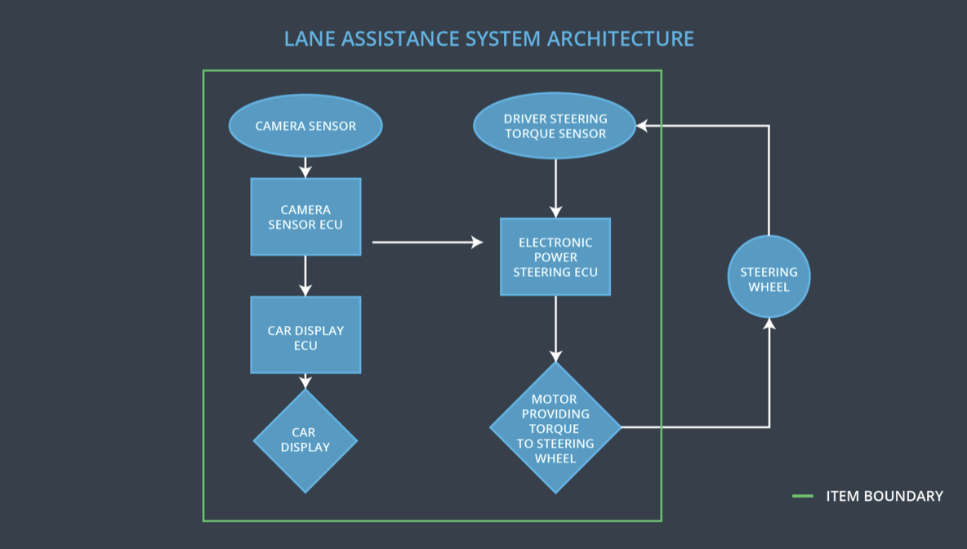

# Goals and Measures

## Goals

This project goals are:

* Identify risk and hazard situations in the system that could cause injuries to the person.
* Evaluate the risks of the hazardous situations.
* Identify the minimal cost for the risk that is acceptable by the society.

## Measures

|  |  |  |
| --- | --- | --- |
| Measures and Activities | Responsibility | Timeline |
| Follow safety processes | All Team Members | Constantly |
| Create and sustain a safety culture | All Team Members | Constantly |
| Coordinate and document the planned safety activities | All Team Members | Constantly |
| Allocate resources with adequate functional safety competency | Project Manager | Within 2 weeks of start of project |
| Tailor the safety lifecycle | Safety Manager | Within 4 weeks of start of project |
| Plan the safety activities of the safety lifecycle | Safety Manager | Within 4 weeks of start of project |
| Perform regular functional safety audits | Safety Auditor | Once every 2 months |
| Perform functional safety pre-assessment prior to audit by external functional safety assessor | Safety Manager | 3 months prior to main assessment |
| Perform functional safety assessment | Safety Assessor | Conclusion of functional safety activities |

# Safety Culture

# Here are some characteristics of a good safety culture:

* **High priority**: safety has the highest priority among competing constraints like cost and productivity
* **Accountability**: processes ensure accountability such that design decisions are traceable back to the people and teams who made the decisions
* **Rewards**: the organization motivates and supports the achievement of functional safety
* **Penalties**: the organization penalizes shortcuts that jeopardize safety or quality
* **Independence**: teams who design and develop a product should be independent from the teams who audit the work
* **Well defined processes**: company design and management processes should be clearly defined
* **Resources**: projects have necessary resources including people with appropriate skills
* **Diversity**: intellectual diversity is sought after, valued and integrated into processes
* **Communication**: communication channels encourage disclosure of problems

# Safety Lifecycle Tailoring

For the lane assistance project, the following safety lifecycle phases are in scope:

Concept phase

Product Development at the System Level

Product Development at the Software Level

The following phases are out of scope:

Product Development at the Hardware Level

Production and Operation

# Roles

|  |  |
| --- | --- |
| Role | Org |
| Functional Safety Manager- Item Level | OEM |
| Functional Safety Engineer- Item Level | OEM |
| Project Manager - Item Level | OEM |
| Functional Safety Manager- Component Level | Tier-1 |
| Functional Safety Engineer- Component Level | Tier-1 |
| Functional Safety Auditor | OEM or external |
| Functional Safety Assessor | OEM or external |

# Development Interface Agreement

A DIA (development interface agreement) defines the roles and responsibilities between companies involved in developing a product. All involved parties need to agree on the contents of the DIA before the project begins.

The DIA also specifies what evidence and work products each party will provide to prove that work was done according to the agreement.

The ultimate goal is to ensure that all parties are developing safe vehicles in compliance with ISO 26262.

Roles and responsibilities are:

* **Functional Safety Manager - Item Level**: Pre-audits, plans the development phase for the Lane Assistance item.
* **Functional Safety Engineer - Item Level**: Develop prototypes, integrate subsystems combining them into the Lane Assistance item.
* **Project Manager - Item Level**: Allocates the resources needed for the item.
* **Functional Safety Manager - Component Level(Sanchit Agrawal)**: Pre-audits, plan the development for the components of the Lane Assistance item.
* **Functional Safety Engineer - Component Level(Sanchit Agrawal)**: Develop prototypes and integrate components conforming the Lane Assistance item.
* **Functional Safety Auditor**: Make sure the project conforms to the safety plan.
* **Functional Safety Assessor**: Judges where the project has increased safety.

# Confirmation Measures

Confirmation measures serve two purposes:

* that a functional safety project conforms to ISO 26262, and
* that the project really does make the vehicle safer.

**Confirmation Measures Definitions**

**Confirmation review**

* Ensures that the project complies with ISO 26262. As the product is designed and developed, an independent person would review the work to make sure ISO 26262 is being followed.

**Functional safety audit**

* Checking to make sure that the actual implementation of the project conforms to the safety plan is called a functional safety audit.

**Functional safety assessment**

* Confirming that plans, designs and developed products actually achieve functional safety is called a functional safety assessment.

A safety plan could have other sections that we are not including here. For example, a safety plan would probably contain a complete project schedule.

There might also be a "Supporting Process Management" section that would cover "Part 8: Supporting Processes" of the ISO 26262 functional safety standard. This would include descriptions of how the company handles requirements management, change management, configuration management, documentation management, and software tool usage and confidence.

Similarly, a confirmation measures section would go into more detail about how each confirmation will be carried out.