

Functional Safety Concept Lane Assistance

**Document Version: [Version]**

**Template Version 1.0, Released on 2017-06-21**



# 

# Document history

|  |  |  |  |
| --- | --- | --- | --- |
| Date | Version | Editor | Description |
| 23/05/2018 | 1.0 | Sanchit Agrawal | First Submission |
|  |  |  |  |
|  |  |  |  |
|  |  |  |  |
|  |  |  |  |

# Table of Contents

Document history

Table of Contents

Purpose of the Functional Safety Concept

Inputs to the Functional Safety Analysis

Safety goals from the Hazard Analysis and Risk Assessment

Preliminary Architecture

Description of architecture elements

Functional Safety Concept

Functional Safety Analysis

Functional Safety Requirements

Refinement of the System Architecture

Allocation of Functional Safety Requirements to Architecture Elements

Warning and Degradation Concept

# Purpose of the Functional Safety Concept

Ultimate goal of functional safety document is to reduce risk to the acceptable level. In this document, system’s high level requirements are identified. These requirements are allocated to different part of item architecture. Looking at this architecture design, we need to figure out what subsystem can be used to meet safety goals.

# Inputs to the Functional Safety Concept

## Safety goals from the Hazard Analysis and Risk Assessment

|  |  |
| --- | --- |
| **ID** | **Safety Goal** |
| Safety_Goal_01 | The oscillating steering torque from the Lane Departure Warning function shall be limited. |
| Safety_Goal_02 | The Lane Keeping Assistance function shall be time limited, and additional steering torque shall end after a given time interval so the driver cannot misuse the system for autonomous driving. |

## Preliminary Architecture

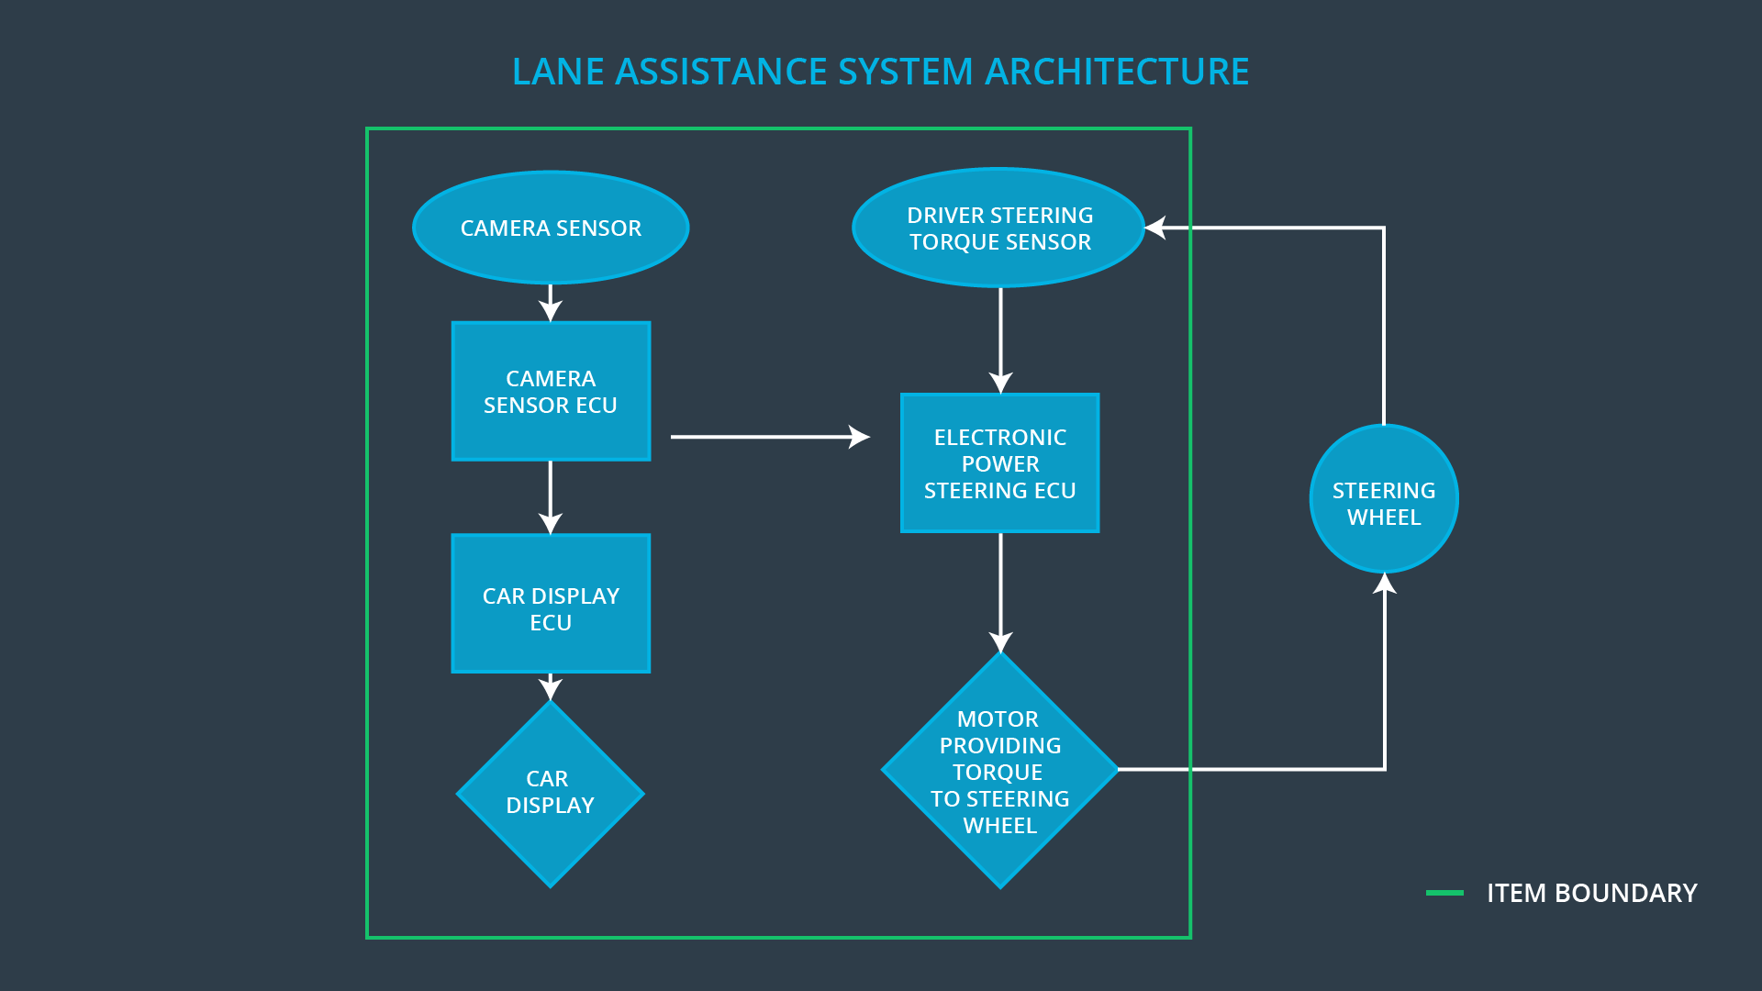

### Description of architecture elements

|  |  |
| --- | --- |
| **Element** | **Description** |
| Camera Sensor | Provides images of road to Camera Sensor ECU. |
| Camera Sensor ECU | Analyze images to get the lane line position and generates a torque request to Electronic Power Steering ECU. |
| Car Display | Shows warning to driver. |
| Car Display ECU | Generates warning signal triggered by Camera Sensor ECU and Electronic Power Steering ECU. |
| Driver Steering Torque Sensor | Senses how much torque already been applied by driver. |
| Electronic Power Steering ECU | Considering the information received from the Driver Steering Torque Sensor and the torque requested by the Lane Keeping Assistance and Lane Warning. Residual torque is being sent to motor. |
| Motor | Applies the torque. |

# Functional Safety Concept

The functional safety concept consists of:

* Functional safety analysis
* Functional safety requirements
* Functional safety architecture
* Warning and degradation concept

## Functional Safety Analysis

|  |  |  |  |
| --- | --- | --- | --- |
| **Malfunction ID** | **Main Function of the Item Related to Safety Goal Violations** | **Guidewords (NO, WRONG, EARLY, LATE, MORE, LESS)** | **Resulting Malfunction** |
| Malfunction_01 | Lane Departure Warning (LDW) function shall apply an oscillating steering torque to provide the driver a haptic feedback | MORE | The Lane Departure Warning function applies an oscillating torque with very high torque amplitude (above limit) |
| Malfunction_02 | Lane Departure Warning (LDW) function shall apply an oscillating steering torque to provide the driver a haptic feedback | MORE | The Lane Departure Warning function applies an oscillating torque with very high torque frequency (above limit) |
| Malfunction_03 | Lane Keeping Assistance (LKA) function shall apply the steering torque when active in order to stay in ego lane | NO | The Lane Keeping Assistance function is not limited in time duration which lead to misuse as an autonomous driving function. |

## Functional Safety Requirements

Lane Departure Warning (LDW) Requirements:

|  |  |  |  |  |
| --- | --- | --- | --- | --- |
| **ID** | **Functional Safety Requirement** | **ASIL** | **Fault Tolerant Time Interval** | **Safe State** |
| Functional  Safety  Requirement  01-01 | The Lane Departure Warning item shall ensure that the lane departure oscillating torque amplitude is below Max_Torque_Amplitude. | C | 50 ms | Vibration torque amplitude below Max_Torque_Amplitude. |
| Functional  Safety  Requirement  01-02 | The Lane Departure Warning item shall ensure that the lane departure oscillating torque frequency is below Max_Torque_Frequency. | C | 50 ms | Vibration torque amplitude below Max_Torque_Frequency. |

Lane Departure Warning (LDW) Verification and Validation Acceptance Criteria:

|  |  |  |
| --- | --- | --- |
| **ID** | **Validation Acceptance**  **Criteria and Method** | **Verification Acceptance**  **Criteria and Method** |
| Functional  Safety  Requirement  01-01 | Test driver reaction on different value chosen for torque amplitudes to prove that appropriate value is taken. | Verify the system does turn off if the Lane Departure Warning exceeded Max_Torque_Amplitude. |
| Functional  Safety  Requirement  01-02 | Test driver reaction on different value chosen for torque frequencies to prove that appropriate value is taken. | Verify the system does turn off if the Lane Departure Warning exceeded Max_Torque_Frequency. |

Lane Keeping Assistance (LKA) Requirements:

|  |  |  |  |  |
| --- | --- | --- | --- | --- |
| **ID** | **Functional Safety Requirement** | **ASIL** | **Fault Tolerant Time Interval** | **Safe State** |
| Functional  Safety  Requirement  02-01 | The electronic power steering ECU shall ensure that the Lane Keeping Assistance torque is applied only Max_Duration. | B | 500 ms | Lane Keeping Assistance system is not activated. |

Lane Keeping Assistance (LKA) Verification and Validation Acceptance Criteria:

|  |  |  |
| --- | --- | --- |
| **ID** | **Validation Acceptance**  **Criteria and Method** | **Verification Acceptance**  **Criteria and Method** |
| Functional  Safety  Requirement  02-01 | Validate the Max_Duration chosen not allow driver to use car as self-driving car. | Verify the Lane Keeping Assistance system turn off if application exceeded Max_Duration |

## Refinement of the System Architecture

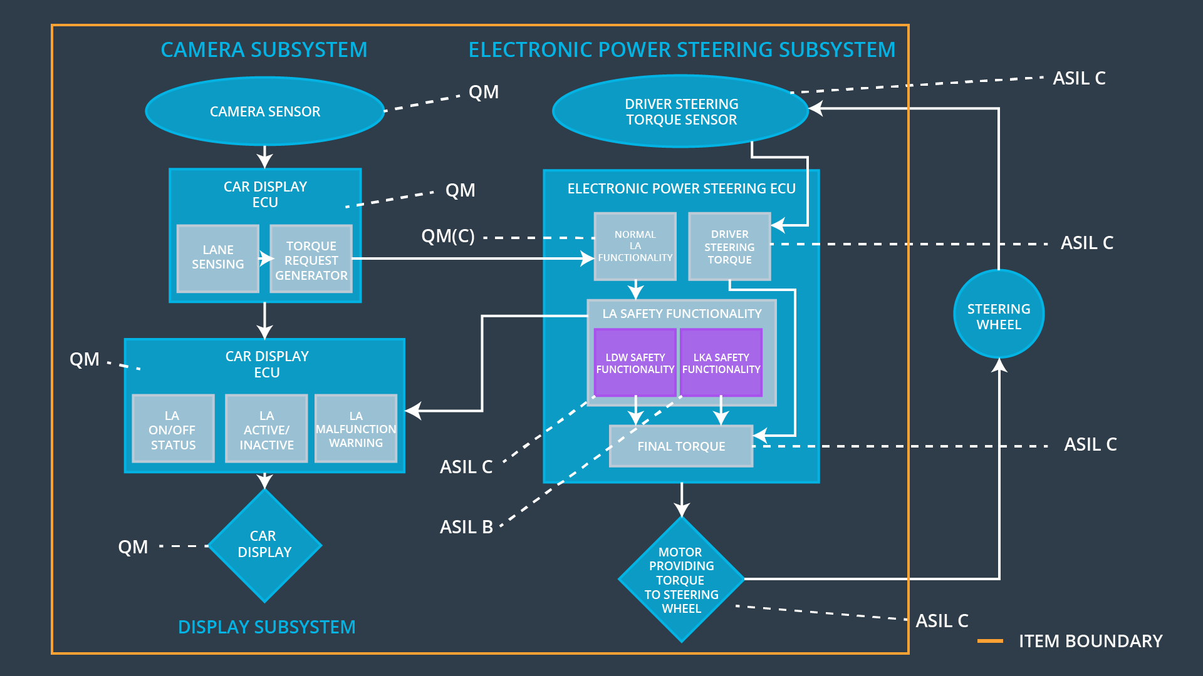

## Allocation of Functional Safety Requirements to Architecture Elements

|  |  |  |  |  |
| --- | --- | --- | --- | --- |
| **ID** | **Functional Safety Requirement** | **Electronic Power Steering ECU** | **Camera ECU** | **Car Display ECU** |
| Functional  Safety  Requirement  01-01 | The Lane Departure Warning item shall ensure that the lane departure oscillating torque amplitude is below Max_Torque_Amplitude. | **YES** | **NO** | **NO** |
| Functional  Safety  Requirement  01-02 | The Lane Departure Warning item shall ensure that the lane departure oscillating torque amplitude is below Max_Torque_Frequency. | **YES** | **NO** | **NO** |
| Functional  Safety  Requirement  02-01 | The electronic power steering ECU shall ensure that the Lane Keeping Assistance torque is applied only Max_Duration. | **YES** | **NO** | **NO** |

## Warning and Degradation Concept

|  |  |  |  |  |
| --- | --- | --- | --- | --- |
| **ID** | **Degradation Mode** | **Trigger for Degradation Mode** | **Safe State invoked?** | **Driver Warning** |
| WDC-01 | Turn off Lane Departure Warning functionality | Malfunction_01,  Malfunction_02 | Yes | Lane Departure Warning Malfunction Warning on Car Display |
| WDC-02 | Turn off Lane Keeping Assistance functionality | Malfunction_03 | Yes | Lane Keeping Assistance Malfunction Warning on Car Display |