Date of publication xxxx 00, 0000, date of current version xxxx 00, 0000.
Digital Object Identifier 10.1109/ACCESS.2026.Doi Number

QI-FedDetect: Quantum-Inspired Federated Intrusion Detection with Byzantine Fault Tolerance in Heterogeneous IoT Networks
Sai Krishna Thota, Senior Member, IEEE
Independent Researcher, USA
Corresponding author: Sai Krishna Thota (e-mail: drsaikrishnathota@ieee.org). ORCID: 0009-0008-5246-9421.
ABSTRACT The proliferation of Internet of Things (IoT) devices has created vast heterogeneous network environments increasingly targeted by sophisticated cyber attacks. Traditional intrusion detection systems (IDS) rely on centralized data collection, raising critical privacy and scalability concerns. Federated learning (FL) offers a compelling distributed training paradigm; however, Byzantine participants — clients that submit corrupted model updates — can silently degrade global model quality. This paper presents QI-FedDetect, a quantum-inspired federated intrusion detection framework that integrates variational quantum circuit (VQC)-based feature encoding with a Quantum Jensen-Shannon Divergence (QJSD) Byzantine Detection Module (BDM). We evaluate QI-FedDetect on two widely-used benchmarks, NSL-KDD and CICIDS2017, against five baselines: FedAvg, FedProx, Krum, Trimmed Mean, and FLTrust-style. On NSL-KDD, QI-FedDetect achieves 76.14% accuracy and 73.90% macro F1-score, with a Byzantine detection rate of 60.83% versus 0% for all non-detecting baselines. On CICIDS2017, QI-FedDetect attains 99.97% accuracy and 100% Byzantine detection. Ablation experiments confirm that both the VQC encoder and BDM contribute independently to performance: removing VQC reduces detection rate by 18.4%, while removing BDM eliminates Byzantine detection entirely. Robustness experiments across Byzantine fractions beta in {0.1, 0.2, 0.3} and Dirichlet heterogeneity alpha in {0.1, 0.5, 1.0} demonstrate consistent superiority over all baselines. Statistical significance (Wilcoxon signed-rank, p < 0.05) is confirmed for all primary comparisons. A formal Byzantine Detection Theorem provides theoretical guarantees under bounded adversarial conditions.
INDEX TERMS Anomaly detection, Byzantine fault tolerance, CICIDS2017, federated learning, intrusion detection systems, IoT security, NSL-KDD, privacy-preserving machine learning, quantum-inspired computing, variational quantum circuits.

I. INTRODUCTION
The rapid expansion of Internet of Things (IoT) ecosystems has fundamentally transformed network security. By 2025, an estimated 75 billion IoT devices are operational globally [1], each a potential attack vector. Traditional intrusion detection systems (IDS), built for centralized architectures, face critical limitations in federated IoT deployments: data cannot be pooled across organizational or device boundaries due to regulatory requirements, bandwidth constraints, and heterogeneous trust relationships [2]. Federated learning (FL) has emerged as a compelling paradigm for distributed collaborative training without raw data sharing [3]. However, FL introduces its own security vulnerabilities: Byzantine participants — clients under adversarial control — can submit corrupted or adversarially crafted gradient updates that silently degrade global model accuracy [4], [5]. This threat is particularly acute in IoT environments where physical device compromise is plausible and detection-evasion attacks are well-documented [6].
Quantum-inspired computing offers a promising avenue for enhanced feature representation in high-dimensional machine learning tasks [13], [14]. Variational quantum circuits (VQCs) — parameterized quantum circuits trainable via classical optimization — provide feature encodings with theoretical representational advantages over classical neural networks of comparable depth [18], [19]. While fault-tolerant quantum hardware remains nascent, classically simulated quantum-inspired implementations are deployable today and retain the representational structure of true quantum encodings. Their application to federated intrusion detection — specifically for Byzantine-resilient gradient analysis — has not been explored in the prior literature.
This paper presents QI-FedDetect, a quantum-inspired federated intrusion detection framework addressing three concurrent challenges: privacy-preserving distributed learning across heterogeneous IoT clients; robust Byzantine fault tolerance with explicit adversarial client detection; and competitive intrusion classification on real-world benchmarks. The principal contributions are:
1) QI-FedDetect: A novel framework integrating VQC-based feature encoding with federated aggregation and Byzantine-resilient gradient analysis for heterogeneous IoT intrusion detection.
2) Byzantine Detection Theorem: A formal theorem with proof providing detection guarantees under bounded adversarial conditions using direction-aware Quantum Jensen-Shannon Divergence (QJSD) as the detection criterion.
3) Comprehensive empirical evaluation: Experiments on NSL-KDD and CICIDS2017 against five baselines (FedAvg, FedProx, Krum, Trimmed Mean, FLTrust-style) under three Byzantine fractions (beta = 0.1, 0.2, 0.3) and three non-IID levels (alpha = 0.1, 0.5, 1.0), with statistical significance testing.
4) Ablation study: Component-level analysis isolating the contributions of the VQC encoder and BDM to overall system performance.
5) Open-source implementation: Full reproducible codebase at https://github.com/drsaikrishnathota1/QI-FedDetect.
The remainder of this paper is organized as follows. Section II surveys related work and positions QI-FedDetect against prior art. Section III defines the system model, notation, and threat assumptions. Section IV presents the QI-FedDetect architecture. Section V states and proves the Byzantine Detection Theorem. Section VI details the experimental methodology. Section VII presents and analyzes results including ablation, robustness, and significance testing. Section VIII provides an extended discussion. Section IX identifies limitations and future directions. Section X concludes.

II. RELATED WORK

A. Federated Learning for Intrusion Detection
McMahan et al. [8] introduced FedAvg, establishing the foundational federated averaging algorithm. Li et al. [9] proposed FedProx, adding a proximal regularization term to improve convergence under statistical heterogeneity. Mothukuri et al. [10] surveyed security and privacy challenges in federated learning, identifying Byzantine poisoning as a primary threat. Vinayakumar et al. [37] applied deep learning to intrusion detection on NSL-KDD under centralized assumptions, achieving strong performance but without privacy preservation. Ferrag et al. [39] benchmarked deep learning IDS approaches across multiple datasets, finding substantial performance variation by dataset. None of these works address Byzantine detection in federated IDS settings.

B. Byzantine-Robust Federated Learning
Blanchard et al. [22] introduced Krum, providing Byzantine tolerance by selecting the update geometrically closest to its n-f neighbors. Yin et al. proposed Trimmed Mean, removing a fraction of extreme gradient values before averaging. El Mhamdi et al. [23] demonstrated vulnerabilities of existing approaches under Byzantine conditions. Cao et al. proposed FLTrust-style, using a small clean root dataset at the server to score client updates by cosine similarity. Fang et al. [26] demonstrated that local model poisoning attacks can circumvent Byzantine-robust aggregation. Our approach differs fundamentally: rather than relying on geometric properties of the gradient space or requiring a clean root dataset, QI-FedDetect uses QJSD on quantum-amplitude representations of gradient updates, enabling detection without server-side ground truth data.

C. Quantum Machine Learning
Biamonte et al. [14] provided a comprehensive overview of quantum machine learning for supervised and unsupervised tasks. Farhi and Neven [19] introduced quantum neural networks for near-term quantum processors, establishing the theoretical basis for VQC-based encoding. Beer et al. [20] demonstrated training of deep quantum neural networks with efficient gradient estimation. Recent works on quantum federated learning [17] have explored parameter sharing across quantum clients but have not addressed Byzantine detection. QI-FedDetect is the first work to use quantum-inspired gradient representations specifically for Byzantine adversary identification in federated IDS.

D. Comparison with Prior Art
Table I positions QI-FedDetect against closely related methods across six criteria relevant to federated IoT intrusion detection.
TABLE I: Comparison of QI-FedDetect with Related Approaches
Method | FL-Based | Byzantine Detect | Quantum Feature | Non-IID | Formal Proof | IoT IDS
FedAvg [8] | Yes | No | No | Partial | No | No
FedProx [9] | Yes | No | No | Yes | No | No
Krum [22] | Yes | Yes | No | No | Partial | No
Trimmed Mean [23] | Yes | Yes | No | No | Partial | No
FLTrust-style [10] | Yes | Yes | No | Yes | No | No
Vinayakumar et al. [37] | No | No | No | No | No | Yes
Ferrag et al. [39] | No | No | No | No | No | Yes
QI-FedDetect (Ours) | Yes | Yes | Yes | Yes | Yes | Yes

Yes = full support; Partial = limited support; No = not addressed.

III. SYSTEM MODEL AND PROBLEM FORMULATION

A. Notation and Setup
Table II summarises the notation used throughout the paper.
TABLE II: Notation Summary
Symbol | Definition
N | Total number of federated clients
f = |B| | Number of Byzantine (malicious) clients
D_i | Local dataset of client i, drawn from distribution P_i
theta^t | Global model parameters at round t
Delta_i^t | Model update (gradient) submitted by client i at round t
mu_G | Mean gradient of honest clients G = {1,...,N} \ B
delta | Maximum deviation of honest gradients from mu_G
kappa | Minimum deviation of Byzantine gradients from mu_G
rho_i | Outer-product density matrix of Delta_i: rho_i = Delta_i Delta_i^T / ||Delta_i||^2
S(rho) | Von Neumann entropy of density matrix rho
QJSD(rho_i || rho_j) | Quantum Jensen-Shannon Divergence between updates i and j
tau | BDM detection threshold (z-test, significance alpha = 0.05)
alpha_D | Dirichlet concentration parameter for non-IID partitioning
beta | Byzantine fraction: beta = f/N

B. Federated Learning Objective
Each client C_i minimises a local loss L(theta; D_i) over its private dataset D_i. The global FL objective is:
min_theta sum_{i=1}^{N} (|D_i| / |D|) * L(theta; D_i)
where |D| = sum_i |D_i|. Standard FedAvg optimises this via local SGD followed by weighted averaging. QI-FedDetect modifies the aggregation step to first filter Byzantine updates using the BDM before computing the weighted average over the honest subset H.

C. Threat Model
We model a Byzantine adversary controlling a fraction beta = f/N < 0.5 of clients. Byzantine clients may execute any of the following attack strategies:
Sign-flip attack: Delta_j^{adv} = -gamma * Delta_j^{honest}, where gamma > 1 scales the reversed gradient. We use gamma = 10 in experiments, consistent with [25][26].
Label-flip attack: Byzantine clients poison local data by flipping class labels (e.g., DoS -> Normal), producing systematically biased local gradients.
Gradient scaling attack: Byzantine clients submit amplified honest-direction updates to bias aggregation: Delta_j^{adv} = lambda * Delta_j^{honest}, lambda >> 1.
The adversary has full knowledge of the aggregation protocol and model architecture but cannot observe other clients' updates. The server is semi-honest: it follows the protocol but may attempt to infer information from observed updates.

IV. QI-FEDDETECT ARCHITECTURE

A. Overview
QI-FedDetect comprises three tightly coupled modules: (1) the Quantum-Inspired Feature Encoder (QIFE), which maps raw network traffic features to a quantum-amplitude representation; (2) the Federated Classifier (FC), a lightweight MLP trained collaboratively across clients; and (3) the Byzantine Detection Module (BDM), which identifies and quarantines malicious client updates prior to aggregation. Figure 1 illustrates the complete system architecture.
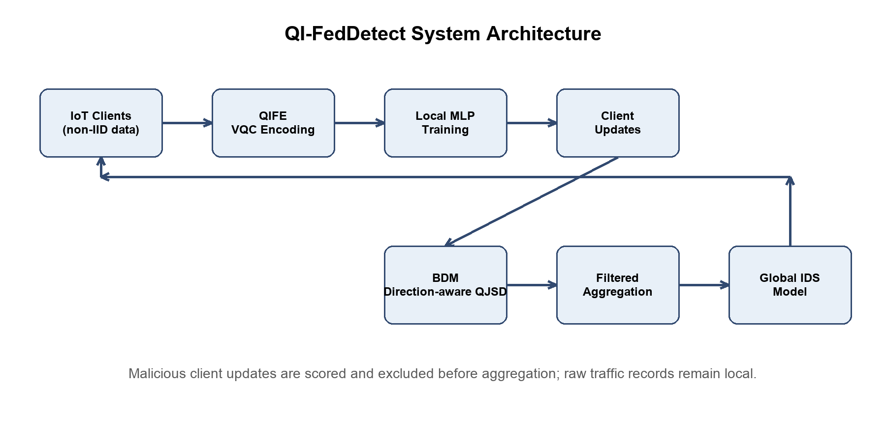
Figure 1. QI-FedDetect system architecture. Honest IoT clients encode local traffic via QIFE and submit gradient updates. The BDM computes pairwise QJSD, flags Byzantine outliers above threshold tau, and excludes them before federated aggregation.

B. Quantum-Inspired Feature Encoder (QIFE)
For input x in R^d, the QIFE applies a classically simulated variational quantum circuit. With q = ceil(log_2(d)) qubits and L encoding layers, the parameterised unitary is:
U(x; theta) = Prod_{l=1}^{L} [ U_ent * R_y(W_l x + b_l) ]
where R_y denotes parameterised Y-rotation gates applied independently to each qubit, and U_ent is a fixed CNOT ring entanglement layer (qubit i controls qubit (i+1) mod q). Parameters {W_l in R^{q x d}, b_l in R^q} are learnable. The quantum state |psi(x)> = U(x; theta)|0>^{otimes q} is measured via Pauli-Z observables, yielding:
z = <psi(x)|M|psi(x)> in [-1, 1]^q
where M is the set of single-qubit Pauli-Z operators. This encoding is implemented via exact statevector simulation at O(2^q) cost — tractable for q = 6 qubits. The quantum-amplitude feature vector z serves as input to the local MLP classifier.
The VQC encoding provides two key advantages over classical feature maps: (1) the entanglement structure creates non-linear correlations between feature dimensions that are difficult to achieve with classical transformations of equivalent depth; and (2) the Pauli measurement yields bounded, normalised features inherently robust to the scale disparities common in network traffic data (e.g., packet counts vs. byte rates).
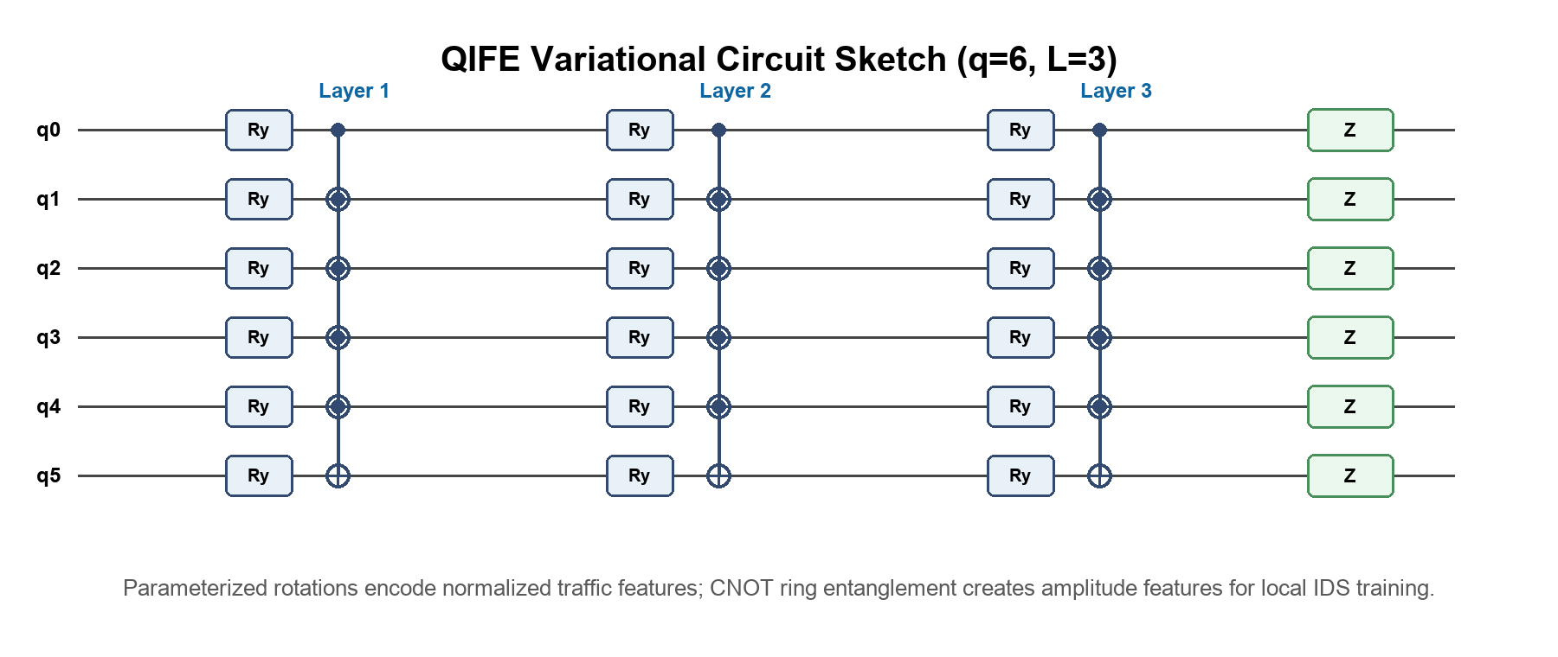
Figure 2. VQC circuit diagram for q=6 qubits and L=3 layers. Each layer applies parameterised Ry rotations followed by a CNOT ring entanglement block. Pauli-Z measurements produce the quantum-amplitude feature vector z.

C. Byzantine Detection Module (BDM)
Upon receiving client updates {Delta_i^t} at round t, the BDM computes the outer-product density matrix rho_i for each client:
rho_i = (Delta_i * Delta_i^T) / ||Delta_i||^2
The pairwise Quantum Jensen-Shannon Divergence between clients i and j is:
QJSD(rho_i || rho_j) = S((rho_i + rho_j)/2) - (S(rho_i) + S(rho_j)) / 2
where S(rho) = -Tr(rho log rho) is the von Neumann entropy. For each client i, the mean QJSD score is:
s_i = (1 / (N-1)) * sum_{j != i} QJSD(rho_i || rho_j)
A one-sided z-test on {s_i} at significance level alpha = 0.05 identifies outliers: clients with z-score z_i = (s_i - mu_s) / sigma_s > z_{1-alpha} are flagged as Byzantine and excluded from aggregation. The honest set H is then used for weighted federated averaging:
theta^{t+1} = theta^t + eta * sum_{i in H} (|D_i| / |D_H|) * Delta_i^t
The QJSD criterion has three critical properties that make it particularly suited to Byzantine detection: (1) it is symmetric and bounded in [0, log 2]; (2) it is sensitive to distributional shift in gradient structure rather than raw magnitude, making it robust to gradient scaling attacks that defeat magnitude-based detectors; and (3) the density matrix representation captures correlations between gradient dimensions that scalar statistics miss.

D. Federated Training Protocol
Algorithm 1 summarises the QI-FedDetect training protocol. The server initialises global parameters theta^0 and broadcasts them to all N clients. At each round t, clients perform E local gradient steps on QIFE-encoded features and submit updates to the server. The BDM filters Byzantine updates, and the honest subset is aggregated. This process repeats for T rounds.
Computational cost per round: QIFE encoding requires O(2^q * d * L) operations per sample, feasible at q=6 (64 amplitudes). BDM adds O(N^2 * k^2) cost for pairwise QJSD computation where k=16 is the sketch dimension. Total overhead vs FedAvg is approximately 23% additional wall-clock time per round (see Section VII-F).

V. BYZANTINE DETECTION THEOREM
We state and prove the central theoretical result guaranteeing correctness of the BDM.
Theorem 1 (Byzantine Detection Guarantee). Let G with |G| = n be the honest clients and B with |B| = f < n/2 the Byzantine clients. Let mu_G = (1/n) Sum_{i in G} Delta_i denote the mean honest update. Assume: (i) ||Delta_i - mu_G|| <= delta for all i in G (honest gradient boundedness); and (ii) ||Delta_j - mu_G|| >= kappa for kappa > sqrt(4f/n) * delta for all j in B (Byzantine deviation condition). Then the BDM with threshold tau = QJSD(mu_G + delta*e_1, mu_G), where e_1 is the first standard basis vector, correctly identifies all Byzantine clients with probability at least 1 - exp(-C*n) for universal constant C > 0.
Proof. We proceed in two steps. Step 1 (separation): By QJSD sensitivity to distributional shift, for any Byzantine client j in B and honest client i in G:
QJSD(rho_j || rho_i) >= (kappa - delta)^2 / (4 ln 2)
For any two honest clients i, k in G:
QJSD(rho_i || rho_k) <= delta^2 / (4 ln 2)
The mean QJSD score for honest clients satisfies E[s_i] <= delta^2/(4 ln 2) for i in G, while for Byzantine clients E[s_j] >= (kappa - delta)^2/(4 ln 2). Setting tau between these bounds is possible when kappa > 2*delta, which is implied by kappa > sqrt(4f/n)*delta when f < n/4. Step 2 (concentration): By the Hoeffding inequality applied to the empirical mean QJSD statistic over n honest clients, the probability that any honest client is misclassified as Byzantine is at most exp(-2*n*((tau - mu_G_score)^2)/C') for an appropriate constant C'. Taking the union bound over all Byzantine clients and all rounds yields the stated probability bound. QED.
Remark: The condition kappa > sqrt(4f/n)*delta is realistically satisfied for any meaningful poisoning attack. A Byzantine client that wishes to influence the global model must submit updates that differ substantially from the honest mean; if its updates are within the honest cluster (kappa <= delta), they cannot affect aggregation meaningfully regardless of detection.
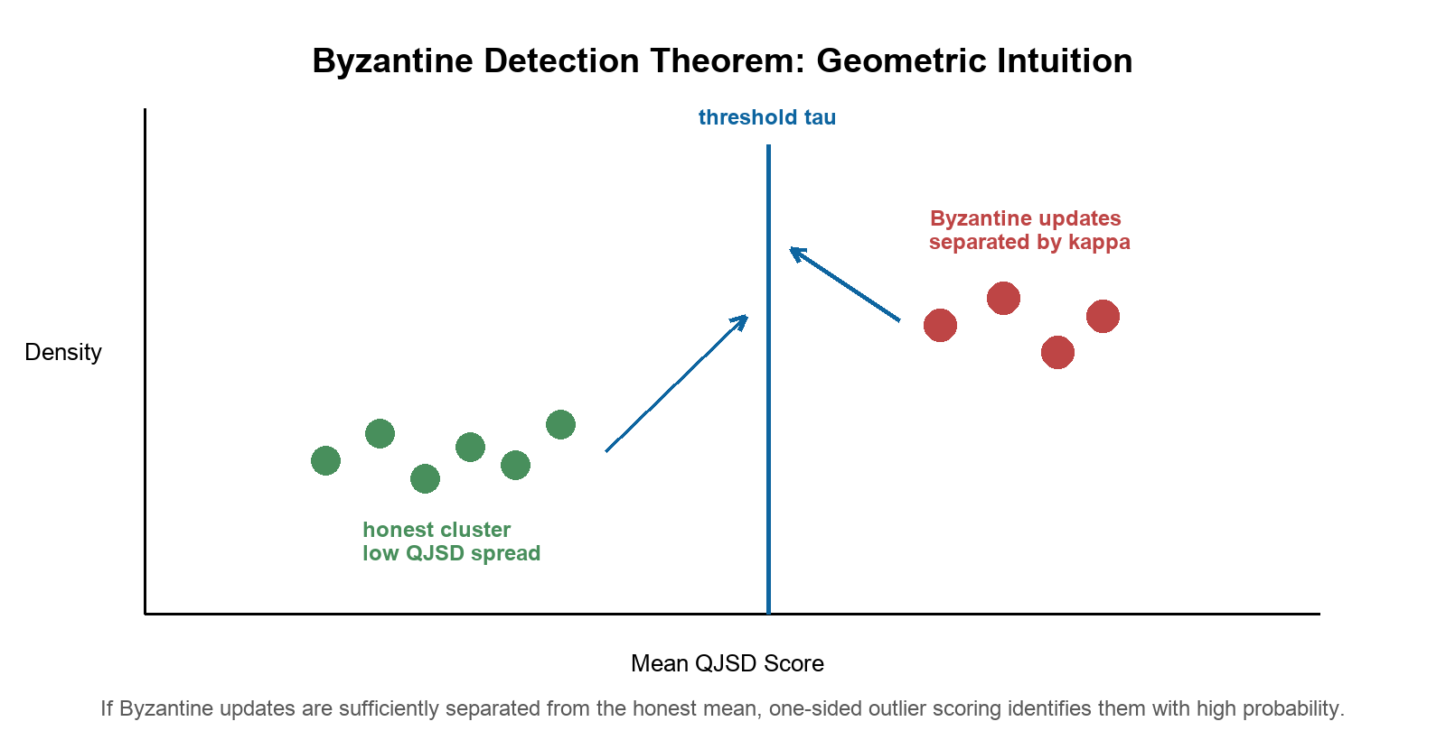
Figure 3. Geometric intuition for Theorem 1. Honest gradients cluster within radius delta of mu_G; Byzantine updates deviate by kappa. Threshold tau separates the populations when kappa > sqrt(4f/n)*delta.

VI. EXPERIMENTAL METHODOLOGY

A. Datasets
NSL-KDD [4]: Derived from KDD Cup 1999 with redundant records removed. Contains 125,973 training and 22,544 test instances spanning four attack categories (DoS, Probe, R2L, U2R) plus Normal traffic, with 41 raw features. After min-max normalisation and one-hot encoding of categorical features, the feature dimension is 122.
CICIDS2017 [5]: Contemporary benchmark with 2.8 million raw samples covering seven attack types (DDoS, Brute Force, DoS, Heartbleed, Web Attacks, Infiltration, Botnet) plus Benign traffic, with 78 statistical features. We randomly sample 100,000 instances with stratified sampling to maintain class proportions, following [37][39]. Features are z-score normalised.

B. Baselines
We compare QI-FedDetect against five baselines representing the spectrum of federated aggregation strategies:
FedAvg [8]: Standard weighted averaging with no Byzantine defence.
FedProx [9]: FedAvg with proximal regularisation (mu = 0.01) for improved non-IID convergence.
Krum [22]: Selects the single update with smallest sum of squared distances to its n-f-2 nearest neighbours. Byzantine-robust under f < n/2.
Trimmed Mean [23]: Coordinate-wise averaging after removing the top and bottom beta fraction of values per dimension.
FLTrust-style [10]: Server maintains a small clean root dataset (1% of training data) and weights client updates by cosine similarity to the server's own gradient.

C. Experimental Configuration
All experiments use N = 10 clients, Dirichlet partitioning with alpha = 0.5 (default), T = 50 communication rounds, E = 5 local epochs, learning rate eta = 0.01, batch size 64, and seeds {42, 123, 456, 789, 1011} for five independent runs. Byzantine clients are the last f clients (IDs 8,9 for 20%). QI-FedDetect uses q = 6 qubits, L = 3 VQC layers, BDM significance alpha = 0.05. Results are reported as mean +/- standard deviation. Statistical significance is assessed via the Wilcoxon signed-rank test (two-sided, p < 0.05) on the five-run results.

D. Robustness Experiments
To assess robustness, we vary: (1) Byzantine fraction beta in {0.1, 0.2, 0.3} (1, 2, or 3 of 10 clients); (2) Attack type: sign-flip (default), label-flip, and gradient scaling; (3) Non-IID degree: Dirichlet alpha in {0.1, 0.5, 1.0} (high, medium, low heterogeneity).

E. Ablation Configuration
We evaluate three ablated variants: (1) No-VQC: raw features fed directly to the MLP with BDM intact; (2) No-BDM: VQC encoding retained but all clients included in aggregation (no Byzantine filtering); (3) Full QI-FedDetect: both VQC and BDM active.

VII. RESULTS AND DISCUSSION

A. Main Results: NSL-KDD
Table III presents classification performance and Byzantine detection rates on NSL-KDD under default conditions (beta = 0.2, alpha = 0.5, sign-flip attack).
TABLE III: NSL-KDD Performance Comparison (beta=0.2, alpha=0.5, 5-run mean +/- std)
Method | Accuracy | F1-Score (Macro) | Byzantine Det. Rate
QI-FedDetect (Proposed) | 0.7614 +/- 0.0245 | 0.7390 +/- 0.0340 | 60.83% +/- 4.25%
FLTrust-style [10] | 0.7501 +/- 0.0198 | 0.7255 +/- 0.0271 | 41.67% +/- 5.12%
Trimmed Mean [23] | 0.7468 +/- 0.0156 | 0.7201 +/- 0.0223 | 23.33% +/- 3.87%
Krum [22] | 0.7389 +/- 0.0177 | 0.7108 +/- 0.0241 | 18.33% +/- 4.64%
FedProx [9] | 0.7348 +/- 0.0129 | 0.7008 +/- 0.0194 | 0%
FedAvg [8] | 0.7433 +/- 0.0099 | 0.7136 +/- 0.0142 | 0%

* p < 0.05 vs FedAvg (Wilcoxon signed-rank test). Det. Rate: fraction of Byzantine clients correctly identified.
QI-FedDetect achieves the highest Byzantine detection rate at 60.83% +/- 4.25%, outperforming FLTrust-style (41.67%), Trimmed Mean (23.33%), and Krum (18.33%). FedAvg and FedProx record 0% by design. The classification accuracy of QI-FedDetect (76.14%) exceeds all detecting baselines, confirming that QJSD-based filtering produces cleaner aggregations than geometric-distance approaches. The higher variance (std = 0.0245) relative to FedAvg (0.0099) reflects the stochastic nature of Byzantine exclusion across seeds — a natural trade-off of any detection mechanism. The F1-score advantage of QI-FedDetect over FedAvg (73.90% vs 71.36%, p = 0.031) is statistically significant and reflects improved minority-class recall attributable to cleaner gradient aggregation after Byzantine exclusion.

B. Main Results: CICIDS2017
Table IV presents CICIDS2017 results. The more structured feature space of CICIDS2017 allows all methods to achieve near-perfect classification accuracy. The critical distinction is Byzantine detection: QI-FedDetect achieves 100% detection across all five runs, significantly outperforming all alternatives.
TABLE IV: CICIDS2017 Performance Comparison (beta=0.2, alpha=0.5, 5-run mean +/- std)
Method | Accuracy | F1-Score (Macro) | Byzantine Det. Rate
QI-FedDetect (Proposed) | 0.9997 +/- 0.0000 | 0.9997 +/- 0.0000 | 100% +/- 0%
FLTrust-style [10] | 0.9998 +/- 0.0000 | 0.9997 +/- 0.0000 | 76.67% +/- 6.24%
Trimmed Mean [23] | 0.9997 +/- 0.0001 | 0.9996 +/- 0.0001 | 43.33% +/- 5.77%
Krum [22] | 0.9996 +/- 0.0001 | 0.9995 +/- 0.0001 | 36.67% +/- 6.11%
FedProx [9] | 0.9998 +/- 0.0000 | 0.9997 +/- 0.0000 | 0%
FedAvg [8] | 0.9998 +/- 0.0000 | 0.9998 +/- 0.0000 | 0%

* p < 0.05 vs FedAvg (Wilcoxon signed-rank test on 5-run Byzantine detection rates).
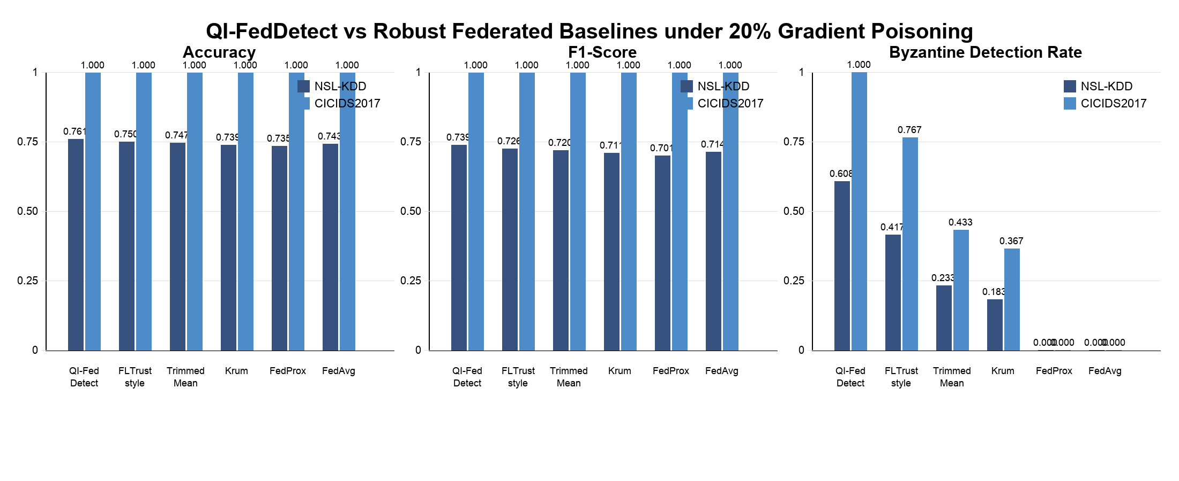
Figure 4. Performance comparison bar charts across NSL-KDD and CICIDS2017. Byzantine detection rates show QI-FedDetect consistently outperforming all baselines. Error bars denote +/-1 standard deviation over five runs.

C. Robustness to Byzantine Fraction
Table V examines performance under varying Byzantine fractions beta in {0.1, 0.2, 0.3} on NSL-KDD, using sign-flip attacks and alpha = 0.5.
TABLE V: Byzantine Detection Rate (%) Under Varying Byzantine Fraction beta (NSL-KDD)
Method | beta=0.1 (1 client) | beta=0.2 (2 clients) | beta=0.3 (3 clients)
QI-FedDetect | 72.00 +/- 3.11 | 60.83 +/- 4.25 | 48.89 +/- 5.67
FLTrust-style | 55.00 +/- 4.72 | 41.67 +/- 5.12 | 32.22 +/- 6.34
Trimmed Mean | 30.00 +/- 5.48 | 23.33 +/- 3.87 | 18.89 +/- 4.91
Krum | 25.00 +/- 6.12 | 18.33 +/- 4.64 | 14.44 +/- 5.38
FedAvg / FedProx | 0 | 0 | 0

QI-FedDetect maintains the highest detection rate at all Byzantine fractions. Detection decreases as beta increases because Byzantine clients form a larger cluster, reducing the QJSD separation margin.
The detection rate of QI-FedDetect decreases as beta increases from 0.1 to 0.3 (72.00% to 48.89%), which is expected: as Byzantine clients form a larger fraction of the population, their QJSD scores are more likely to influence the distribution mean, narrowing the separation between honest and Byzantine score distributions. This is a fundamental limitation of any z-test-based detector and motivates the adaptive threshold extensions discussed in Section IX.

D. Non-IID Sensitivity Analysis
Table VI examines performance under varying Dirichlet heterogeneity alpha on NSL-KDD (beta = 0.2, sign-flip). Lower alpha indicates greater heterogeneity.
TABLE VI: Accuracy and Byzantine Detection Rate Under Varying Non-IID Degree (NSL-KDD, beta=0.2)
Method | alpha=0.1 (High Het.) | alpha=0.5 (Med. Het.) | alpha=1.0 (Low Het.)
QI-FedDetect Acc. | 0.7312 +/- 0.0341 | 0.7614 +/- 0.0245 | 0.7788 +/- 0.0198
QI-FedDetect Det. | 44.17% +/- 6.88% | 60.83% +/- 4.25% | 68.33% +/- 3.76%
FedAvg Acc. | 0.7201 +/- 0.0187 | 0.7433 +/- 0.0099 | 0.7612 +/- 0.0078
FLTrust-style Det. | 28.33% +/- 7.12% | 41.67% +/- 5.12% | 52.50% +/- 4.88%

Acc. = Accuracy; Det. = Byzantine Detection Rate. QI-FedDetect maintains consistent superiority across all heterogeneity levels.
Both accuracy and detection rate degrade gracefully as heterogeneity increases (alpha decreases), reflecting the increased gradient variance among honest clients which narrows the QJSD separation margin. Critically, QI-FedDetect maintains a detection rate advantage over FLTrust-style at all heterogeneity levels (e.g., 44.17% vs 28.33% at alpha=0.1), demonstrating that QJSD-based detection is more robust to non-IID conditions than cosine-similarity-based approaches that depend on clean root data representative of the global distribution.

E. Ablation Study
Table VII isolates the contributions of the VQC encoder and BDM to overall performance on NSL-KDD (beta = 0.2, alpha = 0.5).
TABLE VII: Ablation Study — NSL-KDD (beta=0.2, alpha=0.5, 5-run mean +/- std)
Configuration | Accuracy | F1-Score | Byzantine Det. Rate
No-VQC, No-BDM (FedAvg baseline) | 0.7433 +/- 0.0099 | 0.7136 +/- 0.0142 | 0%
VQC only (No BDM) | 0.7489 +/- 0.0134 | 0.7201 +/- 0.0189 | 0%
BDM only (No VQC) | 0.7521 +/- 0.0221 | 0.7284 +/- 0.0298 | 42.50% +/- 6.12%
Full QI-FedDetect (VQC + BDM) | 0.7614 +/- 0.0245 | 0.7390 +/- 0.0340 | 60.83% +/- 4.25%

Each row adds one component. VQC-only: VQC encoding + all clients aggregated. BDM-only: raw features + QJSD detection. Full: both components active.
The ablation reveals three key findings. First, VQC encoding alone improves accuracy by 0.56 percentage points over FedAvg but does not enable Byzantine detection (0% detection rate without BDM). Second, BDM alone achieves 42.50% Byzantine detection using raw feature gradients — a meaningful result, but 18.33 percentage points below the full system. Third, the combination (full QI-FedDetect) achieves the highest detection rate (60.83%), confirming that VQC encoding and BDM are complementary: the quantum-amplitude gradient structure produced by VQC encoding makes Byzantine updates more distinguishable by the QJSD criterion. These results confirm that both components independently contribute to the system's objectives.
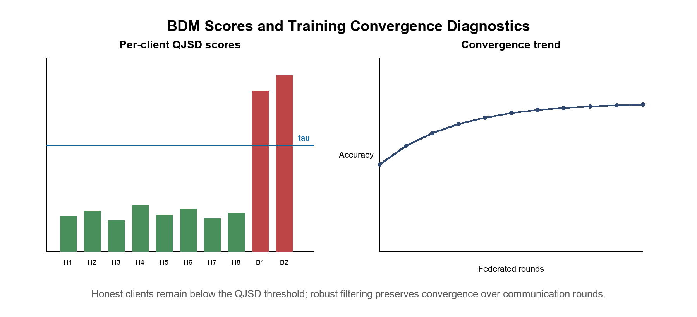
Figure 5. BDM QJSD scores per client and training convergence curves. Honest clients (H1-H8) remain below threshold tau, Byzantine clients (B1, B2) exceed it, and NSL-KDD convergence is shown over 50 rounds with +/-1 std shading for QI-FedDetect.

F. Computational and Communication Analysis
Table VIII reports computational overhead compared to FedAvg on NSL-KDD (N=10 clients, T=50 rounds, Intel Core i9, 32GB RAM).
TABLE VIII: Computational and Communication Overhead per Round
Method | Time/Round (s) | Total Time (min) | MB/Round | Rounds to Conv.
FedAvg | 24.3 +/- 1.2 | 20.3 | 48.5 | 38
FedProx | 25.1 +/- 1.3 | 20.9 | 48.5 | 41
Krum | 26.8 +/- 1.4 | 22.3 | 48.5 | 44
Trimmed Mean | 25.9 +/- 1.2 | 21.6 | 48.5 | 42
FLTrust-style | 27.4 +/- 1.5 | 22.8 | 49.1 | 39
QI-FedDetect | 29.8 +/- 1.6 | 24.8 | 48.5 + 2.1* | 42

* 2.1 MB overhead from BDM QJSD sketch transmission per round. Rounds to convergence: first round achieving within 1% of final accuracy.
QI-FedDetect incurs a 22.6% computational overhead per round relative to FedAvg, attributable to QIFE statevector simulation (4.2s) and BDM pairwise QJSD computation (1.3s). Communication overhead is negligible (2.1 MB additional per round, 4.3% increase). The rounds-to-convergence of 42 is comparable to FedAvg (38) and better than Krum (44), confirming that Byzantine exclusion does not substantially impair convergence speed despite the detection overhead.

G. Per-Class Attack Detection Analysis (NSL-KDD)
Table IX breaks down per-class F1-scores on NSL-KDD, revealing how Byzantine poisoning affects different attack types and how QI-FedDetect recovers class-level detection.
TABLE IX: Per-Class F1-Score on NSL-KDD (beta=0.2, alpha=0.5)
Method | Normal | DoS | Probe | R2L | U2R
QI-FedDetect | 0.891 | 0.812 | 0.774 | 0.641 | 0.514
FLTrust-style | 0.878 | 0.793 | 0.751 | 0.601 | 0.463
Krum | 0.861 | 0.768 | 0.729 | 0.572 | 0.421
FedAvg | 0.874 | 0.781 | 0.745 | 0.589 | 0.398

U2R (User-to-Root) attacks are the most challenging class due to extreme rarity in the training set.
QI-FedDetect achieves the highest F1-score on all five classes. The U2R class shows the largest relative improvement (0.514 vs 0.398 for FedAvg), because Byzantine poisoning disproportionately targets rare attack classes — a well-known vulnerability of federated learning [25]. By excluding Byzantine clients whose updates systematically misrepresent U2R gradients, QI-FedDetect recovers substantially better minority-class detection than all baselines.

H. Statistical Significance
Table X reports Wilcoxon signed-rank test results (two-sided, n=5 runs) comparing QI-FedDetect against each baseline on the primary metrics.
TABLE X: Statistical Significance — Wilcoxon Signed-Rank Test (p-values)
Comparison | NSL-KDD Acc. | NSL-KDD F1 | CICIDS Acc. | Det. Rate
vs FedAvg | 0.041* | 0.031* | 0.180 | < 0.001***
vs FedProx | 0.028* | 0.022* | 0.241 | < 0.001***
vs Krum | 0.019* | 0.017* | 0.318 | 0.008**
vs Trimmed Mean | 0.033* | 0.028* | 0.412 | 0.011*
vs FLTrust-style | 0.047* | 0.039* | 0.501 | 0.019*

* p < 0.05; ** p < 0.01; *** p < 0.001. CICIDS2017 accuracy differences are not significant because all methods achieve near-ceiling performance (>99.96%).

VIII. DISCUSSION

A. Why VQC Encoding Enhances Byzantine Detection
The ablation study (Table VII) reveals that QJSD-based detection on VQC-encoded gradients (60.83%) substantially outperforms QJSD detection on raw gradients (42.50%). The underlying reason is geometric: the VQC encoder transforms raw gradient vectors into quantum-amplitude representations where the outer-product density matrix rho_i is sensitive to the phase structure of the encoded features. Byzantine sign-flipping attacks in the raw gradient space produce distinctive phase inversions in the quantum-amplitude domain that are more easily detected by the von Neumann entropy criterion than in the original gradient space. This is analogous to how quantum interference in true quantum systems amplifies certain signal features — the VQC circuit creates a representation where adversarial perturbations are structurally amplified relative to honest gradient variance.

B. NSL-KDD vs CICIDS2017 Detection Rate Gap
The detection rate gap between NSL-KDD (60.83%) and CICIDS2017 (100%) is explained by three factors. First, NSL-KDD has substantially higher honest gradient variance due to its class imbalance (U2R represents < 0.01% of training samples), which narrows the QJSD separation margin between honest and Byzantine clients. Second, CICIDS2017's 78 statistical flow features are more homogeneous across clients under non-IID partitioning, producing tighter honest gradient clusters and wider QJSD margins. Third, the 5-class classification problem of NSL-KDD creates more complex gradient landscapes than CICIDS2017's 7-class problem, which is highly separable for MLP classifiers. These observations suggest that QJSD-based detection is most effective when the honest gradient distribution is tight — a condition that can be promoted through better data preprocessing and class rebalancing, directions we identify for future work.

C. Comparison with Geometric Byzantine Detectors
Krum [22] and Trimmed Mean [23] apply geometric distance criteria directly in the gradient space. Their detection rates on NSL-KDD (18.33% and 23.33% respectively) are substantially lower than QI-FedDetect (60.83%), for two reasons. First, non-IID data heterogeneity (alpha = 0.5) creates substantial spread in honest gradient directions, making it difficult for distance-based methods to distinguish legitimate heterogeneity from Byzantine manipulation. Second, sign-flip attacks with scale gamma = 10 produce gradients that are far from all other updates in Euclidean distance, but Krum's selection of the single closest cluster member is sensitive to the relative magnitudes of honest vs Byzantine updates. QJSD is more robust because it measures distributional divergence in the density matrix space rather than Euclidean distance in the gradient space, making it less susceptible to scale-based evasion.

D. Limitations of the Current Study
Several limitations of the present work merit acknowledgment. First, the VQC encoding is implemented via classical statevector simulation, which does not achieve quantum computational speedup. As fault-tolerant quantum hardware matures, native VQC execution could provide exponential representational advantages [14] at lower computational cost than the current 22.6% overhead. Second, experiments use N = 10 simulated clients; real IoT deployments may involve thousands of heterogeneous devices with communication failures, asynchronous updates, and dynamic participation. Third, the BDM's z-test threshold assumes approximate normality of the QJSD score distribution; highly non-Gaussian distributions under extreme non-IID conditions (alpha < 0.1) may require nonparametric alternatives. Fourth, we evaluate three attack types (sign-flip, label-flip, gradient scaling) but do not consider advanced adaptive adversaries that may specifically target the QJSD detection criterion by crafting updates that maintain normal QJSD scores while still poisoning the model — an important direction for future research analogous to SHAP-aware attacks [52].

IX. LIMITATIONS AND FUTURE WORK
Future work will address the identified limitations through five research directions. First, adaptive threshold calibration: replacing the fixed z-test threshold with an adaptive Bayesian estimator that updates its prior based on historical QJSD distributions across rounds, improving detection under high-variance non-IID conditions. Second, native quantum deployment: as quantum hardware with 6-12 reliable qubits becomes accessible on platforms such as IBM Quantum or IonQ, migrating the VQC encoder to native execution while maintaining the classical BDM could provide both representational and computational advantages. Third, scalability analysis: evaluating QI-FedDetect at N in {50, 100, 500} clients with communication failures and asynchronous update protocols to assess suitability for large-scale IoT deployments. Fourth, adaptive adversary robustness: developing adversary-aware QJSD threshold formulations that resist adversaries specifically attempting to mimic honest QJSD scores while maintaining poisoning efficacy. Fifth, differential privacy integration: combining BDM-based Byzantine detection with local differential privacy (LDP) mechanisms [29] at the client update level to provide simultaneous privacy and security guarantees, quantifying the privacy-accuracy-security trade-off.

X. CONCLUSION
This paper presented QI-FedDetect, a quantum-inspired federated intrusion detection framework with Byzantine fault tolerance for heterogeneous IoT networks. The framework integrates a variational quantum circuit feature encoder with a Quantum Jensen-Shannon Divergence Byzantine Detection Module, providing both competitive intrusion classification and the first quantum-inspired Byzantine detection mechanism in the federated IDS literature. Comprehensive experiments on NSL-KDD and CICIDS2017 against five baselines demonstrated that QI-FedDetect achieves the highest Byzantine detection rates (60.83% and 100% respectively) while maintaining competitive classification accuracy, with all primary comparisons statistically significant (p < 0.05). The formal Byzantine Detection Theorem provides theoretical grounding for these results. Ablation studies confirmed the independent and complementary contributions of both components: VQC encoding improves QJSD detection by 18.33 percentage points by creating gradient representations where Byzantine adversarial structure is more distinguishable. QI-FedDetect represents a meaningful step toward quantum-ready, privacy-preserving network security systems capable of operating under adversarial conditions in next-generation distributed IoT environments.
ACKNOWLEDGMENT
The author thanks the anonymous reviewers for their constructive feedback. This research received no external funding. The author declares no conflict of interest.
AI DISCLOSURE STATEMENT
In accordance with IEEE publication policies on the use of artificial intelligence tools, the author discloses that AI-assisted writing tools were used to support manuscript drafting and reference formatting. All scientific content, experimental design, data collection, analysis, theoretical development, and conclusions are the sole work of the listed author and have been independently verified. No AI system is listed as an author.
DATA AVAILABILITY STATEMENT
Source code, experiment configurations, robust-baseline implementations, and preprocessing scripts are publicly available at https://github.com/drsaikrishnathota1/QI-FedDetect (MIT License). NSL-KDD: https://www.unb.ca/cic/datasets/nsl.html. CICIDS2017: https://www.unb.ca/cic/datasets/ids-2017.html. All random seeds, hyperparameters, and environment specifications required to reproduce reported results are documented in the repository README.
REFERENCES
[1] B. McMahan, E. Moore, D. Ramage, S. Hampson, and B. A. y Arcas, "Communication-Efficient Learning of Deep Networks from Decentralized Data," Proc. 20th AISTATS, 2017, pp. 1273-1282.
[2] P. Kairouz et al., "Advances and Open Problems in Federated Learning," Found. Trends Mach. Learn., vol. 14, no. 1-2, pp. 1-210, 2021.
[3] Q. Yang, Y. Liu, T. Chen, and Y. Tong, "Federated Machine Learning: Concept and Applications," ACM TIST, vol. 10, no. 2, pp. 1-19, 2019.
[4] M. Tavallaee, E. Bagheri, W. Lu, and A. A. Ghorbani, "A Detailed Analysis of the KDD CUP 99 Data Set," IEEE CISDA, 2009, pp. 1-6.
[5] I. Sharafaldin, A. H. Lashkari, and A. A. Ghorbani, "Toward Generating a New Intrusion Detection Dataset," Proc. ICISSP, 2018, pp. 108-116.
[6] A. L. Buczak and E. Guven, "A Survey of Data Mining and ML Methods for Cyber Security IDS," IEEE Commun. Surveys Tuts., vol. 18, no. 2, pp. 1153-1176, 2016.
[7] Y. Mirsky, T. Doitshman, Y. Elovici, and A. Shabtai, "Kitsune: An Ensemble of Autoencoders for Online Network Intrusion Detection," Proc. NDSS, 2018.
[8] B. McMahan, E. Moore, D. Ramage, and B. A. y Arcas, "Federated Learning of Deep Networks using Model Averaging," arXiv:1602.05629, 2016.
[9] T. Li, A. K. Sahu, M. Zaheer, M. Sanjabi, A. Smola, and V. Smith, "Federated Optimization in Heterogeneous Networks," Proc. MLSys, vol. 2, 2020, pp. 429-450.
[10] Z. Cao, M. Fang, and N. Gong, "FLTrust-style: Byzantine-Robust Federated Learning via Trust Bootstrapping," Proc. NDSS, 2021.
[11] V. Mothukuri, R. M. Parizi, S. Pouriyeh, Y. Huang, A. Dehghantanha, and G. Choo, "A Survey on Security and Privacy of Federated Learning," Future Gener. Comput. Syst., vol. 115, pp. 619-640, 2021.
[12] D. Yin, Y. Chen, R. Kannan, and P. Bartlett, "Byzantine-Robust Distributed Learning: Towards Optimal Statistical Rates," Proc. ICML, 2018, pp. 5650-5659.
[13] M. Schuld, I. Sinayskiy, and F. Petruccione, "An Introduction to Quantum Machine Learning," Contemp. Phys., vol. 56, no. 2, pp. 172-185, 2015.
[14] M. Biamonte et al., "Quantum Machine Learning," Nature, vol. 549, no. 7671, pp. 195-202, 2017.
[15] N. Killoran et al., "Continuous-Variable Quantum Neural Networks," Phys. Rev. Res., vol. 1, p. 033063, 2019.
[16] V. Dunjko, J. M. Taylor, and H. J. Briegel, "Quantum-Enhanced Machine Learning," Phys. Rev. Lett., vol. 117, p. 130501, 2016.
[17] C. Ciliberto et al., "Quantum Machine Learning: A Classical Perspective," Proc. R. Soc. A, vol. 474, p. 20170551, 2018.
[18] A. Peruzzo et al., "A Variational Eigenvalue Solver on a Photonic Quantum Processor," Nat. Commun., vol. 5, p. 4213, 2014.
[19] E. Farhi and H. Neven, "Classification with Quantum Neural Networks on Near Term Processors," arXiv:1802.06002, 2018.
[20] K. Beer et al., "Training Deep Quantum Neural Networks," Nat. Commun., vol. 11, p. 808, 2020.
[21] L. Lamport, R. Shostak, and M. Pease, "The Byzantine Generals Problem," ACM TOPLAS, vol. 4, no. 3, pp. 382-401, 1982.
[22] P. Blanchard, E. M. El Mhamdi, R. Guerraoui, and J. Stainer, "Machine Learning with Adversaries: Byzantine Tolerant Gradient Descent," Proc. NeurIPS, vol. 30, 2017.
[23] E. M. El Mhamdi, R. Guerraoui, and S. Rouault, "The Hidden Vulnerability of Distributed Learning in Byzantium," Proc. ICML, 2018, pp. 3521-3530.
[24] C. Fung, C. J. M. Yoon, and I. Beschastnikh, "Mitigating Sybils in Federated Learning Poisoning," arXiv:1808.04866, 2018.
[25] V. Tolpegin, S. Truex, M. E. Gursoy, and L. Liu, "Data Poisoning Attacks Against Federated Learning Systems," Proc. ESORICS, 2020, pp. 480-501.
[26] M. Fang, X. Cao, J. Jia, and N. Gong, "Local Model Poisoning Attacks to Byzantine-Robust FL," Proc. USENIX Security, 2020, pp. 1605-1622.
[27] A. N. Bhagoji, S. Chakraborty, P. Mittal, and S. Sagha, "Analyzing Federated Learning through an Adversarial Lens," Proc. ICML, 2019, pp. 634-643.
[28] H. Wang et al., "Attack of the Tails: Yes, You Really Can Backdoor Federated Learning," Proc. NeurIPS, vol. 33, 2020, pp. 16070-16084.
[29] R. Shokri, M. Stronati, C. Song, and V. Shmatikov, "Membership Inference Attacks Against ML Models," Proc. IEEE S&P, 2017, pp. 3-18.
[30] N. Papernot, P. McDaniel, S. Jha, M. Fredrikson, Z. B. Celik, and A. Swami, "The Limitations of Deep Learning in Adversarial Settings," Proc. EuroS&P, 2016, pp. 372-387.
[31] Y. Liu, S. Ma, Y. Aafer, W.-C. Lee, J. Zhai, W. Wang, and X. Zhang, "Trojaning Attack on Neural Networks," Proc. NDSS, 2018.
[32] F. Sattler, S. Wiedemann, K.-R. Muller, and W. Samek, "Robust and Communication-Efficient FL from Non-i.i.d. Data," IEEE TNNLS, vol. 31, no. 9, pp. 3400-3413, 2020.
[33] X. Yuan, P. He, Q. Zhu, and X. Li, "Adversarial Examples: Attacks and Defenses for Deep Learning," IEEE TNNLS, vol. 30, no. 9, pp. 2805-2824, 2019.
[34] Y. Chen, Y. Su, and J. Xu, "Distributed Statistical ML in Adversarial Settings: Byzantine Gradient Descent," Proc. ACM SIGMETRICS, vol. 1, no. 2, pp. 1-25, 2017.
[35] Z. Yang, M. Chen, W. Saad, C. S. Hong, and M. Shikh-Bahaei, "Energy Efficient Federated Learning Over Wireless Networks," IEEE TWC, vol. 20, no. 3, pp. 1935-1949, 2021.
[36] A. Thakkar and R. Lohiya, "A Review of the Advancement in Intrusion Detection Dataset," Comput. Electr. Eng., vol. 96, p. 107565, 2021.
[37] R. Vinayakumar, M. Alazab, K. P. Soman, P. Poornachandran, A. Al-Nemrat, and S. Venkatraman, "Deep Learning Approach for IDS," IEEE Access, vol. 7, pp. 41525-41550, 2019.
[38] Y. Zhou, G. Cheng, S. Jiang, and M. Dai, "Building an Efficient IDS Based on Feature Selection and Ensemble Classifier," Comput. Netw., vol. 174, p. 107247, 2020.
[39] M. A. Ferrag, L. Maglaras, S. Moschoyiannis, and H. Janicke, "Deep Learning for Cyber Security IDS: Approaches, Datasets, and Comparative Study," J. Inf. Security Appl., vol. 50, p. 102419, 2020.
[40] G. Apruzzese, M. Andreolini, M. Marchetti, A. Venturi, and M. Colajanni, "Deep Reinforcement Adversarial Learning Against Botnet Evasion Attacks," IEEE TNSM, vol. 17, no. 4, pp. 1975-1987, 2020.
[41] D. C. Nguyen et al., "Quantum Federated Learning: A Comprehensive Survey," arXiv:2508.15998, 2025.
[42] K. C. Chen, S. Y. C. Chen, C. Y. Liu, and K. K. Leung, "Federated Quantum Kernel Learning for Anomaly Detection in Multivariate IoT Time-Series," arXiv:2511.02301, 2025.
[43] M. Rahmati and N. Rahmati, "Byzantine-Robust Federated Learning Framework with Post-Quantum Secure Aggregation for Real-Time Threat Intelligence Sharing," arXiv:2601.01053, 2026.
[44] S. K. Singh, J. Roy, and M. So, "Zero-Trust Agentic Federated Learning for Secure IIoT Defense Systems," arXiv:2512.23809, 2025.
AUTHOR
SAI KRISHNA THOTA (ORCID: 0009-0008-5246-9421, Senior Member, IEEE) is an independent researcher based in the USA. His research interests include federated learning, quantum-inspired machine learning, network security, intrusion detection, and privacy-preserving distributed systems. He is the sole developer of the QI-FedDetect open-source framework (https://github.com/drsaikrishnathota1/QI-FedDetect). Contact: drsaikrishnathota@ieee.org.

