Pfa-calibrated residual neural CFAR for small-target detection in cluttered UAV SAR signals
Research Paper
Dr. Sai Krishna Thota*
Independent Researcher, United States
E-mail: drsaikrishnathota@ieee.org
*Corresponding author.

Abstract
Onboard detection of few-pixel scatterers in unmanned-aerial-vehicle (UAV) synthetic aperture radar (SAR) is a computational signal-processing task. Cell-averaging constant-false-alarm-rate (CA-CFAR) detectors preserve a design false-alarm operating point in homogeneous speckle but can flood heterogeneous land-sea transitions, whereas black-box convolutional detectors can raise detection probability $P_{d}$ without preserving an explicit CFAR constraint. This paper presents PCR-CFAR, a $P_{fa}$-calibrated residual neural CFAR that retains an analytic two-dimensional CA-CFAR threshold and learns only a bounded multiplicative residual. Training combines a weighted detection objective with a logarithmic $P_{fa}$-matching loss on target-free cells. On 40 held-out two-look K-speckle UAV stripmap scenes at design $P_{fa}={10}^{−3}$, PCR-CFAR attains $P_{d}=1.00$ with empirical $P_{fa}=6.62×{10}^{−4}$ (32.5 false alarms per scene), versus $P_{d}=0.50$ and $P_{fa}=5.52×{10}^{−3}$ for CA-CFAR and $P_{d}=1.00$ but $P_{fa}=1.57×{10}^{−3}$ for a matched-capacity CNN baseline. At 4 dB, the CNN retains higher $P_{d}$ than PCR-CFAR (0.517 versus 0.325), while PCR-CFAR reaches $P_{d}=0.950$ at 6 dB. Regionally, PCR-CFAR yields $P_{fa}=6.73×{10}^{−4}$ on sea and $1.53×{10}^{−3}$ in the coastline edge band. On eight public TerraSAR-X clutter chips with injected 8 dB peaks, PCR-CFAR retains $P_{d}=1.00$ with empirical $P_{fa}=5.87×{10}^{−5}$; this transfer value is not design-calibrated. The 5122-parameter residual head therefore improves false-alarm control under the nominal two-look protocol, while labelled airborne-SAR evaluation remains necessary for operational validation.
Keywords: UAV SAR; constant false alarm rate; residual convolutional network; false-alarm calibration; small-target detection; onboard inference

1. Introduction
Low-altitude MiniSAR and UAV apertures now resolve compact ground vehicles and maritime scatterers that occupy only a few resolution cells [1,2]. Those peaks sit in multiplicative speckle whose amplitude is well described by compound-Gaussian, in particular K-distributed, clutter [3]. The classical remedy is CFAR: CA-CFAR, greatest-of (GO) CFAR and order-statistic (OS) CFAR adapt a local threshold so that the false-alarm rate stays near a design value in homogeneous interference [3,4]. Heterogeneous sea-land transitions, multi-target masking and Weibull or K textures can still inflate $P_{fa}$ or suppress $P_{d}$ [4]. Bayesian interference-control CFARs, CFAR-regularized sparse imaging, quadratic-statistic PolSAR CFARs, bilateral-censoring CFARs in log-normal sea clutter, range-compressed CFARs and density-clustering CFARs mitigate some of those failures, but they remain statistical rather than learned residual corrections around an analytic two-dimensional CA threshold [4,5,22,24-26].
Deep detectors for SAR ships and small objects have advanced rapidly. CFAR maps are commonly ingested as extra channels into YOLO- or transformer-style box detectors [6,7]; other networks use clutter-intensity statistics [8], complex-valued backbones [9], global-to-local transformers [10], feature-disentangled YOLO heads [11], MiniSAR vehicle pyramids [1], and compact multiscale fusion intended for constrained platforms [12]. Speckle-aware despeckling-and-detect pipelines further lift recall at low SNR [13-15]. Nested transformers such as FANT-Det target the same few-pixel maritime peaks under land-sea clutter [23]. Automotive radar work shows the analogous split between a CFAR point-cloud front-end and a learned detector on pre-CFAR cubes [16]. Small-boat signatures in staring-spotlight SAR confirm that the scatterer of interest may be only a handful of bright cells [17]. Optical-SAR fusion surveys still treat CFAR as a classical baseline rather than a learned constraint [18]. Optimized YOLO detectors on multi-resolution SAR continue to report inshore false alarms [19], while edge-enhanced transformers suppress those alarms at box level [20]. Lightweight YOLO and Ghost/StarNet variants now target satellite and airborne compute envelopes [29,33-35,37-41,43-45], and range-compressed networks push detection before full azimuth focusing [27,28].
Existing SAR small-target detectors therefore largely follow two complementary directions. Classical and modern CFAR variants retain an explicit false-alarm operating point but can become poorly calibrated in heterogeneous clutter, while most recent deep detectors improve recall or box-level localization without preserving a prescribed pixel-level false-alarm probability. CFARnet [21] is the closest learned-CFAR reference: it imposes a differentiable CFAR constraint on a neural likelihood-ratio test, but the neural detector itself remains free to learn the decision function. To the best of our review, comparatively little work has examined a lightweight UAV SAR pixel detector in which an analytic two-dimensional CA-CFAR threshold remains structurally embedded and the network learns only a bounded residual correction explicitly calibrated to the desired $P_{fa}$ on target-free cells. This distinction matters for onboard processing because the learned component should correct heterogeneous-clutter failure modes without discarding the interpretable analytic prior.
Accordingly, this study asks whether a compact residual learner can improve few-pixel target detection in heterogeneous UAV SAR clutter while maintaining empirical $P_{fa}$ at or below the prescribed operating point under the nominal two-look condition. PCR-CFAR addresses that question through
$$T_{PCR}\left(x,y\right)=T_{CA}\left(x,y\right)exp​\left(g\left(x,y\right) δ\left(x,y\right)\right),$$ (1)
where $T_{CA}$ is the analytic CA-CFAR threshold, $g∈\left(0,1\right)$ is a learned heterogeneity gate and $δ$ is a bounded log-residual. Detection is the pixel test $I>T_{PCR}$.
The contributions are: (i) a fully convolutional residual CFAR that cannot discard the analytic CA prior; (ii) a logarithmic $P_{fa}$-matching loss that performs most of the calibration work in the present coastline protocol, with the gate retained primarily as a conservative fallback; (iii) a fully specified two-look K-speckle UAV stripmap benchmark with region-wise false-alarm accounting, looks-matched CA/GO/OS controls, clutter mismatch, target crowding, centroid box-$F_{1}$, CA-window sensitivity and a public TerraSAR-X real-clutter transfer; and (iv) a lightweight implementation with 5122 learned parameters and 6944 multiply-adds per pixel. Section 2 reviews related detectors, Section 3 describes the method, Section 4 specifies the evaluation protocol, Section 5 reports results, Section 6 discusses limitations, and Section 7 concludes.

2. Related work

2.1 Statistical and clustering CFAR
Classical CFAR remains the reference for radar pixel detection in speckle [3]. GO- and OS-CFAR, and more recent Weibull Bayesian CFARs with area interference control, target heterogeneous windows [4]. Approximate maximum-likelihood bilateral censoring restores CFAR behaviour in log-normal SAR sea clutter [24]. Sparse imaging with a CFAR-ADMM regularizer folds the detector into reconstruction [5]. Quadratic-statistic PolSAR CFARs extend the same philosophy to polarimetric features [22]. A generalized-Gamma CFAR on range-compressed spaceborne echoes detects ships before azimuth compression [25]. Density clustering after a two-parameter CFAR improves heterogeneous and dense-target windows relative to sliding-ring estimators [26]. Concise polarimetric characterization patterns and graph structure-consistency detectors likewise suppress sea clutter when polarimetry is available [42,50]. None of these methods learns a bounded residual around the analytic threshold $T_{CA}$.

2.2 CFAR-guided and box-level deep detectors
CFAR-guided dual-polarization fusion [6] and YOLOv5s-CFAR [7] attach a CFAR map to a box detector. Clutter-intensity statistics can replace a parametric $P_{fa}$ model at box level [8]. Complex-valued networks [9], GL-DETR [10], FDI-YOLO [11], lightweight fusion heads [12], YOLO-OSD [19], SMEP-DETR [20] and FANT-Det [23] improve small-ship recall under inshore clutter, but they output boxes. Wavelet-driven YOLOX [37], CSS-YOLO [30] and DBW-YOLO [31] further target harbour false alarms. Progressive divergence-to-concentration paradigms reframe large-scene ship search as a coarse-to-fine population-then-individual problem [32]. Incept-TextCNN detectors and the RCShip benchmark move the task into the range-compressed domain [27,28]. Despeckling-and-detect pipelines [13-15] attack the low-SNR cliff from the image-formation side. CFARnet [21] is the closest neural baseline, but it is a CFAR constraint on a learned detector rather than a residual correction on an immutable CA-CFAR prior.

2.3 Lightweight detectors for airborne and satellite payloads
UAV and satellite envelopes motivate compact backbones: DFES-Net with deformable fusion and hierarchical pruning [29], LW-SARDet via decomposed convolution [34], faster/lighter GRSL detection [35], SEFRNet [36], LWSARDet with position-morphology matching [33], SSGY [39], multi-level lightweight fusion [40], Ghost-enhanced LGNet [41], DEPDet [49], YOLOv7oSAR [43], LHSDNet [44], a lightweight TAES CNN [45] and enhanced YOLO for small ships [38]. Those designs report SSDD/HRSID-style box metrics rather than a design $P_{fa}$ on a pixel CFAR. Automotive pre-CFAR cubes [16], MiniSAR vehicle pyramids [1], staring-spotlight boats [17] and optical-SAR fusion surveys [18] complete the application context. Rao/Wald maritime-radar tests [46] and triple-channel multimodal radar [47] show that false-alarm control extends beyond stripmap SAR. Quantum matched-filter focusing [48] is a reminder that imaging itself can dominate the compute budget; a residual CFAR must remain small.
Comparison of PCR-CFAR with recent detector families.
Family | Typical output | Design $P_{fa}$ | Typical learned scale | Relation to PCR-CFAR
Statistical CFAR [3-5,22,24-26] | pixel | yes | none | PCR learns a residual on CA; it does not replace GO/OS/K-CFAR theory
CFAR-guided YOLO [6,7] | box | CFAR as extra map | ${10}^{6}$-${10}^{7}$ | complementary box detector, not a pixel test
Lightweight SAR YOLO [29,33-36,39-41,43-45,49] | box | no | ${10}^{6}$ class | mAP-oriented operating point
Transformers / DETR [10,20,23] | box | no | large | inshore recall, not explicit CFAR calibration
CFARnet [21] | pixel / LRT | constrained | neural detector | CFAR penalty on a free learned test; PCR preserves $T_{CA}$
Polarimetric / fusion [9,18,42,50] | box or polarimetric map | mixed | mixed | requires dual-pol or optical information

3. Method

3.1 Scene model
Each $192×256$ intensity map is a two-look K-speckle UAV stripmap with a land-sea coastline, range spreading, and six point targets for training and Tables 1-4 or five targets for showcase figures. Targets are three-pixel Gaussian scatterers at a prescribed signal-to-clutter ratio (SCR). The compound-Gaussian texture follows the family used to analyse CA-CFAR in correlated K sea clutter [3]. Speckle motivates local CFAR thresholding rather than a global threshold [13-15,24]. UAV operation further motivates a lightweight module rather than a multi-million-parameter box detector [1,12,16,29,33-36,39-41,43-45,49]. Range-compressed CFARs [25] and clustering CFARs [26] are complementary priors; this study retains focused two-look intensity. Polarimetric entropy and graph-consistency methods [42,50] would apply only if the UAV collected dual-polarization data.

3.2 Analytic CFAR prior
A $21×21$ window with a $5×5$ guard ring yields
$$N={21}^{2}−5^{2}=416$$ (2)
training cells and a ring mean $μ$ computed by two uniform filters. For exponential single-look intensity, the CA-CFAR scale and threshold are
$$α_{L=1}=N\left(P_{fa}^{−1/N}−1\right), T_{CA}=α_{L=1}μ.$$ (3)
The scenes themselves use two-look K speckle, so $α_{L=1}$ is an analytic approximation rather than an exact K-CFAR scale [3]. For looks-matched analytic controls, the corresponding gamma-model threshold scale is denoted $α_{L}$. The $L=2$ scale is used only for CA-2L/GO-2L/OS-2L controls and is not the prior seen by PCR-CFAR. GO-CFAR takes the greater of left/right rectangular means; OS-CFAR uses a 75th-percentile proxy rather than an exact order statistic [4]. Local coefficient of variation (CV) on the same ring is a third input channel. Changing the CA window to $13×13$ or $31×31$ leaves the exponential-CA empirical $P_{fa}$ near $5.4×{10}^{−3}$-$5.7×{10}^{−3}$, showing that the shoreline excess is not a window-size artefact.
$$α_{L}=N\left(P_{fa}^{−1/(NL)}−1\right)$$ (4)

3.3 Residual head
Inputs are $\left(logI,logT_{CA},CV/5\right)$. Three $3×3$ SiLU convolutions with 16 channels, followed by two $1×1$ heads, produce
$$δ=1.2tanh\left(⋅\right), g=σ\left(⋅\right).$$ (5)
If $g→0$, the threshold falls back to CA-CFAR. In practice, the mean gate is 0.991 on sea, 0.982 on the edge band and 0.990 on homogeneous-only scenes, so this architectural fallback is only weakly used. Figure 3 plots the measured threshold, local CV, gate and gated residual along one range cut. The network cannot discard the analytic threshold; it can only adjust it multiplicatively through the bounded residual. Parameter count is 5122. The multiply-add count per pixel is
$$3\left(3×3×16×16\right)+2\left(1×1×16\right)=6944.$$ (6)

3.4 Loss and training
Let
$$s=\frac{logI−logT}{τ}, τ=0.25.$$ (7)
Binary cross-entropy on target-centre pixels is weighted by 80; clutter pixels use unweighted binary cross-entropy. The calibration term is
$$L_{Pfa}={\left[log​\left(soft\text{-}P_{fa}\right)−logP_{fa}^{⋆}\right]}^{2}, P_{fa}^{⋆}={10}^{−3}.$$ (8)
Soft-$P_{fa}$ is the mean sigmoid score over target-free cells, so the term is differentiable and uses all clutter cells rather than a Monte-Carlo count. This follows the CFAR-constrained learning idea of CFARnet [21], but applies it to a residual around CA-CFAR. A matched-capacity black-box CNN (CNN-CFAR, 4817 parameters) predicts $logT$ from $logI$ alone under the same loss. Training uses 80 scenes with SCR drawn uniformly from 5-12 dB, 16 epochs, Adam at $1.5×{10}^{−3}$, batch size 4, on CPU. The positive weight 80 offsets the $6/49152$ occupancy of target centres.

4. Experimental protocol
Baselines are CA-, GO- and OS-CFAR at the same design $P_{fa}$ with the exponential scale $α_{L=1}$, plus CNN-CFAR. A looks-matched CA-2L control uses $α_{L=2}$ on the same ring mean and is not an input to PCR-CFAR; GO-2L and OS-2L use the same gamma scale. A looks-adaptive CA control uses the local estimator $\hat{L}≈1/{CV}^{2}$ on a $7×7$ ring.
Forty test scenes (seeds 2000-2039) at SCR $=8$ dB give Tables 1, 2 and 4 and Figure 6. Twenty of those scenes, re-rendered at SCR $∈\{4,6,8,10,12\}$ dB, give Table 3 and Figure 4. Table 5 reports: (i) look order $L∈\{1,2,4\}$; (ii) K-texture shape $ν∈\{0.8,1.6,3.2\}$, with $ν=1.6$ used for training; (iii) CA window size $13$, $21$ and $31$; (iv) twelve-target crowding; (v) looks-matched GO-2L and OS-2L; (vi) centroid box-$F_{1}$; and (vii) public-clutter transfer.
A target is counted as detected if any pixel within a two-cell radius of its centre exceeds threshold. False alarms are detections outside a two-cell exclusion around every true centre. Connected-component box-$F_{1}$ matches detected-component centroids to true centres within a three-cell radius. Ablations freeze the trained residual with the gate forced to one. Region-wise $P_{fa}$ uses a four-cell morphological coastline band as the edge region, with the remaining pixels divided into land and sea. Mean gate is also reported on sea, edge and ten homogeneous-sea scenes.
The protocol is simulation plus a public-clutter transfer. Eight $192×256$ chips are cropped from a Wikimedia Commons TerraSAR-X preview of the Wadden Sea and Sylt Island; six Gaussian point targets are injected at SCR $=8$ dB. Display grey is mapped to positive intensity and is not a calibrated two-look K product, so empirical $P_{fa}$ on those chips is not directly comparable with the design ${10}^{−3}$. The transfer therefore asks whether the residual still fires on injected peaks in real spatial texture. It does not replace MiniSAR field trials [1], public SSDD/HRSID/LS-SSDD/RCShip box-level scores [2,6,10,11,19,20,23,28,32], or real small-boat collections [17]. Complex-valued, transformer, progressive-search and polarimetric detectors remain complementary because they output boxes or require polarimetry [9,10,20,23,32,42].

5. Results
Table 1. Mean operating point on 40 UAV SAR scenes at SCR = 8 dB and design $P_{fa}={10}^{−3}$.
Method | $P_{d}$ | Empirical $P_{fa}$ | FA / scene | $F_{1}$
CA-CFAR | 0.500 | $5.52×{10}^{−3}$ | 270.5 | 0.021
GO-CFAR | 0.304 | $3.96×{10}^{−3}$ | 194.1 | 0.018
OS-CFAR | 0.108 | $2.21×{10}^{−3}$ | 108.1 | 0.011
CNN-CFAR | 1.000 | $1.57×{10}^{−3}$ | 77.0 | 0.135
PCR-CFAR | 1.000 ± 0.000 | (6.62 ± 0.12) × 10⁻⁴ | 32.5 | 0.270
Under the nominal two-look condition, PCR-CFAR is the only tested method whose mean empirical $P_{fa}$ is below the design value while detecting every 8 dB point target. CA-CFAR reaches only $P_{d}=0.50$ at $P_{fa}=5.52×{10}^{−3}$; CNN-CFAR saturates $P_{d}$ but remains above the design line at $1.57×{10}^{−3}$.
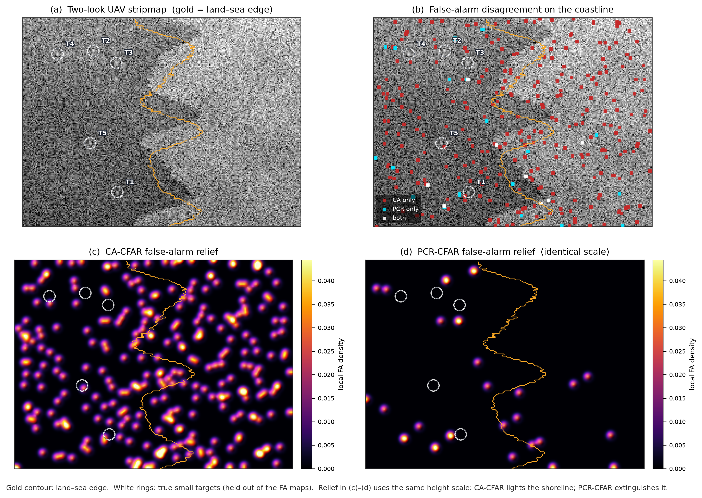
Figure 1. False-alarm atlas of one held-out 8 dB UAV stripmap. (a) Two-look intensity with the land-sea edge in gold. (b) CA-only false alarms (red) versus PCR-only alarms (cyan). (c,d) Shared-scale false-alarm relief.
Figure 1 shows the inshore-interference problem that CFAR-guided and clutter-aware box detectors address at object level [6,8,13,15,19,30,31,37], restated here as a pixel-CFAR calibration problem. CA-CFAR lights the coastline; PCR-CFAR largely suppresses that false-alarm concentration.
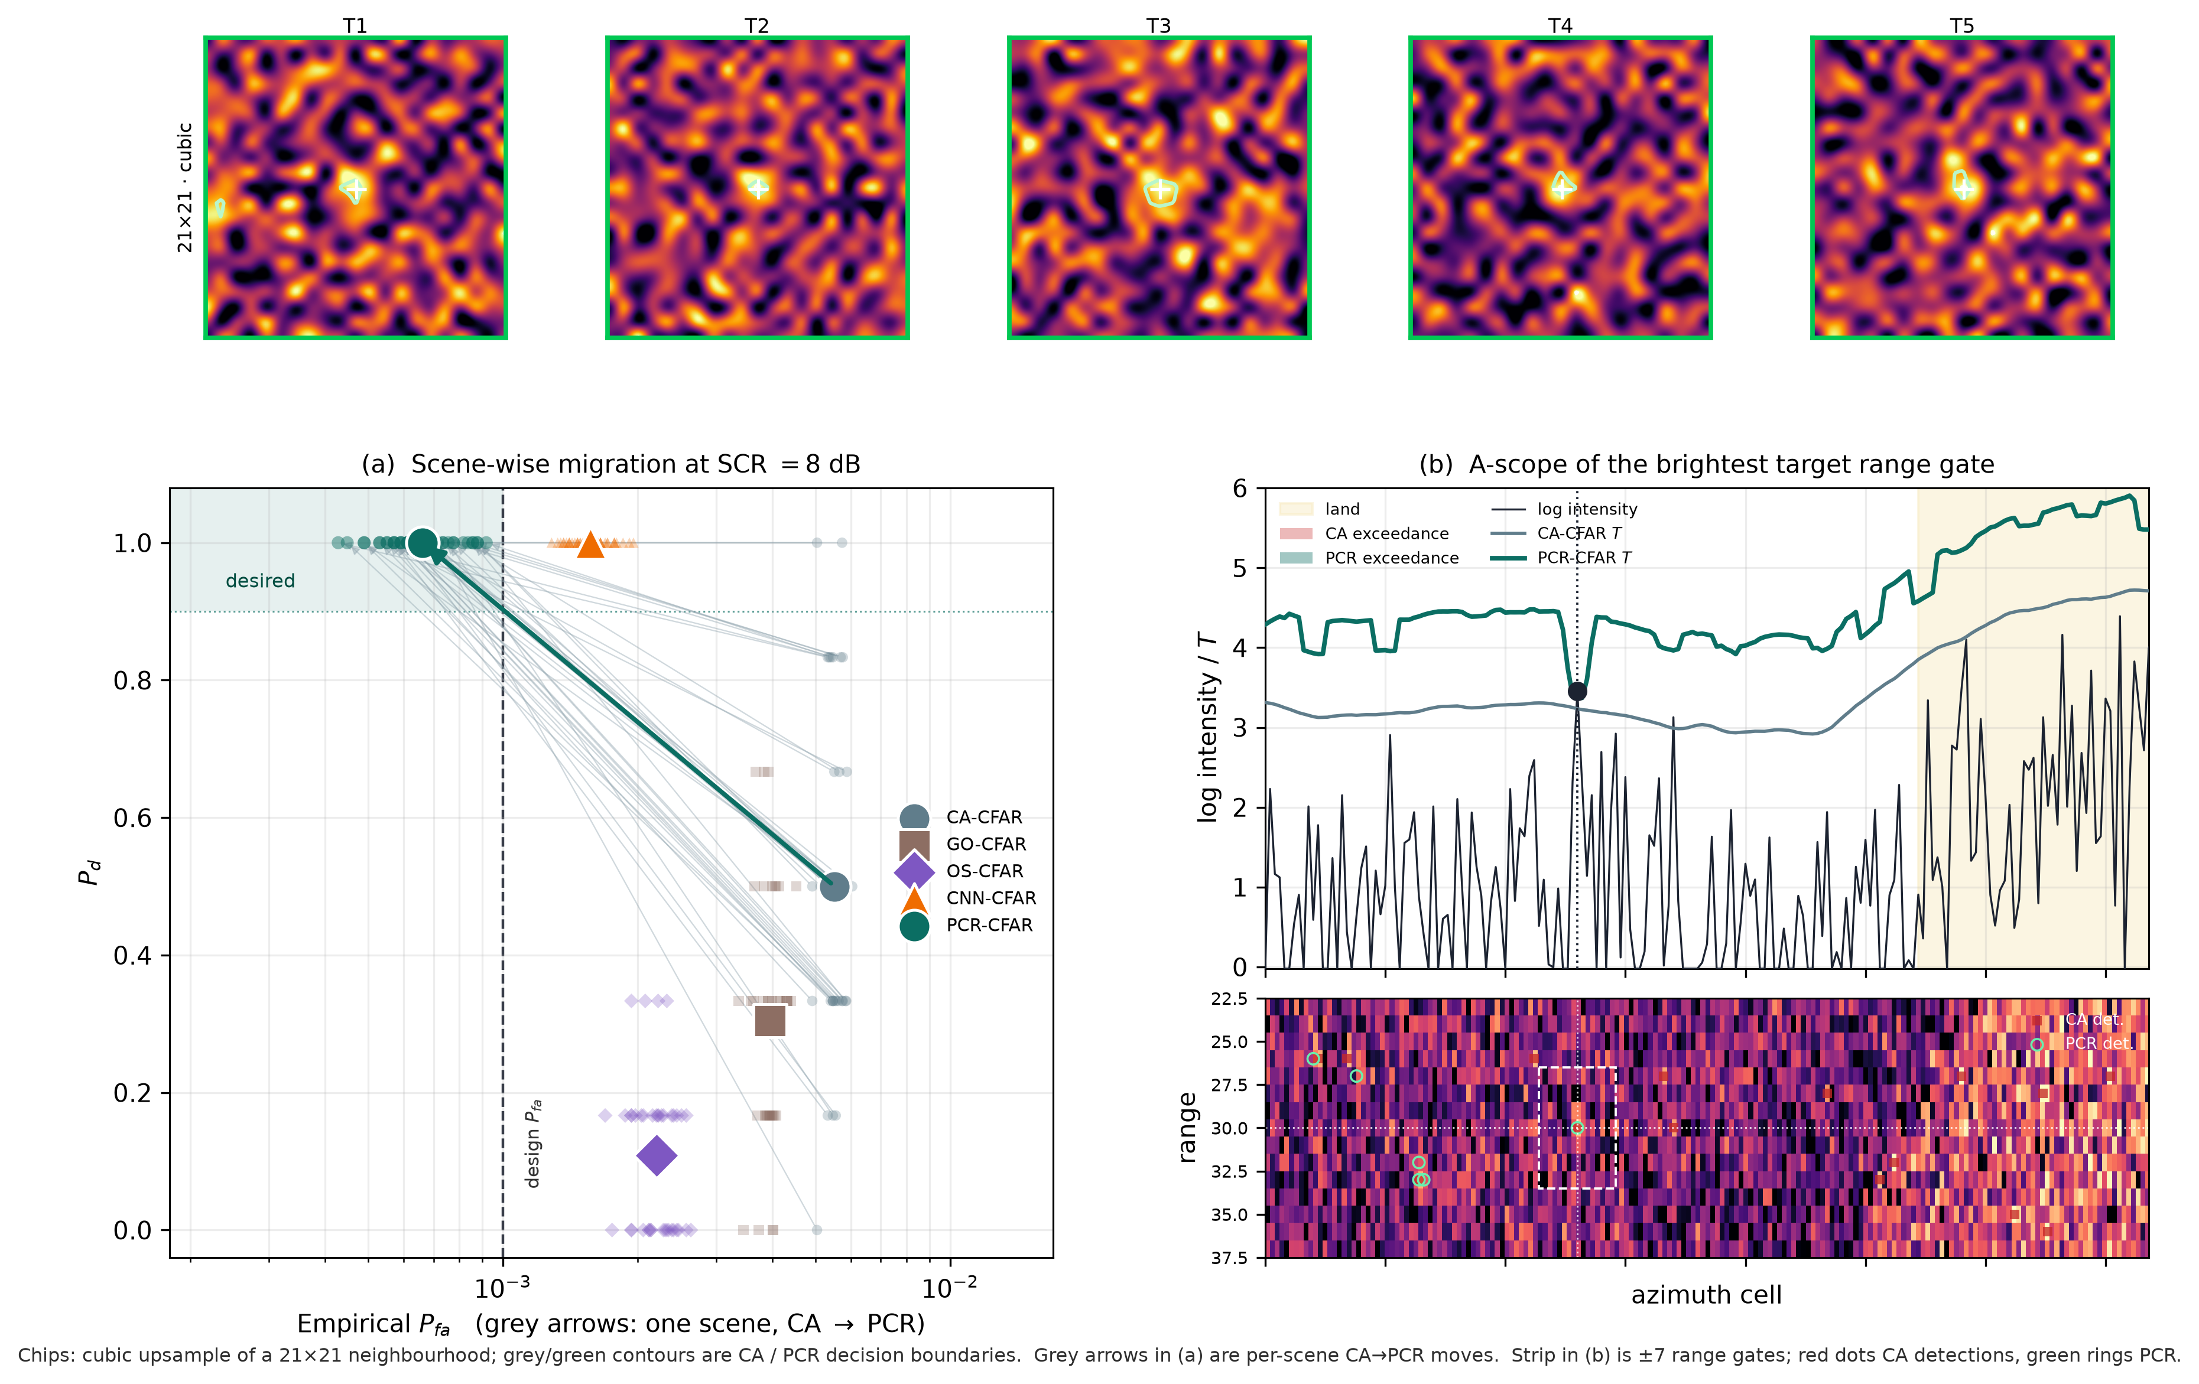
Figure 2. Operating geometry. Top: cubic-upsampled $21×21$ chips. (a) Scene-wise CA-to-PCR migration at SCR = 8 dB. (b) A-scope and range-azimuth strip of the brightest target gate.
Figure 2 makes the few-pixel geometry explicit [1,2,10,15,17,23,38]. The mean operating point moves into the desired quadrant $P_{d}≥0.9$, $P_{fa}≤{10}^{−3}$. CNN-CFAR also saturates $P_{d}$ but remains to the right of the design line, consistent with the accuracy-versus-false-alarm trade-off documented for unconstrained neural detectors [21,45].
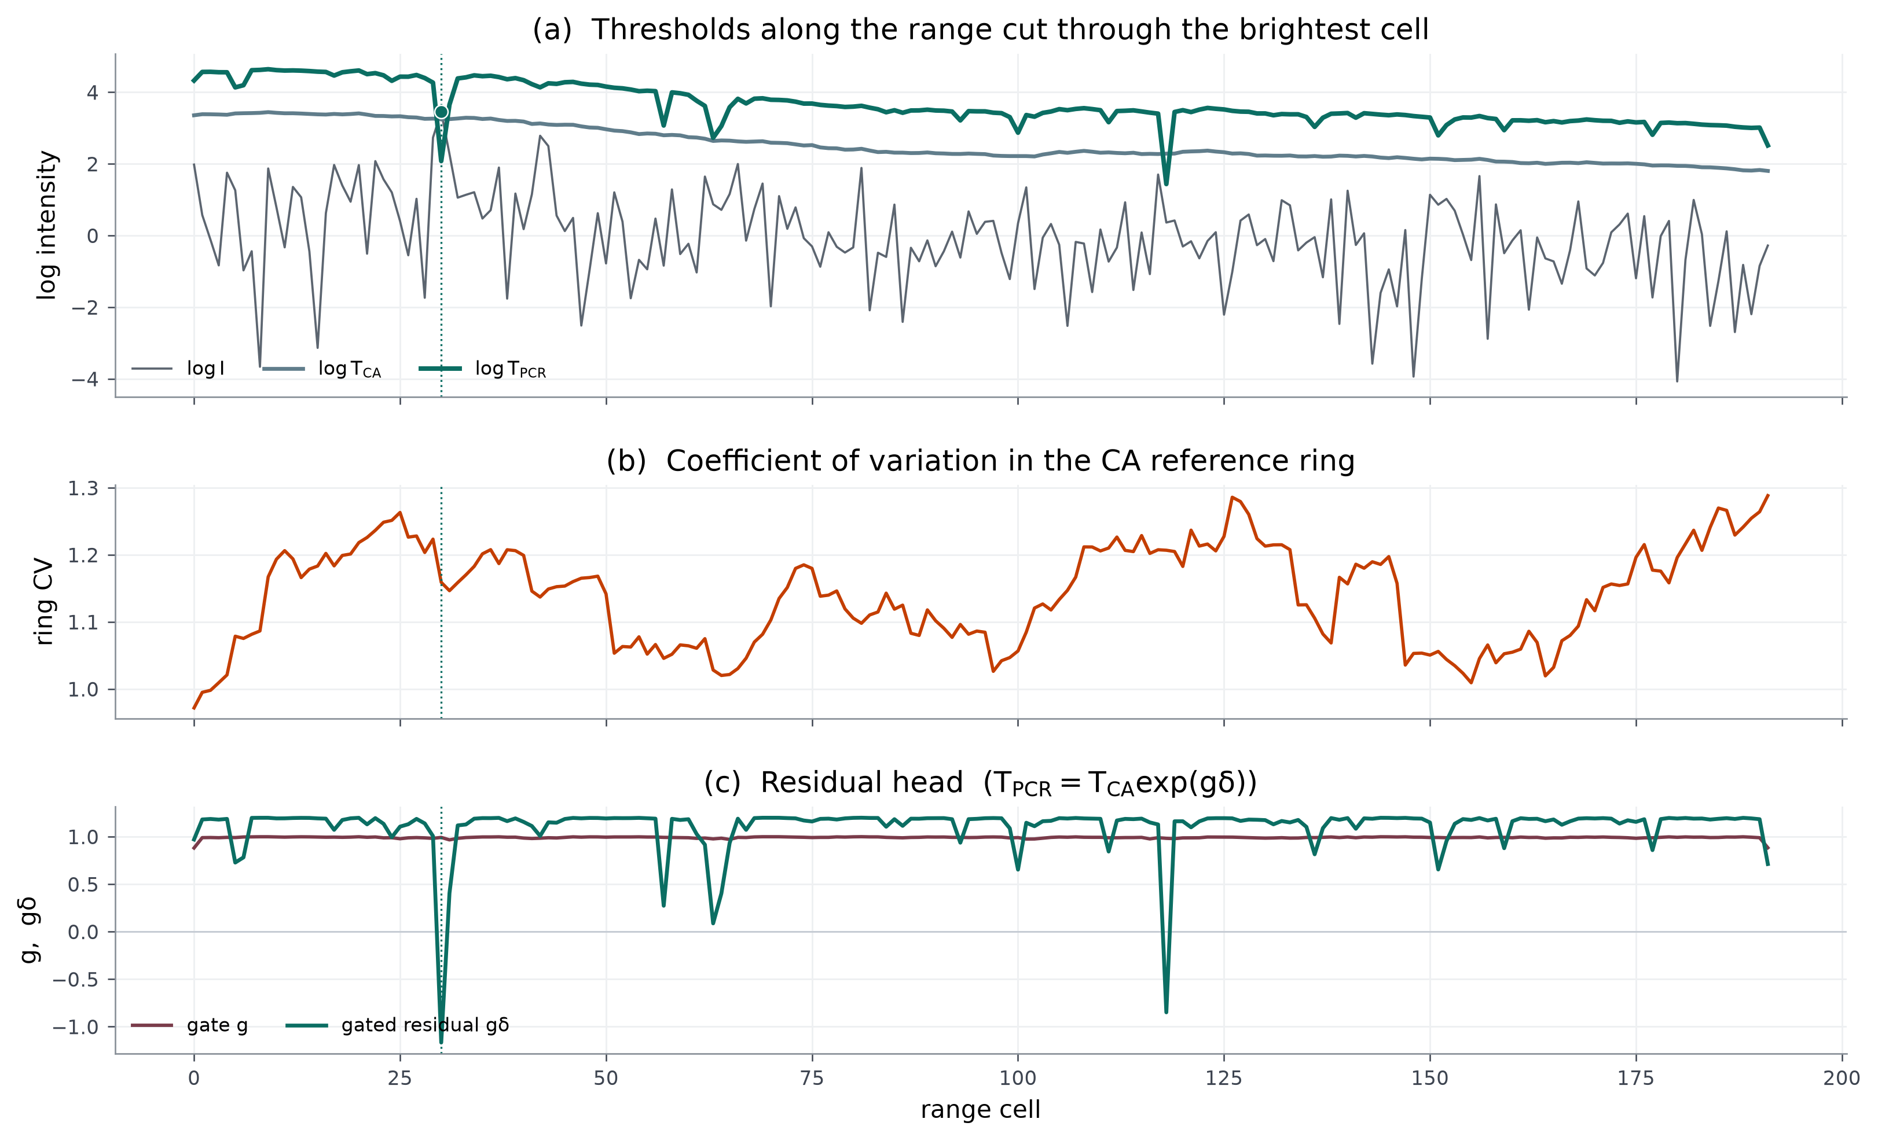
Figure 3. Internals along the range cut through the brightest cell. (a) $logI$ with CA and PCR thresholds. (b) Ring coefficient of variation. (c) Gate $g$ and gated residual $gδ$. The dotted line is the target range.
Figure 3 shows that the learned PCR threshold is mostly a modest residual adjustment to CA-CFAR. The gate remains close to one over most of the cut, confirming that the residual and calibration loss, rather than selective gate closure, dominate the present operating point.
Table 2. Ablation at the 8 dB operating point, including analytic controls.
Variant | $P_{d}$ | Empirical $P_{fa}$
CA-CFAR (exponential $α_{L=1}$, network prior) | 0.500 | $5.52×{10}^{−3}$
CA-CFAR, two-look gamma ($α_{L=2}$) | 1.000 | $4.35×{10}^{−2}$
CA-CFAR, looks-adaptive ($\hat{L}=1/{CV}^{2}$) | 0.721 | $6.62×{10}^{−3}$
Ungated residual (gate $≡1$) | 1.000 | $6.70×{10}^{−4}$
Black-box CNN-CFAR (no CA prior) | 1.000 | $1.57×{10}^{−3}$
PCR-CFAR (gated residual + $P_{fa}$ loss) | 1.000 | $6.62×{10}^{−4}$
Ablation shows that the gate is only weakly selective and the ungated residual already reaches $P_{fa}=6.70×{10}^{−4}$. The $P_{fa}$ loss and bounded residual therefore do most of the calibration work. The looks-matched CA-2L control reaches $P_{d}=1.00$ only with a much larger false-alarm rate, while the looks-adaptive analytic control remains well above design. These controls indicate that PCR-CFAR is not merely reproducing a hidden two-look scale factor.
Table 3. Mean $P_{d}$ versus SCR on 20 scenes.
Method | 4 dB | 6 dB | 8 dB | 10 dB | 12 dB
CA-CFAR | 0.125 | 0.150 | 0.475 | 1.000 | 1.000
GO-CFAR | 0.083 | 0.108 | 0.292 | 0.975 | 1.000
OS-CFAR | 0.042 | 0.042 | 0.108 | 0.975 | 1.000
CNN-CFAR | 0.517 | 0.933 | 1.000 | 1.000 | 1.000
PCR-CFAR | 0.325 | 0.950 | 1.000 | 1.000 | 1.000
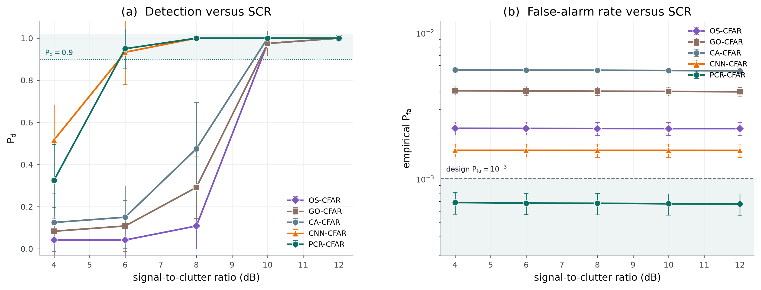
Figure 4. SCR sweep on 20 scenes. (a) Detection probability. (b) Empirical $P_{fa}$ on a log axis; the dashed line is the design rate ${10}^{−3}$.
Figure 4 locates the SNR cliff. At 4 dB, CNN-CFAR leads PCR-CFAR in $P_{d}$ (0.517 versus 0.325); at 6 dB, PCR-CFAR reaches 0.950 while retaining its lower false-alarm operating point. Classical CFARs do not saturate until approximately 10 dB. Empirical $P_{fa}$ is nearly SCR-invariant because the false alarms are clutter-driven.
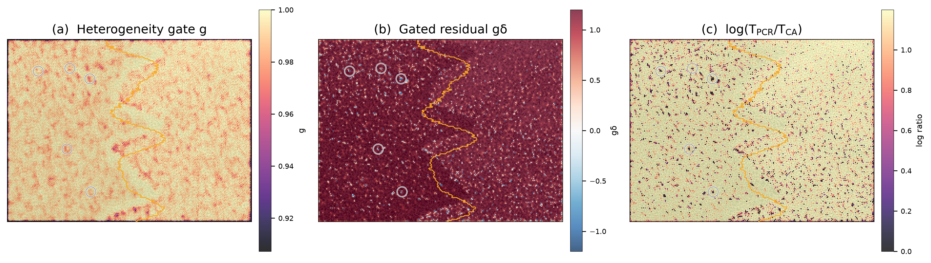
Figure 5. Learned maps on the showcase scene. (a) Gate $g$ (near saturation). (b) Gated residual $gδ$. (c) Log threshold ratio $log\left(T_{PCR}/T_{CA}\right)$.
Figure 5 visualizes the mechanism directly. Mean $g$ is 0.991 on sea and 0.982 on the edge, so the gate is not strongly discriminative on this texture. This supports treating the gate as a conservative fallback rather than as the central source of calibration.
Table 4. Mean regional $P_{fa}$ at 8 dB and computational budget.
Method | Sea | Edge | Land | Params | MAC / pixel
CA-CFAR | $4.80×{10}^{−3}$ | $8.77×{10}^{−3}$ | $5.61×{10}^{−3}$ | - | -
GO-CFAR | $3.50×{10}^{−3}$ | $5.20×{10}^{−3}$ | $4.21×{10}^{−3}$ | - | -
OS-CFAR | $1.82×{10}^{−3}$ | $4.51×{10}^{−3}$ | $2.14×{10}^{−3}$ | - | -
CNN-CFAR | $1.49×{10}^{−3}$ | $4.73×{10}^{−3}$ | $9.43×{10}^{−4}$ | 4817 | $≈7×{10}^{3}$
PCR-CFAR | $6.73×{10}^{−4}$ | $1.53×{10}^{−3}$ | $4.45×{10}^{−4}$ | 5122 | 6944
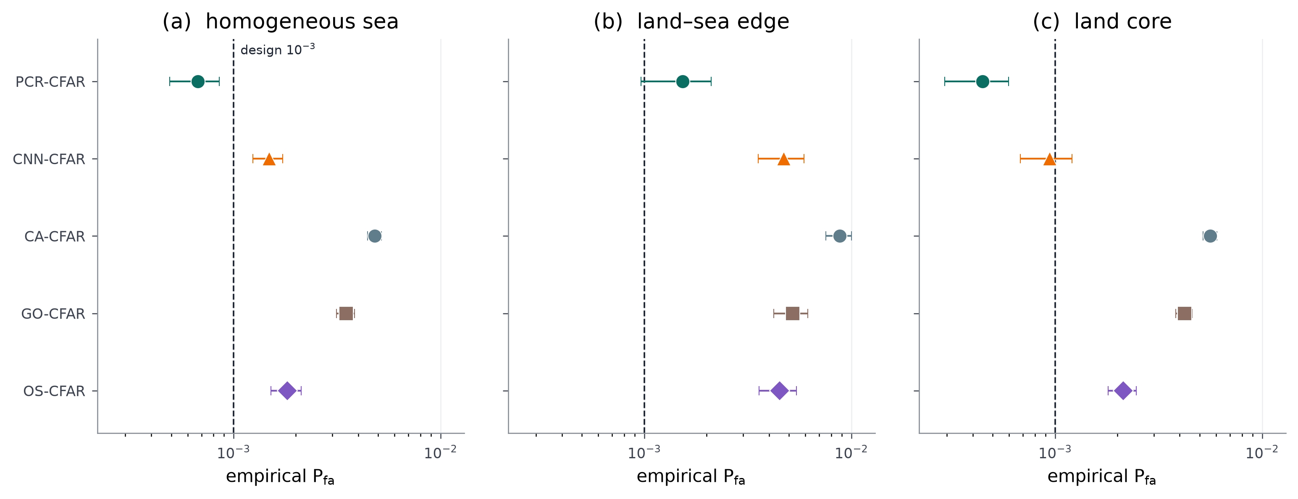
Figure 6. Regional empirical $P_{fa}$ at 8 dB on 40 scenes. Points are means; whiskers are $±1$ s.d. The dashed line is the design rate ${10}^{−3}$.
Figure 6 shows that the remaining PCR-CFAR alarms concentrate on the morphological edge band at $1.53×{10}^{−3}$, still far below CA-CFAR’s $8.77×{10}^{−3}$ there. Sea and land means both lie below the nominal design line.
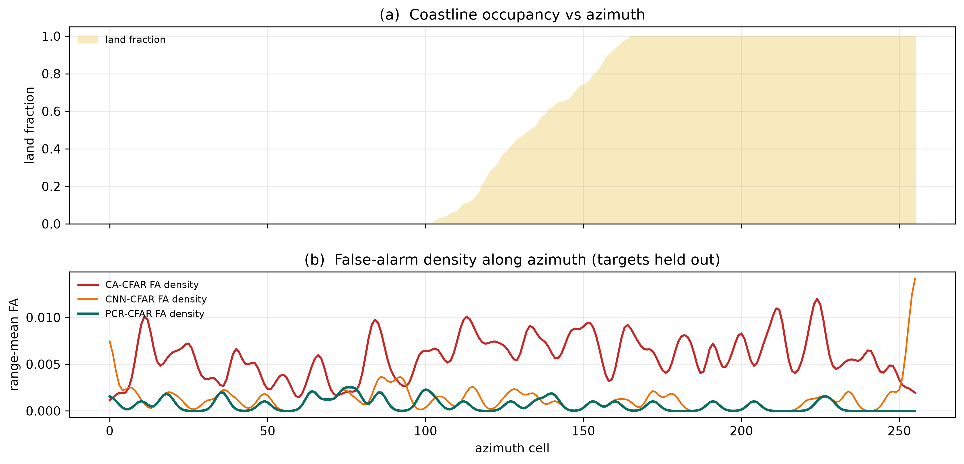
Figure 7. Azimuth collapse of the showcase scene. (a) Land fraction. (b) Range-mean false-alarm density with targets held out.
Figure 7 confirms the same spatial split: CA-CFAR false-alarm density tracks the land mass, PCR-CFAR stays comparatively low across sea and land, and CNN-CFAR exhibits a far-azimuth edge spike in this showcase.
Table 5. Robustness and transfer tests, 20 held-out scenes at SCR = 8 dB unless noted. Training used $L=2$, texture shape $ν=1.6$, a $21×21$ window and six targets.
Study | Setting | CA $P_{d}/P_{fa}$ | CNN $P_{d}/P_{fa}$ | PCR $P_{d}/P_{fa}$
Looks | $L=1$ | $0.483/1.17×{10}^{−2}$ | $0.975/1.99×{10}^{−3}$ | $1.000/1.75×{10}^{−3}$
Looks | $L=2$ (train) | $0.475/5.55×{10}^{−3}$ | $1.000/1.57×{10}^{−3}$ | $1.000/6.80×{10}^{−4}$
Looks | $L=4$ | $0.558/2.45×{10}^{−3}$ | $1.000/1.18×{10}^{−3}$ | $1.000/3.30×{10}^{−4}$
Texture | $ν=0.8$ (spikier) | $0.608/1.25×{10}^{−2}$ | $1.000/1.95×{10}^{−3}$ | $1.000/1.91×{10}^{−3}$
Texture | $ν=3.2$ (milder) | $0.575/2.10×{10}^{−3}$ | $1.000/1.10×{10}^{−3}$ | $1.000/2.83×{10}^{−4}$
Crowding | 12 targets | $0.500/5.50×{10}^{−3}$ | $1.000/1.56×{10}^{−3}$ | $1.000/6.75×{10}^{−4}$
GO-2L | $α_{L=2}$ | $1.000/3.51×{10}^{−2}$ | - | -
OS-2L | $α_{L=2}$ | $1.000/2.33×{10}^{−2}$ | - | -
Box $F_{1}$ | centroid, $r=3$ | 0.022 | 0.153 | 0.297
Public TerraSAR-X clutter | 8 chips, injected 8 dB | $0.938/5.10×{10}^{−6}$ | $1.000/6.12×{10}^{−5}$ | $1.000/5.87×{10}^{−5}$
CA window | $13×13$ | $0.425/5.40×{10}^{−3}$ | - | -
CA window | $21×21$ | $0.475/5.55×{10}^{−3}$ | - | -
CA window | $31×31$ | $0.500/5.65×{10}^{−3}$ | - | -
Centroid box-$F_{1}$ on the same 40 scenes is 0.297 for PCR-CFAR versus 0.153 for CNN-CFAR and 0.022 for CA-CFAR, showing that pixel-level calibration does not by itself eliminate false connected components. On eight public TerraSAR-X Wadden Sea chips with injected 8 dB peaks, PCR-CFAR keeps $P_{d}=1.00$ at $P_{fa}=5.87×{10}^{−5}$ and box $F_{1}=0.944$; those grey-level $P_{fa}$ values are not design-calibrated.
Table 5 is the stress test. Single-look speckle and spikier K texture both lift PCR-CFAR above the nominal ${10}^{−3}$ design line, to $1.75×{10}^{−3}$ and $1.91×{10}^{−3}$, respectively, although PCR-CFAR remains substantially below CA-CFAR and keeps $P_{d}=1.00$. Four-look and milder texture move PCR-CFAR further below design. Twelve-target crowding does not break calibration. Exponential-CA $P_{fa}$ is nearly independent of window size from 13 to 31, reinforcing that the dominant issue is heterogeneity rather than the nominal training-cell count.
End-to-end thresholding of one $192×256$ scene on CPU, including the classical CFAR front-end and residual head, is approximately 183 ms in this implementation. Dual-polarization fusion, complex-valued backbones, DETR-style edges, nested transformers, polarimetric entropy, graph-consistency PolSAR detectors and quadratic PolSAR CFARs [6,9,20,22,23,42,50] would be complementary if corresponding data were available. Optical-SAR fusion [18], range-compressed learning [25,27,28] and quantum focusing [48] are outside the present scope.

6. Discussion
Validation scope. The primary quantitative evidence is obtained from a fully specified two-look K-speckle simulator rather than a labelled airborne MiniSAR field dataset. The TerraSAR-X experiment uses real spatial clutter but synthetic injected peaks, so it should be interpreted as a real-clutter transfer test rather than full real-target validation. Direct evaluation on labelled UAV/MiniSAR imagery, or on a dataset that supports pixel-level false-alarm accounting, remains necessary before making operational generalization claims.
Calibration under mismatch. PCR-CFAR meets the prescribed $P_{fa}$ operating point under the nominal two-look training/test condition, but it is not a distribution-free CFAR guarantee. Single-look speckle and spikier K texture raise empirical PCR-CFAR $P_{fa}$ above ${10}^{−3}$. Future work should therefore examine explicit look/texture conditioning, domain adaptation, or online recalibration when clutter statistics change.
Analytic-control interpretation. The CA-2L, GO-2L and OS-2L controls show that simply replacing the exponential scale by a looks-matched gamma-model scale does not reproduce the PCR operating point on this heterogeneous coastline. Their large empirical false-alarm rates are therefore best interpreted as a property of the analytic controls under the chosen heterogeneous-reference geometry, not as evidence that two-look matching is universally harmful. The present claim is narrower: the learned residual around the fixed exponential CA prior achieves the reported calibrated operating point on this protocol.
Detection and localization limits. The method is a calibrated pixel detector, not a box detector. Pixel $F_{1}=0.270$ and centroid-box $F_{1}=0.297$ still imply substantial false clustering. The detection loss uses target-centre pixels rather than the full three-pixel Gaussian support, and below 6 dB the matched-capacity CNN can lead PCR-CFAR in $P_{d}$. These observations separate false-alarm calibration from downstream object grouping and very-low-SCR sensitivity.
Architectural interpretation. The heterogeneity gate is weakly selective in the present experiments: forcing the gate open gives $P_{fa}=6.70×{10}^{−4}$ versus $6.62×{10}^{−4}$ for the full model. The evidence therefore supports the analytic CA prior + bounded residual + explicit $P_{fa}$-matching loss as the central mechanism. The gate should be viewed as a conservative architectural fallback, not as the primary novelty claim.

7. Conclusion
PCR-CFAR is a $P_{fa}$-calibrated residual around two-dimensional CA-CFAR for small-target detection in heterogeneous UAV SAR clutter. Under the nominal two-look K-speckle coastline protocol, it is the only tested detector whose mean empirical $P_{fa}$ lies below the prescribed ${10}^{−3}$ operating point while detecting every 8 dB point target. Looks-matched analytic CA/GO/OS controls, a CV-based looks estimator, look/texture mismatch, crowding, CA-window sensitivity, centroid box-$F_{1}$, regional false-alarm accounting and a public TerraSAR-X real-clutter transfer show that the gain is not a hidden $L=2$ scale factor or window-size artefact. At the same time, mismatch experiments show that calibration is not universal, the gate contributes little additional calibration in the current setting, and the public transfer does not substitute for labelled target data. The next measurement should therefore be a labelled airborne-SAR evaluation with pixel-level false-alarm accounting, followed by explicit recalibration or adaptation across changing clutter statistics.

CRediT authorship contribution statement
Sai Krishna Thota: Conceptualization, methodology, software, investigation, visualization, writing - original draft, writing - review and editing.

Declaration of competing interest
The author declares that he has no known competing financial interests or personal relationships that could have appeared to influence the work reported in this paper.

Funding
This research did not receive any specific grant from funding agencies in the public, commercial, or not-for-profit sectors.

Declaration of generative AI and AI-assisted technologies in the writing process
The author used an AI coding assistant during software implementation and manuscript drafting. The author reviewed, edited and takes full responsibility for the content of this article.

Data availability
Code, trained weights, metrics and figures: https://github.com/drsaikrishnathota1/pcr-cfar-uav-sar

References
[1] Ye Z, Zhou P, Zhu D, Lv J. Aggregated-refined feature pyramid network for small vehicle target detection in monostatic/bistatic SAR images. IEEE J Sel Top Appl Earth Obs Remote Sens 2025;18:23397–415. https://doi.org/10.1109/JSTARS.2025.3602260
[2] Li C, Zhang P, Hei Y, Li W, Xiao Z. Efficient multiaspect compensation network for small object detection in SAR images. IEEE Trans Aerosp Electron Syst 2025;61:18502–16. https://doi.org/10.1109/TAES.2025.3615169
[3] Medeiros DS, García FDA, Machado R, Santos Filho JCS, Saotome O. CA-CFAR performance in K-distributed sea clutter with fully correlated texture. IEEE Geosci Remote Sens Lett 2023;20:1–5. https://doi.org/10.1109/LGRS.2023.3238169
[4] Zhu X, Yang C, Zhou C, Liu W, Shi Z. Robust CFAR detection in heterogeneous Weibull background via Bayesian area interference control. IEEE Trans Aerosp Electron Syst 2025;61:2516–31. https://doi.org/10.1109/TAES.2024.3476233
[5] Li P, Ding Z, Zhang T, Wei Y, Gao Y. Integrated detection and imaging algorithm for radar sparse targets via CFAR-ADMM. IEEE Trans Geosci Remote Sens 2023;61:1–15. https://doi.org/10.1109/TGRS.2023.3251732
[6] Zeng T, Zhang T, Shao Z, Xu X, Zhang W, Shi J, Wei S, Zhang X. CFAR-DP-FW: A CFAR-guided dual-polarization fusion framework for large-scene SAR ship detection. IEEE J Sel Top Appl Earth Obs Remote Sens 2024;17:7242–59. https://doi.org/10.1109/JSTARS.2024.3358058
[7] Wen X, Zhang S, Wang J, Yao T, Tang Y. A CFAR-enhanced ship detector for SAR images based on YOLOv5s. Remote Sens 2024;16:733. https://doi.org/10.3390/rs16050733
[8] Liu M, Zhu B, Ma H. A new synthetic aperture radar ship detector based on clutter intensity statistics in complex environments. Remote Sens 2024;16:664. https://doi.org/10.3390/rs16040664
[9] Wang Z, Wang R, Kang H, Luo F, Ai J. CV-SAR-Det: Target detection for SAR images via deep complex-valued network. IEEE Trans Aerosp Electron Syst 2024;60:8226–38. https://doi.org/10.1109/TAES.2024.3425392
[10] Li C, Hei Y, Xi L, Li W, Xiao Z. GL-DETR: Global-to-local transformers for small ship detection in SAR images. IEEE Geosci Remote Sens Lett 2024;21:1–5. https://doi.org/10.1109/LGRS.2024.3461212
[11] Wang P, Luo Y, Zhu Z. FDI-YOLO: Feature disentanglement and interaction network based on YOLO for SAR object detection. Expert Syst Appl 2025;260:125442. https://doi.org/10.1016/j.eswa.2024.125442
[12] Gao P, Shi F, Yin Y, Cheng X, Wang M, Zhao M, Chen S. A lightweight global-local multiscale fusion network for small ship detection in remote sensing images. IEEE J Sel Top Appl Earth Obs Remote Sens 2025. https://doi.org/10.1109/JSTARS.2025.3635416
[13] Chen Y, Shen Y, Duan C, Wang Z, Mo Z, Liang Y, Zhang Q. Robust and efficient SAR ship detection: An integrated despeckling and detection framework. Remote Sens 2025;17:580. https://doi.org/10.3390/rs17040580
[14] Hu R, Lin H, Lu Z, Xia J. Despeckling representation for data-efficient SAR ship detection. IEEE Geosci Remote Sens Lett 2024. https://doi.org/10.1109/LGRS.2024.3520955
[15] Zhang Y, Sun Z, Chang S. FAWT-Net: Attention-matrix despeckling and Haar wavelet reconstruction for small-scale SAR ship detection. Remote Sens 2025;17:3460. https://doi.org/10.3390/rs17203460
[16] Yang Y, Yang F, Sun L, Wan Y, Lv P. Anti-low angle resolution: Some adaptive improvements in anchor-based object detection algorithm for automotive radar target detection. Digit Signal Process 2024;151:104562. https://doi.org/10.1016/j.dsp.2024.104562
[17] Zakharov I, Henschel MD, Power D, Burke P, Puestow T, Warren S. Signatures of small boats with TerraSAR-X staring spotlight data. IEEE Geosci Remote Sens Lett 2023;20:1–5. https://doi.org/10.1109/LGRS.2022.3229624
[18] Zhang Z, Zhang L, Wu J, Guo W. Optical and synthetic aperture radar image fusion for ship detection and recognition: Current state, challenges, and future prospects. IEEE Geosci Remote Sens Mag 2024;12(4):132–68. https://doi.org/10.1109/MGRS.2024.3404506
[19] Humayun MF, Nasir FA, Bhatti FA, Tahir M, Khurshid K. YOLO-OSD: Optimized ship detection and localization in multiresolution SAR satellite images using a hybrid data-model centric approach. IEEE J Sel Top Appl Earth Obs Remote Sens 2024;17:5345–63. https://doi.org/10.1109/JSTARS.2024.3365807
[20] Yu C, Shin Y. SMEP-DETR: Transformer-based ship detection for SAR imagery with multi-edge enhancement and parallel dilated convolutions. Remote Sens 2025;17:953. https://doi.org/10.3390/rs17060953
[21] Diskin T, Beer Y, Okun U, Wiesel A. CFARnet: Deep learning for target detection with constant false alarm rate. Signal Process 2024;223:109543. https://doi.org/10.1016/j.sigpro.2024.109543
[22] Yang Z, Liu L, Hou X, Quan Y, Zhang X, Liu T. A general framework for CFAR detection in PolSAR imagery based on quadratic statistics. IEEE J Sel Top Appl Earth Obs Remote Sens 2025;18:10514–29. https://doi.org/10.1109/JSTARS.2025.3555833
[23] Li H, Wang D, Hu J, Zhi X, Yang D. FANT-Det: Flow-aligned nested transformer for SAR small ship detection. Remote Sens 2025;17:3416. https://doi.org/10.3390/rs17203416
[24] Madjidi H, Laroussi T. Approximate MLE based automatic bilateral censoring CFAR ship detection for complex scenes of log-normal sea clutter in SAR imagery. Digit Signal Process 2023;136:103972. https://doi.org/10.1016/j.dsp.2023.103972
[25] Wang C, Guo B, Song J, He F, Li C. A novel CFAR-based ship detection method using range-compressed data for spaceborne SAR system. IEEE Trans Geosci Remote Sens 2024;62:1–15. https://doi.org/10.1109/TGRS.2024.3419893
[26] Li Y, Wang Z, Chen H, Li Y. A density clustering-based CFAR algorithm for ship detection in SAR images. IEEE Geosci Remote Sens Lett 2024;21:1–5. https://doi.org/10.1109/LGRS.2024.3397883
[27] Zeng H, Song Y, Yang W, Miao T, Liu W, Wang W, et al. An Incept-TextCNN model for ship target detection in SAR range-compressed domain. IEEE Geosci Remote Sens Lett 2024;21:1–5. https://doi.org/10.1109/LGRS.2024.3351745
[28] Tan X, Leng X, Ji K, Kuang G. RCShip: A dataset dedicated to ship detection in range-compressed SAR data. IEEE Geosci Remote Sens Lett 2024;21:1–5. https://doi.org/10.1109/LGRS.2024.3366749
[29] Guo Y, Chen S, Zhan R, Wang W, Zhang J. Deformable feature fusion and accurate anchors prediction for lightweight SAR ship detector based on dynamic hierarchical model pruning. IEEE J Sel Top Appl Earth Obs Remote Sens 2025;18:15019–36. https://doi.org/10.1109/JSTARS.2025.3574184
[30] Zhou L, Zhang G, Yang J, Xie Y, Liu C, Liu Y. CSS-YOLO: A SAR image ship detection method for complex scenes. IEEE J Sel Top Appl Earth Obs Remote Sens 2025. https://doi.org/10.1109/JSTARS.2025.3596074
[31] Tang X, Zhang J, Xia Y, Xiao HL. DBW-YOLO: A high-precision SAR ship detection method for complex environments. IEEE J Sel Top Appl Earth Obs Remote Sens 2024;17:7029–39. https://doi.org/10.1109/JSTARS.2024.3376558
[32] Zhang T, Zhang X, Gao G. Divergence to concentration and population to individual: A progressive approaching ship detection paradigm for synthetic aperture radar remote sensing imagery. IEEE Trans Aerosp Electron Syst 2025. https://doi.org/10.1109/TAES.2025.3631066
[33] Zhao Y, Du Y, Wang Q, Li C, Miao Y, Wang T, Song X. LWSARDet: A lightweight SAR small ship target detection network based on a position–morphology matching mechanism. Remote Sens 2025;17:2514. https://doi.org/10.3390/rs17142514
[34] Song Y, Tang L, He G. LW-SARDet: A lightweight SAR ship detector via decomposed convolution. IEEE Geosci Remote Sens Lett 2024;21:1–5. https://doi.org/10.1109/LGRS.2024.3453279
[35] Tian C, Liu D, Xue F, Lv Z, Wu X. Faster and lighter: A novel ship detector for SAR images. IEEE Geosci Remote Sens Lett 2024;21:1–5. https://doi.org/10.1109/LGRS.2024.3351132
[36] Ren X, Bai Y, Zhang Z, Xu W, Tan L. SEFRNet: An SAR ship target detection network with effective feature representation. IEEE Sens J 2024;24:8539–50. https://doi.org/10.1109/JSEN.2024.3361084
[37] Wu F, Hu T, Yu X, Ma B, Sarwar S, Zhang C. WDFA-YOLOX: A wavelet-driven and feature-attention YOLOX network for ship detection in SAR images. Remote Sens 2024;16:1760. https://doi.org/10.3390/rs16101760
[38] Guan T, Chang S, Wang C, Jia X. SAR small ship detection based on enhanced YOLO network. Remote Sens 2025;17:839. https://doi.org/10.3390/rs17050839
[39] He F, Wang C, Guo B. SSGY: A lightweight neural network method for SAR ship detection. Remote Sens 2025;17:2868. https://doi.org/10.3390/rs17162868
[40] Xu W, Guo Z, Huang P, Tan W, Gao Z. Towards efficient SAR ship detection: Multi-level feature fusion and lightweight network design. Remote Sens 2025;17:2588. https://doi.org/10.3390/rs17152588
[41] Chen J, Huang J, Tan Y, Wu Z, Luo R. LGNet: A lightweight Ghost-enhanced network for efficient SAR ship detection. Remote Sens 2025;17:3800. https://doi.org/10.3390/rs17233800
[42] Quan S, Zhang T, Xing S, Wang X, Yu Q. Maritime ship detection with concise polarimetric characterization pattern. Int J Appl Earth Obs Geoinf 2024;131:103954. https://doi.org/10.1016/j.jag.2024.103954
[43] Liu Y, Ma Y, Chen F, Shang E, Yao W, Zhang S, Yang J. YOLOv7oSAR: A lightweight high-precision ship detection model for SAR images based on the YOLOv7 algorithm. Remote Sens 2024;16:913. https://doi.org/10.3390/rs16050913
[44] Dai D, Wu H, Wang Y, Ji P. LHSDNet: A lightweight and high-accuracy SAR ship object detection algorithm. Remote Sens 2024;16:4527. https://doi.org/10.3390/rs16234527
[45] Hao Y, Zhang Y. A lightweight convolutional neural network for ship target detection in SAR images. IEEE Trans Aerosp Electron Syst 2024;60:1882–98. https://doi.org/10.1109/TAES.2023.3344396
[46] Wang Z, Chen H, Li Y, Wang D. Rao and Wald tests for moving target detection in forward scatter radar. Remote Sens 2024;16:211. https://doi.org/10.3390/rs16020211
[47] Wang K, Wang Z. A triple-channel network for maritime radar targets detection based on multi-modal features. Remote Sens 2024;16:4662. https://doi.org/10.3390/rs16244662
[48] Liu X, Peng B, Luo Y, Chen Y, Li H, Zhang Q. Synthetic aperture radar imaging using computer simulation of quantum algorithm and circuits. IEEE Geosci Remote Sens Lett 2025;22:1–5. https://doi.org/10.1109/LGRS.2024.3517135
[49] Zhang J, Deng F, Wang Y, Gong J, Liu Z, Liu W, Zeng Y, Chen Z. DEPDet: A cross-spatial multiscale lightweight network for ship detection of SAR images in complex scenes. IEEE J Sel Top Appl Earth Obs Remote Sens 2024;17:18182–98. https://doi.org/10.1109/JSTARS.2024.3469209
[50] Wu G, Wang SL, Liu Y, Wang A, Wang P, Li Y. Ship detection in PolSAR images based on structure consistency-based graph. IEEE J Sel Top Appl Earth Obs Remote Sens 2025;18:23897–911. https://doi.org/10.1109/JSTARS.2025.3607972

