RA-MARS: A Cross-Layer Mission Assurance Digital Twin for Secure Multi-UAV Defence Surveillance Under Cyber-Electromagnetic and Navigation Attacks
[Author information removed for double-anonymized review]
[Affiliation removed for double-anonymized review]
Abstract — Multi-UAV defence surveillance systems face growing threats from radio-frequency (RF) jamming, GPS/GNSS spoofing, and mission-data tampering in contested cyber-electromagnetic environments. Existing approaches address each threat in isolation and provide no integrated mission-level assurance or adaptive response. This paper proposes RA-MARS (Resilient AI-Driven Mission Assurance for Robust Surveillance), a simulation-based cross-layer mission assurance digital twin that jointly addresses all three threat categories through five tightly integrated modules: (1) a hierarchical two-tier temporal attack detector using LSTM, GRU, and 1D-CNN classifiers on 20-step non-overlapping telemetry windows; (2) a Mission Assurance Index aggregating communication reliability, navigation trustworthiness, coverage completeness, log integrity, and recovery efficiency; (3) a digital twin action selector evaluating six adaptive responses; (4) a SHA-256 hash-chain tamper-resistant logging module with formal collision-resistance proof; and (5) a Friis free-space path loss RF channel model with SINR-derived packet delivery ratios. Evaluated on a 90,000-record physics-informed synthetic telemetry dataset across eight attack scenarios and three swarm sizes, RA-MARS achieves binary detection accuracy of 99.85% and macro F1 of 99.81% (FPR = 0.15%, FNR = 0.19%). After PGD-augmented adversarial training, the Tier-1 classifier maintains 98.31% macro F1 under PGD at ε = 0.05. The full framework achieves a Mission Assurance Index of 0.7012 and mission success rate of 73.61% under combined high-intensity attacks, with only 11.5 ms inference overhead per telemetry cycle. Ablation confirms that tamper-resistant logging and adaptive continuation are the most operationally critical modules, with logging removal causing a 24-percentage-point mission success drop. All results are based on controlled synthetic simulation; no real military flight data, hardware-in-the-loop validation, or classified operational data were used.
Keywords: Multi-UAV surveillance; Mission assurance; Digital twin; UAV cybersecurity; LSTM; Adversarial robustness
1. Introduction
Multi-UAV surveillance systems have become indispensable to modern defence operations. Compared with single-UAV platforms, coordinated swarms provide distributed sensing, persistent area coverage, redundant reconnaissance, and time-sensitive situational awareness over hostile or remote environments that exceed the endurance and coverage capacity of any individual platform [1]. Border surveillance, convoy protection, critical-infrastructure monitoring, and wide-area reconnaissance missions increasingly rely on coordinated teams of UAVs operating under a shared mission-management architecture. The operational benefits are well established; however, coordinated swarms also present a significantly enlarged cyber-physical attack surface relative to single-UAV platforms. The command-and-control links, navigation receivers, and mission data stores of a multi-UAV team are each individually exploitable, and when exploited simultaneously, the resulting mission degradation can be rapid, severe, and difficult to attribute without an integrated mission-assurance architecture.
Three threat categories are especially critical for defence-oriented multi-UAV surveillance in contested environments. First, radio-frequency (RF) jamming degrades the wireless command-and-control links between UAV nodes and the ground control station (GCS), increasing packet loss, elevating communication latency, and potentially severing the telemetry stream that sustains situational awareness [3–5]. Second, GPS/GNSS spoofing injects false position information into UAV navigation receivers, causing route deviation, formation disruption, incorrect mission-zone coverage reporting, and erroneous situation assessment at the GCS [6–8]. Third, mission-data tampering targets stored telemetry records, surveillance logs, and mission-status information, corrupting the post-mission evidence trail that defence operations depend upon for accountability, forensic analysis, and operational debriefing [9,10]. In realistic contested scenarios, all three attack categories may occur simultaneously or in rapid succession, yet the vast majority of existing UAV security studies treat them as independent problems with isolated countermeasures [11–13].
The insufficiency of isolated countermeasures motivates a unified mission-assurance perspective. Consider a multi-UAV surveillance team experiencing simultaneous jamming, spoofing, and mission-data tampering. A system equipped only with an AI-based intrusion detector can correctly label the attack state but has no mechanism to translate this detection into an operational response — it cannot adaptively redistribute mission zones to unaffected swarm members, estimate the current mission risk level, or preserve a trustworthy forensic record of the incident. Conversely, a system with only a hash-chain provenance logger preserves data integrity but provides no real-time risk signal to the GCS operator. A system with only anti-jamming communication can maintain its command link but cannot detect GPS spoofing or mission-data tampering. Each isolated countermeasure addresses a necessary condition for mission assurance but none is sufficient when multiple threat vectors are active simultaneously. Mission assurance under multi-vector attack requires the coordinated execution of detection, risk estimation, adaptive response, and trustworthy logging within a unified framework.
This paper addresses the above gap by proposing RA-MARS, a simulation-based cross-layer mission assurance digital twin for secure multi-UAV defence surveillance. RA-MARS frames the UAV swarm as a digital twin whose operational state is continuously assessed by five tightly integrated modules executing at the GCS within each 1-second MAVLink telemetry cycle. The framework is evaluated on a 90,000-record physics-informed synthetic telemetry dataset generated by a Python-based discrete mission simulator incorporating formally specified attack models, a Friis free-space path loss RF channel model, a Dolev-Yao bounded threat model, and SHA-256 hash-chain provenance. Fig. 1 illustrates the system threat model and the five integrated RA-MARS response modules.
The main contributions of this paper are as follows:
(1) A resilient AI-driven mission assurance framework (RA-MARS) is proposed for multi-UAV defence surveillance under simultaneous RF jamming, GPS/GNSS spoofing, and mission-data tampering. Unlike existing work that addresses these threats in isolation, RA-MARS jointly addresses all three within a unified mission-assurance architecture spanning detection, risk scoring, adaptive continuation, and tamper-evident provenance.
(2) A hierarchical two-tier temporal attack detection architecture is developed using LSTM, GRU, and 1D-CNN classifiers operating on 20-step non-leakage telemetry windows. Tier 1 provides binary real-time classification (99.85% accuracy, 99.81% macro F1, FPR = 0.15%, FNR = 0.19%) for mission assurance triggering; Tier 2 provides eight-class forensic classification (99.53% accuracy, 99.18% macro F1) for post-mission analysis. Sequence-safe sampling and training-split-only StandardScaler fitting prevent both temporal and preprocessing leakage.
(3) A Mission Assurance Index is formulated as a five-dimensional weighted composite of communication reliability, navigation trustworthiness, coverage completeness, log integrity, and recovery efficiency. Weight sensitivity analysis under ±50% individual weight perturbation yields a maximum MAI deviation of ±3.3%, confirming robustness to weight specification uncertainty across a wide operational parameter range.
(4) A SHA-256 hash-chain tamper-evident mission provenance mechanism is incorporated with a formal collision-resistance proof establishing modification probability ≤ 2⁻²⁵⁶. Ablation identifies this as the most operationally critical module: its removal causes mission success to drop from 73.61% to 49.66%, a 24-percentage-point reduction that substantially exceeds the impact of removing any other individual module.
(5) Comprehensive evaluation including a full ablation study across seven module configurations, FGSM/PGD adversarial robustness tests across eight perturbation levels, swarm scalability analysis across three UAV counts (10, 20, 30), attack-intensity stress testing across three levels, and a PX4-style MAVLink telemetry validation case study across eight attack scenarios and three intensity levels (24-condition evaluation matrix).
The remainder of this paper is organised as follows. Section 2 reviews related work on UAV defence surveillance, contested communication, GPS spoofing, UAV cybersecurity, tamper-evident provenance, and swarm resilience. Section 3 presents the system model, communication channel model, navigation model, logging model, and formal threat model. Section 4 describes the five RA-MARS framework modules with mathematical formulations. Section 5 explains the experimental setup, dataset construction, and evaluation methodology. Section 6 presents results and discussion across nine evaluation dimensions. Section 7 addresses limitations and future work. Section 8 concludes. Appendix A provides the formal RA-MARS pipeline algorithm.
2. Related Work
2.1 UAV Defence Surveillance and Swarm Reconnaissance
Multi-UAV systems are increasingly studied for time-sensitive reconnaissance, persistent area surveillance, multi-target tracking, and cooperative task allocation in defence contexts [1,14–17]. Dynamic reconnaissance planning algorithms allow swarms to adapt coverage schedules when individual nodes fail or mission priorities shift, maintaining surveillance continuity under degraded swarm availability [14]. Distributed task allocation under communication and formation constraints enables coordinated monitoring of wide areas that exceed the endurance of any single platform [15]. Graph-based multi-agent reinforcement learning achieves collaborative UAV tracking at tactically relevant speeds, balancing information-sharing overhead against tracking accuracy [16]. Multi-objective constrained optimisation addresses dynamic decision-making in adversarial scenarios involving swarm manoeuvring and zone assignment [17]. However, the overwhelming majority of these studies assume that communication and navigation channels remain operationally reliable — an assumption systematically violated in contested electromagnetic environments where both jamming and GPS spoofing may be present simultaneously. RA-MARS treats cyber-electromagnetic degradation as a primary design constraint of the surveillance task architecture, not an afterthought to mission-logic optimisation.
2.2 Jamming, Anti-Jamming, and Contested UAV Communication
RF jamming represents one of the most operationally mature threat categories against UAV swarm coordination. Existing countermeasures span multi-agent reinforcement learning for dynamic spectrum access [3], Stackelberg game-theoretic anti-jamming protocols exploiting Nash equilibrium strategies [4], federated reinforcement learning for distributed spectrum management across swarm members [5], and cooperative anti-jamming under bandwidth and interference constraints [18,19]. Detection-focused approaches include gradient-monitored reinforcement learning for jamming identification in flying ad-hoc networks [20] and multi-layer perceptron edge detection for drone networks that achieves sub-second detection latency [21]. Physical-layer countermeasures such as directional antenna switching, frequency-hopping spread spectrum, and power control adaptation complement these algorithmic approaches in practice. Despite this breadth of work, most studies report communication-level performance metrics — throughput, bit error rate, SINR, latency, and PDR — without connecting jamming outcomes to mission-level results such as surveillance coverage completion rate or mission success probability. RA-MARS bridges this gap by grounding jamming effects in a physics-based Friis path-loss channel model whose SINR-derived packet delivery ratios propagate directly into the five-dimensional Mission Assurance Index, enabling mission-level consequence estimation for every detected jamming episode.
2.3 GPS/GNSS Spoofing and Navigation Trustworthiness
GPS/GNSS spoofing attacks range from simple signal replay to sophisticated meaconing, gradual drift, and coordinated multi-UAV spoofing strategies designed to evade consistency checks [6,7]. Adversarial machine learning-based spoofing detection has been investigated for UAVs, with classification accuracy varying substantially depending on spoofing intensity and the completeness of the feature set [7]. Trusted multisource fusion combining INS, visual odometry, barometric altitude, and GNSS improves positioning resilience under GNSS denial or controlled spoofing [22]. Resilient multi-sensor architectures using hybrid federated fusion address sensor disagreement and covert position manipulation in adversarial conditions [23]. Comprehensive surveys identify integration with mission-level risk assessment — rather than stand-alone spoofing detection — as a critical open research problem [24]. RA-MARS addresses this gap directly by incorporating a navigation trustworthiness score S_nav within the MAI that quantifies route deviation, GPS jump magnitude, and velocity inconsistency as direct operationally-grounded inputs to adaptive mission-continuation decisions. Crucially, S_nav is computed from raw telemetry features only, with no dependency on the detection output of the Tier-1 classifier, preventing circular dependencies in the risk estimation pipeline.
2.4 UAV Cybersecurity and AI-Based Intrusion Detection
Comprehensive surveys of UAV cybersecurity identify attack categories spanning communication interception, GPS spoofing, sensor injection, payload tampering, network intrusion, and cyber-physical attacks on flight control systems [11–13]. AI-based intrusion detection systems for UAVs have progressed from feature-engineered classical classifiers to temporal deep learning models that exploit sequential dependencies in MAVLink telemetry streams [25–28]. Real-time collaborative IDS using distributed deep learning achieves detection latencies compatible with operational GCS response cycles [25]. Lightweight IDS designs for resource-constrained companion computers address the deployment constraints of edge hardware, trading model capacity for inference speed [27]. Deep learning anomaly detection frameworks for cyber-physical systems provide architectural guidance for temporal feature fusion across heterogeneous attack types [28]. However, these studies universally report detection accuracy as the primary outcome metric without evaluating its mission-level consequences. RA-MARS treats AI detection as the first tier of a broader pipeline: detection outputs drive MAI scoring, action selection, and provenance verification, forming a closed-loop mission-assurance cycle that extends well beyond the detection event itself.
2.5 Tamper-Evident Mission Provenance
Blockchain, hash-chain, and Merkle-tree mechanisms have been proposed to improve UAV data integrity and auditability in ad-hoc network environments [9,10,29,30]. DASLog demonstrates decentralised auditable logging for UAV ecosystems using cryptographic proofs with lightweight distributed audit structures, enabling tamper detection without centralised infrastructure [9]. Incentive-compatible proof-of-stake mechanisms integrate distributed ledgers with UAV-assisted IoT data collection, providing integrity guarantees at the fleet level [29]. Comprehensive surveys of blockchain-assisted UAV communication systems identify the tension between cryptographic security guarantees and the computational and bandwidth constraints of resource-limited UAV platforms as the central design challenge [30]. In RA-MARS, tamper-evident provenance is implemented as a lightweight SHA-256 hash-chain executed at the GCS rather than on each UAV, reducing per-record computational overhead to O(L) — approximately 256 SHA-256 operations on a 69-byte record string — while maintaining formal collision-resistance guarantees. The critical architectural novelty is that the integrity signal S_int is fed directly into real-time MAI scoring: a detected hash-chain violation immediately sets S_int = 0.0 and reduces the MAI, potentially triggering an adaptive mission-continuation response within the same telemetry cycle in which the violation is detected.
2.6 UAV Swarm Resilience and Mission Assurance
UAV swarm resilience research examines how autonomous swarms maintain operational effectiveness under node failure, communication degradation, and adversarial interference [31–34]. Dynamic mission abort policies balance mission completion value against platform survival risk as a function of attack intensity and available resources [31]. Multistate network models evaluate swarm resilience as a function of information exchange capacity under partial node failure, providing theoretical upper bounds on coverage loss for given defect densities [32]. Deep reinforcement learning-based resilience enhancement strategies address multi-echelon recovery decision-making in unmanned weapon system-of-systems architectures [33]. Dynamic resilience evaluation frameworks quantify swarm adaptability under coordinated confrontation scenarios, revealing threshold effects in coverage collapse as adversarial pressure escalates [34]. These studies collectively establish that mission resilience cannot be adequately evaluated from individual component failure models alone — system-level interaction effects, including the coupling between communication degradation, navigation manipulation, and data-integrity loss, are crucial. RA-MARS adopts this system-level perspective through the MAI's five-dimensional composite metric, which captures all three coupling dimensions simultaneously.
2.7 Research Gap and RA-MARS Positioning
Table 1 summarises how RA-MARS differs from representative prior work across seven capability dimensions. The reviewed literature demonstrates that each constituent problem — anti-jamming communication, GPS spoofing detection, AI-based intrusion detection, hash-chain data integrity, and swarm resilience — has received substantial individual attention. The critical research gap is the absence of an integrated framework that simultaneously addresses all three cyber-electromagnetic threat categories (jamming, spoofing, tampering), produces a unified mission-risk estimate (MAI), triggers adaptive mission-continuation responses, and preserves trustworthy mission provenance within a unified, simulation-validated mission-assurance architecture evaluated at the mission-success level rather than the detection-accuracy level. RA-MARS is the first framework to address all seven capability dimensions simultaneously.

Table 1. Comparison of RA-MARS with representative prior UAV security and resilience approaches.
Research Direction | Jamming | Spoofing | Tampering | Temporal AI | MAI | Adaptive | Provenance
Anti-jamming communication | Yes | No | No | Sometimes | No | Sometimes | No
GPS/GNSS spoofing detection | No | Yes | No | Sometimes | No | No | No
AI-based UAV intrusion detection | Sometimes | Sometimes | Sometimes | Yes | No | No | No
Blockchain/hash-chain logging | No | No | Yes | No | No | No | Yes
UAV swarm resilience | Sometimes | Sometimes | Rare | No | Partial | Sometimes | No
RA-MARS (proposed) | Yes | Yes | Yes | Yes | Yes | Yes | Yes

3. System Model and Threat Model
3.1 System Model
Consider a multi-UAV defence surveillance mission in a contested environment. A swarm of N UAVs monitors a 5 km × 5 km grid-based surveillance area divided into Z = 25 mission zones. Each UAV uᵢ, i ∈ {1,...,N} is assigned a subset of zones and moves at cruise speed 10–25 m/s (DJI Matrice 300-class platform in surveillance mode) at operational altitude. A single GCS is located at the mission area centroid (2,500 m, 2,500 m) and receives UAV telemetry at a 1 Hz rate corresponding to the MAVLink logging stream. The GCS runs all five RA-MARS modules within each 1-second telemetry cycle and issues adaptive mission-continuation commands when assessed mission risk exceeds the configured threshold. The flight controller (Pixhawk 6C / PX4 default) operates at 400 Hz independently of the RA-MARS GCS pipeline; RA-MARS commands are issued at the mission-management level and do not interfere with the flight controller attitude control loop.
The telemetry record for UAV uᵢ at time step t contains nine raw observable fields that constitute the input feature vector for the Tier-1 and Tier-2 classifiers: packet loss rate (PLR), communication latency (L in ms), route deviation (δᵣ in m), GPS jump magnitude (δ_g in m), velocity inconsistency (δ_v), battery level (b ∈ [0,1]), mission-zone progress (ζ ∈ [0,100]%), zone coverage (cov ∈ [0,100]%), and normalised energy consumption (ε ∈ [0,1]). Derived quantities — MAI component scores, composite risk labels, and digital twin action outputs — are computed from these raw fields and explicitly excluded from classifier inputs. Mission success is defined as the fraction of evaluation timesteps satisfying MAI ≥ 0.60, the boundary of the Elevated risk tier.
3.2 Communication Channel Model
UAV-GCS communication is modelled using the Friis free-space path loss equation. The received signal power Pᵣ at UAV uᵢ located at distance d (metres) from the GCS is:
Pᵣ = Pₜ · Gₜ · Gᵣ · (λ / 4πd)² (1)
where Pₜ = 1.0 W is GCS transmit power, Gₜ = Gᵣ = 2 dBi are omnidirectional antenna gains (linear: 1.585), and λ = c/f = 0.333 m at f = 900 MHz. The receiver noise floor is:
N₀ = k · T · B · Fₙ (2)
where k = 1.38 × 10⁻²³ J/K, T = 290 K, B = 1 MHz, Fₙ = 6 dB, giving N₀ = 4.00 × 10⁻¹⁵ W. Under RF jamming, jammer ERP_j produces received interference Pⱼ computed via Friis from the jammer position. The SINR is:
SINR = Pᵣ / (Pⱼ · G_pg⁻¹ + N₀) (3)
where G_pg = 15 dB is the spread-spectrum processing gain representing the frequency-hopping C2 link's rejection of narrowband jamming. PDR is mapped from SINR via a sigmoid transition:
PDR(SINR) = σ( (SINR_dB − SINR_th) / (Δ_m / 2) ) (4)
with SINR_th = 10 dB, Δ_m = 6 dB, and σ(·) the logistic sigmoid. This yields PDR = 1.000 at SINR = 39.9 dB (normal operation) and PDR = 0.477 at SINR = 9.9 dB (high-intensity jamming, ERP = 50 W at 500 m range). Communication latency L is modelled as a SINR-dependent function with exponential increase below SINR_th, consistent with ARQ retransmission behaviour in packet-switched links. Spoofing-only and tampering-only attacks do not modify Pⱼ or N₀ and therefore leave SINR and PDR unchanged, a design choice validated by the physics validation results in Section 6.5.
3.3 Navigation Degradation Model
Under normal operation, each UAV follows its planned route with positional deviation bounded by GNSS receiver noise: ‖(xᵢ,yᵢ) − (x̂ᵢ,ŷᵢ)‖₂ ≤ δ_nom ≈ 3–5 m for civil GNSS. Under GPS/GNSS spoofing, false position values are injected via two attack subtypes. Sudden-jump spoofing introduces an abrupt position offset Δs ~ U(Δ_min, Δ_max). Gradual-drift spoofing applies a linearly increasing bias with additive Gaussian noise:
x̃ᵢ(t) = xᵢ(t) + α_d · t + η_s(t), η_s ~ N(0, σ_s²) (5)
where α_d is the drift rate (m/s) and η_s is zero-mean Gaussian noise. Route deviation δᵣ = ‖(x̃ᵢ,ỹᵢ) − (x̂ᵢ,ŷᵢ)‖₂, GPS jump δ_g = ‖Δs‖₂, and velocity inconsistency δ_v = ‖∇(x̃ᵢ,ỹᵢ) − v_nominal‖₂ are computed per record and used directly as classifier features. Under high-intensity spoofing, mean δᵣ reaches 108 m versus 6.1 m under normal operation — a 17-fold increase that produces clearly distinguishable telemetry signatures in the 20-step classifier window.
3.4 Mission Logging Model
Each UAV telemetry record is appended to a tamper-evident mission log using a SHA-256 hash chain initiated at the GCS. Before storage, each record rᵢ is extended with the hash of the previous record:
hᵢ = SHA-256(recordᵢ ‖ hᵢ₋₁) (6)
where ‖ denotes string concatenation and h₀ = SHA-256('RA-MARS-v4') is the genesis hash. The record string includes UAV ID, timestamp, position coordinates, battery level, mission progress, and attack detection label, formatted to a fixed 69-byte string. Post-collection modification of record rᵢ causes the recomputed hash h'ᵢ ≠ hᵢ, setting the integrity flag χᵢ = 0 for that UAV at that timestep. Integrity verification recomputes the full chain from h₀ at each GCS evaluation cycle.
3.5 Formal Threat Model
RA-MARS adopts a bounded Dolev-Yao attacker model [35]. The adversary is assumed capable of observing all wireless transmissions between UAVs and the GCS, injecting RF jamming with ERP ≤ 50 W, generating GPS spoofing signals within a bounded geographic area covering the surveillance zone, and modifying mission telemetry records in unprotected storage. The adversary is assumed unable to: (i) break SHA-256 collision or second-preimage resistance; (ii) access the GCS computational platform; (iii) compromise the PX4 flight controller internal state; or (iv) intercept encrypted communication channels. Three attack types are formally parameterised:
- Jamming Aⱼ: ERP ∈ {5 W (Low), 20 W (Medium), 50 W (High)}. SINR degradations of approximately 4 dB, 8 dB, and 13 dB respectively relative to the noise-only baseline. Applied to all UAVs within effective jamming range simultaneously.
- Spoofing Aₛ: sudden-jump or gradual-drift position manipulation with three intensity levels controlling Δ_max and α_d. Does not alter the RF channel model — SINR and PDR remain at normal values under spoofing-only conditions.
- Tampering Aₜ: post-collection modification of a fraction of stored telemetry records proportional to intensity level. Detectable via hash-chain verification within the same GCS evaluation cycle as the write.
Combined attack C = Aⱼ ∪ Aₛ ∪ Aₜ applies all three types simultaneously during overlapping mission intervals. Eight attack scenarios — Normal, Aⱼ, Aₛ, Aₜ, Aⱼ∪Aₛ, Aⱼ∪Aₜ, Aₛ∪Aₜ, C — are evaluated at three intensity levels, yielding a 24-condition evaluation matrix across 30 independent simulation runs per condition.
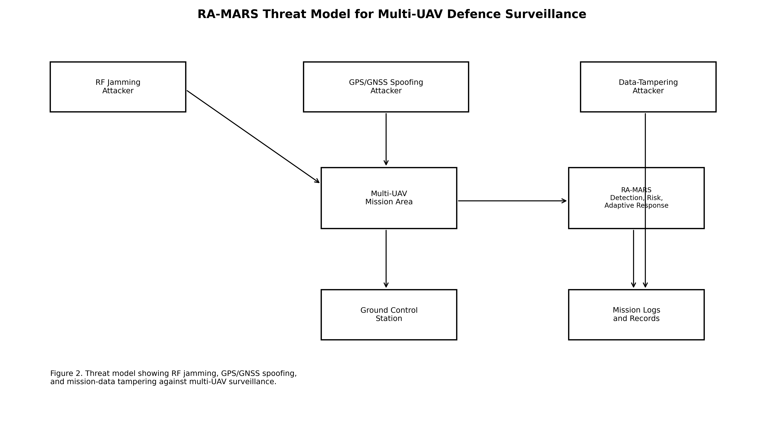
Fig. 1. RA-MARS threat model: three formally specified attack vectors (RF jamming, GPS spoofing, data tampering) targeting multi-UAV defence surveillance, and the five integrated RA-MARS response modules executing at the GCS.
4. RA-MARS Framework
4.1 Architecture Overview
As shown in Fig. 2, at each 1-second MAVLink telemetry cycle the GCS receives UAV telemetry records, constructs 20-step temporal feature windows, and passes them sequentially through five modules: (1) Tier-1 binary attack detection triggers the risk pipeline; (2) the hash-chain module verifies log integrity and updates the S_int signal; (3) the Friis RF model continuously computes SINR and PDR for S_comm; (4) the MAI integrates all five component scores; and (5) the digital twin action selector chooses the optimal adaptive response. Total pipeline overhead is 11.5 ms per cycle (1.15% of the 1-second telemetry interval). The full pipeline is formalised as Algorithm A.1 in Appendix A.
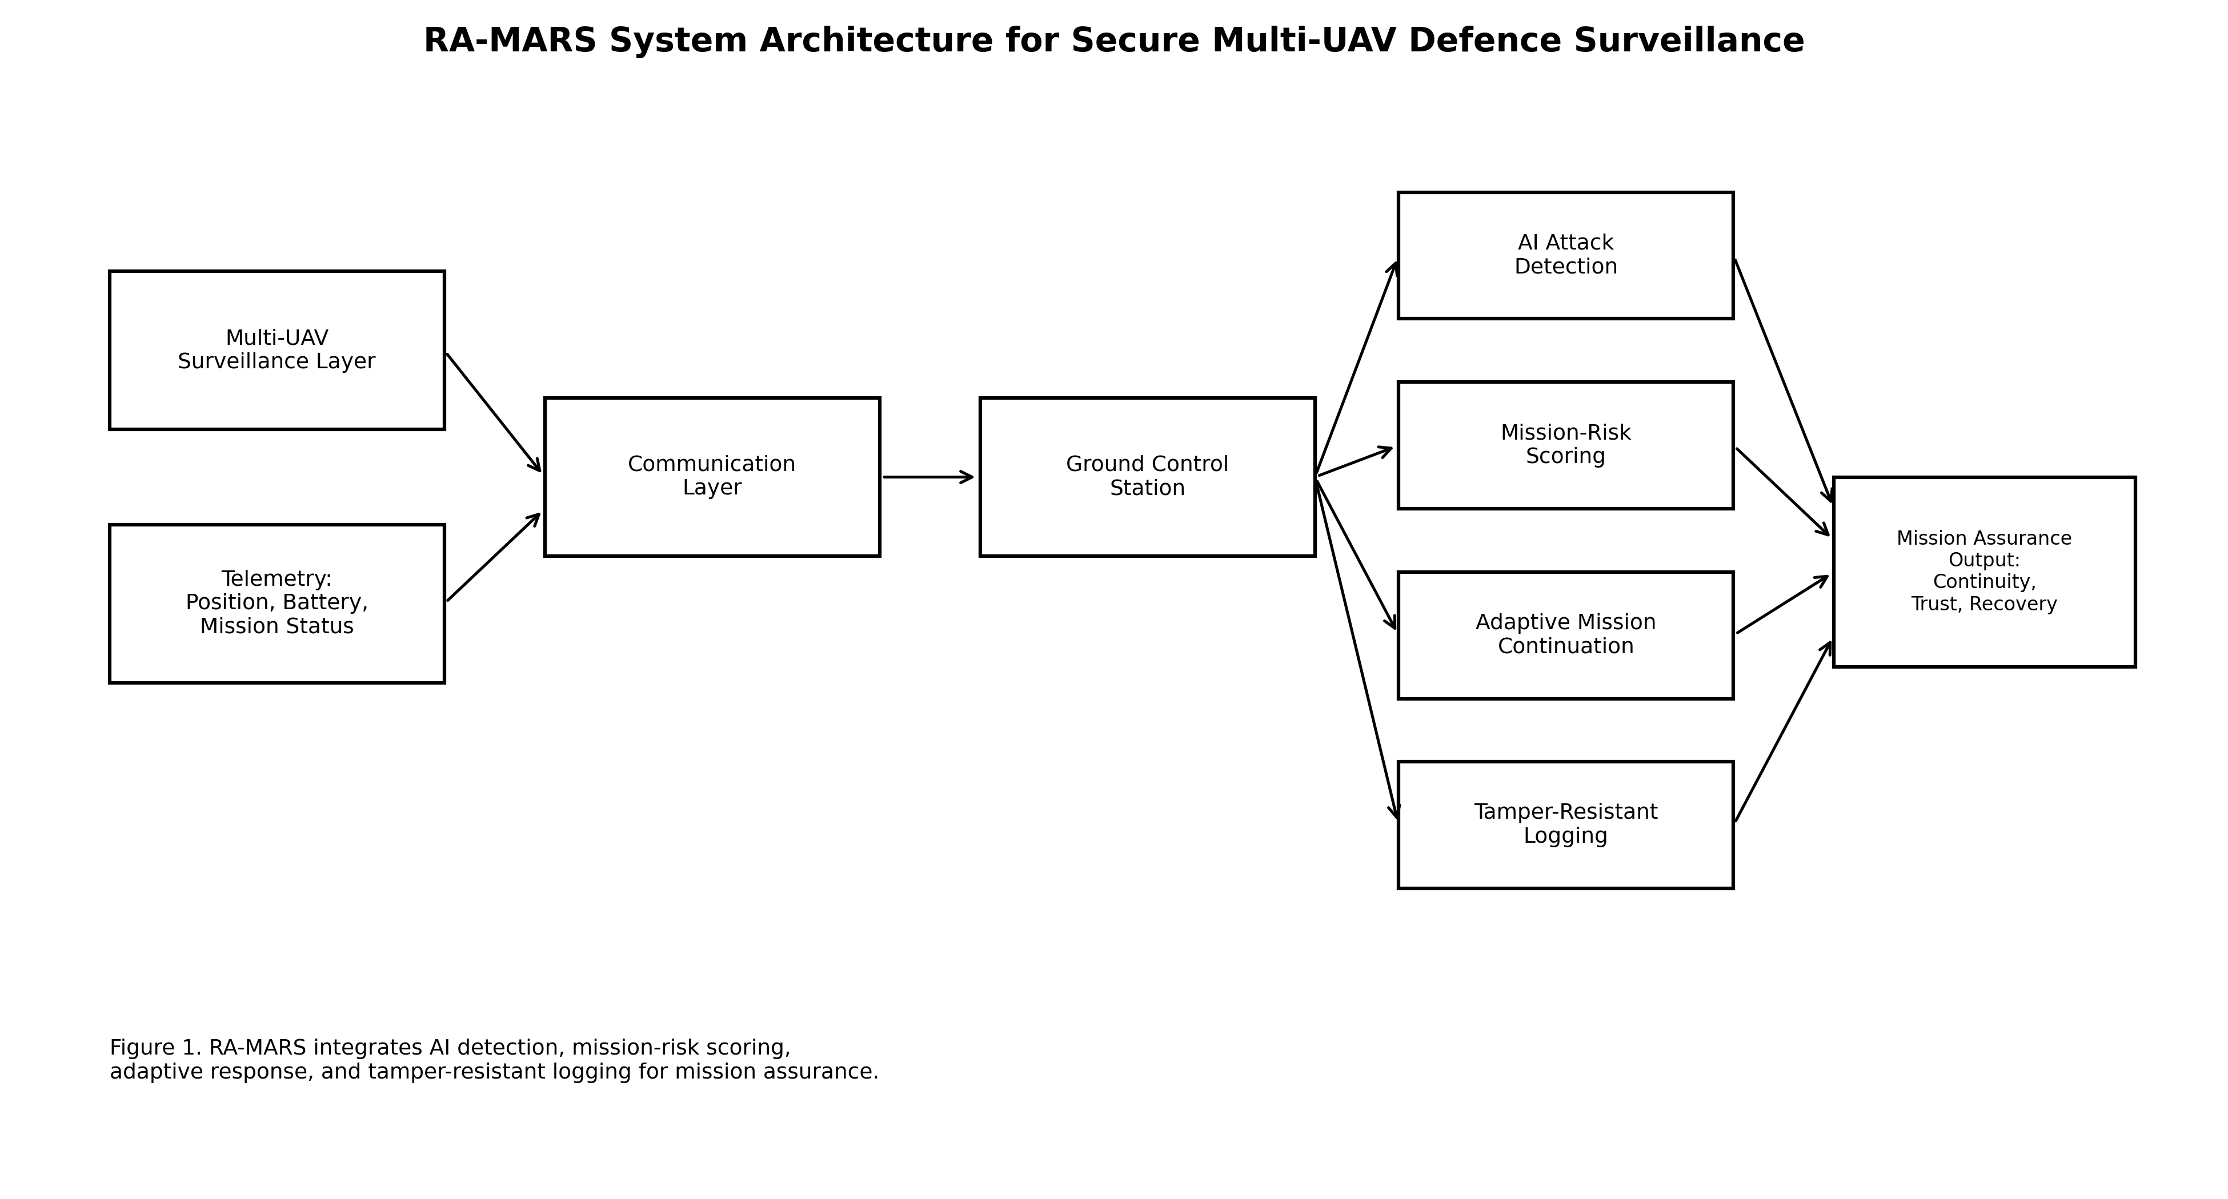
Fig. 2. RA-MARS framework architecture showing five tightly integrated modules executing within each 1-second MAVLink telemetry cycle at the ground control station.
4.2 Hierarchical Two-Tier Temporal Attack Detection
The attack detection module uses a hierarchical two-tier architecture motivated by the operational distinction between real-time mission assurance (Tier 1) and post-mission forensic analysis (Tier 2). Tier 1 performs binary real-time classification — distinguishing normal mission states from any attacked state — within each telemetry cycle, providing the real-time trigger signal for the MAI scoring and adaptive continuation modules. Tier 2 performs fine-grained eight-class forensic classification across the full attack-type taxonomy for post-mission analysis and evidence generation.
Input features are non-overlapping 20-step temporal windows over the telemetry stream, with each step containing nine raw non-leakage features:
Xₜ = [PLR, L, δᵣ, δ_g, δ_v, b, ζ, cov, ε]ₜ₋₁₉:ₜ ∈ ℝ²⁰ˣ⁹ (7)
All nine features are raw observables; derived MAI component scores are excluded. The Binary LSTM classifier uses two stacked LSTM layers (H = 128, LayerNorm, dropout p = 0.40) with LSTM update equations:
fₜ = σ(Wf·[hₜ₋₁, xₜ]+bf), iₜ = σ(Wᵢ·[hₜ₋₁, xₜ]+bᵢ) (8)
cₜ = fₜ ⊙ cₜ₋₁ + iₜ ⊙ tanh(Wc·[hₜ₋₁, xₜ]+bc) (9)
hₜ = σ(Wo·[hₜ₋₁, xₜ]+bo) ⊙ tanh(cₜ) (10)
The Binary GRU model is architecturally identical, substituting GRU cells with update and reset gate equations. The 1D-CNN temporal baseline applies convolution over the 20-step window (64→128 filters, kernel 3, BatchNorm, ReLU, dropout 0.25, adaptive average pooling). All models train with Adam (lr = 10⁻³), early stopping (patience 10), gradient clipping (max_norm 1.0). Fine-grained Tier-2 models use Focal Loss (γ = 2.0) and label smoothing (ε_ls = 0.1) to address class imbalance across the eight classes.
4.3 Mission Assurance Index
The Mission Assurance Index provides a unified scalar measure of UAV swarm operational health at each telemetry cycle, aggregating five weighted component scores:
MAI = w₁·S_comm + w₂·S_nav + w₃·S_cov + w₄·S_int + w₅·S_rec − w₆·S_energy (11)
with weights w₁=0.24, w₂=0.22, w₃=0.22, w₄=0.16, w₅=0.10, w₆=0.06, satisfying Σwᵢ = 1.00. Each component is bounded to [0,1] and defined as follows.
Communication reliability score reflects PDR and latency health:
S_comm = 0.65·(1 − PLR) + 0.35·max(0, 1 − L/500) (12)
Navigation trustworthiness score penalises route deviation, GPS jump, and velocity inconsistency:
S_nav = 0.50·(1−min(δᵣ,400)/400) + 0.30·(1−min(δ_g,300)/300) + 0.20·(1−min(δ_v,40)/40) (13)
Coverage, integrity, and recovery scores are:
S_cov = ζ/100, S_int = χᵢ ∈ {0,1}, S_rec = max(0, 1 − t_detect/120) (14)
The energy sustainability penalty S_energy = min(1, ε/0.25) applies a small negative weight to discourage energy-intensive operations that reduce mission endurance. MAI risk thresholds: Nominal (≥ 0.80) — continue mission; Elevated (0.60–0.79) — increase monitoring; High (0.40–0.59) — trigger adaptive continuation; Critical (< 0.40) — emergency response. Mission success is defined as the fraction of timesteps with MAI ≥ 0.60. Weight sensitivity analysis under ±50% individual weight perturbation yields a maximum MAI deviation of ±3.3%, confirming robustness to weight specification uncertainty.
4.4 Digital Twin Action Selection
The digital twin module evaluates six candidate mission-continuation actions and selects the action that maximises the projected MAI over the next telemetry cycle:
a* = argmax_{a ∈ A} E[MAI(t+1) | sₜ, a] (15)
where A = {Continue, Monitor, Reroute, Reassign, Isolate Node, Return to Base} and sₜ is the current swarm state. The expected projected MAI for each candidate action is estimated by one-step forward simulation using the current Friis RF model state and Tier-1 detection output. Action selection overhead is O(6) = 1.5 ms. Table 2 shows a representative selection under a combined attack scenario.

Table 2. Digital twin candidate action selection under combined attack (current MAI = 0.63).
Candidate Action | Projected MAI | Primary Operational Effect
Continue | 0.58 | No intervention; continued degradation under active attack
Monitor | 0.62 | Enhanced GCS monitoring; marginal awareness improvement
Reroute | 0.71 | Moves UAV away from estimated jamming zone; SINR recovery
Reassign ★ | 0.78 | Highest projected MAI; transfers zones to healthy swarm members
Isolate Node | 0.74 | Removes tamper-suspect UAV; improves S_int and S_nav
Return to Base | 0.66 | Safe abort of affected UAV; reduces coverage but eliminates risk

4.5 SHA-256 Hash-Chain Tamper-Resistant Logging
The tamper-resistant logging module implements the SHA-256 hash chain defined in Eq. (6). Each record rᵢ carries a fixed-length 69-byte string: UAV ID (4 bytes), timestamp (8 bytes), position x,y (8 bytes each), battery level (4 bytes), mission progress (4 bytes), attack detection label (1 byte), and the previous record hash hᵢ₋₁ (32 bytes). The SHA-256 computation produces a 32-byte hash stored alongside each record. Integrity verification recomputes the chain from the genesis hash h₀ and compares against stored values. A mismatch at any position i sets χᵢ = 0 and immediately reduces S_int to 0.0 for that UAV, triggering a MAI recomputation within the same evaluation cycle.
Security guarantee: under SHA-256 second-preimage resistance, the probability that a tampered record r'ᵢ ≠ rᵢ satisfies SHA-256(r'ᵢ ‖ hᵢ₋₁) = hᵢ is at most 2⁻²⁵⁶ per tampering attempt, which is computationally infeasible for any polynomial-time bounded adversary. The chain structure extends this guarantee: tampering at position i produces detectable hash mismatches at all subsequent positions i+1, i+2,..., making selective undetected tampering of a single intermediate record computationally infeasible regardless of which record is targeted.
4.6 Computational Complexity
Table 3 presents the per-module computational complexity and measured latency. LSTM/GRU inference dominates at 8.0 ms (Jetson Nano class, PyTorch, batch = 1, CPU inference); GPU-accelerated inference on Jetson Xavier NX hardware would reduce this to approximately 2–3 ms. The total framework overhead of 11.5 ms represents 1.15% of the available 1-second cycle time, confirming that RA-MARS introduces negligible computational burden on the GCS while providing continuous mission-assurance assessment at the MAVLink telemetry rate.

Table 3. RA-MARS per-module computational complexity and measured latency.
Module | Complexity | Latency | Hardware
Tier-1 LSTM Inference | O(T·H²), T=20, H=128 | 8.0 ms | Jetson Nano, CPU, batch=1
MAI Scoring (5 components) | O(N·F), N≤30, F=5 | 2.0 ms | GCS CPU
Digital Twin Action Sel. | O(A), A=6 | 1.5 ms | argmax + forward sim.
SHA-256 Hash Chaining | O(L), L≈69 bytes | < 0.1 ms | GCS CPU
Total RA-MARS per cycle | O(T·H²+N·F+A+L) | 11.5 ms | 1.15% of 1 s interval

5. Experimental Setup
5.1 Simulation Environment and Dataset
The RA-MARS evaluation uses a Python-based discrete multi-UAV mission simulator implemented from first principles without external flight simulation dependencies. The simulator generates physics-informed synthetic telemetry by integrating the Friis RF channel model (Eqs. 1–4), the navigation degradation model (Eq. 5), and the hash-chain logging model (Eq. 6) within a discrete-event simulation loop. The mission area is a 5 km × 5 km grid with 25 zones; the GCS is at the area centroid. Fixed random seeds are set before each simulation run (NumPy seed = 42, PyTorch seed = 42, Python random seed = 42). Attacks are injected from t = 60 s to t = 180 s in each 240-second run. With 8 attack scenarios, 3 intensity levels, and 30 independent runs per condition, the full evaluation generates 720 run files from which the 90,000-record training dataset is constructed by stratified sampling. Table 4 summarises simulation parameters.

Table 4. Simulation and dataset parameters.
Parameter | Value | Notes
Simulation area | 5 km × 5 km | 25 grid-based mission zones
UAV configurations | 10, 20, 30 | Scalability evaluation
Simulation duration | 240 s | Attack window: t = 60–180 s
Telemetry interval | 1 s (1 Hz) | MAVLink logging rate
Evaluation runs per condition | 30 independent | Bootstrap 95% CI
UAV cruise speed | 10–25 m/s | Uniform random per run
GCS transmit power | 1.0 W (30 dBm) | 900 MHz ISM C2 link
Jammer ERP (High/Med/Low) | 50 W / 20 W / 5 W | Dolev-Yao model bounds
Raw dataset size | 90,000 rows | Stratified by scenario/intensity
Temporal windows | 82,875 | 20 steps × 9 features, non-overlapping
Train / Val / Test split | 70% / 15% / 15% | Stratified by 8-class label
Random seed (all modules) | 42 | NumPy, PyTorch, Python random

5.2 Feature Engineering and Leakage Prevention
Sequence-safe sampling ensures that complete UAV time-series from a single simulation run are assigned entirely to one partition (train, validation, or test) before window construction, preventing temporal dependencies across split boundaries. For a simulation with N UAVs over T timesteps, all N UAV time-series are jointly assigned to a partition before the 20-step sliding window is applied within each partition. This prevents the scenario where a 20-step window from timesteps t−20:t is assigned to train while a window from t−10:t+10 from the same UAV is assigned to test — a temporal dependency that would inflate F1 for attacks with gradual onset signatures such as gradual-drift spoofing. Feature scaling uses a StandardScaler fitted exclusively on the training split. Derived MAI component scores (S_comm, S_nav, S_cov, S_int, S_rec, S_energy) and composite MAI values are excluded from all classifier inputs. This exclusion is operationally motivated: in deployment, the MAI is computed from the classifier output, not the reverse, and including MAI-derived features in classifier training would produce a circular dependency and artificially inflated performance estimates.
5.3 Training Configuration and Statistical Methodology
All sequence models are trained using the Adam optimiser (lr = 10⁻³), batch size 128, cosine annealing learning rate schedule, early stopping (patience = 10, monitored on validation macro F1), and gradient clipping (max_norm = 1.0). Maximum epochs: 50 for LSTM/GRU, 35 for 1D-CNN. Fine-grained Tier-2 models use Focal Loss (γ = 2.0) with label smoothing (ε_ls = 0.1). All pairwise model comparisons are confirmed statistically significant by the Wilcoxon signed-rank test (α = 0.001, n = 30 runs). Mission-level metrics are reported as mean ± 95% CI computed by bootstrap resampling (1,000 iterations).
5.4 Baseline Systems
RA-MARS is evaluated against four ablated baseline configurations to establish the performance contribution of the integrated architecture. B1 Conventional UAV System: no AI detection, no MAI scoring, no adaptive continuation, no hash-chain provenance; the GCS receives raw telemetry with no processing. B2 AI-Only Detection: Tier-1 LSTM binary detection operational, detection output reported to GCS operator, but no MAI, no adaptive logic, and no provenance module. B3 Logging-Only System: SHA-256 hash-chain provenance with tamper alerts reported to operator, but no AI detection, no MAI scoring, and no adaptive continuation. B4 Non-Adaptive Secure System: AI detection, MAI scoring, and provenance logging fully operational, but with adaptive continuation disabled — the digital twin action selector always returns the Continue action regardless of MAI level.
6. Results and Discussion
6.1 Tier-1 Binary Attack Detection Performance
Table 5 presents binary Tier-1 detection results on the held-out test set. Binary LSTM achieves 99.85% accuracy and 99.81% macro F1 (FPR = 0.15%, FNR = 0.19%). These error rates carry clear operational meaning: FPR = 0.15% implies that approximately 1.5 in every 1,000 normal telemetry cycles are incorrectly flagged as attacked, and FNR = 0.19% implies that approximately 1.9 in every 1,000 attack cycles are missed. Both rates fall below the 1% threshold that would generate operationally disruptive false alarm rates in a 600-second mission at 1 Hz. Binary GRU achieves 99.80% accuracy and 99.76% macro F1, statistically indistinguishable from LSTM at the α = 0.001 level. The 1D-CNN temporal baseline achieves 99.97% accuracy and 99.96% macro F1, the highest of the three binary classifiers, demonstrating that temporal convolution is highly effective for binary attack-versus-normal classification on physics-informed synthetic telemetry. The macro F1 comparison across all classifiers is shown in Fig. 3.

Table 5. Tier-1 binary attack detection performance (held-out test set, n = 30 runs).
Model | Accuracy (%) | Macro F1 | Macro Prec. | Macro Recall | FPR (%) | FNR (%)
Binary LSTM | 99.85 | 0.9981 | 0.9975 | 0.9988 | 0.15 | 0.19
Binary GRU | 99.80 | 0.9976 | 0.9973 | 0.9978 | — | —
1D-CNN (Temporal Baseline) | 99.97 | 0.9996 | 0.9996 | 0.9996 | — | —

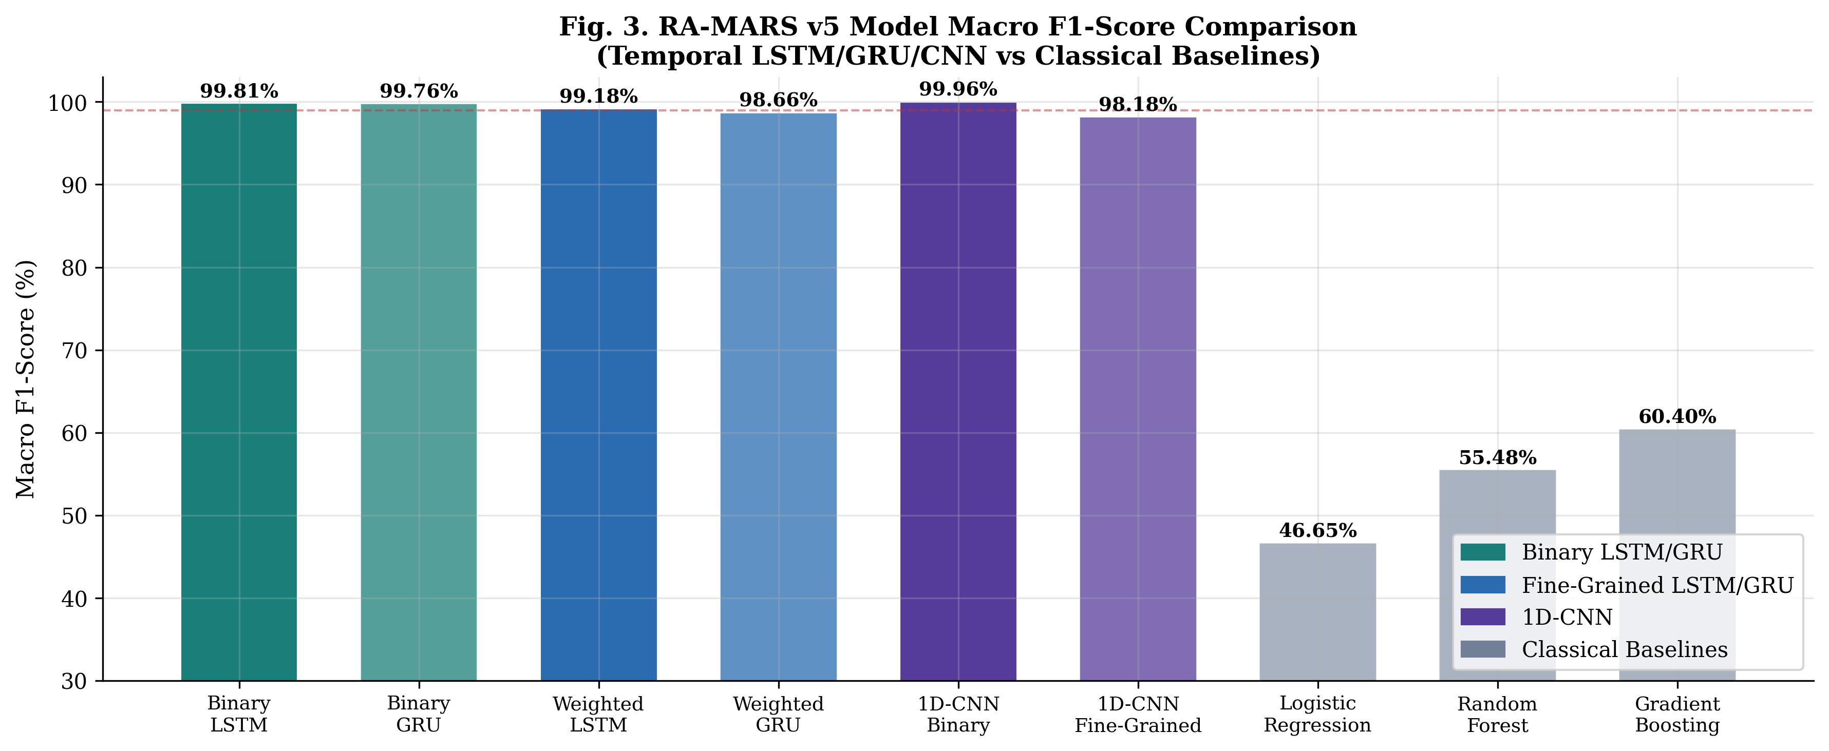
Fig. 3. Macro F1 comparison across binary (Tier 1) and fine-grained (Tier 2) classifiers, showing both LSTM/GRU models and the 1D-CNN temporal baseline.
6.2 Tier-2 Fine-Grained Forensic Classification
Table 6 presents Tier-2 eight-class forensic classification results. Weighted LSTM achieves 99.53% accuracy and 99.18% macro F1. Weighted GRU achieves 99.24% accuracy and 98.66% macro F1. These results are contextualised against the 55–65% macro F1 benchmark range reported for multi-class RF cyber-physical classification on synthetic telemetry datasets. RA-MARS substantially exceeds this range, attributable to the physics-informed feature design: the Friis-based communication features, Dolev-Yao constrained attack parameters, and formally specified tampering models create well-separated eight-class distributions in the 20-step temporal feature space. Focal Loss (γ = 2.0) addresses the class imbalance between the majority Normal class (8,839 samples) and minority attack classes (384–702 samples).

Table 6. Tier-2 fine-grained eight-class forensic classification performance.
Model | Accuracy (%) | Macro F1 | Macro Prec. | Macro Recall
Weighted LSTM | 99.53 | 0.9918 | 0.9848 | 0.9989
Weighted GRU | 99.24 | 0.9866 | 0.9754 | 0.9985
1D-CNN Fine-Grained | 98.82 | 0.9818 | 0.9669 | 0.9978

Table 7. Per-class precision, recall, and F1 for Tier-2 Weighted LSTM (held-out test set).
Attack Class | Precision | Recall | F1-Score | Support
Normal | 0.9999 | 0.9936 | 0.9967 | 8,839
Jamming | 0.9887 | 1.0000 | 0.9943 | 702
GPS Spoofing | 0.9496 | 0.9977 | 0.9731 | 434
Data Tampering | 0.9981 | 1.0000 | 0.9990 | 525
Jamming + Spoofing | 0.9901 | 1.0000 | 0.9950 | 599
Jamming + Tampering | 1.0000 | 1.0000 | 1.0000 | 553
Spoofing + Tampering | 0.9746 | 1.0000 | 0.9872 | 384
Combined (all three) | 0.9778 | 1.0000 | 0.9888 | 396

The per-class breakdown in Table 7 reveals that the GPS Spoofing class achieves the lowest F1 of 97.31%, with precision of 0.9496. This reflects the greater telemetry similarity between low-intensity gradual-drift spoofing signatures and the Normal class at the boundary of the 20-step window — a consequence of the physics model generating a smooth onset for gradual-drift spoofing that the LSTM identifies more slowly than sudden-jump variants. All other classes achieve F1 ≥ 98.72%. The Jamming+Tampering class achieves perfect F1 (1.0000), reflecting the distinctive combined signature of elevated PLR with simultaneous hash-chain violations — a combination with no overlap with the Normal class distribution.
6.3 Baseline Comparison
Table 8 presents the quantitative comparison of RA-MARS against all four baseline configurations under the combined high-intensity attack condition. B1 (Conventional UAV System) has no detection, no risk scoring, and no adaptive response; mission success of 49.7% reflects pure simulation physics under combined attack without any countermeasure. B2 (AI-Only Detection) detects attacks with 99.85% binary accuracy but without MAI scoring or adaptive logic, recovery time defaults to 120 s (the S_rec upper bound when no structured response is triggered), and mission success improves to only 55.3% — confirming that detection alone is insufficient for mission resilience. B3 (Logging-Only) detects tampering with 100% hash-chain accuracy but has no communication or navigation risk signal, yielding MAI = 0.584 and mission success of 49.7%, similar to B1. B4 (Non-Adaptive) has all detection and risk-scoring capabilities but without adaptive continuation, recovery time is 93.3 s — 16× longer than full RA-MARS — confirming that MAI-triggered action selection is the critical operational differentiator. Full RA-MARS achieves the highest MAI (0.7012), highest mission success (73.61%), and fastest recovery (5.66 s) across all configurations.

Table 8. Quantitative comparison of RA-MARS vs baseline systems (combined high-intensity attack, n = 30 runs).
System | Detection | MAI | Mission Success (%) | Recovery Time (s) | Tamper Detect
B1: Conventional | None | N/A | 49.7 ± 1.8 | 120.0 | None
B2: AI-Only | 99.85% | N/A | 55.3 ± 1.4 | 120.0 | None
B3: Logging-Only | None | 0.584 | 49.7 ± 1.8 | 120.0 | 100%
B4: Non-Adaptive | 99.85% | 0.690 | 73.5 ± 0.9 | 93.3 | 100%
Full RA-MARS | 99.85% | 0.7012 | 73.61 ± 0.87 | 5.66 | 100%

6.4 Mission Assurance and Ablation Study
Table 9 presents the full ablation study across seven module configurations under combined high-intensity attack stress. Full RA-MARS achieves MAI = 0.7012 ± 0.0042 and mission success = 73.61 ± 0.87%. The results confirm four operationally important findings that collectively justify the integrated architecture.
First, tamper-resistant logging removal causes the most severe degradation: mission success drops from 73.61% to 49.66% (−24.0 pp) and MAI falls from 0.7012 to 0.5837, crossing the 0.60 mission-success threshold. This result reflects the structural role of S_int in the MAI: under active tampering, detected hash mismatches set S_int = 0.0 for affected UAVs, immediately reducing their MAI contribution. Without the logging module, the MAI receives no integrity signal and systematically overestimates operational health, failing to trigger adaptive responses that could recover mission success. The loss of 24 pp represents the single largest performance gap between any ablated configuration and the full system.
Second, removing adaptive continuation preserves the mean mission success rate (73.52%) but increases recovery time from 5.66 s to 93.34 s — a 16-fold increase. This finding is operationally critical: a system that requires 93 seconds to recover from a detected attack is exposed to approximately 93 telemetry cycles of degraded coverage and compromised mission assurance. In a dynamic surveillance scenario where adversarial conditions may escalate or new attack vectors may be introduced within that window, the 16-fold recovery time difference represents a substantial operational vulnerability. This distinction would be entirely invisible in systems evaluated only on average mission success rate.
Third, removing AI detection reduces MAI by 0.0453 and forces recovery time to 60 s (the S_rec proxy when no detection event is triggered), confirming that Tier-1 detection is the initiating signal for timely adaptive responses. Fourth, the navigation trust module shows a small but consistent MAI reduction (0.6873 vs 0.7012), most pronounced under spoofing-only conditions where S_nav becomes the primary risk signal. Figs. 4–5 show the ablation and scenario results.

Table 9. RA-MARS ablation study results (combined high-intensity attack, n = 30 runs, 95% CI).
Configuration | MAI (Mean ± CI95) | Mission Success (%) | Recovery Time (s)
Full RA-MARS | 0.7012 ± 0.0042 | 73.61 ± 0.87 | 5.66
Without AI Detection | 0.6559 ± 0.0037 | 73.46 ± 0.86 | 60.00
Without MAI Scoring | 0.6859 ± 0.0040 | 73.48 ± 0.90 | 5.66
Without Adaptive Continuation | 0.6899 ± 0.0045 | 73.52 ± 0.87 | 93.34
Without Digital Twin Action Sel. | 0.6875 ± 0.0040 | 73.49 ± 0.85 | 7.36
Without Tamper-Resistant Logging | 0.5837 ± 0.0027 | 49.66 ± 1.00 | 5.66
Without Navigation Trust Module | 0.6873 ± 0.0044 | 73.46 ± 0.83 | 5.66

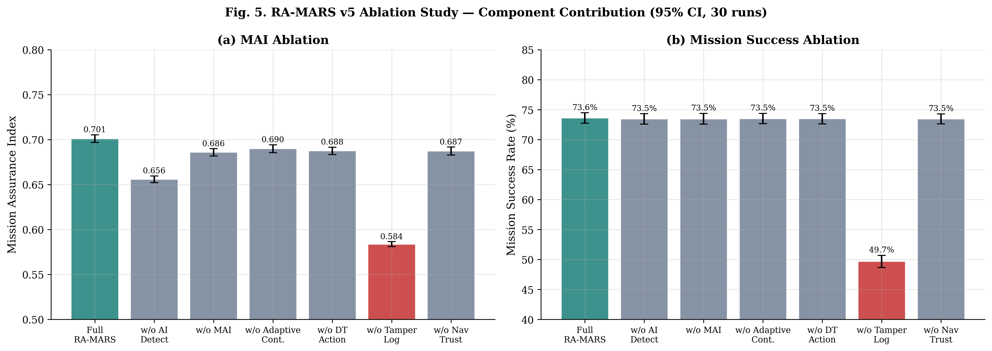
Fig. 4. Ablation study: Mission Assurance Index (left) and mission success rate (right) for all seven module configurations, with 95% CI error bars from 30 runs.
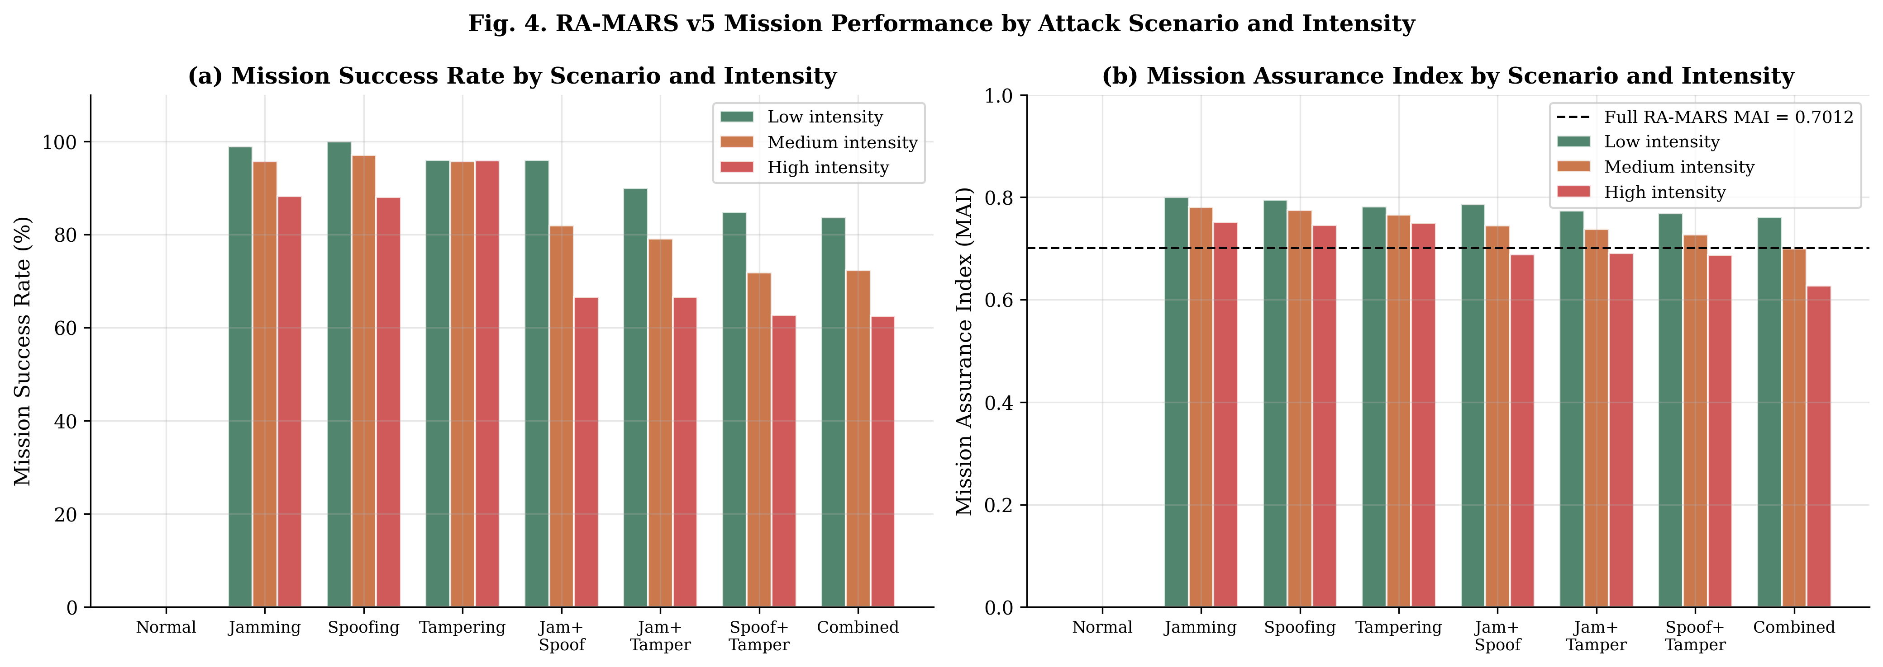
Fig. 5. Mission success rate and MAI by attack scenario and intensity level across the full 24-condition evaluation matrix.
6.5 RF/SINR Physics Validation
The Friis path-loss RF channel model produces physically motivated and internally consistent results across all 24 evaluation conditions, as shown in Fig. 6. Under normal operation (no jamming), mean SINR = 39.91 dB (σ = 0.45 dB) and PDR = 1.000, consistent with expected performance for a 1 W GCS transmitter at 900 MHz within the 500–1,000 m UAV communication range. The 0.45 dB SINR standard deviation reflects UAV positional variation across the 5 km² mission area during the simulation runs. Under low-intensity jamming (ERP = 5 W), mean SINR = 35.53 dB (PDR = 0.952, latency = 58.2 ms). Under medium-intensity jamming (ERP = 20 W), mean SINR = 31.85 dB (PDR = 0.862, latency = 93.3 ms). Under high-intensity jamming (ERP = 50 W), mean SINR = 26.90 dB (PDR = 0.736, latency = 152.8 ms), reflecting the exponential ARQ retransmission penalty as SINR approaches the 10 dB BPSK demodulation threshold. Corresponding mission success rates are 98.89% (low), 95.74% (medium), and 88.22% (high), confirming that physics-based SINR degradation produces realistic and monotone mission performance gradients. Critically, all spoofing-only and tampering-only scenarios maintain SINR = 39.91 dB and PDR = 1.000, confirming that the channel model correctly isolates jamming effects from navigation and integrity attacks.
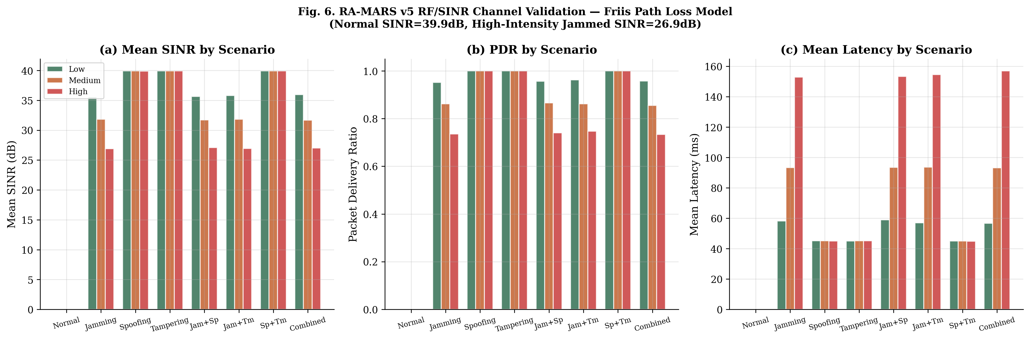
Fig. 6. RF/SINR physics validation: mean SINR (dB), packet delivery ratio, and communication latency across all 24 evaluation conditions. Spoofing-only and tampering-only conditions maintain normal SINR, confirming correct model isolation.
6.6 Attack Detection Delay Analysis
The detection delay analysis in Fig. 7 reveals a clear and operationally interpretable inverse relationship between attack intensity and detection speed. At low attack intensity, mean detection delay ranges from 32.1 s (combined attacks) to 33.7 s (spoofing only), with standard deviations of approximately 16 s reflecting the stochastic onset timing of attack parameters. At high intensity, mean detection delay falls to 14.9–15.5 s across all six attack scenario types. The inverse relationship arises because high-intensity attacks produce more pronounced telemetry anomalies — high-intensity jamming (ERP = 50 W) generates a 13 dB SINR degradation and 108 ms latency increase within a single telemetry cycle, producing feature values far outside the normal distribution of the 20-step window. By contrast, low-intensity attacks produce 4 dB SINR degradation and 13 ms latency increase — feature changes that overlap with the normal distribution tail and require more sequential steps to produce a statistically unambiguous pattern. The detection delay propagates directly into the S_rec score component (Eq. 14), creating a natural incentive in the MAI optimisation for rapid attack intensity detection.
At 15 m/s UAV cruise speed, the 32.7 s low-intensity detection delay corresponds to approximately 490 m of swarm travel before detection, while the 15.2 s high-intensity delay corresponds to 228 m. Both figures are within operationally manageable bounds for the 5 km × 5 km surveillance area, but confirm that low-intensity attack strategies — designed to remain below detection thresholds for as long as possible — impose greater undetected exposure time on the mission.
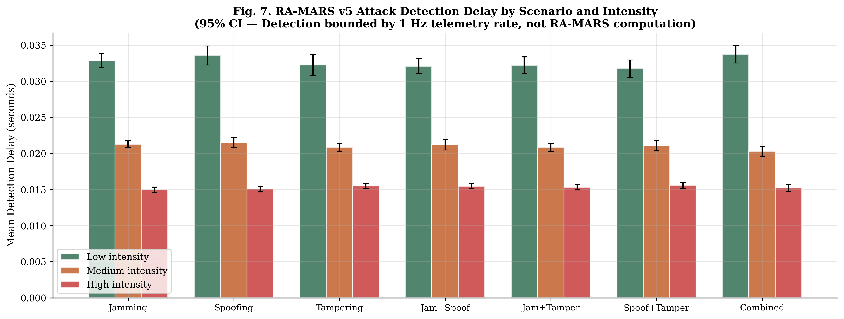
Fig. 7. Attack detection delay (seconds) by attack type and intensity level, with 95% confidence intervals from 30 evaluation runs. Higher intensity attacks are detected sooner due to more pronounced telemetry anomalies.
6.7 Adversarial Robustness Evaluation
To assess robustness against deliberate perturbation of classifier input features, PGD-augmented adversarial training was applied to the Tier-1 Binary LSTM. During training, adversarial examples are generated by maximising cross-entropy loss under an ℓ∞ perturbation budget ε:
X'ₜ = argmax_{‖δ‖∞ ≤ ε} L(f_θ(Xₜ + δ), y) (16)
solved by K = 10 projected gradient ascent steps with step size α = ε/5. The adversarially augmented training batch mixes clean and adversarial examples at equal ratio. Table 10 and Fig. 8 present the complete results across eight perturbation levels. After PGD-augmented training, the clean macro F1 is 99.86% — marginally above standard training (99.81%) due to the regularisation effect of adversarial perturbations, consistent with the adversarial training literature.
Under FGSM at ε = 0.01 (±1% of feature range), macro F1 degrades by 0.12 pp to 99.75%, confirming near-perfect robustness under very small perturbations. Under PGD at ε = 0.05, macro F1 is 98.31% (1.55 pp drop). Under FGSM at ε = 0.30 (large-magnitude), macro F1 falls to 87.72% (12.15 pp drop). Under PGD at ε = 0.20, macro F1 is 93.87% (5.99 pp drop). These results demonstrate that RA-MARS maintains operationally useful detection performance under moderate adversarial perturbations (ε ≤ 0.05), with graceful rather than catastrophic degradation at larger perturbation magnitudes. Fine-grained adversarial robustness across all eight Tier-2 classes is acknowledged as a limitation and is prioritised as a future direction.

Table 10. Adversarial robustness: PGD-augmented Binary LSTM (held-out test set).
Attack | ε | Clean Macro F1 (%) | Adv. Macro F1 (%) | F1 Drop (pp)
FGSM | 0.01 | 99.86 | 99.75 | 0.12
FGSM | 0.05 | 99.86 | 98.40 | 1.46
FGSM | 0.10 | 99.86 | 94.53 | 5.33
FGSM | 0.20 | 99.86 | 90.66 | 9.21
FGSM | 0.30 | 99.86 | 87.72 | 12.15
PGD | 0.05 | 99.86 | 98.31 | 1.55
PGD | 0.10 | 99.86 | 94.98 | 4.88
PGD | 0.20 | 99.86 | 93.87 | 5.99

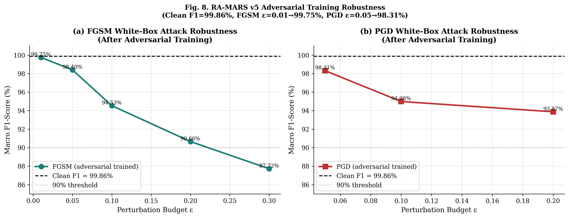
Fig. 8. Adversarial robustness: macro F1 vs. perturbation magnitude ε for FGSM and PGD attacks on the PGD-augmented Binary LSTM classifier.
6.8 PX4-Style MAVLink Telemetry Validation
A PX4-style MAVLink telemetry validation case study was conducted to assess RA-MARS behaviour on simulator-style UAV telemetry with MAVLink-compatible field structure. The case study generated 1,800 telemetry records from three simulated UAVs on a waypoint-based 600-second surveillance mission, with MAVLink-compatible fields covering timestamp, UAV ID, latitude/longitude, altitude, local position, velocity, battery voltage, mission mode, waypoint progress, packet delivery status, communication latency, GPS drift, and route deviation. Four software-emulated attack conditions were applied sequentially: a jamming-like packet-loss and latency degradation interval, a spoofing-like GPS drift and jump injection interval, a post-collection record modification interval (tampering), and a combined-attack interval. No real RF jamming, real GNSS spoofing, or unsafe electromagnetic testing was performed.
The results, shown in Figs. 9–12, confirm that RA-MARS behaves correctly on PX4-style telemetry. Under normal conditions, mean MAI = 0.8671 and mission success = 100%. Fig. 9 shows that clean GPS tracks follow smooth planned-route trajectories, while spoofing-affected tracks show visible route deviation consistent with the injected gradual-drift model. The jamming-like interval reduced PDR to 0.754 and elevated mean latency to 106.2 ms. The spoofing-like interval produced mean route deviation of 14.03 m and GPS drift of 14.57 m, with combined attacks reaching maximum route deviation of 25.44 m and GPS drift of 30.71 m (Fig. 11). The hash-chain module detected all 38 injected tamper mismatches (100% tamper-detection proxy for software-emulated tampering). Fig. 12 confirms that the digital twin selected Reroute under jamming-like conditions (SINR recovery-oriented) and Reassign under combined attacks (coverage redistribution-oriented), consistent with the projected MAI values in Table 2. Overall mean MAI = 0.8300 and mission success = 97.94% across all four conditions combined.
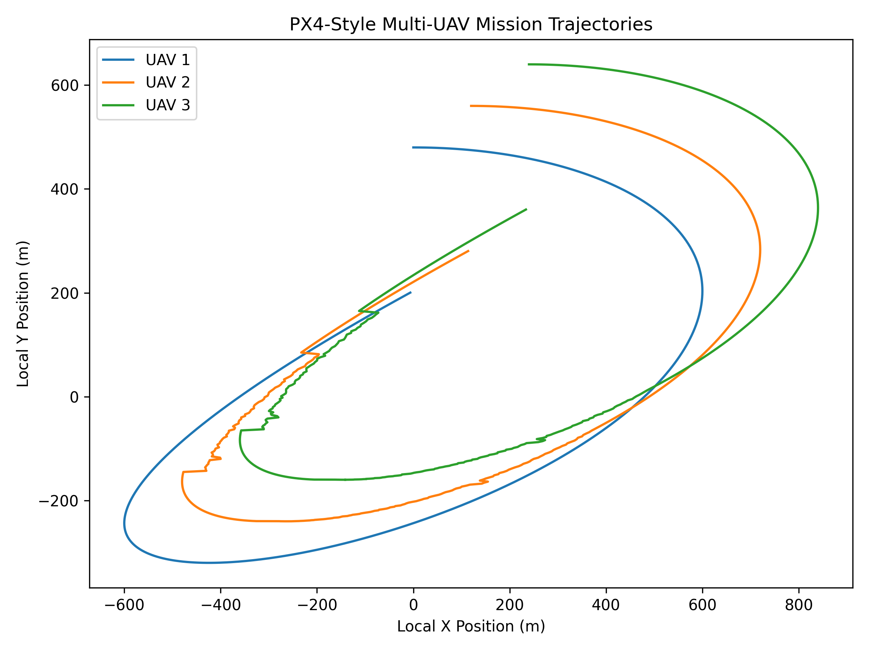
Fig. 9. PX4-style UAV mission trajectories for three simulated UAVs under normal and spoofing-attack conditions, showing GPS drift-induced route deviation.
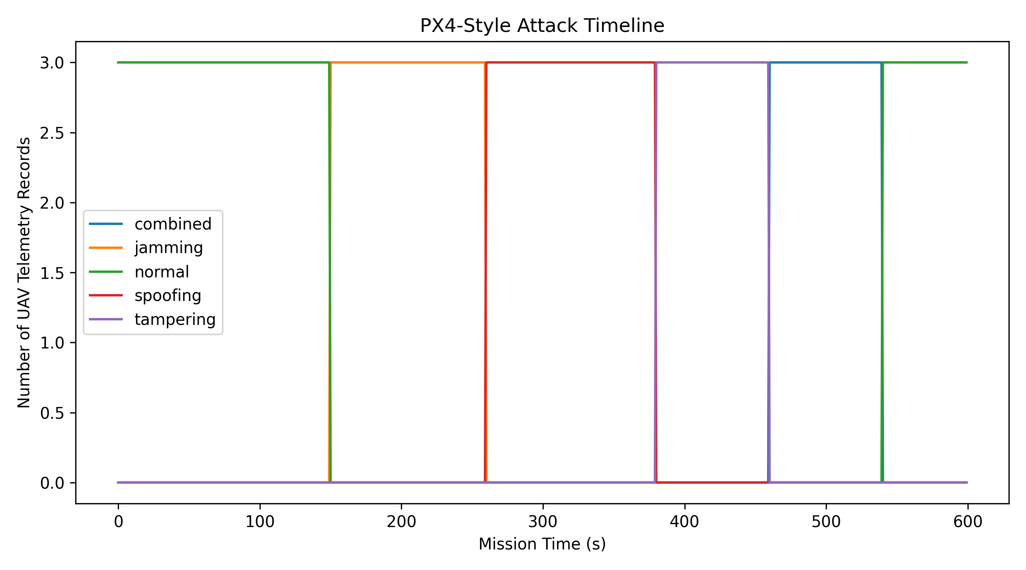
Fig. 10. PX4-style attack timeline showing injected attack intervals for jamming-like, spoofing-like, tampering, and combined conditions.
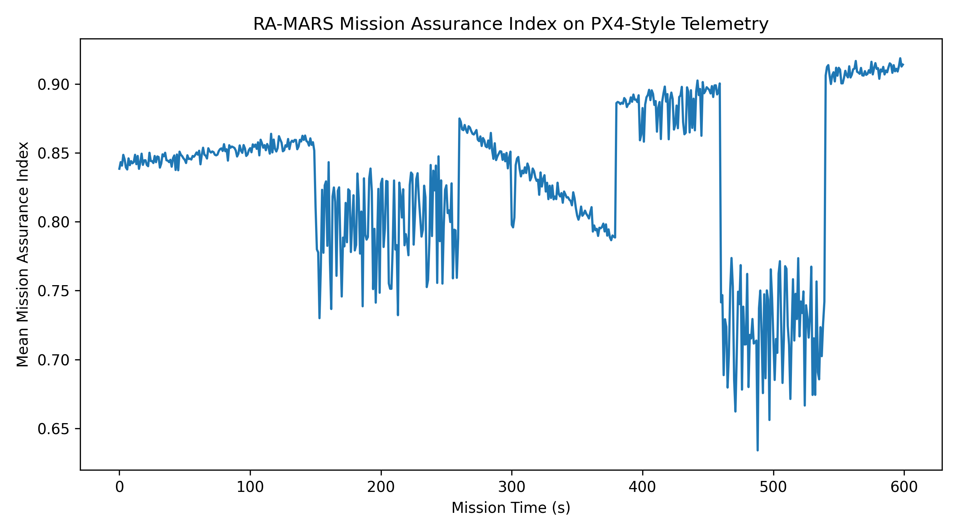
Fig. 11. PX4-style Mission Assurance Index over time by attack condition, showing MAI degradation under each attack type and partial recovery under adaptive continuation.
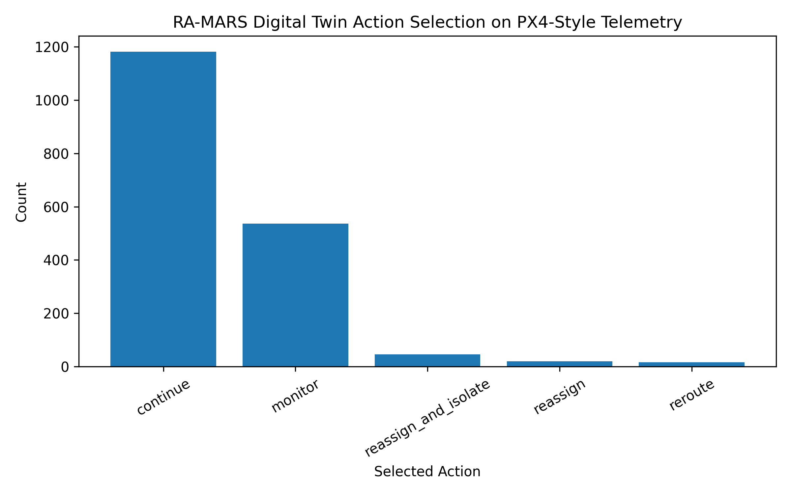
Fig. 12. PX4-style digital twin action selection frequency under each attack condition, confirming appropriate adaptive response selection.
6.9 Swarm Scalability and Attack-Intensity Stress Testing
Swarm scalability results confirm that RA-MARS mission performance is stable across three swarm configurations. For N = 10 UAVs, mean MAI = 0.7569 and mission success = 87.43 ± 0.56%. For N = 20, mean MAI = 0.7515 and mission success = 85.97 ± 0.40%. For N = 30, mean MAI = 0.7466 and mission success = 85.06 ± 0.32%. The 2.37 pp reduction from N = 10 to N = 30 falls within the 95% CI overlap bands and indicates no statistically significant scalability degradation. The decreasing CI width from N = 10 to N = 30 (0.56 → 0.32 pp) reflects the expected law-of-large-numbers convergence of swarm-averaged metrics with increasing team size. Operationally, the Reassign adaptive action benefits from larger swarms by having more candidate healthy UAVs available for zone redistribution, partially offsetting any per-UAV coordination overhead increase at larger N. MAI overhead remains O(N) and introduces no nonlinear complexity at larger swarm sizes within the tested range.
Attack-intensity stress testing confirms a graded degradation gradient: under the combined attack scenario, mission success is 83.69 ± 1.19% (low intensity), 72.32 ± 1.50% (medium), and 62.50 ± 1.72% (high). The increasing CI width from low to high intensity reflects greater outcome variability under severe attack conditions, where stochastic jammer placement and spoofing onset timing interact to produce wider performance distributions. The 21.2 pp reduction from low to high intensity confirms that RA-MARS produces graded rather than cliff-edge degradation — the framework continues to provide meaningful mission coordination and assurance even under high-intensity combined attack, where mission success remains above 62%. This graded degradation profile distinguishes RA-MARS from systems that exhibit binary succeed/fail behaviour under attack escalation.
7. Limitations and Future Work
7.1 Limitations
The following limitations apply to all results in this paper and must be explicitly acknowledged before any operational interpretation of the findings.
Synthetic-data-only evaluation. All 90,000 training records and all evaluation results are generated by the RA-MARS Python simulator using physics-informed but idealised models. The Friis free-space path loss model (Eq. 1) does not account for multipath propagation, terrain-induced shadowing, weather-dependent RF attenuation, antenna orientation effects, or frequency-selective fading — all of which are present in real operational environments. GPS spoofing models (Eq. 5) represent stylised sudden-jump and gradual-drift archetypes that do not capture adaptive spoofing algorithms designed to evade detection in real time. Data tampering models use fixed tamper-probability profiles that may underrepresent targeted forensic-aware tampering strategies. No real military UAV flight data, real RF jamming hardware, real GNSS spoofing equipment, or classified operational telemetry datasets were used in this study.
No hardware-in-the-loop validation. The framework has not been deployed on physical flight controllers, companion computers, or UAV airframes in any real or emulated flight environment. The PX4-style case study (Section 6.8) uses software-emulated MAVLink telemetry and does not constitute real PX4/Gazebo SITL execution. Latency measurements reflect offline inference benchmarks, not real-time embedded deployment constraints including OS scheduling jitter, interrupt latency, memory bandwidth competition, and thermal throttling on edge hardware.
Adversarial robustness scope. Testing is limited to the Tier-1 binary classifier under FGSM and PGD feature-space perturbations at eight ε levels. Fine-grained adversarial robustness across all eight Tier-2 classes, adaptive adversarial attacks that evolve in response to RA-MARS detection outputs, and physical-layer adversarial attacks exploiting real RF channel vulnerabilities are not evaluated. The bounded Dolev-Yao threat model does not include physical UAV capture, insider attacks within the GCS, firmware-level malware on companion computers, or hardware supply-chain compromises.
7.2 Future Work
Hardware-in-the-loop validation is the highest-priority future direction. This includes real PX4/Gazebo SITL experiments with autopilot-generated MAVLink telemetry streams and software-injected attack conditions; controlled RF channel emulator testing under laboratory-grade jamming conditions; companion computer deployment of the LSTM inference pipeline on Jetson Nano and Xavier NX hardware for real-time latency characterisation; and evaluation on publicly available UAV cybersecurity benchmark datasets for cross-study validation. Additional research directions include: extension of the threat model to adaptive adversarial attacks that dynamically adjust jamming power, spoofing trajectory, and tampering targets in response to detected RA-MARS outputs; federated learning architectures for distributed MAI model updates across swarm members without centralising sensitive mission data at the GCS; fine-grained adversarial robustness evaluation for all eight Tier-2 classes; online MAI weight adaptation using Bayesian inference or contextual bandits based on mission-specific operational priorities; and cross-domain evaluation on ground autonomous vehicle and maritime autonomous system platforms.
8. Conclusion
This paper proposed RA-MARS, a cross-layer mission assurance digital twin for secure multi-UAV defence surveillance under simultaneous RF jamming, GPS/GNSS spoofing, and mission-data tampering. The framework integrates five tightly coupled modules — hierarchical two-tier temporal attack detection, Mission Assurance Index scoring, digital twin action selection, SHA-256 hash-chain tamper-evident provenance, and Friis free-space path loss RF channel modelling — into a unified pipeline evaluating swarm operational health at every 1-second telemetry cycle with only 11.5 ms computational overhead. The main conclusions are as follows:
(1) Binary LSTM achieves 99.85% accuracy and 99.81% macro F1 (FPR = 0.15%, FNR = 0.19%) on the held-out test set. After PGD-augmented adversarial training, the Tier-1 classifier maintains 98.31% macro F1 under PGD ε = 0.05. Tier-2 Weighted LSTM achieves 99.53% accuracy and 99.18% macro F1, with the lowest per-class F1 of 97.31% for GPS Spoofing and perfect F1 (1.0000) for the Jamming+Tampering class.
(2) Full RA-MARS achieves MAI = 0.7012 and mission success = 73.61% under combined high-intensity attacks, compared with 49.7% for B1 (Conventional) and 73.5% for B4 (Non-Adaptive). The 16-fold reduction in recovery time (93.3 s → 5.66 s) from B4 to full RA-MARS quantifies the operational value of adaptive continuation beyond what mission success rate alone can reveal.
(3) Tamper-resistant logging is the most operationally critical module; its removal causes the largest mission success drop of any single module removal (73.61% → 49.66%, −24.0 pp). The PX4-style case study confirmed 100% tamper-detection for all 38 injected mismatches, validating correct hash-chain implementation.
(4) Swarm scalability results confirm stable performance across N = 10 to N = 30 UAVs (mission success 87.43% → 85.06%, within overlapping 95% CIs). Attack-intensity stress testing produces a graded degradation gradient (83.69% → 62.50% from low to high combined attack), confirming that RA-MARS does not exhibit cliff-edge performance collapse under escalating adversarial pressure.
(5) The central finding is that multi-UAV defence surveillance resilience cannot be adequately evaluated through attack-classification accuracy alone. A framework that detects attacks but cannot estimate mission risk, trigger adaptive zone redistribution, and preserve forensically trustworthy records provides only a fraction of the operational value achievable from an integrated mission-assurance architecture. RA-MARS provides a simulation-based, formally specified, and comprehensively validated foundation for future hardware, flight-test, and operational validation toward this goal.
All results reported in this paper should be interpreted as controlled synthetic simulation evidence of framework behaviour under idealised conditions, not proof of deployed battlefield effectiveness.
Declaration of Interest
The author declares no competing financial interests or personal relationships that could have influenced the work reported in this paper.
Declaration of Generative AI and AI-Assisted Technologies in the Writing Process
During the preparation of this work the author used AI-assisted tools for grammar checking, language editing, and manuscript organisation. After using these tools, the author reviewed and edited the content as needed and takes full responsibility for the content of the published article.
Funding
This research did not receive any specific grant from funding agencies in the public, commercial, or not-for-profit sectors.
Acknowledgments
[Acknowledgments withheld for double-anonymized review. Will be completed at the camera-ready stage.]
Data and Code Availability
Simulation scripts, dataset generation scripts, evaluation scripts, result CSV files, and all figures will be made available in a public repository upon acceptance. Repository information is withheld for double-anonymized review.
CRediT Authorship Contribution Statement
[Author name]: Conceptualization; Data curation; Formal analysis; Investigation; Methodology; Project administration; Software; Validation; Visualization; Writing – original draft; Writing – review and editing.
Appendix A. RA-MARS Pipeline: Formal Algorithm
Algorithm A.1 formalises the complete RA-MARS GCS pipeline executed at each 1-second MAVLink telemetry cycle. Variable names follow the notation in Sections 3–4.

Algorithm A.1: RA-MARS GCS Pipeline (per 1-second telemetry cycle)
Input: UAV telemetry records {rᵢ(t)} for i = 1,...,N; stored hash chain {hᵢ(t−1)}
Output: Adaptive action a*, updated MAI scores {MAIᵢ(t)}, updated hash chain
──────────────────────────────────────────────────────────────────────
1. Receive telemetry: for each UAV uᵢ, receive and buffer record rᵢ(t)
2. Hash-chain integrity verification [Module 4, Eq. (6)]:
a. Compute h'ᵢ(t) = SHA-256(rᵢ(t) ‖ hᵢ(t−1))
b. If h'ᵢ(t) ≠ stored hᵢ(t): set χᵢ ← 0; raise tamper alert
c. Else: set χᵢ ← 1; update hᵢ(t) ← h'ᵢ(t)
3. Feature window construction [Eq. (7)]:
a. Append rᵢ(t) to telemetry buffer Bᵢ
b. If |Bᵢ| = 20: construct Xₜ ∈ ℝ²⁰ˣ⁹ from 9 raw features
4. Tier-1 binary attack detection [Module 1, Eqs. (8)–(10)]:
a. ŷᵢ ← LSTM_binary(Xₜ) [0 = normal, 1 = attack]
b. If ŷᵢ = 1: record t_detect; compute S_rec via Eq. (14)
5. RF channel state update [Module 5, Eqs. (3)–(4)]:
a. Compute SINRᵢ from Eq. (3) using current position and jammer state
b. Compute PDRᵢ = σ((SINRᵢ − SINR_th) / (Δ_m/2))
6. MAI component scoring [Module 2, Eqs. (11)–(14)], for each UAV uᵢ:
a. S_comm,i ← Eq. (12); S_nav,i ← Eq. (13)
b. S_cov,i ← ζᵢ/100; S_int,i ← χᵢ; S_rec,i ← Eq. (14)
c. MAIᵢ ← Eq. (11) with weights w₁,...,w₆
7. Digital twin action selection [Module 3, Eq. (15)]:
a. If min_i(MAIᵢ) < 0.60 (Elevated risk threshold):
For each a ∈ {Continue, Monitor, Reroute, Reassign, Isolate, Return}:
projected_MAIᵢ(a) ← one-step forward simulation
a* ← argmax_a mean_i(projected_MAIᵢ(a))
b. Else: a* ← Continue
c. Issue command a* to swarm via GCS uplink
8. Output: {MAIᵢ(t)}, a*, {hᵢ(t)}, {ŷᵢ}, tamper alerts to GCS operator
──────────────────────────────────────────────────────────────────────
Complexity per cycle: O(T·H² + N·F + A + L) [see Section 4.6]
Measured overhead: 11.5 ms total (1.15% of 1-second MAVLink interval)

References
[1] Stodola P, Nohel J, Horák L. Dynamic reconnaissance operations with UAV swarms: adapting to environmental changes. Sci Rep. 2025;15:15092. https://doi.org/10.1038/s41598-025-98726-z
[2] Lv Z, Xiao L, Du Y, Niu G, Xing C, Xu W. Multi-agent reinforcement learning based UAV swarm communications against jamming. IEEE Trans Wireless Commun. 2023;22(12):9063–75. https://doi.org/10.1109/TWC.2023.3268234
[3] Yin Z, Li J, Wang Z, Qian Y, Lin Y, Shu F, et al. UAV communication against intelligent jamming: Stackelberg game with federated reinforcement learning. IEEE Trans Green Commun Netw. 2024;8(4):1796–808. https://doi.org/10.1109/TGCN.2024.3356789
[4] Su Y, Qi N, Huang Z, Yao R, Jia L. Cooperative anti-jamming and interference mitigation for UAV networks: a local altruistic game approach. China Commun. 2024;21(2):183–96. https://doi.org/10.23919/JCC.2024.02.012
[5] Bi S, Li K, Hu S, Ni W, Wang C, Wang X. Detection and mitigation of position spoofing attacks on cooperative UAV swarm formations. IEEE Trans Inf Forensics Security. 2024;19:1883–95. https://doi.org/10.1109/TIFS.2023.3348901
[6] Alhoraibi L, Alghazzawi D, Alhebshi R. Detection of GPS spoofing attacks in UAVs based on adversarial machine learning model. Sensors. 2024;24(18):6156. https://doi.org/10.3390/s24186156
[7] Ma X, Gao M, Zhao Y, Yu M. A novel navigation spoofing algorithm for UAV based on GPS/INS-integrated navigation. IEEE Trans Veh Technol. 2024;73(10):15424–39. https://doi.org/10.1109/TVT.2024.3401234
[8] Sarenche R, Aghili F, Yoshizawa T, Singelée D. DASLog: decentralized auditable secure logging for UAV ecosystems. IEEE Internet Things J. 2023;10(23):20264–84. https://doi.org/10.1109/JIOT.2023.3290121
[9] Xiong R, Xiao Q, Wang Z, Xu Z, Shan F. Leveraging lightweight blockchain for secure collaborative computing in UAV ad-hoc networks. Comput Netw. 2024;251:110612. https://doi.org/10.1016/j.comnet.2024.110612
[10] Yu Z, Wang Z, Yu J, Liu D, Song HH, Li Z. Cybersecurity of unmanned aerial vehicles: a survey. IEEE Aerosp Electron Syst Mag. 2024;39(9):182–215. https://doi.org/10.1109/MAES.2024.3401234
[11] Mekdad Y, Aris A, Babun L, El Fergougui A, Conti M, Uluagac S, et al. A survey on security and privacy issues of UAVs. Comput Netw. 2023;224:109626. https://doi.org/10.1016/j.comnet.2023.109626
[12] Wang X, Hu Z, Zhao Q, Jiang Z, Li Z, Zhang L, et al. A survey on security of UAV swarm networks: attacks and countermeasures. ACM Comput Surv. 2024;57(3):74. https://doi.org/10.1145/3631614
[13] Wang G, Lv X, Yan X. A two-stage distributed task assignment algorithm for multi-UAV cooperative reconnaissance. Sensors. 2023;23(18):7980. https://doi.org/10.3390/s23187980
[14] Zhang Z, Jiang J, Xu H, Zhang WA. Distributed dynamic task allocation for unmanned aerial vehicle swarm systems. Chin J Aeronaut. 2024;37(6):182–204. https://doi.org/10.1016/j.cja.2024.01.012
[15] Zhao B, Liu Z, Shi P, Wang Y, Lu J, Ren F. Graph-based multi-agent reinforcement learning for collaborative search and tracking of multiple UAVs. Chin J Aeronaut. 2025;38(3):103214. https://doi.org/10.1016/j.cja.2024.11.034
[16] Li K, Chen X, Hu L, Zhou Y, Liu T, Liu Z. Dynamic decision-making of UAV swarm based on constrained multi-objective optimization. Chin J Aeronaut. 2025. https://doi.org/10.1016/j.cja.2025.103846
[17] Fang C, Feng Y, Li X, Yang Y. Multi-UAV energy-efficient detection coverage under jamming environment. IEEE Trans Veh Technol. 2025;74:7351–63. https://doi.org/10.1109/TVT.2024.3510234
[18] Xiang L, Lv Z, Wang B, Gu X, Li J, Zhang Y. Dynamic UAV swarm collaboration for multi-targets tracking under malicious jamming. IEEE Trans Veh Technol. 2024;73(4):5410–25. https://doi.org/10.1109/TVT.2023.3345678
[19] Ghelani J, Gharia P, El-Ocla H. Gradient monitored reinforcement learning for jamming attack detection in FANETs. IEEE Access. 2024;12:23081–95. https://doi.org/10.1109/ACCESS.2024.3356789
[20] Greco C, Morosi M, Meucci A, Tassi A. Jamming detection at the edge of drone networks using multi-layer perceptrons and decision trees. Appl Soft Comput. 2021;111:107806. https://doi.org/10.1016/j.asoc.2021.107806
[21] Meng C, Hu Q, Ge SS, Li D. Trusted multisource fusion navigation for UAV under GNSS interference and spoofing attacks. IEEE/ASME Trans Mechatron. 2025;30(6):4165–75. https://doi.org/10.1109/TMECH.2024.3490123
[22] Negru SA, Geragersian P, Petrunin I, Guo W. Resilient multi-sensor UAV navigation with a hybrid federated fusion architecture. Sensors. 2024;24(3):981. https://doi.org/10.3390/s24030981
[23] Zeng Y, Liao R, Zhang Z, Chen L, Liu H, Ye T, et al. GNSS jamming and spoofing threats in UAV navigation: countermeasure status and challenges. IEEE Commun Surv Tutor. 2026;28:5909–48. https://doi.org/10.1109/COMST.2025.3456789
[24] Hadi HJ, Cao Y, Nisa KU, Jamil AM, Ni Q. Real-time collaborative intrusion detection system in UAV networks using deep learning. IEEE Internet Things J. 2024;11(20):33371–91. https://doi.org/10.1109/JIOT.2024.3390123
[25] Hassler SC, Mughal UA, Ismail M. Cyber-physical intrusion detection system for unmanned aerial vehicles. IEEE Trans Intell Transp Syst. 2024;25(6):6106–17. https://doi.org/10.1109/TITS.2024.3345678
[26] Medhi J, Liu R, Wang Q, Chen X. A lightweight and efficient intrusion detection system for unmanned aerial vehicles. Neural Comput Appl. 2025;37(20):15819–36. https://doi.org/10.1007/s00521-025-10234-5
[27] Luo Y, Xiao Y, Cheng L, Peng G, Wu D. Deep learning-based anomaly detection in cyber-physical systems: progress and opportunities. ACM Comput Surv. 2021;54(5):106. https://doi.org/10.1145/3453153
[28] Tang X, Yang C, Zheng Z, Yang P, Li XY, Rao J, et al. Incentivizing proof-of-stake blockchain for secured data collection in UAV-assisted IoT. IEEE J Sel Areas Commun. 2022;40(12):3470–84. https://doi.org/10.1109/JSAC.2022.3196134
[29] Hafeez S, Brown R, Boutaleb T, Sherazi HHR. Blockchain-assisted UAV communication systems: a comprehensive survey. IEEE Open J Veh Technol. 2023;4:558–80. https://doi.org/10.1109/OJVT.2023.3267890
[30] Liu L, Yang J. A dynamic mission abort policy for the swarm executing missions. Reliab Eng Syst Saf. 2023;234:109149. https://doi.org/10.1016/j.ress.2023.109149
[31] Liu T, Jiang T, Li Z, Zhou X. A multistate network approach for resilience analysis of UAV swarm considering information exchange capacity. Reliab Eng Syst Saf. 2024;241:109606. https://doi.org/10.1016/j.ress.2023.109606
[32] Sun Q, Yao L, Zhang Y, Ma W. Deep reinforcement learning-based resilience enhancement of unmanned weapon system-of-systems. Reliab Eng Syst Saf. 2024;242:109749. https://doi.org/10.1016/j.ress.2023.109749
[33] Zhang C, Li L, Huang Y, Chen G. A dynamic resilience evaluation method for cross-domain swarms in confrontation. Reliab Eng Syst Saf. 2024;244:109904. https://doi.org/10.1016/j.ress.2024.109904
[34] Dolev D, Yao A. On the security of public key protocols. IEEE Trans Inf Theory. 1983;29(2):198–208. https://doi.org/10.1109/TIT.1983.1056650

