Curriculum Vitae

PERSONAL DETAILS
Name:  DOB:  Citizenship:  Marital Status:  Languages: |  | Saeed Ahmad  July/17/1992  Indian  Married  English, Hindi, Urdu, Arabic | 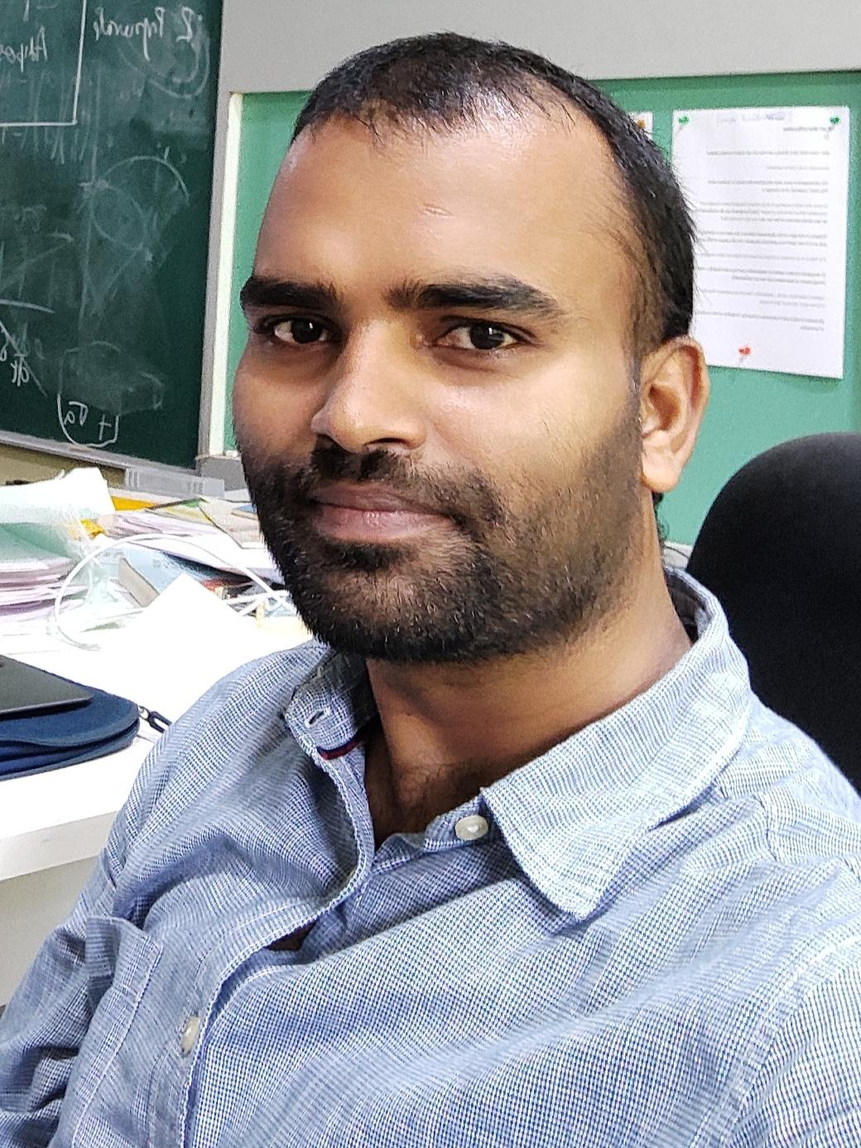

Present Address: 575 Children’s Xrd, Nationwide Children’s Hospital, Columbus, OH 43215
📞 +19513861058, +918452013248
📧 saeediitb@gmail.com, saeed.ahmad@nationwidechildrens.org
Google Scholar | Linkedin | Researchgate | GitHub

EDUCATION
Ph.D. 2017–2022, IIT Bombay, CPI—9.33 (in 10) in coursework.
Thesis title: “First Passage in Biased Diffusion with Stochastic Resetting”
Supervisor— Prof. Dibyendu Das
M.Sc. 2014–2016, IIT Indore, CPI—8.5 (in 10)
Thesis title: “Photoproduction Cross-section of the eta-prime ($η^{'}$) meson with CLAS”
Supervisor— Prof. Ankhi Roy
B.Sc. 2011–2014, Jamia Millia Islamia (JMI), Percentage—74.04 (in 100)
XII 2007–2009, Board of High School and Intermediate Education, UP, Percentage—68.00 (in 100)
X 2005–2007, Board of High School and Intermediate Education, UP, Percentage—64.5 (in 100)

RESEARCH INTEREST
My research is aimed at understanding theoretical and computational problems in stochastic processes (specifically in biological systems and immunology). Currently, I am involved in developing model to understand Natural Killer (NK) cell response using various frameworks. These models are designed to predict CAR-NK cytotoxic activity, explore clonal variability and analyze spatial statistics of receptor clustering.
Previously, my focus was on optimizing target search in stochastic environments. I have been applying various strategies to optimize such process. A strategy of stochastic resetting is one that optimizes under certain conditions.
In addition, I have investigated the assembly and disassembly of virus capsid. In general, the virus is encapsulated inside the capsid, which plays a very interesting role in the virus fate. My research examines how these processes unfold under different physiological conditions.

ACADEMIC APPOINTMENT
- Postdoctoral fellow, Nationwide Children’s Hospital, Columbus 09/2023-Present
- Postdoctoral fellow, University of California, Riverside 09/2022-09/2023

PUBLICATIONS
[1] Saeed Ahmad, Indrani Nayak, Ajay Bansal, Amitabha Nandi, Dibyendu Das: “First passage of a particle in a potential under stochastic resetting: A vanishing transition of optimal resetting rate” Physical Review E, 99, 022130 (2019)
[2] Saeed Ahmad, Dibyendu Das: “Role of dimensions in first passage of a diffusing particle under stochastic resetting and attractive bias” Physical Review E, 102, 032145 (2020)
[3] Saeed Ahmad, Krishna Rijal, Dibyendu Das: “First passage in the presence of stochastic resetting and a potential barrier” Physical Review E, 105, 044134 (2022)

[4] Saeed Ahmad, Dibyendu Das: “Comparing the roles of time overhead and spatial dimensions on optimal resetting rate vanishing transitions, in Brownian processes with potential bias and stochastic resetting” J. Phys. A: Mathematical and Theoretical (2023)
[5] Saeed Ahmad, Kun Xing, Marcelo S. F. Pereira, Stephanie Castle, Harshana Rajakaruna, Indrani Nayak, William C Stewart, Kyle A Beckwith, Mitchell S. Cairo, Meisam Naeimi Kararoudi, Dean A Lee, Jayajit Das: “A framework integrating multiscale in silico modeling and experimental data predicts CAR-NK cell cytotoxicity across target cell types” Proc. Natl. Acad. Sci., 123, 2500319123 (2026)
[6] Darren Wethington, Saeed Ahmad, Marc Potempa, Giuseppe Giuliani, Oscar A. Aguilar, Maheshwor Poudel, Simon Grassmann, William Stewart, Nicholas M. Adams, Joseph C. Sun, Lewis L. Lanier, Jayajit Das: “Clonal stochasticity in early NK cell response to mouse cytomegalovirus is generated by mature subsets of varying proliferative ability” Elife (2025)

[7] Saeed Ahmad, Debangana Mukhopadhyay, Rajdeep Grewal, Ciriyam Jayaprakash, Jayajit Das: “Resting-state spatial statistics of NK cell receptors may improve early signal discrimination” Biophysical Journal (2026)

RELEVANT SKILLS
Programming Languages: Python, NumPy, Pytorch, scikit-learn, pandas, SciPy, matplotlib, Cuda GPU, MPI, C++
Model Development: Virus growth model, Stochastic Protein-protein interaction model, Multiscale cell growth model and Protein Language model
Software Skills: Mathematica, LaTeX, Gnu, Keynote, Microsoft Office, Xmgrace, OVITO
Operating Systems: MacOS, Linux, Windows

TEACHING EXPERIENCE
Physics general lab (experimental)

REFERENCES
Prof. Dibyendu Das, Dept. of Physics, IIT Bombay, Mumbai 400076, India
📧 dibyendu@phy.iitb.ac.in, ☎️ +91-22-25767555
Prof. Jayajit Das, Steve and Cindy Rasmussen Institute for Genomic Medicine, Abigail Wexner Research Institute, Nationwide Children’s Hospital, Columbus, OH
📧 jayajit.das@nationwidechildrens.org, ☎️ +1(614)-355-5632
Prof. Amitabh Nandi, Dept. of Physics, IIT Bombay, Mumbai 400076, India
📧 amitabha@phy.iitb.ac.in, ☎️ +91-22-25767599,
Prof. Mithun Kumar Mitra, Dept. of Physics, IIT Bombay, Mumbai 400076, India
📧 mithun@phy.iitb.ac.in, ☎️ +91-22-25767565,

SCHOOL AND CONFERENCES
- OSUCCC-Pelotonia Institute for Immuno-Oncology Sixth Annual Immuno-Oncology Symposium Poster Presentation
- OSUCCC-Pelotonia Institute for Immuno-Oncology Sixth Annual Immuno-Oncology Symposium Guest talk
- NCH retreat conference (2024)
- Ohio State University (College of Medicine) Poster Presentation
- Presented Poster in Indian Statistical Physics Community Meeting, ICTS, India, 2019.
- Attended Bangalore School on Statistical Physics - X, ICTS, India, 2019.

AWARDS AND ACHIEVEMENTS
- Best Poster award, at PIIO conference (2024)
- Gold Medal, 2014 in B.Sc.
- JAM, 2014 in Physics.
- CSIR-JRF, 2016 in Physics.
- GATE, 2017 in Physics.
- Fellowship for Teaching Assistantship (TA) at IIT Bombay.

