
SECP3204: Software Engineering WBL

System Documentation

Project Title

Version X

Date

School of Computing, Faculty of Engineering

Prepared by: <Team name>

Revision Page
- Overview
Describe the content of the current version (referring to the current SD).

- Target Audience
State the targeted audience for the SD.

- Project Team Members
List the team members in a table by stating their roles and the status for each assigned task (complete, partially complete, incomplete). If the assigned tasks are not done and have been assigned to other team members, state accordingly.

- Version Control History
Version | Primary Author(s) | Description of Version | Date Completed
e.g. Version 1.0 | Team leader 1 | Completed Section… | dd/mm/yyyy
e.g. Version 2.0 | Team leader 2 | Completed Section… | dd/mm/yyyy
Note: The title page should show the latest version, in the e.g. it should be 2.0. For your first submission (PR2-Chap.1 and 2), it should be 1.0, then 2.0 for PR3 and 3.0 for PR4. Primary author(s) could be the team leaders who should compile all materials for the purpose of SD submission. [remove this note in red texts and the examples in the table above]

Note:
This System Documentation (SD) template is adapted from IEEE Recommended Practice for Software Requirements Specification (SRS) (IEEE Std. 830-1998), Software Design Descriptions (SDD) (IEEE Std. 10161998 1), and Software Test Documentation (IEEE Std. 829-2008) that are simplified and customized to meet the need of SCSJ2203 course at Faculty of Computing, UTM. Examples of models are from Arlow and Neustadt (2002) and other sources stated accordingly.

Table of Contents
8 | Test Cases
 | 8.1 | TC001: Test <Name of Package 1> Subsystem: <Name of Use Case (UC001)>
 |  | 8.1.1 | TC001_01: Test <Scenario of Sequence Diagram 1 (SD001)>
 |  | 8.1.2 | TC001_02: Test <Scenario of Sequence Diagram 2 (SD002)>
 | 8.2 | TC002: Test <Name of Package 2> Subsystem: <Name of Use Case (UC002)>
 | 8.3 | TC003: Test <Name of Package 3> Subsystem: <Name of Use Case (UC003)>
9 | Test Approach Analysis
 | Appendices
 | Appendix A: Traceability Matrix

- Test Cases
This is a numbered list of tests. Use tables to group similar tests. For each test, specify:
- Test ID and name
- Additional description if test name is not descriptive enough
- The input data
- The expected output data
- The actual output data (not in the scope of this course – leave blanks)
- Result: pass or fail (not in the scope of this course – leave blanks)

  - TC001: Test <Name of Package 1> Subsystem: <Name of Use Case (UC001)>
List all test cases before providing the details for each under each package/subsystem and use case.
This test contains the following test cases:
- TC001_01: Test <Scenario of sequence diagram1 (SD001)>
- TC001_02: Test <Scenario of sequence diagram2 (SD002)>
- …

    - TC001_01: Test <state scenario of sequence diagram1 (SD001)>
Provide the details for each test case. For the scope of this course, leave blanks for the columns on actual results and pass/fail status. See an example as below for better understanding. If there are alternate and exception scenarios, repeat the table below under this sub-section also.
This test contains the following alternate and exception scenarios (if any):
- TC001_01_01: Test <alternate scenario1 of sequence diagram1 (SD001)>
- TC001_01_02: Test <exception scenario1 of sequence diagram1 (SD001)>
- …
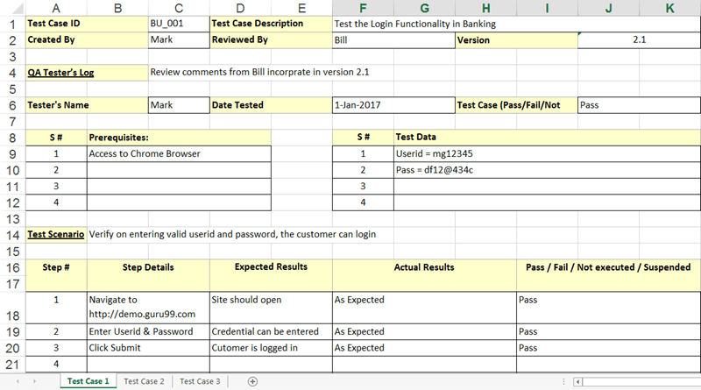
    - TC001_02: Test <Scenario of sequence diagram2 (SD002)>
Provide the details for this test case.
    - TC001_n: Test <Scenario of sequence diagram n (…)>
Provide the details for this test case.
  - TC002: Test <Name of Package 2> Subsystem: <Name of Use Case (UC002)>
List all test cases before providing the details for the second use case in module1. Include the sub-sections accordingly.
This test contains the following test cases:
- TC002_01: Test <Scenario of sequence diagram4 (SD004)>
- TC002_02: Test <Scenario of sequence diagram5 (SD005)>
- …

  - TC003: Test <Name of Package 3> Subsystem: <Name of Use Case (UC003)>
List all test cases before providing the details for the first use case in module2. Include the sub-sections accordingly.
This test contains the following test cases:
- TC003_01: Test <Scenario of sequence diagram6 (SD006)>
- TC003_02: Test <Scenario of sequence diagram7 (SD007)>
- …

- Test Approach Analysis
The test approach includes the use of (describe briefly)…
This is a description of how you tested the software. It includes any tools you employed for automated testing, test scripts, the testing techniques employed (white box, black box, and a discussion on the success or failure of your approach.

For the scope of this course, state the use of black-box testing strategy using equivalence partitioning (EP) and boundary value analysis (BVA). Indicate the test case ID as stated in the respective sub-section and state the step# that uses the EP and BVA (input data that is mandatory and with input condition).

Recap that EP creates the partitions for input data:
- If an input condition specifies a range or a specific value, one valid and two invalid equivalence classes defined.
- If an input condition specifies a Boolean or a member of a set, one valid and one invalid

Then create test cases using the input values that sit at the border using BVA e.g. for a range:
Test Case ID | Step# | Input data | Invalid | Valid | Invalid
TC001_01 | n
…

Then create test cases using the input values that sit at the border using BVA e.g. for a Boolean:
Test Case ID | Step# | Input data | Valid | Invalid
TC001_02 | n
…

Note that input data that is mandatory to be entered should have value (not null) for valid and null for invalid (an example for a Boolean input condition). If the same input data has a more specific input condition such as a range, this should be under a specific test case ID. An input data that is not mandatory and does not have any specific input conditions, are not required in this section.

Appendix A: Traceability Matrix

Test Case ID | Use Case ID/  Sequence Diagram ID | Package ID
TC001 for <Name of Package 1> Subsystem  - TC001_01  - TC001_02 | UC001  - SD001  - SD002 | P001
TC002 for <Name of Package 2> Subsystem  - TC002_01  - TC002_02 | UC002  - SD004  - SD005 | P001
…
TC003 for <Name of Package 3> Subsystem  - TC003_01  - TC003_02 | UC003  - SD006  - SD007 | P002
…

