
SECP3204: Software Engineering WBL

System Requirements Specification (SRS)

Project Title

Version X

Date

School of Computing, Faculty of Engineering

Prepared by: <Team name>

Table of Contents
1 | Introduction |  |  | 1
 | 1.1 | Purpose |  | 1
 | 1.2 | Scope |  | ?
 | 1.3 | Definitions, Acronyms and Abbreviations |  | ?
 | 1.4 | References |  | ?
 | 1.5 | Overview |  | ?
2 | Specific Requirements |  |  | ?
 | 2.1 | External Interface Requirements |  | ?
 |  | 2.1.1 | User Interfaces
 |  | 2.1.2 | Hardware Interfaces
 |  | 2.1.3 | Software Interfaces
 |  | 2.1.4 | Communication Interfaces
 | 2.2 | System Features
 |  | 2.2.1 | UC001: Use Case <Name of Use Case 1>
 |  | 2.2.2 | UC002: Use Case <Name of Use Case 2>
 |  | 2.2.3 | UC003: Use Case <Name of Use Case 3>
 |  | 2.2.n | UCn: Use Case <Name of Use Case n>
 | 2.3 | Performance and Other Requirements
 | 2.4 | Design Constraints
 | 2.5 | Software System Attributes
 | Appendices
- Introduction
The following sections of the System Documentation (SD) should provide the details of the entire document comprises SRS, SDD, STD. Remove the notes in read texts when submitting including these notes.

  - Purpose
This subsection should:
- Delineate the purpose of the SD;
- Specify the intended audience for the SD.

This SD describes…

  - Scope
This subsection should:
- Identify the software product(s) to be produced by name (e.g., Host DBMS, Report Generator, etc.);
- Explain what the software product(s) will, and, if necessary, will not do;
- Describe the application of the software being specified, including relevant benefits, objectives, and goals;
- Be consistent with similar statements in higher-level specifications (e.g., the system requirements specification), if they exist.

The software product is…

  - Definitions, Acronyms and Abbreviation
This subsection should provide the definitions of all terms, acronyms, and abbreviations used in the SD.

Definitions of all terms, acronyms and abbreviation used are to be defined here.

  - References
This subsection should:
- Provide a complete list of all documents referenced elsewhere in the SD;
- Identify each document by title, report number (if applicable), date, and publishing organization;
- Specify the sources from which the references can be obtained.

Specify complete list of references using a standardized reference format.

  - Overview
This subsection should:
- Describe what the rest of the SD contains;
- Explain how the SD is organized.

Give an overview of the content of this SD document.
- Specific Requirements
This section of SD serves as the SRS that should contain all the software requirements to a level of detail sufficient to enable designers to design a system to satisfy those requirements, and testers to test that the system satisfies those requirements. Throughout this section, every stated requirement should be externally perceivable by users, operators, or other external systems. These requirements should include at a minimum a description of every input (stimulus) into the system, every output (response) from the system, and all functions performed by the system in response to an input or in support of an output.

  - External Interface Requirements
    - User Interfaces
This should specify the following:
- The logical characteristics of each interface between the software product and its users.
This includes those configuration characteristics (e.g., required screen formats, page or window layouts, content of any reports or menus, or availability of programmable function keys) necessary to accomplish the software requirements.
- All the aspects of optimizing the interface with the person who must use the system.
This may simply comprise a list of do’s and don’ts on how the system will appear to the user. One example may be a requirement for the option of long or short error messages. Like all others, these requirements should be verifiable, e.g. “A clerk typist grade 4 can do function X in Z min after 1 h of training” rather than “a typist can do function X.” (This may also be specified in the Software System Attributes under a section titled Ease of Use.)
Describe how the system will interact with its users.

    - Hardware Interfaces
This should specify the logical characteristics of each interface between the software product and the hardware components of the system. This includes configuration characteristics (number of ports, instruction sets, etc.). It also covers such matters as what devices are to be supported, how they are to be supported, and protocols. For example, terminal support may specify full-screen support as opposed to line-by-line support.
Specify the logical characteristic here…

    - Software Interfaces
This should specify the use of other required software products (e.g., a data management system, an operating system, or a mathematical package), and interfaces with other application systems (e.g., the linkage between an accounts receivable system and a general ledger system). For each required software product, the following should be provided:
- Name;
- Mnemonic;
- Specification number;
- Version number;
- Source.
For each interface, the following should be provided:
- Discussion of the purpose of the interfacing software as related to this software product.
- Definition of the interface in terms of message content and format. It is not necessary to detail any [a reference to the document defining the interface is required].

Specify here…
    - Communication Interfaces
This should specify the various interfaces to communications such as local network protocols, etc.
Specify here…

  - System Features
The system features include…
[Include use case diagram here – see example of Online Shopping below, source: https://www.uml-diagrams.org/index-examples.html]
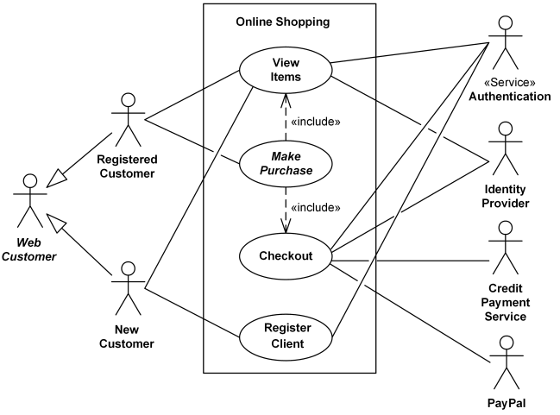
Figure 2.1: Use Case Diagram for <Name of the System>
[Include the activity diagram here that describes the general sequence of actions for several objects and use cases for the purpose of functional modelling in the system as the whole].
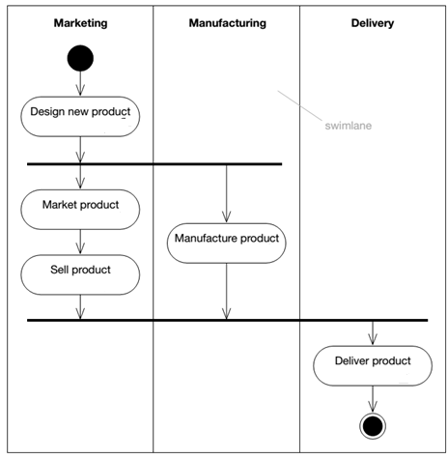
Figure 2.2: Activity Diagram for <Name of the System>

[Include domain model i.e. class diagram without the operation part – only attributes without details on visibility and type, explain each class and its attributes including the relationships among the classes, see the example. For the class with the states only, consider including its state machine diagram, see the example for state machine diagram of Account class]
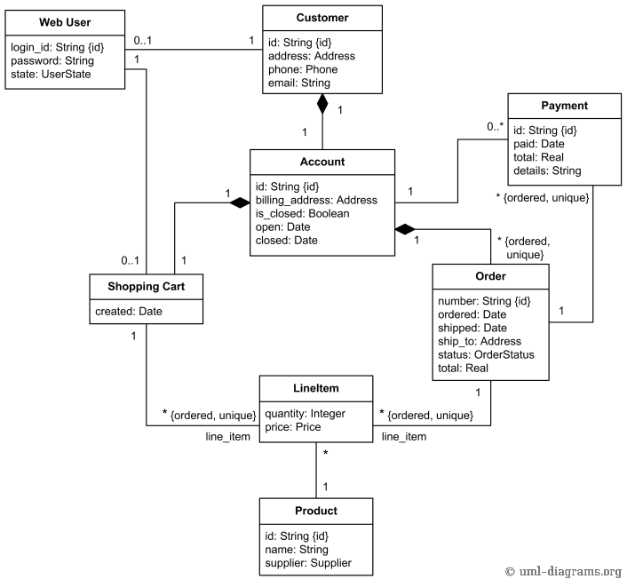
Figure 2.3: Domain Model for <Name of the System>
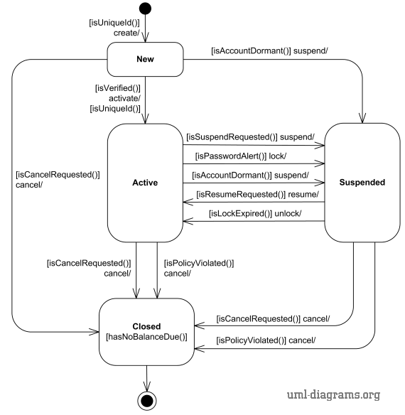
Figure 2.4: State Machine Diagram for <Name of the Class>
As this is often the largest and most important part of the SRS, the following principles apply:
- Specific requirements should be stated in conformance with all the characteristics described in 4.3. (IEEE Std 830-1998)
- Specific requirements should be cross-referenced to earlier documents that relate.
- All requirements should be uniquely identifiable. [Provide ID to each functional requirement]
- Careful attention should be given to organizing the requirements to maximize readability.
[For each functional requirement, indicate its details using use case description. Include sequence diagram for each use case i.e. functional requirement. Combine alternate flows in the same sequence diagram. Split only if they are too cluttered to be combined.]
    - UC001: Use Case <Name of Use Case 1>
[Provide code for each use case such as UC001 and so on… Include Use Case Description for each use case as in the example below. If there are any alternative flows, add the rows accordingly. Otherwise, just remove the rows. Ensure each use case has its own unique ID and the name of the heading above corresponds to the name of use case in the use case diagram (refer to Figure 2.1). Different scenarios of a use case require separate use case descriptions.]

Table 2.1: Use Case Description for <Name of Use Case>
Use case: <Name of Use Case>
ID: UCxxx
Actors:
Preconditions:

Flow of events:
1.
2.
3.
…

Postconditions:

Alternative flow n:

Postconditions:

Exception flow (if any):

[Include system sequence diagram and activity diagram for each respective use case. See example below. May consider including different scenarios in different diagrams if necessary, to avoid clutter.]
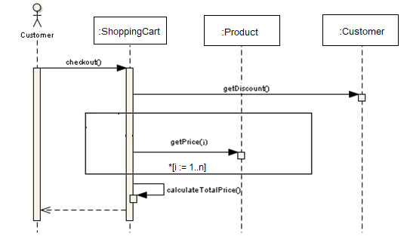
Figure 2.5: Sequence Diagram for <Name of Use Case/Scenario if more than one scenario>
    - UC002: Use Case <Name of Use Case 2>

    - UC003: Use Case <Name of Use Case 3>

    - UCn: Use Case <Name of Use Case n>
…

  - Performance and Other Requirements
State and refer to the specific functional requirement that is related to performance non-functional requirement (if any).
State also other quality characteristics or non-functional requirements for either customers/users or developers such as adaptability, flexibility, interoperability, maintainability, portability, reliability, reusability and usability.
State here…

  - Design Constraints
Explain any constraints imposed by the organization where the software product will be used such as the system must adhere to certain organizational standard and other related non-functional requirements.
State here…

  - Software System Attributes
Indicate any specific attributes that the customers/users request such as system must be attractive and easy to use for any specific customers.
State here…

