
SECP3204: Software Engineering WBL

System Design Descriptions (SDD)

Project Title

Version X

Date

School of Computing, Faculty of Engineering

Prepared by: <Team name>

Table of Contents
3 | System Architectural Design |  |  | ?
 | 3.1 | Architectural Style and Rationale
 | 3.2 | Component Model
4 | Detailed Description of Components |  |  | ?
 | 4.1 | Complete Package Diagram
 | 4.2 | Detailed Description
 |  | 4.2.1 | P001: <Name of Package 1> Subsystem
 |  | 4.2.2 | P002: <Name of Package 2> Subsystem
 |  | 4.2.3 | P003: <Name of the n Package> Subsystem
5 | Data Design |  |  | ?
 | 5.1 | Data Description
 | 5.2 | Data Dictionary
6 | User Interface Design |  |  | ?
 | 6.1 | Overview of User Interface
 | 6.2 | Screen Images
 | Appendices
- System Architectural Design
This section of the SD serves as part of SDD that should describe the architectural style and the rationale or justification of your selection. The component and subsystem diagram should also be included.

  - Architecture Style and Rationale
State your chosen architectural style and the rationale of choosing that particular style.
State here

  - Component Model
Develop a component model and explain the relationships between the components to achieve the complete functionality of the system. This is a high level overview of how responsibilities of the system were partitioned and then assigned to subsystems. Identify each high level subsystem and the roles or responsibilities assigned to it. Describe how these subsystems collaborate with each other in order to achieve the desired functionality. Do not go into too much detail about the individual subsystem. The main purpose is to gain a general understanding of how and why the system was decomposed, and how the individual parts work together. Provide a diagram showing the major subsystems and data repositories and their interconnections. Describe the diagram clearly.
[Include component diagram here]
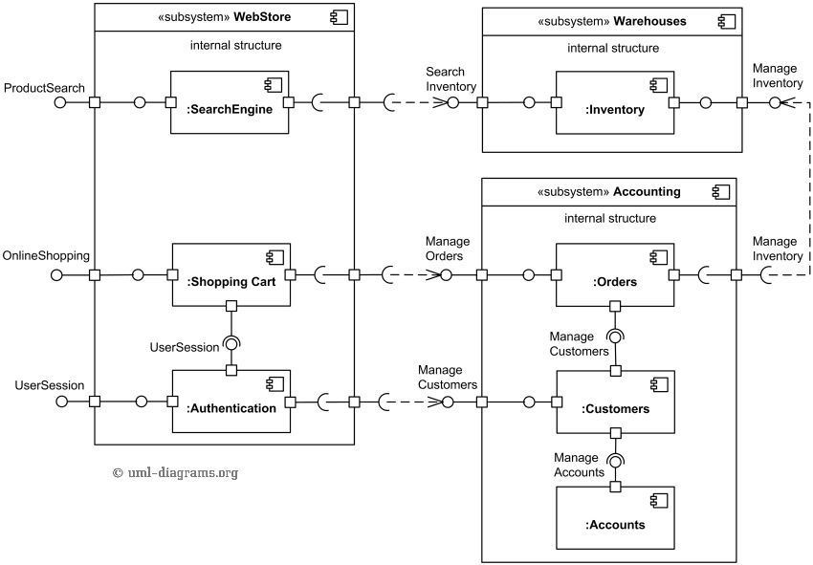
Figure 3.1: Component Diagram of <Name of the System>

- Detailed Description of Components
This section of SD serves as part of SDD that describes each module or subsystem in the project.
  - Complete Package Diagram
Include the overall package diagram of your system here. [Example package diagram for a Sale System adapted from Satzinger (2011)] Indicate the navigation visibility based on the dependency among classes in the design class diagram. If the diagram is too cluttered, simplify the classes by showing the class name only without showing the attributes and methods. The details can be shown in the following class diagram sub-section for respective subsystem/package.
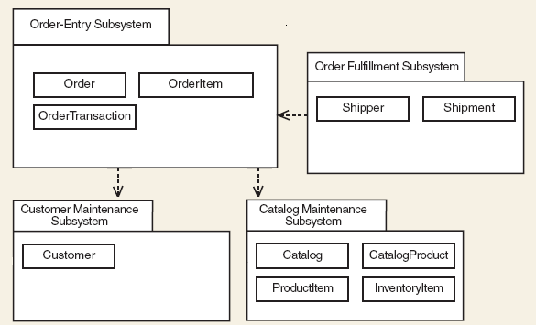
Figure 4.1: Package Diagram for <Name of the System>

  - Detailed Description
For each subsystem/package there must be ONE class diagram and several sequence diagrams based on how many use cases you have in the subsystem/package. Use branching in sequence diagram to combine alternate flow in the same sequence diagram. If the diagram is cluttered, consider a new sequence diagram for respective scenario/alternate flow. The given example includes view, domain and data access layer in respective packages. Organise subsystem/package according to the chosen architectural style. Note that if you choose model-view-controller (MVC) or other architectural styles, then the packages should follow the selected styles. However, for the scope of this course, you may follow the example.
    - P001: <Name of Package 1> Subsystem
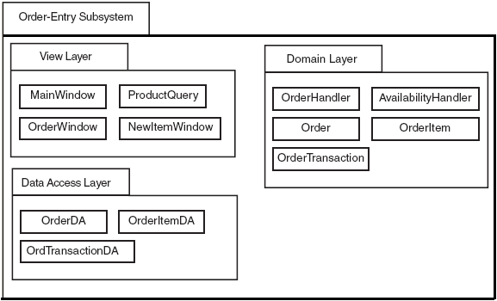
Figure 4.2: Package Diagram for <Name of Package 1> Subsystem
      - Class Diagram
Include class diagram to represent all classes in the respective subsystem/package. Include the controller classes.

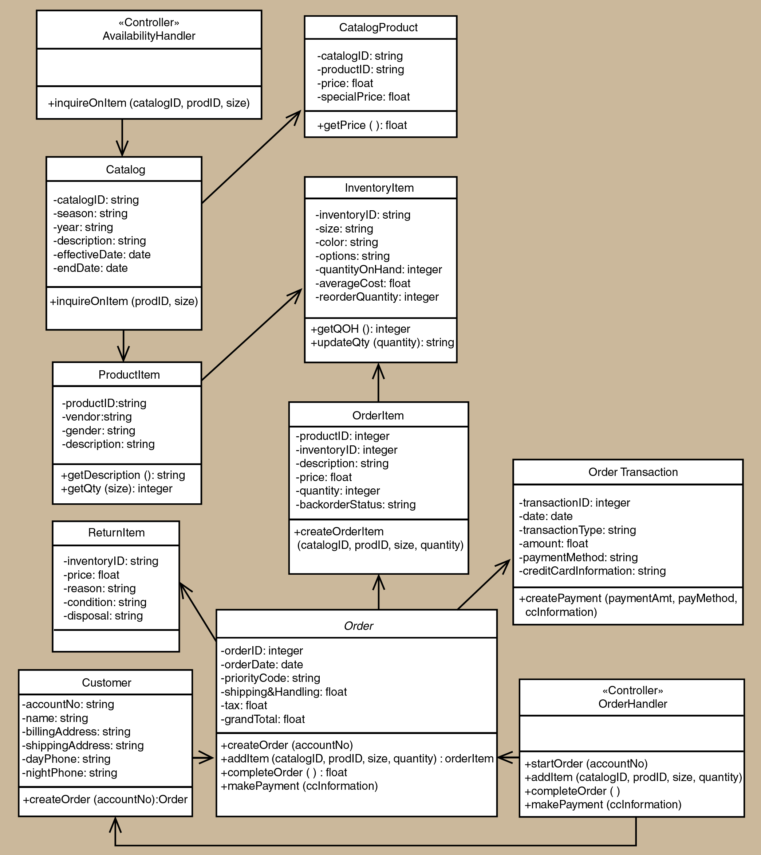
Figure 4.3: Class Diagram for <Name of Package 1> Subsystem
List all methods in a table for respective entity (add the table accordingly), then write its algorithm. Example of algorithm as shown below.
Step1: Start
Step2: Read/input A and B
Step3: If A greater than B then C=A
Step4: If B greater than A then C=B
Step5: Print C
Step6: End
Entity Name | e.g. Order
Method Name | e.g. createOrder
Input
Output
Algorithm | - Start  - …  - End

      - Sequence Diagram
Include sequence diagram for each respective use case in your package. In these examples only sequence diagram Create New Phone Order Scenario and Cancel an Order Scenario are shown. Include the final sequence diagram that comprises view layer, controller, and its problem domain (entity) and data access layer. Provide a unique code for each scenario of sequence diagram to be used in Section 7: Requirements Matrix. If you have only one scenario, then you only need one sequence diagram.

a) SD001: Sequence diagram for Create New Phone Order
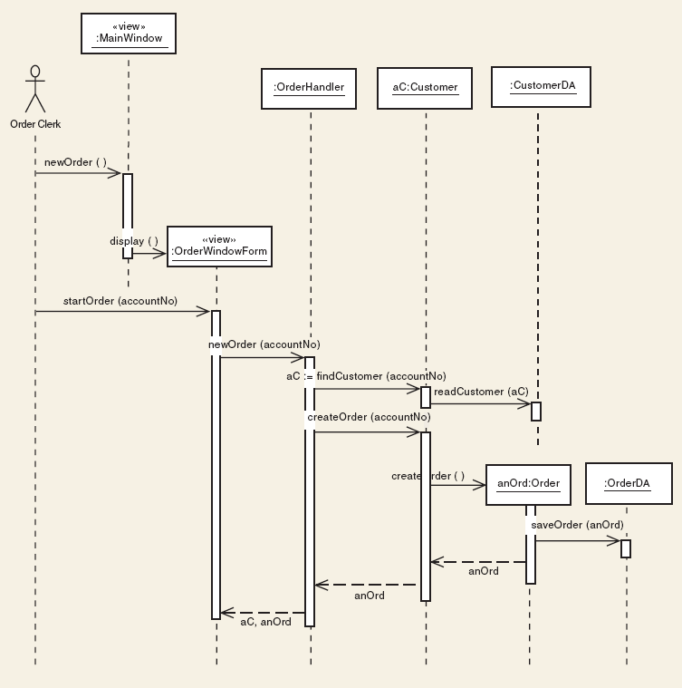
Figure 4.4: Sequence Diagram for <Create New Phone Order Scenario>

b) SD002: Sequence diagram for Create Cancel an Order Scenario

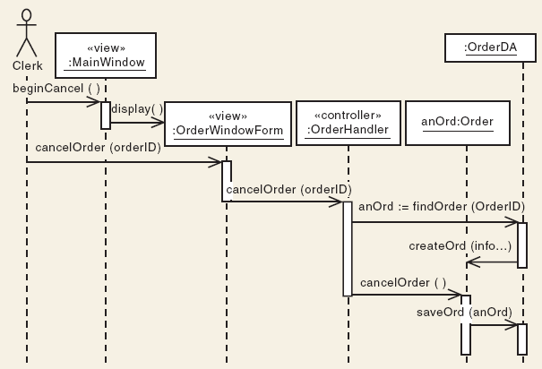
Figure 4.5: Sequence Diagram for <Cancel an Order scenario>
    - P002: <Name of Package 2> Subsystem

      - Class Diagram

      - Sequence Diagram

    - P003: <Name of Package n> Subsystem

      - Class Diagram

      - Sequence Diagram
- Data Design
  - Data Description
Explain how the information domain of your system is transformed into data structures. Describe how the major data or system entities are stored, processed, and organized. List the database(s) or data storage items. For a small system, there is normally only one database. It consists of all the tables in which for object-oriented they are classes/objects as also stated in the domain model. Use table for the listing.
The major data or systems entities are stored into a relational database named as…, processed and organized into n entities as listed in Table 5.1.

Table 5.1: Description of Entities in the Database
No. | Entity Name | Description

  - Data Dictionary
Alphabetically list the system entities or major data along with their types and descriptions (class/object, attributes). Focus on classes in domain layer; omit the controller/handler class. Use tables for easy listing as shown below.

    - Entity: <First Entity>
Attribute Name | Type | Description

    - Entity: <Second Entity>
Attribute Name | Type | Description

- User Interface Design
  - Overview of User Interface
Describe the functionality of the system from the user’s perspective. Explain how the user will be able to use your system to complete all the expected features and the feedback information that will be displayed for the user.
The interface includes…

  - Screen Images
Display screenshots showing the interface from the user’s perspective. These can be drawn using an automated drawing tool. Just make them as accurate as possible. Organise the images by subsystem/package.
Insert the screenshot here

Figure 6.1: Interface for <State the Feature/Function>

