
SECJ2203: Software Engineering

System Documentation (SD)

Project Title

Version X

Date

Faculty of Computing

Prepared by: <Team name>

Revision Page
- Overview
Describe the content of the current version of SD (see below – the note in red).

- Target Audience
State the targeted audience for the SD.

- Project Team Members
List the team members in a table by stating their roles and the status for each assigned task e.g. by sections for this SD version (complete, partially complete, incomplete). If the assigned tasks are not done and have been assigned to other team members, state accordingly.
Member Name | Role | Task | Status

- Version Control History
Version | Primary Author(s) | Description of Version | Date Completed
1.0 | Team leader 1 (Full Name) | Completed Chapter X, Section… | dd/mm/yyyy
…

Note: The title page should show the latest version. For your first submission (Assignment 2), the version should be 1.0, then 2.0 for Assignment 3, and then 3.0 for Assignment 4. Primary author(s) could be the team leaders who should compile all materials for the purpose of SD submission. [remove this note in red texts and the examples in the table above]

Note:
This System Documentation (SD) template is adapted from IEEE Recommended Practice for Software Requirements Specification (SRS) (IEEE Std. 830-1998), Software Design Descriptions (SDD) (IEEE Std. 10161998 1), and Software Test Documentation (IEEE Std. 829-2008) that are simplified and customized to meet the need of SECJ2203 course at Faculty of Computing, UTM. Examples of models are from Arlow and Neustadt (2002) and other sources stated accordingly.

Table of Contents
1 | Introduction |  |  |  | 1
 | 1.1 |  | Purpose |  | 1
 | 1.2 |  | Scope |  | ?
 | 1.3 |  | Definitions, Acronyms and Abbreviations |  | ?
 | 1.4 |  | References |  | ?
 | 1.5 |  | Overview |  | ?
2 | Specific Requirements |  |  |  | ?
 | 2.1 |  | User Characteristics
 | 2.2 |  | System Features
 |  |  | 2.2.1 | UC001: Use Case <Name of Use Case 1>
 |  |  |  | Use Case Specification of UC001
 |  |  |  | Activity Diagram of UC001
 |  |  |  | System Sequence Diagram of UC001
 |  |  | 2.2.2 | UC002: Use Case <Name of Use Case 2>
 |  |  |  | Use Case Specification of UC002
 |  |  |  | Activity Diagram of UC002
 |  |  |  | System Sequence Diagram of UC002
 |  |  | 2.2.n | UCn: Use Case <Name of Use Case n>
 |  |  |  | Use Case Specification of UC00n
 |  |  |  | Activity Diagram of UC00n
 |  |  |  | System Sequence Diagram of UC00n
 | 2.3 |  | Software System Attributes, Performance and Other Requirements
 | 2.4 |  | Design Constraints
 |  |  | Update this table of content accordingly
- Introduction
The following sections of the System Documentation (SD) should provide the details of the entire document comprising System Requirements Specification (SRS), System Design Document (SDD), and System Testing Document (STD). Remove the notes in read texts when submitting including these notes. For this Assignment 2, you are required to submit the partial SD by completing the SRS part only that covers Section 1.0 and Section 2.0.

  - Purpose
This subsection should:
- Delineate the purpose of the SD;
- Specify the intended audience for the SD.

Example…
The purpose of this System Documentation (SD) is to provide a comprehensive overview of the system development process, including the System Requirements Specification (SRS), System Design Document (SDD), and System Testing Document (STD). The SD serves as a reference document for stakeholders involved in the system development process, including developers, testers, project managers, and clients. The SD provides a clear understanding of the system requirements, design, and testing processes, ensuring that all stakeholders are aligned and working towards the same goals. By providing the structured and comprehensive documentation, the SD helps to ensure the success of the system development process, reducing the risk of errors, increasing efficiency, and improving overall project outcomes.

  - Scope
This subsection should:
- Identify the software product(s) to be produced by name (e.g., Online Learning System, Emotion Chatbot Anlayzer, etc.);
- Explain what the software product(s) will, and, if necessary, will not do;
- Describe the application of the software being specified, including relevant benefits, objectives, and goals;

Example…
This System Documentation (SD) pertains to the software product called "Emotion Chatbot Analyzer" and is designed to provide a clear understanding of the system development process, including the System Requirements Specification (SRS), System Design Document (SDD), and System Testing Document (STD).
The "Emotion Chatbot Analyzer" software product will analyze the user input in a chatbot conversation and determine the user's emotion based on the language and sentiment used in the conversation. The software product will not generate responses for the chatbot, nor will it provide any additional functionality outside of the analysis of user emotions.
The "Emotion Chatbot Analyzer" software product will be developed to analyze the user input in a chatbot conversation and determine the user's emotion based on the language and sentiment used in the conversation. The software product will be designed to improve the user experience of chatbots by providing insights into user sentiment and emotional responses.

The scope of the "Emotion Chatbot Analyzer" software product includes the following:
- Identification of the user and system requirements specification, including functionality, performance, usability, reliability, and security requirements.
- The software product will be developed using the agile-driven approach, ensuring that it is scalable and maintainable.
- The software product will be compatible with different chatbot platforms and be able to integrate with existing chatbot systems.
- The software product will be developed following best practices in software engineering, including coding standards, testing procedures, and quality assurance processes.
- The software product will be tested using a combination of manual and automated testing methods to ensure that it meets all specified requirements and performs as expected.
- The software product will be delivered with a user manual and installation guide to assist users in the setup and use of the software product.

  - Definitions, Acronyms and Abbreviation
This subsection should provide the definitions of all terms, acronyms, and abbreviations used in the SD.

Definitions of all terms, acronyms and abbreviations used are to be defined here.

Below is the example
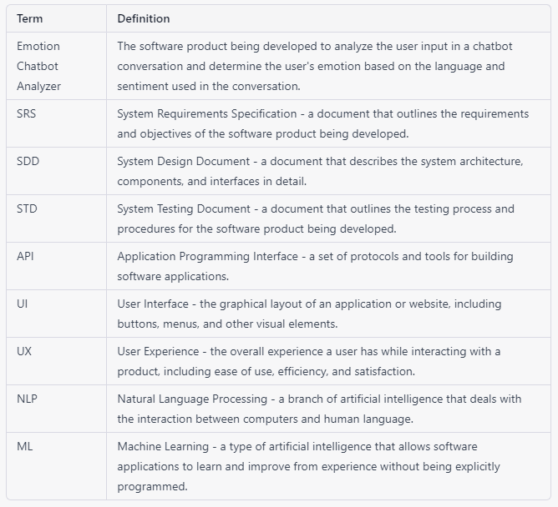

  - References
This subsection should:
- Provide a complete list of all documents referenced elsewhere in the SD;
- Identify each document by title, report number (if applicable), date, and publishing organization;
- Specify the sources from which the references can be obtained.

Specify a complete list of references using a standardized reference format.

  - Overview
This subsection should:
- Describe what the rest of the SD contains;
- Explain how the SD is organized.

Example
The System Documentation (SD) provides a comprehensive description of the Emotion Chatbot Analyzer software product being developed. This document comprises three main sections: System Requirements Specification (SRS), System Design Document (SDD), and System Testing Document (STD).

The SD is organized as follows:

User Characteristics: This section outlines the target users of the Emotion Chatbot Analyzer software product, including their needs, expectations, and relevant characteristics.
System Features: This section provides a detailed description of the functional and non-functional requirements of the software product, including use cases, scenarios, and interfaces.
System Quality Attributes: This section outlines the quality attributes that are essential to the Emotion Chatbot Analyzer software product, such as reliability, usability, maintainability, and portability.
Performance and Design Constraints: This section describes the performance requirements and design constraints that must be adhered to during the development of the software product.
This SD document is intended to serve as a reference for all stakeholders involved in the development, testing, and implementation of the Emotion Chatbot Analyzer software product. It provides a clear and concise overview of the software requirements, design, and testing procedures, and should be consulted throughout the software development lifecycle.
- Specific Requirements
This section of SD serves as the SRS that should contain all the software requirements to a level of detail sufficient to enable designers to design a system to satisfy those requirements, and testers to test that the system satisfies those requirements. Throughout this section, every stated requirement should be externally perceivable by users, operators, or other external systems. These requirements should include at a minimum a description of every input (stimulus) into the system, every output (response) from the system, and all functions performed by the system in response to an input or in support of an output.

  - User characteristics
This should specify the following:
In an SRS, the user characteristics section describes the intended users of the system and their characteristics, such as their technical expertise, knowledge, and physical abilities. This section is important because it provides the development team with a clear understanding of whom the system is designed for, and helps to ensure that the system is developed to meet the needs of its intended users.
Example. Describe how the system will interact with its users.
The "Emotion Chatbot Analyzer" software will be used by two main types of users: UTM students and UTM counselors.
2.1.1 UTM Students
- The UTM students who will use the software are expected to have basic computer skills, including familiarity with web-based applications.
- They may have varying levels of emotional intelligence and may experience a wide range of emotional states, from mild stress to severe anxiety or depression.
- Some students may be reluctant to seek counseling or may not have access to professional ccounseling services, making the chatbot a valuable resource for emotional support and guidance.
2.1.1 UTM Counsellors
- The UTM counsellors who will use the software are expected to have professional training and experience in counselling and psychology.
- They may have varying levels of technical expertise, but will receive training on how to use the software.
- They will use the software to access student emotion records and provide counselling services to students as needed.
- Both types of users will be required to provide personal information such as name and email address in order to register for the software. The software will be designed with privacy and security measures in place to protect user information.

  - System Features
Specify the product perspective.
Example.
The Emotion Chatbot Analyzer is a software system that operates on mobile devices, including both Android and iOS operating systems. The system provides a means for UTM students to better manage their emotional health and at the same time simplifies the process of seeking emotional support from UTM counselors The system also implemented a real-time cloud-based database for better user experiences.

Specify the product module and function..
Include use case diagram here – see an example of Emotion Chatbot Analyzer below
Then, provide the description of each module and function using a table.

Example.
The system features is illustrated in Figure X.X below. The detail description of each module and functions is tabulated in Table X.X.

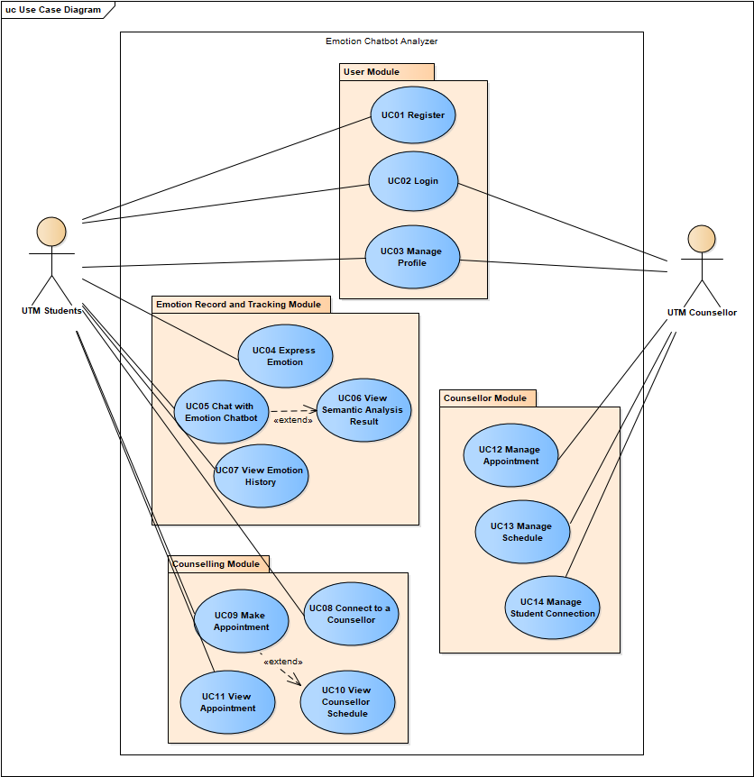
Figure X.X: Use Case Diagram for <Name of the System>

Table X.X: Description of Module and Functions for <Name of the System>
Module | Function | Description
User Module | UC01 – Register | This use case allows students to sign up as a user for the mobile application.

[Include domain model i.e. class diagram without the operation part – only attributes without details on visibility and type, explain each class and its attributes including the relationships among the classes, see the example.]
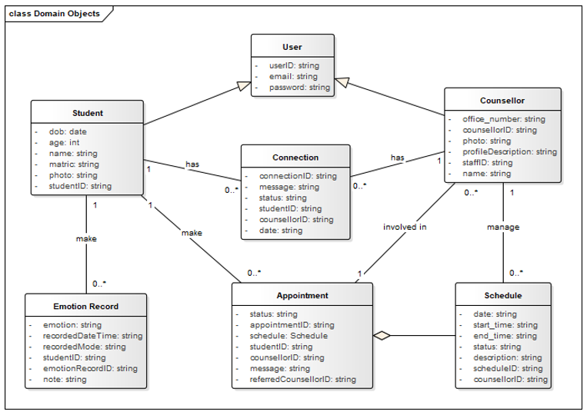
Figure X.X: Domain Model for <Name of the System>

    - UC001: Use Case <Name of Use Case 1>
[Provide code for each use case such as UC001 and so on… Include Use Case Description for each use case as in the example below. If there are any alternative flows, add the rows accordingly. Otherwise, just remove the rows. Ensure each use case has its own unique ID and the name of the heading above corresponds to the name of use case in the use case diagram (refer to Figure X.X). Different scenarios of a use case require separate use case descriptions.]
Table X.X: Use Case Description for <Name of Use Case>
Use case: <Name of Use Case>
ID: UCxxx
Actors:
Preconditions:

The flow of events:
1.
2.
…

Postconditions:

Alternative flow n:

Postconditions:

Exception flow (if any):

Example.
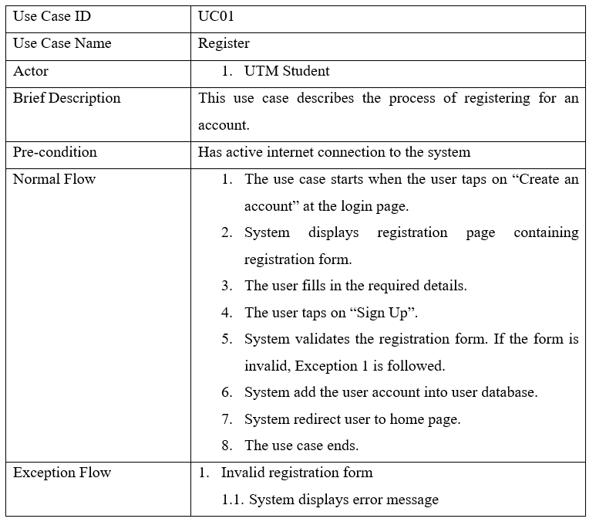

[Include activity diagram for each respective use case. See the example below. May consider including different scenarios in different diagrams if necessary, to avoid clutter.]
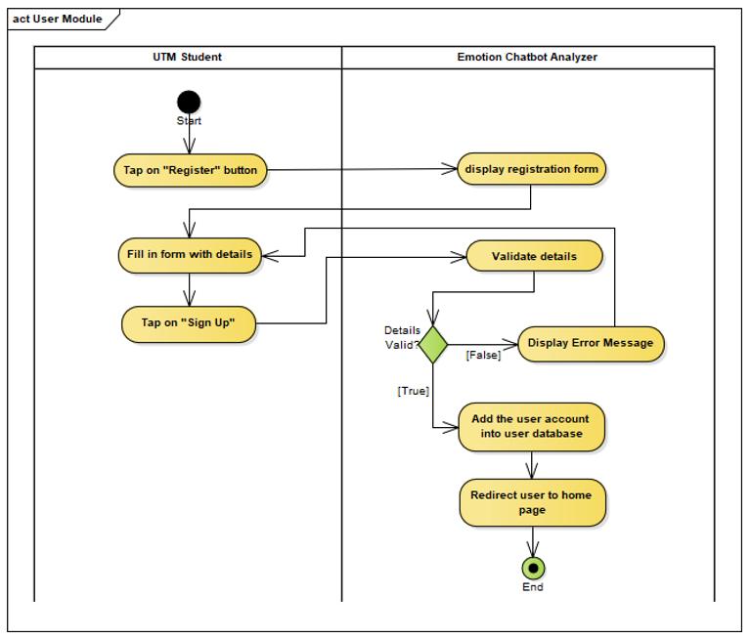
Figure X.X: Activity diagram for <Name of Use Case/Scenario if more than one scenario>

[Sequence diagrams are used to model the interactions between the actors and the objects showing their behavior within a system. If the use case involves interaction between actors and the system, include a system sequence diagram to demonstrate their behavior. See the example below. May consider including different scenarios in different diagrams if necessary, to avoid clutter. Example as below.]
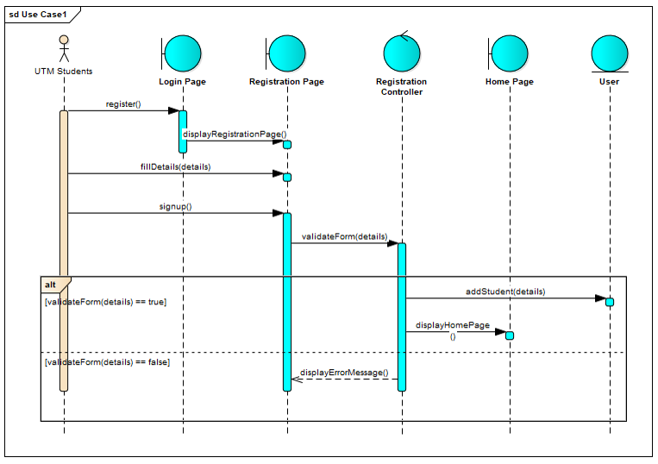
Figure X.X: Sequence Diagram for <Name of Use Case/Scenario if more than one scenario>

    - UC002: Use Case <Name of Use Case 2>

    - UCn: Use Case <Name of Use Case n>
…

  - Software System Attributes, Performance and Other Requirements
Non-functional requirements are the requirements that describe how the system should behave or operate, rather than what it should do. They address the characteristics or qualities of the system, such as its usability, reliability, performance, security, maintainability, and compatibility. Non-functional requirements are important to write in the SD because they help ensure that the system meets the stakeholders' needs and expectations.The ISO/IEC/IEEE 29148 standard suggests that non-functional requirements should be specified under three main categories: Software System Attributes, Performance and Other Requirements.

Example of Software System Atrributes are as follows:
Software system attributes define the overall qualities or characteristics of the software. These attributes are the foundation on which the software is built, and they include the following:
- Usability: The ease with which users can interact with the system.
- Reliability: The ability of the system to perform its functions correctly and consistently.
- Maintainability: The ease with which the system can be modified, repaired, and enhanced.
- Portability: The ability of the system to run on different hardware and software platforms.
- Compatibility: The ability of the system to work with other systems and components.

Example of Performance is as follows:
Performance requirements define the system's capability to respond to user requests and handle data in a timely manner. These requirements include the following:
- Response Time: The time it takes for the system to respond to a user request.
- Throughput: The number of requests the system can handle in a given period of time.
- Capacity: The maximum number of users or amount of data that the system can handle.
- Availability: The percentage of time the system is operational and accessible to users.

Example of Other Requirements is as follows:
Other requirements refer to any non-functional requirements that do not fit under the categories of software system attributes or performance. These requirements include the following:
- Security: The protection of the system and its data from unauthorized access and malicious attacks.
- Safety: The ability of the system to operate safely without causing harm to users or the environment.
- Legal and Regulatory: Compliance with laws, regulations, and standards.
- Environmental: The impact of the system on the environment.

  - Design Constraints
Explain any constraints imposed by the organization where the software product will be used such as the system must adhere to certain organizational standards and other related non-functional requirements.

The example is as follows:
Environmental constraints: These constraints relate to the physical environment in which the system will operate, such as temperature, humidity, and lighting conditions. An example of an environmental constraint is: "The system must be designed to operate in temperatures ranging from 0°C to 40°C."

Hardware constraints: These constraints relate to the specific hardware components that will be used in the system, such as processors, memory, and storage. An example of a hardware constraint is: "The system must be designed to run on a minimum of 8GB of RAM."

Security constraints: These constraints relate to the security requirements for the system, such as data encryption, authentication, and access control. An example of a security constraint is: "The system must be designed to encrypt all sensitive user data using AES-256 encryption."

Compatibility constraints: These constraints relate to the compatibility requirements for the system, such as compatibility with specific software or hardware components. An example of a compatibility constraint is: "The system must be designed to be compatible with Windows 10 operating system."

Performance constraints: These constraints relate to the performance requirements for the system, such as response time, throughput, and capacity. An example of a performance constraint is: "The system must be designed to support a maximum of 1000 concurrent users with a response time of less than 5 seconds."
- Section 1 and Section 2 must be updated/amend accordingly based on feedback from your lecture
- Next combine with new Section 3, Section 4, and Section 5 to complete and submit this Assignment 3.

- System Architectural Design
This section of the SD serves as part of the SDD that should describe the architectural style and the rationale or justification of your selection. The component and subsystem diagram should also be included.

  - Architecture Pattern and Rationale
State your chosen architectural pattern and the rationale for choosing that particular pattern.
The Example is as follows:
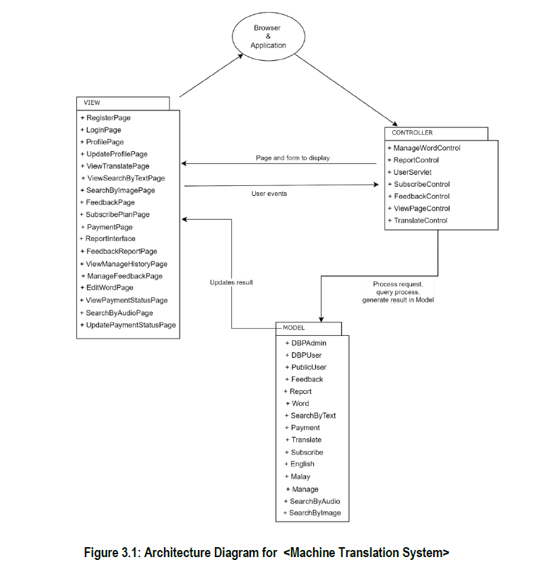

  - Component Model
Develop a component model and explain the relationships between the components to achieve the complete functionality of the system. A component diagram is a type of UML diagram that shows the structure of a software system by depicting the system's components and their dependencies. Components are software units that can be assembled to create a system. They can be classes, modules, libraries, or executable files. Dependencies are relationships between components that indicate that one component uses or relies on another component.
[Include component diagram here]
The Example is as follows:

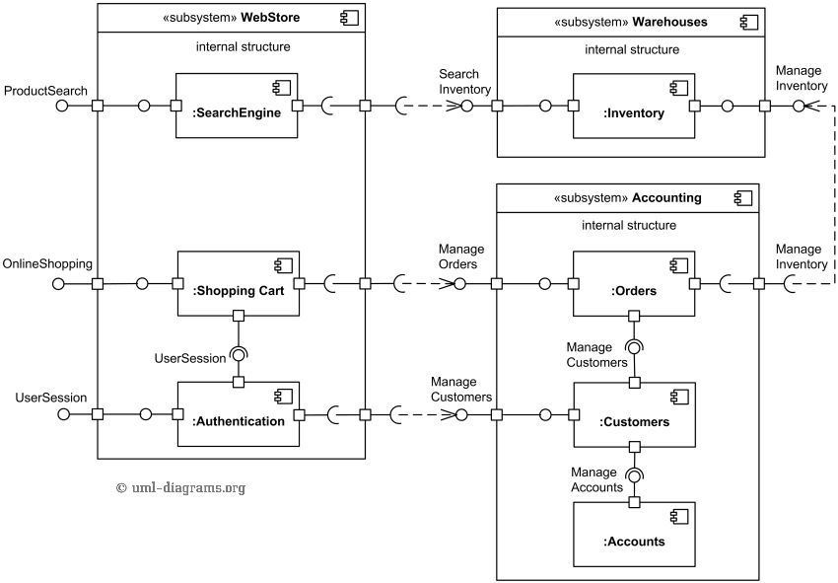
Figure 3.2: Component Diagram of <Online Shopping System>

- Detailed Description of Components
This section of SD serves as part of SDD that describes each module or subsystem in the project.
  - Complete Package Diagram
Package diagrams denote which classes work together as a subsystem. Include the overall package diagram of your system here.
[Example package diagram for a Sale System adapted from Satzinger (2011)] Indicate the navigation visibility based on the dependency among classes in the design class diagram. If the diagram is too cluttered, simplify the classes by showing the class name only without showing the attributes and methods. The details can be shown in the following class diagram sub-section for the respective subsystem/package.]
The Example is as follows:

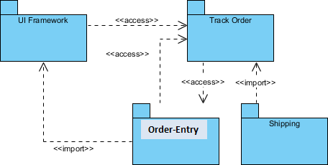
Figure 4.1: Package Diagram for <Order System>

  - Detailed Description
For each subsystem/package, there must be ONE class diagram and sequence diagram(s) based on how many use cases you have in the subsystem/package. Use branching in the sequence diagram to combine alternate flow in the same sequence diagram. If the diagram is cluttered, consider a new sequence diagram for the respective scenario/alternate flow. The given example includes the view, domain, and data access layer in respective packages. Organise subsystem/package according to the chosen architectural style. Note that if you choose model-view-controller (MVC) or other architectural patterns, then the packages should follow the selected pattern. However, for the scope of this course, you may follow the example.
    - P001: <Name of Package 1> Subsystem
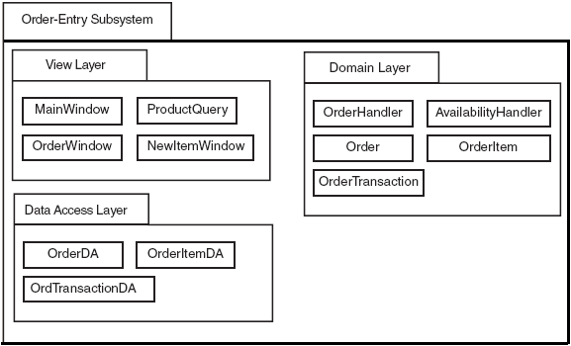
Figure 4.2: Package Diagram for <Order-Entry> Subsystem

      - Class Diagram
Include class diagram to represent all classes in the respective subsystem/package. Include the controller classes.

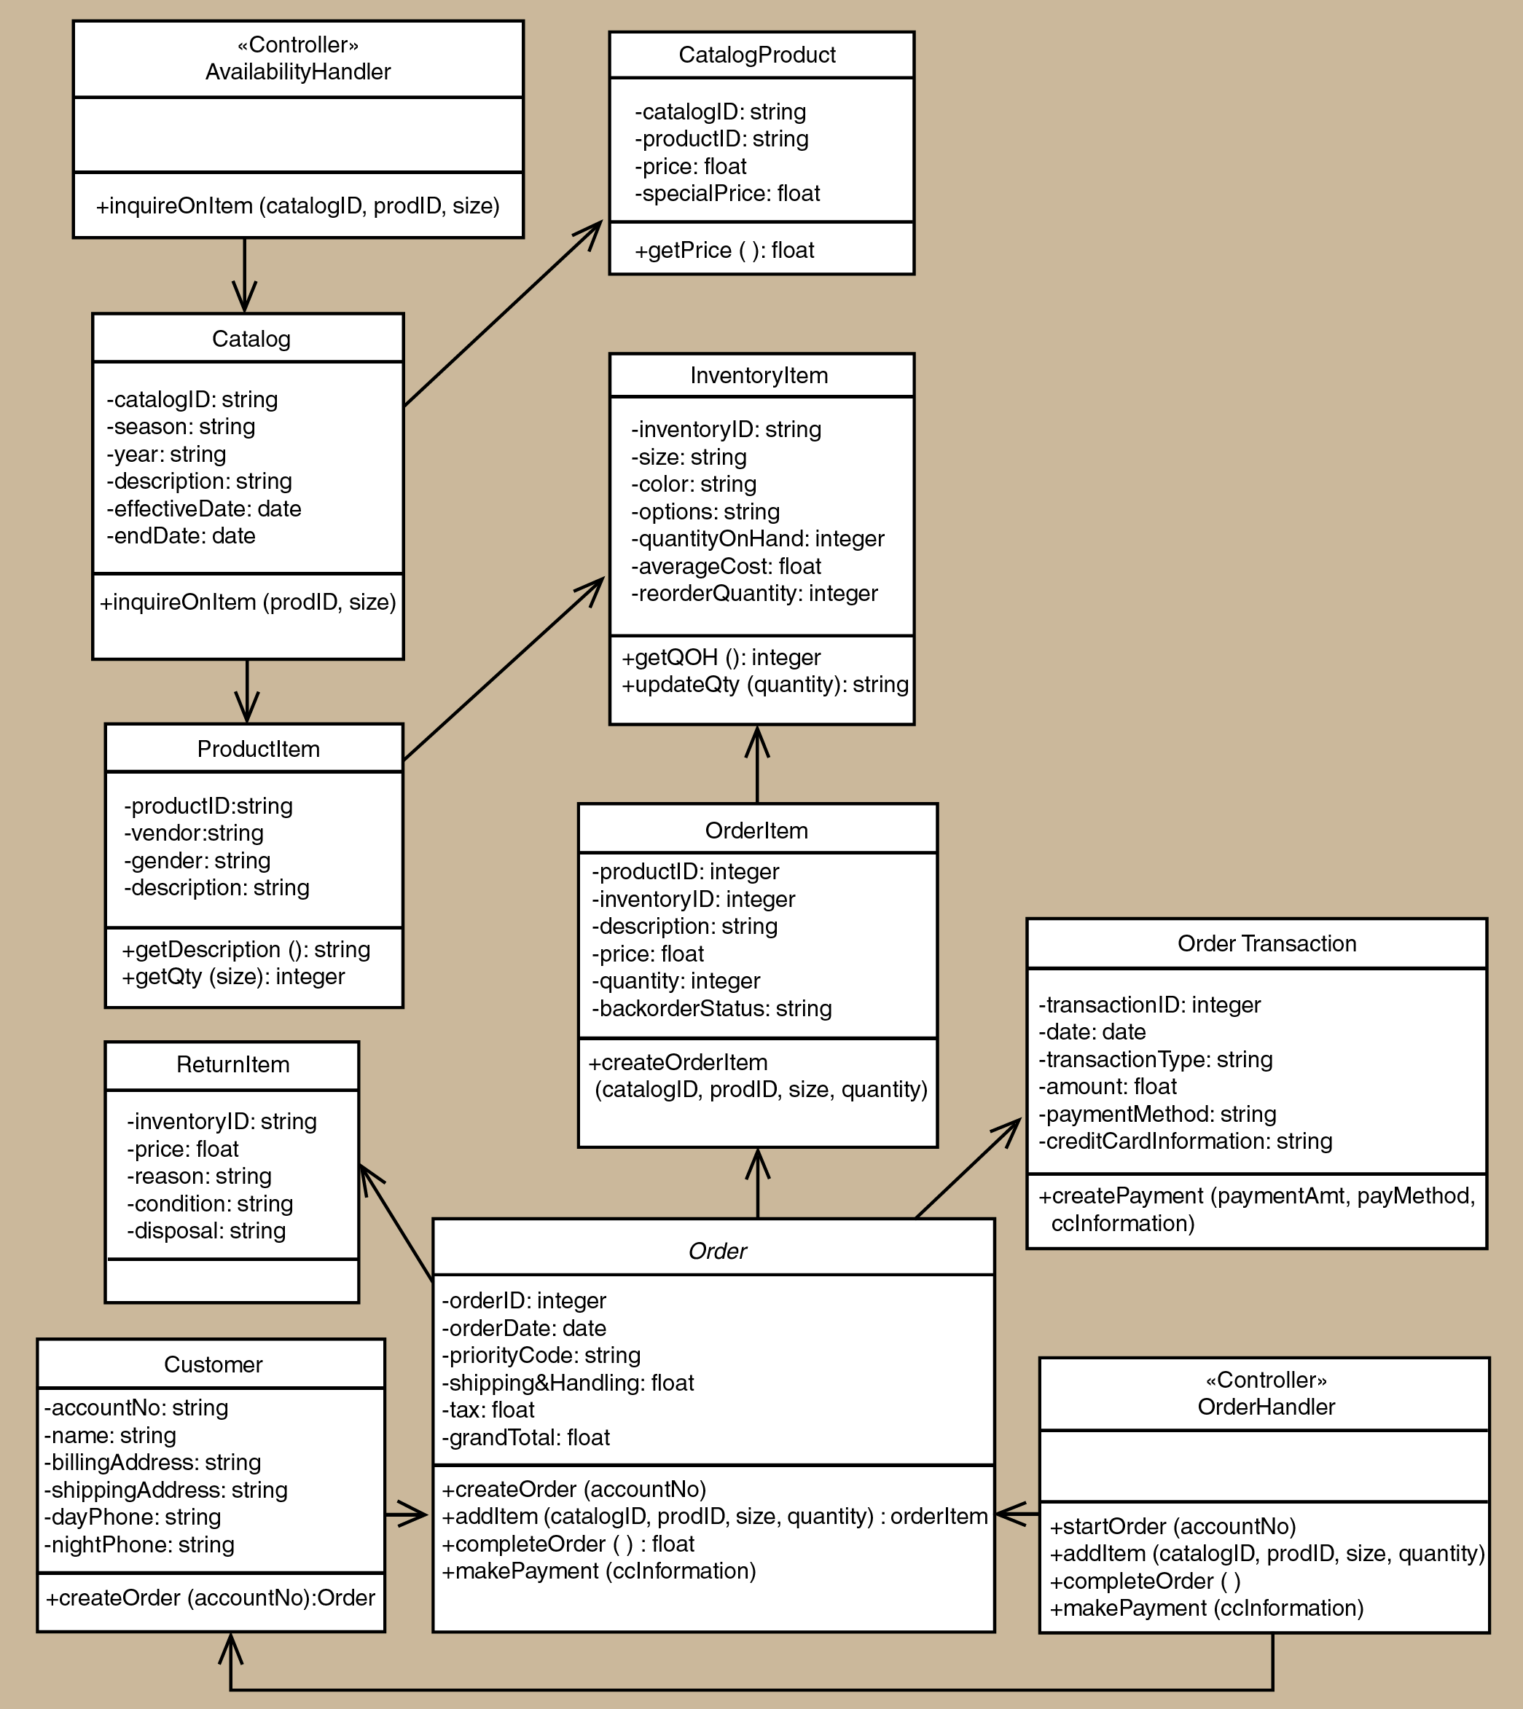
Figure 4.3: Class Diagram for <Order-Entry> Subsystem
List all methods in a table for respective entity (add the table accordingly), then write its algorithm. Example of algorithm as shown below.
Step1: Start
Step2: Read/input A and B
Step3: If A greater than B then C=A
Step4: If B greater than A then C=B
Step5: Print C
Step6: End
Entity Name | e.g. Order
Method Name | e.g. createOrder
Input
Output
Algorithm | - Start  - …  - End

      - Sequence Diagram
Include sequence diagram for appropriate use case in your subsystem package. In these examples only sequence diagram Create New Phone Order Scenario and Cancel an Order Scenario are shown. Include the final sequence diagram that comprises view layer, controller, and its problem domain (entity) and data access layer. Provide a unique code for each scenario of sequence diagram to be used in Section 7: Requirements Matrix. If you have only one scenario, then you only need one sequence diagram.

a) SD001: Sequence diagram for Create New Phone Order
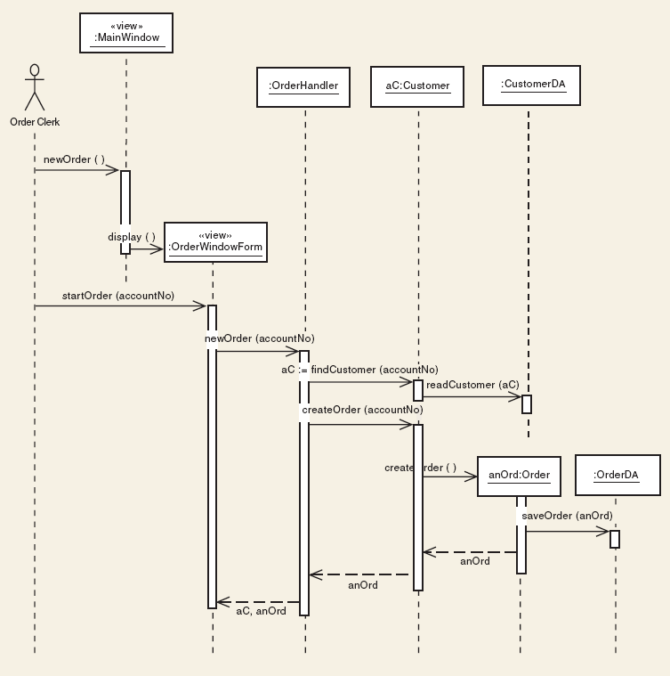
Figure 4.4: Sequence Diagram for <Create New Phone Order Scenario>

b) SD002: Sequence diagram for Create Cancel an Order Scenario

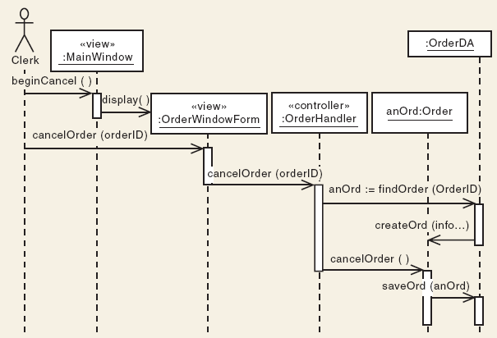
Figure 4.5: Sequence Diagram for <Cancel an Order scenario>
    - P002: <Name of Package 2> Subsystem

      - Class Diagram

      - Sequence Diagram

    - P003: <Name of Package n> Subsystem

      - Class Diagram

      - Sequence Diagram
- Data Design
  - Data Description
Explain how the information domain of your system is transformed into data structures. Describe how the major data or system entities are stored, processed, and organized. List the database(s) or data storage items. For a small system, there is normally only one database. It consists of all the tables in which object-oriented they are classes/objects as also stated in the domain model. Use table for the listing.
The major data or systems entities are stored into a relational database named as…, processed and organized into n entities as listed in Table 5.1.

Table 5.1: Description of Entities in the Database
No. | Entity Name | Description

  - Data Dictionary
Alphabetically list the system entities or major data along with their types and descriptions (class/object, attributes). Focus on classes in domain layer; omit the controller/handler class. Use tables for easy listing as shown below.

    - Entity: <First Entity>
Attribute Name | Type | Description

    - Entity: <Second Entity>
Attribute Name | Type | Description

