 | SCHOOL OF COMPUTING  FACULTY OF ENGINEERING  UNIVERSITI TEKNOLOGI MALAYSIA

PSM 1 (SCSx 3032)
REPORT CORRECTION AND RESUBMISSION FORM

Session/Semester: ……2022/23-2……………

Instruction: [Student] - Please submit a completed form to the PSM1 Department Coordinator.
SECTION A: STUDENTS DETAILS (to be completed by Student)

Name | : ………Islam Mohammed Ruzhan………………………………………….
Project Title | : FC Research Grant Finder
 | ……………………………………………………………………………….
Year/Course | :3SECJ……………………………………………………………………………….
No.KP/Passport | : A03614366….… | Matric No. | : A20EC4028……………..….………
E-mel | : islamruzhan@graduate.utm.my | No. Tel/HP | : 01128616264
Date | : 25/06/2023 | Signature | : 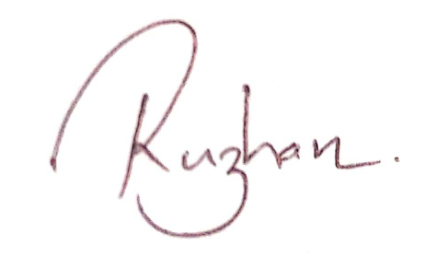

SECTION B: EXAMINER DECLARATION (to be completed by Examiner)
[Examiner 1]: I , ……………………………………………………… certify that I have reviewed the correction of the Project Report of the abovementioned student..

Date: |  | Signature & Official Stamp:

[Examiner 2 – if needed or required by evaluator]: I , …………………………………………………… certify that I have reviewed the correction of the Project Report of the abovementioned student..

Date: |  | Signature & Official Stamp:
SECTION C: SUPERVISOR DECLARATION (to be completed by Supervisor)

I Prof. Madya Mohd Shahizan bin Othman………………. declared had accepted and reviewed the Project Report Correction and I have also accepted and reviewed the Log Book of the abovementioned student..

Date: | Signature & Official Stamp:

