 | SCHOOL OF COMPUTING  FACULTY OF ENGINEERING  UNIVERSITI TEKNOLOGI MALAYSIA

PSM 1 (SCSJ 3032)
PROJECT SUPERVISION CONSENT FORM
Session/Semester : 2022/2023-2

Instruction: Please complete Section A and Section B, then submit this form to your PSM 1 Department Coordinator
SECTION A: STUDENT DETAILS

Name : JOHN MATTHEW HAYUN BANAYAD

Year/Course: 4 SCSJ
No. KP/Passport: P9148831B | Matric. No.: A17CS5069
E-mail Add.: banayadjohn@gmail.com | 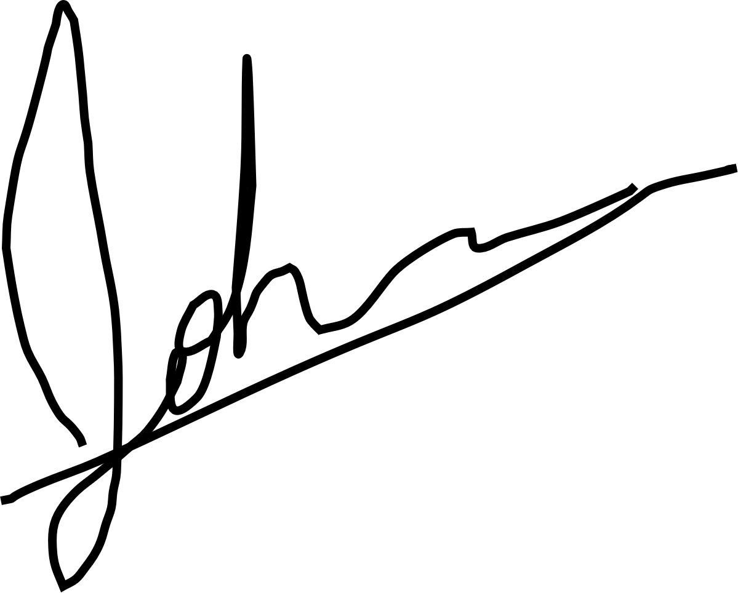  No. Tel/HP: +6010 – 420 1517
Date: APRIL 05, 2023 | Signature:

SECTION B: SUPERVISOR AGREEMENT

I …… PROF. MADYA. TS. DR. MOHD SHAHIZAN BIN OTHMAN ……agree/disagree * to be an Undergraduate Supervisor for this student where he/she will develop a project with the title:
…… Using Decision Tree or Support Vector Machines Algorithms to Analyze Microclimate Data in Aiding the Safeguarding of Cultural and Historical Architectures ….……………………

Date: April 5, 2023 Signature : ……………..………….
Official Stamp

SECTION C: PSM 1 DEPARTMENT COORDINATOR

Date Received : ………………………. Signature : ……………..………….
Official Stamp

