🎯 Strategy & Fit
- Strategic Alignment
- Use Case Qualification Criteria
- Automation Decision Tree
- Agent Readiness Gate

🤖 Agent Design & Oversight
- AI Agent Classification (L1–L4)
- Design & Development Principles
- Control Mode Matrix
- Agent Decision Map & Governance

🛡 Governance & Risk
- Governance & the Three Lines of Control
- Risk Management & Responsible AI
- Content Governance for Agents
- Mapping AURA to Regulatory Frameworks
- Formal PIAs
- Auditability & Explainability Logs

⚙ Technical Controls
- Model Context Protocol (MCP)
- Tech–Business Convergence Layer
- Third-Party AI Vendor Governance

📈 Scale & Measurement
- Scaling Roadmap
- Scenario Stress Testing
- Real-Time Monitoring + Controls
- Market Simulation for L4 Agents

🧠 Cultural Enablement
- People Readiness Stream
- Oversight Spectrum (HITL/HOTL)

🏗 Architecture Layer
- AURA 7+2 Layered Architecture

4. Agent Readiness Gate
Purpose:
A structured, step-by-step gate that ensures every prerequisite is in place before an agent is built or deployed. This prevents rework, embeds governance early, and aligns technical design with business needs.

When to Use
- Pre-Project Kickoff: As soon as a use case is approved for pilot or build.
- Prior to Design Workshops: To confirm all inputs and responsibilities are ready.
- Before Code or Config Development: To lock in data contracts, escalation flows, and ownership.

Step-by-Step Workflow
Phase | Activity | Owner | Tool/Artifact
1. Intake | • Complete Process Profile Worksheet detailing each onboarding step and decision point. | Business SME | Process Profile Worksheet (template)
 | • Score process complexity & variability on a 1–5 scale. | AI CoE | Complexity & Variability Scorecard
2. Data Review | • Inventory all required data feeds (HRIS, directory, ID scans). | Data Owner | Data Availability & Sensitivity List
 | • Tag each field with sensitivity level (public, internal, PII). | Data Governance | Data Sensitivity Tagging Template
3. Risk Triage | • Run use case through Risk Tiering Assessment (A1–A6). | AI Risk Lead | Risk Tiering Scorecard
 | • Auto-trigger PIA if tier ≥ A2 and any PII present. | Scorecard | AURA Scorecard
4. Escalation | • Define fallback flows for common failures (e.g., ID-OCR errors → HITL to HR rep). | Process Owner | Escalation Path Template
 | • Document SLA thresholds and retry logic. | Dev Lead | SLA & Retry Configuration Worksheet
5. Sponsorship | • Confirm business sponsor and steering committee sign-off on KPIs (e.g., 30% faster onboarding). | Sponsor | Sponsorship & KPI Charter
6. MCP Tagging | • Map out required MCP metadata: context_source, intent, data_sensitivity, execution_scope. | Architect | MCP Tagging Guide & Spreadsheet
7. Gate Review | • Convene Readiness Gate meeting; review all artifacts and sign off. | Steering Comm. | Readiness Gate Checklist

Inputs
- Process Profile Worksheet
Captures detailed flow, actors, inputs/outputs, decision rules.
- Complexity & Variability Scorecard
Quantifies process structure to feed Automation Decision Tree.
- Data Availability & Sensitivity List
Enumerates all HRIS/API fields with sensitivity tags.
- Risk Tiering Scorecard
Classifies use case into A1–A6, auto-flags PIA.
- Escalation Path Template
Defines human fallback, retries, and SLA thresholds.
- Sponsorship & KPI Charter
Documents business owner, success metrics, and steering committee.
- MCP Tagging Guide
Spreadsheet of required metadata elements and values.

Outputs
- Readiness Gate Sign-Off
Official approval to proceed to design.
- Agent Readiness Report
Consolidated document summarizing all inputs, findings, and action items.
- Risk & Compliance Flags
Auto-filed PIA request, third-party risk check, data-flow approvals.
- MCP Tagging Configuration
Pre-populated metadata definitions for implementation.
- Escalation & SLA Config
Ready-to-use JSON/YAML definitions for orchestration engine.

Sample Templates & Links
- Process Profile Worksheet: playbook/templates/process_profile.xlsx
- Risk Tiering Scorecard: playbook/templates/risk_tiering.xlsx
- Escalation Path Diagram: playbook/templates/escalation_path.drawio
- MCP Tagging Guide: playbook/templates/mcp_tags.csv
- Readiness Gate Checklist: playbook/templates/readiness_checklist.docx

RACI Summary
Activity | Business SME | AI CoE | Data Owner | AI Risk Lead | Architect | Sponsor | Steering Comm.
Complete Process Profile | R | C | – | – | – | – | –
Data Inventory & Tagging | – | – | R | C | – | – | –
Risk Tiering & PIA Trigger | – | – | – | R | – | – | –
Define Escalation Paths | R | C | – | – | C | – | –
Sponsorship & KPI Charter | – | – | – | – | – | R | C
MCP Metadata Mapping | – | – | – | – | R | – | –
Gate Sign-Off | – | – | – | – | – | C | A

5. Sample Agent Readiness Report

# Agent Readiness Report: OnboardingOrch_L3
**Date:** 2025-07-15
**Business Sponsor:** HR Operations Lead
**Risk Tier:** A2 (PII present → PIA requested)

## 1. Process Profile
- Completed ✔
- Complexity Score: 3/5

## 2. Data Review
- All feeds live ✔
- PII fields tagged & masked ✔

## 3. Risk Triage
- Tier A2 → PIA triggered and in progress

## 4. Escalation & Fallback
- HITL override defined for ID-OCR failures
- Retries: 3 attempts, 5-minute interval ✔

## 5. Sponsorship & KPIs
- Time-to-productivity target: –30%
- Satisfaction target: ≥85%

## 6. MCP Tagging
- context_source=HR_portal
- intent=onboarding_start
- execution_scope=write
- data_sensitivity=PII

### Gate Sign-Off:
| Reviewer | Role | Date | Decision |
|----------------|-------------------|------------|----------|
| Jane Smith | HR Operations Lead| 2025-07-15 | Approved |
| Mark Lee | AI Risk Lead | 2025-07-15 | Approved |

Next Steps: Once sign-off is complete, export the Agent Readiness Report to the project workspace and kick off the Design & Development phase (see Playbook Section 5).
This feeds its outputs (the signed-off Agent Readiness Report, MCP metadata, escalation configs, KPI charter, etc.) directly into that model:
- The Agent Role Brief and Control Mode Config leverage the readiness artifacts.
- The Agent Registry entry is populated with the metadata you captured in Steps 1–7.
- The Performance Metrics you agreed with your Sponsor become the ongoing KPIs in the digital coworker model.

8. Agent Decision Map & Governance

Purpose
Provide a clear, operational guide for capturing, governing, and measuring every decision an AI agent makes—ensuring traceability, accountability, and continuous improvement.

Decision Types & Map
Decision Type | Description | Example
Retrieval | Fetching data or content from a source or knowledge base | “Pull employee benefits policy document”
Task Selection | Choosing which action or workflow to invoke | “Create ITSM ticket vs. escalate to human”
Delegation | Handing off work to another agent or human | “HR Agent → IT Agent for account provisioning”

Rationale & Trace Requirements
- Mandate: Every decision must be accompanied by a short rationale.
- MCP Snapshot: Capture the full AgentContext object at decision time (input, intent, system state).
- Trace Log: Record the reasoning chain (e.g. rules fired, embeddings consulted, confidence score).

Fallback & Escalation Policies
- Define for each decision type what constitutes a failure or out-of-scope request.
- Configure an automatic escalation path (HITL or Supervisor queue) when confidence < threshold or errors occur.
- Log all escalations with reason codes and human response.

Decision Governance Metrics
Metrics at the agent, use case, or system level:
Metric | Definition | Why It Matters
Decision Volume | # of decisions made per agent per day | Tracks load, use, and scale
Decision Confidence Distribution | % of decisions made with high/low model confidence | Identifies when/where agents are uncertain
Escalation Rate | % of decisions escalated to humans | Measures how often agents defer or exceed scope
Override Frequency | # of decisions reversed by human reviewers | Signals risk, misunderstanding, or hallucination
Decision Failure Rate | % of decisions flagged as incomplete, incorrect, or out-of-scope | Used for retraining and trust scoring
Audit Completeness | % of decisions with complete MCP trace + context snapshot | Ensures compliance and forensic traceability

• A decision logging schema (based on MCP fields + reasoning chain)
• A dashboard template showing decision risk signals by agent or domain
• Alerting thresholds (e.g., >15% override triggers governance review)
• Example queries for audit review or post-incident forensics
Artifacts:
- Decision Logging Schema
A fully-specified JSON/CSV template that captures every decision event. Fields include:
  - timestamp
  - agent_id
  - decision_type
  - input
  - rationale
  - confidence_score
  - mcp_context (last_input, system_state)
  - fallback_triggered
  - escalated
- Dashboard Template
A ready-to-use spreadsheet or BI mock-up showing:
  - Daily decision volume per agent
  - Confidence distribution heatmap
  - Escalation and override trends over time
  - Failure and audit completeness rates
- Alerting Thresholds
Prescriptive thresholds and sample automation rules for your Control Tower:
  - Escalation Rate > 15% → trigger “High Escalation” alert
  - Override Frequency > 10% → email Ops Lead and Risk team
  - Decision Failure Rate > 5% → open incident in ServiceNow
  - Audit Completeness < 100% for L3–L4 → generate compliance ticket
- Audit & Forensics Queries
Example queries to extract and analyze decision logs:
sql
CopyEdit
-- All decisions escalated in the past 7 days
SELECT timestamp, agent_id, decision_type, rationale
FROM decision_logs
WHERE escalated = true
AND timestamp >= NOW() - INTERVAL '7 days';
elasticsearch
CopyEdit
GET /decision-logs/_search
{
"query": {
"bool": {
"must": [
{ "term": { "agent_id": "OnboardingOrch_L3" }},
{ "range": { "confidence_score": { "lt": 0.5 }}}
]
}
}
}
These artifacts let you jump-start implementation, configure your monitoring and alerting, and satisfy any post-incident or regulatory audit with minimal customization.

Artifact :

Control Tower dashboard layout for tracking decision metrics

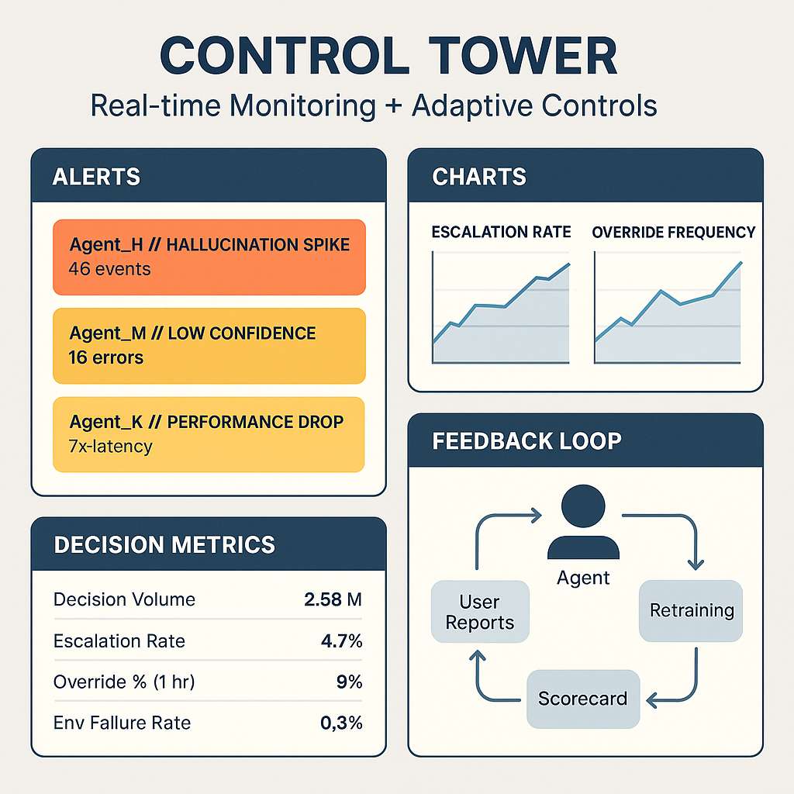

11. Human-in-the-Loop (HITL) vs Human-on-the-Loop (HOTL): AURA Oversight Design

Section Definition:
In AI governance, the level and timing of human involvement determines both risk exposure and control strength. AURA formalizes these modes into a graduated spectrum of oversight:
- Human-in-the-Loop (HITL): A human must review, approve, or correct AI output before action. Ideal for high-risk, high-impact tasks (e.g., insurance claim approvals).
- Human-on-the-Loop (HOTL): A human supervises operations and may intervene if the system misbehaves. Ideal for lower-risk, time-sensitive tasks (e.g., algorithmic trading, portfolio rebalancing).
AURA embeds these modes directly into the agent governance fabric through graduated escalation paths and agent-level tiering.

How to Use This Module in Practice
Stage | Action | Output
Design Time | Tag the agent with oversight mode (HITL, HOTL, Exception-only) in the AURA Scorecard | Populated field with enforcement logic
Review Time | Verify oversight mode matches risk level and autonomy tier (L1–L4) | Governance log and fact sheet documentation
Deployment Time | Integrate with ServiceNow or equivalent for approvals, alerts, or escalation triggers | Live monitoring hooks and kill-switch configurations
Operational Monitoring | Detect drift, hallucination, or bias via CQM → auto-escalate to human reviewer if thresholds are exceeded | Dynamic oversight alerts and logs

📥 Inputs
- AURA Agent Scorecard (risk tier, autonomy level)
- Use case description and business criticality
- Agent Fact Sheet (oversight mode field)
- L1–L4 Agent Classification
- CQM policy thresholds (for escalation triggers)

📤 Outputs
- Oversight Mode assigned per agent (stored in MCP)
- Escalation workflow (automated if Tier 1–2)
- Approval logs, override trails, and notifications
- Governance snapshot aligned to OSFI / AIDA

🧠 Framework Integration
This module is mandatory for all agents classified as Tier 1 or Tier 2.
It directly supports:
- Lifecycle Governance
- PIA Integration
- Auditability + Explainability Logs
- ServiceNow-integrated control gates

1. AURA’s Oversight Spectrum
Summary:
AURA supports a graduated oversight model from full human control to exception-based governance. Each agent is tagged with its oversight mode, which determines monitoring tools, escalation paths, and fallback procedures.
Oversight Mode | Definition | AURA Enforcement | Examples
Direct (HITL) | Human must review/approve output before action | Workflow integration via ServiceNow or decision inbox | Claim approvals, credit decisions
Supervisory (HOTL) | Human monitors system over time and can override | Dashboard alerts, drift monitors, approval thresholds | Portfolio rebalancing, budget reallocation
Exception-only | Human notified only upon escalation trigger or anomaly | Triggered via CQM risk signals or usage policy breaches | LLM-based research assistants, internal copilots

2. Operational Modes with Examples
Mode | Description | Use Case Example | Escalation Strategy in AURA
HITL | Pre-decision human validation is mandatory | Claims processing, disability adjudication | Queue-based approval before execution
HOTL | System acts autonomously, human can intervene | Wealth portfolio balancing, demand forecasting | Exception dashboards with override access
Exception-only | Fully autonomous, escalates only on policy breaches | Legal summarizer, product categorizer | Auto-notification if threshold exceeded

3. Agent Levels (L1–L4) Mapped to Oversight and Override Requirements
Summary:
AURA's L1–L4 agent taxonomy aligns directly with required levels of human governance. Higher agent autonomy triggers stronger monitoring and override protocols.
Agent Level | Description | Primary Oversight Mode | Override Governance
L1 – Tool Assistants | Passive, no goal-seeking | Optional human oversight | None required; output sandboxed
L2 – Guided Agents | Act with user instruction | HITL or Direct mode | All outputs reviewed pre-action
L3 – Autonomous Agents | Pursue goals within constraints | HOTL or Supervisory | Human can halt or adjust behavior
L4 – Strategic Agents | Self-replanning, cross-domain | Exception-only with red teaming | Must have kill-switch, anomaly triggers, and audit replay

4. AURA Escalation & Governance Infrastructure
Summary:
AURA integrates escalation policies via the Risk & Control layer using:
- Scorecard thresholds for risk-aware triggers (e.g., confidence score, content risk)
- Agent Fact Sheets to document oversight mode and fallback behaviors
- Integrated workflows with ServiceNow for real-time human approvals or alerts
- CQM-based anomaly detection to escalate hallucinations, bias, or drift
Each agent is evaluated at design-time and run-time to ensure the appropriate human touchpoint is enforced.
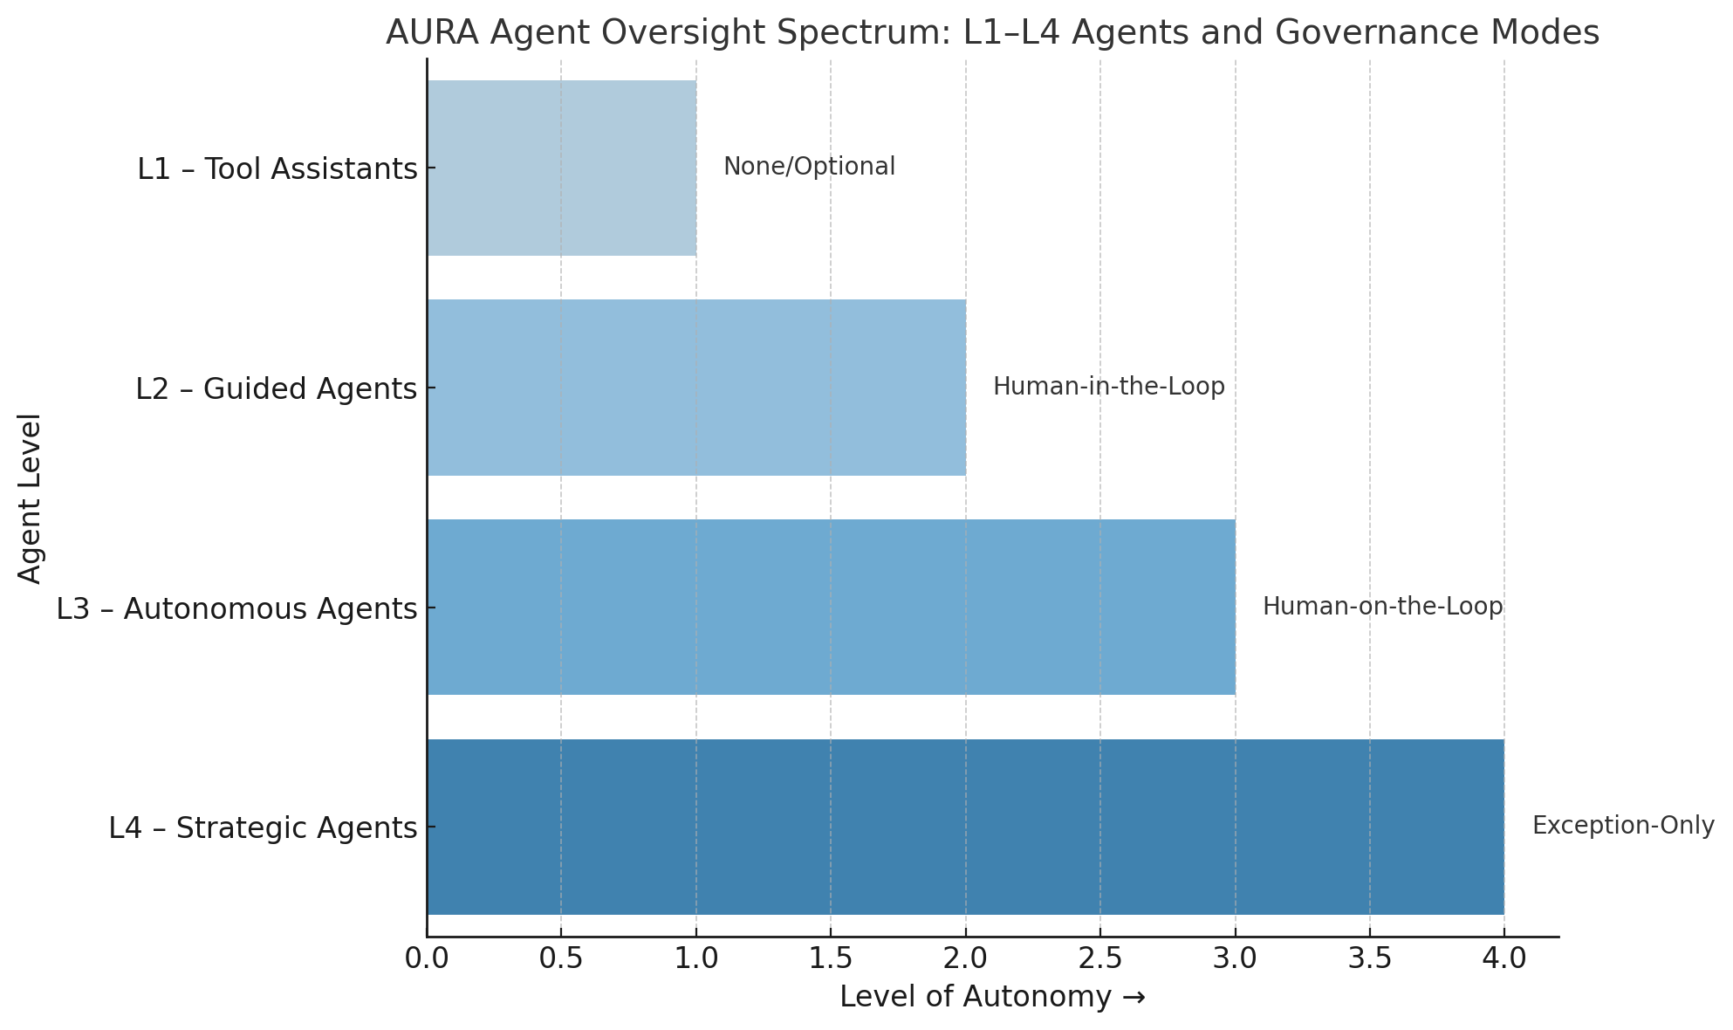
The visual outlines L1–L4 agent autonomy mapped to appropriate governance models, while the template provides a structured worksheet to define oversight and escalation protocols for new AI agents.
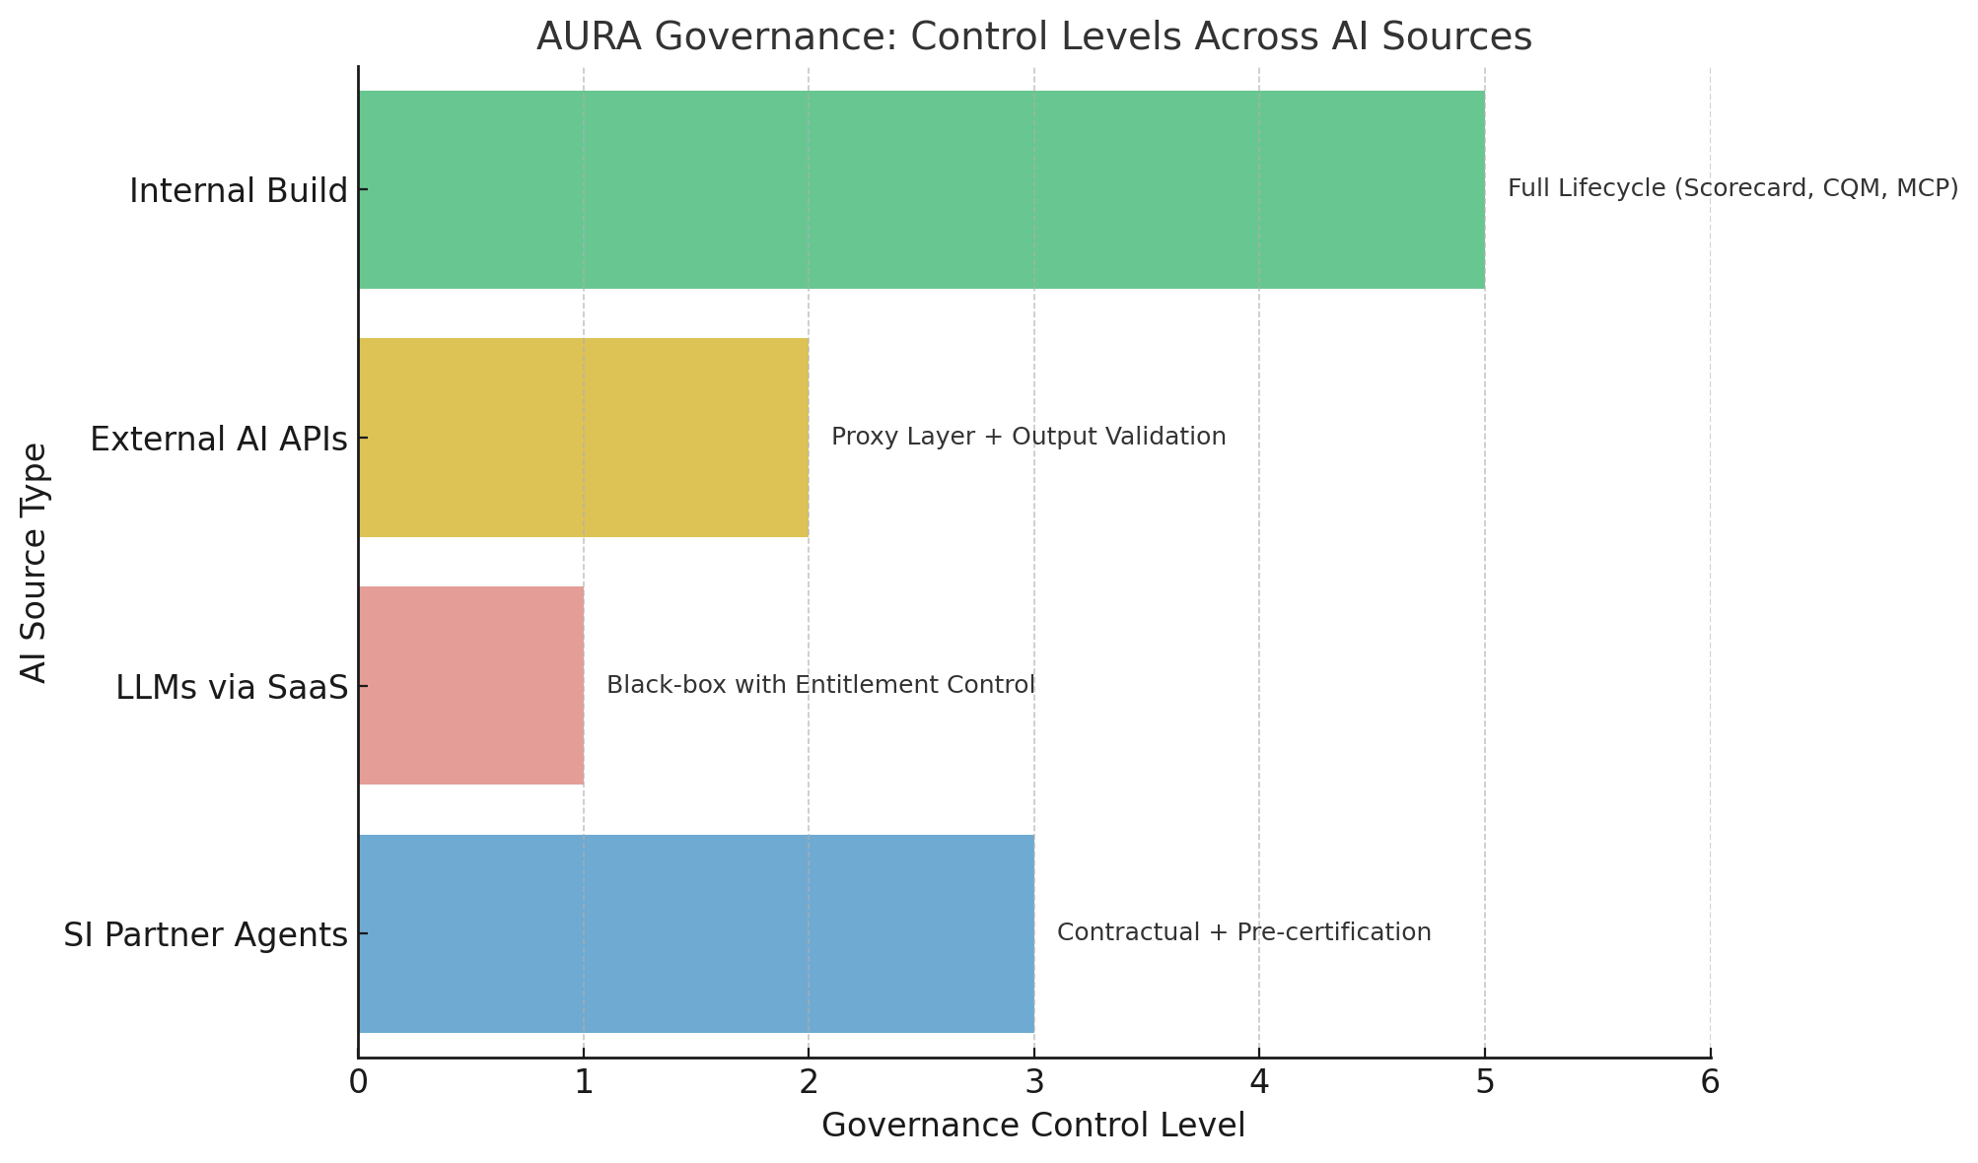

AURA Oversight Mode Mapping & Agent Oversight Design Template

1. Oversight Mode Mapping: Agent Level vs Oversight Requirement
Agent Level | Description | Primary Oversight Mode | Override Governance
L1 – Tool Assistants | Passive, non-goal-seeking tools (e.g., summarizers, extractors) | Optional / Exception-only | None required; output sandboxed
L2 – Guided Agents | Follow instructions with limited autonomy | HITL | Pre-action approval required
L3 – Autonomous Agents | Pursue defined goals within constraints | HOTL | Supervisory override enabled via dashboards
L4 – Strategic Agents | Cross-domain planners with replanning and learning | Exception-only | Kill-switch, anomaly triggers, and full audit trail

2. Agent Oversight Design Template
Fill this template for each new agent design to determine and justify oversight mode:
Agent Name
Use Case Description
Agent Tier (1–2)
Agent Level (L1–L4)
Proposed Oversight Mode (HITL, HOTL, Exception-only)
Justification for Oversight Mode
Escalation Protocol (if any)
Fallback or Kill-Switch Enabled?
Linked PIA Status
Approver (Business/Risk)

- Content Governance for Agents

- Mapping AURA Governance to Canadian Regulatory Frameworks
This section outlines how AURA's governance capabilities align to Canadian AI and data regulations, including OSFI E-23 (Model Risk), AIDA (proposed AI Act), PIPEDA (Privacy), and Quebec Law 25. It supports design-time compliance triggers, review-time validations, and audit-time traceability through tools like agent scorecards, lifecycle logs, and tiering logic. AURA’s modular components — including the Model Context Protocol (MCP), Content Quality Management (CQM), and Risk Tiering Engine — enable proactive regulatory alignment. Outputs include cross-regional compliance matrices, auto-triggered workflows, and audit-ready documentation. Ownership spans Risk, Privacy, Legal, Architecture, and Business, following the Three Lines of Defense. Optional tooling such as ServiceNow modules and fact sheet generators can operationalize this mapping at scale.

How This Module Is Used in Practice
- Design time: As part of the agent approval process, use this mapping to check if the agent’s capabilities trigger any regulatory actions (e.g., "Does it involve automated decisions on personal data?" → Law 25 applies).
- Review time: Governance teams use the table to verify that documentation and safeguards (e.g., PIA, explainability, fallback) match regional requirements.
- Audit time: Internal or external auditors request proof that agent development and deployment aligned with regulatory standards.

Optional Tools to Operationalize This
- Excel-based crosswalk template
- ServiceNow integration module for compliance auto-checks
- AI Fact Sheet Generator that embeds regulation mapping
- Red/yellow/green dashboard for jurisdictional readiness

Inputs (What you need to generate this mapping):
Input Artifact / Data | Purpose
🧾 List of Applicable Regulations (e.g., OSFI E-23, AIDA, PIPEDA, Law 25) | Identifies the obligations your AI program must satisfy
🧠 AURA Capabilities Inventory | The modules of your framework (e.g., CQM, MCP, Tiering Engine, Fact Sheets, etc.)
📊 Use Case Catalog with Risk Tiers | Allows mapping of regulatory requirements to the right agent class (e.g., A4–A6 = “High Impact”)
📁 Internal Policy Documents or PIA Templates | Help link AURA triggers to existing compliance processes (e.g., Privacy reviews, Model inventory)
📋 AI Risk Scorecard / Fact Sheet (from each project) | Needed to document transparency, explanation, and monitoring attributes per regulation
🔗 Third-Party Contracts | To flag gaps in regulatory compliance from external vendors or APIs

Outputs (What this mapping produces):
Output Artifact | Use
✅ Regulatory Mapping Table | Aligns AURA controls to clauses in OSFI E-23, AIDA, etc.
📎 Compliance Alignment Matrix | Shows jurisdictional readiness: Canada, U.S., EU (NIST RMF, AI Act)
📑 Regulatory Assurance Deck (optional) | For internal/external audit teams and regulatory stakeholders
📄 Evidence Logs | Stored per agent or model to show alignment (via MCP, Scorecard, PIA)
🛡️ Auto-Triggered Compliance Workflows | E.g., if agent is Tier 1 or above, launch a Privacy Impact Assessment
📌 Flags in ServiceNow / Governance Tracker | Operational enforcement of controls (e.g., block promotion if AIDA gaps exist)

Owners of the Regulatory Mapping Function in AURA
Role / Team | Type | Responsibility
AI Governance Lead / AI Risk Officer | 2nd Line (Risk) | Owns the mapping table, ensures AURA capabilities align to regulatory obligations (OSFI, AIDA, PIPEDA, Law 25)
Privacy Office (CPO) | 2nd Line (Risk / Legal) | Co-owns sections tied to PIPEDA and Law 25 (e.g., Consent, Limiting Collection, PIAs, Right to Explanation)
Legal & Compliance | 2nd Line (Control Function) | Validates regulatory interpretation, reviews changes in legislation
Enterprise Architecture / AI CoE | 1st Line (Builder) | Implements MCP, agent tiering, explainability logs; feeds into the mapping structure
Data Governance Team / CDO Office | 1st & 2nd Line | Responsible for metadata tagging, CQM enforcement, and ensuring content governance aligns to privacy/data laws
Information Security / CISO | 2nd Line | Ensures safeguards in the mapping (e.g., for access, logging, sensitivity levels) are implemented
Internal Audit | 3rd Line | Periodically reviews that mapping is current and used to govern agent deployment decisions
Business Owners of High-Risk Agents | 1st Line | Accountable for completing scorecards, PIAs, and understanding which regulations apply to their agents

Suggested RACI Model
Activity | Builder (1st Line) | Risk Owner (2nd Line) | Auditor (3rd Line)
Populate Use Case Scorecard | ✅ Responsible | 🔍 Consulted | -
Maintain Regulatory Mapping | 🔍 Consulted | ✅ Accountable | -
Validate Agent Tier vs. Reg Flag | ✅ Responsible | ✅ Accountable | -
Ensure MCP & Logs Exist | ✅ Responsible | - | 🔍 Audited
Regulatory Update Review | - | ✅ Responsible | -
Audit Readiness Check | - | 🔍 Consulted | ✅ Accountable

Summary of Key Owners
Section | Primary Owner | Supporting
OSFI E-23 Alignment | AI Governance / Risk Officer | Internal Audit, EA
AIDA Alignment | Legal + AI Risk | AI Governance
PIPEDA & Law 25 | Privacy Officer (CPO) | Legal, Data Governance
Risk-Tiering Logic | EA / AI CoE | Risk & Compliance
Compliance Matrix | AI Risk Lead | Legal, Audit, EA

A. OSFI E-23 – Model Risk Management
OSFI Pillar | AURA Governance Capability | Alignment
Model Governance | Three Lines of Defense with Agent Lifecycle Tracking | Ensures accountability across model ownership, development, and validation, including autonomous agents.
Model Risk Tiering | AURA’s Tiering Logic for Agentic vs Traditional AI | Classifies models/agents by complexity, adaptivity, and potential impact.
Model Inventory | MCP (Model Context Protocol) + Knowledge Graph Registry | Ensures traceability and versioning of traditional and agentic models.
Model Validation | CQM + LLMOps Validation Guardrails | Includes content testing, explainability, and red teaming for LLM-based agents.
Ongoing Monitoring | Event-based monitoring with ServiceNow & AIOps | Detects drifts, emergent behaviors, and regulatory non-compliance over time.

B. AIDA – Artificial Intelligence and Data Act (Proposed)
AIDA Focus Area | AURA Capability | Compliance Coverage
High-impact AI systems | AURA Agent Tiering (A1–A6) | Flags autonomous agents (A4–A6) as high-impact by default.
Risk Management Plans | Agent Fact Sheets + AURA Scorecard | Captures use case intent, harm scenarios, and mitigation plans.
Transparency & Explanation | CQM + MCP Descriptions | Standardizes model metadata and explanations for stakeholders.
Auditability | Agent Lifecycle Logging + LLMOps Pipelines | All steps in agent generation, training, fine-tuning, and usage are auditable.
Data Governance | CQM + Synthetic Data Strategy | Ensures lawful basis, quality, and minimization of training content.

C. PIPEDA – Privacy
PIPEDA Principle | AURA Capability | Enforcement Mechanism
Consent | Use-case templating with data type tagging | Enables consent management at the data field or feature level.
Limiting Collection | CQM + Synthetic Substitution | Minimizes real data collection by generating synthetic twins.
Access & Accuracy | Knowledge Graph with Semantic Labels | Supports user access to model decisions and data lineage.
Safeguards | ServiceNow-integrated Risk Engine | Flags models with exposure to sensitive or identifiable data.

D. Quebec Law 25 (formerly Bill 64)
Law 25 Requirement | AURA Capability | Alignment Strategy
Privacy Impact Assessment (PIA) | Auto-triggered via AURA Scorecard | For all new LLMs or agents using personal data.
Automated Decision Notice | CQM + Agent Output Metadata | Captures source content and rationale for user decisions.
Right to Explanation | Agent Fact Sheets + Replay Logs | Supports traceability of reasoning paths in GenAI output.
High-risk Processing | AURA Risk Tiering + Flags | Tier 1/2 Agentic use cases must go through extra privacy review.

2. Compliance Alignment Matrix (Country-Specific)
AURA Module | Canada (OSFI/AIDA/PIPEDA/Law 25) | U.S. (NIST AI RMF) | EU (AI Act/GDPR) | Notes
MCP (Model Context Protocol) | ✔ | ✔ | ✔ | Supports traceability across regions
AURA Scorecard | ✔ | ✔ | ✔ | Localized risk templates per region
CQM (Content Quality Management) | ✔ | Partial | ✔ | Language coverage varies
Tiering Engine | ✔ | ✔ | ✔ | Custom logic for each country
Agent Lifecycle Governance | ✔ | Partial | ✔ | Integrates with local DSAR, PIA processes
Knowledge Graph Registry | ✔ | ✔ | ✔ | Semantic layers tailored per compliance domain
Fact Sheets | ✔ | ✔ | ✔ | Aligns with transparency obligations

3. Risk-Tiering Logic: Agentic AI vs Traditional AI
Risk Attribute | Traditional AI | Agentic AI (AURA A1–A6) | Regulatory Impact
Autonomy | Rule-based, passive | Intent-driven, goal-seeking | Triggers "high-impact" label under AIDA
Learning Behavior | Static or supervised | Self-updating, dynamic | Requires enhanced monitoring under OSFI
Explainability | Easier (structured models) | Harder (LLMs, RLHF) | Mandates agent-level explanations under Law 25
Data Sensitivity | Structured inputs | Multi-modal unstructured inputs | Heightens privacy obligations under PIPEDA
Operational Control | Centralized pipelines | Distributed, decentralized | Must track agent lifecycle for audit trails
Emergent Behavior Risk | Low | High (esp. A5–A6) | Requires red-teaming, simulation sandboxing

Automation Decision Tree

📥 Inputs (Required Artifacts):
These are usually captured during discovery or intake phases of automation or AI projects.
- Process Profile Worksheet
  - Description of the business process
  - Input/output formats
  - Business rules and exception types
- Complexity & Variability Scorecard
  - Quantifies how structured, repetitive, and predictable the process is
  - Often uses 3–5 criteria scored on a Likert scale
  - Example: Complexity = High, Variability = Medium, Risk = High
- Risk Tiering Assessment
  - Regulatory exposure
  - PII/PCI handling
  - Operational or reputational risk

📤 Outputs (Generated Artifacts):
- Automation Fit Report (Decision Artifact)
  - Recommended automation type: RPA / RDA / Agentic AI
  - Justification summary
  - Reference to source data and stakeholder inputs
  - Can be uploaded to ServiceNow, JIRA, or an internal AI CoE tracker
- Decision Tree Audit Log (Optional)
  - Captures who made the decision, when, and with what data
  - Useful for governance, especially if automation decisions are later challenged
- Updated Use Case Register / Catalog
  - Tags the use case with its automation path
  - Enables portfolio-level prioritization and funding decisions

Optional Tooling Integration
Operationalize this as a:
- Web form or Excel-based tool for smaller orgs
- Custom ServiceNow module
- Jupyter-based scoring app for data teams
Artifact templates for the Automation Decision Tree
This document includes:
- Process Profile Worksheet
- Complexity & Variability Scorecard
- Risk Tiering Assessment
- Automation Fit Report

Formal PIAs (Privacy Impact Assessments) in AURA

Summary:
AURA embeds Privacy Impact Assessments (PIAs) directly into the agent lifecycle, not as an afterthought but as a risk-tier–driven escalation mechanism. This ensures any agent using personal, health, or regulated data is evaluated before deployment, in alignment with PIPEDA, AIDA, Quebec Law 25, and other data protection standards.

INPUTS
Input Artifact / Data | Purpose
AURA Agent Scorecard | Captures risk tier, data sensitivity, and automation type (auto-triggers PIA if thresholds are crossed)
Data Sensitivity Tagging | Identifies if personal, financial, or health data is processed or stored
Region of Operation | Determines jurisdiction (e.g., Canadian data processed in U.S. cloud → escalates cross-border handling flag)
Use Case Description | Provides business context, enabling proper classification of risk
MCP Metadata | Tracks agent version, use case purpose, prior PIA approvals, and drift risk
PIA Questionnaire Template | Standardized form used to perform the actual privacy review

OUTPUTS
Output Artifact | Use
PIA Approval Status | Logged in MCP; required before go-live for Tier 1 and Tier 2 agents
PIA Audit Log | Records approver, date, version, and notes; supports compliance reporting
Re-validation Trigger | Alerts if the same agent is reused for a different purpose or context
PIA Summary Report | Linked to the agent fact sheet for business, compliance, and audit visibility

HOW TO USE THIS MODULE
Lifecycle Phase | Action
Design Time | Fill the AURA Scorecard; if PII/PHI detected or cross-border risk → auto-trigger PIA
Review Time | Privacy Officer or Risk team completes the PIA checklist; record outcome in MCP
Go-Live | Deployment blocked unless PIA status = Approved (especially for Tier 1/2 agents)
Re-Use or Modification | AURA detects purpose drift and flags for PIA re-validation
Audit or Incident | Review agent logs and MCP metadata to confirm privacy vetting occurred

TECHNOLOGY ENABLERS
Tech Component | Function
AURA Scorecard | Automates PIA trigger logic based on risk, tier, and data tags
MCP (Model Context Protocol) | Stores structured PIA metadata (status, approver, timestamps)
⚙️ ServiceNow Workflow | Routes flagged use cases to Privacy Officer for review and approval
📄 LLMOps Redaction Module | Automatically detects and removes sensitive terms from training data
📊 Compliance Dashboard | Tracks PIA pipeline, approval status by tier, and regional compliance gaps
🔍 Reusability Tracker | Detects and flags agent reuse across use cases or jurisdictions for PIA recheck

Example Triggers in AURA
Trigger Scenario | Example | AURA Response
Agent uses identifiable user data | Benefits agent accessing health records | Auto-escalate to Privacy Officer via scorecard
LLM trained on sensitive data | Includes employee chat logs | Flag for dataset redaction and PIA review
Cross-border data inference | Canadian input, U.S. cloud inference | Region-aware compliance check and PIA trigger

Auditability + Explainability Logs

Summary:
This module ensures that all agent actions are traceable, explainable, and regulatory-ready, going beyond simple event logging. Every decision, from input to output, is captured in a replayable and standardized format, aligned with regulatory standards like OSFI E-23, AIDA, and GDPR.

When to Use This Module
Stage | Trigger | AURA Use
Design Time | Agent operates in a regulated domain or impacts users | Include this module in the agent’s design blueprint and MCP layer
Development Time | LLM or agent includes autonomous reasoning or RAG | Enable Decision Trace Logging and connect to source registry
Pre-Deployment Review | Agent is classified Tier 1 or Tier 2 | Mandatory inclusion of explainability metadata and audit snapshot
Post-Deployment Monitoring | Agent causes unexpected outcome or complaint | Use logs to replay and simulate behavior for RCA or audit
Regulatory or Internal Audit | Requested by auditors (internal/external) | Export logs using standardized formats and schema alignment
Model Drift or Fine-Tuning | Model behavior shifts | Compare execution snapshots over time to detect changes in logic or source grounding

Example Use Cases That Require This Module
- Insurance Claim Denial Explanation: Trace how an agent recommended rejection, which policies were referenced, and if human review occurred
- HR Promotion Agent: Explain why a candidate was excluded; show decision trace and RAG content
- Healthcare Symptom Checker: Show sources, model version, and context at time of suggestion
- Agent Conflict Escalation: Determine what decision path caused a user escalation and if it was flagged appropriately

Technology Components
Component | Purpose
MCP Snapshot | Stores model version, config, and execution context
Decision Trace Log (JSONL) | Captures input → intermediate reasoning → output
Fact Source Registry | Lists content, knowledge base docs, or API responses used
Agent Oversight Register | Pulls metadata from ServiceNow: who approved, fallback path
Log Export Tool | Exports standardized logs for audit (JSON, CSV, PDF)
Replay Engine (Optional) | Simulates agent behavior for RCA or red-teaming scenarios

Output Artifacts
- Execution Snapshot File
- Explainability Log (per output)
- Model + Retrieval Context Report
- Replayable Trace JSON
- Audit Export Bundle (ZIP or package for regulatory handoff)
  - Technical Controls
- Model Context Protocol (MCP) Compliance
- Tech–Business Convergence Layer
- Third-Party AI Vendor Governance in AURA

When to Use This Module
Use this module whenever:
Scenario | Trigger
AI models are sourced via API (e.g., OpenAI, Anthropic) | Limited control, needs wrapper enforcement
LLMs are accessed via SaaS platforms (e.g., Copilot, Einstein) | Usage is opaque; requires access restrictions and logging
System Integrator (SI) builds the agent for you | Requires pre-certification, joint governance, and contract alignment
Any external model or agent is deployed in a regulated workflow | Tier classification, risk checks, and AURA Scorecard must apply

🛠️ Module Use in Practice
Stage | Action | Output
Pre-Procurement | Apply control archetype mapping to proposed AI source | Control strategy selection (internal/SaaS/API/SI)
Contracting | Include AURA certification clauses (CQM, MCP, oversight) | Signed obligations from vendor
Pre-Deployment Review | Trigger compliance certification for external agents | Certification checklist (CQM, MCP, Tier, Security, Country Fit)
Post-Deployment Monitoring | Apply third-party risk lens (data, model, security, reputation) | Live controls (e.g., masked tokens, fallback, prompt filters)

📥 Inputs
- Vendor name and control archetype (API / SaaS / SI)
- Use case details and autonomy level
- Country of deployment
- Pre-existing model documentation (model cards, audits)
- Privacy/data classification of use case
- MCP and Scorecard metadata

📤 Outputs
- External Agent Certification Report (internal record)
- Third-Party Risk Register entry
- Region-specific compliance overlay (e.g., AIDA / GDPR flags)
- Escalation hooks and fallback routing (for SaaS/API sources)
- Contract annex for governance terms

When to Use This Module
- When sourcing an AI capability or model from an external vendor, including APIs, SaaS, or SI-built agents
- When the AI model is not trained or hosted internally
- When there is limited visibility into model training data or inner workings
- When the vendor is responsible for building, fine-tuning, or deploying agents on your behalf
- When integrating third-party LLMs into regulated workflows (e.g., financial, health, or legal)
- When compliance with data residency, privacy, or model risk regulations (e.g., AIDA, PIPEDA, GDPR) is required
- When creating contracts or statements of work involving AI delivery or co-development
- When evaluating model cards, audit reports, or fallback mechanisms before deployment
- When applying region-aware compliance overlays across jurisdictions (e.g., Canada, EU, US)

- Control Archetypes: Build vs Buy vs Partner
Summary:
AURA classifies AI sources into four control archetypes — internal build, external APIs, SaaS-based LLMs, and SI-built agents — each with distinct governance models. Internal builds follow full AURA compliance, while external APIs and SaaS tools are wrapped with monitoring and proxy layers. SI partnerships are treated as co-development and require pre-certification.
AI Source | AURA Control Model | Governance Approach | Examples
Internal Build | Full control | Full AURA lifecycle: scorecard, tiering, CQM, MCP | Proprietary GenAI agents
External APIs | Limited control | Proxy-layer monitoring, fallback mechanisms | OpenAI, Anthropic, Cohere
SaaS LLMs | Black-box usage | Logging + role-based guardrails | Microsoft Copilot, Salesforce Einstein
SI Partner Agents | Co-build | Certification + joint governance | Accenture or TCS-delivered agents

2. Contractual and Oversight Frameworks
Summary:
Each third-party model type requires unique oversight:
- External APIs need latency monitoring, indemnity clauses, and output validation.
- SaaS LLMs must be logged, access-controlled, and periodically audited.
- SI-developed agents must conform to AURA protocols via contract and pre-production certification.

A. External AI APIs
- Enforce output safety and contract terms for hallucination and IP risks.
- Use gateway-level control and caching for resiliency.

B. LLMs via SaaS
- Require third-party audit reports and role-based access to prevent uncontrolled exposure.
- Incorporate region-aware logging for compliance with data laws like PIPEDA.

C. SI Partner Agents
- Use vendor contracts to mandate AURA compliance (MCP, scorecard, CQM).
- Establish joint governance boards for backlog management, testing, and release.

3. Third-Party Risk Lens in AURA’s Risk & Control Layer
Summary:
AURA integrates a third-party risk lens into its Risk & Control Layer by categorizing risk into six domains: data, model, operational, security, regulatory, and reputational. Controls like encrypted proxies, provenance checks, fallback agents, and country-specific compliance flags ensure responsible use of external AI sources.
Risk Area | Example Risk | AURA Control Strategy
Data Risk | Personal data leakage | Token masking, synthetic substitution
Model Risk | Unknown training data | Require source disclosures & model cards
Operational | API downtime | Fallback to local models
Security | Prompt injection | Prompt filters + input validation
Regulatory | AIDA or Law 25 violations | Country-based control overlays
Reputational | Offensive content | Multi-layered CQM pipelines

4. Agent Compliance Certification Guidelines (Pre-Integration)
Summary:
Before integration, all externally sourced agents (from APIs, SaaS, or SIs) must pass AURA certification, including metadata documentation (MCP), content quality thresholds (CQM), risk tiering, security scans, and human oversight documentation. Certification ensures agents are production-safe, traceable, and legally compliant.
Checkpoint | Description
MCP Metadata | Covers intent, versioning, training context
CQM Scorecard | Validates output quality and factuality
Tier Classification | Ensures risk-aligned deployment controls
PIA | Required for personal/sensitive data
Security Scan | Prevents known prompt and dependency exploits
Testing | Includes both scenario-based and red-team testing
Human Oversight | For high-impact use cases
Country Compliance | Reviewed for Canada (AIDA, PIPEDA, Law 25), US, EU

Scale & Measurement
- Scaling Roadmap

Scenario Stress Testing for Agents

For test templates, prompt injection libraries, and sample resilience scorecards, see the AURA Playbook, Section 5.2 – Scenario Stress Testing Toolkit.

Inputs (What You Need)
- Agent version and design context (from MCP)
- Test scenarios (e.g., adversarial prompts, data drift, outage simulations)
- Defined risk tier and autonomy level (AURA Scorecard metadata)
- Performance baselines or expected thresholds
- Fallback logic and escalation triggers configured in agent design

Outputs (What It Produces)
- Scenario Test Matrix (by agent type and failure class)
- Stress Test Logs (timestamped and reproducible)
- Resilience Scorecard (visual comparison across agents or model versions)
- Escalation Pathways Triggered (logged in ServiceNow or equivalent)
- Audit-Ready Evidence (linked to Tiering, MCP, and Lifecycle Governance)

Who Uses This Module
- Enterprise Architects – to validate fallback and integration points
- AI Risk Officers / Governance Teams – to confirm risk controls are tested
- Model Developers / Agent Builders – to run test cases and tune guardrails
- Internal Audit & Compliance Teams – for pre-deployment and audit review

When to Use This Module
- During agent design and pre-deployment validation for Tier 1–3 agents
- Whenever agents interact with regulated, user-facing, or sensitive domains
- When deploying LLM-based or autonomous agents with non-deterministic behavior
- Before model version upgrades, vendor model swaps, or architectural changes
- As part of governance gate reviews or regulatory assurance preparation

Summary:
Stress testing is a critical safeguard in agentic AI governance, ensuring that agents can operate reliably under unpredictable, adversarial, or degraded conditions. AURA embeds scenario stress testing directly into its Measurement Layer to evaluate not only performance but also resilience, failover integrity, and recovery behavior. This is essential for enterprise environments where agents influence sensitive decisions and automated operations.

1. What Scenario Stress Testing Covers in AURA
Test Type | Simulated Scenario | Purpose | AURA Capability
What-if Testing | “What if data quality drops?” or “What if policy changes?” | Evaluate agent adaptability and boundary behavior | MCP-defined stress scenarios + CQM mutation testing
Resilience Testing | Network outages, rate-limiting, API downtime | Ensure graceful degradation and fallback mechanisms | Built into Measurement Layer; fallback simulation environment
Failure Simulation | Hallucinations, toxic content, agent looping | Examine system safety, escalation, and rollback paths | Red-teaming modules + exception triggering in Agent Scorecard
Data Drift Scenarios | Input feature distribution shifts, schema drift | Test agent’s ability to detect or adapt to subtle data changes | Drift monitoring integrated with Agent Lifecycle Logs
Adversarial Prompts | Malicious or ambiguous user input | Validate prompt-hardening and safety guardrails | CQM prompt injection test suite

2. AURA’s Measurement Layer: Resilience Testing Module
Summary:
AURA extends its Measurement Layer to support Resilience Testing, allowing architects and risk teams to simulate and log stress scenarios before deployment. This includes built-in test harnesses for:
- Latency injection and API throttling
- Data corruption and null field injection
- Simulated service unavailability
- Response misclassification under time pressure
- Role misalignment in multi-agent chains
Results are recorded in the Agent Scorecard and versioned in the Knowledge Graph Registry, enabling comparison across model upgrades or configuration changes.

3. Simulated Agent Breakdown Scenarios
Scenario | What AURA Does | Failure Handling
Network Loss or API Timeout | Injects timeout simulations during testing | Agent must retry or trigger fallback content; log incident
Data Drift | Introduces synthetic changes in input distributions | CQM drift flags escalate to ServiceNow or human supervisor
LLM Hallucination | Includes adversarial prompts + factual benchmarking | Failure leads to escalation if hallucination threshold breached
Toxic Output | Uses offensive prompt bank + moderation filters | Output blocked; trigger red-flag and route to content QA team
Looping Behavior (A3–A4 agents) | Stress test with goal ambiguity or non-terminal states | Agent terminated after set threshold; incident logged for root cause review

4. Governance Linkage: Risk Layer + Testing Evidence
All scenario tests are:
- Linked to the Agent Tier and Risk Rating
- Logged into the Agent Lifecycle and MCP
- Reviewed in governance gates before production deployment
This ensures stress-tested behavior is traceable, reproducible, and auditable — supporting regulatory compliance (e.g., OSFI E-23, AIDA).
Artifact-
• A scenario test matrix template for use case onboarding?
• A resilience scorecard visualization across agent types?

Employee Training for Agentic AI: AURA’s People Readiness Stream

Summary:
AURA recognizes that governance is not only technical but cultural. As enterprise agents become more autonomous (L1–L4), success hinges on user trust, literacy, and the ability to work effectively with agents — not just manage them. The People Readiness stream in AURA ensures that training, communication, and adoption are embedded alongside controls and risk policies.
It spans:
- Change management
- Persona-specific upskilling
- Behavioral guardrails
- Agent certification literacy
- Shared responsibility awareness

When to Use This Module:
- During agent design and pilot planning phases
- Before any enterprise-wide agent deployment or workflow integration
- When introducing autonomous or high-risk agents (Tier 1/2, L3/L4)
- During regulatory audits, where training proof and cultural safeguards are assessed
- As part of operational readiness checks in deployment governance gates

👤 Who Uses This Module:
- Change Management Teams – coordinate training and communications
- HR & L&D Functions – embed into employee training cycles
- Agent Product Owners / SMEs – ensure adoption and accurate usage
- Risk, Legal & Compliance Teams – review regulatory literacy content
- Technology Teams – tailor technical training for builder personas

📥 Inputs (What You Need):
- Agent Fact Sheets with autonomy and oversight details
- MCP metadata (to align persona to agent tier and function)
- Use case scope and business owner list
- Existing training formats (e.g., LMS modules, microlearning, videos)
- Feedback loop mechanisms (e.g., surveys, ServiceNow incident logs)

📤 Outputs (What It Produces):
- ✅ Persona-based training tracks (Ops, Legal, Tech, SMEs)
- ✅ Microlearning content and FAQ kits tailored to use cases
- ✅ Updated Governance Handbook with team responsibilities
- ✅ Adoption metrics and behavioral KPIs (tracked in dashboard)
- ✅ Escalation and red-flag handling workflows embedded in tools like ServiceNow

1. AURA’s People Readiness Stream
Summary:
AURA embeds change management across all agent deployment phases, ensuring teams are not just informed but empowered. The stream activates during:
Phase | Action
Design & Planning | Identify impacted teams and required skill uplift
Pilot Testing | Co-create usage guardrails with target users (e.g., legal, operations)
Deployment | Run persona-based training; publish Agent Fact Sheets
Post-deployment | Collect feedback loops, update training content dynamically
Change Anchors:
- Promote a copilot, not replacement narrative
- Track and reward responsible usage
- Embed escalation ownership into team workflows (e.g., ServiceNow tasks)

2. Agent-Facing Personas & Training Levels
Summary:
Different enterprise roles interact with agents in different ways. AURA defines training tiers by persona, matching complexity and risk exposure.
Persona | Role in Agent Ecosystem | Training Focus | Training Level
Operations | Use agents for task execution (e.g., claims, benefits) | HITL/HOTL modes, escalation, fallbacks | Level 1 – Operational Proficiency
Business SMEs | Provide domain context, evaluate outcomes | Use case alignment, explainability | Level 2 – Business Impact Literacy
Technology | Build, integrate, or monitor agents | MCP, Scorecard, CQM, drift management | Level 3 – Technical Governance
Legal & Risk | Approve, audit, and monitor compliance | Agent classification, PIAs, regulatory mapping | Level 4 – Risk & Compliance Readiness

3. Training Artifacts in AURA
Artifact | Purpose | Audience
Agent Fact Sheets | Explain purpose, autonomy, oversight model | All users
Agent Literacy Modules | Scenario-based microlearning (e.g., “What to do when the agent goes off script”) | Ops, Business
Red Team Playbooks | Teach adversarial prompt and failure mode awareness | Tech, Risk
Governance Handbook | Outlines escalation paths, tiering logic, compliance duties | Tech, Legal
FAQ + Comms Kits | Manage expectations, myths, and misunderstandings | Broad enterprise

4. KPIs for Cultural Maturity
AURA tracks adoption and readiness using:
Metric | Goal
% of agents with human owner assigned | 100%
% of users completing agent literacy training | ≥ 90% per persona
# of agent escalations handled appropriately | Increasing (measured, not penalized)
% of red flags not escalated | Decreasing trend
Employee feedback on agent usefulness and clarity | ≥ 80% positive

Artifacts :
The following employee enablement assets for Agentic AI are in the appendix:
- Agentic AI Training Rollout Plan — Tailored by persona with modules, formats, and timelines.
- Agent Literacy Module – Scenario & Quiz Template — A sample training table with realistic agent failure scenarios and correct user responses.

Real-time Monitoring + Adaptive Controls in AURA

Summary:
Static logs and post-mortem audits are no longer sufficient in an era of autonomous agents. AURA elevates its governance model by embedding live supervisory intelligence into its Supervisory Orchestration Layer, enabling real-time monitoring, adaptive control actions, and closed-loop feedback. This ensures agents not only act within policy, but can also be dynamically corrected as risks or conditions evolve.

1. Feedback Loops & Adaptive Signal Architecture
Summary:
AURA introduces active feedback loops between agents, monitoring systems, and governance controllers to provide:
- Live telemetry (usage patterns, context shifts, input changes)
- Threshold-based alerts (drift, toxicity, hallucination, performance dips)
- Agent self-assessments (confidence scores, fallback triggers)
- Human re-injection when trust or safety thresholds are breached
These are not passive logs — they are live signals powering adaptive governance.
Signal Type | Trigger | AURA Response
Drift Detection | Change in input/output distribution | Alert + auto-throttle or switch agent version
Hallucination Spike | Deviation from known fact patterns | Confidence flag + route to human reviewer
Latency/Degradation | Execution time exceeds SLA | Alert to Control Tower + fallback activation
Repetition/Looping | Output lacks task convergence | Trigger containment protocol
Prompt Abuse | Input flagged as adversarial or unsafe | Drop session + raise security alert

2. AURA Control Tower: Supervisory Orchestration Layer
Summary:
AURA’s Control Tower is the central, real-time governance interface across the entire AgentOps landscape. It combines observability, policy enforcement, and automated response orchestration.
Control Tower Function | Description
Agent Telemetry Dashboard | Displays live agent health: drift, task time, confidence, fallbacks
Policy Enforcement Hub | Triggers rules (e.g., kill-switches, agent de-escalation) across systems
Alert Routing Engine | Connects to ServiceNow, Teams, Slack for targeted human-in-the-loop interventions
Scenario Replay Viewer | Allows forensic replay of recent agent runs to diagnose issues
Risk Escalation Ruleset | Maps risk tier + failure type to predefined interventions
Auto-Adaptive Agent Switching | Dynamically routes tasks to backup agents or sandbox models
Agent Ethics Overlay | Flags use cases with new ethical risk signals (e.g., decision-making overreach)

3. Integrated Monitoring Stack Components
Component | Function in AURA
LLMOps/AgentOps Metrics Collector | Pulls latency, accuracy, hallucination %, feedback scores
CQM Runtime Validator | Real-time content checks for toxicity, factual grounding, redundancy
Feature Drift Detector | Compares live input stats with baseline feature distributions
MCP Live Tracker | Links agent activity to model lineage, training provenance, and use case intent
Anomaly Trigger Engine | Connects signal thresholds to remediation actions

4. Governance Benefits
- Proactive Agent Risk Management: Avoid failures before they escalate.
- Live Oversight with Human Re-entry Points: Meets regulatory demands for supervisory control (e.g., OSFI E-23, AIDA).
- Audit and Simulation Ready: Every signal is logged and replayable to satisfy internal/external audit.

How to Use This Module (Playbook Guidance)
- Set Up the Monitoring Stack
  - Deploy components like:
    - LLMOps/AgentOps Metrics Collector
    - CQM Runtime Validator (toxicity, grounding)
    - MCP Live Tracker (model lineage + use case traceability)
    - Feature Drift Detector (real-time input/output comparison)
    - Anomaly Trigger Engine (links thresholds to actions)
- Define Trigger Thresholds
  - Calibrate acceptable ranges for:
    - Latency (e.g., >2s triggers fallback)
    - Confidence scores (e.g., <60% requires HITL escalation)
    - Hallucination %, repetition, toxicity levels
- Configure the AURA Control Tower
  - Connect telemetry feeds into:
    - Supervisory dashboards
    - Alert Routing Engine (e.g., ServiceNow, Slack, MS Teams)
    - Auto-adaptive agent switching logic
    - Replay Viewer for simulation and audit
- Create Escalation & Intervention Rules
  - Map agent Tier (A1–A6) + Level (L1–L4) to:
    - Human override paths (e.g., reinjection points)
    - Auto-throttle or shutdown actions
    - Notifications to risk, business, or legal teams
- Log Everything for Forensic Audit
  - Ensure all telemetry is versioned and stored:
    - Agent version + input/output snapshot
    - Real-time anomaly detection events
    - Actions taken (fallback, human escalation, etc.)
- Test Before Production
  - Run simulation tests via the Scenario Stress Testing module
  - Confirm triggers behave as intended under drift, failure, or prompt abuse
- Review Weekly
  - Conduct control dashboard reviews with:
    - Risk and Compliance (Tier 1–2)
    - Ops/Engineering (for tuning and fix loops)
Artifact:
A signal-to-action mapping matrix for your alerting policy?

Market Behavior Simulation for L4 Agents

Summary:
For L4 strategic agents, which can act across domains or influence decisions at scale (e.g., dynamic pricing, capital allocation), AURA adds market behavior simulation capabilities to pre-empt emergent coordination risks, such as multiple agents triggering systemic volatility.

Simulation Sandbox Features:
Capability | Description
Multi-agent Scenario Testing | Run concurrent agents with overlapping goals to observe interaction effects
Economic Impact Simulation | Model how agent decisions ripple through KPIs like profit, equity risk, or customer churn
Behavior Containment Walls | Prevent agents from accessing each other’s signals inappropriately
Rate-Limiting Guardrails | Control the cadence of decisions to prevent feedback loops or flash reactions
Synthetic User Personas | Populate the simulation with behaviorally modeled stakeholders

Safeguards Against Herding Behavior:
Risk | AURA Control
Agents copy each other’s signals | Isolation between agent memory layers + delay injection
Price convergence across agents | Diversity injection in objectives + sandbox test requirements
Shared LLM backbone leads to similar outputs | Agent versioning & training diversity enforced via MCP
Temporal cascades (e.g., all agents act at once) | Staggered execution scheduling + replay analysis
All L4 agents must pass Market Simulation Review before production deployment.
Artifacts –
- Template PIA Risk Evaluation Form — For identifying privacy-sensitive agents requiring formal assessments.
- Sample Audit Trace Record Format — A structured log format for full decision traceability.
- Sandbox Simulation Configuration Template — For safely testing L4 agent interactions and market dynamics.

