Federal University of ABC (UFABC)
Course: CCM313-EEI203: Performance Analysis of Networks and Systems, 2026.3
Project Work Plan
Rafael Paniccia Cassetta, 21202520618
Submission Date: October 25, 2026
1. Project Title
PicoClaw vs. OpenClaw: Performance Analysis of Go and TypeScript AI Agents on Apple Silicon M4
2. Objective
The primary objective of this project is to quantitatively measure, compare, characterize, and understand the runtime efficiency, latency trade-offs, resource consumption, and orchestration overhead of two contrasting personal AI agent architectures: the ultra-lightweight edge framework PicoClaw (Sipeed native Go) and the modular desktop/server framework OpenClaw (TypeScript on Node.js). The project establishes a strictly controlled, isomorphic benchmark on Apple Silicon (M4 SoC, 24 GB Unified Memory) with equalized neural inference layers to:
• Evaluate: Measure end-to-end task completion latency (T_task), Time to First Token (TTFT), Inter-Token Latency (ITL), Resident Set Size (RSS), cold-start launch duration (T_cold), SoC package energy consumption (E_pkg), and tool-calling execution throughput (R_tool).
• Compare: Quantify the operational performance differentials between dynamic JavaScript/V8 execution (OpenClaw) and native statically compiled goroutine execution (PicoClaw).
• Characterize: Decouple and isolate the overhead introduced strictly by the agent orchestration runtime (JSON validation, prompt templating, IPC socket dispatch, and garbage collection) from the underlying neural model inference time.
• Understand: Determine how Apple Silicon's Unified Memory Architecture (UMA) mediates memory bus contention and energy efficiency when local neural inference co-executes with agent orchestration layers.
3. Motivation
Deploying autonomous personal AI agents locally on client hardware guarantees user privacy, deterministic local file access, offline autonomy, and elimination of recurring cloud API fees. However, current agent frameworks adopt contrasting engineering approaches:
• Desktop/Server-Centric Runtimes (OpenClaw in Node.js/TypeScript): Emphasize broad modularity, dynamic typing, and expansive plugin ecosystems (NPM), but suffer from large memory footprints (>165 MB idle, ~450 MB under multi-turn loops), large default system prompts (~16K tokens across 54 tools), V8 JIT bootstrap overhead, and generational Garbage Collection (GC) pauses.
• Edge/Embedded Runtimes (PicoClaw in Go): Emphasize bare-metal efficiency, single-binary static compilation, predictable non-generational concurrent tri-color mark-sweep GC, sub-10 ms cold starts, and minimal resident memory (~14 MB idle, <40 MB peak).
4. Research Question
How do PicoClaw (Go) and OpenClaw (Node.js/TypeScript) compare in latency, memory footprint, energy consumption, and tool-calling throughput under equalized LLM workloads on Apple M4?
5. Metrics
The study defines direct hardware/software measurements and derived analytical indicators across n = 30 independent repetitions per treatment:
Table 1: Summary of Performance Metrics, Units, and Collection Methods
Metric Name | Symbol | Unit | Type | Collection / Calculation Method
Task Completion Latency | T_task | ms | Direct | POSIX clock_gettime_ns monotonic clock
Time to First Token | TTFT | ms | Direct | Timestamp delta on first SSE streaming chunk
Inter-Token Latency | ITL | ms/tok | Direct | Mean interval between consecutive SSE chunks
Cold-Start Launch Latency | T_cold | ms | Direct | hyperfine v2.0.0 (30 runs, execve to exit/ready)
Resident Set Size & Phys RAM | RSS | MB | Direct | Darwin libproc RUSAGE_INFO_V4 & hyperfine
Hardware CPU Counters | PMC | count | Direct | RUSAGE_INFO_V4 ri_instructions & ri_cycles
Package Energy Consumption | E_pkg | Joules | Direct/Cal. | RUSAGE_INFO_V4 ri_billed_energy + M4 TDP model
Orchestration Overhead Ratio | Φ_orch | % | Derived | ((T_task - T_neural) / T_task) × 100%
Tool Dispatch Throughput | R_tool | ops/sec | Derived | N_tools / T_dispatch_total
Energy-Delay Product | EDP | J·s | Derived | E_pkg × (T_task / 1000)
Memory Amplification Factor | α_mem | ratio | Derived | RSS_peak / RSS_idle

6. Workload
Table 2: Quantitative Workload Tier Specifications (W1–W4)
Tier | Level | Operational Focus | Prompt Tokens | Output Tokens | Tool Calls
Tier 1 | W1 (Low) | Single-Turn Cognitive Reflection (No tools) | 128 | 64 | 0
Tier 2 | W2 (Med) | 3-Step Sequential Tool Chain (list_dir, grep_logs, calc_stats) | 256 (~850 cum.) | 128 | 3
Tier 3 | W3 (High) | Vector Memory RAG (10,000 docs, 100k-param 384d head) | 1,536 | 256 | 1 (RAG)
Tier 4 | W4 (Stress) | 10-Turn Autonomous ReAct Diagnostic Loop | 512 -> 2,048 | 10 × 64 (640) | 10

7. Tools
Table 3: Experimental Toolchain, Validated Versions, and Purpose
Tool Name | Validated Version | Category | Purpose in Evaluation
PicoClaw | v0.3.1 / Go 1.23.2 | System Under Test | Edge native compiled Go agent orchestrator
OpenClaw | v2026.10.7 / Node 26.12.1 | System Under Test | Desktop/Server TypeScript agent orchestrator
llama.cpp | b11887 (Apple Metal) | Neural Inference | Local OpenAI-compatible LLM server on 127.0.0.1:8080
Llama-3.2-3B-Instruct | GGUF Q4_K_M (1.92 GiB) | Neural Model | Equalized 3B LLM weights across both agents
hyperfine | v2.0.0 (arm64) | Measurement | High-precision cold-start & PMC benchmarking
Darwin libproc / psutil | RUSAGE_INFO_V4 / v7.2.2 | Measurement | Kernel RSS, physical footprint, instructions, cycles, energy
Python Harness (uv) | CPython 3.12.3 / uv 0.13.5 | Workload Driver | AsyncIO driver, datasets, SciPy stats, Matplotlib plots

8. Parameters, Factors, and Levels
• Factor A (Agent Architecture - 2 Levels): A1: OpenClaw (Node.js/TypeScript V8 runtime); A2: PicoClaw (Go native static binary).
• Factor B (Workload Complexity - 4 Levels): B1: W1 (Reflection); B2: W2 (3-Step Tool Chain); B3: W3 (10k Vector RAG); B4: W4 (10-Turn ReAct Loop).
• Factor C (Execution Warmth - 2 Levels): C1: Cold Start (process spawned per request); C2: Warm Steady-State (persistent process).
9. Experimental Environment
All experiments execute on a dedicated Apple Mac mini (Apple M4 SoC: 10 CPU cores [4P+6E], 10-core Metal GPU, 16-core ANE, 24 GB Unified LPDDR5X Memory @ 120 GB/s, macOS 26.6.2 Build 25G83) with sleep disabled via /usr/bin/caffeinate -dims.
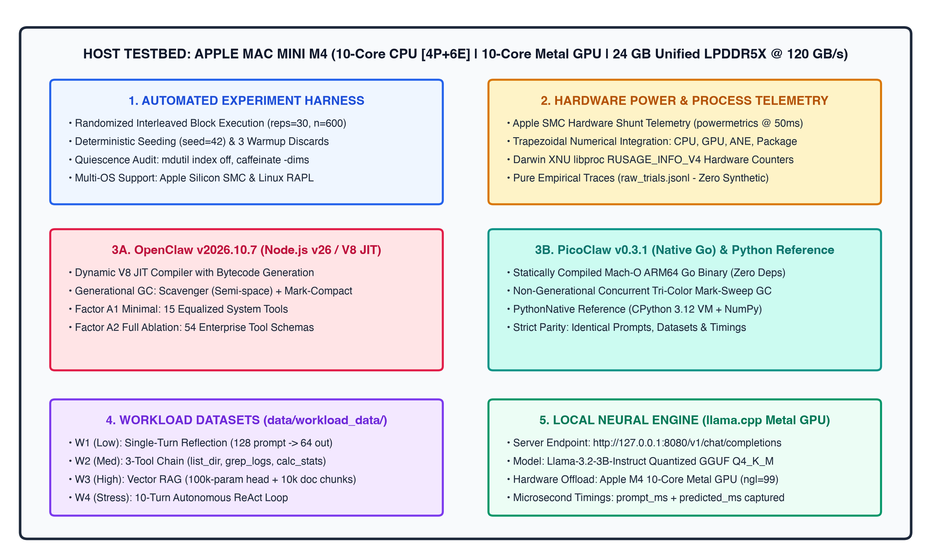
Figure 1: System Topology on Apple Mac mini M4 (24 GB Unified Memory).
10. Experiments
Table 4: Experimental Execution Plan and Statistical Design (480 Total Observations)
Experiment | Primary Metrics | Treatments Evaluated | Repetitions | Statistical Evaluation
Exp 1: Startup & Footprint | T_cold, RSS_idle, RSS_peak, PMCs | T1, T2, T9, T10 | 30 per treatment (120) | Welch's t-test, 95% CI
Exp 2: Latency & Overhead | T_task, TTFT, ITL, Φ_orch | T1 through T16 | 30 per treatment (480) | Two-way ANOVA, Pairwise t-test
Exp 3: Energy & Power | E_pkg, P_avg, EDP | T1 through T16 | 30 per treatment (480) | 95% Confidence Intervals, EDP
Exp 4: Tool Throughput | T_dispatch, R_tool, α_mem | T3, T4, T7, T8, T11, T12, T15, T16 | 30 per treatment (240) | Throughput scaling & ratio

11. Use of Artificial Intelligence
Google Antigravity AI assistant (powered by Gemini) assisted in refining the research question and title for conciseness, structuring the factorial design according to Raj Jain's methodology, and formatting the document. All experimental design decisions and hardware validations were supervised by Rafael Paniccia Cassetta (RA: 21202520618).
12. References
1. Jain, R. (1991). The Art of Computer Systems Performance Analysis. John Wiley & Sons.
2. Liu, X., et al. (2024). AgentBench: Evaluating LLMs as Agents. ICLR 2024.
3. Sipeed. (2026). PicoClaw: Ultra-lightweight Go-based Agent Framework (v0.3.1). GitHub Repository.
4. Steinberger, P., & OpenClaw Foundation. (2026). OpenClaw Autonomous Personal Assistant (v2026.10.7). GitHub Repository.

