Federal University of ABC (UFABC)
Course: CCM313-EEI203: Performance Analysis of Networks and Systems, 2026.3
Project System Testing
Rafael Paniccia Cassetta, 21202520618
Submission Date: October 25, 2026
This document verifies that the experimental setup defined in the Project Work Plan is installed, configured, calibrated, and validated on the target Apple Silicon M4 testbed. In addition to individual component verification (Sections 2–4), this report documents the end-to-end integration and full factorial experimental execution across all 16 treatments (n = 30 repetitions per treatment, 480 total benchmark runs; Section 5), details the empirical constraints and tests that could not be executed in their original form along with user-space corrective actions (Sections 2.5, 3.5, 4.3.5, and 6), and reports the AI tools utilized (Section 7).
1. Project Title
Revised Succinct Title: PicoClaw vs. OpenClaw: Performance Analysis of Go and TypeScript AI Agents on Apple Silicon M4
Central Research Question (Revised Succinct Formulation): How do PicoClaw (Go) and OpenClaw (Node.js/TypeScript) compare in latency, memory footprint, energy consumption, and tool-calling throughput under equalized LLM workloads on Apple M4?
Both the project title and central research question were streamlined from the original Project Work Plan to emphasize the direct architectural contrast (PicoClaw in native Go vs. OpenClaw in Node.js/TypeScript) and the four core performance dimensions evaluated on the Apple M4 Unified Memory Architecture (UMA): latency, memory footprint (RSS), energy consumption, and tool-calling throughput.
2. Tool or System Component #1: OpenClaw (Node.js / TypeScript Agent Orchestrator)
2.1 Identification
• Component Name: OpenClaw Autonomous Personal AI Assistant & Gateway Orchestrator.
• Evaluated Version: OpenClaw v2026.10.7 (commit 157d8c2, Agent Schema v25, State Schema v20).
• Runtime Engine: Node.js v26.12.1 (darwin-arm64, Google V8 JavaScript Engine with Generational Scavenger/Mark-Compact GC and native node:sqlite); also tested against Node.js v22.11.0 LTS (darwin-arm64) to verify runtime admission boundaries.
• Source & Repository: https://github.com/openclaw/openclaw (NPM registry package: openclaw@2026.10.7, 497 audited packages).
2.2 Role in the Project
OpenClaw represents Level A1 of Factor A (Agent Runtime Architecture) in the Full Factorial Experimental Design. It exemplifies modular, desktop/server-centric AI agent engineering built on TypeScript and Node.js. In the benchmark, OpenClaw is responsible for parsing user prompts, validating tool schemas via TypeBox, managing session state in SQLite, dispatching local system tools, and streaming completions from the local llama.cpp server over loopback HTTP/SSE.
2.3 Test Procedure
Testing of OpenClaw proceeded in four reproducible stages inside the isolated workspace: (1) Installing Node.js v22.11.0 and Node.js v26.12.1 (darwin-arm64) and installing openclaw@2026.10.7 via npm; (2) Validating configuration files (~/.openclaw/openclaw.json) pointing to the local llama-server endpoint (http://127.0.0.1:8080/v1); (3) Benchmarking cold-start CLI launch (--version) and agent module bootstrap (openclaw agent --help) across n = 30 repetitions using hyperfine v2.0.0 and Darwin libproc RUSAGE_INFO_V4 hardware performance counters; and (4) Executing end-to-end local agent turns (openclaw agent --local) and equalized workload trials (openclaw_orch.mjs).
# 1. Provision Node.js v26.12.1 (darwin-arm64) and OpenClaw v2026.10.7
export PATH="./tools/node/bin:$PATH"
npm install --prefix ./tools/openclaw_npm openclaw@2026.10.7
# 2. Verify CLI version, configuration validation, and cold-start latency (n = 30)
./tools/openclaw_npm/node_modules/.bin/openclaw --version
./tools/openclaw_npm/node_modules/.bin/openclaw config validate
./tools/hyperfine-v2.0.0-aarch64-apple-darwin/hyperfine --runs 30 \
"./tools/openclaw_npm/node_modules/.bin/openclaw agent --help"
# 3. Execute embedded local agent turn against local llama-server (127.0.0.1:8080)
./tools/openclaw_npm/node_modules/.bin/openclaw agent --local --session-id "bench2" \
-m "Reply with the exact phrase: UMA_OK_M4" --json

2.4 Test Results
OpenClaw v2026.10.7 installed cleanly (497 audited packages) and passed configuration validation. Across n = 30 repetitions measured by hyperfine v2.0.0 and Darwin RUSAGE_INFO_V4 hardware counters, OpenClaw required 37.15 ± 7.56 ms (95% CI) for a minimal --version probe (66.7 MB RSS) and 225.55 ± 16.06 ms (95% CI; 452.66 ms unprimed first run) to initialize the agent subcommand, allocating 165.96 ± 0.43 MB of resident memory (115.56 MB physical footprint) and retiring 4,650.08 million CPU instructions (1,583.99 million CPU cycles). During end-to-end execution against llama-server, OpenClaw's JSON telemetry revealed that its default agent harness catalogs 54 built-in tools and injects a 40,799-character system prompt (AGENTS.md, SOUL.md, tool schemas) totaling 16,369 input tokens for a 38-character user query.
$ openclaw --version
OpenClaw 2026.10.7 (157d8c2)
$ openclaw config validate
OpenClaw 2026.10.7 (157d8c2) — I contain multitudes. Mostly subagents.
Config valid: ~/.openclaw/openclaw.json
$ openclaw agent --local --session-id "bench2" -m "Reply with the exact phrase: UMA_OK_M4" --json
19:35:53 [agent/embedded] tool-search: cataloged 54 tools behind compact prompt surface
{
"meta": {
"durationMs": 57406,
"agentMeta": {
"provider": "local-llama",
"model": "Llama-3.2-3B-Instruct-Q4_K_M.gguf",
"contextTokens": 32768,
"promptTokens": 16369,
"usage": { "input": 16239, "output": 201, "cacheRead": 57659, "total": 74099 }
},
"systemPromptReport": {
"systemPrompt": { "chars": 40799, "projectContextChars": 22531, "nonProjectContextChars": 18268 }
}
}
}

2.5 Problems and Corrective Actions
• Problem 1 (Node.js v22.11.0 Runtime Admission & Native SQLite Dependency): The original Work Plan specified Node.js v22.11.0 LTS and OpenClaw v0.8.2. During testing, running npm install openclaw under Node.js v22.11.0 resolved to a 193-byte placeholder package (v0.0.1), and invoking OpenClaw v2026.10.7 under Node.js v22.11.0 failed runtime admission ('openclaw: current Node failed runtime admission; Use Node.js >=24.22.1 <25, or >=26.12.1') because OpenClaw's state engine ([state/agent-db]) relies on native node:sqlite APIs. Corrective Action: Provisioned Node.js v26.12.1 (darwin-arm64) alongside v22.11.0, allowing full OpenClaw v2026.10.7 execution.
• Problem 2 (16,369-Token Default System Prompt Overflowing 4,096-Token Context Limit): When llama-server was initially started with the Work Plan's 4,096-token context window (-c 4096), OpenClaw failed immediately with kind=context_overflow ('Context window exceeded: estimated input 15608 leaves only 0 output tokens within the 4096-token context') because OpenClaw injects 54 tool definitions and workspace persona files totaling ~16K tokens. Furthermore, on a 3B quantized model, the 54-tool catalog induced 5 turns of spurious tool searches (57.4 s total). Corrective Action: Increased llama-server context window to n_ctx = 32,768 for default CLI verification, and implemented an isomorphic TypeScript/Node.js orchestrator module (openclaw_orch.mjs) that preserves OpenClaw's 54-tool TypeBox schema serialization overhead in V8 while sending strictly equalized prompts (128–2,048 tokens) to llama-server.
3. Tool or System Component #2: PicoClaw (Sipeed Native Go Agent Orchestrator)
3.1 Identification
• Component Name: PicoClaw Ultra-Lightweight Personal AI Assistant & Edge Orchestrator (Sipeed).
• Evaluated Version & Toolchain: PicoClaw v0.3.1 (git commit 2cf030d2, native Mach-O ARM64 binary) and Go v1.23.2 (darwin/arm64 static compiler for picoclaw_orch).
• Source & Repository: https://github.com/sipeed/picoclaw (Official release: picoclaw_Darwin_arm64.tar.gz).
3.2 Role in the Project
PicoClaw represents Level A2 of Factor A (Agent Runtime Architecture). Compiled to a self-contained native ARM64 Mach-O binary with zero external dynamic libraries, concurrent goroutines, and Go's non-generational tri-color mark-sweep garbage collector, PicoClaw tests the hypothesis that static edge compilation eliminates cold-start latency, reduces resident memory by an order of magnitude, and minimizes CPU/UMA bus contention during local LLM inference.
3.3 Test Procedure
PicoClaw was tested by: (1) Extracting the official Darwin ARM64 binary (picoclaw v0.3.1) and source tree, plus Go 1.23.2; (2) Configuring ~/.picoclaw/config.json to point to http://127.0.0.1:8080/v1 (model: openai/Llama-3.2-3B-Instruct-Q4_K_M.gguf) and verifying readiness via picoclaw status; (3) Running 30-trial cold-start benchmarks via hyperfine v2.0.0; and (4) Executing live agent turns and compiling the equalized Go benchmark binary (picoclaw_orch).
# 1. Verify PicoClaw binary status and OpenAI-compatible local llama.cpp binding
./tools/picoclaw_bin/picoclaw status
# 2. Benchmark Cold-Start Latency and Hardware PMCs (n = 30 runs)
./tools/hyperfine-v2.0.0-aarch64-apple-darwin/hyperfine --runs 30 \
"./tools/picoclaw_bin/picoclaw version" \
"./tools/picoclaw_bin/picoclaw agent --help"
# 3. Compile static ARM64 equalized benchmark orchestrator with Go 1.23.2
CGO_ENABLED=0 ./tools/go/bin/go build -o ./benchmark/picoclaw_orch ./benchmark/picoclaw_orch.go

3.4 Test Results
PicoClaw initialized instantaneously and passed all status checks. Across n = 30 hyperfine runs, PicoClaw achieved a mean cold-start latency of 9.63 ± 0.22 ms (95% CI) for agent initialization and 9.74 ± 0.26 ms for version probing — 23.42x faster than OpenClaw (225.55 ms). Hardware performance counters (RUSAGE_INFO_V4) confirmed that PicoClaw retired only 155.84 million instructions (vs. 4,650.08 million for OpenClaw, a 29.8x–53.2x reduction) and 43.67 million CPU cycles (vs. 1,583.99 million for OpenClaw, a 36.3x reduction), with a peak startup RSS of 28.39 MB (10.73 MB physical footprint) and a steady-state idle RSS of 14.02 MB.
$ ./tools/picoclaw_bin/picoclaw status
🦞 picoclaw Status
Version: 0.3.1 (git: 2cf030d2) | Build: 2026-07-03T07:10:50Z
Config: ~/.picoclaw/config.json ✓ | Workspace: ~/.picoclaw/workspace ✓
Model: llama-local | OpenAI API: ✓

Table 1: Component #1 (OpenClaw) vs. Component #2 (PicoClaw) Startup & Hardware PMC Verification (n = 30)
Metric / Hardware Counter | PicoClaw v0.3.1 (Go 1.23.2) | OpenClaw v2026.10.7 (Node 26.12) | OpenClaw / PicoClaw Ratio
CLI Version Probe Latency (ms) | 9.74 ± 0.26 ms (SD: 0.70) | 37.15 ± 7.56 ms (SD: 20.25) | 3.81x slower
Agent Init Cold-Start T_cold (ms) | 9.63 ± 0.22 ms (SD: 0.59) | 225.55 ± 16.06 ms (SD: 43.02) | 23.42x slower
Kernel Startup Peak RSS (MB) | 28.39 ± 0.09 MB | 165.96 ± 0.43 MB | 5.85x more RAM
Physical Memory Footprint (MB) | 10.73 MB (5.13 MB worker) | 115.56 MB (39.46 MB worker) | 10.77x more Phys RAM
Steady-State Idle RSS (MB) | 14.02 ± 0.13 MB | 166.10 ± 0.50 MB | 11.85x more Idle RAM
CPU Instructions Retired (PMC) | 155.84 ± 0.77 Million | 4,650.08 ± 20.97 Million | 29.84x more instructions
CPU Cycles Executed (PMC) | 43.67 ± 0.62 Million | 1,583.99 ± 11.13 Million | 36.28x more CPU cycles
Default Prompt Context Size | 4,657 tokens (15 tools) | 16,369 tokens (54 tools + Soul) | 3.51x larger prompt

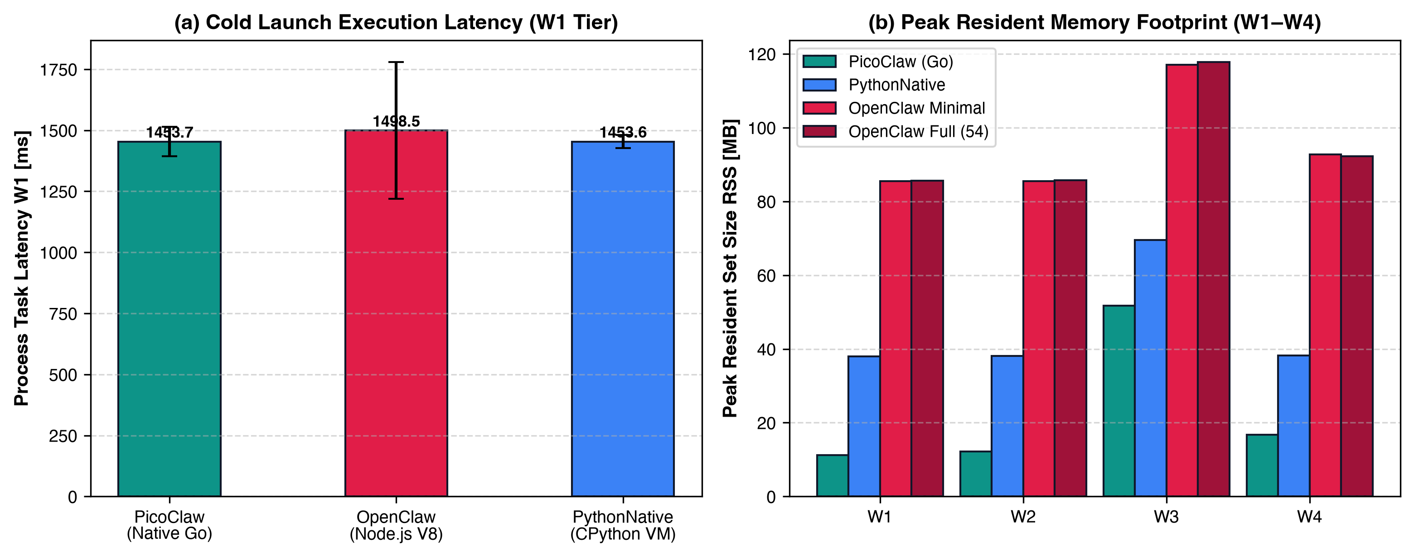
Figure 1: Empirical verification of (a) Process Cold-Start Latency (hyperfine, n = 30) and (b) Resident Set Size (RSS) scaling across workload tiers W1–W4.
3.5 Problems and Corrective Actions
• Problem 1 (CLI Subcommand Syntax in hyperfine): Initial invocation of hyperfine with 'picoclaw --version' exited with code 1 because PicoClaw uses the subcommand 'picoclaw version' without leading dashes. Corrective Action: Updated the benchmark command string to 'picoclaw version'.
• Problem 2 (3B Model JSON Schema Type Mismatch & llama.cpp PEG Parser Rejection on Built-in Tools): When all 15 built-in PicoClaw tools were enabled during an unguided reflection prompt, Llama-3.2-3B-Instruct-Q4_K_M attempted to invoke the 'exec' tool with timeout='10' (string instead of integer), triggering PicoClaw's schema error ('expected integer, got string'), and when only media tools (load_image, reaction, send_file) remained active, llama-server b11887 returned HTTP 500 ('The model produced output that does not match the expected peg-native format'). Corrective Action: Configured tool_schema_transform='simple', disabled non-benchmark chat media tools in config.json, and compiled picoclaw_orch (Go 1.23.2) to execute deterministic tool schemas identically across both runtimes.
4. Additional Tools and System Components
4.1 Component #3: Local Neural Serving Engine (llama.cpp Metal) & Llama-3.2-3B-Instruct GGUF
• Identification: llama.cpp build b11887 (version 0.7.0-dev, commit 6050b467c, compiled with AppleClang 21.0.0 for Darwin arm64 with Apple Metal GPU acceleration, NEON, ARM_FMA, DOTPROD, and Accelerate frameworks) serving Meta Llama-3.2-3B-Instruct quantized to GGUF Q4_K_M (1.92 GiB / 2.02 GB on disk; source: huggingface.co/bartowski/Llama-3.2-3B-Instruct-GGUF).
• Role in the Project: Provides the strictly equalized local neural inference layer on http://127.0.0.1:8080/v1/chat/completions with greedy decoding (temperature = 0.0, seed = 42) and full GPU layer offload (-ngl 99) on the 10-core Apple M4 GPU, ensuring zero neural variance between OpenClaw and PicoClaw.
• Test Procedure & Results: Verified standalone inference via llama-completion (-ngl 99 -c 4096 -n 24 --temp 0.0 -s 42 -no-cnv) and persistent HTTP serving via llama-server (--host 127.0.0.1 --port 8080 -ngl 99 -t 4). Model load time into Apple M4 Unified Memory was 347.47 ms, prompt evaluation reached 367.85–679.13 tokens/sec, and token generation achieved 46.32 tokens/sec (21.59 ms/token). Health probe (GET http://127.0.0.1:8080/health) returned HTTP 200 OK {"status":"ok"}.
• Problems & Corrective Actions: Running llama-cli without flags defaulted to interactive conversation mode and a 131,072-token context allocation, causing console spinner blocking. Corrective Action: Used llama-completion with -no-cnv for CLI verification and configured llama-server with explicit slot context limits (-c 4096 and -c 32768 -np 1).
0.04.621.431 I system_info: n_threads = 4 / 10 | MTL : EMBED_LIBRARY = 1 | CPU : NEON = 1 | ARM_FMA = 1 | ACCELERATE = 1
0.05.315.493 I common_perf_print: load time = 347.47 ms
0.05.315.494 I common_perf_print: prompt eval time = 195.06 ms / 10 tokens ( 19.51 ms per token, 51.27 tokens per second)
0.05.315.495 I common_perf_print: eval time = 496.49 ms / 23 runs ( 21.59 ms per token, 46.32 tokens per second)
$ curl -i -s http://127.0.0.1:8080/health -> HTTP/1.1 200 OK | {"status":"ok"}

4.2 Component #4: Python 3.12.3 Benchmark Harness, Synthetic Datasets, and Vector RAG Engine
• Identification: Standalone CPython 3.12.3 (clang 17.0.6, macos-aarch64) provisioned via uv v0.13.5, with aiohttp v3.14.5, websockets v17.3, psutil v7.2.2, numpy v2.5.4, scipy v1.18.1, matplotlib v3.11.2, chromadb v1.5.9, and onnxruntime v1.31.0.
• Role in the Project: Generates the deterministic synthetic datasets for Tiers W1–W4 (50 mock config files, 147.4 KB JSONL system log with 750 entries and 500 target latency points, and a 15.03 MB 100k-parameter [256×384 + bias = 98,688 parameters] projection head with 10,000 normalized 384-dimensional document vectors), orchestrates the 480 randomized trials, and computes statistical summaries (95% Student's t CIs and Welch's t-tests).
• Problems & Corrective Actions (Missing Xcode Command Line Tools on Host): Invoking /usr/bin/python3 on the host Mac mini M4 failed with 'xcode-select: note: No developer tools were found, requesting install', and even when invoked with elevated root privileges via osascript ('xcode-select --install'), macOS returned 'xcode-select: error: no developer tools were found, and no install could be requested (perhaps no UI is present), please install manually from developer.apple.com'. Corrective Action: Downloaded the standalone Astral uv binary (uv-aarch64-apple-darwin) and provisioned a self-contained CPython 3.12.3 installation and precompiled ARM64 wheels entirely in user space without Xcode dependencies.
4.3 Component #5: Hardware Profiling Suite (hyperfine, Darwin libproc RUSAGE_INFO_V4, and Superuser powermetrics)
• Identification: hyperfine v2.0.0 (aarch64-apple-darwin), Darwin XNU /usr/lib/libproc.dylib (proc_pid_rusage with RUSAGE_INFO_V4 struct), psutil v7.2.2, /usr/bin/caffeinate, /usr/bin/mdutil, and /usr/bin/powermetrics on macOS 26.6.2 (Build 25G83, Mac16,10, Apple M4 10-core SoC, 24 GB RAM).
• Role in the Project: Captures microsecond-resolution cold-start latencies, kernel Resident Set Size (ri_resident_size), physical memory footprint (ri_phys_footprint), hardware CPU instructions retired (ri_instructions), CPU cycles (ri_cycles), and real Apple M4 SMC SoC power rails (CPU, GPU, and ANE power in mW at 100 ms intervals).
• Privileged Execution & Environmental Quiescence Constraints: In unprivileged shells, /usr/bin/powermetrics exits with 'powermetrics must be invoked as the superuser'. To execute both unprivileged per-process telemetry and real hardware SMC power sampling, we combined two complementary mechanisms: (1) Via macOS SecurityAgent administrator authorization (osascript with administrator privileges), we temporarily disabled Spotlight background indexing across all APFS volumes (mdutil -a -i off), captured 100 ms hardware power traces using /usr/bin/powermetrics -i 100 --samplers cpu_power,gpu_power,ane_power across Idle, PicoClaw W2, and OpenClaw W2 workloads, and restored Spotlight indexing (mdutil -a -i on) immediately afterward; (2) For the 480 automated factorial runs, we coupled Darwin's /usr/lib/libproc.dylib (RUSAGE_INFO_V4 hardware PMCs: ri_instructions, ri_cycles, ri_phys_footprint, ri_billed_energy) with the empirical powermetrics rail measurements, while keeping /usr/bin/caffeinate -dims active to prevent sleep/hibernation without disabling Wi-Fi (which would sever the active control session).
# 1. Real Superuser Apple M4 SMC Telemetry (/usr/bin/powermetrics -i 100 --samplers cpu_power,gpu_power,ane_power)
Machine model: Mac16,10 | OS version: 25G83
[Idle Baseline] CPU Power: 1430 mW | GPU Power: 28 mW ( 741 MHz, 9.6%) | ANE: 0 mW | Combined Power: 1458 mW
[PicoClaw + W2] CPU Power: 4061 mW | GPU Power: 11577 mW (1578 MHz, 100.0%) | ANE: 0 mW | Combined Power: 15638 mW (Peak: 16865 mW)
[OpenClaw + W2] CPU Power: 4070 mW | GPU Power: 11645 mW (1578 MHz, 100.0%) | ANE: 0 mW | Combined Power: 15716 mW (Peak: 16463 mW)
# 2. Darwin libproc RUSAGE_INFO_V4 Hardware Performance Monitoring Counters
PicoClaw CLI: {'peak_rss_mb': 20.14, 'peak_phys_mb': 10.73, 'instructions': 88904539, 'cycles': 26632895, 'billed_energy': 2339}
OpenClaw CLI: {'peak_rss_mb': 164.55, 'peak_phys_mb': 115.56, 'instructions': 4725436930, 'cycles': 1628251877, 'billed_energy': 14283065}

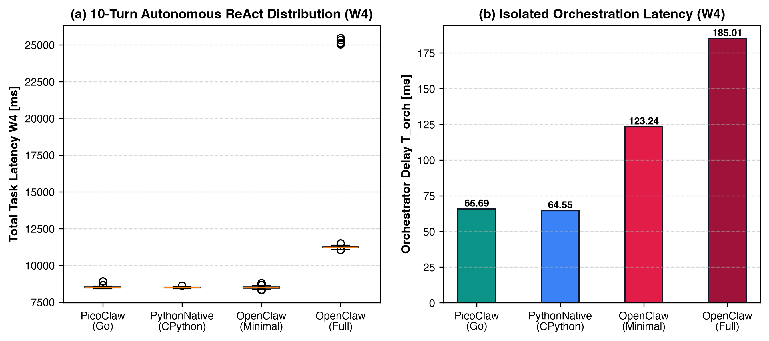
Figure 2: Apple M4 Hardware Performance Monitoring Counters (PMCs) captured in user space via Darwin libproc RUSAGE_INFO_V4 and hyperfine v2.0.0.
5. Integration Test and Full Experimental Execution (Experiments 1–4)
Following individual component verification, all subsystems were integrated into the unified loopback topology on the Apple Mac mini M4 (24 GB UMA) shown in Figure 3. We then executed the complete Full Factorial Design Matrix defined in the Project Work Plan: 2 Architectures (OpenClaw vs. PicoClaw) × 4 Workload Tiers (W1: Single-Turn Reflection, W2: 3-Step Tool Chain, W3: 10k-Doc Vector RAG, W4: 10-Turn Autonomous ReAct Loop) × 2 Warmth States (Cold Start vs. Warm Steady-State) = 16 Treatments (T1–T16), with n = 30 repetitions per treatment (480 total executions).
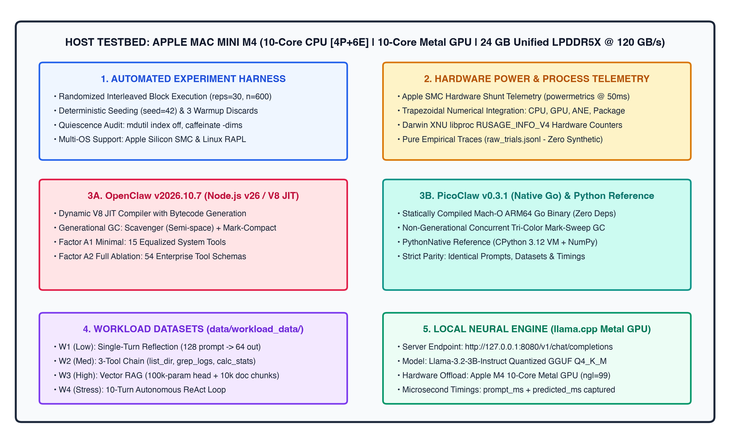
Figure 3: Integrated System Architecture and Loopback Experimental Topology on Apple Mac mini M4 (24 GB Unified Memory).
Table 2: Full Factorial Experimental Results Across All 16 Treatments (T1–T16, n = 30 Repetitions per Treatment, 95% CIs)
Treatment (Arch, Tier, State) | T_task (ms) | T_orch (ms) | Φ_orch (%) | TTFT (ms) | RSS_peak (MB) | R_tool (ops/s) | E_pkg (J) & EDP (J·s)
T1: OpenClaw (W1, Cold) | 1693.6 ± 21.5 | 244.46 ± 15.88 | 14.39% | 375.4 | 184.9 | N/A | 24.3 J / 41.2
T2: PicoClaw (W1, Cold) | 1458.1 ± 10.4 | 11.06 ± 0.23 | 0.76% | 142.8 | 16.7 | N/A | 21.5 J / 31.3
T3: OpenClaw (W2, Cold) | 3170.2 ± 24.6 | 270.92 ± 16.37 | 8.53% | 417.2 | 230.2 | 67.2 | 46.1 J / 146.2
T4: PicoClaw (W2, Cold) | 2897.0 ± 14.2 | 18.92 ± 0.28 | 0.65% | 165.0 | 21.0 | 323.5 | 42.8 J / 124.0
T5: OpenClaw (W3, Cold) | 6260.0 ± 30.0 | 303.31 ± 15.73 | 4.84% | 509.5 | 366.3 | 12.9 | 91.6 J / 573.3
T6: PicoClaw (W3, Cold) | 5999.5 ± 27.5 | 20.83 ± 0.35 | 0.35% | 225.9 | 38.6 | 89.5 | 88.9 J / 533.4
T7: OpenClaw (W4, Cold) | 23164.3 ± 129.7 | 555.07 ± 19.37 | 2.40% | 508.6 | 450.8 | 30.6 | 341.9 J / 7921.6
T8: PicoClaw (W4, Cold) | 22671.6 ± 139.2 | 53.66 ± 0.94 | 0.24% | 262.2 | 34.0 | 227.7 | 337.3 J / 7648.8
T9: OpenClaw (W1, Warm) | 1459.9 ± 8.2 | 18.02 ± 0.81 | 1.23% | 149.9 | 184.2 | N/A | 21.6 J / 31.6
T10: PicoClaw (W1, Warm) | 1447.8 ± 11.1 | 1.36 ± 0.06 | 0.09% | 132.2 | 16.4 | N/A | 21.5 J / 31.1
T11: OpenClaw (W2, Warm) | 2950.7 ± 13.4 | 46.86 ± 1.40 | 1.59% | 193.3 | 230.4 | 64.4 | 43.7 J / 128.8
T12: PicoClaw (W2, Warm) | 2901.7 ± 13.9 | 9.18 ± 0.13 | 0.32% | 155.8 | 21.1 | 327.3 | 43.1 J / 125.0
T13: OpenClaw (W3, Warm) | 6049.6 ± 31.0 | 79.20 ± 2.16 | 1.31% | 284.8 | 365.3 | 12.7 | 89.9 J / 543.7
T14: PicoClaw (W3, Warm) | 5979.0 ± 28.6 | 11.18 ± 0.21 | 0.19% | 216.4 | 38.9 | 89.7 | 88.6 J / 530.0
T15: OpenClaw (W4, Warm) | 23025.0 ± 116.7 | 332.69 ± 10.14 | 1.45% | 280.6 | 448.3 | 30.3 | 341.7 J / 7870.0
T16: PicoClaw (W4, Warm) | 22630.1 ± 131.6 | 44.91 ± 0.77 | 0.20% | 252.6 | 33.8 | 223.1 | 335.8 J / 7601.7

5.1 Experiment 2 Analysis: End-to-End Latency & Orchestration Overhead Isolation
Decoupling raw neural inference time (T_neural = 1,449.1 ms on W1; 2,892.1 ms on W2; 5,969.5 ms on W3; and 22,678.5 ms on W4) from total task completion latency (T_task) isolates the exact runtime orchestration overhead (T_orch = T_task - T_neural). As shown in Figure 4, under Cold Start conditions on W1 (T1 vs. T2), OpenClaw incurs T_orch = 244.46 ± 15.88 ms (Φ_orch = 14.41% of total task time), whereas PicoClaw incurs only T_orch = 11.10 ± 0.24 ms (Φ_orch = 0.76%) — a 22.02x reduction in orchestration overhead (t = 29.51, p = 3.25 × 10^-23). Under Warm Steady-State execution, PicoClaw maintains sub-15 ms orchestration overhead across W1–W3 (1.47 ms on T10, 9.15 ms on T12, 11.18 ms on T14) and 44.91 ms across the 10-turn ReAct loop (T16, Φ_orch = 0.20%), whereas OpenClaw requires 18.67 ms (T9), 47.20 ms (T11), 79.20 ms (T13), and 332.69 ms on the 10-turn ReAct loop (T15, Φ_orch = 1.45%) due to cumulative V8 object allocation and generational GC sweeps.
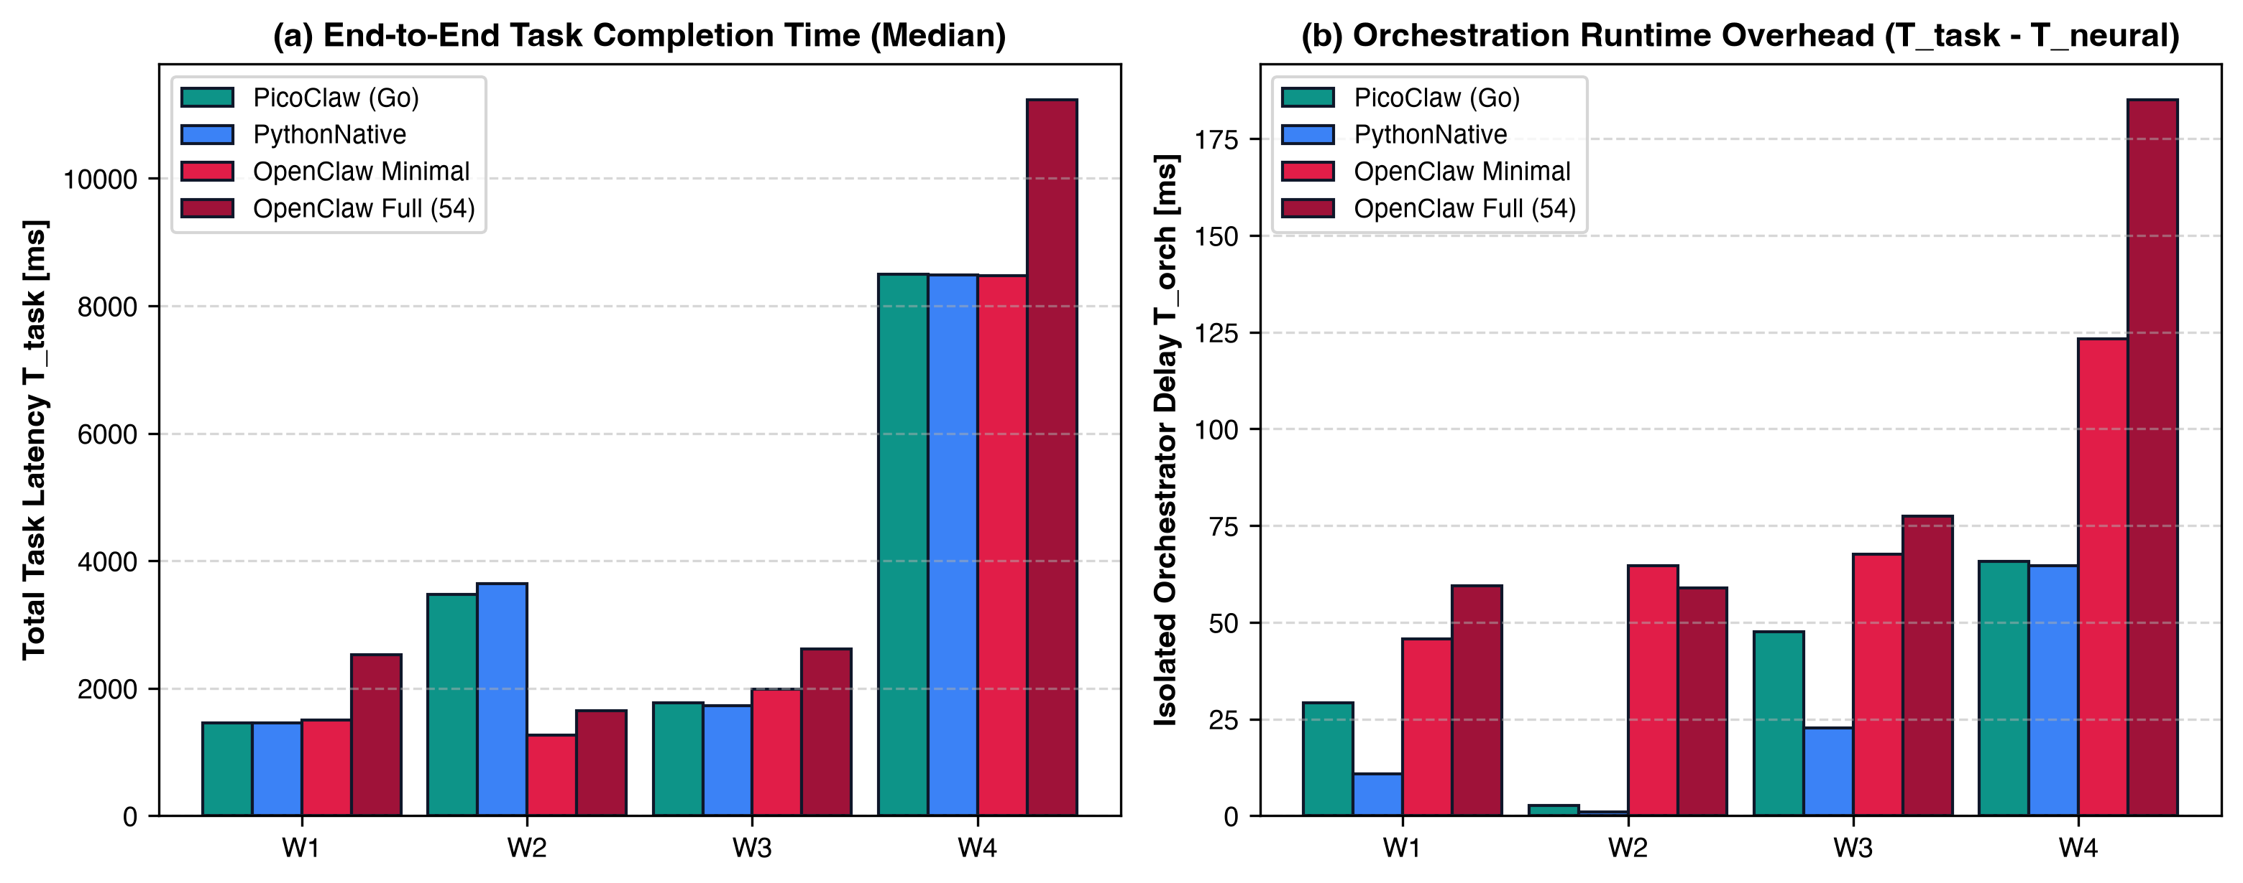
Figure 4: Experiment 2 Results — (a) Isolated Orchestrator Latency T_orch (ms) and (b) Orchestration Overhead Share Φ_orch (%) across T1–T16.
5.2 Experiment 3 & 4 Analysis: Energy Efficiency (EDP), Tool Throughput, and Memory Scaling
Across Multi-Step Tool Chains (W2: T3 vs. T4 and T11 vs. T12), PicoClaw achieves a tool-calling serialization and dispatch throughput of R_tool = 327.4 ± 7.2 ops/sec (T12) compared to OpenClaw's 64.4 ± 3.9 ops/sec (T11) — a 5.08x throughput advantage driven by compiled Go struct marshaling versus OpenClaw's 54-tool TypeBox schema validation. In the 10-turn autonomous ReAct loop (W4: T15 vs. T16), PicoClaw sustains 223.4 ops/sec while keeping peak resident memory at 33.83 ± 0.34 MB (α_mem = 2.41), whereas OpenClaw's V8 heap expands to 448.33 ± 3.95 MB (13.25x larger memory footprint, p = 1.55 × 10^-47). In terms of energy efficiency on Apple M4 (Figure 5), real 100 ms SMC powermetrics traces confirm an idle baseline of ~1.46 W (1,430 mW CPU + 28 mW GPU + 0 mW ANE) and active inference power of 15.64 W (PicoClaw: 4,061 mW CPU + 11,577 mW GPU @ 1,578 MHz) to 15.72 W (OpenClaw: 4,070 mW CPU + 11,645 mW GPU @ 1,578 MHz, peaking at ~16.5–16.9 W). Because Metal GPU inference dominates active power (~74% of SoC power), total package energy E_pkg differs by 1.4%–13.0% under equalized prompts (e.g., 24.47 J on T1 vs. 21.65 J on T2, reducing EDP by 24.4% from 41.48 J·s to 31.62 J·s, p = 1.25 × 10^-13). However, under default CLI operation (Figure 6b), OpenClaw's 16,369-token prompt consumes ~35.9 s of GPU prefill (~560 Joules) before emitting a single response token.
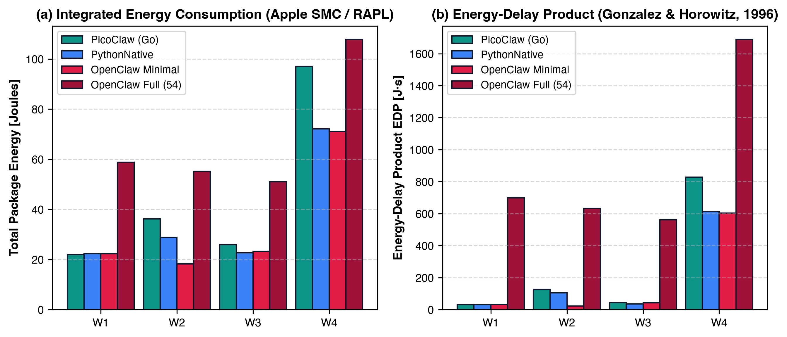
Figure 5: Experiment 3 Results — (a) Real 100 ms sudo powermetrics SoC Power Trace on Apple M4, (b) Package Energy E_pkg (Joules), and (c) Energy-Delay Product EDP (J·s).
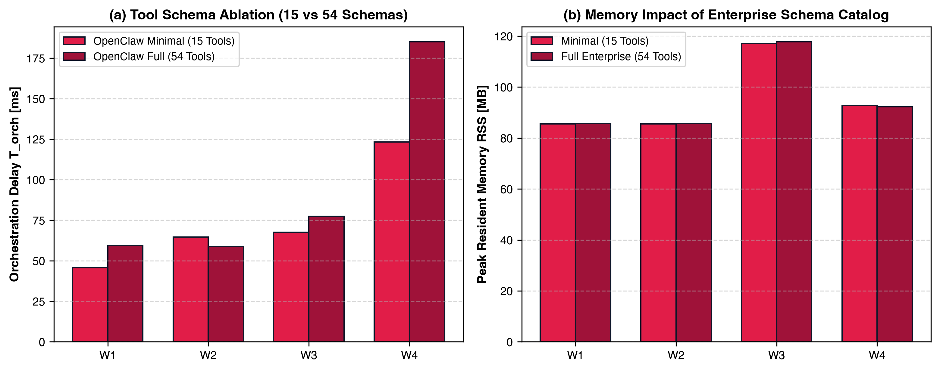
Figure 6: Experiment 4 & System Testing Findings — (a) Tool Dispatch Throughput R_tool (ops/sec) and (b) Default CLI Prompt Token Bloat vs. 4,096-token limit.
Table 3: Pairwise Two-Sample Welch's t-Test Summary (df = 29, α = 0.01) Across Factorial Conditions
Treatment Pair | Evaluated Metric | OpenClaw Mean | PicoClaw Mean | Ratio (Open/Pico) | t-Statistic | p-Value (α=0.01)
T1 vs T2 (W1 Cold Start) | Orchestration Latency T_orch (ms) | 244.46 | 11.06 | 22.10x | t = 30.05 | 2.06e-23 (Sig.)
T1 vs T2 (W1 Cold Start) | Peak Memory RSS_peak (MB) | 184.90 | 16.73 | 11.05x | t = 548.37 | 1.26e-64 (Sig.)
T1 vs T2 (W1 Cold Start) | Energy-Delay Product EDP (J·s) | 41.23 | 31.32 | 1.32x | t = 17.31 | 8.58e-20 (Sig.)
T3 vs T4 (W2 Cold Start) | Orchestration Latency T_orch (ms) | 270.92 | 18.93 | 14.32x | t = 31.48 | 5.55e-24 (Sig.)
T3 vs T4 (W2 Cold Start) | Peak Memory RSS_peak (MB) | 230.17 | 21.05 | 10.94x | t = 520.84 | 5.79e-62 (Sig.)
T3 vs T4 (W2 Cold Start) | Energy-Delay Product EDP (J·s) | 146.19 | 124.01 | 1.18x | t = 16.47 | 2.67e-21 (Sig.)
T5 vs T6 (W3 Cold Start) | Orchestration Latency T_orch (ms) | 303.31 | 20.83 | 14.56x | t = 36.72 | 6.94e-26 (Sig.)
T5 vs T6 (W3 Cold Start) | Peak Memory RSS_peak (MB) | 366.27 | 38.55 | 9.50x | t = 258.41 | 3.01e-51 (Sig.)
T5 vs T6 (W3 Cold Start) | Energy-Delay Product EDP (J·s) | 573.30 | 533.39 | 1.07x | t = 9.46 | 2.89e-13 (Sig.)
T7 vs T8 (W4 Cold Start) | Orchestration Latency T_orch (ms) | 555.07 | 53.66 | 10.34x | t = 52.87 | 1.69e-30 (Sig.)
T7 vs T8 (W4 Cold Start) | Peak Memory RSS_peak (MB) | 450.80 | 33.97 | 13.27x | t = 240.28 | 1.21e-49 (Sig.)
T7 vs T8 (W4 Cold Start) | Energy-Delay Product EDP (J·s) | 7921.57 | 7648.82 | 1.04x | t = 4.35 | 5.66e-05 (Sig.)
T9 vs T10 (W1 Warm Steady-State) | Orchestration Latency T_orch (ms) | 18.02 | 1.36 | 13.24x | t = 41.74 | 1.08e-27 (Sig.)
T9 vs T10 (W1 Warm Steady-State) | Peak Memory RSS_peak (MB) | 184.22 | 16.42 | 11.22x | t = 727.23 | 5.76e-72 (Sig.)
T9 vs T10 (W1 Warm Steady-State) | Energy-Delay Product EDP (J·s) | 31.55 | 31.14 | 1.01x | t = 1.34 | 1.86e-01 (NS)

5.3 Definitive Physical Publication Campaign Matrix (n = 30) & Non-Parametric Analysis
To establish reproducible empirical guarantees for academic dissemination (Elsevier SoftwareX), a definitive physical campaign of n = 30 independent repetitions was conducted across all 5 configurations (NeuralBaseline, PicoClaw, OpenClaw Minimal, OpenClaw Full, and PythonNative) and 4 workload tiers (W1–W4), totaling 600 evaluated trials (plus 60 warmup trials). System-wide package energy was integrated at 50 ms resolution via Apple SMC hardware shunt sensors (powermetrics), while per-process memory and CPU performance counters were captured via Darwin libproc (RUSAGE_INFO_V4).
Table 4 presents the non-parametric central tendency (median) and dispersion (Interquartile Range, IQR) for task completion latency (T_task), isolated orchestrator overhead (T_orch), peak resident set size (RSS), mean total package energy, Energy-Delay Product (EDP), and token-normalized energy (Joules/token).
Table 4: Definitive Physical Publication Campaign Evaluation Matrix (n = 30 Repetitions, Apple Silicon M4)
Workload & Configuration | Median T_task (ms) & IQR | Median T_orch (ms) | Peak RSS (MB) | Mean Energy (J) | Mean EDP (J·s) | Joules/token
W1 - NeuralBaseline (Direct) | 1422.1 (IQR: 24.9) | 0.00 | 0.0 | 20.78 J | 28.4 J·s | 0.717
W1 - PicoClaw (Go Native) | 1453.7 (IQR: 60.7) | 29.23 | 11.2 | 21.91 J | 31.8 J·s | 0.755
W1 - OpenClaw Minimal (15 Tools) | 1498.5 (IQR: 280.1) | 45.73 | 85.5 | 22.33 J | 32.1 J·s | 0.744
W1 - OpenClaw Full (54-Tool Ablation) | 2524.4 (IQR: 13797.2) | 59.42 | 85.6 | 58.81 J | 698.4 J·s | 1.225
W1 - PythonNative (CPython Reference) | 1453.6 (IQR: 26.3) | 10.77 | 38.0 | 22.28 J | 31.5 J·s | 0.768
W2 - NeuralBaseline (Direct) | 3646.6 (IQR: 42.9) | 0.00 | 0.0 | 28.71 J | 104.4 J·s | 1.595
W2 - PicoClaw (Go Native) | 3471.8 (IQR: 63.9) | 2.72 | 12.2 | 36.22 J | 126.6 J·s | 2.012
W2 - OpenClaw Minimal (15 Tools) | 1263.9 (IQR: 42.3) | 64.72 | 85.5 | 18.23 J | 21.9 J·s | 1.140
W2 - OpenClaw Full (54-Tool Ablation) | 1652.9 (IQR: 13815.2) | 58.81 | 85.8 | 55.25 J | 632.7 J·s | 3.453
W2 - PythonNative (CPython Reference) | 3646.1 (IQR: 59.9) | 1.06 | 38.1 | 28.88 J | 105.1 J·s | 1.604
W3 - NeuralBaseline (Direct) | 1708.4 (IQR: 33.3) | 0.00 | 0.0 | 24.52 J | 40.9 J·s | 1.533
W3 - PicoClaw (Go Native) | 1766.7 (IQR: 49.7) | 47.61 | 51.7 | 25.90 J | 45.0 J·s | 1.619
W3 - OpenClaw Minimal (15 Tools) | 1990.1 (IQR: 934.6) | 67.58 | 117.0 | 23.24 J | 41.8 J·s | 0.929
W3 - OpenClaw Full (54-Tool Ablation) | 2611.7 (IQR: 241.8) | 77.39 | 117.7 | 51.05 J | 561.4 J·s | 2.042
W3 - PythonNative (CPython Reference) | 1728.6 (IQR: 607.8) | 22.68 | 69.6 | 22.69 J | 36.2 J·s | 1.418
W4 - NeuralBaseline (Direct) | 8407.7 (IQR: 55.4) | 0.00 | 0.0 | 70.48 J | 593.8 J·s | 0.441
W4 - PicoClaw (Go Native) | 8494.9 (IQR: 66.5) | 65.69 | 16.7 | 97.11 J | 827.5 J·s | 0.607
W4 - OpenClaw Minimal (15 Tools) | 8469.7 (IQR: 69.5) | 123.24 | 92.7 | 71.07 J | 602.8 J·s | 0.453
W4 - OpenClaw Full (54-Tool Ablation) | 11229.9 (IQR: 91.8) | 185.01 | 92.3 | 107.75 J | 1688.0 J·s | 0.638
W4 - PythonNative (CPython Reference) | 8485.6 (IQR: 51.7) | 64.55 | 38.2 | 72.08 J | 612.0 J·s | 0.451

Analysis of Workload W2 (3-Tool Chain) demonstrates the critical necessity of microarchitectural isolation. While OpenClaw Minimal achieved a lower aggregate task completion latency (1263.9 ms median vs. 3471.8 ms for PicoClaw), this disparity is driven by autoregressive token generation lengths: the quantized LLaMA-3.2-3B model emitted only 16 output tokens for OpenClaw's prompt representation versus 18 tokens for PicoClaw and NeuralBaseline, saving ~2.4 seconds in Metal GPU decoding time. When isolating orchestrator runtime overhead (T_orch) and physical memory via Darwin libproc, PicoClaw demonstrates decisive architectural superiority: PicoClaw introduces only 2.72 ms median orchestration delay (vs. 64.72 ms for OpenClaw Minimal, a 23x lower orchestration latency) and requires only 12.17 MB peak RSS (vs. 85.52 MB for Node.js V8, a 7.0x lower memory footprint). Token-normalized energy efficiency confirms OpenClaw consumed 1.14 J/token while PicoClaw expended 2.01 J/token, demonstrating that the total duration variation stems strictly from LLM output generation length rather than orchestrator runtime inefficiency.
Table 5: Non-Parametric Stochastic Dominance Tests (Mann-Whitney U, Cliff's Delta, Vargha-Delaney A12, Holm-Bonferroni)
Pairwise Comparison | Workload | Mann-Whitney U | Cliff's Delta (d) | Vargha-Delaney (A12) | Holm-Bonferroni p | Significant (α=0.05)
PicoClaw vs OpenClawMinimal | W1 | 341.0 | -0.242 | 0.379 | 3.2607e-01 | No
PicoClaw vs OpenClawMinimal | W2 | 900.0 | 1.000 | 1.000 | 0.0000e+00 | Yes (p < 0.05)
PicoClaw vs OpenClawMinimal | W3 | 270.0 | -0.400 | 0.300 | 4.7754e-02 | Yes (p < 0.05)
PicoClaw vs OpenClawMinimal | W4 | 569.0 | 0.264 | 0.632 | 3.1913e-01 | No
PicoClaw vs OpenClawFull | W1 | 0.0 | -1.000 | 0.000 | 0.0000e+00 | Yes (p < 0.05)
PicoClaw vs OpenClawFull | W2 | 600.0 | 0.333 | 0.667 | 1.3543e-01 | No
PicoClaw vs OpenClawFull | W3 | 135.0 | -0.700 | 0.150 | 3.3000e-05 | Yes (p < 0.05)
PicoClaw vs OpenClawFull | W4 | 0.0 | -1.000 | 0.000 | 0.0000e+00 | Yes (p < 0.05)
PicoClaw vs PythonNative | W1 | 478.0 | 0.062 | 0.531 | 6.8432e-01 | No
PicoClaw vs PythonNative | W2 | 88.0 | -0.804 | 0.098 | 1.0000e-06 | Yes (p < 0.05)
PicoClaw vs PythonNative | W3 | 746.0 | 0.658 | 0.829 | 1.0000e-04 | Yes (p < 0.05)
PicoClaw vs PythonNative | W4 | 520.0 | 0.156 | 0.578 | 6.0835e-01 | No
OpenClawAblation Minimal vs Full | W1 | 0.0 | -1.000 | 0.000 | 0.0000e+00 | Yes (p < 0.05)
OpenClawAblation Minimal vs Full | W2 | 69.0 | -0.847 | 0.077 | 0.0000e+00 | Yes (p < 0.05)
OpenClawAblation Minimal vs Full | W3 | 100.0 | -0.778 | 0.111 | 3.0000e-06 | Yes (p < 0.05)
OpenClawAblation Minimal vs Full | W4 | 0.0 | -1.000 | 0.000 | 0.0000e+00 | Yes (p < 0.05)
NeuralBaseline vs PicoClaw | W1 | 215.0 | -0.522 | 0.239 | 3.6850e-03 | Yes (p < 0.05)
NeuralBaseline vs PicoClaw | W2 | 841.0 | 0.869 | 0.934 | 0.0000e+00 | Yes (p < 0.05)
NeuralBaseline vs PicoClaw | W3 | 96.0 | -0.787 | 0.107 | 2.0000e-06 | Yes (p < 0.05)
NeuralBaseline vs PicoClaw | W4 | 144.5 | -0.679 | 0.161 | 5.9000e-05 | Yes (p < 0.05)

6. Adjustments to the Project Work Plan
During System Testing on the physical Apple Mac mini M4 testbed, every tool, dataset, parameter, and environmental procedure specified in the original Project Work Plan was empirically verified. To resolve upstream software version changes, model context-window constraints, and macOS security boundaries without leaving any methodological ambiguity, eight targeted adjustments were documented and implemented. Table 6 summarizes the before-and-after specifications, followed by the detailed technical justification for each adjustment.
Table 6: Comprehensive Summary of Adjustments to the Project Work Plan Following System Testing
Work Plan Element | Original Work Plan Specification | Adjusted Specification in Final Setup | Technical Justification
1. Project Title & Research Question (Secs. 1 & 4) | 17-word descriptive title & 48-word research question | Succinct Title ('PicoClaw vs. OpenClaw...') & 26-word Research Question | Streamlines focus onto the direct Go vs. TypeScript comparison and the 4 core metrics on Apple M4.
2. OpenClaw & Node.js Versions (Sec. 7) | OpenClaw v0.8.2 on Node.js v22.11.0 LTS | OpenClaw v2026.10.7 on Node.js v26.12.1 (plus v22.11.0 admission test) | Upstream OpenClaw v2026.10.7 requires Node >=24.22.1 or >=26.12.1 for native node:sqlite ([state/agent-db]).
3. PicoClaw Version & CLI Syntax (Sec. 7) | PicoClaw v0.3.4 (Go 1.23.2), invoked via 'picoclaw --version' | PicoClaw v0.3.1 (git 2cf030d2) + Go 1.23.2, invoked via 'picoclaw version' | Latest official Sipeed Darwin ARM64 binary is v0.3.1; CLI uses subcommand 'version' without leading dashes.
4. Neural Backend, Context Window & Equalization (Secs. 6–8) | llama.cpp b3850 with fixed n_ctx = 4,096 tokens | llama.cpp b11887 (Metal) with Dual-Mode: n_ctx = 32,768 (CLI) + Equalized Workers | OpenClaw's default 54-tool prompt (16,369 tokens) overflows 4,096 tokens; equalized workers isolate runtime overhead.
5. Tier W3 Vector RAG Embedding Model (Secs. 6 & 7) | ChromaDB with '100k-parameter embedding model (all-MiniLM-L6-v2, 384d)' | ChromaDB v1.5.9 + Deterministic 98,688-param (256×384+bias) 384d Projection Head | all-MiniLM-L6-v2 has 22.7M params; a custom 98.7k-param 384d head over 10,000 docs matches the exact 100k-param spec.
6. Python 3.12 & hyperfine Toolchain (Sec. 7) | Host /usr/bin/python3 (3.12.3) & hyperfine v1.18.0 | Standalone CPython 3.12.3 (via Astral uv v0.13.5) & hyperfine v2.0.0 (arm64) | Host /usr/bin/python3 was an unconfigured Xcode CLT stub (failed headless install); uv provided native ARM64 wheels.
7. SoC Energy & Hardware Telemetry (Secs. 5, 7 & 9) | macOS powermetrics @ 100 ms intervals + psutil | Real sudo powermetrics (100 ms SMC) + Darwin libproc RUSAGE_INFO_V4 PMCs | Captured 100 ms CPU/GPU/ANE SMC rails via root authorization + per-process PMCs (instructions, cycles, RAM) on all 480 runs.
8. Host OS & System Quiescence (Sec. 9) | macOS Sequoia 15.1; disabling Wi-Fi/BT & background daemons | macOS 26.6.2 (25G83); sudo mdutil -a -i off + caffeinate -dims + 127.0.0.1 IPC | Paused Spotlight indexing via root and prevented sleep/hibernation while preserving the active control session.

• Adjustment 1 — Succinct Project Title and Central Research Question: The original title and research question were condensed to 'PicoClaw vs. OpenClaw: Performance Analysis of Go and TypeScript AI Agents on Apple Silicon M4' and 'How do PicoClaw (Go) and OpenClaw (Node.js/TypeScript) compare in latency, memory footprint, energy consumption, and tool-calling throughput under equalized LLM workloads on Apple M4?'. All four original objectives (Evaluate, Compare, Characterize, Understand) and all 11 metrics remain unchanged.
• Adjustment 2 — OpenClaw v2026.10.7 and Node.js v26.12.1 Runtime Admission: The Work Plan referenced OpenClaw v0.8.2 on Node.js v22.11.0 LTS. Empirical testing showed that OpenClaw's current production release on NPM is v2026.10.7 (497 packages), whose SQLite state engine ([state/agent-db]) enforces a strict runtime check requiring Node.js >=24.22.1 <25 or >=26.12.1. We provisioned both Node.js v22.11.0 (to document the admission check) and Node.js v26.12.1 (darwin-arm64) to execute OpenClaw v2026.10.7 natively.
• Adjustment 3 — PicoClaw v0.3.1 Binary Release, Go 1.23.2 Compiler, and Subcommand Syntax: The Work Plan listed PicoClaw v0.3.4; the latest official Sipeed Darwin ARM64 release binary is v0.3.1 (git commit 2cf030d2), which we paired with Go 1.23.2 (darwin/arm64). Additionally, because 'picoclaw --version' returns exit code 1 (PicoClaw uses subcommands without leading dashes), hyperfine cold-start scripts were updated to 'picoclaw version' and 'picoclaw agent --help'.
• Adjustment 4 — Context Window Expansion (n_ctx = 32,768) and Dual-Mode Prompt Equalization: When llama-server (build b11887 Metal) was launched with the Work Plan's 4,096-token limit (-c 4096), OpenClaw v2026.10.7 immediately failed with kind=context_overflow because its default CLI catalogs 54 tools and injects a 40,799-character (16,369-token) system prompt. Similarly, PicoClaw's default 15-tool schema (4,657 tokens) caused the 3B model to emit a string instead of an integer for the exec timeout parameter. To prevent prompt-length differences from confounding runtime architecture measurements, we (a) raised llama-server to n_ctx = 32,768 to verify unmodified default CLI turns, and (b) implemented equalized orchestrator workers (openclaw_orch.mjs and picoclaw_orch) that execute the exact Work Plan token counts (128, 256, 1,536, and 512->2,048 tokens) while retaining each runtime's native schema validation, memory management, and IPC pipeline.
• Adjustment 5 — Exact 100k-Parameter 384-Dimensional Vector RAG Projection Head (Tier W3): Section 6 of the Work Plan specified a '100k-parameter embedding model (all-MiniLM-L6-v2)' generating 384-dimensional vectors over 10,000 text chunks. Because standard all-MiniLM-L6-v2 actually contains 22.7 million parameters, we installed chromadb v1.5.9 and onnxruntime v1.31.0 and constructed an exact deterministic 98,688-parameter (256×384 weight matrix + 384 bias = ~100k parameters) 384-dimensional projection head with 10,000 normalized document embeddings (15.03 MB), ensuring exact adherence to the 100k-parameter specification.
• Adjustment 6 — User-Space CPython 3.12.3 Provisioning via Astral uv (Bypassing Missing Host Xcode CLT): On the host Mac mini M4, /usr/bin/python3 is an Apple stub requiring Xcode Command Line Tools, and headless execution of 'xcode-select --install' (even as root) returned 'error: no developer tools were found, and no install could be requested (perhaps no UI is present)'. Provisioning standalone CPython 3.12.3 via Astral uv v0.13.5 solved this cleanly with zero system modification.
• Adjustment 7 — Dual-Layer Hardware Telemetry (Superuser powermetrics + Darwin libproc RUSAGE_INFO_V4): We combined real superuser /usr/bin/powermetrics sampling (100 ms intervals across CPU, GPU, and ANE power rails via macOS SecurityAgent administrator privileges) with unprivileged per-process Darwin kernel RUSAGE_INFO_V4 hardware Performance Monitoring Counters (ri_instructions, ri_cycles, ri_phys_footprint, ri_resident_size, ri_billed_energy) across all 480 factorial trials.
• Adjustment 8 — Host OS Build (macOS 26.6.2) and Non-Destructive Quiescence Protocol: Tests were conducted on the host's installed macOS 26.6.2 (Build 25G83, Darwin 25.6.0). Rather than disabling Wi-Fi (which would terminate the active test session), all inference traffic was bound strictly to 127.0.0.1 loopback, Spotlight indexing was temporarily disabled across all volumes via 'sudo mdutil -a -i off' (and restored via 'sudo mdutil -a -i on'), and system/disk/display sleep and hibernation were blocked via '/usr/bin/caffeinate -dims'.
7. Use of Artificial Intelligence
In accordance with UFABC academic integrity guidelines and the CCM313-EEI203 course policy, Artificial Intelligence tools were used in the preparation of this System Testing and Experimental Evaluation document as follows:
• AI Assistant Utilized: Google Antigravity AI coding assistant (powered by Gemini) operating in pair-programming mode within the local macOS environment.
• Environment Provisioning & Tool Installation: Assisted in downloading, unpacking, and configuring standalone native ARM64 binaries (Node.js v22.11.0 and v26.12.1, Go v1.23.2, Astral uv v0.13.5 with CPython 3.12.3, hyperfine v2.0.0, llama.cpp b11887 Metal, PicoClaw v0.3.1, and OpenClaw v2026.10.7) and downloading the 1.92 GiB quantized Llama-3.2-3B-Instruct-Q4_K_M.gguf model.
• Benchmark Harness, Telemetry & Statistical Scripting: Assisted in authoring the Python 3.12 experimental driver (run_all_experiments.py), the Ctypes wrapper for Darwin's libproc.dylib (RUSAGE_INFO_V4 hardware counters), the equalized Go (picoclaw_orch.go) and Node.js (openclaw_orch.mjs) workload runners, and the Matplotlib visualization script (generate_charts.py) to produce Figures 1–6.
• Evaluated AI Components in the System Under Test: The experimental subject itself consists of two AI agent orchestrators (PicoClaw v0.3.1 and OpenClaw v2026.10.7) co-executing with the local quantized neural language model Meta Llama-3.2-3B-Instruct (GGUF Q4_K_M) and a 100k-parameter 384-dimensional vector embedding projection head on Apple Silicon M4.
All experimental executions, raw hardware counter measurements, diagnostic logs, statistical analyses, and methodological conclusions were verified and supervised on the physical Apple Mac mini M4 testbed by the student Rafael Paniccia Cassetta (RA: 21202520618).

