Notes 2021 Install Quick Start

Feb. 12. 2020

Dale Sinder

The following describes how to quickly install Notes 2021 Blazor Edition.

What you will need:

1. A computer running Windows 10 Pro or Windows Server with IIS installed.
2. IIS configured to run Core 3.1 apps. See: <https://docs.microsoft.com/en-us/aspnet/core/host-and-deploy/iis/?view=aspnetcore-3.1>
3. Some version of SQL Server. (Express, Developers Edition or some paid version) <https://www.microsoft.com/en-us/sql-server/sql-server-downloads>
4. SQL Server Management Studio: <https://docs.microsoft.com/en-us/sql/ssms/download-sql-server-management-studio-ssms?view=sql-server-ver15>
5. The Published.zip file: <https://github.com/drsinder/Notes2021Blazor/blob/master/Published.zip>

Steps:

1. Unzip Published.zip
2. Create a folder to hold your Web App. I like to use a subfolder at C:\WebApps. I will use C:\WebApps\MyNotes for this example but you can use any suitable place.
3. Copy the contents of the unzipped Published.zip to the sub folder you created in step 2 (C:\WebApps\MyNotes).
4. Find the Sample-appsettings.json. Rename it to appsettings.json. We will edit this file later.
5. Open IIS Manager: On Windows 10 Pro: Computer Management -> Services and Applications -> IIS Manager.
6. Go to the Application Pools folder and create a new Application Pool named MyNotes: 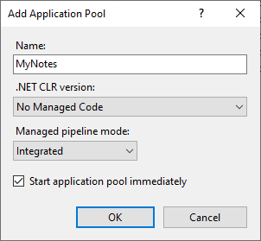
7. Open SQL Server Management Studio and create a new Database named MyNotes: 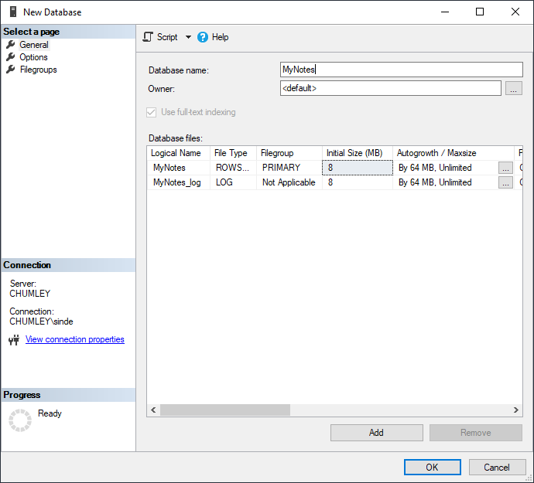
8. In SQL Server Management Studio create a new database login and give it access to MyNotes. The Login name must match the App Pool you created above “IIS APPPOOL\MyNotes”: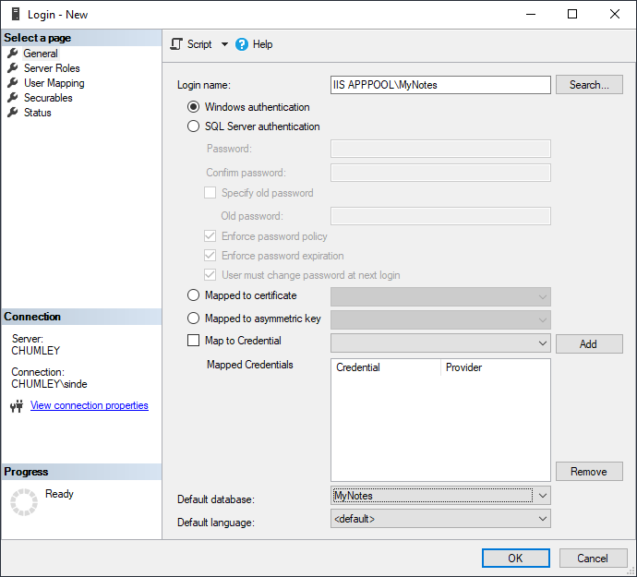
9. Give it access to the new Database as shown here: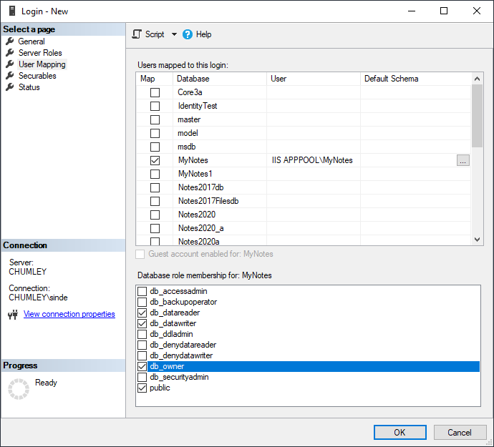
10. Now we need to edit the appsettings.json file from step 4. Open it in a text editor: 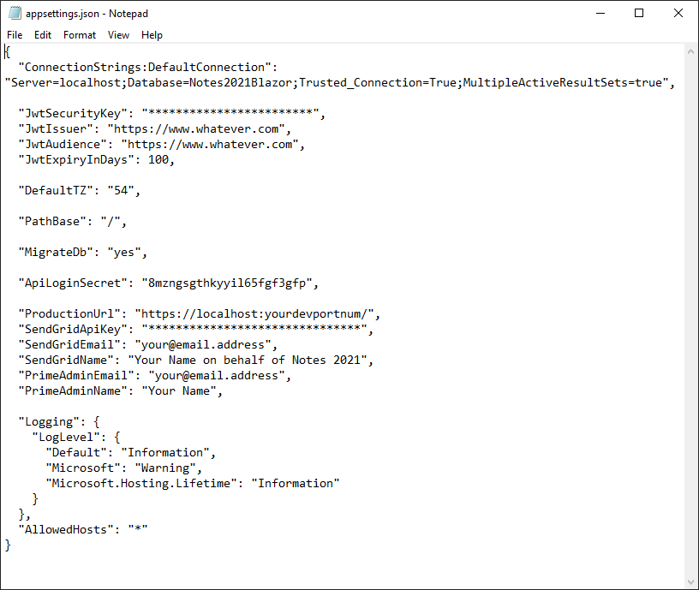
11. Change "ConnectionStrings:DefaultConnection": "Server=localhost;Database=Notes2021Blazor;Trusted_Connection=True;MultipleActiveResultSets=true", to: "ConnectionStrings:DefaultConnection": "Server=localhost;Database=MyNotes;Trusted_Connection=True;MultipleActiveResultSets=true", substituting the name of your Database: MyNotes
12. Change JwtSecurityKey from ********** to some long random string for security.
13. Change "PathBase": "/", to "PathBase": "/MyNotes",. This must match where we deploy the web app on your site! It must NOT end with a “/”.
14. Change "ApiLoginSecret": to be some random string, say: "ApiLoginSecret": "5u4u6hj5ewn3fghfhh",
15. Change "ProductionUrl": to match where you are deploying your app. I used: "ProductionUrl": "https://www.drsinder.com/MyNotes/", It MUST end with a “/”.
16. Change "PrimeAdminEmail": "your@email.address", to use the email you will login with. This login will become the app admin.
17. Change “Your Name” in two locations as appropriate.
18. We will not configure the SendGrid items yet. Here is my completed appsetting.json.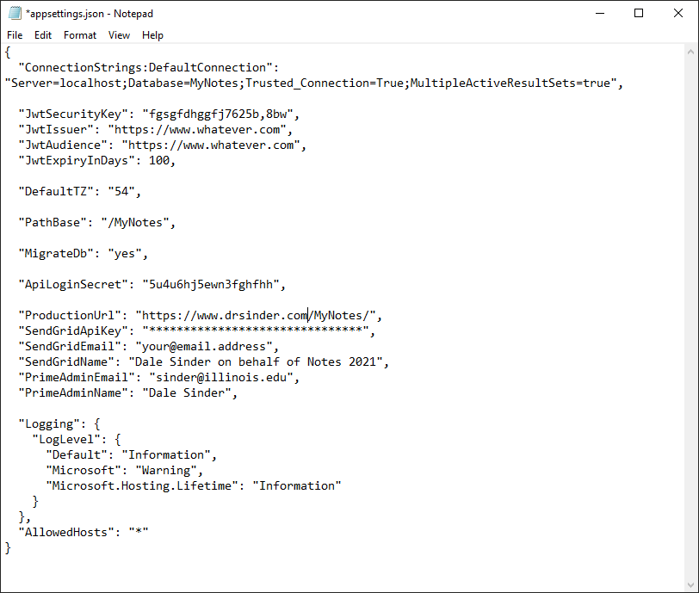
19. In your sub folder MyNotes\Notes2021Blazor.Client\dist, find the index.html file and open it in a text editor: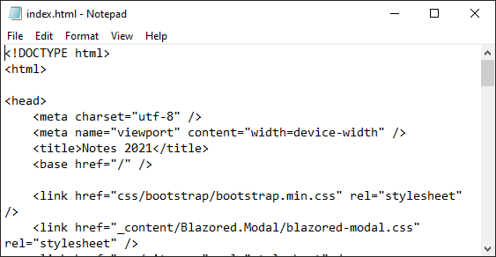
20. Change the <base href="/" /> line to: <base href="/MyNotes/" />. Failure to do this will result in the most perplexing failure of the app!! 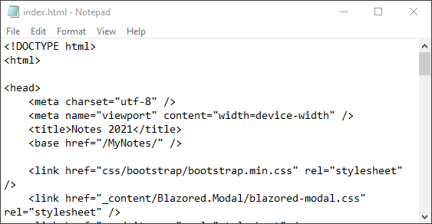
21. Finally, it’s time to create your web application! Return to the IIS Manager (step 5). Now open “Sites” and select the site you will use and right click on it and Select “add Application”. Set up as shown: 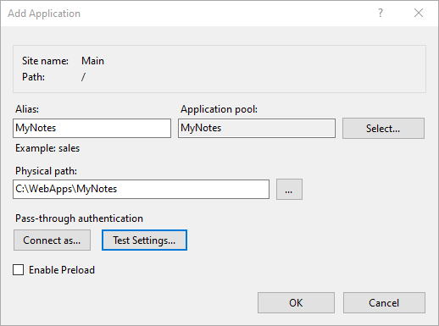
22. Click on Connect as… Select Specific user and enter your login info. Use your login info!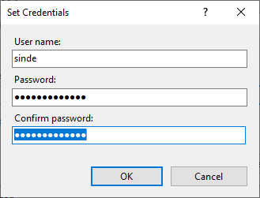
23. Before clicking OK on the Add Application dialog click Test Settings. Both items must be green;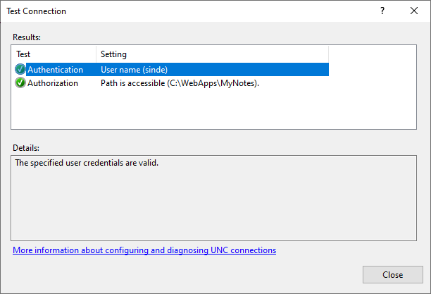
24. Now browse your application. Be patient. The app has to create database tables and populate one table. You should then see: 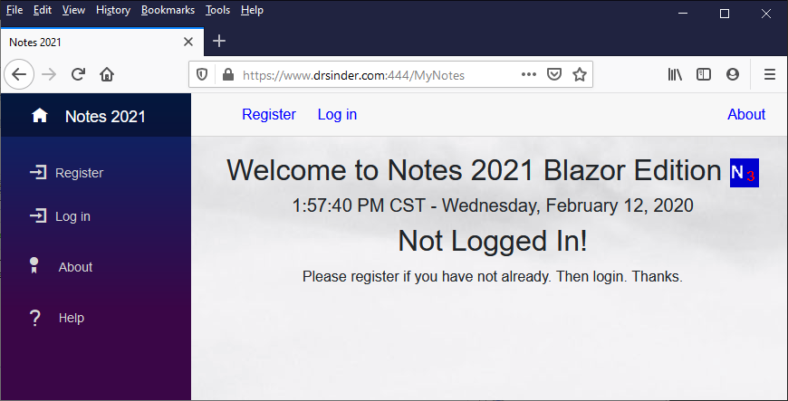
25. Register and login using the email you configured to be an admin in step 16. 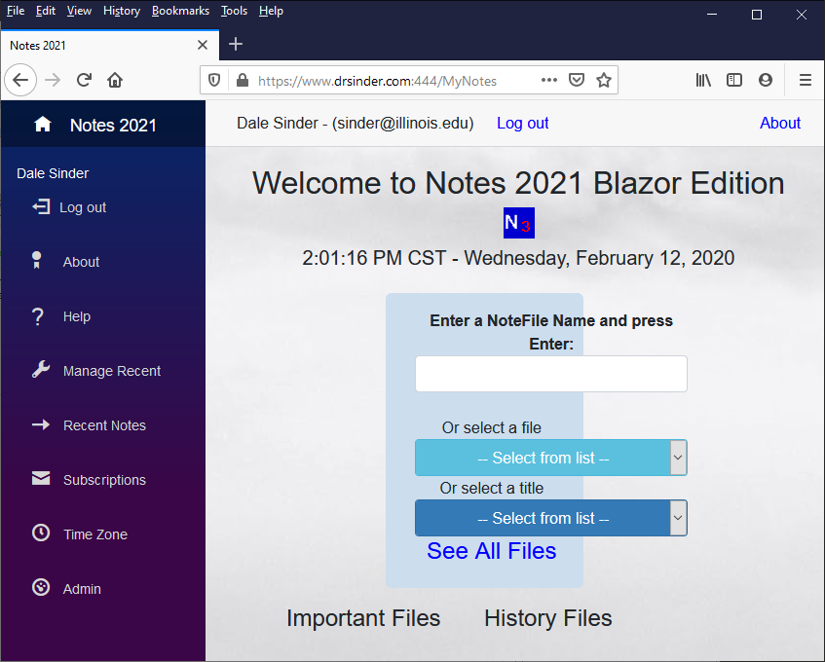
26. Almost done! Click on Admin and Select NoteFile Manager: 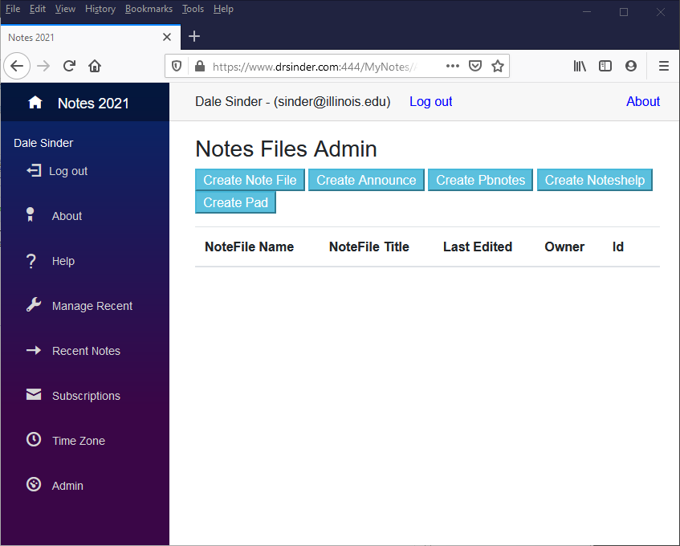
27. Click the buttons to create Announce, Pbnotes, NotesHelp, and Pad. Return Home and you will see some files have been added. You can now enter content. Success! 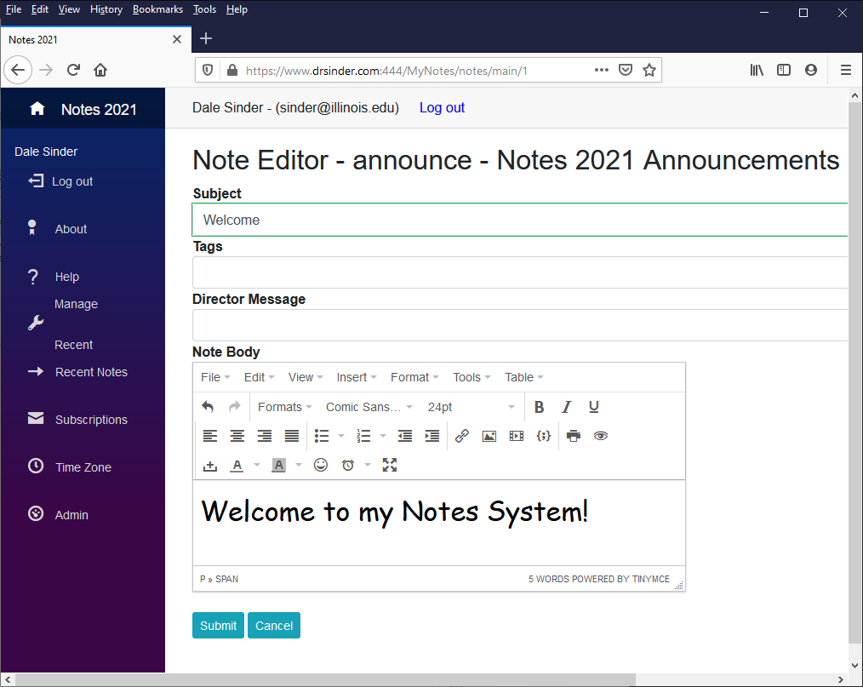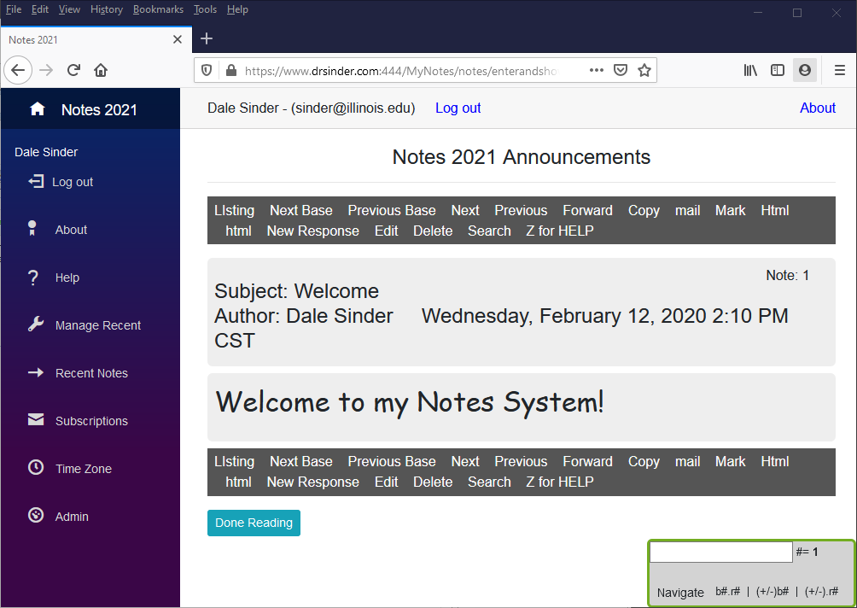

Enjoy!

To use the email capability go to <https://signup.sendgrid.com/> and sign up for a free or paid account. Then just fill in the SendGridApiKey in the appsetting.json.