JPEG AI Forensic Pilot Interface
Installation Manual and Operational Manual
Companion tool to: “Forensic Integrity and Tamper Localization in JPEG AI-Compressed Images: A Problem Formulation and Research Framework”
Document version 1.0 · Interface build: single-file HTML, client-side only
Contents
1. Overview
2. Installation Manual
3. Operational Manual
4. Metric & Control Reference
5. Troubleshooting
6. Appendix: Mapping to the Research Framework

1. Overview
The JPEG AI Forensic Pilot Interface is a self-contained, single-file web application that provides an interactive front end for the evaluation pipeline proposed in the companion research article. It implements the legitimate encode/decode path and the Class B (pixel-domain) threat branch of the dual-branch forensic framework described in that article — specifically Algorithm 1 (tamper-sample generation), Algorithm 2 (ELA-style pixel-only detection and localization), and Algorithm 3 (batch evaluation loop) — and exposes them through two working modes: a Single-Image Analysis mode for step-by-step inspection of one image, and a Batch Result-Set mode that reproduces the multi-image tables (Tables 1 and 2) from Section 5 of the article on any set of images the user supplies.
The interface runs entirely inside the user's web browser. No image is uploaded to a server and no image data leaves the device it is opened on; all computation — JPEG-proxy encoding/decoding, tamper simulation, Error-Level-Analysis localization, and metric computation — executes locally using the HTML5 Canvas API.
Scope note: As documented in the interface's own “Method & Coverage Notes” tab, this tool uses the browser's built-in JPEG encoder as an explicitly labeled proxy for the JPEG AI analysis/synthesis transforms, because JPEG AI's learned codec cannot currently run inside a browser page. Class C (latent-domain) tampering and the latent-aware detector are therefore not implemented in this interface; see Section 6 of this manual and Section 5 of the article for the full rationale.

2. Installation Manual

2.1 System Requirements
Requirement | Minimum
Browser | A current version of Chrome, Edge, Firefox, or Safari (released within the last ~2 years); JavaScript enabled
Operating system | Any OS capable of running one of the above browsers (Windows, macOS, Linux, iOS, Android)
Network access | None required after the file is obtained — the interface has no server component and makes no network calls
Disk space | < 1 MB (single HTML file)
Screen size | Usable from 360 px width upward; a desktop-width screen (≥ 1024 px) is recommended for the four-panel image view

2.2 Option A — Use the Hosted Version
Step 1 — Open the link. Open the published interface link provided with this manual in any supported browser. No account, download, or configuration is required.
Step 2 — Confirm it loaded. The page header “🔍 JPEG AI Forensic Pilot Interface” and three tabs (Single-Image Analysis, Batch Result-Set, Method & Coverage Notes) should be visible immediately. If they are not, see Section 5, Troubleshooting.
This is the recommended installation method for most users: there is nothing to download, and the hosted copy always reflects the current build of the interface.

2.3 Option B — Local / Offline Installation
The interface is distributed as a single self-contained HTML file (no external dependencies, stylesheets, or scripts are fetched over the network at runtime), so it can also be installed and run entirely offline.
Step 1 — Obtain the file. Download the file named jpeg_ai_forensic_pilot_interface.html supplied alongside this manual, and save it anywhere on the local filesystem (e.g., Desktop or a project folder).
Step 2 — Open it directly. Double-click the file, or right-click it and choose “Open with” → your browser. Most operating systems open .html files in the default browser automatically. The address bar will show a file:// URL.
Step 3 — (Optional) Serve it from a local web server. Some browsers apply stricter file:// permissions than http(s):// permissions to certain page features. If any control appears unresponsive when opened directly as a file, serve the folder containing the HTML file with a minimal local web server instead, for example:
# Python 3 (any OS with Python installed):
cd /path/to/folder/containing/the/file
python3 -m http.server 8000
# then open http://localhost:8000/jpeg_ai_forensic_pilot_interface.html
Step 4 — Verify. Confirm the three tabs render and the Method & Coverage Notes tab displays the equations and coverage diagram correctly (see Section 2.4).
No build step: There is no compilation, package installation, or dependency resolution step. The file is plain HTML, CSS, and JavaScript and can be archived, emailed, or version-controlled as a single artifact.

2.4 Verifying the Installation
After opening the interface by either method, perform this quick check before proceeding to normal use:
• Click each of the three tabs (Single-Image Analysis, Batch Result-Set, Method & Coverage Notes) and confirm each renders without a blank panel.
• On the Single-Image Analysis tab, confirm the “Run Pipeline” button is present but disabled (grayed out) until an image is chosen — this confirms the page's script has initialized correctly.
• Open the browser's developer console (F12 or Ctrl+Shift+I / Cmd+Option+I) and confirm no red error messages appear on page load.
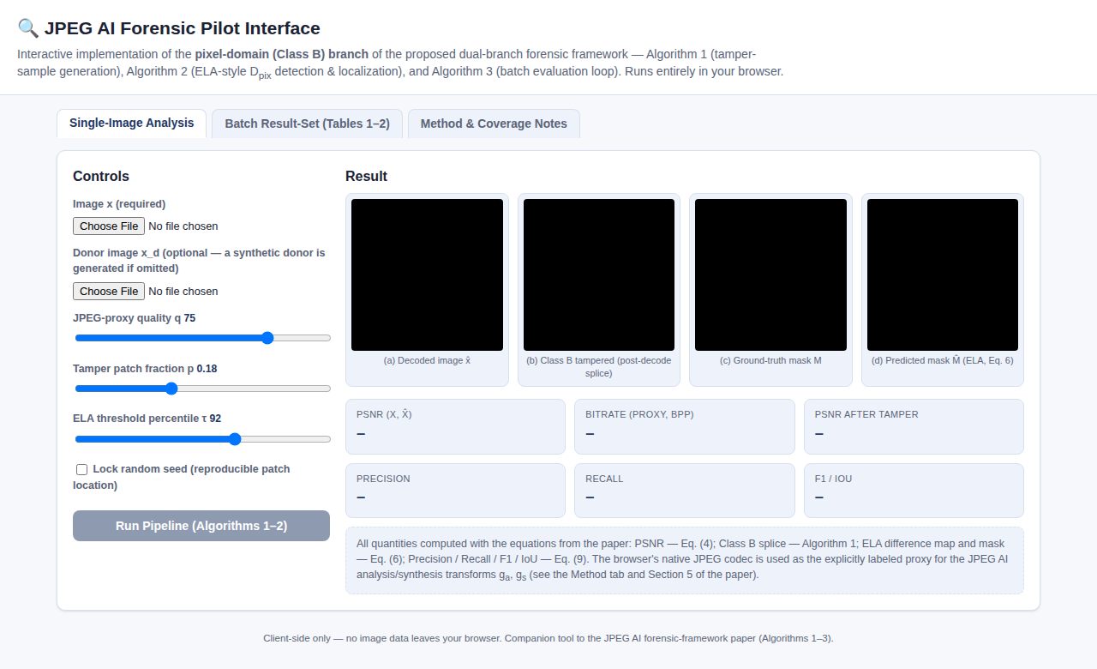
Fig. A Single-Image Analysis tab immediately after a successful installation (no image loaded yet).

2.5 Troubleshooting Installation
Symptom | Likely cause / fix
Page is blank / all-white | JavaScript is disabled in the browser, or the page is being viewed inside a restrictive in-app browser (some corporate or mobile-app webviews block Canvas APIs). Open in a standard desktop or mobile browser.
“Choose File” control does nothing | Rare in modern browsers; try Option B (serve via local HTTP server) instead of opening the file directly.
Layout looks broken / unstyled | The HTML file was altered or only partially downloaded. Re-download the original single file; do not edit it unless you intend to.
Console shows a red error immediately on load | Take a screenshot of the console and consult Section 5 of this manual (Troubleshooting — Operation).

3. Operational Manual

3.1 Interface Layout
The interface is organized into three tabs, selected with the buttons at the top of the page:
• Single-Image Analysis — upload one image (and, optionally, a donor image), configure three parameters, and run the full Algorithm 1 → Algorithm 2 pipeline on it interactively, with all four intermediate images and six metrics displayed.
• Batch Result-Set — upload a set of 2–40 images and run Algorithm 3 across all of them automatically, producing a results table equivalent to Tables 1–2 of the companion article, exportable as CSV or JSON.
• Method & Coverage Notes — a static reference tab explaining exactly which parts of the full research framework this interface implements, which equations are used where, and the interface's known limitations.

3.2 Single-Image Analysis Mode
Step 1 — Load the target image. Click “Choose File” under “Image x (required)” and select any image file (JPEG, PNG, WebP, etc.). The image is automatically resized and center-cropped to a 256×256 square, matching the pilot protocol in Section 5 of the article, and appears in panel (a).
Step 2 — (Optional) Load a donor image. Click “Choose File” under “Donor image x_d (optional)” and select a second image. The donor supplies the patch that will be spliced into the target to simulate tampering. If no donor is supplied, the interface automatically generates a synthetic gradient/blob donor image so the pipeline can still run.
Step 3 — Set the three parameters. Adjust the sliders as needed (see Section 4, Metric & Control Reference, for the meaning and recommended range of each): JPEG-proxy quality q, tamper patch fraction p, and ELA threshold percentile τ.
Step 4 — (Optional) Lock the random seed. Tick “Lock random seed” if you want the tamper patch to be placed at the same location on repeated runs (useful for isolating the effect of changing q, p, or τ without also changing the tamper location).
Step 5 — Run the pipeline. Click “Run Pipeline (Algorithms 1–2)”. The button disables briefly while the pipeline executes (typically under one second for a 256×256 image); a status line beneath the button reports progress and completion.
Step 6 — Read the results. Four images update: (a) the decoded (proxy-compressed) image, (b) the same image after a Class B splice tamper and re-encoding, (c) the ground-truth tamper mask, and (d) the mask predicted by the ELA-style detector. Six metric tiles below report PSNR, estimated bitrate, post-tamper PSNR, precision, recall, and F1/IoU.
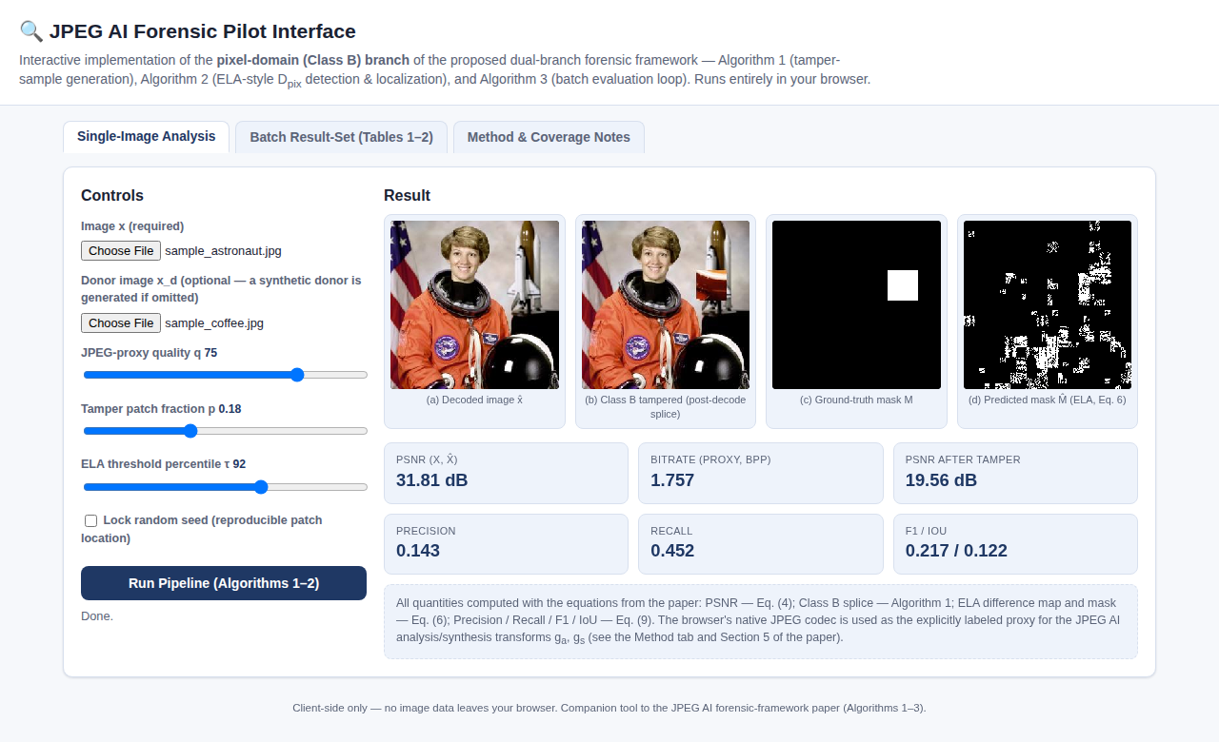
Fig. B A completed Single-Image Analysis run: panels (a)–(d) and all six metric tiles are populated.
Re-running with different slider values (without re-choosing files) immediately produces a new result using the same loaded images — this is the fastest way to explore how quality, patch size, and threshold affect PSNR and localization accuracy.

3.3 Batch Result-Set Mode
Step 1 — Select multiple images. On the Batch Result-Set tab, click “Choose Files” and select between 2 and 40 image files at once (most file pickers support multi-select with Ctrl/Cmd-click or Shift-click). The “Run Batch” button enables once at least 2 files are selected.
Step 2 — Set shared parameters. The same three parameters (q, p, τ) apply to every image in the batch; adjust them before running if the defaults are not appropriate.
Step 3 — Run the batch. Click “Run Batch (Algorithm 3)”. Each image is processed in turn — used once as the tamper target and, for another image in the set, as the donor — following the pairing scheme of Algorithm 3. The status line reports progress (e.g., “Processing 4/6”).
Step 4 — Review the table. On completion, a table appears with one row per image (PSNR, bitrate, post-tamper PSNR, F1, IoU) and a bolded Average row, directly analogous to Tables 1 and 2 in the companion article.
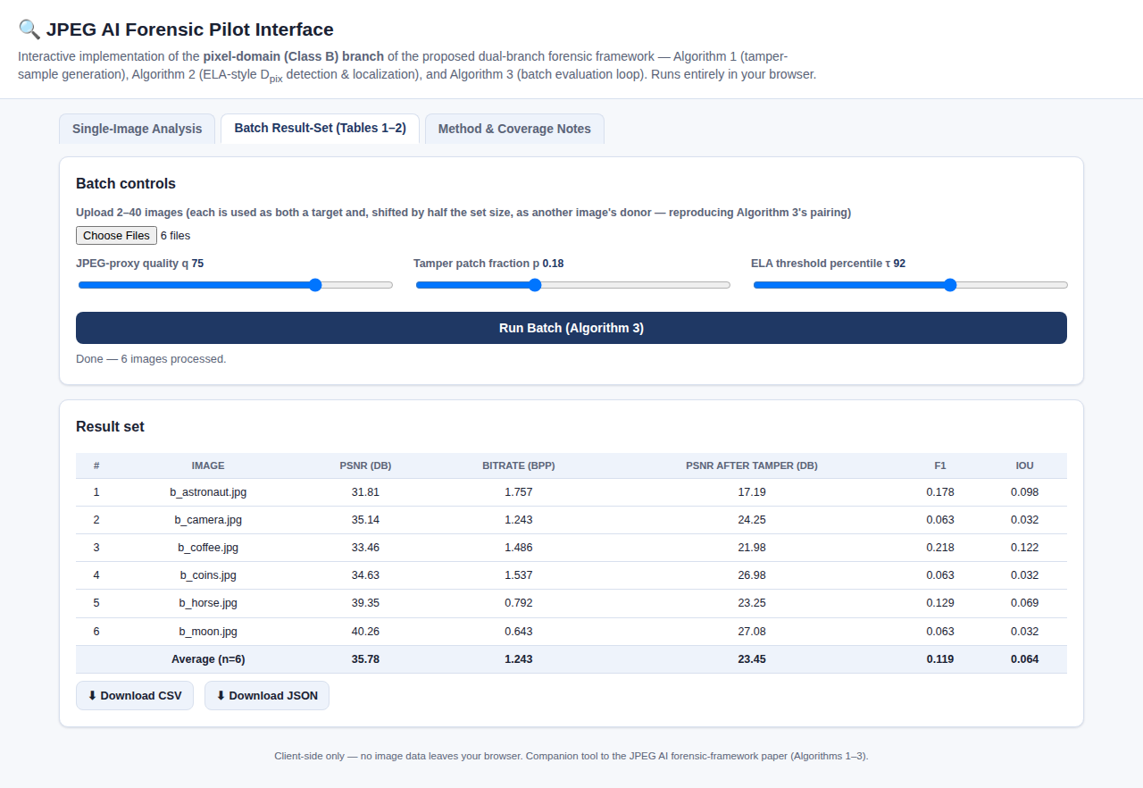
Fig. C A completed Batch Result-Set run on six sample images, with the automatically computed Average row.
Step 5 — Export the results. Click “Download CSV” or “Download JSON” to save the full result set to a file, which the browser (or, in the Claude app, a confirmation dialog) will prompt you to save. The CSV format matches the column layout of the on-screen table; the JSON format additionally includes the three parameter values used for the run.
Batch size guidance: Processing time scales roughly linearly with the number of images (each involves two proxy encode/decode passes). Forty 256×256 images typically complete in well under a minute on a modern laptop; very large batches on low-power devices may take longer.

3.4 Method & Coverage Notes Tab
This tab is read-only reference material and requires no interaction. It displays a compact diagram of which stages of the full research framework this interface covers (highlighted in green) versus does not cover (highlighted in red — Class C latent-domain tampering and the latent-aware detector), restates the three equations the interface uses internally (PSNR, the ELA difference/threshold operator, and the F1/IoU formulas), and lists the interface's known limitations in plain language.
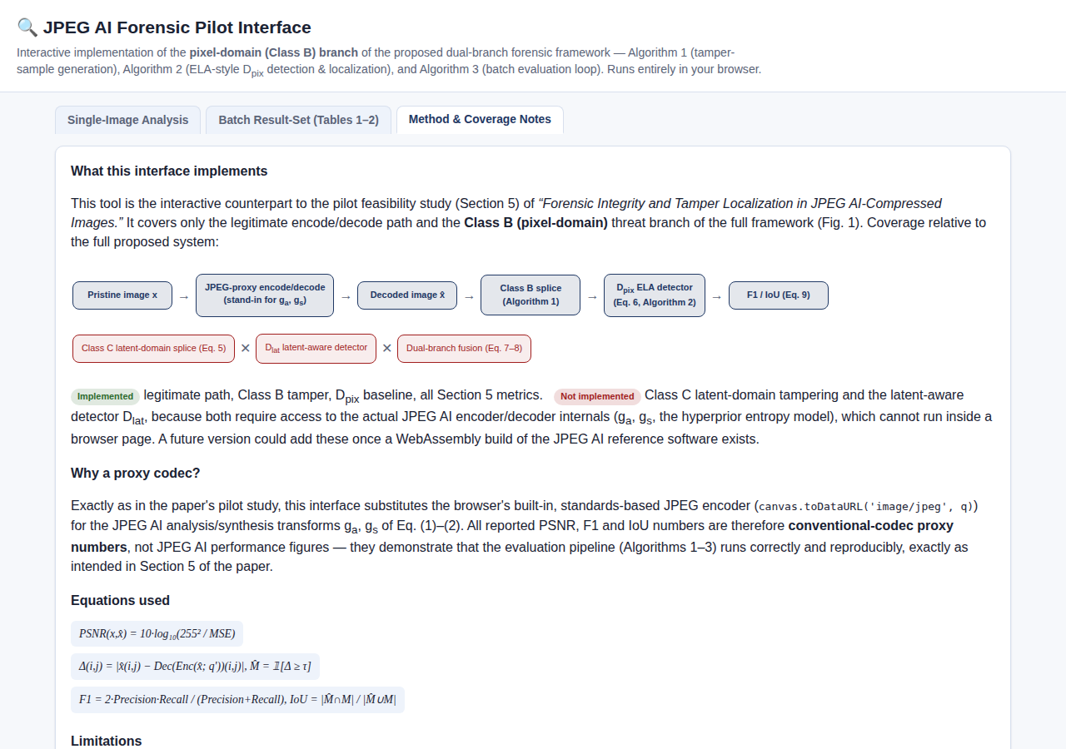
Fig. D The Method & Coverage Notes tab, showing the implemented-vs-not-implemented coverage diagram.

4. Metric & Control Reference

4.1 Controls
Control | Range / default | Effect
JPEG-proxy quality q | 10–95, default 75 | Sets the quality parameter passed to the browser's JPEG encoder, standing in for the JPEG AI rate-point λ. Lower q → lower bitrate and lower PSNR; higher q → higher bitrate and higher PSNR.
Tamper patch fraction p | 0.05–0.40, default 0.18 | Fraction of the 256×256 image's linear dimension used as the side length of the square splice patch (Algorithm 1). Larger p → larger, generally easier-to-localize tampered region.
ELA threshold percentile τ | 80–99, default 92 | Percentile of the per-pixel ELA difference map (Eq. 6) above which a pixel is classified as tampered. Lower τ → more pixels flagged (higher recall, lower precision, typically); higher τ → fewer pixels flagged (higher precision, lower recall).
Lock random seed | off / on | When on, fixes the pseudorandom seed controlling the tamper patch location and the donor-patch source location, for reproducible single-image runs.

4.2 Metrics
Metric | Equation | Interpretation
PSNR (x, x̂) | Eq. (4) | Reconstruction fidelity of the single-pass proxy compression, in dB. Higher is better; typical range in the pilot study was 30–49 dB at q = 75.
Bitrate (bpp) | — (bytes × 8 / pixels) | Approximate bits-per-pixel of the proxy-compressed image, estimated from the encoded data size.
PSNR after tamper | Eq. (4), applied post-splice + re-encode | Fidelity of the tampered-and-re-encoded image relative to the untampered decoded image; always lower than the single-pass PSNR.
Precision / Recall | Eq. (9) | Pixel-level precision and recall of the predicted tamper mask against the ground-truth mask.
F1 / IoU | Eq. (9) | Combined localization-accuracy metrics; F1 is the harmonic mean of precision and recall, IoU is intersection-over-union of predicted and ground-truth masks. Both range 0–1 (higher is better).

5. Troubleshooting
Symptom | Likely cause / fix
“Run Pipeline” stays disabled | No target image (x) has been chosen yet — the button only enables after “Image x” is loaded successfully. Confirm the filename appears next to the “Choose File” button.
Results look identical across two runs | “Lock random seed” is ticked — untick it to get a new random tamper location, or intentionally keep it ticked when isolating the effect of q, p, or τ.
F1 / IoU are consistently very low | This matches the article's own findings (Section 5.2): the simple percentile-based ELA baseline is intentionally a weak detector, achieving mean F1 ≈ 0.07 in the reference pilot study. Very low scores are expected behavior, not a malfunction — see Section 3.4 and the article's Section 6 for why this motivates the learned detectors proposed in the framework.
“Run Batch” stays disabled | Fewer than 2 files are selected. Select at least 2 images (multi-select in the file picker).
Download button does nothing / no file appears | In some hosting contexts the built-in save capability may be unavailable; the interface automatically falls back to a standard browser download in that case. Check the browser's default downloads folder, and check for a blocked-popup or blocked-download notice in the address bar.
Batch run is slow or the tab becomes unresponsive | Very large batches (close to the 40-image limit) or very large source images increase processing time. Wait for the status line to report completion; avoid closing the tab mid-run.
Images appear stretched or oddly cropped | This is expected: every uploaded image is center-cropped to a 256×256 square (“cover” fit) to match the fixed-size pilot protocol used throughout the companion article, so non-square source images will lose some content at the top/bottom or left/right edges.

6. Appendix: Mapping to the Research Framework
This appendix cross-references interface elements to the corresponding equations, algorithms, and sections of the companion article, for readers who want to relate what they see on screen to the formal framework.
Interface element | Article reference
Proxy compression of the target image (panel a) | Eq. (1)–(2), analysis/synthesis transforms g_a, g_s, with the browser JPEG encoder substituted as described in Section 5
“PSNR (x, x̂)” metric tile | Eq. (4)
Class B splice tamper (panel b) | Algorithm 1, threat Class B, Section 4.3
Ground-truth mask (panel c) | Mask M produced by Algorithm 1
ELA-style predicted mask (panel d) | Eq. (6); D_pix baseline, Section 4.5
Precision / Recall / F1 / IoU tiles | Eq. (9)
Batch Result-Set table and Average row | Algorithm 3; Tables 1–2, Section 5
CSV / JSON export | Machine-readable form of the same result set reported in Tables 1–2
“Not implemented” items on the Method tab | Class C latent-domain tamper (Eq. 5); latent-aware detector D_lat and dual-branch fusion (Eq. 7–8) — out of scope for a browser-only tool, per Section 4.5 and Section 6 of the article
For the full mathematical formulation, threat model, dataset-construction protocol, and discussion of expected outcomes, see the companion article, Sections 3–6.

