**Ideas**

I should add a quote!

**Home**

**http://mrcthms.com/**

I like these triangles

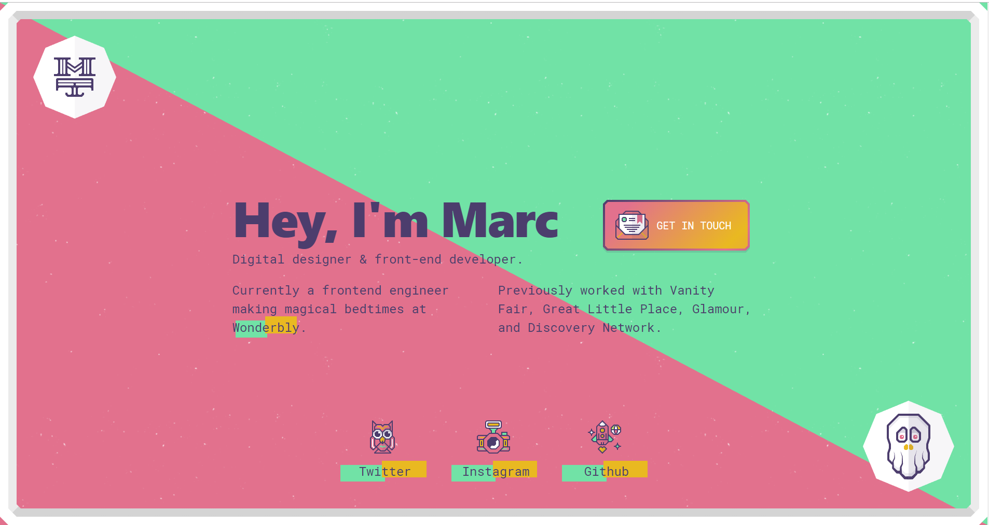

**About Me**

**WHO AM I?**

My name is Eric Marsh and I am a programmer and web developer living in Boise, Idaho. I have been programming for 5 years now. I started my freshman year of college and I have been obsessed with it ever since. My education emphasised the software engineering part of computer science, but I have since then been focusing on website and web applications. I am currently employed at Yardi Systems inc, and doing contract work on the side.

**WHAT CAN I DO FOR YOU??**

I can help your ideas come to life! I love to make beautiful websites that are responsive, easy to use and work on any device. Whatever project you have in mind, send me a message!

**AreoLeds**

AreoLeds is a company based in Boise, Idaho that manufactures LED bulbs for aircrafts. In September of 2018 they asked me to add functionality to their website for product warranties. This means adding a front-end page so that users can input and send their product information, and then store that warranty information on a backend. I finished in the following November, and now it is easier than for the employees at AreoLeds to manage their warranties as well as customers to send their own.

Tools I used for this job:

* Wordpress
* HTML/CSS
* JS/Jquery
* PHP

**Yardi Systems Inc**

I am currently a full stack software engineer at Yardi Systems Inc, which is one of the largest companies to provide real estate software. I help develop for their Senior Living Suite software. This software helps nurses provide assisted care to seniors by giving them a mobile/browser-based platform to perform assisted living operations, access health records, and other things. I help on all levels of this software, doing things like testing and debugging, solving bugs, adding features, setting up and modifying servers, and other things. It is nice to know that my work helps nurses perform their jobs.

Tools I use for this job:

* .net/MVC
* VB code
* HTML/CSS
* JS/Jquery
* SQL

**Digilent** **Inc**

In the summer of 2016, I was an intern at Digilent Inc in Pullman, Washington. Digilent provides technology-based education tools to teach electrical engineering concepts. Among their products are microprocessors and microprocessor modules, which I coded libraries and demo projects for. I also wrote documentation and blog posts to help educate and sell their products.

Tools I used:

* C/C++
* Arduino Ide

**Twist BioScience**

In the winter of 2015, I got an offer to help Twist BioScience by writing a Python program. The program was to help by taking lab data, storing it in a readable format, and translating it into analyzable data. The end product took raw lab data from a LabVIEW program, and executed a Python script that translated it into a Excel document and visualized the data into graphs.

Tools I used:

* Python
* LabVIEW

**Education**

**University of Idaho**

I attended the University of Idaho from 2013-2018. Here I graduated with a major in Computer Science and a minor in Mathematics. My studies gave me a strong understanding of the software engineering side of computer science. I learned how to program data structures in multiple languages, how to design and create compilers, and how to work with a team I building software. When I wasn’t studying, I had a part time job as a Music Director at the college radio station. At this job, I used programming to create scripts to chart weekly music plays to online college-radio charting websites.

**Polymorphic Games**

One of my proudest achievements at the University of Idaho was working with Polymorphic Games. Polymorphic Games is a programming studio populated with undergraduate students, who were tasked with creating educational videogames that teach the foundations of evolutionary biology. Using genetic algorithms to program enemy AI, we were able to create a game that evolves based on the players actions. For example, if the player failed to kill enemies that were fast and had fire attacks, these traits would spread to the next wave of enemies, effectively making the game harder. This project helped me learn how to program AI, to develop software with other engineers, and to work with biologists and artists to create something great.

**30 websites in 30 days**

After college, I realized that I wanted to design and program websites and web applications. Although I was taught the fundamentals of programming websites in college, I still had a lot to learn. I decided to jump into the deep end of learning web development by challenging myself to program 30 websites in 30 days. It started off really challenging and I sometimes struggled to make a website every day. But I eventually started to make some great websites. I learned to design beautiful pages using design frameworks such as bootstrap, to create fun and interactive front ends with jQuery and node.js, and to go the next level by integrating a backend through using PHP and SQL. Besides that, I learned that the best way to learn new technology is to dive in and create something using it. I really enjoy revisiting these websites and trying all the silly and fun things I made. Feel free to revisit my journey through learning web development here.

**Contact**

**http://melaniedaveid.com/**

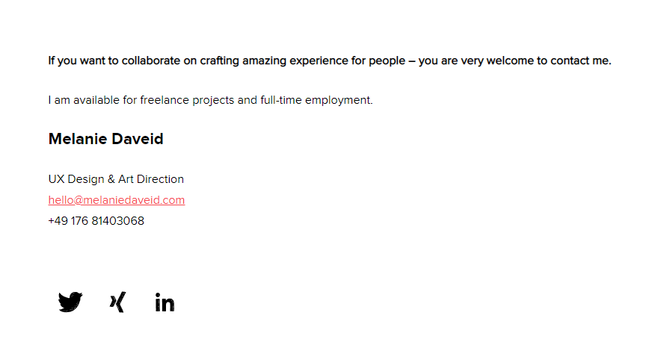

**http://ryanscherf.net/**

