Invention name in English:
Acoustic Drone Detection and Tracking Device
International Patent Classification (IPC):
G01S 3/80 (also G01S 3/808, G01S 5/18, G01S 5/20, G06F 18/24)
Summary In English (Abstract):
An acoustic system detects an unmanned aerial vehicle (UAV) and tracks its two-dimensional position from rotor sound alone. An acoustic detection system of synchronised, spatially distributed microphone units applies a machine-learning model, trained on rotor-harmonic characteristics, to produce for each frequency band a probability that the band contains a UAV component. This per-band probability vector — the UAV source-specific acoustic state — first selects and then weights the time-frequency components entering the inter-unit cross-correlation, yielding source-conditioned time-difference-of-arrival measurements from which a candidate azimuth and distance are computed and transmitted, with the band probabilities, as a candidate report to a separate tracking unit. The tracking unit accepts a candidate into the trajectory only if it is consistent both with a reference acoustic state built from previously accepted reports and with the kinematically predicted position, and feeds the reference state back to the detection system for the next interval. False tracks from harmonic ground sources are thereby suppressed.
Background Of The Invention:
Small unmanned aerial vehicles have become inexpensive and widely available and are increasingly used for unauthorised surveillance, smuggling and attacks on infrastructure. Their small radar cross-section, low flight altitude and, increasingly, the absence of any radio emission (pre-programmed or fibre-guided flight) make radar, radio-frequency and optical detection unreliable. Acoustic detection exploits an emission that cannot be removed: the rotors of a UAV must displace air to fly and therefore produce a sound field dominated by the blade-pass frequency and its harmonics.
Known acoustic UAV systems fall into three groups. Single-microphone systems compare the received spectrum with a library of stored UAV signatures and raise an alert on a match; they provide no direction or position. Microphone-array systems estimate the direction of the sound by beamforming or by generalised cross-correlation with phase transform (GCC-PHAT) between microphone pairs, and classify the sound as UAV or non-UAV by a separate classifier operating on spectral features; several such systems combine the bearings of two or more arrays to obtain a position. In these systems the classifier and the localiser operate independently: the classifier decides whether a UAV is present, and the localiser then processes the entire received signal, so that wind noise, traffic, machinery and reflections from the ground contribute to the cross-correlation and degrade the TDOA. A third group, developed mainly for speech, weights the cross-correlation by a time-frequency mask estimated by a neural network so that only components dominated by the target enter the correlation; a related approach for UAVs detects the blade-pass frequency by pitch estimation and filters the signal to the detected harmonics before localisation. These approaches apply a single soft mask or a single hard filter, estimate it separately at each microphone, require an explicit fundamental-frequency estimate or a training set of the target class, and do not connect the mask to the subsequent tracking decision.
Independently of the localisation method, known systems form the UAV trajectory by kinematic gating alone: a new position is associated with the track if it lies within a distance gate of the predicted position. A stationary or slowly moving noise source in the same frequency range — a generator, an air-conditioning unit, a ground vehicle — therefore produces plausible positions that are accepted into the track, and false tracks are a principal operational problem of acoustic UAV systems.
There is therefore a need for an acoustic UAV localisation and tracking system in which the identification of the UAV sound and the measurement of its position are not independent stages but a single conditioned chain, in which the position measurement uses only the sound components attributable to the UAV, in which the tracking decision verifies that each accepted position still sounds like the tracked UAV, and in which the detection and the tracking functions can be implemented as separate devices with a defined interface so that either can be deployed, replaced or scaled independently.
Description Of Invention:
The invention provides a method and a system for obtaining the two-dimensional location and the trajectory of a UAV from acoustic signals, in which the machine-learning identification of the UAV sound controls, component by component, the cross-correlation used for localisation, and in which the tracking decision is gated by both acoustic and kinematic consistency.
The system comprises two separate devices. The acoustic detection system (SDS) comprises a plurality of acoustic sensor units at known relative positions, each with a microphone array and synchronised sampling hardware, and a processing module. The tracking unit is a separate device connected to the SDS by a wired or wireless data interface and receives from it a sequence of candidate reports.
In the SDS, the synchronised acoustic signals are transformed to the time-frequency domain and acoustic features are extracted. A machine-learning model, trained on recordings of a plurality of UAV types labelled per frequency band according to the presence of rotor-harmonic components, and on recordings of non-UAV sources including harmonic non-UAV sources, produces for each frequency band a probability that the band contains a component attributable to a UAV. The vector of these probabilities is the UAV source-specific acoustic state. Because the model learns the structure of rotor-harmonic sound — harmonic spacing, band width, amplitude modulation and inter-harmonic amplitude ratios — rather than the absolute frequencies of particular UAV models, it produces valid per-band probabilities for UAV types not contained in the training data, and it does not require an explicit estimate of the blade-pass frequency.
From the acoustic state, two quantities are derived and applied in sequence. First, a component selection: the time-frequency components whose band probability meets a selection criterion — in the preferred embodiment, exceeds a selection threshold — form a subset; all other components are excluded from further processing. Second, a component weight for each component of the subset, equal to the band probability or a monotonic function of it. The same selection is derived once and applied to the signals of every sensor unit, since the harmonic set of a UAV is common to all units and only its phase differs between them.
The inter-unit cross-correlation with phase transform is then computed between pairs of sensor units using only the selected components, each contributing in proportion to its weight. The peak of the resulting cross-correlation gives, for each pair, a source-conditioned TDOA measurement: a delay estimated exclusively from the sound attributable to the UAV. From a plurality of these measurements and the known unit positions, a candidate two-dimensional location is computed as azimuth and distance relative to a reference point of the SDS.
The SDS outputs, over its interface, a candidate report comprising the candidate location, the time reference of the acquisition and acoustic-state information — at least the probabilities of the selected bands. The SDS does not itself form a trajectory.
The tracking unit maintains for the tracked UAV a reference acoustic state, formed as a running combination of the acoustic-state information of previously accepted reports, and a kinematic state comprising at least the last accepted location and its time. For each received report it evaluates an acoustic-source consistency criterion — the similarity between the report's acoustic-state information and the reference acoustic state exceeds a similarity threshold — and a spatial-temporal consistency criterion — the reported location lies within a gate around the location predicted from the kinematic state for the report time. The location is incorporated into the trajectory, and both states are updated, only when both criteria are satisfied; otherwise the report is discarded. A trajectory is initiated only after a predetermined number of consecutive reports satisfy both criteria.
After each incorporation the tracking unit transmits the updated reference acoustic state and the predicted next location back to the SDS, which uses them to adjust the selection threshold or the component weights for the next acquisition interval, closing the loop between tracking and detection.
The invention thereby provides: TDOA measurements free of the contribution of non-UAV components; localisation that does not require fundamental-frequency estimation and generalises to unseen UAV types; a trajectory in which every accepted position has been verified against both the sound and the motion of the tracked UAV; and a two-device architecture with a defined interface, allowing the detection system and the tracking unit to be deployed, replaced and scaled independently.
Detailed Description:
1. System architecture (FIG. 1, FIG. 5, FIG. 6)
The system 100 comprises an acoustic detection system 110 and a tracking unit 150 connected by a data interface 140. The acoustic detection system 110 comprises N acoustic sensor units 112-1 to 112-N (N ≥ 2) and a processing module 120. Each sensor unit comprises a microphone array 114 of M microphones (M = 8, arranged at the vertices of a regular octagon of diameter 200 mm), digital pulse-density-modulation (PDM) microphones sampled at 48 kHz by synchronised sampling circuitry 116, and a local pre-processor 118 performing automatic gain control, band-pass filtering to 80 Hz – 8 kHz and adaptive noise suppression. Synchronisation between units is achieved by IEEE 1588 precision time protocol over Ethernet to within 10 µs. The relative positions of the units are surveyed at installation to within 0.1 m and stored in the processing module 120. Pre-processed signals are transmitted to the processing module 120 over Ethernet. The processing module 120 comprises a feature-extraction module 122, a machine-learning module 124, a correlation-processing module 126, a localisation module 128 and an output interface 130. The tracking unit 150 comprises an input interface 152, a memory 154 holding a reference acoustic state 156 and a kinematic state 158, a gating module 160 and an output 162 to an external security or monitoring system. FIG. 6 shows the two devices, the interface 140 and the fields of the candidate report. The acoustic detection system 110 contains no module that forms a trajectory; trajectory formation is performed exclusively in the tracking unit 150. The number of sensor units determines the localisation mode of section 6: with two units the candidate location is obtained jointly from the single inter-unit TDOA and the intra-unit bearings of the two units; with three or more units it is obtained by multilateration, four or more units being preferred for redundancy.
2. Signal acquisition and feature extraction (FIG. 2)
The signals of all microphones are segmented into frames of 64 ms with 50 % overlap and transformed by a short-time Fourier transform of 4096 points, giving for each unit n, microphone m, frame t and frequency bin k a complex value X_{n,m}(t,k). The frequency axis is partitioned into B frequency bands (B = 64), each of width Δf = 62.5 Hz in the range 80 Hz – 4 kHz; band b covers bins k ∈ K_b. For each unit a reference channel is chosen (microphone 1) and the following features are extracted per frame: the log-power spectrum in each band, mel-frequency cepstral coefficients (MFCCs) of order 13, the spectral flux, and the per-band amplitude-modulation spectrum over 0.5 s. These features form the input vector to the machine-learning module 124.
3. Machine-learning module and UAV source-specific acoustic state (FIG. 4)
The machine-learning module 124 implements a convolutional neural network whose output layer has B sigmoid units, one per frequency band. The output p_b(t) ∈ [0, 1] is the probability that band b in frame t contains an acoustic component attributable to a UAV. The vector s(t) = (p_1(t), p_2(t), …, p_B(t)) is the UAV source-specific acoustic state.
Training of the model is performed offline on a separate computer and forms no part of the operation of system 100; only the resulting model parameters are stored in the machine-learning module 124 at deployment (FIG. 4, lower frame). The model is trained on a dataset of recordings, made with the same sensor unit hardware, of a plurality of multi-rotor UAV types in flight at ranges of 20–200 m, together with recordings of non-UAV sources including wind, road traffic, generators, air-conditioning plants, ground vehicles and birds. For each UAV recording the blade-pass frequency f₀ and its harmonics are determined from the rotor speed telemetry of the recorded UAV, and each band is labelled 1 if it contains a harmonic k·f₀, for every harmonic index k up to the highest harmonic within the analysed frequency range, within half a band width, and 0 otherwise; all bands of non-UAV recordings are labelled 0. The model is trained with per-band binary cross-entropy. Because the model is trained on the structure of rotor-harmonic sound — harmonic spacing, band width, amplitude modulation and inter-harmonic amplitude ratios — and not on the absolute frequencies of particular models, it produces valid per-band probabilities for UAV types absent from the training set; this was verified by holding out one UAV type from training and measuring a per-band area under the receiver operating characteristic curve between 0.65 and 0.95 for that type. No explicit estimate of f₀ is required at runtime.
Optionally, the state s(t) is smoothed over 3 consecutive frames to reduce frame-to-frame fluctuation.
4. Component selection and weighting
From s(t) the correlation-processing module 126 derives, in sequence:
(i) the component selection S(t) = { (t,k) : k ∈ K_b, p_b(t) > θ_sel }, with selection threshold θ_sel = 0.5. All bins not in S(t) are excluded from the cross-correlation. When fewer than B_min = 3 bands are selected, no TDOA is computed for the frame.
(ii) the component weight w(t,k) = g(p_b(t)) for (t,k) ∈ S(t), where g is a monotonic function; in the preferred embodiment g(p) = p, in an alternative g(p) = p^γ with γ = 2.
The same S(t) and w(t,k) are applied to the signals of every sensor unit. A single selection is sufficient because the harmonic set of the UAV is identical at all units, only the phase of each component differing according to propagation delay. Where the machine-learning module is executed at the sensor units rather than centrally (section 13), the per-unit states are combined by averaging before the common selection is derived.
5. Source-conditioned cross-correlation and TDOA (FIG. 3)
For each pair (i,j) of sensor units the cross-power spectrum of the reference channels is formed, G_ij(t,k) = X_i(t,k)·X_j*(t,k), and the source-conditioned generalised cross-correlation with phase transform is computed as
*R_ij(τ) = Σ_{k∈S(t)} w(t,k) · G_ij(t,k) / |G_ij(t,k)| · e^{j2π k f_s τ / N_FFT},*
where f_s is the sampling rate and N_FFT the transform length, so that k·f_s/N_FFT is the centre frequency of bin k; i.e. the phase transform is applied only to the selected bins, each weighted by w(t,k), and all other bins contribute zero. The correlation is evaluated for delays |τ| ≤ d_ij / c, where d_ij is the distance between the units and c the speed of sound corrected for the measured air temperature. The delay at the maximum of R_ij(τ), refined by parabolic interpolation, is the source-conditioned TDOA measurement τ_ij(t). A measurement is rejected when the ratio of the highest to the second-highest peak of R_ij is below 1.5. For M-microphone units, the intra-unit cross-correlations are computed identically and supply a per-unit bearing used to resolve ambiguities of the inter-unit solution. No beamforming is required.
6. Candidate location
The localisation module 128 operates in one of two modes according to the number N of sensor units. N sensor units provide N(N−1)/2 inter-unit pairs, of which N−1 time differences of arrival are independent; a two-dimensional position requires at least two independent measurements. (a) Multilateration mode, N ≥ 3: from the accepted τ_ij(t) the module forms the hyperbolic equations |x − u_i| − |x − u_j| = c·τ_ij, where u_i are the known unit positions, and solves them for the UAV position x in the horizontal plane by iterative weighted least squares, the weight of each equation being the peak ratio of its correlation; at least two independent accepted TDOAs (at least two accepted pairs involving three distinct units) are required, and N ≥ 4 is preferred so that the solution is over-determined and the residual is meaningful. (b) Joint mode, N = 2: only one inter-unit pair exists and the hyperbolic equation alone does not fix x; each unit therefore also derives an intra-unit bearing θ_n from the cross-correlations between its own M microphones, computed with the same component selection and weights as the inter-unit correlation, and the module solves the single hyperbolic equation together with the two bearing equations atan2(x − u_n) = θ_n, n = 1, 2, by weighted least squares, the bearing equations being weighted by the peak ratios of the intra-unit correlations. Intra-unit bearings may also be added to the multilateration of mode (a) as further equations. The solution is converted to azimuth φ and distance r relative to the reference point of the acoustic detection system (the centroid of the unit positions). No candidate location is produced for a frame in which fewer than two independent accepted TDOAs are available in mode (a), or in which the inter-unit TDOA or either intra-unit bearing is not accepted in mode (b).
7. Candidate report and interface (FIG. 6)
For each frame yielding a candidate location the output interface 130 transmits over the interface 140 a candidate report comprising: the time reference of the frame (UTC, microsecond resolution); the azimuth φ and distance r; a location-quality value (the number of accepted pairs and the residual of the least-squares solution); and the acoustic-state information, consisting of the indices of the selected bands and their probabilities p_b(t), b ∈ selected bands. The report is encoded as a fixed binary structure and transmitted at the frame rate of approximately 30 reports/s. The acoustic detection system holds no trajectory and performs no tracking.
8. Tracking unit — reference acoustic state and kinematic state (FIG. 7)
The tracking unit 150 stores in the memory 154, for the UAV being tracked, the reference acoustic state 156, denoted ŝ — a B-vector formed as the exponentially weighted running mean of the acoustic-state information of previously incorporated reports, ŝ ← (1−α)ŝ + α s, α = 0.2, with unselected bands entered as 0 — and the kinematic state 158 comprising the last accepted position (φ, r converted to Cartesian x), the velocity estimate v, and the time of last acceptance, maintained by a constant-velocity Kalman filter.
9. Dual consistency gate (FIG. 7)
For each report received through the input interface 152 the gating module 160 evaluates:
(i) Acoustic-source consistency: the similarity σ, the cosine similarity, between the report's acoustic-state vector s and the reference acoustic state 156, ŝ (bands absent from either taken as 0); the criterion is satisfied when σ > θ_sim, θ_sim = 0.7. For a UAV the selected bands and their probabilities change slowly with rotor speed; for a noise source, or for a different UAV, the pattern differs and σ falls below the threshold even when the reported position is plausible.
(ii) Spatial-temporal consistency: the position x_pred predicted from the kinematic state 158 by the kinematic filter for the report time is compared with the reported position x; the criterion is satisfied when the Mahalanobis distance of x from x_pred under the filter's innovation covariance is below the chi-square threshold χ²_{2,0.99}, equivalently when x lies within the prediction gate.
The report is incorporated — the kinematic state 158 updated with x by the Kalman filter, the reference acoustic state 156 updated with s — only when both criteria are satisfied. Otherwise the report is discarded and the filter performs prediction only. A new trajectory is initiated when 3 consecutive reports satisfy both criteria against a provisional reference state formed from the first report; a trajectory is terminated after 2 s without an accepted report. The trajectory is provided at the output 162.
10. Feedback to the acoustic detection system (FIG. 8)
After each incorporation the tracking unit 150 transmits over the interface 140 the updated reference acoustic state 156, ŝ, and the predicted position for the next interval. The correlation-processing module 126 uses ŝ to adjust the selection for the next frame: bands with ŝ_b > 0.6 have their selection threshold lowered to 0.3 and their weight multiplied by (1 + ŝ_b), so that the harmonics of the tracked UAV remain selected during brief drops of instantaneous probability (e.g. during a manoeuvre), while bands never present in the reference retain the standard threshold. The predicted position is used to restrict the TDOA search window of each pair to ± 2 ms around the delay predicted for that position.
11. Operation
In operation the acoustic detection system runs continuously. In the absence of a UAV all band probabilities are low, no components are selected, no cross-correlation is computed, and no candidate report is issued. When a UAV enters the coverage area, the rotor-harmonic bands acquire high probability, the source-conditioned TDOAs are computed from those bands alone, and candidate reports are transmitted. The tracking unit confirms a trajectory after the initiation count, outputs azimuth, distance and velocity of the UAV to the external monitoring system at the report rate, and feeds the reference state back to the detection system. Harmonic ground sources produce band probabilities that the model, trained on harmonic negatives, keeps low; where such a source is nevertheless reported, its acoustic-state pattern does not match the reference of a tracked UAV and the report is rejected by the acoustic-source gate even if its position lies within the kinematic gate.
12. Variants
The number of sensor units, microphones per unit, bands, thresholds and filter parameters given above are those of the preferred embodiment and may be varied. The machine-learning model may be executed in the processing module 120 or distributed to the sensor units, each unit computing its own state and the processing module combining them by averaging before deriving the common selection. The tracking unit may be implemented as a separate hardware device, as software on a server of the monitoring system, or as a software module on a common hardware platform with the acoustic detection system, the interface 140 then being an internal data channel; in all cases the two functions exchange candidate reports and reference states as described. The two localisation modes of section 6 may be combined in a deployment of three or more units by including the intra-unit bearings as additional equations in the multilateration. The kinematic filter may be replaced by an interacting-multiple-model or particle filter. The candidate location may be extended to three dimensions where the unit geometry permits elevation estimation.
The protection elements in English:
Claim 1 — Independent — method performed by the acoustic detection system (SDS)
A method, performed by an acoustic detection system, for obtaining a candidate two-dimensional location of an unmanned aerial vehicle (UAV) from acoustic signals acquired by a plurality of spatially distributed acoustic sensor units having known relative positions, the method comprising:
(a) synchronously acquiring acoustic signals at the acoustic sensor units;
(b) extracting acoustic features from the acquired acoustic signals;
(c) processing the extracted acoustic features using a machine-learning model to establish a UAV source-specific acoustic state, the UAV source-specific acoustic state comprising, for each of a plurality of frequency bands, a probability that the frequency band contains an acoustic component attributable to the UAV;
(d) deriving from the UAV source-specific acoustic state
(i) a component selection identifying a subset of time-frequency components of the acquired acoustic signals whose frequency band has a probability meeting a predetermined selection criterion, all other time-frequency components being excluded, and
(ii) a component weight for each time-frequency component of the subset, the component weight being a function of the probability of the frequency band to which the component belongs;
(e) performing an inter-unit cross-correlation operation between pairs of the acoustic sensor units using only the time-frequency components of the subset identified in step (d)(i), each retained component contributing to the cross-correlation in proportion to its component weight of step (d)(ii), and deriving from a peak of the resulting cross-correlation a source-conditioned time-difference-of-arrival (TDOA) measurement associated with the UAV for each pair;
(f) determining a candidate two-dimensional location of the UAV, expressed as an azimuth and a distance relative to a reference point of the acoustic detection system, from at least one of the source-conditioned TDOA measurements together with the known relative positions of the acoustic sensor units and, where fewer than two independent source-conditioned TDOA measurements are available, together with an intra-unit bearing of the UAV derived at each of at least two of the acoustic sensor units from cross-correlations between the microphones of that unit computed with the component selection and component weights of step (d); and
(g) outputting, over an interface of the acoustic detection system, a candidate report comprising the candidate two-dimensional location, a time reference of the acquisition, and acoustic-state information derived from the UAV source-specific acoustic state, the acoustic-state information comprising at least the probabilities of the frequency bands meeting the selection criterion.
Claim 2 — Shared selection across units
The method of claim 1, wherein the component selection of step (d)(i) is derived once from the UAV source-specific acoustic state and the same component selection is applied to the acquired acoustic signals of every acoustic sensor unit prior to the inter-unit cross-correlation operation.
Claim 3 — Model and training
The method of claim 1 or 2, wherein the machine-learning model has been trained on acoustic recordings of a plurality of UAV types labelled, per frequency band, according to whether the band contains a rotor-harmonic component of the recorded UAV, and on acoustic recordings of non-UAV sources including harmonic non-UAV sources, such that the model outputs the per-band probabilities of step (c) for a UAV type absent from the training recordings.
Claim 4 — Selection criterion and weight
The method of any one of claims 1 to 3, wherein the predetermined selection criterion is that the probability of the frequency band exceeds a selection threshold, and the component weight of step (d)(ii) equals the probability of the frequency band or a monotonic function thereof, and wherein a time-frequency component whose frequency band has a probability below the selection threshold makes no contribution to the inter-unit cross-correlation operation.
Claim 5 — State update
The method of any one of claims 1 to 4, wherein steps (c) to (g) are repeated for successive acquisition intervals, the UAV source-specific acoustic state is re-established in each acquisition interval from the acoustic features of that interval, and the component selection and component weights of step (d) of each interval are derived from the UAV source-specific acoustic state of that interval.
Claim 6 — Independent — method performed by the tracking unit
A method, performed by a tracking unit that is separate from and connected to an acoustic detection system, for obtaining a trajectory of an unmanned aerial vehicle (UAV), the method comprising:
(a) receiving from the acoustic detection system a sequence of candidate reports, each candidate report comprising a candidate two-dimensional location of the UAV expressed as an azimuth and a distance, a time reference, and acoustic-state information comprising per-frequency-band probabilities that the respective frequency band contains an acoustic component attributable to the UAV;
(b) maintaining, for the UAV being tracked, a reference acoustic state formed from the acoustic-state information of candidate reports previously incorporated into the trajectory, and a kinematic state comprising at least a last accepted location and a time reference thereof;
(c) for each received candidate report, evaluating
(i) an acoustic-source consistency criterion comparing the acoustic-state information of the candidate report with the reference acoustic state, the criterion being satisfied when a measure of similarity between the two exceeds a similarity threshold, and
(ii) a spatial-temporal consistency criterion comparing the candidate two-dimensional location and time reference of the candidate report with a location predicted from the kinematic state for that time reference, the criterion being satisfied when the candidate two-dimensional location lies within a predetermined gate around the predicted location;
(d) incorporating the candidate two-dimensional location into the trajectory of the UAV, and updating the reference acoustic state and the kinematic state from the candidate report, only when both the acoustic-source consistency criterion and the spatial-temporal consistency criterion are satisfied, and discarding the candidate report otherwise; and
(e) outputting the trajectory.
Claim 7 — Confirmation over successive reports
The method of claim 6, wherein a trajectory is initiated only after a predetermined number of consecutive candidate reports have satisfied both criteria, and wherein the reference acoustic state is formed as a running combination of the acoustic-state information of the candidate reports incorporated into the trajectory.
Claim 8 — Feedback to the detection system
The method of claim 6 or 7, further comprising transmitting from the tracking unit to the acoustic detection system, after each incorporation, the updated reference acoustic state and a location predicted from the kinematic state for the next acquisition interval.
Claim 9 — Independent — combined method
A method for detecting and tracking an unmanned aerial vehicle (UAV) in a system comprising an acoustic detection system and a tracking unit separate from and connected to the acoustic detection system, the method comprising, in the system:
(a) producing, by the acoustic detection system, a sequence of candidate reports by performing the method of any one of claims 1 to 5;
(b) obtaining, by the tracking unit, a trajectory of the UAV from the sequence of candidate reports by performing the method of any one of claims 6 to 8;
(c) transmitting, by the tracking unit to the acoustic detection system after each incorporation, the updated reference acoustic state; and
(d) adjusting, by the acoustic detection system, the predetermined selection criterion or the component weights of step (d) of the method of claim 1 for the next acquisition interval in dependence on the received reference acoustic state,
steps (a) to (d) being performed as a single operation of the system.
Claim 10 — Independent — acoustic detection system (SDS device)
An acoustic detection system for obtaining a candidate two-dimensional location of an unmanned aerial vehicle (UAV), comprising:
a plurality of spatially distributed acoustic sensor units having known relative positions and comprising synchronised sampling circuitry configured to acquire synchronised acoustic signals;
a feature-extraction module configured to extract acoustic features from the synchronised acoustic signals;
a machine-learning module configured to establish from the extracted acoustic features a UAV source-specific acoustic state comprising, for each of a plurality of frequency bands, a probability that the frequency band contains an acoustic component attributable to the UAV;
a correlation-processing module configured to derive from the UAV source-specific acoustic state a component selection identifying a subset of time-frequency components whose frequency band has a probability meeting a predetermined selection criterion, and a component weight for each component of the subset as a function of that probability; to perform an inter-unit cross-correlation operation between pairs of the acoustic sensor units using only the components of the subset, each contributing in proportion to its component weight; and to derive a source-conditioned time-difference-of-arrival (TDOA) measurement for each pair from a peak of the resulting cross-correlation;
a localisation module configured to determine a candidate two-dimensional location of the UAV, as an azimuth and a distance relative to a reference point of the system, from at least one of the source-conditioned TDOA measurements together with the known relative positions and, where fewer than two independent source-conditioned TDOA measurements are available, together with an intra-unit bearing of the UAV derived at each of at least two of the acoustic sensor units from cross-correlations between the microphones of that unit computed with the component selection and component weights; and
an output interface configured to transmit to an external tracking unit a candidate report comprising the candidate two-dimensional location, a time reference and acoustic-state information comprising at least the probabilities of the frequency bands meeting the selection criterion,
the acoustic detection system containing no module configured to incorporate the candidate two-dimensional location into a trajectory.
Claim 11 — Independent — tracking unit
A tracking unit for obtaining a trajectory of an unmanned aerial vehicle (UAV), comprising:
an input interface configured to receive, from an acoustic detection system separate from the tracking unit, a sequence of candidate reports each comprising a candidate two-dimensional location of the UAV expressed as an azimuth and a distance, a time reference, and acoustic-state information comprising per-frequency-band probabilities that the respective frequency band contains an acoustic component attributable to the UAV;
a memory storing, for the UAV being tracked, a reference acoustic state formed from the acoustic-state information of candidate reports previously incorporated into the trajectory and a kinematic state comprising at least a last accepted location and its time reference;
a gating module configured to evaluate, for each received candidate report, an acoustic-source consistency criterion comparing the acoustic-state information of the report with the reference acoustic state, and a spatial-temporal consistency criterion comparing the candidate two-dimensional location and time reference with a location predicted from the kinematic state, and to incorporate the candidate two-dimensional location into the trajectory and update the reference acoustic state and the kinematic state only when both criteria are satisfied; and
an output configured to provide the trajectory.
Claim 12 — Combined system
A system for detecting and tracking an unmanned aerial vehicle (UAV), comprising the acoustic detection system of claim 10 and the tracking unit of claim 11, the output interface of the acoustic detection system being connected to the input interface of the tracking unit, and the tracking unit being further configured to transmit the updated reference acoustic state to the acoustic detection system, which is configured to adjust the predetermined selection criterion or the component weights for a subsequent acquisition interval in dependence on the received reference acoustic state.
Claim 13 — Computer-readable medium — acoustic detection system
A non-transitory computer-readable storage medium storing instructions which, when executed by a processor of an acoustic detection system connected to a plurality of spatially distributed acoustic sensor units, cause the processor to perform the method of any one of claims 1 to 5.
Claim 14 — Computer-readable medium — tracking unit
A non-transitory computer-readable storage medium storing instructions which, when executed by a processor of a tracking unit connected to an acoustic detection system, cause the processor to perform the method of any one of claims 6 to 8.
The graphics:
Main shape file: FIG. 1 (FIG1_system_overview.png). Additional shape files: FIG. 2 to FIG. 8.
Brief description of the graphics in English:
FIG. 1 — System Overview (100).
FIG. 1 is a block diagram of the acoustic UAV detection and tracking system 100 according to an embodiment of the invention. The system comprises two separate devices: the acoustic detection system 110 and the tracking unit 150, connected by the data interface 140. The acoustic detection system 110 comprises a plurality of acoustic sensor units 112-1 … 112-N, each having a microphone array 114, synchronised sampling circuitry 116 and a pre-processor 118, and a processing module 120 comprising a feature-extraction module 122, a machine-learning module 124 producing the UAV source-specific acoustic state s(t), a correlation-processing module 126 performing component selection, weighting and source-conditioned GCC-PHAT, a localisation module 128 producing azimuth φ and distance r, and an output interface 130. The tracking unit 150 comprises an input interface 152, a memory 154 holding the reference acoustic state 156 and the kinematic state 158, a gating module 160 applying the acoustic-source and spatial-temporal consistency criteria, and an output 162 to an external monitoring or security system. Candidate reports pass from 130 to 152 over interface 140; the reference acoustic state and predicted position are fed back from 150 to 126 (dashed arrow).
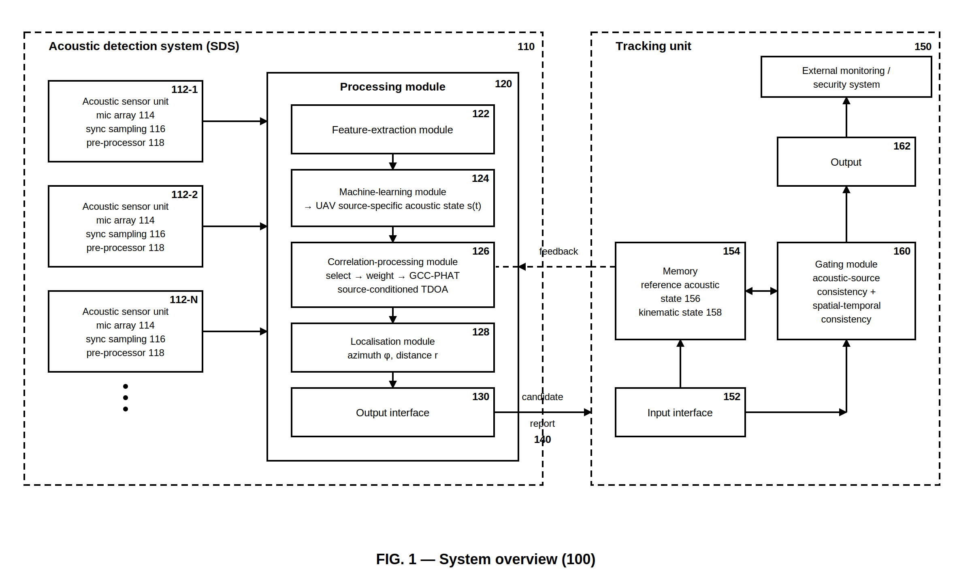
FIG. 2 — DSP Signal-Processing Pipeline (200).
FIG. 2 illustrates the signal-processing chain executed for each acoustic sensor unit 112-n: microphones 114, synchronised sampling 116, pre-processing 118 (automatic gain control, band-pass filtering, noise suppression), framing and short-time Fourier transform giving X(t,k), partition of the frequency axis into B bands K_b, and feature extraction 122. The extracted features are supplied to the machine-learning module 124 (detailed in FIG. 4), which outputs the UAV source-specific acoustic state s(t) = (p_1(t), …, p_B(t)). The lower part of the figure shows the derivation performed by the correlation-processing module 126: step (d)(i), the component selection S(t) comprising the time-frequency components whose band probability exceeds the selection threshold θ_sel, all other components being excluded; and step (d)(ii), the component weight w(t,k) = g(p_b(t)) assigned to each selected component. The same S(t) and w(t,k) are applied to the signals of every sensor unit and passed to the correlation stage of FIG. 3.
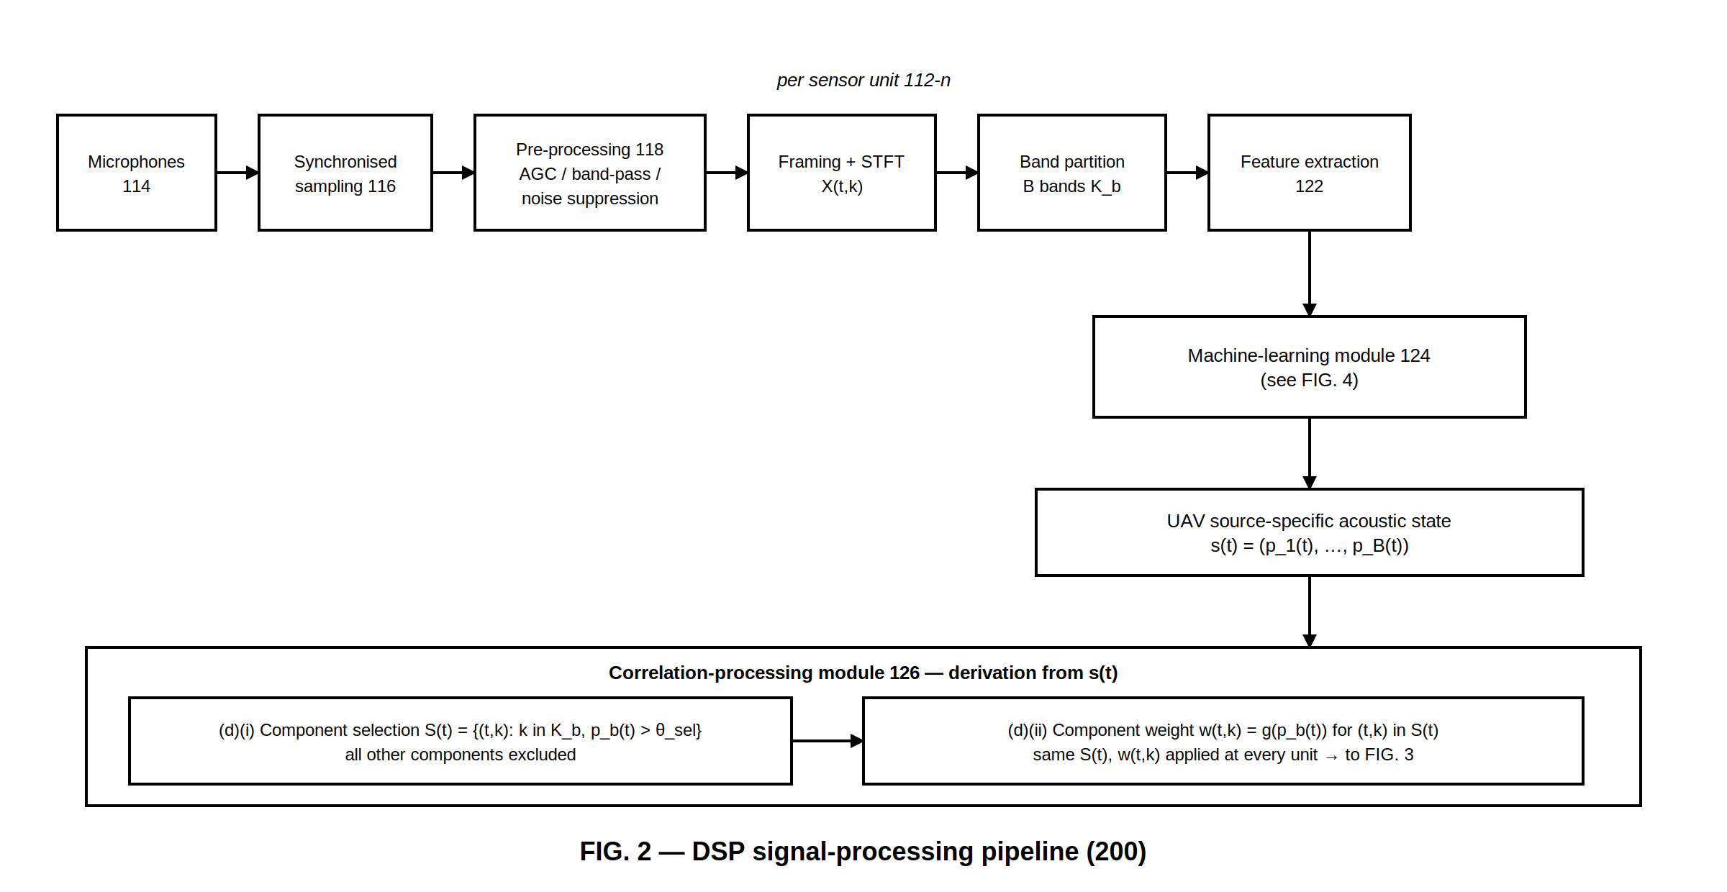
FIG. 3 — Source-Conditioned TDOA and 2D Localisation (300).
FIG. 3 illustrates the source-conditioned inter-unit cross-correlation and localisation. For a pair of sensor units i and j, the reference-channel spectra X_i(t,k) and X_j(t,k) form the cross-power spectrum G_ij = X_i · X_j*. The cross-power spectrum is masked by the selection S(t) — bins outside S(t) are set to zero — and multiplied by the weights w(t,k) received from FIG. 2, then phase-transformed (G_ij / |G_ij|) and inverse-transformed to give the cross-correlation R_ij(τ) over the physically admissible delay range |τ| ≤ d_ij / c. The inset shows R_ij(τ) with the dominant peak whose position, refined by interpolation and validated by a peak-ratio test, is the source-conditioned TDOA measurement τ_ij(t). The localisation module 128 solves the hyperbolic equations |x − u_i| − |x − u_j| = c·τ_ij for at least three pairs by weighted least squares, using the known unit positions u_1 … u_N, and expresses the candidate location as azimuth φ and distance r. The result is assembled into the candidate report transmitted over interface 140.
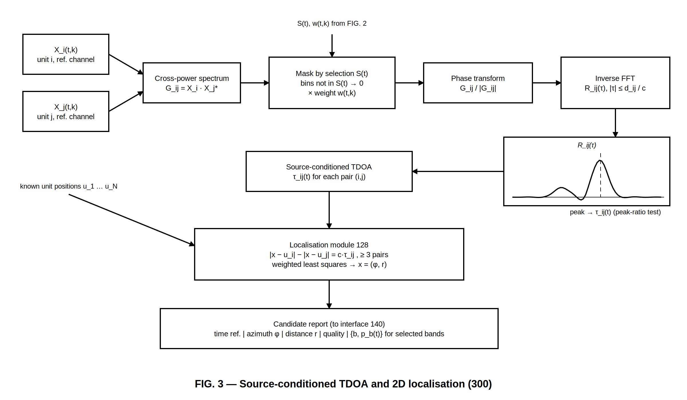
FIG. 4 — Machine-Learning Module and UAV Source-Specific Acoustic State (400).
FIG. 4 illustrates the machine-learning module 124 at runtime (upper, solid frame) and the offline training procedure (lower, dashed frame). At runtime, per-frame input features — per-band log power, log-mel or MFCC coefficients, spectral flux and per-band amplitude-modulation spectrum — are processed by a model with trained parameters (convolutional layers, a dense layer and B sigmoid output units) to produce, for each frequency band b, the probability p_b(t) that the band contains an acoustic component attributable to a UAV. The bar chart shows the resulting state s(t); bands with p_b above the selection threshold θ_sel (black bars) correspond to the rotor harmonics of the UAV and form the component selection. The lower frame shows the offline training, which is performed on an external computer and forms no part of system 100: recordings of K UAV types labelled per band from the blade-pass frequency f_0, and recordings of non-UAV sources with all band labels zero, are used for per-band binary cross-entropy training; the resulting model parameters are loaded once into module 124 at deployment (dashed arrow).
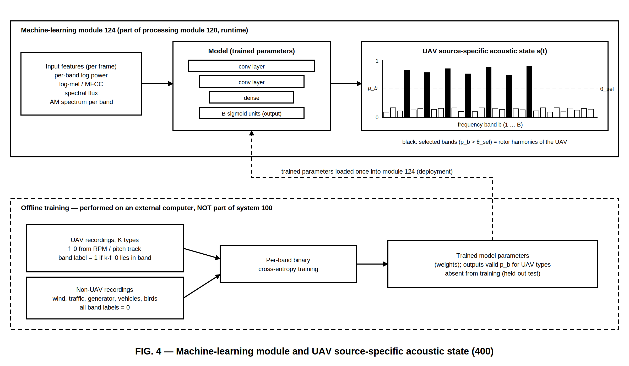
FIG. 5 — Distributed Acoustic Sensor Network, Plan View (500).
FIG. 5 is a plan view of a deployment of four acoustic sensor units 112-1 … 112-4 at surveyed positions u_1 … u_4, each with a coverage zone (dashed circles) and each connected to the processing module 120 (solid lines). A UAV within the overlapping coverage is shown with the propagation paths to each unit (dashed lines), whose pairwise differences give the source-conditioned TDOA measurements τ_ij. The candidate two-dimensional location of the UAV is expressed as the azimuth φ, measured from north at the reference point of the system (the centroid of the unit positions), and the distance r from that reference point.
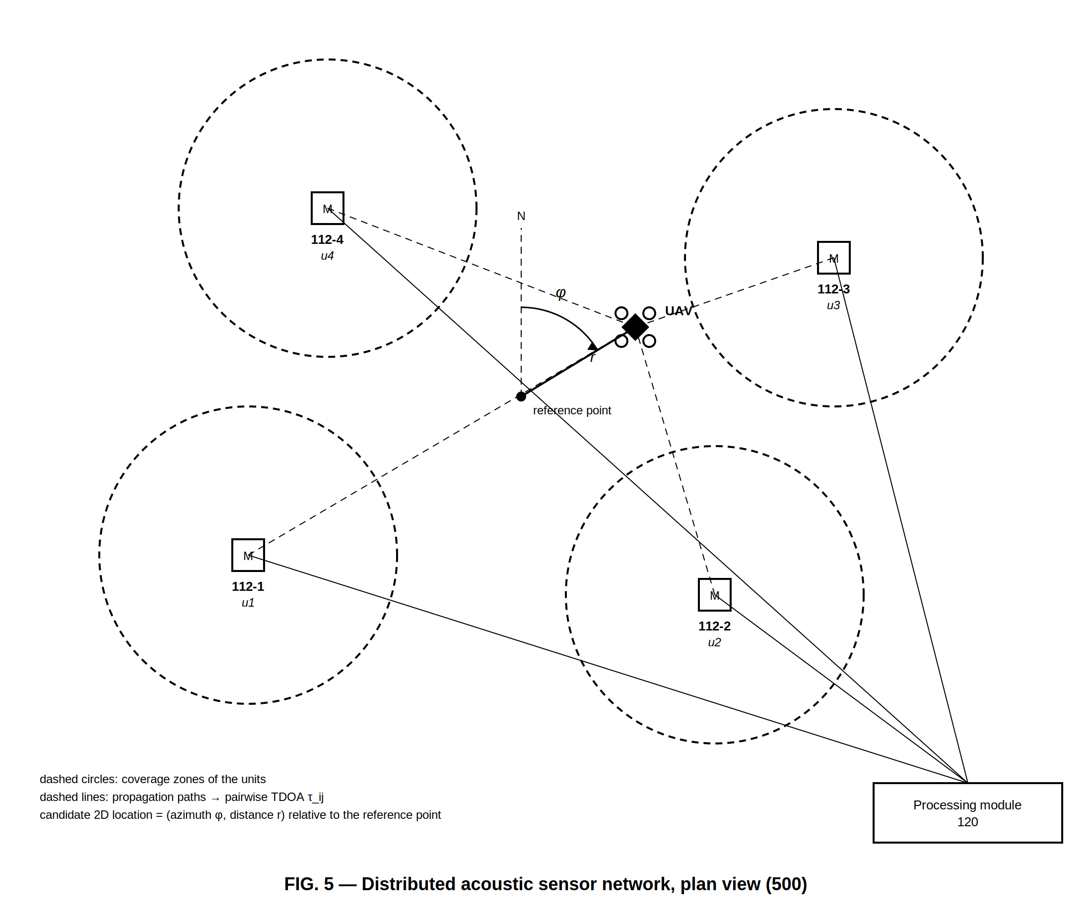
FIG. 6 — Two-Device Architecture and Candidate Report Structure.
FIG. 6 illustrates the separation of the system into the acoustic detection system 110 and the tracking unit 150 and defines the data exchanged between them over the interface 140. The acoustic detection system 110 — sensor units 112-1 … N, processing module 120 (122, 124, 126, 128) and output interface 130 — produces candidate locations but forms no trajectory. The tracking unit 150 — input interface 152, memory 154 with reference acoustic state ŝ (156) and kinematic state (158), gating module 160 and output 162 — receives the candidate reports and forms the trajectory. The reference acoustic state and predicted position are returned to the processing module 120 (dashed arrow). The lower part of the figure shows the structure of the candidate report transmitted once per acquisition frame: time reference, azimuth φ, distance r, a quality field (number of accepted pairs and least-squares residual), and the acoustic-state information consisting of the indices b and probabilities p_b(t) of the selected bands.
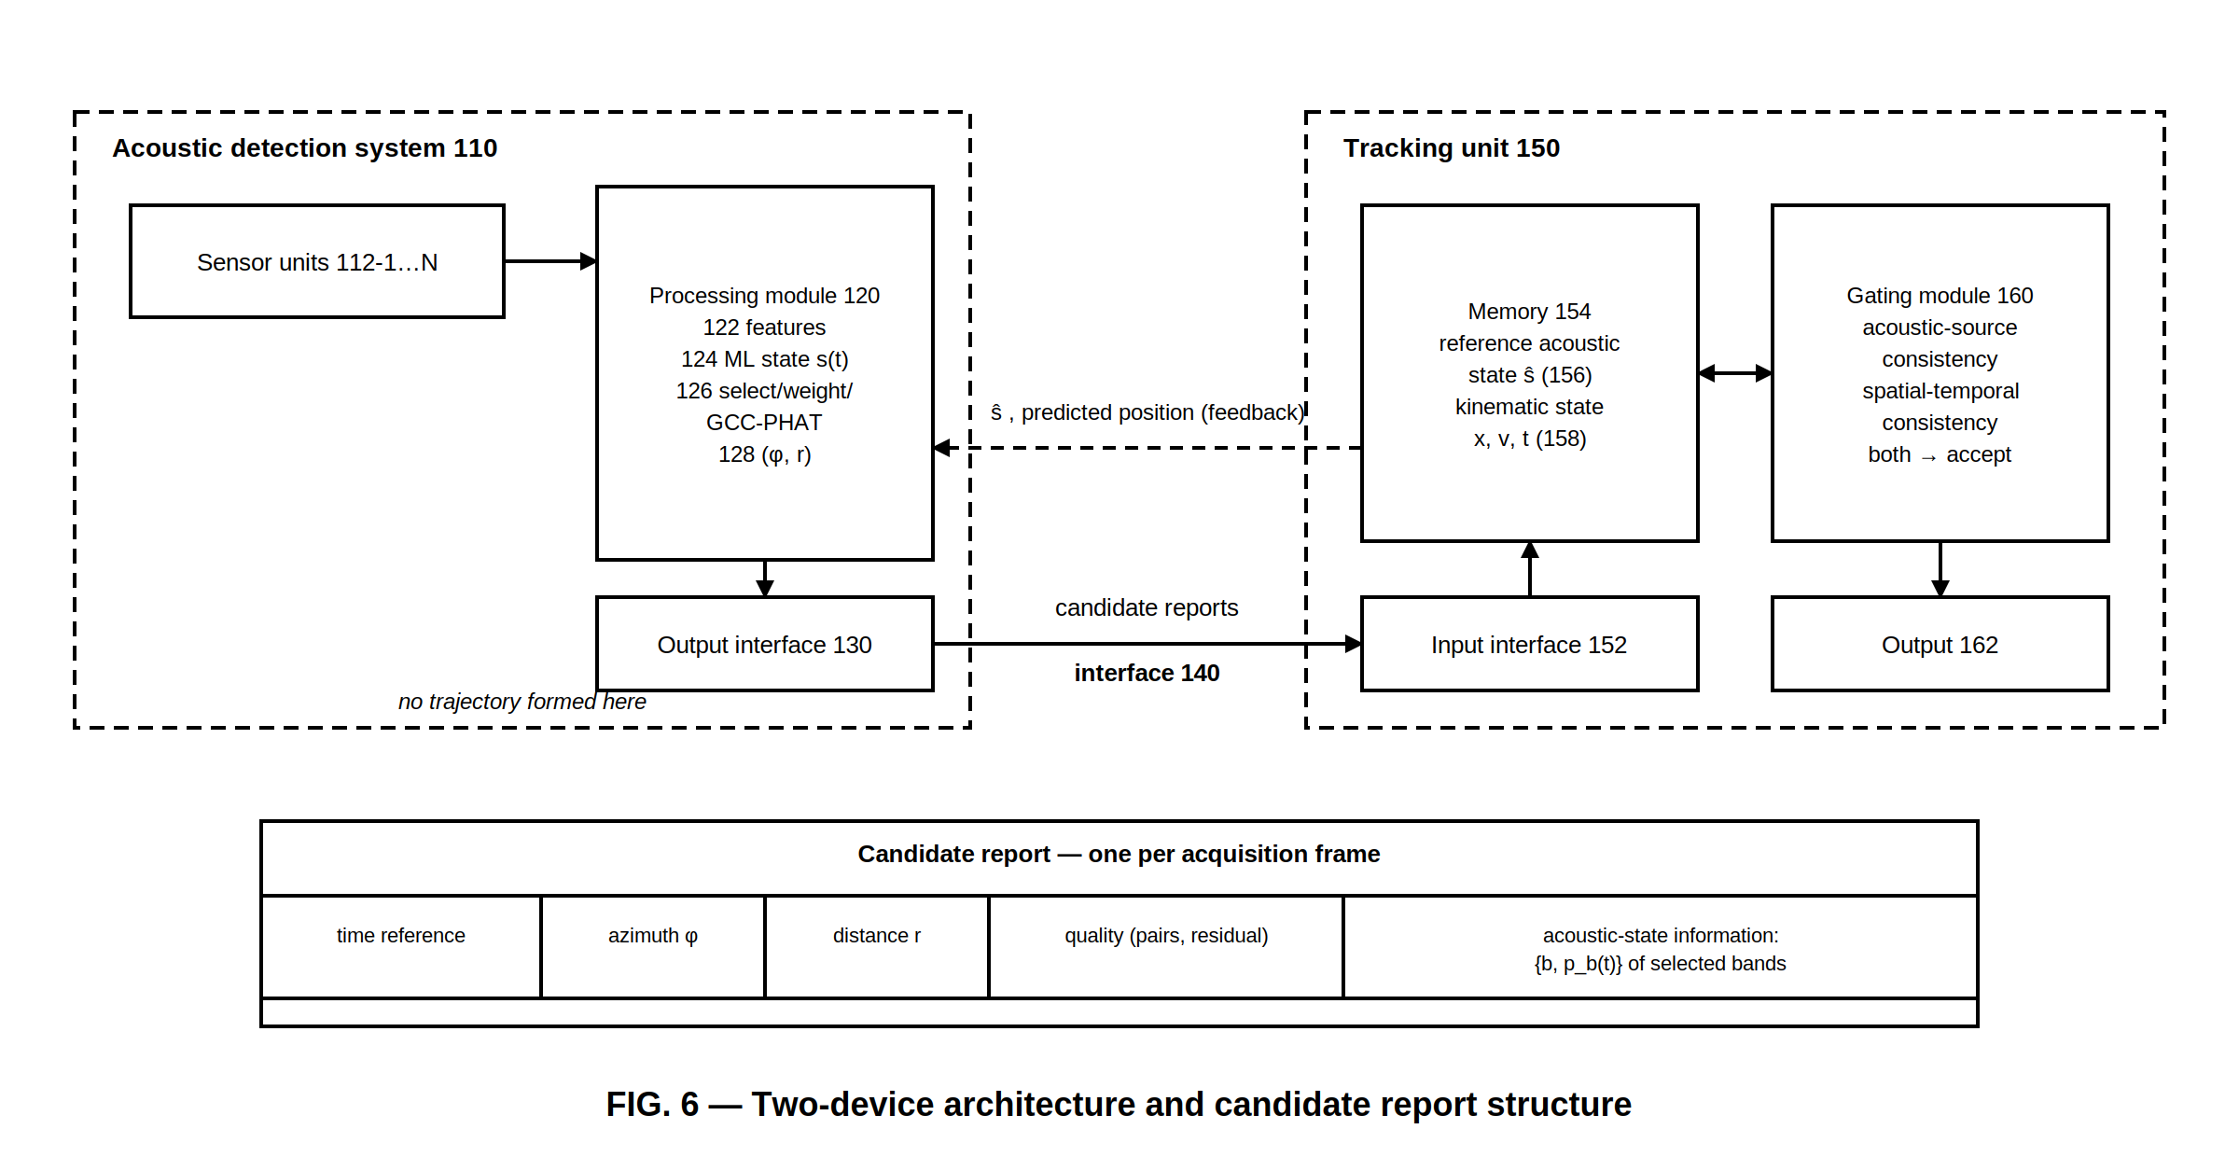
FIG. 7 — Tracking-Unit Processing: Dual Consistency Gate and Trajectory Update.
FIG. 7 is a flow chart of the processing performed by the tracking unit 150 for each received candidate report (φ, r, t, {b, p_b}). The reference acoustic state ŝ and the kinematic state (x, v, t_last) are read from memory 154. Two criteria are evaluated in parallel: the acoustic-source consistency criterion, in which the similarity σ between the acoustic-state information s of the report and the reference ŝ (for example the cosine similarity) is compared with the threshold θ_sim; and the spatial-temporal consistency criterion, in which the position x_pred(t) predicted from the kinematic state is compared with the reported position x by the Mahalanobis distance d and tested against the prediction gate. Only when both criteria are satisfied is the candidate location incorporated into the trajectory — the Kalman filter is updated with x and the reference state is updated as ŝ ← (1−α)ŝ + αs; otherwise the report is discarded and the filter performs prediction only. The trajectory is output at 162 and the updated ŝ and predicted position x_pred(t+1) are transmitted to the acoustic detection system (FIG. 8). Track initiation after N_init consecutive accepted reports and termination after T_end without an accepted report are indicated.
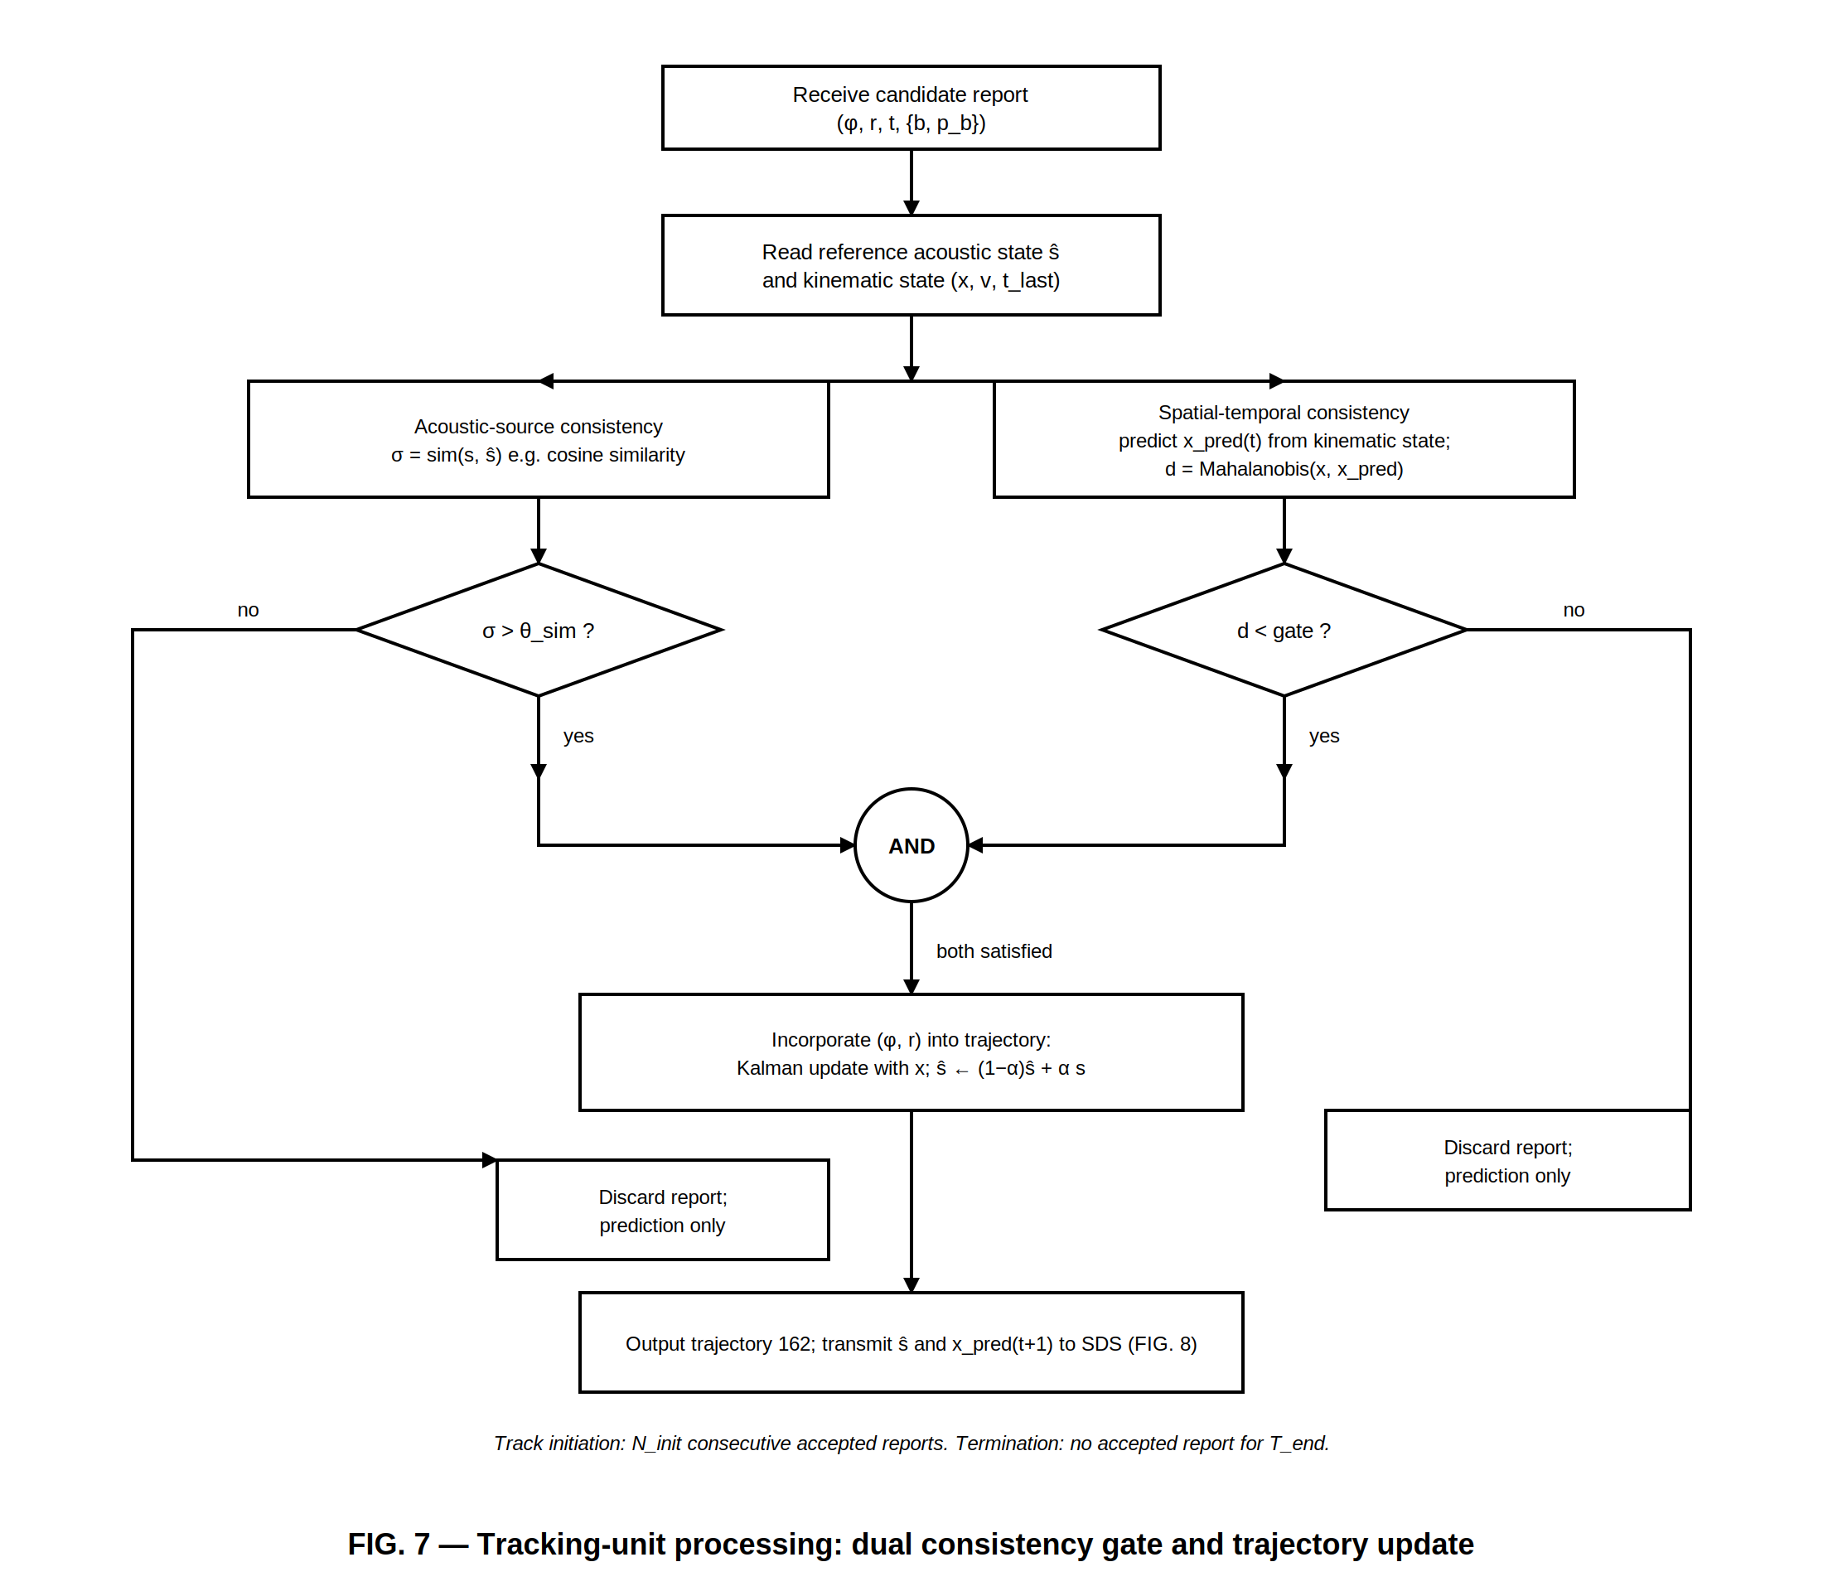
FIG. 8 — Feedback from Tracking Unit to Correlation-Processing Module.
FIG. 8 illustrates the use, in the correlation-processing module 126 during the next acquisition interval, of the reference acoustic state ŝ and the predicted position x_pred(t+1) transmitted by the tracking unit 150 after each accepted report. In the per-band adjustment, bands whose reference value ŝ_b exceeds a threshold θ_ref have their selection threshold lowered from θ_sel to θ_low and their component weight multiplied by (1 + ŝ_b), so that the harmonics of the tracked UAV remain selected during brief drops of instantaneous probability while unrelated bands are unaffected; the adjusted selection S(t+1) and weights w feed step (d) of FIG. 2. In parallel, the predicted position is converted into a predicted delay τ_pred_ij for each pair, and the peak search of R_ij(τ) in FIG. 3 is restricted to the window [τ_pred_ij − Δ, τ_pred_ij + Δ]. The resulting source-conditioned TDOA, candidate location and candidate report are returned to the tracking unit, closing the loop.
