Finance-Data-Viz-Insight.R

drsunjava

2025-04-13

# Finance-Driven Data Visualization with ggplot2  
# Author: Dr. Sunday Adetunji, MD PhD Epi | Data Science & Quant Finance  
# Title: "Visual Finance: Strategic Insight from Charts"  
  
# Rooted in insights from:  
# - Osterwalder & Pigneur’s *Business Model Generation* (value proposition, key metrics, revenue streams)  
# - Berk & DeMarzo’s *Corporate Finance* (risk, return, CAPM, capital budgeting, firm valuation)  
# - Dyer et al.’s *Innovator’s DNA* (creative associations for data storytelling)

# 1. Setup: Libraries & Data Simulation

library(tidyverse)

## ── Attaching core tidyverse packages ──────────────────────── tidyverse 2.0.0 ──  
## ✔ dplyr 1.1.4 ✔ readr 2.1.5  
## ✔ forcats 1.0.0 ✔ stringr 1.5.1  
## ✔ ggplot2 3.5.1 ✔ tibble 3.2.1  
## ✔ lubridate 1.9.3 ✔ tidyr 1.3.1  
## ✔ purrr 1.0.2   
## ── Conflicts ────────────────────────────────────────── tidyverse_conflicts() ──  
## ✖ dplyr::filter() masks stats::filter()  
## ✖ dplyr::lag() masks stats::lag()  
## ℹ Use the conflicted package (<http://conflicted.r-lib.org/>) to force all conflicts to become errors

library(scales)

##   
## Attaching package: 'scales'  
##   
## The following object is masked from 'package:purrr':  
##   
## discard  
##   
## The following object is masked from 'package:readr':  
##   
## col_factor

# Simulated data for 3 key sectors  
set.seed(42)  
dates <- seq(as.Date("2023-01-01"), as.Date("2023-12-31"), by = "week")  
stocks <- tibble(  
 date = rep(dates, 3),  
 sector = rep(c("Technology", "Energy", "Healthcare"), each = length(dates)),  
 return = c(  
 cumsum(rnorm(length(dates), mean = 0.8, sd = 2.5)),  
 cumsum(rnorm(length(dates), mean = 0.5, sd = 1.8)),  
 cumsum(rnorm(length(dates), mean = 0.6, sd = 1.2))  
 )  
)

# 2. Strategic Visuals: Cumulative Returns

# Value: Shows sector momentum, useful in portfolio design (per Berk & DeMarzo Ch. 10-11)  
  
ggplot(stocks, aes(x = date, y = return, color = sector)) +  
 geom_line(size = 1.1) +  
 labs(  
 title = "Cumulative Stock Returns by Sector (2023)",  
 x = "Date",  
 y = "Cumulative Return",  
 color = "Sector"  
 ) +  
 theme_minimal() +  
 scale_y_continuous(labels = dollar_format(prefix = "$"))

## Warning: Using `size` aesthetic for lines was deprecated in ggplot2 3.4.0.  
## ℹ Please use `linewidth` instead.  
## This warning is displayed once every 8 hours.  
## Call `lifecycle::last_lifecycle_warnings()` to see where this warning was  
## generated.

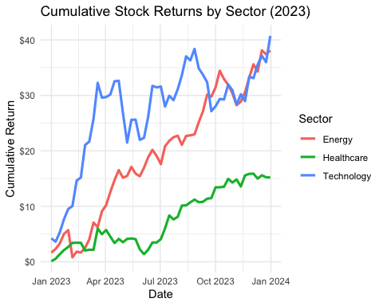

# 3. Trend Inference with LOESS Smoothing

# Value: Helps stakeholders recognize macro trends without volatility noise  
  
ggplot(stocks, aes(x = date, y = return, color = sector)) +  
 geom_line(alpha = 0.3) +  
 geom_smooth(se = FALSE, method = "loess", span = 0.2, size = 1.2) +  
 labs(  
 title = "Smoothed Return Trends by Sector",  
 subtitle = "LOESS smoothing for decision clarity",  
 x = NULL, y = "Return ($)", color = "Sector"  
 ) +  
 theme_light()

## `geom_smooth()` using formula = 'y ~ x'

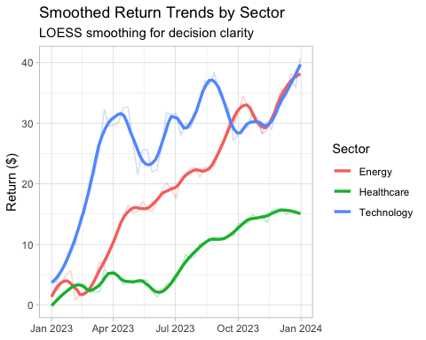

# 4. Faceted Panels: Investor Lens

# Use: Enables VCs or finance managers to assess individual industry behavior  
  
ggplot(stocks, aes(x = date, y = return)) +  
 geom_line(color = "steelblue") +  
 facet_wrap(~sector, scales = "free_y") +  
 labs(  
 title = "Sector-Specific Return Paths",  
 x = NULL, y = "Cumulative Return"  
 ) +  
 theme_bw()

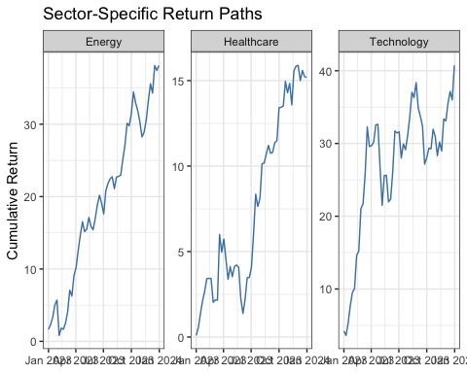

# 5. Year-End Distribution for Risk Management

# Value: Borrowing from *Business Model Generation*, this aligns with key metrics for CFOs  
final_return <- stocks %>%  
 group_by(sector) %>%  
 summarise(end_return = last(return))  
  
ggplot(final_return, aes(x = sector, y = end_return, fill = sector)) +  
 geom_col(show.legend = FALSE) +  
 geom_text(aes(label = round(end_return, 1)), vjust = -0.5, size = 5) +  
 labs(  
 title = "Year-End Returns by Sector",  
 y = "Final Return ($)", x = NULL  
 ) +  
 theme_minimal()

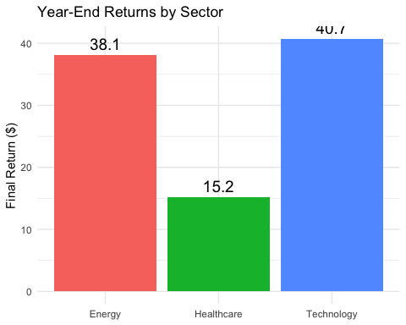

# 6. Scenario Simulation – Governance & Regulation

# Insight: Scenario-based modeling (inspired by CAPM, arbitrage theory in *Corporate Finance*)  
shock_stocks <- stocks %>%  
 mutate(shock = if_else(date == as.Date("2023-09-01"), -10, 0),  
 return = return + shock)  
  
ggplot(shock_stocks, aes(x = date, y = return, color = sector)) +  
 geom_line(size = 1) +  
 geom_vline(xintercept = as.Date("2023-09-01"), linetype = "dashed", color = "red") +  
 annotate("text", x = as.Date("2023-09-01"), y = 0, label = "Shock Event", vjust = -1.2, color = "red") +  
 labs(  
 title = "Shock Event Simulation on Sector Returns",  
 subtitle = "Applied on Sept 1st across all sectors",  
 y = "Return ($)"  
 ) +  
 theme_minimal()

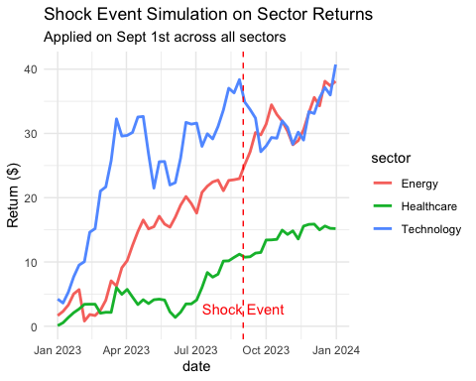

# Advanced Insight:  
# • Business Model Generation: Use visuals to align ROI, customer segment, and revenue stream.  
# • Corporate Finance: Use graphs for DCF insight, IRR visibility, and risk-return profiles.  
# • Innovator's DNA: Combine financial metrics with creative cross-industry visuals to craft strategy.